SELF MONITORING AND CLEANING SYSTEM FOR
SOLAR PANEL
Karpagam N ¹, Sridhar M S ², Boobaesh S ³ and Santhosh S ⁴
¹ Professor, ^{2,3,4} Student
Department of Electrical and Electronics Engineering,
Velammal College of Engineering and Technology,
Madurai, 625009, India.
E-mail: ¹ n.karpagam@vcet.ac.in*, ² smartsri2002@gmail.com,
³boobaesh123@gmail.com, ⁴ santhoshfrizzera@gmail.com

Abstract: In India, Both urban and rural residents have had significant problems with the supply of energy. Energy is one of the major problems facing the globe today. Agribusiness waste and fuel wood provide 60–70% of the nation's energy needs. The sun radiates energy, which is a renewable resource with great potential. To replace the use of electric energy derived from petroleum, renewable energy is necessary. The utilisation of solar energy must be increased as it is now a source of renewable energy. Solar PV modules are typically employed in dusty environments, such those seen in tropical nations like India. Dust accumulates on the module's front surface, blocking incident sunlight.. It lowers the module's ability to generate electricity. If the module is not cleaned for a month, the power output might drop by up to 50%. The cleaning system, which was created, uses embedded code to clean the module. The power efficiency of the PV modules will be increased by cleaning off the dust.

Keywords: Solar panel, digital sensors, photovoltaic Conversion, Analog to Digital conversion

1. INTRODUCTION
There is a plentiful supply of solar energy in nature since the sun emits energy at a very high rate. If all solar energy could be transformed into usable forms, the world's energy needs might be more than satisfied. But this isn't possible because of atmospheric conditions including temperature, dust, and shadows. Solar energy can be transformed by solar panels into other useful energy forms. There is a record amount of interest in renewable energy, particularly solar energy as it produces power without emitting any carbon dioxide. One of the most promising strategies for meeting the world's increasing energy needs is the photovoltaic method of using solar energy.
Due to environmental factors, solar panels' effectiveness is restricted, hence it’s crucial to monitor variables like temperature, humidity, and dust. The effectiveness of solar panels in this environment, both with and without dust deposition, has been investigated. The created system includes the planning and execution of a microcontroller-based dust-cleaning system. The main objective of the project is to equip solar panels with a self-contained dust removal device.

2. Theory of Operation
There are numerous methods to modify it, such as enhancing its functionality with surface brush cleansers and water spray. This can be changed by sensors. In this project, power was supplied by a power supply; however, solar panels might be used in place of the power supply. The regions where silicone brushes have the longest cleaning life can be employed. The Arduino programme can be replaced by a more superior and extensive selection of micro-controllers. It can also be operated by remote controls for necessary cleaning operations. Rack systems can be replaced with belt drives. Even though everything about our project went according to plan and it was functioning as planned, there is still more that can be done to improve it and make it more automated, capable of detecting dust and overheating, and a battery-operated, night-time device.

3.COMPONENTS USED
3.1 MICRO CONTROLLER
The fundamental component of this procedure is the microcontroller. The sensor parameters and actuators can only be monitored and controlled by one device. In this case, we are choosing a microcontroller of the PIC kind. When compared to a simple controller, the controller includes a few unique characteristics. The controller contains analogue to digital conversion, pulse width generation, and inbuilt erasable program memory.

3.2 MAGNETIC REED SENSOR
The magnetic reed sensor, which is used to regulate the motor distance, is nothing more than a magnetically activated switch. The reed sensor is positioned at each end of the frame, and when the motor reaches a specific end, it will alert the controller and halt. To operate, the switch requires a magnetic field. At each end of the sliding frame, a pair of magnets will be positioned. The block diagram is shown in fig.1
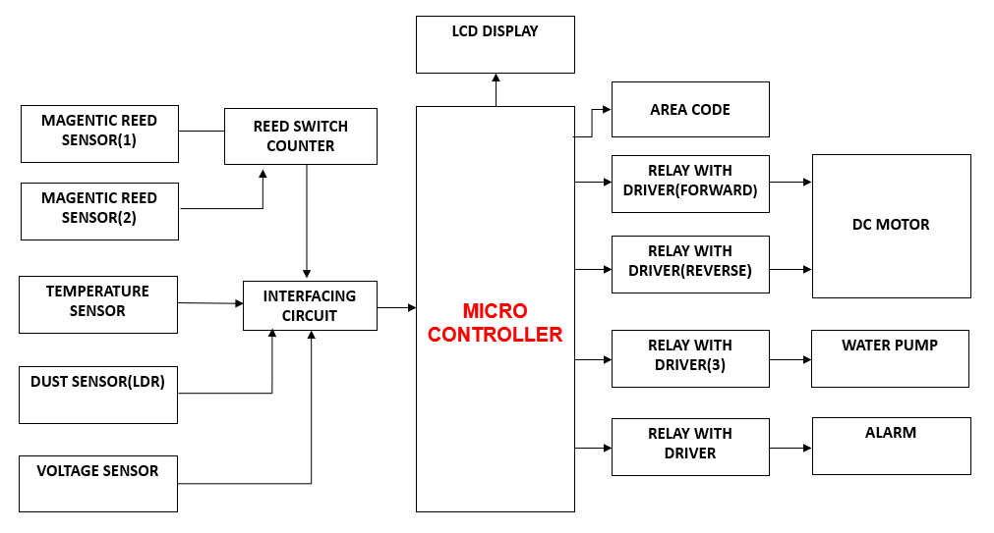
Fig.1 Block Diagram of Self Monitoring and Cleaning System of Solar Panel

3.3 RELAY DRIVER
Relays are switches that operate electrically. A relay driver circuit is a sort of circuit that drives a relay, helping the circuit perform as it should. The relay switch then operates according to the needs of the circuit and opens or closes as necessary. The Relay Driver is shown in fig.2
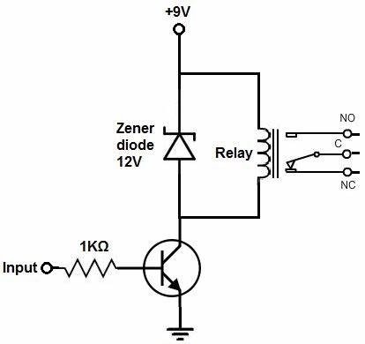
Fig.2: Relay Driver Circuit

3.4 INTERFACING UNIT
The microprocessor needs to access memory in order to read the data and instruction codes that are kept there when we execute an instruction. Certain signals are required by the CPU and memory in order to read from and write to registers. The interface technique includes a few essential elements that must line up with the signals from the CPU and memory requirements. As a result, the interfacing circuit should be designed to meet the requirements for both the memory signal and the microprocessor signal.

3.5 DUST SENSOR
To assess the amount of dust surrounding a panel, a dust sensor is employed. The sensor is built utilising a voltage divider circuit with an analogue output that allows for accurate reading of the value. The voltage level will be converted into digital via the controller's internal analogue to digital conversion circuit.

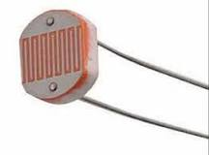
Fig.3:Light dependent resistor

3.6 TEMPERATURE SENSOR
Precision integrated-circuit temperature sensors, the LM35 sensor's output voltage is directly correlated with the temperature in Celsius (Centigrade). The LM35's linear output, low output impedance, and precise intrinsic calibration make it very easy to connect with control or readout circuitry. It can be utilised with a single power supply or with both positive and negative power supplies. The LM35 can operate in a temperature range of -55° to +150°C.
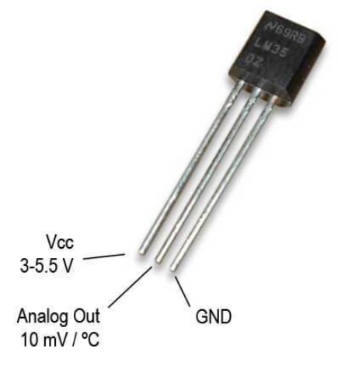
Fig. 4 : Temperature Sensor

3.7 LCD DISPLAY
The LCD display shows the controller's current status, and a buzzer circuit alerts the user to whether the cleaning process is active or not. The LCD display is shown in fig. 5
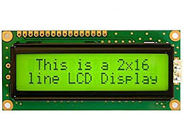
Fig.5: LCD display

3.8 VOLTAGE SENSOR
A voltage sensor is a sensor that measures and records the voltage level of an object. Voltage sensors are able to detect the AC or DC voltage level. The sensor's input is voltage, and its outputs can be switches, current signals, analogue voltage signals, or aural signals. Sensors are instruments that are able to recognise and react to particular optical or electrical signals. The employment of voltage and current sensor techniques has become a great substitute for conventional methods of measuring current and voltage. The voltage sensor circuit diagram & hardware structure is shown in fig.6

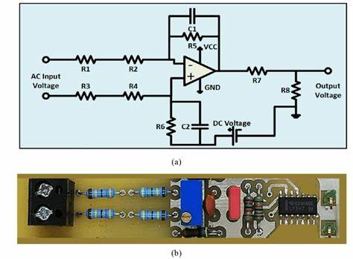
Fig.6:(a) Voltage sensor circuit diagram
(b) Hardware Structure

3.9 LIMITATION

- It would be necessary to alter the rolling brush, which is made of electrostatic cloth.
- It would also be necessary to scale it up for a bigger project (for example, by increasing the motor's torque).
- It would also be ineffective for sticky dust and unable to remove dust from corners.
- The sticky dust has to be scrubbed away with a strong brush or by mopping.

3.10 PROTOTYPE OF SOLAR PANEL CLEANING SYSTEM
Self Monitoring and Cleaning System of Solar Panel is shown in fig.7

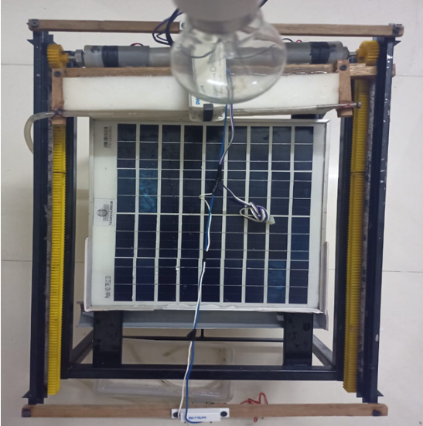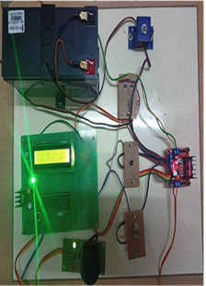

Fig.7: Model of Self Monitoring and Cleaning System of Solar Panel

4. WORKING PRINCIPLE
The fundamental component of this procedure is the microcontroller. The sensor parameters and actuators can only be monitored and controlled by one device. We are choosing a microcontroller unit of the PIC type here. When compared to the most basic kind of controller, the controller includes a few really unique features. The controller can generate pulse widths, convert analogue to digital, and has internal erasable programme memory.
A magnetically activated switch is all that a magnetic reed sensor is, and it is utilised to regulate the motor distance. The reed sensor is positioned at each end of the frame, and when the motor reaches that end, the sensor alerts the controller, causing the motor to stop. For the switch to operate, a magnetic field is required. There will be two magnets positioned at either end of the sliding frame.
The DHT11 sensor is used to determine the relative humidity and temperature. The one wire communication based sensor has low cost and higher efficiency. Update rate of the sensor is only limitation and it’ll take more than 1000 millisecond to update their internal characteristics. Controller activates the timer module and updates the sensor parameter within a second of interval.
A dust sensor measures the amount of dust that surrounds a panel. The voltage divider circuit and light-dependent resistor used in the sensor's construction provide an analogue output for precise value reading. The voltage level will be converted from analogue to digital via the controller's internal circuit.
In order to determine the generating voltage, the controller receives the output voltage from the solar panels. The controller will be shielded from higher voltage readings by the voltage divider circuit. When any of the sensor parameters are abnormal, the controller gathers all of the data and turns on the motor. A water pump will spritz water onto the panel, and a brush will remove any remaining dust and water from the panel.
The LCD display shows the controller's current status, and a buzzer circuit alerts the user to whether the cleaning process is active or not.
In addition, the count of the cleaning process is also displayed in the LCD display after the completion of cleaning as well as the area code of the system is also shown in the control room /LCD display.

- METHODOLOGY
5.1 DURING NORMAL CONDITION
Under normal weather, voltage and temperature from the PV panel is monitored using voltage sensor and temperature sensor. Voltage, temperature, Area code and count are displayed in the LCD Display.
5.2 DURING LOW EFFICIENCY
Under the presence of dust on the PV panel, LDR detects whether it is day or night. during day time, if the output voltage is low, signal from the LDR and Voltage sensor is given to the controller through the interfacing circuit and the system starts cleaning the panel and the count is incremented.
During night time, output from the LDR is not given to the controller so that system doesn’t have to clean the panel.
5.3 DURING TEMPERATURE EXCEEDING
Whenever the temperature exceeds the particular limit, Signal from the temperature sensor is given to the controller. Based on that signal, The System starts cleaning the panel to decrease the temperature by pumping water via the water pump. Alarm runs to indicate the entire cleaning process and the count is incremented.

5.4 DURING FAULT CONDITIONS
Whenever fault occurs or Input power supply is low during the cleaning process, The Cleaning System goes to the initial position with the help of motor drive after the problem is rectified.

- OUTPUT AND RESULT

Solar Panel Cleaning System is tested under different conditions of shading, dust environment and high temperature. The output voltage and temperature of the solar panel were observed and provided in Table 1. It is observed that with the developed Self Monitored Cleaning System. The efficiency (η) of the solar panel was increased.

S.  No | Shading or Dust  (Yes/No) | Cleaning Time  (sec) | Water Sprinkling  (Yes/No) | No. of Count | Voltage(V) |  | η | Temperature
 |  |  |  |  | Before  Cleaning | After Cleaning | (%) | Before  Cleaning | After  Cleaning
1 | No | 8 | No | 1 | 7 | 10.6 | 88.3 | 25°C | 25°C
1 | Yes | 10 | No | 1 | 5.3 | 8.9 | 74.1 | 25°C | 25°C
2 | No | 10 | No | 1 | 7.8 | 10 | 83.3 | 30°C | 30°C
2 | Yes | 13 | No | 2 | 7.4 | 11.3 | 94.16 | 30°C | 30°C
3 | No | 12 | Yes | 1 | 10 | 11.7 | 97.5 | 35°C | 25°C
3 | Yes | 14 | Yes | 2 | 8 | 11 | 91.6 | 35°C | 25°C
4 | No | 13 | Yes | 1 | 9.7 | 11.9 | 99.1 | 40°C | 27°C
4 | Yes | 16 | Yes | 2 | 8.8 | 10.6 | 88.3 | 40°C | 27°C
5 | No | 14 | Yes | 2 | 10 | 11.8 | 98.4 | 43°C | 28°C
5 | Yes | 17 | Yes | 3 | 8 | 10.9 | 90.8 | 43°C | 28°C
6 | No | 17 | Yes | 2 | 10.6 | 11.7 | 97.5 | 46°C | 30°C
6 | Yes | 20 | Yes | 3 | 8.4 | 12 | 100 | 46°C | 30°C

Table 1: Observation of Voltage and Operating Conditions of Solar Panel Cleaning System

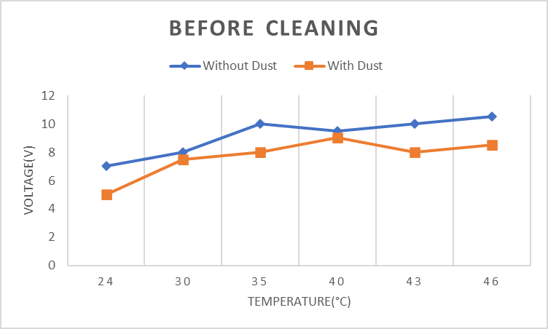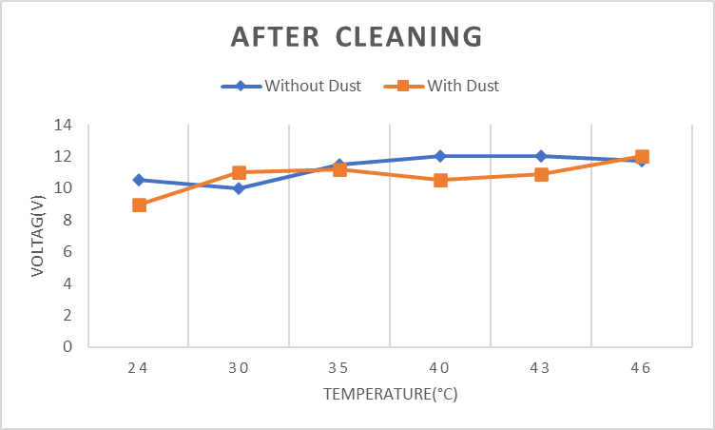
Fig.8:(a) Efficiency of Panel Before and After Cleaning

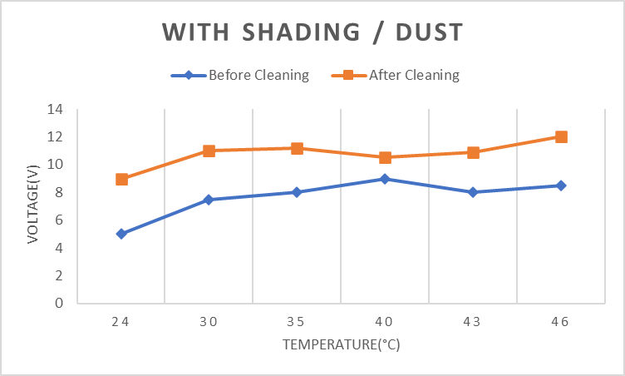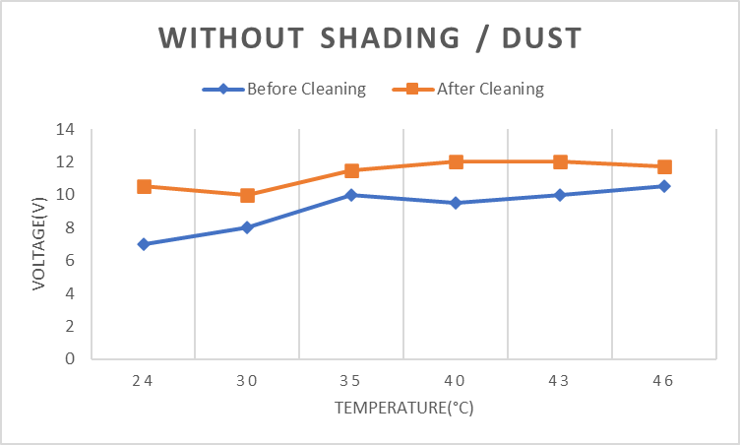
Fig.8:(b) Efficiency of Panel With and Without Shading / Dust

The final output for Self Monitoring and Cleaning System of PV Panel is given in fig.8

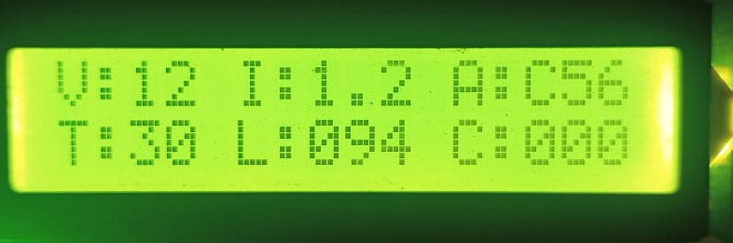

Fig.9(a): Sensor Parameters under normal condition

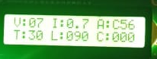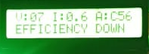
Fig.9(b): Low efficiency Cleaning Process

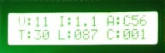
Fig.9(c):Increasing of Count After Cleaning

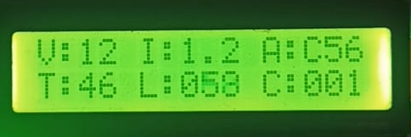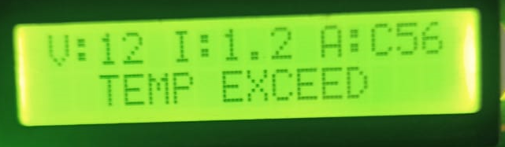
Fig.9(d): Temp Limit Exceed Cleaning Process

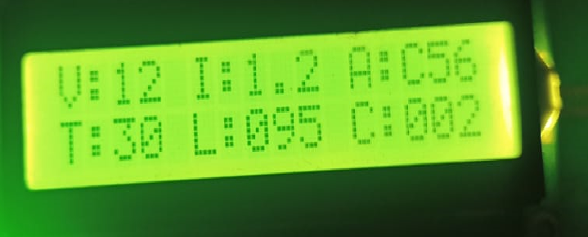
Fig.9(e):Increasing of Count After Cleaning with water
Fig.9: Main Results from the Self Monitoring and Cleaning System of
Solar Panel

6. Conclusion
Presently available automatic cleansers primarily target big arrays and are frequently unhappy for installation on lower arrays, similar as domestic rooftops. This implies that individualities with limited space simply need to make a lower array, making our offer extremely profitable for those lower spots. Our technology may be fitted for solar panels on roofs. The design parameters were originally taken into account when creating the solar panel cleaning system. Following testing of our model, the following findings were drawn the rack and pinion system functions as intended. The direct selector system performed admirably and successfully satisfied the necessary design parameter. Although the encounter did an excellent job of cleaning, the sticky dust was too tenacious for it to remove. It's necessary to clear the sticky dust with a strong encounter or by mopping. As a consequence, the cleaning operation stops the solar panel's face dust from originally erecting before it gets too sticky to remove. As we all know, prevention is better than cure.
7. References

- Gupta, V.; Sharma, M.; Pachauri, R.; Babu, K.N.D. Design and development of self-cleaning PV sliding system. Clean Energy 2022, 6, 392–403.
- Pagani, V.H.; Los, N.A.; Maidana, W.; Leitão, P.; Casaro, M.M.; Nascimento, C.B. Soiling Monitoring Modelling for Photovoltaic System. In CONTROLO 2020; Lecture Notes in Electrical Engineering; Springer: Cham, Switzerland, 2021; Volume 695, pp. 592–601.
- S.Alagoz and Y.Apak,”Removal of spoiling materials from solar panel surfaces by applying surface acoustic waves,”J.Cleaner Production,vol.253,2020,119992.
- Mohamed, M.; Attia, M.A.; Asim, A.M.; Abdelaziz, A.Y.; Kanwar, N. Optimization of cleaning frequency and dust accumulation effect on photovoltaic panels. J. Interdiscip. Math. 2020, 23, 53–68.
- Winston, D.P.; Ganesan, K.; Kumar, B.P.; Samithas, D.; Baladhanautham, C.B. Experimental investigation on output power enhancement of partial shaded solar photovoltaic system. Energy Sources Part A Recovery Util. Environ. Eff. 2020, 1–17.
- Hashim, N.; Mohammed, M.N.; AL Selvarajan, R.; Al-Zubaidi, S.; Mohammed, S. Study on Solar Panel Cleaning Robot. In Proceedings of the 2019 IEEE International Conference on Automatic Control and Intelligent Systems, I2CACIS 2019, Selangor, Malaysia, 29 June 2019; pp. 56–61.
- K.P.Amber et al., “A self-cleaning device for pole mounted solar photovoltaic installations,”Thermal Science, vol.23,no.2A,pp.739-49-2019.
- Attia, O.H.; Adam, N.M.; As’Arry, A.; Rezali, K.A. Removal of Dust from the Solar Panel Surface using Mechanical Vibrator. J. Physics Conf. Ser. 2019, 1262, 012021.
- Aditya Sinha. Automatic Solar Tracker with Pre-Installed Panel Cleaner.ijariit.2017; 3(5): pp. 232-238.
- V. A. Ballal, Prof. R. M. Autee. Dual axis solar panel and panel cleaningsystem.icrisem.2016; pp. 265-271.

