Design of Microstrip Anteena for Cognitive radio’s using CST
Aleddula Abhishek Reddy
Assistant Professor, Dept. of ECE, Matrusri Engineering College
abhishek.a.reddy@matrusri.edu.in
Abstract : A new frequency reconfigurable ultra wideband (UWB) microstrip antenna is designed for cognitive radio applications. The proposed system has communicating antenna and the sensing antenna within the same system. Frequency configurability can be obtained by configuring switches that are connected between feeding lines and extended transmission lines. Configuring-I acts as sensing antenna that operates in the frequency range from 2.96 GH to 14.95 GHz. Configurations II to V operates the antenna in narrow bands within the ultra-wide band range
Keywords: Cognitive radio, Reconfigurable antenna, PEC switches.
1 Introduction
In today’s world, wireless devices are increasing day by day, this results in huge requirement of spectrum. But the available spectrum for communication is very less. Some application areas such s cellular communication and WLAMN[3]. The spectrum congestion is very high. Whereas, in some applications like military and TV the spectrum is rarely used. To avoid the problems of lack of spectrum and inefficient use of spectrum, cognitive radio concept is introduced. Cognitive radio is a radio that detects the unused bands of the licensed user in the radio environment and assigns it to unlicensed users [4] . This avoids inefficient use of spectrum and improves spectrum efficiency.
UWB antennas use is increasing day by day. UWB antennas have advantages such as less power consumption, less costs and provides high data rates which is the major requirement in today’s world[1-2] .
Reconfigurable antennas are antennas that can modify its parameters such as frequency, radiation patterns based on the requirements [7] . The advantages with reconfigurable antenna is it accommodates the features of number of antennas within the same antenna.
Microstrip antenna has many advantages such as many advantages such as low sizes, les power consumption and easiness to fabricate. Antenna parameters can be reconfigured by changing the electrical length or surface current distribution of the antenna[5-6]. Changing in electrical length and surface current distribution “v”can be changes by inserting switches into the antenna. Some of the switches are RF MEMS, PEC switches, photoconductive switches, PIN diodes, varactors etc. the proposed design senses the and in the ultra-wideband range, communicates in narrow bands within the ultra-wideband range

2 .Proposed Model

The proposed antenna makes use of switches for frequency reconfigurability. By changing switching configurations, surface current distributions changes on the patch and ground surface that changes the resonant frequency of the antenna. The top and the bottom views of the proposed antenna are shown in figure 1

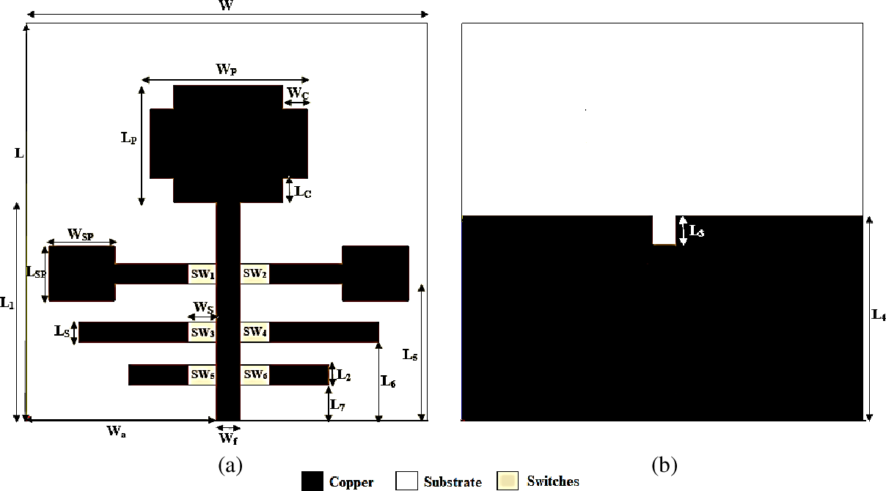

Fig.1 The proposed cognitive radio antenna, (a) Front side (b) Backside

UWB sensing antenna has a partial elliptical ground plane (GND plane) and the communicating antenna has a rectangular patch with slots cut at four edges. The two structures are printed on FR4 epoxy substrate with 4.4 dielectric constant, height (h) 1.6 mm. Using the above parameters, the design of the antenna is done with the design rules explained by Balanis[8].
2.1 UWB Sensing Antenna Design
The sensing antenna is the back of the antenna. It contains partial ground plane that allows the antenna to operate in the ultra-wide band range. It has slot at the center that gives impedance matching. The sensing antenna is shown in figure 2.
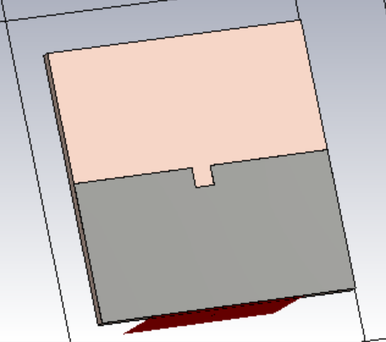
Fig 2.. The sensing antenna.

2.2 Communicating Antenna Design
The communicating antenna consists of rectangular patch with slots cut at the four edges to allow the antenna to operate in ultra-wideband rages. The antenna is feeded by 50 ohm microstrip line. Six extended transmission lines are printed on the FR4 substrate that are connected or disconnected to the feeding line for obtaining frequency reconfigurability. The communicating antenna is shown in figure 2.3 antenna with slots cut at four edges, which allows the antenna to operate in wideband. A 50Ω microstrip line is used for feeding the antenna. Six extended transmission lines are printed on substrate that are connected or disconnected to feedline through PEC switches, to obtain frequency reconfigurability. The communicating antenna is shown in figure 3.

The design equations of the communicating antenna are given from equations from (1) to (4) respectively.
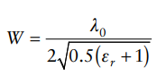 (1)
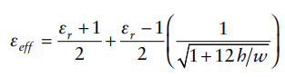 (2)

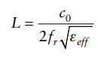 (3)
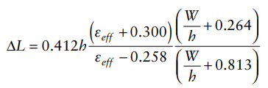 (4)

1.
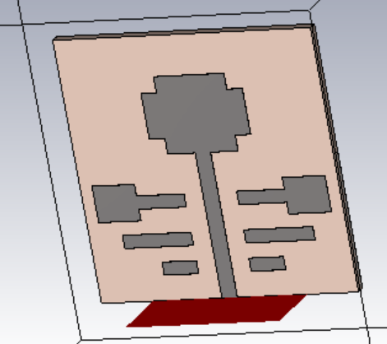
Fig 3. The communicating antenna.

3. Results and dıscussıons

The CST software is used to simulate the proposed cognitive radio antenna. The simulated (S11) and VSWR vs frequency of the UWB sensing antenna are shown in Figure 4& 5, which has an operating band cover the UWB (2.95-14.95) GHz and with VSWR (<2).

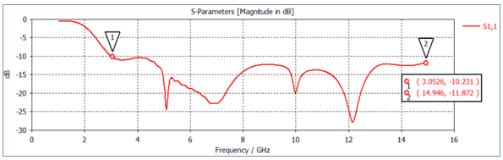

Fig 4. The simulated (S11) parameter versus UWB sensing antenna

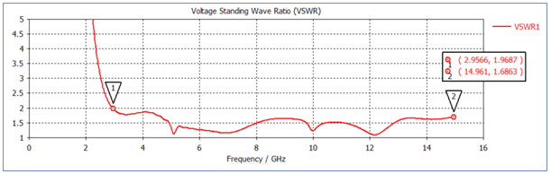

Fig 5 VSWR versus frequency of the UWB sensing antenna

When the switching status is changed from all OFF to at least one is ON, the antenna turns out to be a narrow band antenna exhibiting frequency reconfigurable nature. The reconfigurability illustrated from Fig. 6 and 9 provides coverage of UWB as narrow bands from 2.95 to 14.95 GHz as per simulation using perfect electric conducting sheet switches.

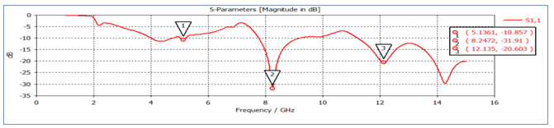

Fig 6. The simulated (S11) parameter versus frequency for Configuration II

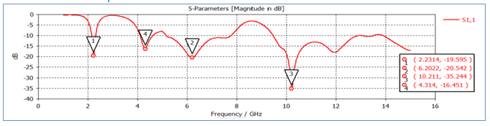

Fig 7. S11 versus frequency for Configuration III

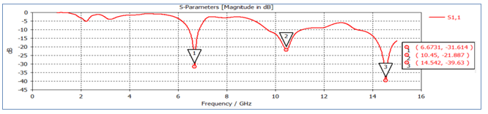
Fig 8 S11 Magnitude vs frequency for confifguration IV
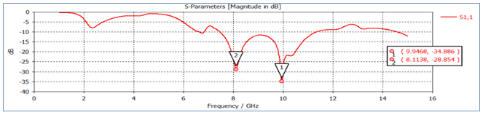
Fig 9 S11 Magnitude vs frequency for confifguration V

The (2D) radiation pattern of the proposed antenna are shown in Figure 10(a) to 10 (e) respectively for frequencies at 5.1 GHz, 8.24GHz ,10.23GHz, 6.66GHz and 9.94GHz respectively
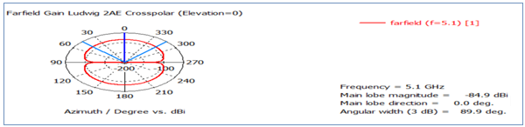

- Configuration I
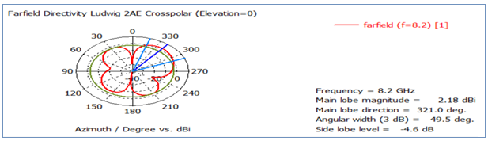
- Configuration II

Figure.6. 2D radiation pattern of the proposed antenna in (a)configuration I for 5.1GHz (b)configuration II for 8.2 GHz

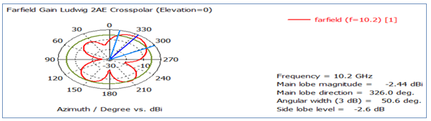
- Configuration III
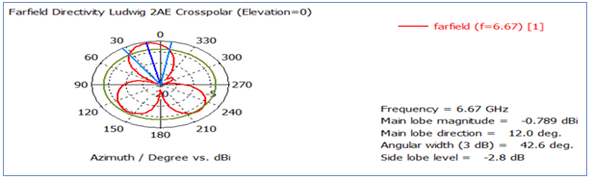
- Configuration IV

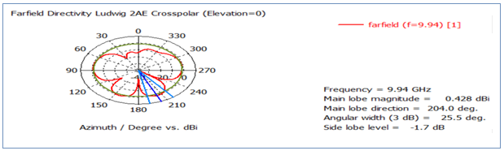
- Configuration V

Figure.6. the proposed antenna 2D radiation pattern in (c ) configuration III for 10.23 GHz (d)configuration IV for 6.66 GHz (e) configuration V for 9.94 GHz

- Conclusion

A simple compact microstrip antenna has been designed that accommodate both the sensing and transmission or reception parts within the same design. configuration I makes the antenna suitable for spectrum sensing part of cognitive radio, and configuration II to V allow the antenna to be used for communicating within the UWB spectrum.
References
- Liang, X. L., “Chapter 7: Ultra wideband current status and future trends,” Ultra Wideband Antenna and Design, 127–152, 2012.
- Fontana, R., “Recent system applications of short-pulse ultra-wideband (UWB) technology,” IEEE Trans. Microw. Theory Techn., Vol. 52, No. 9, 2087–2104, 2004.
- Li, T., H. Zhai, X. Wang, L. Li, and C. Liang, “Frequency-reconfigurable bow-tie antenna for Bluetooth, WiMAX, and WLAN applications,” IEEE Antennas Wireless Propag. Lett., Vol. 14, 171–174, 2015.
- Tawk, Y., J. Costantine, S. Hemmady, G. Balakrishnan, K. Avery, and C. G. Christodoulou, “Demonstration of a cognitive radio front end using an optically pumped reconfigurable antenna system (OPRAS),” IEEE Trans. Antennas Propag., Vol. 60, No. 2, 1075–1083, 2012.
- Tummas, P., P. Krachodnok, and R. Wongsan, “A frequency reconfigurable antenna design for UWB applications,” 2014 11th International Conference on Electrical Engineering/Electronics, Computer, Telecommunications and Information Technology (ECTICON), 2014.
- Li, F. and T. Wang, “Design of reconfigurable UWB microstrip antenna with MEMS switches,” 2016 IEEE International Conference on Microwave and Millimeter Wave Technology (ICMMT), 740–742, 2016.
- Tawk, Y. and C. Christodoulou, “A new reconfigurable antenna design for cognitive radio,” IEEE Antennas Wireless Propag. Lett., Vol. 8, 1378–1381, 2009.
- Balanis, C. A., Antenna Theory: Analysis and Design, John Wiley Sons, Hoboken, NJ, 2012.

