Comparative Evaluation of Antibacterial Effectual Characteristics of Triple Herbal Leaf Extracts against Respiratory Pathogenic Isolates
*K. Priya ¹ , M. Thenmozhi¹ , S. Jayavarshini ¹ , S. Varsha¹
K. Priya , Asst , Professor in Microbiology,
M. Thenmozhi¹ , S. Jayavarshini ¹ , S. Varsha ¹ - Research Students
Corresponding Author
Abstract
The goal of the current study was to assess the antibacterial efficacy of herbal leaf aqueous extracts (Justicia adhatoda, Mukia maderaspatana, and Solanum triloblatum) against respiratory pathogenic isolates. The antibacterial activity of J. adhatoda's aqueous extract demonstrated a zone of inhibition of 14 mm, 15 mm, and 13 mm against E. coli, S. aureus, and K. pneumoniae, respectively, while M. maderaspatana leaf extract demonstrated a zone of inhibition of about 13 mm, 17 mm, and 21 mm against E. coli, S. aureus, and K. pneumoniae, respectively. Using the agar well diffusion method, the S. triloblatum leaf extract demonstrated approximately 17mm, 17mm, and 20mm against E. coli, S. aureus, and K. pneumoniae. Based on these results, it was determined that the Solanum triloblatum aqueous extract outperformed the other two extracts in terms of antibacterial activity against all pathogenic organisms tested. The findings showed that herbal plants' leaves had antibacterial qualities, making them a viable source of herbal medicines with antibacterial capabilities.

Introduction
The most frequent acute illness assessed in the outpatient environment is respiratory tract infections. In addition, acute RTIs, especially pneumonia, continue to be one of the leading causes of death in both adults and children (approximately 50 million fatalities globally). According to Bosch et al. (2013), pneumonia accounts for more fatal cases in children under the age of five than AIDS, malaria, and measles put together. Although bacterial infections also cause significant morbidity and have the potential to be fatal, viral infections account for the majority of RTIs (Morris, 2007).
Very little saliva is present in the best sputum samples because saliva contaminates the sample with oral bacteria. The clinical microbiologist evaluates this incident by looking at a sputum Gram stain. A salivary contamination is indicated by more than 25 squamous epithelial cells at modest enlargement. White blood cells, cellular debris, dead tissue, serous fluid, and viscous liquid (mucus) are all components of pus found in purulent sputum. It is primarily green and yellow in color. According to Michael Binuyo (2013), it occurs in cases of bronchiectasis, lung abscess, advanced bronchitis, acute upper respiratory tract infection (common cold, laryngitis), and laryngitis.

Unbelievable claims have been made about the antibacterial effectiveness of several plants in the treatment of diseases. An estimated 10% of all flowering has been consumed by local populations.
Unbelievably effective antibacterial treatment for diseases has been linked to some plants. Although just 1% of flowering plants on Earth have been recognized by current science, local cultures are thought to have employed roughly 10% of them to treat various illnesses (Kafaru. E, 1994). Searches for plants that possess antimicrobial compounds are common due to their widespread use as treatments for numerous infectious disorders (Betoni, J.E.C. et al., 2006).
Materials and Methods
Sputum Sample
Sputum samples for the current investigation were obtained from Swasti Diagnostic and Health Centre in Kumbakonam. Transferring the material to the microbiological lab for additional analysis using the sterile container.
Identification and Isolation
By using the swab approach, the sputum sample was infected in nutrients agar plate and incubated at 30°C for 24-48 hours. Selected colonies of the sputum sample were transferred from the mixed culture of the plate onto the appropriate agar plates and agar slants, and incubated at 30oC for 48 hours after the incubation time. Slants with pure cultures were kept at 4oC for future analysis. Colonies of isolates were employed in the identifying process. The microorganisms were identified using the biochemical test, Gram staining, motility, and selective media plate.
Physical and Morphological Test
Following a 48-hour incubation period at 37°C, the cultural traits of pure isolates on nutritional agar media were noted. Both macroscopic and microscopic morphological techniques are used. Light microscopy was used for the microscopic characterization. Color, shape, and morphology were used to describe an organism's appearance using microscopic techniques.
The gathering of plant material (leaves) From a nursery, fresh leaves of Justicia adhatoda, Mukia maderaspatana, and Solanum trilobatum were gathered.
Making of Plant Extract
With double distilled water, the leaves of Justicia adhatoda, Mukia maderaspatana, and Solanum triloblatum were completely cleaned. After being dried at 50°C for 48 hours, the materials were ground into fine powders in an electric blender. With this powder, aqueous extraction was performed. To create 100ml of extracts (25%w/v), 25g of powdered plant material was dissolved in aqueous solution. The mixtures were allowed to stand at room temperature for 25 hours in sterile flasks covered with aluminum foil to prevent evaporation before being filtered with whatmanNo. 1 filter paper. Following filtering, the extracts were evaporated in a water bath until 25ml remained in the container, and their antibacterial activity was assessed using the agar well diffusion method.
Well-Diffusion
Antibacterial Sensitivity test against the isolated pathogens, the antibacterial efficacy of Justicia adhatoda, Mukia maderaspatana, and Solanum triloblatum (leaves) was examined. The antibacterial activity was tested using the agar well diffusion method. The Muller Hinton agar plates were well-prepared, and a center hole (6–8 mm in diameter) was aseptically punched with a sterile cork borer. According to the test protocol, a fixed plant extract was added to the well and incubated for the necessary amount of time and temperature. Following incubation, the clean zone surrounding the well was measured in millimeters and designated as the zone of inhibition for the organisms being tested.
RESULT
Pathogenic Bacteria Isolation
A sterile container was used to collect the sample of sputum. Using a sterile cotton swab approach, the pathogenic bacteria were recovered from the sputum sample and isolated on nutrient agar medium.
Bacterial Pathogen Identification
Gram staining and several other biochemical assays were used to identify the isolated organisms. One gram-positive and two gram-negative organisms were found in the test results. Using the Eosin methylene blue, Macconkey, and Mannitol salt agar mediums, the presence of the bacterium was established.
Escherichia coli, Staphylococcus aureus and Klebsiella pneumoniae were extracted from the sputum sample and identified as the organisms.
Plant Material (Leaves) and Its Aqueous Extract:
Aqueous extracts of fresh leaves from Justicia adhatoda, Mukia maderaspatana, and Solanum triloblatum were made. Leaf extract from Justicia adhatoda has antibacterial properties.
Justicia adhatoda's aqueous leaf extract exhibits a zone of inhibition against Escherichia coli, Staphylococcus aureus and Klebsiella pneumoniae of 14 mm, 15 mm, and 13 mm, respectively. (Fig -1)
The Mukia maderaspatana aqueous leaf extract exhibits a zone of inhibition against Escherichia coli, Staphylococcus aureus and Klebsiella pneumoniae of 13 mm, 17 mm, and 21 mm, respectively.(Fig -2)
Leaf extract from Solanum triloblatum has antibacterial properties Solanum triloblatum's aqueous leaf extract exhibits a zone of inhibition against Escherichia coli, Staphylococcus aureus, and Klebsiella pneumoniae of 17 mm, 17 mm, and 20 mm, respectively. (Fig -3)
Table : Antibacterial Activity of Medicinal plants
Microorganisms | Aqueous extract zone of inhibition (dm) |  |  | Control
 | Justicia adhatoda | Mukia Maderaspatana | Solanum triloblatum
Escherichia coli | 14mm | 13mm | 17mm | -
Staphylococcus aureus | 15mm | 17mm | 17mm
Klebsiella pneumonia | 13mm | 21mm | 20mm | -

Fig. 1 Justicia adhatoda Aqueous Extract's Antibacterial Activity against Respiratory Pathogens
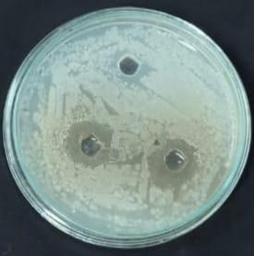
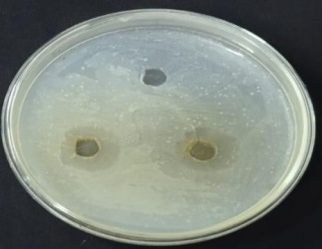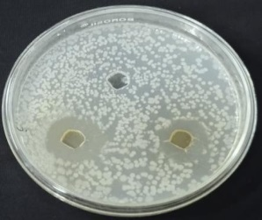
Escherichia coli Staphylococcus aureus Klebsiella pneumonia
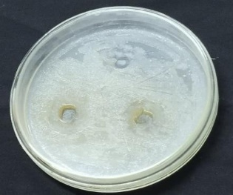
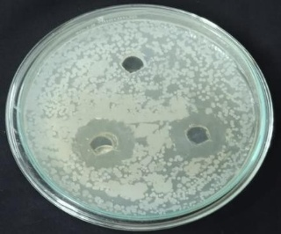
Fig – 2 Mukia maderaspatana Aqueous Extract Antibacterial Activity
Escherichia coli Staphylococcus aureus
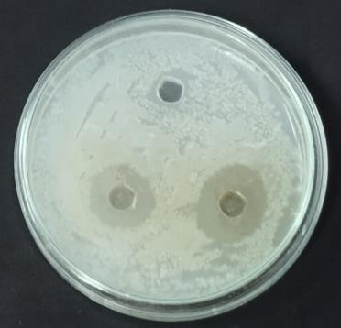 Klebsiella pneumonia
Fig – 3 Solanum triloblatum Aqueous Extract's Antibacterial Activity against Respiratory Pathogens
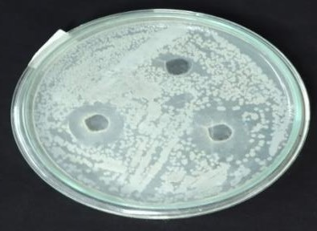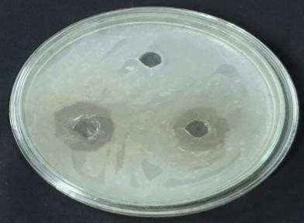
Staphylococcus aureus Escherichia coli Klebsiella pneumoniae
DISCUSSION
The most frequent infections are those caused by a range of bacteria, including pathogenic Escherichia coli, Salmonella spp., and Staphylococcus aureus. Drug resistance to human pathogenic microorganisms has been widely documented in recent years, according to Parastoo Karimi Alavijeh et al. (2012).
Five Gram-negative bacteria, including Klebsiella pneumoniae, Escherichia coli, Pseudomonas aeruginosa, Acinetobacter baumannii, and Enterobacter cloacae, and five Gram-positive bacteria, including Staphylococcus epidermidis, Staphylococcus aureus, Staphylococcus aureus, Staphylococcus aureus, and Staphylococcus. Therefore, Klebsiella pneumoniae, Candida tropicalis, and Staphylococcus epidermidis were the most frequently isolated bacteria from the clinical samples taken from individuals who had RTI symptoms.( G.O.O. Hassan et al., 2019)
Escherichia coli, Klebsiella pneumoniae, and Staphylococcus aureus were the most common pathogens recovered from the study's sputum sample.A large number of bacterial species have developed resistance to anti-bacterial medications, which is a global problem (Garau et al., 1994). Therefore, it is necessary to assess the effectiveness of plant compounds in relation to the development of bacteria by plant extracts to be employed, including maceration, soxhlet fluid extraction, and dichloromethane extraction (Laenger et al., 1996). Due to the inaccessibility of these formulations for self-medication, (Jindal A., Vashist H, 2013) claimed that medicinal plants are abundant sources of antibacterial agents. This research was also conducted to determine the antibacterial properties of therapeutic plants like Justicia.
According to Dhankhar S et al. (2011), the proverb from ancient India that reads, "No man suffering from phthisis needs despair as long as the Vasaka plant exists" can be used to understand the significance of the Vasaka plant in the treatment of respiratory ailments.Similar to previous research, the zone of inhibition in millimeters was measured in the current study's evaluation of Justicia adhatoda leaves for antibacterial activity.
The current experiment also sought to ascertain Solanum triloblatum's antibacterial effectiveness against gram positive and gram negative microorganisms. When compared to gram positive bacteria, the Solanum triloblatum aqueous leaf extract exhibits the highest zone of inhibition against gram negative bacteria. Escherichia coli and Staphylococcus aureus had zones of inhibition that might be as large as 20 mm, but Klebsiella pneumoniae had a smaller zone.
In conclusion, research on the potential antibacterial effects of herbal plant extracts against bacterial human diseases revealed encouraging results. The findings of numerous herbal researchers also suggested that successful outcomes may be expected from scientific investigations into medicinal plants with long-standing efficacy claims. These plants might be a good source for developing novel antibacterial substances.
.
References
1. Betoni, J.E.C.; Mantovani, R.P.; Barbosa, L.N.; Di-Stasi, L.C.; Fernandes, A.( 2006) Synergism between plant extract and antimicrobial drugs used on Staphylococcus aureus diseases. Mem. Inst. Oswaldo Cruz, 101, 387-390.
2.Bosch A., Biesbroek G., Trzcinski K., Sanders E. and Bogaert D. (2013) Viral and bacterial interactions in the upper respiratory tract // PLoS Pathog., № 1. P. 1–12.
3.Dhankhar S, Kaur R, Ruhil S, Balhara M, Chhillar AK.( 2011) A review on Justicia adhatoda: A potential source of natural medicine. Afr J Plant Sci; 5(11): 620-627.
4. G.O.O. Hassan, M.E.A. Mosa, M.W.A. Ibrahim, N.S. Karamova.( 2019) Isolation And Identification of Microorganisms Associated With Respiratory Tract Infections From Patients In Egypt, Izvestia Ufimskogo Nauchnogo Tsentra RAN.
5. Garau, J. (1994) B- lactamase: current situation and clinical importance Intensive Care Med. 20 (suppl.) 3: 55-59
6. Jindal A.,Vashist H. (2013) Antimicrobial Activities of Medicinal Plants- view. International Journal of Research in Pharmaceutical and Biomedical Sciences, 3(1):222-30
7.Kafaru, E. (1994) Immense help formative workshop. In Essential Pharmacology; 1st Ed. Elizabeth Kafaru Publishers: Lagos, Nigeria.
8. Laenger, R., Mechtler, C. & Jurenitsch, J. (1996) Composition of the essential oils of commercial samples of Salvia officinal is L. and S. fruticase Miller: A comparison of oils obtained by extraction and steam distillation, Phytochemical Analysis, 7:289-293. Products fitoter. picos.Rev.Farm. Bioqu.m. 31, 35-38
9. Michael Binuyo, (2013), Bacterial Isolates From Sputum Samples And Their Susceptibility Reaction To Antibiotics, Ladoke Akintola University of Technology.
10. Morris D. P. (2007) Bacterial biofilm in upper respiratory tract infections

11. Parastoo Karimi Alavijeh, Parisa Karimi Alavijeh and Devindra Sharma (2012).A study of antimicrobial activity of few medicinal herbs. Asian J. Plant Sci. Res., 2 (4):496-50.

