PHYTOREMEDIATION : REMEDIATION OF CONTAMINATION
Prasad Vadigeri^{1*} and Ramesh M Maradi²
1 Junior plant breeder, Nusun genetic research limited. telangana
Email : prasadv261@gmail.com
2 Research Scholor, Department of Entomology, UAS, Dharwad, Karnataka Email : maradiramesh2011@gmail.com
Introduction
Acute and diffuse contamination of soil and water by heavy metals and metalloids cause wide, environmental and social concern. Among the techniques used to cleanup affected sites, phytoremediation has recently emerged as a new, cost-effective, environment-friendly alternative. After a short introduction to the types of plant-based cleanup techniques, this review focuses on metal hyperaccumulator plants and their potential use in phytoextraction technology. Acute water and soil pollution are evident consequences that call for rapid and efficient solutions. However, in addition, diffuse contamination of large expenses of land is an ever-growing problem that requires sustainable correction measures.
Toxic heavy metals and organic pollutants are the major targets for phytoremediation. In recent years, knowledge of the physiological and molecular mechanisms of phytoremediation began to emerge together with biological and engineering strategies designed to optimize and improve phytoremediation. In addition, several field trials confirmed the feasibility of using plants for environmental cleanup. This review concentrates on the most developed subsets of phytoremediation technology and on the biological mechanisms that make phytoremediation work.
Phytoremediation can be applied to both organic and in organic pollutants, present in solid substrates (e.g. soil), liquid substrates (e.g. water) and the air. Phytoremediation is defined as the use of green plants to remove pollutants from the environment or to render them harmless.
Why to use phytoremediation?
- The plants can be easily monitored
- Useful for treating a wide variety of environmental contaminants.
- There is possibility of the recovery and re-use of valuable metals
- It is potentially the least harmful method because it uses naturally occurring organisms and preserves the environment in a more natural state.
- It preserves the topsoil, maintaining the fertility of the soil
- Increases soil health, yield, and plant phytochemicals
- The use of plants also reduces erosion and metal leaching in the soil
- It is a cost-effective method
Remediation of contamination
The cleanup of soils contaminated by hazardous chemical substances is a cost-intensive, technically complex procedure. Conventional methods of in situ or ex situ remediation are based on a number of techniques such as
• Leaching of pollutant by flushing with water or a chelate. The leachate is recovered and treated on– or off-site.
• Solidification/stabilization by either physical inclusion or chemical interactions between the stabilizing agent and the pollutant.
• Vitrification using thermal energy for soil fusion, allowing physical or chemical stabilization.
• Electrokinetical treatment: ionic species of the pollutant migrate to electrodes inserted into the soil.
• Chemical oxidation or reduction of the pollutant to at-tain chemical species with lower toxicity that are more stable and less mobile.
In most cases, these techniques are expensive and technically limited to relatively small areas. These technical difficulties, together with improved knowledge of the mechanisms of uptake, transport, tolerance and exclusion of heavy metals,other potentially hazardous, contaminants in microorganisms and plants, have recently promoted the development of a new technology, named bioremediation. It was not until the 1990s that the concept of phytoremediation emerged as a new technology that uses plants for cleaning or decreasing the toxicity of soils and surface and waste waters contaminated by metals, organic xenobiotics, explosives or radionuclides.
Requirements of plants for phytoremediation
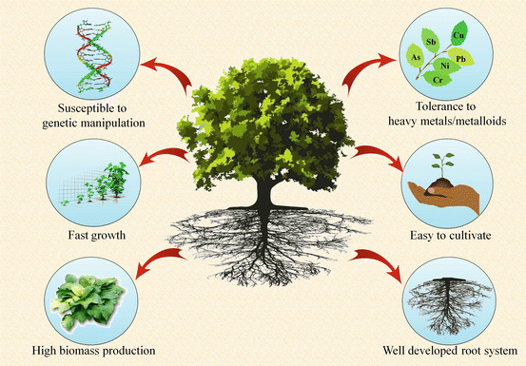
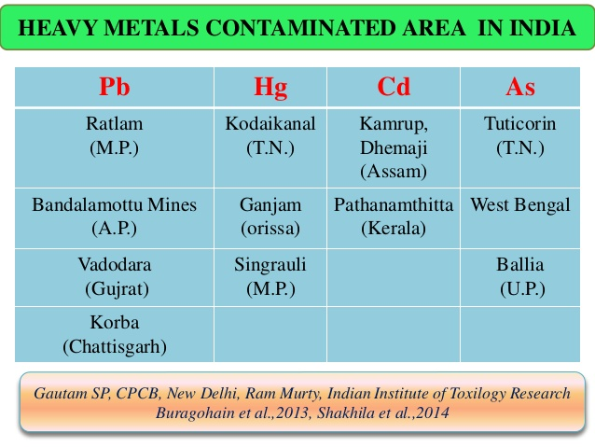
Processes involved in phytoremediation
Phytoremediation of soils contaminated by heavy metals can be achieved by a number of techniques
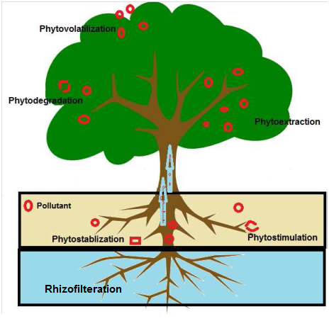
1. Phytoextraction : This technique reduces soil metal concentrations by cultivating plants with a high capacity for metal accumulation in shoots. Plants used for this purpose should ideally combine high metal accumulation in shoots and high biomass production. Many hyperaccumulator species fulfill the first, but not the second condition. Therefore, species that accumulate lower metal concentrations but are high biomass producers may also be useful. When plants are harvested, the contaminants are removed from the soil. Recovery of high-price metals from the harvested plant material may be cost effective (e.g. phytomining. If not, the dry matter can be burnt and the ash disposed of under controlled conditions. By definition, hyperaccumulators are herbaceous or woody plants that accumulate and tolerate without visible symptoms a hundred times or greater metal concentrations in shoots than those usually found in non-accumulators.
Hyperaccumulators are metallophytes and belong to the natural vegetation of metal-enriched soils. These species have evolved internal mechanisms that allow them to take up and tolerate large metal concentrations that would be extremely toxic to other organisms . These
plants are perfectly adapted to the particular environmental conditions of their habitat and high metal accumulation may contribute to their defense against herbivores and fungal infections.

Several hypotheses have been proposed to explain the mechanisms of metal hyperaccumulation are

i. Complex formation and compartmentation: Hyperaccumulators
synthesize chelators that detoxify metal ions by complex formation. The soluble, less-toxic, organic-metal complex is transported to cell compartments with low metabolic activity (cell wall, vacuole) where it is stored in the form of a stable organic or inorganic compound.
ii. Deposition hypothesis: Hyperaccumulators separate metals from the root, accumulating them in plant parts that are abscised (old leaves), leached by rain (epidermis, hairs) or burnt.
iii. Inadverted uptake: Hyperaccumulation of the metal is thought to be the by-product of an adaptation mechanism to other adverse soil characteristics (e.g. Ni hyperaccumulation in serpentinophytes)
iv. Hyperaccumulation as a defense mechanism against abiotic or biotic stress conditions. Metal effectiveness against certain pathogenic fungi and bacteria and on leaf-consuming herbivores has been reported.
Hyperaccumulators concentrate, in a specific way, certain trace metals or metalloids that may be essential (Cu, Mn, Zn, or Ni) or not (e.g. Cd, Pb, Hg, Se, Al, As) at amounts that would be extremely toxic to other plants.
Most metallophytes that can colonize metal-polluted soils base their metal resistance on efficient exclusion of metal ions from root tip meristems and shoot. In contrast, hyperaccumulators, preferentially accumulate the metal in shoots and, in the case of hyperaccumulation of essential trace elements, this capacity is frequently accompanied by plant requirement for unusually high substrate availability of the metal in order to avoid deficiency.
A metal can be bound by a number of ligands within distinct plant organs and compartments. In this regard, in 1975, Mathys and Ernst proposed the malate shuttle hypothesis. According to this hypothesis, in Zn-resistant plants excess Zn is bound to malate in the cytoplasm and, after transport to the vacuole, a ligand exchange occurs. Zn forms more stable complexes with citrate, oxalate or other ligands, while malate returns to the cytoplasm. Recent research shows that ligand exchange can also play a critical role in hyperaccumulators.
there are two basic strategies of phytoextraction being developed: those are chelate-assisted phytoextraction, which we term induced phytoextraction ; and long-term continuous phytoextraction . Of the two processes, chelate-assisted phytoextraction is the more developed and is presently being implemented commercially. Continuous phytoextraction is also being studied by several groups for the removal of metals such as zinc, cadmium, and nickel and oxianionic metals such as selenium, arsenic, and chromium.

Induced Phytoextraction the concept of chelate-assisted phytoextraction There are no reliable reports of plants capable of naturally accumulating the most environmentally important toxic metals such as lead, cadmium, arsenic, and radionuclides. For example, vegetation growing on heavily lead-contaminated soil or solutions has been reported to contain only 0.01–0.06% of shoot dry biomass as lead , levels well belowthat required for efficient phytoextraction. Early studies by Jøgensen showed that application of synthetic metal chelates such as ethylenediaminetetraacetic acid (EDTA) to soils enhances lead accumulation by plants. Huang et al. and Blaylock et al. were able to achieve rapid accumulation of lead in shoots to greater than 1% of shoot dry biomass. These discoveries paved the way to successful phytoremediation of lead and to defining strategies for the development of phytoextraction of other toxic metals using appropriate chelates.

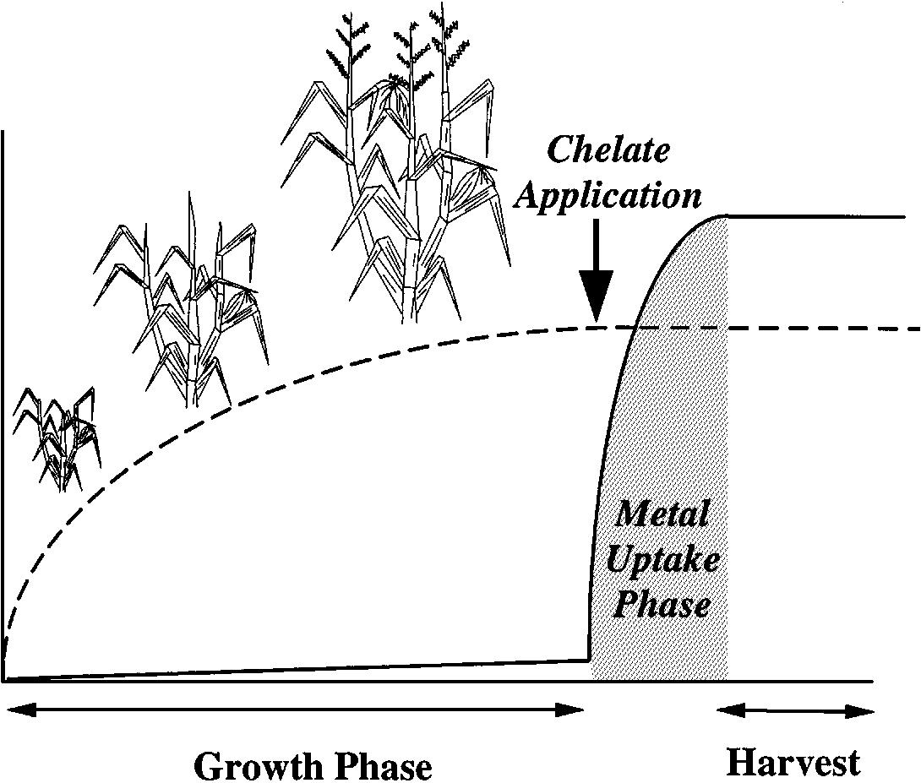
Schematic representation of chelate-assisted phytoremediation. Solid line represents metal concentration in shoot biomass; dashed line represents shoot biomass.

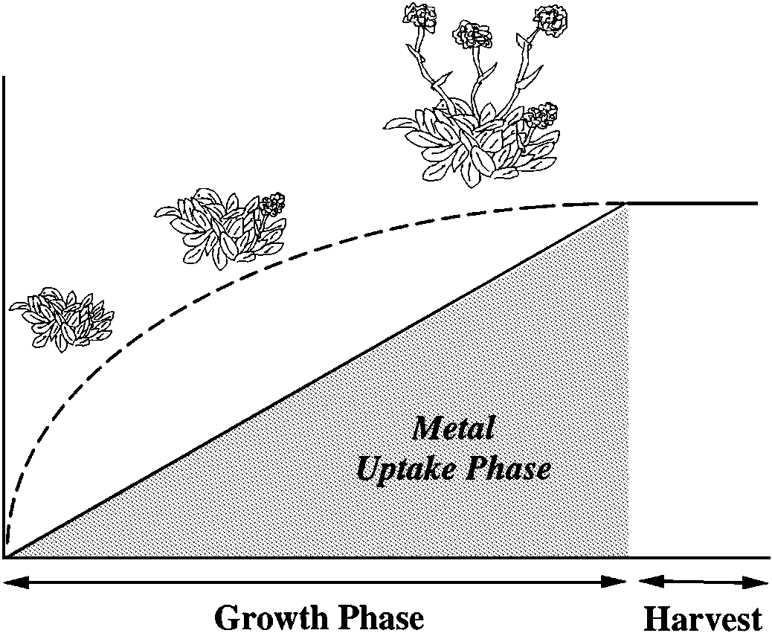

Schematic representation of continuous phytoextraction. Solid line represents metal concentration in shoot biomass; dashed line represents shoot biomass.

Conventional breeding and genetic engineering for efficient phytoextraction
As stated at the beginning of this review, the development of commercial phytoextraction technologies requires plants that produce high biomass and that accumulate high metal concentrations in organs that can be easily harvested, i.e. in shoots. There are two main approaches to this problem:
(1) Domestication and breeding of improved hyperaccumulator species and
(2) Application of genetic engineering to develop fastgrowing high biomass plants with improved metal uptake, translocation and tolerance.
The first approach, mainly developed in the USA by the group headed by Chaney, involves several crucial steps: selection of hyperaccumulator plants that are likely to be domesticated, collection of seeds from wild plants and bioassay of their phytoextraction utility, breeding for improved cultivars and development of adequate soil and crop management practices. The usefulness of this system has been shown for Co and Ni and has obtained a utility patent. However, the authors recognize that in situations where available hyperaccumulator species are too small to afford economic cleanup procedures, biotechnology may be required to combine hyperaccumulation and high biomass production.
The V Framework Research Program of the European Community includes two projects on the production of genetically modified plants for phytoremediation, PHYTAC and METALLOPHYTES. The former aims to transfer genes from the hyperaccumulator Thlaspi caerulescens to the high biomass– producing Brassica or tobacco. While the METALLOPHYTES project is devoted to engineering Festuca for improved metal tolerance and or accumulation.

2. Rhizofiltration : This technique is used for cleaning contaminated surface waters or wastewaters by adsorption or precipitation of metals onto roots or absorption by roots or other submerged organs of metal-tolerant aquatic plants. For this purpose, plants must not only be metal-resistant but also have a high adsorption surface and must tolerate hypoxia. Rhizofiltration is a type of phytoremediation, which refers to the approach of using hydroponically cultivated plant roots to remediate through absorption, concentration, and precipitation of pollutants. This process is very similar to phytoextraction in that it remove contaminants by trapping them into harvestable plant biomass. The most commonly used plants are willows and poplars, which can grow 6 - 8’ per year and have a high flood tolerance. For deep contamination, hybrid poplars with roots extending 30 feet deep have been used.
3. Phytostabilization : Plants are used for immobilizing contaminant metals in soils or sediments by root uptake, adsorption onto roots or precipitation in the rhizosphere. By decreasing metal mobility, these processes prevent leaching and groundwater pollution. Bioavailability is reduced and fewer metals enter the trophic web. Phytostabilization reduces the mobility of substances in the environment, the plant immobilizes the pollutants by binding them to soil particles making them less available for plant or human uptake. Unlike phytoextraction, phytostabilization focuses mainly on sequestering pollutants in soil near the roots but not in plant tissues. Plants should be able to tolerate high levels of contaminants, have high production of root biomass with the ability to immobilize contaminants, and the ability to hold contaminants in the roots.
4.Phytodegradation: Elimination of organic pollutants by decomposition through plant enzymes or products. Phytodegradation, also called phyto-transformation, is the breakdown of contaminants taken up by plants through metabolic processes within the plant, or the breakdown of contaminants surrounding the plant through the effect of compounds (such as enzymes) produced by the plants. The term "Green Liver" is used to describe phytotransformation, as plants behave analogously to the human liver when dealing with these xenobiotic compounds..
5. Rhizodegradation : Decomposition of organic pollutants by means of rhizosphere microorganisms. Phytostimulation (or rhizodegradation) is the enhancement of soil microbial activity for the degradation of organic contaminants, typically by organisms that associate with roots. Plants release carbohydrates and acids that stimulate microorganism activity which results in the biodegradation of the organic contaminants.
Works well in removal of petroleum hydrocarbons.

6. Phytovolatilization : Organic pollutants absorbed by plants are released into the atmosphere by transpiration, either in their original form or after metabolic modification.In addition, certain metals can be absorbed and volatilized by certain organisms. Several species of the genus Astragalus accumulate and volatilize Se. Uptake and evaporation of Hg is achieved by some bacteria. The bacterial genes responsible have already been transferred to Nicotiana or Brassica species, and these transgenic plants may become useful in cleaning Hg-contaminated soils.

Phytovolatilization is a process, in which plants take up contaminants from soil and release them as volatile form into the atmosphere through transpiration. Phytovolatilization has been primarily used to remove mercury. Poplar trees are one of the most successful plants for removing contaminants through this process due to its high transpiration rate.
Volatilization of selenium from plant tissues may provide a mechanism of selenium detoxification. As early as 1894, Hofmeister proposed that selenium in animals is detoxified by releasing volatile dimethyl selenide from the lungs. He based this proposal on the fact that the odor of dimethyl telluride was detected in the breath of dogs injected with sodium tellurite. Using the same logic, it was suggested that the garlicky odor of plants that accumulate selenium may indicate the release of volatile selenium compounds. Lewis (97) was the first to show that both selenium nonaccumulator and accumulator species volatilize selenium. This was later confirmed by other authors. The volatile selenium compound released from the selenium accumulator Astragalus racemosus was identified as dimethyl diselenide. Selenium released from alfalfa, a selenium nonaccumulator, was different from the accumulator species and was identified as dimethyl selenide.
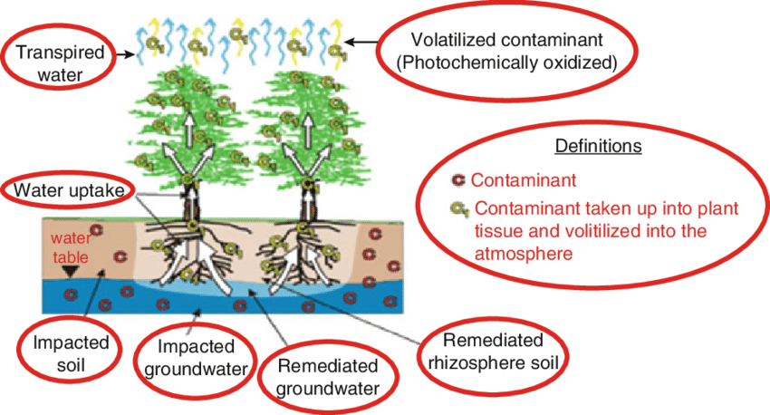

However, it is not clear whether plants are able to take inorganic selenium (as selenate or selenite) and reduce and methylate it to the volatile methyl forms. Recentwork by Zayed&Terry demonstrated that addition of the antibiotic penicillin to hydroponically grown Indian mustard (Brassica juncea) inhibited selenium volatilization by approximately 90% when selenium was provided as selenate. However, plants may still volatilize selenium in the absence of rhizobacteria when it is supplied as selenomethionine. This suggests that root-associated bacteria play an important role in reducing and assimilating selenium into organic forms. However, more work is needed to clarify the role of microbial and plant biochemical processes in selenium volatilization by
Plants.

7. Hydraulic control : This technique uses plants that absorb large amounts of water and thus prevent the spread of contaminated wastewater into adjacent uncontaminated areas. Phreatophytes can be used for cleaning saturated soils and contaminated aquifers.

8. Phytorestauration : Revegetation of barren areas by fast-growing resistant species that efficiently cover the soil, thus preventing the migration of contaminated soil particles and soil erosion by wind and surface water run-off. This technique reduces the spread of contaminants and also visual impact. However, previous soil conditioning is required (e.g. liming or berengerite amendments) to enable plants to colonize the polluted substrate.
Overview of phytoremediation process
Mechanism | Contaminants | Plants
Phytoextraction | Inorganics: Ag,Cu,Cr,Cd,Co,Zn,Hg  Radionuclides: 137Cs,230Pb, 234,238U | Indian mustard, penny cress, sunflower
Rhizofiltration | Organics/ Inorganics | Water hyacinth, sunflower
Phytodegradation | Organic compounds,  chlorinated solvents,phenols,herbicides | Black willow,stonewart,  hybrid poplar
Phytostabilization | Inorganics:As, Cd,Cu,Hg,Pb,Zn | Indian mustard,hybrid poplars
Rhizodegradation | Organic compounds.  chlorinated solvents,PAHs, pesticides | Red mulberry,grass,cattail
Phytovolatilization | Organics / Inorganics | Poplar,alfalfa,Indian mustard
How long will it take?
Depends on amount of metals present
Type and number of plants used
Size and depth of polluted area and
Type of soil and conditions present.
Future prospects and conclusion
Phytoremediation is a new, attractive technique that has emerged over recent years. This technique offers excellent perspectives for the development of plants with the potential for cleaning metal-contaminated soils, at least under certain, favorable conditions and for using adequate crop management systems. Advances in molecular biology and genetic engineering of plants have been indispensable for this progress. However, this spectacular development would not have been possible without the invaluable contribution of a small group of researchers. More than thirty years ago they showed extraordinary scientific insight by recognizing the enormous potential of plants that can colonize metal-contaminated soils and they dedicated many years of conscientious research to the geobotany and ecophysiology of metallophytes. Exploratory studies of this kind are still necessary and should be supported in order to preserve the immense natural genetic resources of metallipherous habitats and to increase our basic knowledge about the natural adaptation mechanisms of hyperaccumulators.
References
Clemens, S., Palmgren, M.G. and Kramer, U., 2002, A long way ahead: understanding and engineering plant metal accumulation. Trends in plant science., 7(7):309-315.
Diwan, H., Ahmad, A. and Iqbal, M., 2008, Genotypic variation in the phytoremediation potential of Indian mustard for chromium. Environmental management., 41(5):734-741.
Peuke, A.D. and Rennenberg, H., 2005, Phytoremediation. EMBO reports., 6(6):497-501.
Poschenrieder, C. and Coll, J. B., 2003, Phytoremediation: principles and perspectives. Contributions to science., 333-344.
Rugh, C.L., Senecoff, J.F., Meagher, R.B. and Merkle, S.A., 1998, Development of transgenic yellow poplar for mercury phytoremediation. Nature biotechnology., 16(10):925-928.
Salt, D.E., Smith, R.D. and Raskin, I., 1998, Phytoremediation. Annual review of plant biology., 49(1):643-668.

