“Anticoagulants- Recent updates”
Dr. Shadabi Bano
Department of Biosciences
Jamia Millia Islamia
New Delhi, India
Email ID: drshadabibano@gmail.com

ABSTRACT
Anticoagulants play a key role in the prevention and treatment of thrombotic disorders by preventing the formation of blood clots. Recent research has led to the development of new oral anticoagulants (NOACs) that offer improved ease of use and safety compared to traditional K antagonists (VKA). These NOACs, including direct thrombin inhibitors and factor Xa inhibitors, show predictable pharmacokinetics and do not require routine monitoring, making them more patient friendly. In addition, innovative reversal agents have been introduced for NOACs associated with bleeding complications and emergency procedures. Despite their advantages, anticoagulants present problems with their optimal use. Individual variability in drug response requires careful dosing, which emphasizes the importance of personalized medicine. The lack of standardized laboratory tests to monitor NOAC values, as seen with VKA and international normalized ratio (INR), prevents assessment of treatment efficacy and dose adjustments. Furthermore, the management of bleeding complications associated with anticoagulant therapy remains a clinical challenge, underscoring the need for effective weaning strategies. Their rapid onset and action offer an advantage over VKA in perioperative therapy. However, careful patient selection, appropriate dosing and monitoring strategies are important for optimal results. When prescribing anticoagulants, physicians must also be aware of potential drug interactions, patient comfort, and renal function. The availability of reversal agents for NOACs has addressed concerns about bleeding complications and improved the overall safety profile of these agents. The advent of factor XI/XII-based anticoagulants has revolutionized anticoagulant therapy, changing the landscape of thrombosis prevention and treatment. However, most of these drugs are in clinical trials and the results of their safety and efficacy profiles are awaited.
Keywords: Anticoagulants, Cardiovascular diseases, Thrombosis, Vitamin K anticoagulants, Direct oral anticoagulants, Factor XI anticoagulants.

- INTRODUCTION
- Definition of anticoagulants
Anticoagulants are drugs that modify the biochemical process of coagulation resulting in the prevention or treatment of blood clots. Blood clots can form in the arteries or veins, and if left untreated, they can cause serious health complications, such as stroke, heart attack, deep vein thrombosis, and pulmonary embolism [1]. Anticoagulants are essential in preventing these life-threatening events in patients with various medical conditions, including atrial fibrillation, deep vein thrombosis, pulmonary embolism, and heart valve disease.
- Necessity of anticoagulant drugs
Blood coagulation is a finely orchestrated process involving numerous proteins, enzymes, and signaling pathways. It aims to staunch bleeding while ensuring blood flow remains unimpeded. Central to this process are anticoagulant factors, which naturally inhibit excessive clot formation. However, when this balance is disrupted, the risk of thrombotic events increases. Anticoagulant medications are experiencing heightened demand due to the prevalence of stress and unhealthy lifestyle habits [2]. The development of thrombosis is a significant consequence resulting the thromboembolism, cardiovascular diseases, and arteriosclerosis, which may be inherited or acquired risk factors that increase the probability for likelihood circumstance. Globally, this condition leads to approximately 18 million fatalities. Arterial or venous blood stasis, hypercoagulable states, and damaged arterial endothelial linings contribute to the formation of thrombi, although their pathophysiological mechanisms differ notably between arterial and venous thrombosis [3]. Venous thrombosis is not typically caused by vascular damage unlike arterial thrombi but rather by regular vein flow interruption; thus it remains a primary cause of mortality worldwide as pathological events obstruct vessels' normal blood flow resulting in severe illnesses. Altogether arterial and venous thrombosis involve many pathophysiological events like deep vein thrombosis, ischemic heart disease, myocardial infarction, stroke, and limb ischemia among others - where anticoagulant therapy plays a crucial role in improving life expectancy by preventing clotting incidence rates significantly [4].
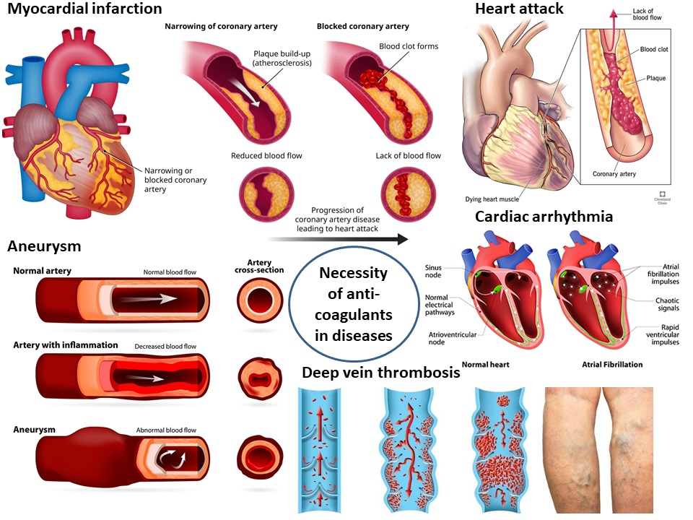
Figure 1: Necessity of anticoagulants in diseases.
Anticoagulants are useful in treating blood clots in patients with symptomatic antiphospholipid as well as secondary thrombosis. For the treatment of secondary thrombosis in patients with a history of thrombosis, long-term anticoagulation therapy is recommended. For instance, Warfarin is considered to be the drug of choice for secondary thrombosis prevention in patients with APS as it has proven to be effective in suppressing clot formation [5]. Moreover, newer oral anticoagulants such as Apixaban have been approved by the FDA for multiple uses including prevention of venous thromboembolism in patients after orthopaedic surgery. Overall, anticoagulants provide an effective treatment option for preventing thrombosis and reducing the risk of complications in patients with various conditions associated with thrombotic events, such as cardiovascular diseases and arteriosclerosis [6].
- Types of Anticoagulants
Anticoagulants are a class of drugs used to prevent and treat blood clots, which can lead to serious health complications, including stroke, pulmonary embolism, and deep vein thrombosis. Several types of anticoagulants can be administered intravenously, subcutaneously, or orally and target different factors of coagulation cascade such as heparin, warfarin, and the newer direct oral anticoagulants (DOACs) [7].
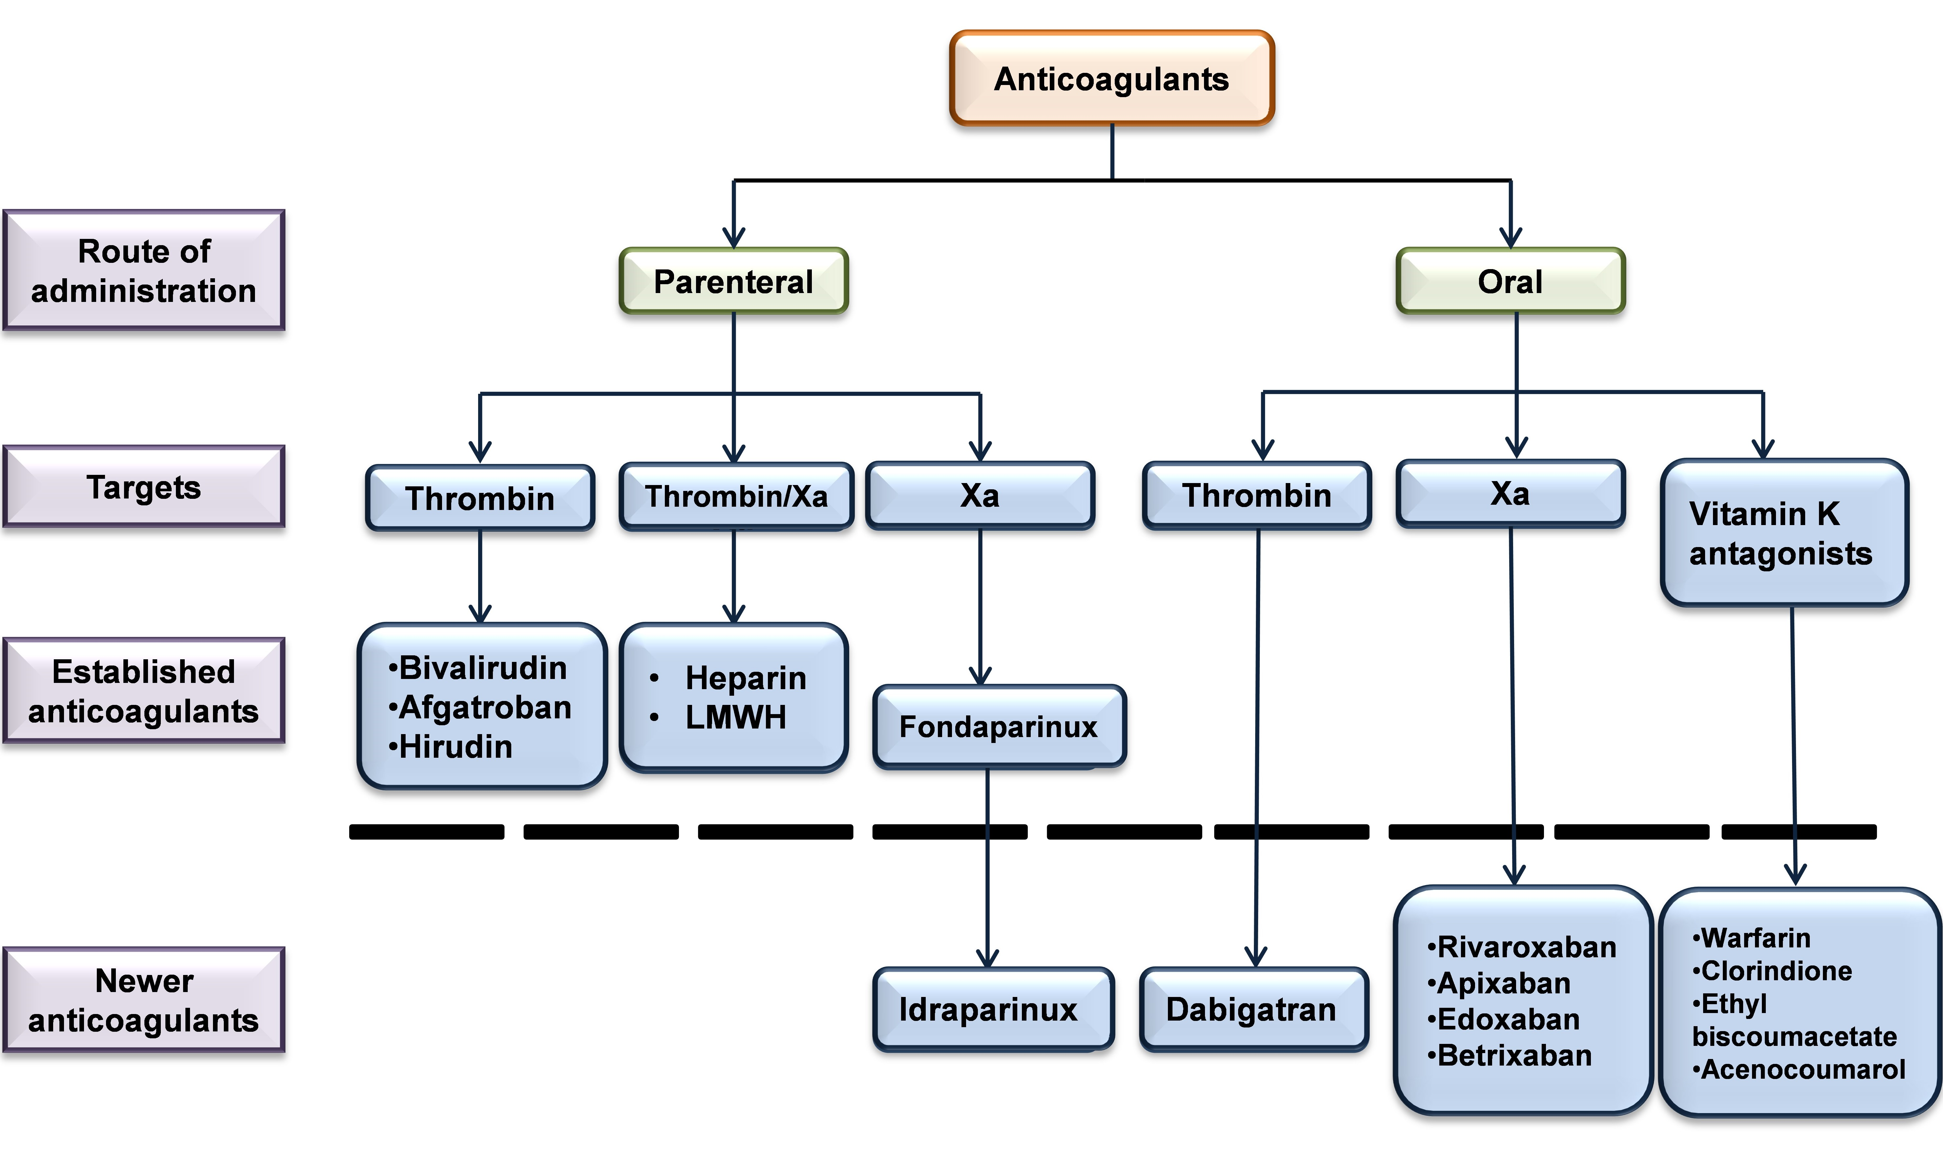
Figure 2: Types of anticoagulants with their route of administration.
- ORAL ANTICOAGULANTS
Oral anticoagulants are drugs that are taken orally (by mouth) and are in charge of thinning the blood clot. Due to their direct inactivation of thrombin (FIIa) and factor X, NOACs (new oral anticoagulants) are also known as direct oral anticoagulants or target anticoagulants (FXa). To prevent hemorrhagic stroke in individuals with atrial fibrillation (AF) and to prevent major bleeding, direct oral anticoagulants (DOACs) are quickly taking the lead as the most frequently prescribed oral anticoagulants for consideration and care for venous thromboembolism (VTE) [8]. When compared to vitamin K antagonists, they have proven to be more beneficial. The well-known and frequently prescribed anticoagulants are heparin, warfarin, dabigatran, and rivaroxaban. Warfarin, dabigatran, and rivaroxaban are medications that must be taken by mouth, whereas heparin is supplied parenterally [9], [10]. Anticoagulants play a significant role in increasing life expectancy and reducing the severity of pathological conditions related to anticoagulants by diluting the thrombus (clot). A promising treatment option for this condition is provided by novel anticoagulants from various sources. Therefore, any possible novel molecule must demonstrate equivalent anticoagulant potential with few off-target side effects before it can be marketed as a true substitute for already available medications. Oral anticoagulants, in particular sulfated polysaccharides, are important because of their distinct modes of action and lack of bleeding [9]. Their demand is increasing day by day for the prevention of thromboembolic stroke and venous thromboembolism.
- HEPARIN
Heparin is a most effective medication that is commonly used as a fast-acting anticoagulant and has been in clinical use for almost a decade. It is a naturally occurring substance that is found in the liver and other tissues of the body, but it is also produced synthetically for use as a medication [11]. There are two main types of heparin: unfractionated heparin and low molecular weight heparin (LMWH). Unfractionated heparin is derived from the mucous membranes of pigs and cows and is composed of a mixture of molecules of different sizes. LMWH, on the other hand, is produced by chemically modifying unfractionated heparin to produce smaller molecules that are more consistent in size. LMWH is often preferred over unfractionated heparin because it has a more predictable effect on the body and requires less frequent monitoring [12]. Heparin works by interfering with the body's natural clotting mechanism. Blood clots are formed when a protein called fibrinogen is converted into fibrin, which forms a mesh-like network of fibers that trap platelets and other blood cells. Heparin prevents this conversion from occurring by binding to proteins called antithrombin III or heparin cofactor II, which in turn blocks the activity of enzymes that are involved in the clotting process. By inhibiting these enzymes, heparin prevents the formation of blood clots [13], [14]. Heparin is used to treat a variety of medical conditions that involve abnormal blood clotting. These include deep vein thrombosis (DVT), pulmonary embolism, and atrial fibrillation. It is also used to prevent blood clots from forming during surgery, particularly in patients who are at high risk for developing clots. Heparin is typically administered intravenously or subcutaneously, and the dosage and frequency of administration are carefully monitored to ensure that the medication is effective and safe [15]. Despite its effectiveness, heparin is not without risks. One of the most serious side effects of heparin is bleeding. Because heparin prevents blood clots from forming, it can also increase the risk of bleeding in the body and can cause heparin-induced thrombocytopenia [16]. This can be particularly dangerous in patients who have bleeding disorders or who are undergoing surgery. Other common side effects of heparin include pain or irritation at the injection site, low blood pressure, and headaches [11]. In conclusion, heparin is a valuable medication that plays an important role in the prevention and treatment of blood clots. It is a powerful anticoagulant that can help prevent serious medical conditions, but it must be used carefully and under the supervision of a qualified healthcare provider. As with any medication, it is important to weigh the risks and benefits of heparin before deciding to use it and to follow the dosage and administration instructions carefully to ensure that it is safe and effective.
Derivatives of heparin:
The use of heparin as an anticoagulant has been restricted by its biological properties such as a short half-life, poor bioavailability, and non-specific binding to plasma proteins. To overcome these limitations, various derivatives of heparin have been developed.
    - Unfractionated heparin
Unfractionated heparin is heparin that has not been fractionated to sequester the fraction of molecules with low molecular weight. The varying size of heparin molecules is important for its anticoagulant properties. The action of unfractionated heparin (UFH) alters the conformation of antithrombin (AT) and makes it a more effective inhibitor of circulating thrombin (factor IIa), Kallikrein, factor Xa, factor IXa, and factor XIIa [17]. Only one-third of the glycosaminoglycans in heparin's heterogeneous glycosaminoglycan mixture—which has a mean molecular weight of 15,000 daltons [18]. The anticoagulant effects of an unfractionated heparin formulation are significantly influenced. The anticoagulant effects of an unfractionated heparin formulation are significantly influenced by the different sizes of the heparin molecules. Unlike thrombin inactivation, which requires the formation of a ternary complex composed of heparin, AT, and thrombin, factor Xa inactivation only requires the binding of AT by heparin. Consequently, smaller heparin molecules can catalyze factor Xa inactivation, whereas larger molecules (at least 18 saccharide units) are required to affect the binding of both AT and thrombin, which is required to catalyze thrombin inactivation [18]. The vast majority of molecules in low-molecular-weight compounds are antifactor Xa active. Thus, the size of the heparin molecule has a large impact on its activity [19].
    - Low Molecular Weight Heparin (LMWH)
LMWH is obtained by depolymerization of unfractionated heparin using chemical or enzymatic methods. The molecular weight of LMWHs ranges from 1,000 to 10,000 d, with a typical molecular weight of 3500 to 6,000 daltons. LMWH has a smaller molecular weight than unfractionated heparin, which results in increased bioavailability and a longer half-life. So, LMWH requires less frequent administration and has a more predictable anticoagulant effect. LMWH is commonly used in the prevention and treatment of deep vein thrombosis and pulmonary embolism [20]. LMWHs are less effective at inactivating thrombin than UFH because the smaller size cannot attach to AT and thrombin at the same time. Although bridging between AT and factor Xa is less important for antifactor Xa activity, thus, can be inactivated by smaller ones than larger molecules. The main advantage of LMWH over UFH is that it has a more predictable dose-response relationship, allowing for weight-adjusted dosing [12], [21].
    - Ultra-Low Molecular Weight Heparin (ULMWH)
ULMWH is a further modification of LMWH, which has an even lower molecular weight (<3000 daltons) than LMWH. ULMWH is synthesized by further depolymerization of LMWH using chemical or enzymatic methods. ULMWH has been found to have greater antithrombotic activity than LMWH, and it may be more effective in the treatment of certain thrombotic disorders [22], [23]. Heparanase-resistant ULMWH developed recently as the structural analog of fondaparinux that lacks internal Glc A residue but has potent anti-factor Xa activity [24].
    - Pentasaccharides
Pentasaccharide is formed when the heparin 5-saccharide molecule binds to antithrombin. It is widely regarded as a pure Xa inhibitor, even though it may have minor upstream effects on coagulation because it no longer has a saccharide tail that would allow it to aid in the binding of thrombin to antithrombin. Nonetheless, because AT is required as a middleman, it indirectly opposes factor Xa in the same way that UFH and LMWH do [25]. Fondaparinux and idraparinux are two well-known pentasaccharides. They both work through the same mechanism. Fondaparinux works by rapidly attaching to antithrombin at a specific site, causing the antithrombin molecule conformational change that tends to inhibit the thrombin. This roughly triples antithrombin's affinity for factor Xa [26]. The irreversible formation of inactive antithrombin-factor Xa complexes inhibits factor Xa activity. Fondaparinux is unmodified when it is released from antithrombin at the end of the reaction and is then free to bond to another antithrombin molecule. Fondaparinux inhibits factor Xa only after antithrombin has been activated, with little to no effect on antithrombin-induced thrombin inhibition [25]. Anticoagulants, such as heparin, have activity against both factor Xa and factor IXa, enhancing the inhibitory effect of antithrombin on thrombin. Heparin's action may have an adverse effect on platelet and protein C activity, whereas fondaparinux is said to have no such effects [27].
    - Synthetic Heparin
Synthetic heparin is a completely synthetic version of heparin that has been designed to overcome the limitations of natural heparin. Synthetic heparin is produced by chemical synthesis and has a uniform chemical structure. Synthetic heparin has a longer half-life and greater bioavailability than natural heparin, and it may be more effective in the treatment of certain thrombotic disorders. Enoxaparin, Dalteparin, and Tinzaparin are a few examples of synthetic heparin [28].
    - Heparinoids
Heparinoids are synthetic compounds that mimic the anticoagulant properties of heparin. Heparinoids are chemically modified versions of heparin that have been designed to have greater bioavailability, longer half-life, and more specific anticoagulant activity. Heparinoids are commonly used in the prevention and treatment of deep vein thrombosis, pulmonary embolism, and other thrombotic disorders [29]. Recently, a unique biologically active pentasaccharide heparinoid has been introduced that contains l-guluronic acid instead of l-iduronic acid without affecting its anticoagulant activity [30].
Table 1: Characteristics of therapeutic heparinoids [31]

Heparinoid: Generic name  (Brand name) | Composition (method of heparin modification) | Molecular weight (kDa)
Dalteparin (Fragmin) | LMWH (deamination cleavage with nitrous acid) | 4.0 – 6.0
Nadroparin (Fraxiparine) | LMWH (deamination cleavage with nitrous acid) | 2.4 – 7.2
Enoxaparin (Clexane, Lovenox) | LMWH (β –eliminative cleavage by alkaline treatment) | 3.5 – 5.5
Tinzaparin (Innoparin, Logiparin) | LMWH (β –eliminative cleavage by heparinase) | 3.4 – 5.6
Sulodexide (Vessel Due F) | 80% ‘fast-moving’ heparin + 20% dermatan sulfate | <8.0
Danaparoid (Orgaran) | 84% heparin sulfate + 12% dermatan sulfate + 4% chondroitin sulfate | 4.0 – 10.0
Fondaparinux (Arixtra) | Pentasaccharide: C31H43N3Na10S8 | 1,728

    - Pentosan Polysulfate (PPS)
PPS is a sulfated polysaccharide that is similar in structure to heparin. PPS has been found to have anticoagulant and anti-inflammatory properties, and it is used in the treatment of interstitial cystitis and osteoarthritis. PPS has also been investigated as a potential therapeutic agent in the treatment of thrombotic disorders. Largely, the development of various derivatives of heparin has significantly expanded its therapeutic applications. These derivatives have been designed to overcome the limitations of natural heparin and to provide more specific and effective anticoagulant therapy. LMWH and heparinoids are widely used in the treatment of thrombotic disorders, while ULMWH and synthetic heparin are being investigated as potential alternatives. PPS is a sulfated polysaccharide that has potential therapeutic applications beyond the field of anticoagulation [32].
- VITAMIN K ANTAGONISTS
Vitamin K antagonists (VKAs) have played a significant role in the prevention and treatment of various medical conditions. These medications inhibit the synthesis of vitamin K-dependent clotting factors, primarily thrombin and factors VII, IX, and X. The most commonly prescribed VKA is warfarin, which has been extensively studied and utilized for decades. Vitamin K antagonists work by inhibiting the enzyme vitamin K epoxide reductase, which is crucial for the activation of vitamin K-dependent clotting factors. By impeding this enzyme, VKAs disrupt the production of functional clotting factors and limit blood coagulation [33]. Consequently, the clotting process is delayed, reducing the risk of thromboembolic events. VKAs are clinically recommended for the treatment of stroke associated with atrial fibrillation, deep vein thrombosis, pulmonary embolism, and mechanical heart valve-related thrombosis. VKAs have shown reversible effects in case of bleeding complications or the need for urgent surgery, administration of vitamin K or clotting factor concentrates can counteract the anticoagulant effects of VKA [34]. These drugs are also associated with several limitations such as a narrow therapeutic window, requiring regular monitoring of the international normalized ratio (INR) to maintain the desired anticoagulation level. VKAs have a delayed onset and offset of action due to their mechanism of action. It takes several days to achieve a therapeutic effect and a similar duration for the anticoagulant effect to subside after discontinuation. VKAs are influenced by numerous drug-drug and drug-food interactions, necessitating careful monitoring and adjustment of dosages. Frequent laboratory testing is required to maintain the INR within the target range [35].
Current Perspectives:
While VKAs have been the cornerstone of anticoagulant therapy for decades, newer oral anticoagulants, such as direct oral anticoagulants (DOACs), have emerged as alternative options. DOACs offer several advantages, including predictable pharmacokinetics, fewer interactions, and no need for routine monitoring. However, VKAs still have a role in specific patient populations, such as those with mechanical heart valves or certain renal conditions where DOACs may be contraindicated.
- Non-vitamin K oral anticoagulants
In recent years, the field of anticoagulation therapy has witnessed significant advancements with the introduction of non-vitamin K oral anticoagulants (NOACs). These novel agents have revolutionized the management of various thromboembolic disorders, offering improved efficacy, safety, and convenience compared to traditional vitamin K antagonists (VKAs) such as warfarin. NOACs, including direct oral anticoagulants (DOACs), act by selectively targeting specific clotting factors in the coagulation cascade. The four approved DOACs are dabigatran etexilate, rivaroxaban, apixaban, and edoxaban. Dabigatran directly inhibits thrombin (factor IIa), while rivaroxaban, apixaban, and edoxaban target factor Xa, interrupting the formation of fibrin clots. By selectively inhibiting these key factors, NOACs effectively prevent the formation of blood clots, thereby reducing the risk of thromboembolic events [36], [37]. NOACs have been approved for various medications that include the prevention and treatment of venous thromboembolism (VTE), stroke prevention in non-valvular atrial fibrillation (NVAF), and prophylaxis in orthopedic surgery. In VTE, NOACs have demonstrated comparable efficacy to traditional anticoagulants, while reducing the risk of bleeding complications. In NVAF, these agents have emerged as the preferred choice due to their rapid onset and offset of action, fixed dosing regimens, and minimal drug interactions compared to VKAs. Additionally, NOACs have demonstrated a reduced risk of intracranial hemorrhage compared to VKAs, enhancing patient safety [38]. They are administered orally; thus, eliminating the need for frequent clinic visits for monitoring, as required with VKAs. NOACs have also shown significant benefits in reducing the risk of recurrent VTE and stroke, promoting their use as long-term therapy. The contemporary detail of approved and under trial drugs of DOAcs family are listed in table 2.
Table 2: List of currently licensed and under trial DOACs and the summary of their clinical use [37].

Drug | Target | Phase | Dose administration | Onset of action | Half-life | Targeted clinical indications
Dabigatran | Anti - IIa | Approved drug | 75, 110 and 150 mg | 0.5 – 2 h | 12 – 17 h | Prevention and management of VTE; prevention of thromboembolism in atrial fibrillation
Apixaban | Anti -FXa | Approved drug | 2.5 and 5.0 mg | 2 – 4 h | 8 – 15 h | Prevention and management of VTE; prevention of thromboembolism in atrial fibrillation
Edoxaban | Anti -FXa | Approved drug | 15, 30, and 60 mg | 1 – 2 h | 8 – 10 h | Management of VTE; prevention of thromboembolism in atrial fibrillation
Rivaroxaban | Anti -FXa | Approved drug | 2.5, 10, 15, and 20 mg | 2.5 – 4 h | 5 – 9 h | Prevention and management of VTE; prevention of thromboembolism in atrial fibrillation; Prevention and management of acute coronary syndrome
Betrixaban | Anti -FXa | Approved by FDA | Oral, 40 and 80 mg | 3-4 h | 19 – 27 h | FDA approved in U.S. in 2018 for VTE prevention in acute medically ill hospitalized patients; prevention of thromboembolism in atrial fibrillation
Darexaban | Anti -FXa | Phase II/III study completed | Oral, 15 - 120 mg | < 1 h | 11 – 14 h | Prevention of arterial and venous thrombosis
Eribaxaban | Anti -FXa | Phase II study completed | Oral, 2.5 – 150 mg | 3-4 h | 10 h | Prevention of venous thrombosis
Letaxaban | Anti -FXa | Phase II study completed | Oral, 10 – 160 mg | N/A | 9 – 13 h | Treatment of acute coronary syndrome; prevention of VTE after orthopaedic surgery
Nokxaban | Anti -FXa | Phase I study completed | Oral, 20 – 40 mg | < 1 h | 3 – 9 h | Not yet defined
NOACs have emerged as a major advancement in the field of anticoagulation therapy, offering several advantages over traditional VKAs. NOACs are also associated with some limitations -as they are generally more expensive than VKAs, which may pose challenges for certain patients or healthcare systems. Several NOACs require dose adjustments in patients with impaired renal function, highlighting the importance of proper patient selection and monitoring [38]. Direct oral anticoagulants have also been reported to be associated with gastrointestinal bleeding with VKAs. Unlike VKAs, which can be reversed with vitamin K or specific reversal agents, the reversal options for NOACs are limited, although newer reversal agents have been approved for some NOACs.
- ANTICOAGULANT DRUG TARGETS
In the complex environment of cardiovascular health, anticoagulant drug targets emerge as signs of hope. These molecular foci, intricately woven into the fabric of our clotting mechanisms, offer a unique opportunity for intervention. By perfecting these specific goals, researchers and medical scientists try to balance the equilibrium between coagulation and circulation by preventing dangerous blood clots, while maintaining vital coagulation functions. As research and technology advance, the search for optimal anticoagulant therapies continues, promising a future in which the risk of thrombotic events can be precisely and carefully reduced. Following are the descriptions of anticoagulant drug targets and associated drugs.
Figure 3: Anticoagulant drug with their target protease
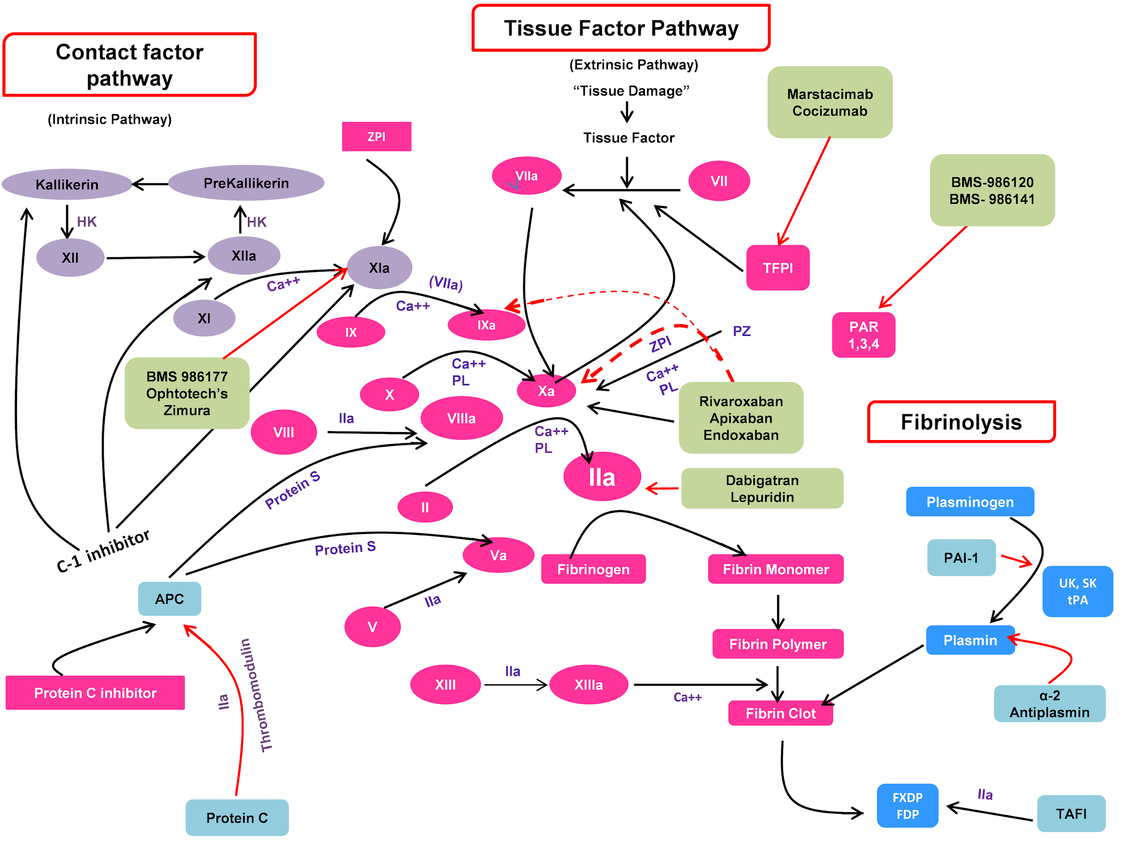
- Direct thrombin inhibitor
For the prevention of stroke and systemic embolism in individuals with non-valvular atrial fibrillation, the direct thrombin inhibitor (DTI) –dabigatran is preferred which is classified as an oral anticoagulant. Dabigatran has other benefits than its ability to prevent thrombosis [39]. It has been hypothesized to have some pro-thrombotic effects because it encourages thrombin’s ligation to the high-affinity platelet receptor glycoprotein (GP) in atrial fibrillation patients. However, lepirudin, a drug belonging to a different class of DTIs, activates the inhibitory cyclic guanosine monophosphate (cGMP)/soluble guanylate cyclase pathway in human platelets. lepirudin and dabigatran, when spiked into the platelets of healthy volunteers, affected GPIb-mediated platelet aggregation and agglutination [40], [41].
- Direct factor Xa inhibitor
Direct factor Xa inhibitors have revolutionized anticoagulant therapy by providing more predictable, convenient, and effective options for the prevention and treatment of thromboembolic disorders. These agents specifically target factor Xa, a key component in the coagulation cascade, thereby preventing the formation of blood clots [42]. Direct FXa inhibitors, such as rivaroxaban, apixaban, and edoxaban, directly bind to and inhibit factor Xa and clot-associated FXa. By inhibiting this key clotting factor, these agents disrupt the coagulation cascade, preventing the conversion of prothrombin to thrombin and the subsequent formation of fibrin clots. The low-dose rivaroxaban in combination with antiplatelet therapy shown to be effective in preventing major cardiovascular events and mortality in patients with recent acute coronary syndrome, chronic coronary artery disease, or peripheral artery disease [43]. Unlike, indirect FXa inhibitors, which require antithrombin as a cofactor, direct FXa inhibitors act independently, offering a more direct and predictable anticoagulant effect [44].
Table 3: Direct thrombin inhibitors vs direct factor Xa inhibitor.

Anticoagulant properties | Direct thrombin inhibitors | Direct factor Xa inhibitors
Drug name | Desirudin  Bivalirudin  Argatroban  Dabigatran | Apixaban  Betrixaban  Edoxaban  Rivaroxaban  Fondaparinux
Mechanism of action | - Reversibly bind to thrombin and clot- bound thrombin in circulation.  - Inhibit further conversion of fibrinogen to fibrin | - Reversibly bind to factor Xa and inhibit the coagulation cascade progression  - Inhibit the thrombin activation by Xa and thus inhibit clot formation
Route of administration | Bivalirudin, Lepirudin, Argatroban: Intravenous  Dabigatran: Oral | Oral
Side effects | - Bleeding (Antidote: Idarucizumab)  - Nausea, dyspepsia, gastritis  - Hypersensitive reaction  - Thrombosis and strokes if discontinued suddenly | - Bleeding (Antidote: Andexanet alfa)  - Thrombosis and strokes if discontinued suddenly

- Potential new targets for anticoagulant drugs
The biggest global cause of illness and mortality is thrombosis. The first anticoagulants to be used successfully in the prevention and treatment of thrombosis were heparin and vitamin K antagonists (VKAs). But they are linked to a chance of bleeding. These medications aim to affect several coagulation factors. Heparin thus primarily inhibits factor Xa and thrombin by activating antithrombin, while VKAs reduce the levels of the vitamin K-dependent clotting factors. Only factor Xa or thrombin is inhibited by direct oral anticoagulants, which have taken the place of VKAs for numerous purposes. Although bleeding is still a direct oral anticoagulant’s principal side effect, it is less common than it is with VKAs. Factor XI has been identified as a target for possibly safer anticoagulant medicines in epidemiological and animal research because factor XI deficiency or inhibition protects against thrombosis and causes less bleeding [45]. FXI/ FXII is considered the most promising drug target due to its involvement in inhibiting the contact pathway and regulating the pathological thrombus formation. A large surge of thrombin after traumatic vessel wall injury is sufficient to induce hemostatic plug formation without requiring amplification of thrombin generation through intrinsic pathway. In contrast, a modest thrombin burst after atherosclerotic plaque lysis requires amplification by the contact pathway to induce pathological thrombus formation. Inhibitors against the factor XI synthesis or its activity that somehow reduces the FXI levels or activity may thus able to prevent thrombosis without compromising hemostasis [46][47].
- Factor XI inhibitors
Factor XI plays a significant role in anticoagulation because it acts as a connecting link between factor IX and factor XII. Factor XIIa activates factor XI which further activates factor IX. The contact system needs to go through an autoactivation stage to start. When polyanions are present, FXI autoactivates and further FXIIa activates PK (prekallikrein) coupled to HK (kininogen) to produce kallikrein(Ka). Ka triggers FXII in turn, boosting the production of FXIIa. The intrinsic route is activated by FXIIa, which also stimulates FXI. The distal coagulation pathway is connected through thrombin’s back activation of FXI. Several Factor XIa inhibitors are currently in clinical trials, including BMS-986177 and Ophthotech's Zimura [46], [47].
- Factor XII inhibitors
Animal experiments have shown that FXII is necessary for the production of pathogenic thrombi but not for hemostasis. According to this, preventing FXII/FXIIa is a cutting-edge approach to creating new, safer antithrombotic drugs. Epidemiological statistics, however, are contrasted [48]. Recent epidemiological research has not been able to show that FXII plays a part in venous thromboembolism, stroke, or myocardial infarction [49]. The physiopathology of venous thrombosis brought on by compromised spontaneous anticoagulation in mice, FXII was not involved. However, the primary clinical application of FXII inhibitors is to prevent contact-mediated thrombosis brought on by blood-contacting devices in a safe manner. FXII inhibitors have anti-inflammatory characteristics and could be used to treat the root cause of contact-mediated thrombosis without raising the risk of bleeding [50], [51].
- Tissue factor pathway inhibitor (TFPI)
TFPI is a protein that inhibits the activity of tissue factor, which is involved in the initiation of the extrinsic pathway of coagulation. Increasing TFPI activity has been shown to reduce thrombosis without increasing bleeding risk. Several TFPI mimetics are currently in development, including marstacimab and concizumab for the treatment of hemophilia A and B [52], [53].
- Protease-activated receptor (PAR) antagonists
PARs are a family of G protein-coupled receptors that are activated by proteases involved in the coagulation cascade. Inhibiting PARs has been shown to prevent thrombosis without increasing bleeding risk. Several PAR antagonists are currently in clinical trials, including BMS-986120 and BMS-986141 [54]–[56].
- ANTITHROMBIN AS AN ANTICOAGULANT THERAPEUTICS
Antithrombin is an important endogenous anticoagulant that can be used as a therapeutic agent to prevent and treat thrombosis. The serine protease inhibitor antithrombin (AT, also known as AT III) belongs to the serpin superfamily that controls the proteolytic activity of procoagulant proteases in both intrinsic and extrinsic pathways. It is made up of 432 amino acids, three disulfide linkages, and four possible sites for glycosylation as a single-chain glycoprotein in the liver. It circulates in plasma at a concentration of 0.125 mg/mL (2.5 mol/L). Inhibition of thrombin and fXa halts the coagulation cascade. Antithrombin also makes fXIa, fXIIa, and VIIa inactive, though to a lesser amount. AT is largely inactive until it binds to the heparan side chains that line the microvasculature. The structure of a dimer of latent and active antithrombins, each in contact with the high-affinity pentasaccharide, reveals the accompanying conformational shift of antithrombin. During inhibitory activation, the reactive center loop is extruded to provide a more exposed orientation to protease and β-sheet available in a five-stranded state. After inhibition, RCL inserts into and as third sheets into the serpin body. Antithrombin’s initial tight binding to the heparans and the subsequent release of the antithrombin-protease complex into the circulation are both explained by concurrent conformational changes at the heparin-binding site [57], [58]. Since the serine proteases of the coagulation cascade are inhibited by antithrombin in nature when they bind to heparans, their coagulant activity can be used to treat damaged tissue outside of the vascular system. Antithrombin is also available in a recombinant form, known as recombinant human antithrombin (rhAT). RhAT is approved for use in the prevention of thromboembolism in patients with hereditary antithrombin deficiency and the treatment of thrombosis associated with heparin-induced thrombocytopenia (HIT). RhAT is administered intravenously and works by enhancing the natural anticoagulant activity of antithrombin in the body. It has a rapid onset of action and a short half-life, and its effects can be monitored using laboratory tests such as the activated partial thromboplastin time (aPTT) [59], [60].
- DRAWBACKS OF ANTICOAGULANT DRUGS
As everything have its pros and cons, so also in the case of anticoagulant drugs. Anticoagulant medications are efficient at preventing and treating blood clots, but they also have several disadvantages that must be taken into account [61]. These drawbacks include:
- Renal impairment
It is a major concern in elder patients. Warfarin dose in renal-impaired patients can be managed but it is next to impossible in patients with doses of dabigatran because kidneys clear about 85% of active dabigatran. So, proper and routine renal assessment is necessary in patients with different anticoagulant therapy to monitor the renal activity [39].
- Gastrointestinal bleeding
Randomized Evaluation of Long-Term Anticoagulation Therapy (RE-LY) trials showed that Compared to dose-adjusted warfarin, dabigatran, and rivaroxaban, respectively, were linked to increase gastrointestinal bleeding. This may be a result of an active, unabsorbed medication entering the lower digestive tract and coming into contact with the intestinal mucosa in vulnerable places [43].
- Antidote
The absence of a specific antidote in circumstances when it could be required, such as urgent surgery or life-threatening bleeding, is another drawback of target-specific oral anticoagulants. In this case, rapid reversal is required which is possible by haemodialysis but it is impossible to conduct and manage in emergency conditions [62]. Moreover, Xa inhibitors are not dialysable because of high protein binding. Nowadays, the majority of the treatment is supportive and consists of stopping anticoagulants, fluid resuscitation, transfusions of red blood cells, diagnostic and therapeutic procedures to locate the source of bleeding, and the use of local homeostatic techniques. Synthetic factor VIIa (rFVIIa), fresh frozen plasma (FFP) and prothrombin complex concentrates (PCC) have both been investigated as potential TSOA (target-specific oral anticoagulants) reversal treatments [44].
- Slow onset of action
Warfarin has a slow activation mode as compared to other anticoagulants. Due to delayed arrangements, warfarin is given in combination with heparin which creates complications in administration. It increases the INR levels in humans. Despite tremendous improvement, there is a requirement for regular monitoring and cases of ineffective anticoagulation. Another drug, Ximelagatran, thrombin inhibitor but causes liver toxicity in patients that’s why not in much use. Oral anticoagulants no doubt have advantages but can’t be replaced completely [37].
- Cost
Some anticoagulant drugs can be expensive, which may limit their accessibility to some patients.
- Risk of thrombosis and thrombocytopaenia
Paradoxically, anticoagulant drugs can increase the risk of thrombosis in some patients, especially those with underlying conditions such as cancer or autoimmune disorders.
- Dietary restriction
Some anticoagulant drugs, such as warfarin, require patients to avoid certain foods that contain high levels of vitamin K, which can interfere with the drug's effectiveness.
- CONCLUSION
The development of anticoagulants has greatly contributed to the management and prevention of thrombotic disorders, revolutionizing patient care in the field of cardiovascular medicine. Anticoagulants are critical medications for preventing and treating blood clots, but their use requires careful consideration of the patient's medical history, comorbidities, and other factors. Healthcare providers should be aware of the benefits and limitations of each type of anticoagulant and use evidence-based guidelines to guide their treatment decisions. The choice of anticoagulant will depend on the patient's specific condition, clinical history, and individualized risk-benefit analysis. The introduction of direct oral anticoagulants (DOACs) has significantly transformed anticoagulation therapy by providing alternatives to traditional vitamin K antagonists, such as warfarin. DOACs offer several advantages, including predictable pharmacokinetics, fewer drug interactions, and a lower risk of bleeding complications. Their ease of use, with fixed dosing regimens and no need for routine monitoring, has simplified anticoagulation management and improved patient compliance. Overall, the identification of new targets in the coagulation pathway offers the potential for the development of safer and more effective anticoagulants for the prevention and treatment of thrombosis. However, further research is needed to determine the safety and efficacy of these novel targets and their inhibitors in clinical trials.
- FUTUTRE PROSPECTS
The ongoing research and development in the field of anticoagulation hold promising prospects for the future. One area of interest is the identification and validation of biomarkers that can assist in predicting individual patient response to anticoagulant therapy, allowing for personalized treatment strategies. Additionally, advancements in genetic testing may provide valuable insights into genetic variations that affect anticoagulant metabolism, efficacy, and safety, facilitating the customization of anticoagulation regimens. Another avenue of exploration is the development of reversal agents for DOACs. While DOACs have demonstrated a reduced risk of bleeding compared to traditional agents, the availability of specific antidotes to rapidly reverse their anticoagulant effects is crucial in emergencies or for patients requiring urgent surgical interventions.
REFERENCES
[1] T. Baglin et al., “Clinical guidelines for testing for heritable thrombophilia.,” Br. J. Haematol., vol. 149, no. 2, pp. 209–220, Apr. 2010.
[2] J. D. Douketis et al., “Perioperative Bridging Anticoagulation in Patients with Atrial Fibrillation,” N. Engl. J. Med., vol. 373, no. 9, pp. 823–833, 2015.
[3] J. I. Weitz and J. Harenberg, “New developments in anticoagulants: Past, present and future.,” Thromb. Haemost., vol. 117, no. 7, pp. 1283–1288, Jun. 2017.
[4] C. Kearon et al., “Antithrombotic Therapy for VTE Disease: CHEST Guideline and Expert Panel Report.,” Chest, vol. 149, no. 2, pp. 315–352, Feb. 2016.
[5] J. Carré, G. Jourdi, N. Gendron, D. Helley, P. Gaussem, and L. Darnige, “Recent advances in anticoagulant treatment of immune thrombosis: A focus on direct oral anticoagulants in heparin-induced thrombocytopenia and anti-phospholipid syndrome,” Int. J. Mol. Sci., vol. 23, no. 1, pp. 1–15, 2022.
[6] M. Koupenova, B. E. Kehrel, H. A. Corkrey, and J. E. Freedman, “Thrombosis and platelets: An update,” Eur. Heart J., vol. 38, no. 11, pp. 785–791, 2017.
[7] D. Wardrop and D. Keeling, “The story of the discovery of heparin and warfarin.,” Br. J. Haematol., vol. 141, no. 6, pp. 757–763, Jun. 2008.
[8] J. Sikorska and J. Uprichard, “Direct oral anticoagulants: A quick guide,” Eur. Cardiol. Rev. , vol. 12, no. 1, pp. 40–45, 2017.
[9] M. Keltai and K. Keltai, “New anticoagulants in the prevention and treatment of venous thromboembolism,” Orv. Hetil., vol. 152, no. 25, pp. 983–992, 2011.
[10] J. Fareed, C. Adiguzel, and I. Thethi, “Differentiation of parenteral anticoagulants in the prevention and treatment of venous thromboembolism,” Thromb. J., vol. 9, no. 1, p. 5, 2011.
[11] E. I. Oduah, R. J. Linhardt, and S. T. Sharfstein, “Heparin: Past, present, and future,” Pharmaceuticals, vol. 9, no. 3, pp. 1–12, 2016.
[12] J. Hirsh et al., “Heparin and low-molecular-weight heparin: mechanisms of action, pharmacokinetics, dosing, monitoring, efficacy, and safety.,” Chest, vol. 119, no. 1 Suppl, pp. 64S-94S, Jan. 2001.
[13] L. B. Warnock and D. Huang, “Heparin.,” Treasure Island (FL), 2023.
[14] A. Onishi, K. St Ange, J. S. Dordick, and R. J. Linhardt, “Heparin and anticoagulation.,” Front. Biosci. (Landmark Ed., vol. 21, pp. 1372–1392, Jun. 2016.
[15] M. Qiu et al., “Pharmacological and clinical application of heparin progress: An essential drug for modern medicine,” Biomed. Pharmacother., vol. 139, no. December 2020, p. 111561, 2021.
[16] I. Ahmed, A. Majeed, and R. Powell, “Heparin induced thrombocytopenia: Diagnosis and management update,” Postgrad. Med. J., vol. 83, no. 983, pp. 575–582, 2007.
[17] R. Tahir, “A review of unfractionated heparin and its monitoring,” U.S. Pharm., vol. 32, no. 7, pp. 1–22, 2007.
[18] C. R. Parker and V. Kataria, “Monitoring Unfractionated Heparin: A Review of Activated Partial Thromboplastin Time Versus Antifactor Xa.,” AACN Adv. Crit. Care, vol. 30, no. 4, pp. 305–312, Dec. 2019.
[19] R. D. Rosenberg and L. Lam, “Correlation between structure and function of heparin,” Proc. Natl. Acad. Sci. U. S. A., vol. 76, no. 3, pp. 1218–1222, 1979.
[20] J. Harenberg, “Pharmacology of low molecular weight heparins.,” Semin. Thromb. Hemost., vol. 16 Suppl, pp. 12–18, Oct. 1990.
[21] J. Hirsh, “Low-Molecular-Weight Heparin,” Circulation, vol. 98, no. 15, pp. 1575–1582, 1998.
[22] M. A. Lima et al., “Ultra-low-molecular-weight heparins: precise structural features impacting specific anticoagulant activities.,” Thromb. Haemost., vol. 109, no. 3, pp. 471–478, Mar. 2013.
[23] Z. Liu, S. Ji, J. Sheng, and F. Wang, “Pharmacological effects and clinical applications of ultra low molecular weight heparins,” Drug Discov. Ther., vol. 8, no. 1, pp. 1–10, 2014.
[24] H. Ham et al., “Design of an Ultralow Molecular Weight Heparin That Resists Heparanase Biodegradation.,” J. Med. Chem., vol. 66, no. 3, pp. 2194–2203, Feb. 2023.
[25] H. Abdel-Razeq, “Pentasaccharides. The new anticoagulants.,” Saudi Med. J., vol. 25, no. 8, pp. 983–990, Aug. 2004.
[26] G. Izaguirre, W. Zhang, R. Swanson, T. Bedsted, and S. T. Olson, “Localization of an antithrombin exosite that promotes rapid inhibition of factors Xa and IXa dependent on heparin activation of the serpin.,” J. Biol. Chem., vol. 278, no. 51, pp. 51433–51440, Dec. 2003.
[27] J. Farkas, “Unfractionated heparin ( UFH ), LMWH , fondaparinux , argatroban , and bivalirudin,” 2020. [Online]. Available: https://emcrit.org/ibcc/heparin/.
[28] L. J. Linhardt, Robert J., “Synthetic heparin,” Curr Opin Pharmacol., vol. 23, no. 2, pp. 217–219, 2012.
[29] N. S. Gunay and R. J. Linhardt, “Heparinoids: structure, biological activities and therapeutic applications.,” Planta Med., vol. 65, no. 4, pp. 301–306, May 1999.
[30] M. Herczeg et al., “Synthesis of a Heparinoid Pentasaccharide Containing l-Guluronic Acid Instead of l-Iduronic Acid with Preserved Anticoagulant Activity.,” J. Org. Chem., vol. 87, no. 23, pp. 15830–15836, Dec. 2022.
[31] T. J. Wijnhoven et al., “Characterization of anticoagulant heparinoids by immunoprofiling,” Glycoconj. J., vol. 25, no. 2, pp. 177–185, 2008.
[32] S. Gill, S. C. Naiman, A. Jamal, and L. M. Vickars, “Massive bleeding on a bladder protectant: a case report of pentosan polysulfate sodium-induced coagulopathy.,” Arch. Intern. Med., vol. 162, no. 14, pp. 1644–1645, Jul. 2002.
[33] W. I. Gonsalves, R. K. Pruthi, and M. M. Patnaik, “The new oral anticoagulants in clinical practice.,” Mayo Clin. Proc., vol. 88, no. 5, pp. 495–511, May 2013.
[34] A. Zirlik and C. Bode, “Vitamin K antagonists: relative strengths and weaknesses vs. direct oral anticoagulants for stroke prevention in patients with atrial fibrillation,” J. Thromb. Thrombolysis, vol. 43, no. 3, pp. 365–379, 2017.
[35] P. L. Gross and J. I. Weitz, “New anticoagulants for treatment of venous thromboembolism,” Arterioscler. Thromb. Vasc. Biol., vol. 28, no. 3, pp. 380–386, 2008.
[36] A. Sánchez-Fuentes, J. M. Rivera-Caravaca, R. López-Gálvez, F. Marín, and V. Roldán, “Non-vitamin K Antagonist Oral Anticoagulants and Drug-Food Interactions: Implications for Clinical Practice and Potential Role of Probiotics and Prebiotics,” Front. Cardiovasc. Med., vol. 8, 2022.
[37] G. Lippi, R. Gosselin, and E. J. Favaloro, “Current and Emerging Direct Oral Anticoagulants: State-of-the-Art,” Semin. Thromb. Hemost., vol. 45, no. 5, pp. 490–501, 2019.
[38] A. C. Fanaroff and E. M. Ohman, “Non–Vitamin K Antagonist Oral Anticoagulants in the Treatment of Atrial Fibrillation,” Annu. Rev. Med., vol. 70, no. 1, pp. 61–75, 2019.
[39] G. J. Hankey and J. W. Eikelboom, “Dabigatran etexilate: A new oral thrombin inhibitor,” Circulation, vol. 123, no. 13, pp. 1436–1450, 2011.
[40] C. J. Lee and J. E. Ansell, “Direct thrombin inhibitors,” Br. J. Clin. Pharmacol., vol. 72, no. 4, pp. 581–592, 2011.
[41] K. Trabold, S. Makhoul, S. Gambaryan, J. van Ryn, U. Walter, and K. Jurk, “The Direct Thrombin Inhibitors Dabigatran and Lepirudin Inhibit GPIbα-Mediated Platelet Aggregation.,” Thromb. Haemost., vol. 119, no. 6, pp. 916–929, Jun. 2019.
[42] A. G. G. Turpie, “Oral, direct factor Xa inhibitors in development for the prevention and treatment of thromboembolic diseases.,” Arterioscler. Thromb. Vasc. Biol., vol. 27, no. 6, pp. 1238–1247, Jun. 2007.
[43] D. Scott et al., “Oral Rivaroxaban for Symptomatic Venous Thromboembolism,” N. Engl. J. Med., vol. 363, no. 26, pp. 2499–2510, 2010.
[44] S. Kustos and P. Fasinu, “Direct-Acting Oral Anticoagulants and Their Reversal Agents—An Update,” Medicines, vol. 6, no. 4, p. 103, 2019.
[45] J. C. Fredenburgh and J. I. Weitz, “News at XI: moving beyond factor Xa inhibitors,” J. Thromb. Haemost., vol. 21, no. 7, pp. 1692–1702, 2023.
[46] J. I. Weitz and J. C. Fredenburgh, “Factors XI and XII as targets for new anticoagulants,” Front. Med., vol. 4, no. FEB, pp. 1–6, 2017.
[47] J. C. Fredenburgh and J. I. Weitz, “Factor XI as a Target for New Anticoagulants,” Hamostaseologie, vol. 41, no. 2, pp. 104–110, 2021.
[48] B. A. Prisco.D, Mattioli.I, Caterina. De. R., “View of The new era of anticoagulation_ factor XI and XII inhibitors.pdf,” Bleeding, Thromb. Vasc. Biol., vol. 2, no. 76, 2023.
[49] D. V. Kalinin, “Factor XII(a) inhibitors: a review of the patent literature,” Expert Opin. Ther. Pat., vol. 31, no. 12, pp. 1155–1176, 2021.
[50] C. Davoine, C. Bouckaert, M. Fillet, and L. Pochet, “Factor XII/XIIa inhibitors: Their discovery, development, and potential indications.,” Eur. J. Med. Chem., vol. 208, p. 112753, Dec. 2020.
[51] A. Tashchilova et al., “New Blood Coagulation Factor XIIa Inhibitors: Molecular Modeling, Synthesis, and Experimental Confirmation,” Molecules, vol. 27, no. 4, 2022.
[52] J. N. Mahlangu, “Progress in the Development of Anti-tissue Factor Pathway Inhibitors for Haemophilia Management,” Front. Med., vol. 8, no. May, 2021.
[53] A. D. Shapiro, “Concizumab: a novel anti-TFPI therapeutic for hemophilia,” Blood Adv., vol. 5, no. 1, pp. 279–279, 2021.
[54] S. J. Wilson et al., “PAR4 (Protease-Activated Receptor 4) Antagonism with BMS-986120 Inhibits Human Ex Vivo Thrombus Formation,” Arterioscler. Thromb. Vasc. Biol., vol. 38, no. 2, pp. 448–456, 2018.
[55] E. S. Priestley et al., “Discovery of Two Novel Antiplatelet Clinical Candidates (BMS-986120 and BMS-986141) That Antagonize Protease-Activated Receptor 4,” J. Med. Chem., vol. 65, no. 13, pp. 8843–8854, Jul. 2022.
[56] M. M. Miller et al., “Discovery of Potent Protease-Activated Receptor 4 Antagonists with in Vivo Antithrombotic Efficacy,” J. Med. Chem., vol. 62, no. 16, p. 7400, 2019.
[57] I. Björk and S. T. Olson, “Antithrombin. A bloody important serpin.,” Adv. Exp. Med. Biol., vol. 425, pp. 17–33, 1997.
[58] N. S. Quinsey, A. L. Greedy, S. P. Bottomley, J. C. Whisstock, and R. N. Pike, “Antithrombin: in control of coagulation,” Int. J. Biochem. Cell Biol., vol. 36, no. 3, pp. 386–389, 2004.
[59] “Recombinant human antithrombin III: rhATIII.,” Drugs R. D., vol. 5, no. 2, pp. 110–112, 2004.
[60] U. R. Desai, “New antithrombin-based anticoagulants.,” Med. Res. Rev., vol. 24, no. 2, pp. 151–181, Mar. 2004.
[61] S. Schulman, “Advantages and limitations of the new anticoagulants,” J. Intern. Med., vol. 275, no. 1, pp. 1–11, 2014.
[62] K. Harter, M. Levine, and S. O. Henderson, “Anticoagulation drug therapy: A review,” West. J. Emerg. Med., vol. 16, no. 1, pp. 11–17, 2015.

