English Language Teaching Scenario in India: A Critical Analysis of ESL Learners, Teachers, and Pedagogy
By

Dr. Kaushik Trivedi,  Assistant Professor, Faculty of Humanities, Indukaka Ipcowala Institute of Management, Charotar University of Science and Technology, Gujarat, India | Dr. Bhaskar Pandya,  Professor, Faculty of Humanities,  Indukaka Ipcowala Institute of Management, Charotar University of Science and Technology, Gujarat, India

ABSTRACT

In the rapidly evolving landscape of the 21st Century, English Language Teaching (ELT) in India has undergone substantial transformations, encompassing various aspects such as ESL (English as a Second Language) learners, teachers, and pedagogical approaches. This chapter critically analyzes the contemporary scenario of ELT education in India. The role of ESL teachers has significantly transformed in response to evolving learner dynamics. Educators are required to adopt innovative teaching methodologies that cater to individual needs, incorporate technology, and foster critical thinking. Modern ESL teachers are no longer just transmitters of knowledge; they have become facilitators, mentors, and cultural guides. The pedagogical approaches employed in ELT have witnessed a paradigm shift, moving away from traditional methods towards more communicative and learner-centered techniques. This shift has given rise to innovative techniques such as flipped classrooms, project-based learning, and personalized learning plans. The chapter provides critical views on the effectiveness of these modern approaches, considering their alignment with the needs of diverse ESL learners. It also explores the significant role English Teachers have to play for the teaching-learning of English language in Indian context.

Keywords: 21st Century, English Language Teaching, English as a Second Language, Pedagogy Learner Centric Approach

- INTRODUCTION

In the 21st century, English is increasingly becoming the dominant language in global communication. The flow of the changing economy, new technology, and developments in the industrial sector have made English without a doubt one of the most influential languages in the world as a growing number of individuals use English as their official or second language. Over the past few decades, the number of speakers of English has risen at a phenomenal pace. Crystal (1997) states that before considering any language truly a global, it should evolve and play a significant role in growth and development of any nation and be acknowledged by the people of the nation. The current state of the English language in India is the similar one. In India and its subcontinents, the English language has an official standing (Study Mode, 2010). The following infographic based on a survey conducted by Lok Foundation presents a glimpse of data of English speakers in India.

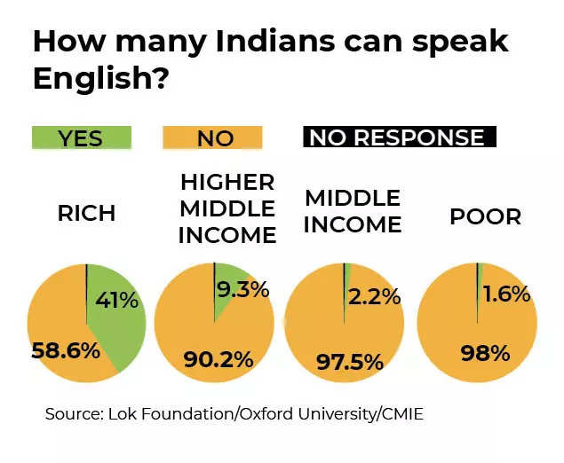
(Image 1: As cited in Times of India, 2023)
English is the language of the global corporate world (Neeley, 2012 in Harvard Business Review article headlined Global Business Speaks English). National Educational Policy 2020 and various India Skills Reports equally emphasize on English communication skills as one of the important job skills for career in private (in both Indian Industries and MNCs) and public sectors which undoubtedly makes English an official global language for business communication.

- ENGLISH AS A SECOND LANGUAGE IN INDIA

With the spread and development of English in India, it has started being used as a second language and for some people it enjoys the status of the first language too. This language has a high prestige in India. As per data provided by Data and Graphic Journalist at Reuters Graphics, Vijdan Kawoosa (2018), it puts English as the second highest known language in India.

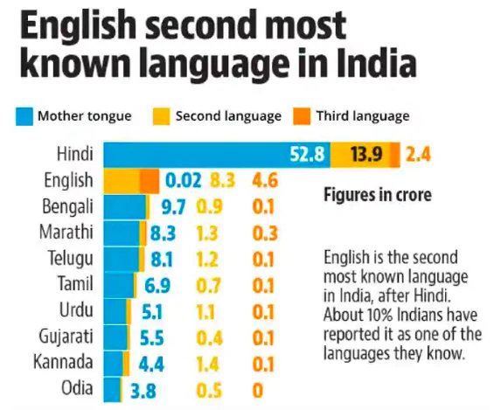

(Image 2: Kawoosa, 2018)

At present, the role and status of English in India is higher than ever marked till date. It is evidenced by its position as a key subject in schools, colleges, and universities. It comes with many challenges of teaching English to the students of ESL in India. Thus, the different teaching approaches are being used to gauge the efficacy of the teaching process as the number of English learners grows in India. This change has impacted the teaching and learning of English at primary to higher level of Education in India.

- A CASE OF GUJARAT

Gujarat has undertaken many efforts that shows significance of English in the state. The Government of Gujarat has made a policy to hire English Language Teachers and Professors 2pecialized in English Language Teaching in order to meet the need and expectations of ESL Learners and lay a strong foundation for English language in the state. Due to these efforts students now have greater opportunities to participate in the teaching and learning of the English language, as well as access to qualified teachers of English (Trivedi, 2017). As a result, the students are now considering English as their second language and have gained the confidence needed in order to learn it at the most advanced level alongside other subjects and languages. The need for learning English has grown as a result of its position as a language of opportunities. IPD Education estimates that between 1.3 and 1.4 million Indians take the IELTS exam each year to get ready for higher education and job opportunities overseas (Manya, 2023) and majority of them are from Gujarat.

This has compelled nearly all of Gujarat’s Institutes and Technological Universities to include the course of English Language or Communication in English or Compulsory English as a part of the curriculum in the various professional degree and diploma programmes has which also boosted students’ interest in the subject. Since everyone wants to speak English more fluently, the desire for learning and using refined English has recently been at its highest point in the state. The indirect effects of English’s status as a global language have caused English teachers in Gujarat (and almost all the states in India) to shift their focus more towards task-based teaching of the language as it facilitates students quickly acquire the communication skills in English. Another significant effect that is clearly seen in the realm of education is the increasing awareness of the widespread use of innovative teaching and learning methods in order to prepare students for a global workplace.

Thus, not only in Gujarat but also in more or less all the states of India, the status of English as a Global language has increased due to the paradigmatic shift in the economy, science and technology, and other knowledge domains, which has substantially impacted the teaching and learning of English in India. With these changes, the techniques, methods, tools, and approaches used to teach English language have changed and are continuously being updated. The current, cutting-edge methods of English Language Teaching (ELT) have nearly replaced the conventional method of teaching.

- ESL LEARNERS AT TERTIARY LEVEL

A learner enters the English classroom during the teaching-learning process with a wide range of objectives and goals in mind. It is because the ESL students have many prejudices regarding the significance and influence of the English language before participating in English courses at the primary, secondary, or tertiary levels. They perceive English as a tool for transforming their lives. The learners with a native language background have a challenging time acquiring English since they have not received enough exposure or any formal training for the English language learning.

i.e. In the class of 1st semester B. Tech. – a degree engineering course – the students with little English language background have a psychological fear towards the use and application of English language. They start considering themselves inferior to those who can produce good language in the classroom. This inferiority complex does not allow one to take part in any interactive activity or language game or individual, group or pair work. They cannot perform well in comparison to the students studying in English medium schools and having English language background even at their home too. They are desirous to speak or share in the English language and even try for the same; however, they cannot as they often try to translate the ideas from their mother tongue to English. As a result, they don’t feel confident and even if they produce the language, it is faulty and full of error – an example of translation but not trans-creation. Because of this barrier they cannot achieve fluency in English Language. They are more concerned about communicative English and want more activities and practice to overcome this weakness. They are always eager to learn English which will help them to perform better in the recruitment process. Students with the English Language background are one step ahead as they have good command over communicative English. That makes them confident one. They are eager for discussions and group activities as they want more and more chances to speak. They want to learn how to put arguments logically and in proper order. They are always concerned about their body language and presentation style so as to improve it and shine in during communication in public and private places, especially in the classroom.

- SIGNIFICANT ROLE OF ENGLISH TEACHER

According to Svinicki (2004), many students have a strong conviction that effective teachers actually motivate them to accomplish their academic goals, which ultimately facilitates teacher taking decisions on making use of innovative methods and techniques for teaching English. Teachers grapple with the learning needs of learners and how to meet them in order to be more abreast on the advancement of English as a global language, which make them aware of the global standard of teaching-learning of English language. This leads towards student- centric classrooms, where the teacher plays the role of a facilitator and tries his/her best to satisfy the aspirations and expectations of the students. Thus, the build up of expectations plays a pivotal role in motivating students, teachers, and even the classroom environment to be more productive in terms of language teaching and learning. With the advancement in pedagogy of Teaching-learning of English, academia has witnessed many drastic changes and paradigmatic phases in this realm. The reform of the teaching-learning of English in India follows the trend in contemporary English language teaching pedagogies which have focused on developing learners’ communicative competence and promoting learning strategies and learner autonomy in language classrooms. Based on the premise that students can acquire knowledge more effectively when they are aware of their learning objectives, the learner-centric pedagogy was developed. In student centric approach (Raelyn, 215), teachers assess the progress of each learner in both formal and informal methods, such as through activities, tasks, projects, participation, enthusiasm etc. Subsequently, the teacher's main responsibility is to guide and support each student's learning and overall comprehension of the topic (Teach.com, 2020)

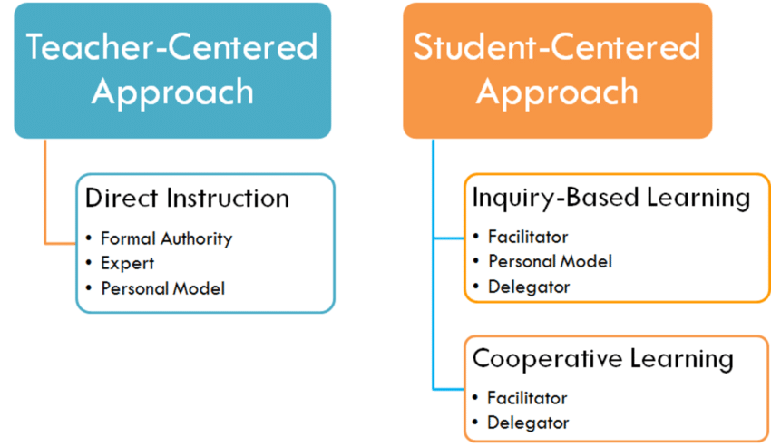

(Image 3: Teach.com)

Thus, in a learner-centered classroom, teachers play a role of knowledge facilitators who assist students in acquiring the skills rather than only being the source of knowledge. (Amcadias, 2008)

By establishing and sustaining a learning environment with communicative tasks that allow students to improve their language and learning abilities to become autonomous learners, teachers can promote learner autonomy (Han, 2021). Learner autonomy is supported by the learner-centered approach, which has been widely accepted by experts and researchers. The learner-centered approach has the potential to enhance their students’ positive attitudes towards learning English. As students engage with a more innovative teaching methodology, they are more confident using English language.

As a result, ESL teachers are now mindful of the need to change their role from that of knowledge transmitters to that of facilitators, assisting students in learning and thinking utilising a variety of resources on their own. However, this move faces many challenges, including a shortage of qualified teachers, large classrooms, and a shortage adequate resources and materials. Therefore, it is essential to find remedies that address these problems equally. Only by doing so teaching-learning scenario can be empowered while meeting the global standards of English language teaching in India.

- CONCLUSION

In navigating the complexities of ELT in India, collaboration among stakeholders emerges as a key theme. Governments, educational institutions, teachers, and communities must work together to bridge educational disparities, provide access to relevant resources, and foster a supportive learning environment (Education for All in India, 2023). Additionally, the integration of technology, when done thoughtfully, can enhance language learning experiences while preserving the value of human interaction. In essence, the critical analysis of the English Language Teaching scenario in India underscores the need for a holistic and context-aware approach. It emphasizes the importance of recognizing and celebrating linguistic and cultural diversity, while also advocating for inclusive and innovative educational practices. By fostering a deep appreciation for the interconnectedness of ESL learners, teachers, and pedagogical approaches, India can navigate the challenges of the 21st century while nurturing English language proficiency.

REFERENCES

- Study Mode, “Future of English”, 2010, retrieved from https://www.studymode.com/essays/Future-Of-English-754236.html
- Abel, “The Issues on the Implementation of Thailand’s Learner-Centered Approach in Teaching English as Foreign Language”, 2008, retrieved from https://amcadias.wordpress.com
- M. S. Akramovna, T. A. Alimovna, F. N. Djurakulovna, “Possibilities of Educational Technologies in English Classes”, nternational Engineering Journal For Research & Development, Volume 6, Issue 6, 2021.
- D. Crystal, “English as a global language”, Cambridge: Cambridge University Press, 1997
- Neeley, T. (2012). Global Business Speaks English. Harvard Business review.
- India Skills Report, Wheelbox. The Confederation of Indian Industry, All India Council for Technical Education. 2019.
- MHRD, National Education Policy, Government of India, 2020.
- Education for All in India, “The Pursuit of Quality School Education: A Key Imperative for India’s Future, 2023”, 2023, retrieved from https://educationforallinindia.com/quality-school-education-in-india-2023/

- K. Han, “Fostering Students' Autonomy and Engagement in EFL Classroom Through Proximal Classroom Factors: Autonomy-Supportive Behaviors and Student-Teacher Relationships”, Frontiers in Psychology, Volume, 2021.
- M. D. Svinicki, “Learning and motivation in the postsecondary classroom”, Bolton, MA: Anker, 2004.
- S. Chaudhari, R Sharma, “70 years on, India is still fighting over a national language”, Times of India, 2023.
- V. M. Kawoosa, “English Second most known language in India”, Twitter, 2018
- Manya Group, “Eligibility Criteria for IELTS”, 2023, retrieved from https://www.manyagroup.com/ielts/eligibility-criteria-for-ielts/
- V. Raelyn, “Adopting an Experiential Mindset”, 2015, 10.13140/RG.2.1.4366.5120, retrieved from https://www.researchgate.net/figure/A-comparison-between-teacher-centered-and-student-centered-learning-Taken-from-teachcom_fig3_281275288
- Teach.com, “Teaching Methods”, 2020, retrieved from https://teach.com/what/teachers-know/teaching-methods/

