Enhancing Heat Transfer Analysis in Phase Change Materials using Artificial Intelligence

Anand K Joshi1,Research Scholar

Dept. of Mechanical Engineering

Presidency University Bengaluru India

anandkjoshi.mech@gmail.com

Dr.Devendra Dandotiya2, Assistant Professor

Dept. of Mechanical Engineering

Presidency University Bengaluru India

Dr.Rudra Naik3, Principal Dr.Kanchan Ganvir4,Assistant Professor

Principal, BMSCE (Evening) Department of Mechanical Engineering

Basavangudi, Bengaluru, India Priyadarshini Bhagwati College of Engineering Umer Road, Nagpur India

ABSTRACT

Nowadays the utilization of Phase Change Materials (PCMs) has revolutionized various industries by enabling efficient thermal energy storage and temperature regulation. This Chapter focused on harnessing the power of Artificial Intelligence (AI) to enhance the analysis of heat transfer phenomena within PCMs. PCMs exhibit unique characteristics during phase transitions, demanding intricate heat transfer analysis for optimal application. This chapter delves into the integration of AI techniques, including machine learning and neural networks, to predict and optimize heat transfer processes in PCM-based systems. Through case study and discussions on Prospectus, the chapter underscores the potential of AI-driven methodologies in revolutionizing PCM-related research and applications. This chapter unveils new horizons for efficient energy storage, thermal management, and innovative industrial solutions by bridging the gap between complex heat transfer dynamics and intelligent algorithms.

Keywords—PCM; Heat Transfer; Artificial Intelligence.

# INTRODUCTION

# 

In the wake of swift global economic and industrial advancements in recent times, the energy crisis has emerged as a pivotal apprehension for numerous nations. The effective harnessing of current energy reservoirs has surfaced as a prominent subject of research. Energy storage phase change materials (PCMs) have steadily ascended in prominence as functional materials, acclaimed for their exceptional energy storage characteristics. Researchers across the globe are focusing their attention on phase change materials (PCMs) owing to their vast promise in the field of thermal energy storage. In the wake of nanotechnology and the proliferation of technologies reliant on electrochemical devices, the imperative to address the challenges associated with managing the heat emanating from them has gained equivalent significance. Phase change materials (PCMs) are substances that can store and release thermal energy during phase transitions, such as solid-to-liquid (melting) and liquid-to-solid (freezing) transitions. PCMs have the unique property of having a high heat of fusion, which allows them to absorb or release a significant amount of energy while maintaining a nearly constant temperature. This makes them invaluable in various applications where precise temperature control and energy storage are crucial.

The fundamental understanding of heat transfer processes in PCMs is pivotal for optimizing the performance of PCM-based systems. Proper analysis can lead to improved efficiency, enhanced energy storage, and more precise control over temperature-dependent processes. Furthermore, the ability of PCMs to store and release energy on demand finds applications in various sectors, including building and construction, energy, electronics, textiles, and transportation. In recent years, the convergence of advanced technology and scientific inquiry has led to the transformative integration of Artificial Intelligence (AI) techniques with the analysis of heat transfer phenomena. Particularly, this integration has found significance in Phase Change Materials (PCMs), where complex challenges arise due to the intricate dynamics of heat transfer during phase transitions. Conventional analytical methods, while valuable, often struggle to capture the nuanced behaviors and interactions governing these intricate processes. Consequently, there is a growing interest in utilizing AI's capabilities, encompassing machine learning and neural networks, to deepen our understanding of heat transfer in PCMs and enhance predictive modeling. This interdisciplinary approach holds the potential to reshape heat transfer analysis and revolutionize the applications of PCMs across industries reliant on energy storage, thermal management, and temperature regulation. The assimilation of AI techniques into the analysis of heat transfer in PCMs represents a transformative paradigm shift. AI introduces a data-centric approach capable of tackling the intricate dynamics of heat transfer that often exceed the scope of conventional analytical methods. Machine learning algorithms adeptly identify patterns, correlations, and nonlinearities within extensive datasets, enabling precise predictions of heat transfer behaviors in PCMs. Neural networks, a subset of AI, excel at capturing complex interdependencies among variables, effectively modeling the inherent complexity of such phenomena. This fusion of AI and heat transfer analysis unravels the nuanced relationships among material properties, boundary conditions, and temperature variations during phase transitions. The integration of AI-driven analysis into PCM research offers numerous advantages. It accelerates accurate predictions, reducing the need for exhaustive experimental trials and numerical simulations. Additionally, AI-driven analysis accommodates multiple variables simultaneously, fostering a holistic understanding of heat transfer dynamics. Lastly, AI contributes to the optimization of PCM-based systems for specific applications, culminating in heightened efficiency and performance.

The intersection of AI-driven analysis and heat transfer investigations within Phase Change Materials unveils a captivating avenue for advancing our comprehension of these materials' conduct during phase transitions. The formidable computational capabilities of AI, coupled with the intricate thermal attributes of PCMs, possess the potential to revolutionize industries reliant on efficient energy storage, temperature regulation, and thermal modulation. As the exploration of AI-enhanced heat transfer analysis in PCMs progresses, novel insights and solutions are poised to reshape domains spanning energy, electronics, and beyond.

**II.PHASE CHANGE MATERIALS**

The history of using phase change materials for thermal energy storage dates back to ancient times, with paraffin wax being popular. The mid-20th century saw significant advancements in PCM development, including the use of salt hydrates and paraffin waxes in space missions. The 1970s-1980s saw efficient energy storage research, focusing on latent heat properties, stability, and practical usability across various industries. The 1990s saw a shift towards optimizing PCM materials, encapsulation methodologies, and real-world integration, expanding the scope beyond space missions to include building insulation, electronics cooling, and textiles for temperature regulation. The advent of nanotechnology further diversified the spectrum of PCM applications.

A. **Phase change phenomenon and its Heat Transfer.**

Heat transfer analysis in Phase Change Materials (PCMs) holds paramount importance in various industries due to the unique thermal properties exhibited by these materials during phase transitions. PCMs undergo a phase change, such as a solid-to-liquid or liquid-to-solid transition, while maintaining a nearly constant temperature. This latent heat storage capacity allows them to absorb and release substantial amounts of energy, making them indispensable for efficient thermal management, energy storage, and temperature regulation.

The fundamental understanding of heat transfer processes in PCMs is pivotal for optimizing the performance of PCM-based systems. Proper analysis can lead to improved efficiency, enhanced energy storage, and more precise control over temperature-dependent processes. Furthermore, the ability of PCMs to store and release energy on demand finds applications in various sectors, including building and construction, energy, electronics, textiles, and transportation. The forthcoming section will delve into comprehensive applications that have been thoroughly explored.

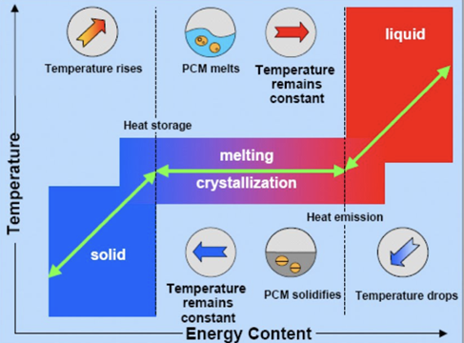

Fig.1 Phase Change Phenomena of P CM [1]

Phase change materials can be categorized into distinct subgroups determined by their chemical composition. These subgroups encompass three main categories: (i) organic compounds, (ii) inorganic compounds, and (iii) inorganic eutectics or eutectic mixtures (as depicted in Figure 2). Each category presents its characteristic ranges concerning melting temperature and enthalpy.

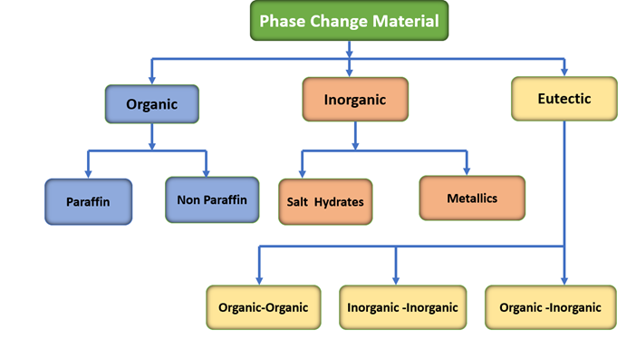

Fig.2 Classification of Phase Change Material

B. **Heat transfer mechanisms during phase change: Solid-to-liquid and liquid-to-solid transitions.**

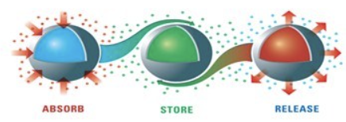

Fig.3 Process of Heat Transfer in PCM

During phase change processes, such as solid-to-liquid and liquid-to-solid transitions, distinct heat transfer mechanisms come into play. These mechanisms play a crucial role in determining the rate and efficiency of the phase change. Let’s delve into the heat transfer mechanisms that occur during these transitions:

Solid-to-Liquid Transition (Melting):

Conduction: Conduction is the primary heat transfer mechanism during the melting of a solid into a liquid. Heat is transferred from the hotter regions of the solid phase to the interface where melting occurs. The molecules at the interface gain sufficient energy to overcome the cohesive forces holding them in the solid state, thus transitioning into the liquid state.

Latent Heat Absorption: As the solid absorbs heat, its temperature remains constant at the melting point. The absorbed heat is used to break the intermolecular bonds and transform the solid into a liquid. This heat is the latent heat of fusion, which characterizes the energy required for the phase change without a change in temperature.

Convection: While convection is less prominent during solid-to-liquid transitions, it can occur when a fluid (liquid or gas) is in contact with the melting solid. Convection currents can aid in distributing heat throughout the solid, facilitating a more uniform melting process.

Liquid-to-Solid Transition (Freezing):

Conduction: Similar to melting, conduction remains a significant heat transfer mechanism during the freezing of a liquid into a solid. Heat is transferred from the warmer regions to the interface where freezing begins. As molecules lose energy, they form solid bonds and transition from the liquid to the solid state.

Latent Heat Release: During freezing, the latent heat of fusion is released as the liquid loses energy and forms solid bonds. This heat release keeps the temperature constant until the entire liquid has solidified.

Convection: Convection currents can also occur during freezing, aiding in the distribution of heat throughout the liquid as it transitions to a solid state. These currents can affect the rate of freezing and the uniformity of the resulting solid structure.

In both solid-to-liquid and liquid-to-solid transitions, the latent heat exchange plays a pivotal role. It allows the material to absorb or release significant amounts of energy without a change in temperature, ensuring a constant thermal environment during the phase change. The balance between these heat transfer mechanisms determines the efficiency and speed of the phase change process and has implications for various applications, including energy storage, thermal management, and temperature regulation.

C**. Applications of PCMs in energy storage, thermal management, and temperature regulation.**

Phase Change Materials (PCMs) find diverse applications in energy storage, thermal management, and temperature regulation across various industries. Their unique ability to absorb and release thermal energy during phase transitions makes them invaluable in these fields: The illustration as shown in Fig.4

1. Energy Storage:

Thermal Energy Storage Systems: PCMs are integrated into thermal energy storage systems to store excess heat energy generated during off-peak hours and release it when demand is high. This improves energy utilization, reduces the peak load on power grids, and enhances overall energy efficiency.

Solar Thermal Storage: PCMs store solar energy during sunny periods and release it later for use during cloudy or nighttime hours. This application enhances the efficiency of solar energy systems by enabling continuous energy supply.

2. Thermal Management:

Electronics Cooling: PCMs are used in electronic devices to manage and dissipate heat generated during operation. They absorb excess heat, preventing overheating and ensuring optimal performance and lifespan of electronic components.

Automotive Thermal Management: PCMs regulate the temperature in vehicles by absorbing excess heat generated by engines and releasing it when needed. This improves engine efficiency, reduces emissions, and enhances passenger comfort.

3. Building and Construction:

Thermal Regulation in Buildings: PCMs are integrated into building materials, such as walls, roofs, and floors, to regulate indoor temperatures. They absorb excess heat during the day and release it at night, reducing the need for heating and cooling systems and enhancing energy efficiency.

HVAC Systems Enhancement: PCMs can be incorporated into HVAC systems to store and release heat, reducing energy consumption and enhancing overall comfort in buildings.

4. Textiles and Apparel:

Smart Fabrics: PCMs integrated into clothing materials create “smart” textiles that regulate body temperature. These fabrics absorb excess heat when the body is warm and release it when the body is cooler, ensuring wearer comfort in varying conditions.

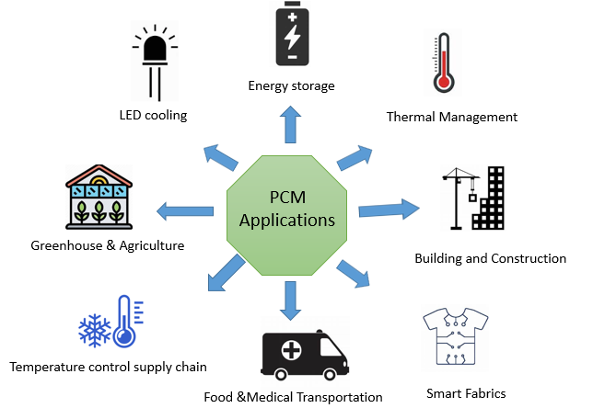

Fig.4 Application of PCM in various fields

5. Food and Medical Transportation:

Temperature-Sensitive Transport: PCMs are used in packaging to maintain a constant temperature range during the transportation of perishable goods, such as food and pharmaceuticals. This prevents spoilage and maintains product integrity.

6. Cold Chain Management:

Temperature Control in Supply Chain: PCMs are utilized in cold chain logistics to maintain a specific temperature range during the transport and storage of temperature-sensitive products, ensuring their quality and safety.

7. Greenhouses and Agriculture:

Temperature Regulation in Greenhouses: PCMs regulate temperatures in greenhouses by absorbing excess heat during the day and releasing it at night. This stabilizes temperature fluctuations, enhancing plant growth and productivity.

8. Energy-Efficient Lighting:

LED Cooling: PCMs are employed to cool LEDs, preventing overheating and extending the lifespan of these energy-efficient lighting sources.

In each of these applications, PCMs contribute to improved energy efficiency, enhanced performance, and optimized resource utilization. Their ability to store and release thermal energy on demand addresses challenges related to temperature fluctuations, energy consumption, and sustainable resource management.

**III. INTEGRATION OF ARTIFICIAL INTELLIGENCE (AI) FOR ENHANCED ANALYSIS**

The integration of Artificial Intelligence (AI) techniques in heat transfer analysis of PCMs presents a paradigm shift in the way these complex processes are understood and optimized. AI, including machine learning and neural networks, offers a data-driven approach to capture intricate relationships within heat transfer dynamics, which might be challenging through conventional analytical methods.

Machine learning algorithms can identify patterns, correlations, and nonlinearities in large datasets, enabling accurate predictions of heat transfer behaviors in PCMs. Neural networks, a subset of AI, excel in capturing intricate relationships among variables and offer the capability to model highly complex phenomena. The synergy between AI and heat transfer analysis allows for the exploration of nuanced interdependencies between material properties, boundary conditions, and temperature variations during phase transitions.

Incorporating AI-driven analysis into PCM research offers several benefits. First, it enables rapid and accurate predictions, reducing the need for extensive experimental testing and numerical simulations. Second, AI-driven analysis can account for multiple variables simultaneously, facilitating a more holistic understanding of the heat transfer dynamics. Lastly, AI can aid in optimizing PCM-based systems for specific applications, leading to enhanced efficiency and performance.Fig.4 shows the Incorporation of artificial intelligence techniques into systems for thermal energy storage.

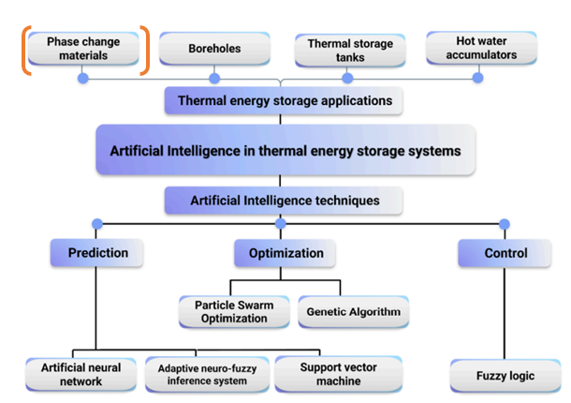

Fig. 4 Integrating artificial intelligence methods into thermal energy storage systems[2]

A**. AI Models for Heat Transfer Analysis in PCMs**

Artificial Intelligence (AI) and machine learning have emerged as revolutionary tools in various fields, including heat transfer analysis. These technologies enable computers to learn from data, recognize patterns, and make predictions or decisions without being explicitly programmed. Among the key components of AI, neural networks, deep learning, and various algorithms play pivotal roles:

1. Neural Networks:

Neural networks are computational models inspired by the structure and functioning of the human brain's interconnected neurons. They consist of layers of interconnected nodes, or neurons, which process and transmit information. Each connection between neurons carries a weight that determines the strength of the signal. Neural networks are capable of learning complex relationships in data, enabling them to recognize patterns and make predictions.

2. Deep Learning:

Deep learning is a subset of machine learning that involves neural networks with multiple layers, referred to as deep neural networks. These networks are designed to automatically learn hierarchies of features from data. Deep learning excels at capturing intricate patterns and representations, making it highly effective in tasks like image recognition, natural language processing, and complex data analysis.

3. Algorithms:

Machine learning algorithms are the mathematical frameworks that guide AI systems to learn from data. These algorithms include techniques for supervised learning, unsupervised learning, and reinforcement learning. Supervised learning involves training a model with labeled data to make predictions, while unsupervised learning focuses on finding patterns in unlabeled data. Reinforcement learning revolves around training models to make sequential decisions by rewarding desired behaviors and penalizing undesired ones.

AI and machine learning's application to heat transfer analysis revolutionizes the field in various ways:

1. Enhanced Prediction: Neural networks and deep learning can capture complex heat transfer behaviors, enabling accurate predictions even in intricate systems with multiple variables.

2. Data-Driven Insight: Machine learning algorithms analyze large datasets from experiments and simulations, extracting valuable insights that might be challenging through traditional methods.

3. Model Optimization: AI techniques assist in optimizing heat transfer models, enabling the discovery of optimal conditions for efficient energy storage, thermal management, and temperature regulation.

4. Multivariable Relationships: AI's capacity to handle multiple variables simultaneously facilitates a comprehensive understanding of the interdependencies affecting heat transfer during phase change.

5. Rapid Analysis: AI-driven analysis accelerates heat transfer predictions, reducing the need for time-consuming and resource-intensive experimental trials.

6. Complexity Handling: Neural networks excel at managing complex, nonlinear relationships within heat transfer dynamics, aiding in solving intricate problems.

As AI and machine learning continue to evolve, their integration into heat transfer analysis empowers researchers and engineers to delve deeper into the behavior of Phase Change Materials, transforming industries reliant on efficient energy storage, temperature control, and thermal management.

**IV CASE STUDY**

**Creation of the predictive model based on recurrent neural networks**

In the present case study, a recurrent neural network (RNN) has been discussed from the literature to forecast the liquid fraction time series of a Phase Change Material (PCM) using surface temperature time series as input. This RNN model is intended to serve as a diagnostic tool for thermal management systems. A diverse range of heat flux scenarios is taken into account, including constant, pulsed, randomly increasing, and randomly decreasing heat fluxes. These scenarios encompass the real-life heat flux boundary conditions of latent heat thermal storage (LHTS) systems, providing a comprehensive training dataset for the RNN model [3].

The training data for the neural network is generated using the enthalpy-porosity formulation, which simulates the phase transition process of a PCM. Subsequently, the RNN model's performance is evaluated using various heat flux scenarios that extend beyond the scope of the initially trained data. This assessment involves predicting the liquid fraction of the PCM under different external heat flux conditions.

A recurrent neural network (RNN) is a class of artificial neural networks where the nodes are connected with a temporal sequence containing directed or undirected graphs, allowing data handling with dynamic behavior. The RNNs use an internal state (memory) called gated storage units for handling different lengths of data sequences with time delays.

A. Architecture of Gated Recurrent Unit (GRU) and Data Set Generation

One improvised version of RNN is the Gated Recurrent Unit (GRU).GRU uses multiple gating mechanisms to manage the information flow between various nodes of the network. A GRU uses an update gate and a reset gate to control vanishing gradients.

This study focuses on a segment of the radial heat sink (depicted in Fig.5) to construct the essential dataset for training the RNN model. The heat input is administered as surface heat flux on the inner surface, while a convection boundary condition with h = 10 W/m² and T∞ = 300 K [4] is applied to the outer surface.

(GRU) is used in this study to predict the liquid fraction of PCM for all types of heat inputs. The inner surface temperature of the heat sink is chosen as the input parameter to the model as it can be measured easily. The RNN is trained using the Tensor flow API with the Adam optimization technique [39]. Adaptive Moment Estimation (Adam) squares the estimated gradient after calculating an exponential weighted moving average of the gradient. The network also features two decay parameters that regulate the rates at which these produced moving averages degrade. The sigmoid function is used as activation for the recurrent units. The model is trained with a learning rate of 0.01 and a loss-monitored early callback for 75 epochs. Performance metrics like root mean square error, RMSE, and mean absolute error, MAE [5] for the numerical and the predicted liquid fractions were calculated for networks with varying nodes and layers.

For the constant and pulsed heat input scenarios, the Latin hypercube sampling technique is employed to sample heat flux. Meanwhile, random heat input involves pseudo-random generation for all time steps, scaled between 0 and 1900 W/m². The Wiener process, a real-valued continuous-time stochastic process, generates heat flux as well. The data generation process accommodates the PCM's discharging phase, considering its significantly longer duration compared to charging in thermal management systems. To ensure data uniqueness during discharging, a minor heat flux is applied, simulating the heat generated during PCM discharge in systems like PCM-based battery thermal management.

To enhance model resilience, Gaussian noise is introduced to the generated temperature time series. A total of 345 cases are generated through numerical simulations, spanning a uniform distribution of various heat flux scenarios. Within the dataset, 85% of samples are allocated for model training, while 15% are reserved for validation. The data generation procedure is illustrated in Fig. 5. Additionally, the unrolled recurrent neural network, illustrating temperature as input and PCM liquid fraction as output, is depicted in Fig. 5.

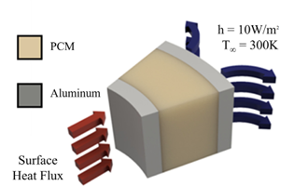

Fig.5 Diagram depicting the configuration of the radial PCM-based heat sink employed in this investigation [3]

B. Results and Discussion

An RNN model has been formulated to encompass diverse heat inputs that extend beyond the confines of the trained dataset. The predictive parameter chosen in this context is the liquid fraction of the PCM, representing a pivotal metric for characterizing the system's state. The proportions of liquid and solid PCM inherently convey precise insights into the cumulative energy absorbed by the PCM until the specific point in time.

Inclusion within the training dataset encompasses an array of heat inputs, coupled with their corresponding temperature profiles serving as inputs, and the associated liquid fractions serving as the target values. As such, the training dataset's composition holistically captures the interplay between thermal input, temperature variations, and the evolving liquid fractions, ultimately facilitating the RNN model's capacity to comprehend and predict intricate thermal behaviors.

*a*. *Constant Heat Flux*

Constant heat flux is a prevalent method employed to characterize latent heat energy storage systems, especially in laboratory-scale assessments. While real-world latent heat thermal storage (LHTS) systems may occasionally encounter such heat inputs, they typically exhibit distinct behavior. When subjected to constant heat input, the PCM undergoes a continuous energy absorption process characterized by three stages: (i) sensible heating in the solid phase, (ii) latent energy absorption, and (iii) sensible energy absorption in the liquid phase. As depicted in Figure 6(a) & (b), the heat input, along with corresponding surface temperatures, is generated through numerical simulations. Additionally, the RNN-predicted and numerically derived liquid fraction for the constant heat input case is presented.

As anticipated, the initial response involves a rapid temperature increase within the solid and liquid phases, characterized by corresponding liquid fractions of 0 and 1, respectively. However, during the latent heat absorption phase, the temperature evolution exhibits a gradual increase as the PCM transitions from a solid to a liquid state. This progression aligns with the variation in the liquid fraction across this phase. A subsequent comparison of different heat input scenarios and their impacts can provide further insights into the dynamic behavior of the PCM-based system under various thermal conditions.

|  |  |
| --- | --- |
|  |  |

Fig.6 (a) the inner surface temperature of the heat sink, generated by employing constant heat flux from testing data. (b) Liquid fractions, both numerically determined and predicted, correspond to the temperatures outlined in (a).[3]

*b. Pulsating Heat flux*

Pulsating heat flux is prominently observed in contexts like electric vehicles, satellite components, and electronics. This heat flux pattern entails recurrent heating and cooling intervals, affecting the PCM within the latent heat thermal storage (LHTS) system. During the heating phase, both temperature and liquid fraction ascend, while they decline during the cooling phase. Given the PCM's inherent low thermal conductivity due to self-insulation, the temperature and liquid fraction ascent and descent are dissimilar but proportionate. As the number of pulsating cycles increases, both temperature and liquid fraction experience elevation, since the PCM's discharge duration extends.

Illustrated in Figure 7(a) & (b), the temperature and liquid fraction trends for pulsating heat input exhibit this fluctuating pattern. Remarkably, the RNN model demonstrates precise prediction capability for the liquid fraction curve under pulsating heat input, with a high R-squared (R2) value of 0.999. This underscores the model's accuracy in capturing the intricate dynamics of the PCM's response to pulsating heat flux, a characteristic prevalent in various dynamic thermal management scenarios.

|  |  |
| --- | --- |
|  |  |

Fig. 7(a) The temperature of the heat sink's inner surface, produced through the utilization of pulsed heat flux derived from testing data.

(b) Liquid fractions, encompassing both numerically computed and predicted values, associated with the temperatures delineated in (a).[3]

**V CONCLUSION AND PROSPECTS**

In conclusion, the integration of Artificial Intelligence (AI) techniques into the analysis of heat transfer within Phase Change Materials (PCMs) marks a transformative leap in our understanding and manipulation of these intricate thermal processes. This chapter delves into a case study that employs Recurrent Neural Networks (RNNs) to anticipate the liquid fraction of Phase Change Material (PCM) within a range of thermal management and storage systems, encompassing diverse heat flux scenarios. This convergence propels the exploration of these materials to new dimensions, promising innovation across energy storage, electronics cooling, and diverse industrial sectors reliant on efficient thermal management.

The journey of enhancing heat transfer analysis in Phase Change Materials (PCMs) through the infusion of Artificial Intelligence (AI) is poised to pave an exciting path forward. As AI-driven methodologies continue to evolve, there's immense potential for even greater precision in predicting heat transfer behaviors across various PCM configurations. The prospect of expanding AI applications to encompass multi-dimensional phase change scenarios, transient simulations, and intricate material interactions holds significant promise. Moreover, the integration of real-time data assimilation and AI-driven control strategies into PCM-based systems could revolutionize adaptive thermal management. The collaboration between materials science, AI, and thermal engineering is expected to yield breakthroughs that not only elevate our comprehension of heat transfer in PCMs but also foster sustainable advancements in energy-efficient technologies. As AI matures and more data becomes available, the horizon of possibilities in enhancing heat transfer analysis within PCMs becomes increasingly captivating, ushering in a new era of efficient thermal management and innovative energy solutions.

##### REFERENCES

[1] S. Tandle, “PHASE CHANGE MATERIAL TECHNIQUE FOR THERMAL MANAGE- MENT OF,” no. September, pp. 0–16, 2020, doi: 10.13140/RG.2.2.30463.84648.

[2] A. G. Olabi *et al.*, “Application of artificial intelligence for prediction, optimization, and control of thermal energy storage systems,” *Therm. Sci. Eng. Prog.*, vol. 39, no. August 2022, p. 101730, 2023, doi: 10.1016/j.tsep.2023.101730.

[3] G. V. S. Anooj, G. K. Marri, and C. Balaji, “A machine learning methodology for the diagnosis of phase change material-based thermal management systems,” *Appl. Therm. Eng.*, vol. 222, no. December 2022, p. 119864, 2023, doi: 10.1016/j.applthermaleng.2022.119864.

[4] C. Zhao, M. Opolot, M. Liu, F. Bruno, S. Mancin, and K. Hooman, “Numerical study of melting performance enhancement for PCM in an annular enclosure with internal-external fins and metal foams,” *Int. J. Heat Mass Transf.*, vol. 150, p. 119348, 2020, doi: 10.1016/j.ijheatmasstransfer.2020.119348.

[5] R. Srikanth, P. Nemani, and C. Balaji, “Multi-objective geometric optimization of a PCM based matrix type composite heat sink,” *Appl. Energy*, vol. 156, pp. 703–714, Oct. 2015, doi: 10.1016/J.APENERGY.2015.07.046.