Heat Transfer Enhancement Study with Rectangular and Trapezoidal Fins using Finite Volume Method

¹Kiran Kumar Amireddy, ²Ch.Indira Priyadarsini, ³P.Anjani Devi
^{1,2,3}Department of Mechanical Engineering, Chaitanya Bharathi Institute of Technology, Hyderabad-500075 Telangana, India
¹akirankumar_mech@cbit.ac.in ²priyadarshini_mech@cbit.ac.in ³panjanidevi_mech@cbit.ac.in

Abstract
A heat exchanger is an element built for efficient heat transfer from one medium to another. The media may be separated by a solid wall to prevent mixing or they may be in direct contact. Now a days shell and tube heat exchanger are the most common type heat exchanger widely use in oil refinery and other large chemical process, as it is suitable for pressure greater than 30 bar and temperature greater than 260^{O}C. The objective of this work is to analyse the performance of a shell and tube heat exchanger for three configurations with and without fins on tube surface. Numerical analysis is carried out using commercially available software FLUENT. The convective heat transfer process is analyzed for rectangular finned, and bare tube type heat exchanger. In simulation pressure-based solvers are used. k-e turbulent model is used to visualize the flow of eddies. Fluid domain is assigned with material of water inside the tubes surrounded by steam in shell. Boundary conditions have been applied to both shell and tubes, at inlet, velocity with energy condition is assigned. The convection boundary condition is applied for tube walls in terms of heat transfer coefficient and ambient temperature. The results indicated that there is a heat transfer enhancement in trapezoidal finned tube heat exchanger compared to rectangular finned configuration. The post processes results have been used to calculate the overall heat transfer rate. Rectangular finned model showed 32 % heat transfer more than that of bare tube model.

Keywords – CFD, FLUENT, Heat exchanger, shell and tube, Trapezoidal and Rectangular fins

Introduction

Shell and tube heat exchanger

Shell and tube heat exchangers consist of series of tubes. One set of these tubes contains the fluid that must be either heated or cooled. The second fluid runs over the tubes that are being heated or cooled so that it can either provide the heat or absorb the heat required. A set of tubes is called the tube bundle and can be made up of several types of tubes: plain, longitudinally finned, etc. Shell and tube heat exchangers are typically used for high-pressure applications (with pressures greater than 30 bar and temperatures greater than 260 °C). This is because the shell and tube heat exchangers are robust due to their shape. Several thermal design features must be considered when designing the tubes in the shell and tube heat exchangers. There can be many variations on the shell and tube design. Typically, the ends of each tube are connected to plenums (sometimes called water boxes) through holes in tube sheets. The tubes may be straight or bent in the shape of U, called U-tubes. Fig 1. shows the typical configuration of U tube heat exchanger. Advantages of shell and tube type are condensation or boiling heat transfer can be accommodated in either the tubes or the shell, and the orientation can be horizontal or vertical. The pressures and pressure drops can be varied over a wide range, Thermal stresses can be accommodated inexpensively., There is substantial flexibility regarding materials of construction to accommodate corrosion and other concerns. The shell and the tubes can be made of different materials, Extended heat transfer surfaces (fins) can be used to enhance heat transfer and cleaning and repair are relatively straight forward, because the equipment can be dismantled for this purpose.

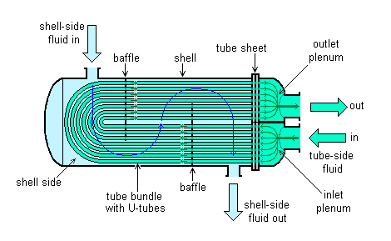
Figure 1. U-tube heat exchanger

Selection of tube material

To be able to transfer heat well, the tube material should have good thermal conductivity. Because heat is transferred from a hot to a cold side through the tubes, there is a temperature difference through the width of the tubes. Because of the tendency of the tube material to thermally expand differently at various temperatures, thermal stresses occur during operation. This is in addition to any stress from high pressures from the fluids themselves. The tube material also should be compatible with both the shell and tube side fluids for long periods under the operating conditions (temperatures, pressures, pH, etc.) to minimize deterioration such as corrosion. All of these requirements call for careful selection of strong, thermally conductive, corrosion-resistant, high quality tube materials, typically metals, including copper alloy, stainless steel, carbon steel, non-ferrous copper alloy, nickel and titanium. Fluoropolymers such as Pero-Fluoro-Alkoxy alkane (PFA) and Fluorinated Ethylene Propylene (FEP) are also used to produce the tubing material due to their high resistance to extreme temperatures. Poor choice of tube material could result in a leak through a tube between the shell and tube sides causing fluid cross contamination and possibly loss of pressure.

  - Fins

The heat conducted through solids, walls or boundaries has to be continuously dissipated to the surroundings or environment to maintain the system in a steady state condition. In many engineering applications large quantities of heat has to be dissipated from small areas. Heat transfer by convection between surface and fluid surroundings it can be increased by attaching to the surface thin strips of metals called FINS. These fins are also called as “extended surfaces”. When the ﬁn elements are conical or cylindrical, they may be referred to as spines or pegs. Fig 2. shows the radial and longitudinal fin configurations with different cross-section.

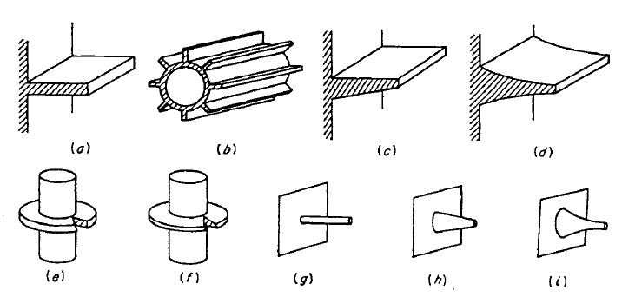
Figure 2. Fins of different configurations a) Longitudinal fin of rectangular profile b) Cylindrical tube equipped with rectangular fin profile, c) Longitudinal fin of tapered profile, d) Longitudinal fin of parabolic profile, e) Cylindrical tube equipped with radial fin of rectangular profile, f) Cylindrical tube equipped with radial fin of trapezoidal profile, g) Cylindrical spine, h) Truncated Conical Spine, i) Truncated parabolic spine

In this work two different radial fins are considered, Trapezoidal and Rectangular fins.

LITERATURE

Shiv Kumar Rathore et al [1] identified the advantages of low-finned tube Heat Exchangers over Plain tube (Bare Tube) units. To use finned tubes to advantage in this application, several technical issues were to be addressed. (1) Shell side and tube side Pressure, (2) Cost, (3) Weight and (4) Size of Heat Exchanger, Enhanced tubular heat exchangers results in a much more compact design than conventional plain tube units, obtaining not only thermal, mechanical and economical advantages for the heat exchanger, but also for the associated support structure, piping and skid package unit, and also notably reduce cost for shipping and installation of all these components. The results of this analysis showed that the finned tube heat exchanger is more economical than Conventional Bare tube Exchanger. The tube side pressure drops and fluid velocity is higher than the conventional bare tube exchanger, which prevent fouling inside the tubes, The shell side pressure drop is some lesser but fluid velocity is higher than the conventional heat exchanger. S.Rajasekaran, et al [2], has developed and tested a model of optimizing the early design phase of shell and tube Heat Exchangers via the application of Modified Genetic Algorithm (MGA). The Modified Genetic Algorithm is based on the integration of classical genetic algorithm structure and a systematic neighborhood structure. The MGA model can help the designers to make decisions at the early phases of the design process. With a MGA model, it is possible to obtain an approximately better prediction, even when required information is not available in the design process. This model proved that MGA is capable of providing better solutions with higher quality even with inadequate data. Swapnaneel Sarma, et al [3], studied the energy present in the exit stream of many energy conversion devices such as I.C engine gas turbine etc. goes as waste, if not utilized properly and predicting the performance of a shell and finned tube heat exchanger in the light of waste heat recovery application. The performance of the heat exchanger has been evaluated by using the CFD and has been compared with the existing experimental values. An attempt has also been made to calculate the performance of the above heat exchanger by considering triangular fins instead of regular rectangular fins and the result so obtained have been compared. The performance parameters pertaining to heat exchanger such as effectiveness, overall heat transfer coefficient, energy extraction rate etc., have been reported in this work. Heidar Sadeghzadeh, et al [4], found that the heat transfer rate and cost significantly affect designs of shell and tube heat exchangers, from the viewpoint of engineering, an optimum design is obtained via maximum heat transfer rate and minimum cost. Here, an analysis of a radial, finned, shell and tube heat exchanger is carried out, considering nine design parameters: tube arrangement, tube diameter, tube pitch, tube length, number of tubes, fin height, fin thickness, baffle spacing ratio and number of fins per unit length of tube. The “Delaware modified” technique is used to determine heat transfer coefficients and the shell-side pressure drop. In this technique, the baffle cut is 20 percent and the baffle ratio limits range from 0.2 to 0.4. The optimization of the objective functions (maximum heat transfer rate and minimum total cost) is performed using a non-dominated sorting genetic algorithm (NSGA-II), and compared against a one-objective algorithm, to find the best solutions. The results are depicted as a set of solutions on a Pareto front, and show that the heat transfer rate ranges from 3517 to 7075 kW. Also, the minimum and maximum objective functions are specified, allowing the designer to select the best points among these solutions based on requirements. Additionally, variations of shell-side pressure drop with total cost are depicted, and indicate that the pressure drop ranges from 3.8 to 46.7 kPa. Manasa Kishtapati et al [5], explained importance of heat shell and tube exchanger in every process industry, due to their robust geometry construction, easy maintenance and possible improvements. The improvement in overall heat transfer coefficient decreases the size of the exchanger resulting in savings in space and cost of the exchanger. The flow on the shell side is usually complex and results in lower values of the shell-side coefficient when compared to that of the tube-side. Efforts made to improve shell side coefficient using different types of baffle arrangements and enhanced tubes. Pradeep singh et al [6], analized the heat transfer performance of fin by design of fin with various extensions such as rectangular extension, trapezium extension, triangular extensions and circular segmental extensions. The heat transfer performance of fin with same geometry having various extensions and without extensions is compared. Near about ranging 5% to 13% more heat transfer can be achieved with these various extensions on fin as compare to same geometry of fin without these extensions. Prabhmeet Singh et al [7], explained different profiles of fins they were considered for thermal analysis in an IC engine. The boundary conditions were set up using Ansys and studied the steady state temperature distribution in Fins and to improve the heat transfer rate. In this paper we have also considered helical profile at various angle for heat transfer and temperature distribution. B.Chandra shekar et al [8], dealt with the numerical analysis of thermal sizing of multi tube pass shell and tube heat exchanger is obtained. The thermal sizing of multi tube pass shell and tube Heat Exchanger his desired with the bell manual method and for the same the numerical Analysis have been carried out based on the prescribed pressure drop criteria. The analysis of shell and tube Heat Exchanger and performance of evaluation is presently established technique used in power plant industry. In this paper the numerical investigation on tube side water flow pressure drop variations for Multi tube pass shell and tube heat Exchanger in addition to heat transfer coefficients are to be obtained. The pressure drop values for 1,2,4,6 tube pass shell and tube heat Exchanger are obtained by using C PROGRAMING and compared with Bell Manual Method values. Chintan D Patel et al [9] suggested the optimizing techniques for design they used Taguchi method to perform screening of experiments and to identify the important significant parameters which are affecting the efficiency of shell and tube type heat exchanger. The prefix parameters (tube diameter, mass flow rate and pitch length) are used as input variable and the output parameter is maximum temperature difference of shell and tube heat exchanger.
Several thermal design features must be considered when designing the tubes in the shell and tube heat exchangers: Shell and tube heat exchanger is divided into three parts: the front head, the shell, and the rear head. Figure 1. illustrates the TEMA nomenclature for the various construction possibilities of a shell and tube heat exchangers. Exchangers are described by the letter codes for the three sections — for example, a BFL exchanger has a bonnet cover, a two-pass shell with a longitudinal baffle, and a fixed-tube sheet rear head. The heat conducted through solids, walls or boundaries has to be continuously dissipated to the surroundings or environment to maintain the system in a steady state condition. In many engineering applications large quantities of heat has to be dissipated from small areas. Heat transfer by convection between surface and fluid surroundings it can be increased by attaching to the surface thin strips of metals called FINS. These fins are also called as “extended surfaces”. When the ﬁn elements are conical or cylindrical, they may be referred to as spines or pegs.

III. MATERIALS AND METHODOLOGY

3.1 Material and its properties :

Stainless steel grade 304 material was used to study the heat exchanger and properties are shown in Table-1., properties of cold and hot fluids shown in Table-2.

Table-1 Properties of stainless steel

Properties | Stainless Steel (Grade 304)
Density (1000 kg/m³) | 7.75-8.1
Elastic Modulus (GPa) | 190-210
Poisson's Ratio | 0.27-0.3
Thermal Expansion (10⁻⁶/K) | 9.0-20.7
Melting Point (°C) | 1371-1454
Thermal Conductivity (W/m-K) | 11.2-36.7
Specific Heat (J/kg-K) | 420-500

Table -2 Properties of cold and hot fluid

Properties | Water at  25 ⁰C | Steam at  350 ⁰C, 1 atm
Density (kg/m³) | 998 | 114
Kinematic viscosity (m²/s) | 0.885 x 10⁻⁶ | 0.233 x 10⁻⁶
Specific heat (J/kg-K) | 4178 | 16425
Thermal conductivity ( W/m-K) | 0.603 | 0.107

3.2. Modelling
Geometry for present model was taken from Shiv Kumar Rathore et al [1]. But due to computational time and mesh constraints the number of tubes we have taken are seven, the dimensions are scaled to 5:1.

Table -3 Details of Bare tube and Finned tube Heat Exchanger

Shell outer diameter | 30 mm
Shell Thickness | 4mm
Length of the tube | 120mm
Tube outer diameter | 6mm
Tube thickness | 3mm
Tube Layout | Triangular pitch
Tube pitch | 9mm
No. of tubes | 7
No. of baffles | 6
Baffle spacing | 16mm

Table -4 Details of Rectangular Fin Profile

Thickness of Fin | 0.305mm
Height of Fin | 0.3mm
Space between fins | 0.6mm
No. of fins | 110

Table -5 Details of Trapezoidal Fin Profile

Base Thickness of fin | 0.7mm
Thickness of fin at tip | 0.3mm
Height of fin | 0.5mm
Space between fins | 0.25mm
No. Of fins | 110

3.3 Bare tube type shell and tube heat exchanger

Based on above geometry the model bare tube type shell and tube heat exchanger is designed using CATIA V5. Figure 3 and 4 shows the geometry of bare tube, rectangular fins and trapezoidal fins.

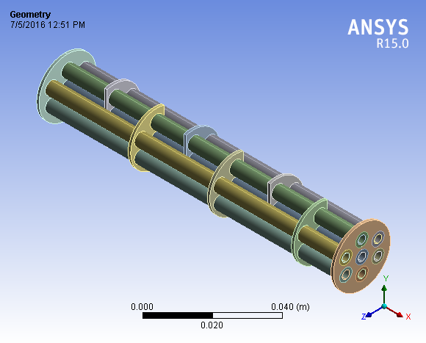  a | 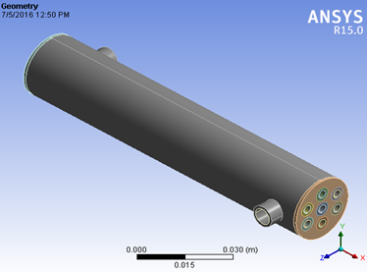  b

Figure 3. a) Internal view of bare shell and tube heat exchanger without fins b) outer shell model

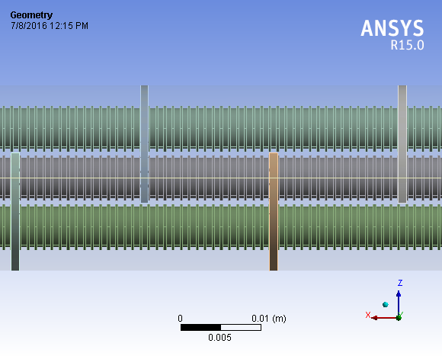  a | 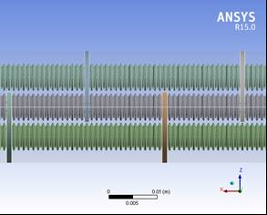  b

Figure 4. a) Rectangular fin profile, b) Trapezoidal fin profile

2.2.3 Meshing
The three-dimensional model is then discretized in ICEM CFD. In order to capture both the thermal and velocity boundary layers the entire model is discretized using hexahedral mesh elements which are accurate and involve less computation effort. Fine control on the hexahedral mesh near the wall surface allows capturing the boundary layer gradient accurately.
Initially a relatively coarser mesh is generated. This mesh contains mixed cells (Tetra and Hexahedral cells) having both triangular and quadrilateral faces at the boundaries. Care is taken to use structured cells (Hexahedral) as much as possible, for this reason the geometry is divided into several parts for using automatic methods available in the ANSYS meshing client. It is meant to reduce numerical diffusion as much as possible by structuring the mesh in a well manner, particularly near the wall region. Later on, for the mesh independent model, a fine mesh is generated.

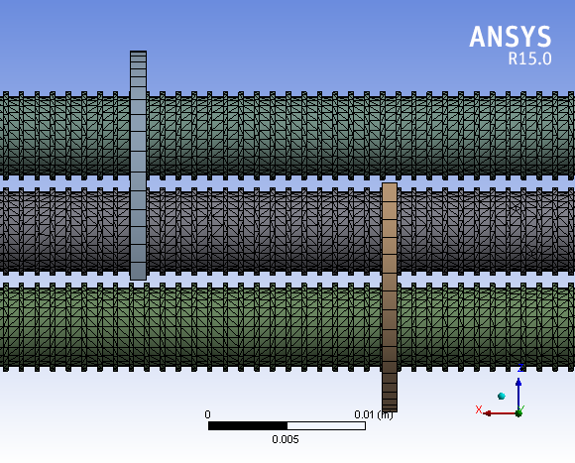  a | 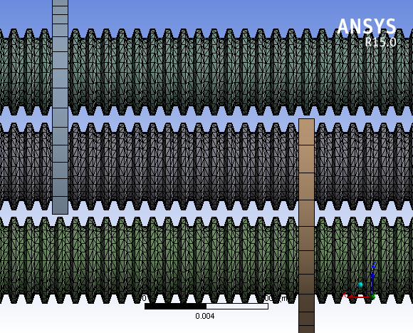  b

Figure 5. a) Rectangular fin mesh profile, b) Trapezoidal fin mesh profile

2.2.4 Boundary conditions
The following parametrs has been applied for numerical analysis from the literature that are proved from an expirimental study

Table -6 Boundary conditions (Shiv Kumar et al,[1])

Parameter | Shell side | Tube side
Velocity inlet (m/s) | 0.85 | 0.0709
Temperature inlet (K) | 300 | 623
Heat transfer coefficient (W/m²-k) | - | 60

IV.RESULTS AND DISCUSSION
4.1 Flow of temperature

Temperature is the crucial parameter to find the overall heat transfer rate and effectiveness of heat exchanger from shell side to tube Figure 6, 7 and 8 shows temperature distribution across the three different heat exchangers, which explains that tube side fluid temperature is decreasing from inlet to outlet due to transfer of heat to the tube wall by conduction and by convection from the tube surface whereas in shell side fluid temperature increases from inlet to outlet by taking heat from the surface of tube.

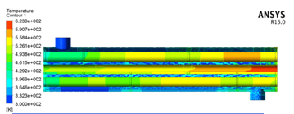  (a) | (b)
Figure 6. a) Flow of temperature in without fins, b) Variation of shell side tube side temperature with length in without fins model

Figure 6 a and b shows that the tube side fluid temperature drop is high than the temperature rise shell side fluid, it is because there is a loss of heat to tube wall and thermal conductivity of steel is low by which heat transfer to surrounding from tube outer surface is decreased in case of no fins attachment to heat exchanger.

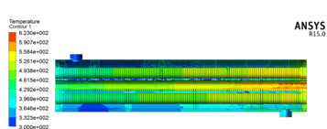  (a) | (b)
Figure 7. a) Flow of temperature in rectangular fins, b) Variation of shell side tube side temperature with length in rectangular fins

Figure 7. a and b show that the tube side fluid temperature drop is high than the temperature rise shell side fluid, it is because there is a loss of heat to tube wall and thermal conductivity of steel is low by which heat transfer to surrounding from tube outer surface is reduced. The temperature drop is more in tube side fluid of rectangular finned heat exchanger when compared to the bare tube heat exchanger

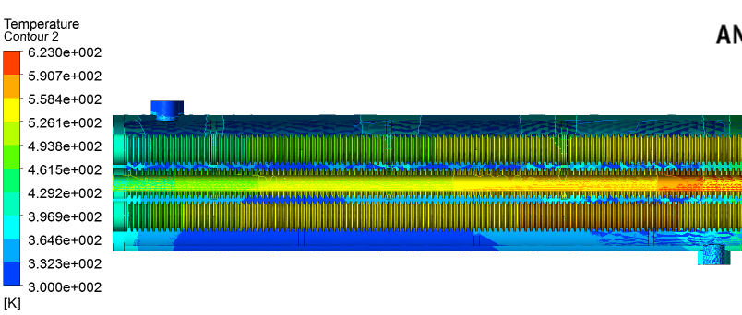  (a) | (b)
Figure 8. a) Flow of temperature in trapezoidal fins b) Variation of shell side tube side temperature with length in trapezoidal fins
Figure 8 a and b show that the tube side fluid temperature drop is high than temperature rise in shell side fluid, it is because there is a loss of heat to tube wall and thermal conductivity of steel is low by which heat transfer to surrounding from tube outer surface is decreased. The temperature drop in tube side fluid of trapezoidal heat exchanger is more when to compare to bare tube, rectangular finned heat exchanger since more amount of area is exposed for convection.
Figure 9. Comparison of temperature for tube side fluid flow

Figure 10. Comparison of temperature for shell side fluid flow

The temperature drop is more in trapezoidal profile when compare to rectangular finned and bare tube heat exchanger. In trapezoidal profile more amount of surface is exposed for convection than the other configurations which help to transfer more amount of heat.

V.CONCLUSION
An analysis was carried out for predicting the performance of shell and tube heat exchanger with different configurations computationally and temperature distribution was observed in each configuration. Based on the results obtained the following conclusions have made
- Temperature drop was more in trapezoidal finned heat exchanger than the rectangular finned and bare tube heat exchanger.
- Heat transfer is more in trapezoidal and rectangular finned heat exchanger when compared to that of bare tube heat exchanger.
- To achieve the same heat transfer of bare tube heat exchanger we require a smaller number of tubes in trapezoidal and rectangular finned heat exchanger. Therefore, there is reduction in total weight and also cost of a heat exchanger.
- By reducing the number of tubes, the shell diameter of finned tube heat exchanger is less than the bare tube heat exchanger, which saves the material and helps in easy installation in the plant.

Statements and Declarations
Conflict of Interests/Competing Interests: There is no conflict of Interests. All authors are contributed equally and shared the work. We all are agreed to the policies of the Journal.

Funding: No funding agency or financial interests that are directly or indirectly related to the work submitted for publication.

REFERENCES
- Shiv Kumar Rathore, Ajeet Bergaley, Comparative analysis of finned tube and bared tube type shell and tube heat exchanger Vol. 2, Issue 1, July 2012.
- S.Rajasekaran, Dr.T.Kannadasan, Optimization of shell and tube heat exchangers using modified genetic algorithm Vol. 3 No. 4, December, 2010.
- Swapnaneel Sarma, D.H.Das, CFD analysis of shell and tube heat exchanger using triangular fins for waste heat recovery processes Vol.2, No.6, December 2012.
- Heidar Sadeghzadeh, Mehdi Aliehyaei and Marc A. Rosen, Optimization of a finned shell and tube heat exchanger using a multi-objective optimization genetic algorithm 25 August 2015.
- Manasa Kishtapati Meda Kalyan Kumar, Improvisation of shell side heat transfer coefficient in shell and tube heat exchangers using different configurations Vol. 4 Issue 06, June-2015.
- Pardeep Singh, Harvinder lal, Baljit Singh Ubhi, Design and analysis for heat transfer through fin with extensions Vol. 3 Issue 5 may 2014.
- Prabhmeet Singh, K. K. Jain, R. K. Dave, Pooja Tiwari, Comparison of performance of different profile of fins using thermal analysis, Vol. 4, Issue-1, March 2015.
- B. Chandra sekar, D Krishnaiah, F. Anand Raju, Thermal analysis of multi tube pass shell and tube heat exchanger,Vol.3, Issue-11, November 2014.
- Chintan D Patel, Prashant Sharma and Amitesh Paul, Parameter optimization of shell and tube type heat exchanger for improve its efficiency, Vol.3,February 2014.
- M. Belghazi, A. Bontemps, C. Marvillet, Condensation heat transfer on enhanced surface tubes: experimental results and predictive theory, Journal of Heat Transfer 124 (2002) 754–761.

