IOT Enabled Smart Automobile Advanced Safety System for Passengers
A.Abdul Hayum¹ R.Karuppusamy² A.Vidhyasekar³ B.Paulchamy⁴
Assistant Professor, Department of Electronics and Communication Engineering^{1,2,3}
Professor and Head, Department of Electronics and Communication Engineering⁴
Hindusthan Institute of Technology, Coimbatore - 641 032, Tamil Nadu, India^{1, 2, 3, 4}
Corresponding author mail id: aabdulhayum@gmail.com

Abstract-This proposed system presents a real-time display by Smart Automobile Safety System for Passengers using IOT remotely monitoring the cleanliness status of restrooms. This is to allow for cleaners to be dispatched as needed, rather than at fixed intervals. The Auto hygiene monitoring system allows the building owner, FM and cleaning companies to monitor usage across multiple restrooms and use the data to plan resources ahead of time based on usage patterns. Thus the restrooms visit monitoring system is the efficient way to allocate resources for building owners, FM and cleaning industries. As soon as the mq145 detects, an extra cistern having phenol is flushed to remove the smell and maintain the freshness till the toilet is cleaned.
Keywords: - IoT Technology, Automobile, Real Time Application.

1. INTRODUCTION
India has the world second largest population of 1.35 billion with the sanitation coverage of 39%. Government launched new scheme in Oct 2014. Under this mission, community sanitary complexes are proposed to make localities open defecation free. Hygienic practice will help to reduce the incident of those diseases which are commonly acquired or transmitted through excreta or contaminated water. However, cleanliness is often been neglected in these toilets [1].
Although devices like smart urinal pots exist, but deploying these at large scale is not so cost effective [2]. Instead smart monitoring and control using IoT approach is likely to be much cheaper to implement very easy. There are several signatures for auto hygiene indicator gases like H₂, 30% of N H₃, 14% of H₂S and organic solvent vapors are the prime constituent of urine odor detection [3-4]. Odor can be used as a signature for Auto hygiene monitoring [5-9]. Measuring these gases is done using calibrated instrument placed vertically at a height of 1.2 meters [10]. Detection of the concentration of these gases is done using pumping these sample gas into detection unit with the flow rate 1.5L/min. The detection unit comprises of metal oxide gas sensor which measures the concentration respectively [3]. Since the Auto hygiene standard varies from com- munity to community, universal calibration of gas sensor will not be effective.
We propose a system to measure the traces of ammonia and hydrogen sulfide in the toilet complexes and communicate this value to the server. A mobile app issued to provide user rating on the cleanliness of the toilet complexes. This algorithm is designed that takes user feedback along with sensor data and map the user feedback to the concentration bands for ammonia and hydrogen sulfide. Since readings from gas sensors are dependent upon its sensitivity, point of installation and the type of ventilation supported, in conventional design, every such installation requires calibration against these parameters. Further, Auto hygiene standards vary from community to community, and it may be desirable to use auto hygiene scale benchmarked by relevant community standards. Hence, we propose a model of device auto-calibration by classifying and mapping the user rating of the sensor readings. These values are represented in a graphical form in m2x platform and also uploaded in the cloud.

1.1. PROJECT OBJECTIVE
In this paper to maintain the proper auto hygiene sanitation in toilets. The toilet is monitored automatically and also provides with good hygienic conditions. It prevents excessive use of water and it also improves the productivity of cleaning companies. Finally this concept is the stepping stone for “Proper Hygienic Clean and Disease free zone in India.

Fig.1 Global Impact

1.2 LITERATURE REVIEW
K.Elavarasi et.al has proposed developing smart toilets using IoT. This paper examines one proposed solution to monitor the toilet and also deals with the IoT using image processing in a public toilet.

Using water in place of toilet paper is indeed more hygienic, clean and environmentally friendly. All the public toilets should be clean and auto hygiene. A clean india would be the best tribute India could pay to Mahatma Gandhi on his 150 birth anniversary in 2019, said Shri Narendra Modi as he launched the Swachh Bharat Mission at Rajpath in New Delhi. On 2nd October 2014, Swachh Bharat Mission was launched throughout length and breadth of the country as a national movement. The campaign aims to achieve the vision of a ‘Clean India’ by 2nd October 2019. Keeping the toilets uncontaminated is the one of the objective of Clean India scheme. In future this scheme can show the major part in clean India scheme [2]. In an existing system, they are focused only on identifying the dirt in the toilets. Invest india will play a key role in this proposed facilitation system. We can create the smart toilets.
Task 1: In the first stage, IR sensor is used to discover the dirt present in the toilet. Here the set of sample images are given as input. After using the toilet, the sensor senses the basin of the toilet. Then it relates the sensed image with the input image. If the dirt present, it increases the alarm. Then the user wants to be clean the waste.
Task 1: In the second stage, Figaro sensor is used to perceive the unwanted gases present in the toilet. In the Figaro sensor, a particular range is to be stable earlier manner. If the range gets extended, it can send the alert message to the sweeper. Then they cleaned it by using proper fragrant.
Task 1: In the third stage, RFID reader (Radio Frequency Identification) is used to observe the sweeper’s activities. Initially, the sweeper wants to show his/her individuality tag in front of RFID reader. It can be shown before and after cleaning the toilet.

1.3 EXISTING SYSTEM
One of the emerging technologies for the means of communication between various devices is through cloud. This is not implemented in the existing system. For the initial threshold value there was an experiment conducted. And then data were collected for a week and volunteers were instructed to provide feedback. These feedbacks are recorded and preprocessed. The calibrations and calculations of data are represented by OBS (Odour Banding Spectrum) differ for different location by the same set of users.
Disadvantages:
They are not focused on uploading the data on cloud for data analysis. There is a chance for the failure of LCD, which is the major role of that project.

2. WORKING PRINCIPLE
The node created using MQ135 Sensor and the ESB8266 integrated inside a bulb will read the values from toilet. This node will send the values to the master controller cc3200 using Wi-Fi server and Client communication. The cc3200 will process the data from the connected client and upload the values to the M2X cloud. And also shows the Auto hygiene level of toilet using LCD. The Nexmo and Twilio cloud services will make calls to the cleaning people if the value becomes higher than the threshold value. The feedback button provided in cc3200, So that the user can notify if the cleaning is not done at the correct time. The RFID is used to scan the cards of the workers who are cleaning the toilets at what time of the day. The gyro sensor is used for theft protection and xyz axis of the node is noted. The Current Sensor is used to intimate the flow of water speed determines the consumption of current, where we can know the flow of water in motor. The water level sensor will indicate the level of the water in water tanks and also indicate the flow of water in the valves and pipes in the toilet.

2.1. ARCHITECTURE OF THE PROPOSED SYSTEM

SYSTEM DESIGN

Figure 2: Block diagram of Master

Figure 3: Block diagram of Node

A. Sensor Node
Sensor node comprise of micro-controller equipped with sensors like MQ135 for ammonia [11], gyro sensor, water flow sensor and current sensor. Studies shows that public toilets produce some peculiar gases out of which Hydrogen Supplied
Ammonia is the prime constituent of Municipal Solid Waste [12-13]. The function of micro-controller is to periodically sense the environment in terms of Ammonia concentration in PPM.
Fig.4 Sensor Node
B. Android Application
Android Application is broadly divided into two categories namely feedback Side and Client Side.
Feedback Application: Feedback Side application will focus primly on feedback and the value associated with the sensor during that time-stamp. To get the data from the sensor, the device is required to be connected via Bluetooth. The data sent from the device will then get stored into database and the average value corresponding to sensors and rating will get updated. To hide the information of user, device ID is used to identify each user. If the average value of any vital falls below threshold flag will get set without any interference of Client Application.
Client Application: Client Side is again divided into categories namely admin and cleaner. Admin can use it to monitor the current scenario of any toilet based on feedback received. It will provide the option to take decision to send cleaner over particular location. Every such decision will notify the cleaner with a notification.
Fig.5 Client Application

B. Cloud Server
Cloud Server is again divided into two categories namely Data Server and Auto-Calibration Module.
1) Data Server: Database is used to store important data which is crucial for the functioning of entire system. To handle the data, we are using firebase real time database whereas authentication is done using firebase authentication Server.
2) Auto-Calibration Module: To remove the requirement of calibration with each installation, we are proposing a model to calibrate our sensor irrespective of sensor’s dependencies. This auto-calibration module takes user feedback in terms of rating and PPM value of ammonia as input and computes boundary for modified OBS boundary for each classes.
Fig.6 Specifications

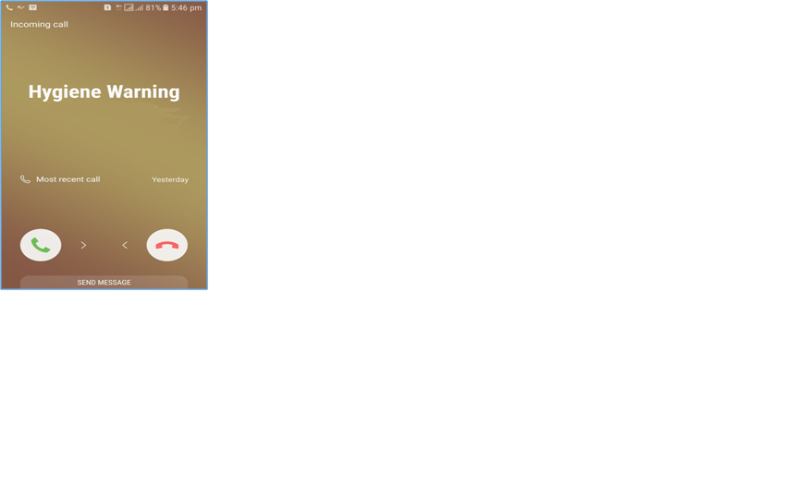
EXPERIMENT ANDRESULTS

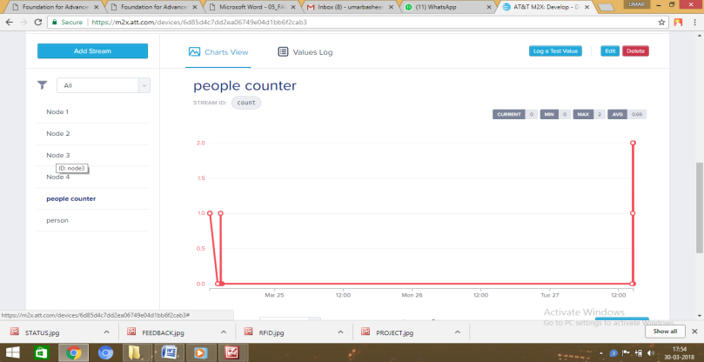

Fig. 7 Simulation Results

CONCLUSION
In this paper we conclude to provide a automation sanitation monitoring system for toilets to provide the clean society and better environment and support the Swachh Bharat Moment.

REFERENCES

- Shubham Chandra, Sanjay Srivastava, “Anil Roy Public Toilet Hygiene Monitoring and Reporting System”, IEEE, 10.1109/ICSENS.2018.8589894, 2018.
- Elavarasi K, Suganthi V, Jayachitra J, Developing “Smart Toilets Using IOT, International Journal of Pure and Applied Mathematics”, 2018.
- Anthony Fleury, Michel Vacher, Norbert Noury, “SVM-Based Multimodal Classification Of Activities Daily Living in Health Smart Homes: Algorithms and First Experimental Results, IEEE Transactions on Information Technology in Biomedicine”Volume: 14, Issue: 2, March 2010
- Chanda Rajurkar, S. Prabaharan, S. Muthulakshmi, “IoT Based Water Management”, DOI:10.1109/ICNETS2.2017.8067943, 2017.
- Masaya Kurahashi, Kazuya Murao, Tsutomu Terada, Masahiko Tsukamoto, “Personal Identification System Based on Rotation of Toilet Paper Rolls”, DOI: 10.1109/PERCOMW.2017.7917617, 2017.
- Ravi Kishore Kodali, Siva Ramakrishna P Modern “Sanitation Technologies for Smart Cities”, DOI: 10.1109/R10-HTC.2017.8289055, 2017.
- Ji-Jer Huang, Sheng-I Yu, Hao-Yi Syu, “Development of the smart toilet equipment with measurements of physiological parameters”, DOI: 10.1109/UIC-ATC.2012.143, 2012.
- Mei Chen, Linghan Zhu, The Application of “Intelligent Control Algorithm in Sanitation Monitoring System”, DOI: 10.1109/ICRAE.2017.8291391, 2017.
- Ade Asmi; Jouvan Chandra Pratama Putra; Ismail Bin Abdul Rahman, “A Study of Indoor Air Quality of Public Toilet in University’s Building”, DOI: 10.1109/CHUSER.2012.6504347, 2012.
- Phuntsho Choden, Thara Seesaard, Ugyen Dorji, Chutintorn Sriphrapradang, Teerakiat Kerdcharoen, ”Urine Odor Detection by Electronic Nose for Smart Toilet Application”, DOI: 10.1109/ECTICon.2017.8096205, 2017.
- Ummer Iqbal, M. Dar, Syed Nisar Bukhari, “Intelligent Hospitals based on IOT”, DOI:10.1109/AEEICB.2018.8480947, 2018.
- W. Sherine Mary S. Muthukumar A. Manisha; K. Nandhini; R. Vanitha, “Sensor based automated washroom monitoring system”, DOI: 10.1109/ICEDSS.2018.8544266, 2018.
- Klaiwad Boonyakan; Naratsaporn Heamra; Attawit Changkamanon, “Water Efficient Toilet : Setting a Suitable Automatic Flushing Duration”, DOI: 10.1109/ICDAMT.2018.8376512, 2018.
- S. Vinoth Kumar; T. Senthil Kumaran; A. Krishna Kumar; Mahantesh Mathapati, “Smart Garbage Monitoring and Clearance System using Internet of Things”, DOI: 10.1109/ICSTM.2017.8089148, 2017.

