Review of Protein and Peptide Delivery-What We Learned from Covid-19 - What's Next?
Jampala Rajkumar*¹ , Jithendar Reddy Mandhadi³, M.D. Arif Pasha², Chandrashekar Thalluri³,
¹Vaageswari College of Pharmacy, Karimnagar-505572, TS, India.
²K. R. Mangalam Univesity-Delhi.
³Faculty of Pharmaceutical Science, Assam Down Town University, Panikhaiti, Guwahati, Assam-781026, India.

Corresponding author: Dr. Jampala Rajkumar, HOD,
Dept. of Pharmacceutics
Vaageswari College of Pharmacy,
Karimnagar, Telangana.
Email: jampalarajkumar@gmail.com

Abstract
Protein and peptide-based drug delivery technologies are "new." Proteins and peptides are abundant in living cells. Their roles include enzymes, hormones, structural elements, and immunoglobulins. Peptide linkages between amino acids generate peptides and proteins. Despite the fact that peptides have less than 20 amino acids while proteins contain 50 or most amino acids and a molecular weight more than this, the two types of molecules are interchangeable. Of course, pharmaceutical proteins and peptides are commonly delivered via IM, IV, or subcutaneous injection. Many pharmacological approaches are required to overcome the challenges of administering protein and peptide drugs.
Recent protein and peptide research has altered infectious disease treatment. In the COVID-19 pandemic coming, finding effective treatments is critical. It's the fear of re-infection or pandemic outbreaks that drives intensive and successful research on broad-spectrum coronavirus vaccinations and treatments. Reusing existing drugs saves money and time. We summarized anti-SARS-CoV and anti-SARS-CoV2 peptides identified in silica and molecular studies based on chromosomal homology. Understanding viral infection at the molecular level may lead to new antiviral drugs that target viral proteins or host components. These peptides may help clinical scientists worldwide create and test COVID-19 therapeutic and preventative medications. We also covered the latest SARS-CoV-2 peptide treatments.
Keywords: Proteins and peptides, COVID-19, Viable therapy, Anti-viral medicines, SARS-CoV.

INTRODUCTION
Protein and Peptide is a Novel Drug Delivery System and a Novel Approach. Most living systems and cells contain protein and peptides [1]. Hormones, enzymes, structural elements, and immunoglobulins are all in there [2, 3]. It also plays a role in various metabolic processes, immunogenic defense, and biological functions [4]. Proteins are one of the most prevalent organic compounds in biological systems. The name Protein comes from the Greek word Proteios, which means first. Proteins are high molecular weight polymers of Alpha amino acids linked by Peptide Linkages. Nitrogen, Oxygen and Sulfur Molecules are found in Protein [5-7]. The Covenant Linkages hold the molecules with linear chain amino acids together. Peptide Bonds Peptides are Alpha Amino Acid Condensed Products[8]. An amino acid's alpha amino group is a condensed alpha carboxyl group. Protein is found in all living cells and is used for nutrition and bodybuilding. It is vital for plant and animal cells. Proteins operate as enzymes in biochemical reactions and transport metabolites and genes. It is used to shape and strengthen cells and tissues. It can influence the metabolic pathways, PH, Osmotic Pressure, and Temperature [9, 10]. Insulin regulates blood sugar levels. Muscle growth and mechanical work require it. Two amino acids are dipeptides, three amino acids are tripeptides, four amino acids are tetrapeptides, and polypeptides are 2-20 amino acids. Proteins are polymers of 100 or more amino acids. Proteins are categorised into two categories based on solubility and architectural complexity. First, they are divided into two groups based on solubility. protein, globular and fibrous Globular proteins are soluble in water or common salts, while Fibrous proteins are insoluble in water or common solvents. The second type of protein is categorised by complexity [11]. Thirdly, derived proteins are hydrolysis products created by physiological agents like heat, chemical agents and enzymatic activity on protein molecules. Protein structure is divided into four categories. First, protein primary structure. The amount, type, and sequence of amino acids along with polypeptide chain are referred to as the primary structure of protein. Alpha helical structure and Beta Pleated sheet are two secondary protein structural patterns. These folding findings the (R-) group is a side chain amino acid, these interactions are largely (H-) bound Interactions. The final form of a protein's tertiary structure is elapsed, globe, or irregular [12]. The quaternary structure of proteins is formed by two or more polypeptide chains held together by non-covalent bonds, such as hemoglobin. Endogenous Proteins and Peptides are used to sustain Biological Environments. The discovery of several hormones and peptides has vital applications in medical practices, drug discovery processes, and research activities [13].

NEED OF PROTEIN AND PEPTIDE DRUG DELIVERY SYSTEM
1. Proteins and peptides have critical roles in biological cells and organic molecules.
2. Diseases such as diabetes mellitus are caused by a lack of proteins and peptides. (As a result of a deficiency of the protein INSULIN)
3. R-DNA technology and hybridoma procedures are now being applied in protein and peptide-based medicines [14].

ADVANTAGES OF PROTEIN AND PEPTIDE DRUG DELIVERY SYSTEM [15-21]

1. Erythropoietin is mostly used in the formation of red blood cells.

2. Tissue plasminogen activator is a protein that is used to treat heart attacks and strokes.

3. Oxytocin is used to relieve labor pain.

4. Bradykinin stimulates peripheral circulation.

5. Somatostatin reduces gastric ulcer hemorrhage.

6. Ovulation is induced by gonadotropin.

7. Insulin keeps blood sugar levels stable.

FUNCTIONS OF PROTEIN AND PEPTIDE DRUG DELIVERY SYSTEM [22-28]
1. Small molecules and biological molecules are transported and stored.
2. Muscle contraction allows for coordinated motion.
3. Fibrous protein provides mechanical support.
4. Nerve impulse generation and transmission
5. Catalysis by enzymes in biological reactions.
6. Antibodies provide immune defense.
7. Hormones are used to control growth and differentiation.
INCORPORATION OF PROTEINS AND PEPTIDES INTO DRUG DELIVERY MATRIX

The drug incorporated into the Protein and Peptide drug delivery system is subjected to three different processes, which are as follows: [29-34]

1. Emulsification

2. Drying with Extrusion and Spray Drying

3. Polymerization

1. EMULSIFICATION Aqueous (water solution) -soluble medicines first dissolve in aqueous (water solution). Mixing the two liquids produces an emulsion-free mixture. The emulsifier is added to the primary emulsion to make it w/o/w. Finally, the organic solvent is removed from the emulsion by filtration and increasing the temperature [35].

2. EXTRUSION AND SPRAY DRYING

There are two ways to make microspheres: with the help of extrusion and spraying. The core material or matrix, which is made of drug-filled Solution, and the Particulate, which comes out of the orifice, fine tubes or nozzles to make small droplets. The size of the droplet is mostly determined by the properties of the liquid (melt, solution, and suspension) and the diameter of the orifice to the speed of the jet.

3. POLYMERIZATION
Polymerization in hydrogels created by mixing monomer, drug, initiator, and cross linking agents. Intra vascular protein distribution by a photo polymerized hydro system on the inner side of a blood artery. One of the disadvantages of protein and peptide drug delivery systems is that radiators degrade protein molecule integrity.

APPLICATION
1. Drugs that act on the cardiovascular system Proteins and peptides (anti-Angiotensin 2 antagonists, Bradykinin, and Captopril) are critical for lowering blood pressure and increasing peripheral circulation in the therapy of heart failure.
2. CNS active proteins and peptides (Cholecystokinin, B-endorphin) are required for appetite suppression and pain relief [36].
3. GI-active Proteins and Peptides (Gastrin antagonist, pancreatic enzymes) are critical for reducing gastric acid output and are necessary for digestive supplementation [37].
4. Immunomodulation of proteins and peptides (Bersin, Cyclosporin, and Interferon) is critical for selective B-cell differentiation. Inhibits T-lymphocyte activities and enhances the activity of killer cells [38].
5. Proteins and peptides that modulate metabolism (Insulin, Vasopressin) are critical in the treatment of diabetes mellitus and diabetes insipidus.[39]

Characteristic features of SARS-CoV and SARS-CoV-2 proteins and the importance in drug discovery
The spike (S) protein, the envelope (E) protein, the membrane (M) protein, and the nucleocapsid (N) protein are the four primary structural proteins found in SARS-CoV-2. Additionally, there are 16 non-structural proteins (NSPs) that may be developed as drugs. S protein is composed of two subunits,[40]. S1 and S2. S1 has a receptor-binding domain (RBD) that is important in viral entrance and binding to the host receptor protein ACE2, while S2 is involved in viral fusion [41, 42] M and E proteins are engaged mostly in viral assembly. N protein is an RNA-binding multivalent protein that is required for viral replication and genome packaging. Due to the importance of structural and nonstructural protein mutations in virulence and virus propagation, they should also be considered while developing treatments and vaccines [43]
SARS-CoV-2 carries major genetic alterations that are entirely novel to the human population's innate immune system. According to research, this virus is capable of infecting a sizable proportion of the human population. Ganesh et al. Gathered the findings, which can be used to compare the epidemiology and Pathobiology of SARS-CoV-2 to that of SARS and MERS while treatments are being developed [44].

Scientists created three medication development strategies to combat coronaviruses. First, test existing broad-spectrum antivirals. Their spectrum is too vast, notwithstanding their advantages in terms of metabolic properties, doses, potential efficacy, and adverse effects. The second technique is high throughput screening of existing molecular databases for compounds with anti-coronavirus activity [45] The third option is to create novel targeted medications based on coronavirus genetic and clinical features. Based on these discoveries, we compiled research findings on peptide therapies and their molecular mechanisms. This article includes an overview of SARS-CoV peptide treatments that potentially be repurposed for SARS-CoV-2 as well as an update on SARS-CoV-2 peptides previously developed. However, wet lab and clinical investigations are required to fully understand SARS-CoV-2 infection and improve treatment development [46].

Peptide therapeutics and their importance in SARS-CoV-2 research
Insufficient action, resistance, safety and efficacy difficulties, and side effects are among the drawbacks of existing antiviral medicines. They are less effective at disrupting long protein binding surfaces. Peptides are gaining popularity in the pharmaceutical business. Less toxicity, less side effects, and less selectivity make peptide-based medications a better alternative than small molecule therapies [47]. These are synthesized and chemically stabilized. Peptides and peptidomimetics are widely accepted in chemical biology. Peptides compete for binding by mimicking a protein surface. Peptide medicines are unstable, susceptible to hydrolysis and oxidation, have a short half-life, and have low membrane permeability. More than 400 peptide-based medications are now in clinical trials, with over 60 already authorized. Using peptide research, epitope-based vaccination screening may potentially be possible. However, no effective peptide-based medicines exist for SARS-CoV-2 [48].
Antiviral peptides (AVPs) could be an effective antiviral against SARSCoV2. AVPs are of particular relevance since they are more effective than other antiviral agents at inhibiting viral infection. AVPs block viral adsorption, penetration, endosomal escape, uncoating, genome replication, and mature viri release. Studies on natural and biological sources, as well as computer methodologies like high-throughput screening, help find a potential AVP. We previously discovered seven antimicrobial peptides (AMPs) as potential MERS therapeutics. Fosgerau et al. reviewed the numerous peptide therapy techniques and potential. It has been postulated that existing antiviral peptide medicines could be repurposed to treat MERS-CoV. The current coronavirus epidemic can be managed using existing antivirals and knowledge gathered previous SARS and MERS outbreaks [49-55].
Several publications have reviewed the use of peptides as COVID-19 treatment alternatives. Cherian et al. evaluated virus- and host-based medication repurposing potential for coronaviruses in general and SARS-CoV-2 in particular [56] . Many publications stress the importance of repurposing medications for SARS-CoV-2. It is clear that peptides can be used as anti-SARS-CoV-2 components. On the other hand, we give a complete assessment of the peptides with therapeutic and preventive potential in SARS-CoV that could be used against SARS-CoV-2. As seen in Tables 1–3, tremendous progress has been made since the identification of SARS-CoV [57-60].

Classification of peptide therapeutics for COVID-19 based on the mechanism of action
Anti-coronavirus treatments can be divided into two groups based on the target: those that work on the virus itself or those that work on the host or the immune system. Based on how the peptides might work, we put them into three groups: virus entry/fusion blockers, virus replication blockers, and immune modulators.
Peptides affecting viral entry and fusion:
The SARS-CoV spike (S) protein binds to the human angiotensin-converting enzyme 2 (hACE2) receptor to allow coronavirus entrance into cells. Lu et al. used bioinformatics to identify peptides with B cell epitopes within the S protein of SARS-cove that could be used in diagnosis. RBD in the spike protein's S1 subunit is a target for virus attachment inhibitors, neutralising antibodies, and vaccinations. Barh et al. identified potential SARS-CoV-2 spike RBD inhibitor peptides. Using bioinformatics, they identified critical residues interacting with the spike RBD. -helices from ACE2's protease domain were employed to create SARSCoV-2 peptide inhibitors. RBD S1 binds directly to ACE2 PD. SBP1, a 23 MER peptide fragment of the ACE2 PD 1 helix, can inhibit the SARS-CoV-2 spike protein from binding with ACE2 [61].
The coronavirus spike proteins are class I fusion proteins with two heptad repeat (HR) regions, HR1 and HR2. The heptad repeat interacts with the ACE2 receptor on the target cell to generate a six helical bundle, which is a key and conserved mechanism for viral fusion and entrance. So many attempts have been made to find fusion inhibitors that could treat CoV infections. The HR1 and HR2 sections of SARS-CoV and SARS-CoV-2 have 92.6 percent and 100% sequence homology, respectively, suggesting that HR2 peptides shown to inhibit SARS-CoV may similarly inhibit SARSCoV-2 [62, 63]. Tang et al. evaluated HR2-based inhibitory peptides for SARS-CoV and MERS-CoV, opening the door for peptide or small molecule based anti-CoV fusogenics to stop SARS-CoV-2 membrane fusion. In a recent study on SARS-CoV-2, a few HR2 sequence based fusion inhibitors were reported to prevent cell fusion. Xia et al. created EK1, a pan-coronavirus inhibitor that targets the HR1 domain. They also created the very powerful lipopeptide EK1C4, which targets the spike protein in pan-coronavirus fusion [64]. To increase inhibitory efficacy against SARS-CoV-2, EK1C4 was created by adding cholesterol residue to EK1. EKIC4 inhibited membrane fusion mediated by SARS-CoV-2 spike protein as well as entry of pseudotyped human coronaviruses like SARS-CoV and MERSCoV. With an EC50 of 36.5 nm, EK1C4 is more powerful than the EK1 peptide, which has an EC50 of 2.47 M. IPB02, a lipopeptide fusion inhibitor based on HR2 sequences, inhibited SARS-CoV-2 spike protein-mediated cell-cell fusion and pseudovirus transduction.
Unlike previous peptide medicines, EK1C4 can be breathed as an aerosol, lowering viral load in the lungs and minimising pulmonary inflammatory reaction. Intranasal injection of EK1C4 shows promise as a SARS-CoV-2 therapy. This is because the HR1 domain in the S2 subunit of the S protein is highly conserved, making drug resistance mutations difficult to develop [64, 65].
Peptides inhibiting viral replication and release Polyprotein processing
Once within the host cell, the coronavirus modifies the transcription machinery to manufacture its proteins. With ORF1a and ORF1b, the SARS-CoV positive stranded RNA genome encodes two polyproteins, pp1a and pp1ab. These polyproteins are proteolytically degraded to yield 16 non-structural proteins essential for viral replication, two of which are proteases, 3-chymotrypsin-like (3CLpro/Nsp5) and papain-like (PLpro/Nsp3). SARS-3CLpro CoV-2's shares 99.02 percent sequence identical with SARS-CoV. The idea of developing peptide inhibitors targeting the substrate binding pocket of SARSCoV-2 3CLpro was examined and two peptidomimetic aldehydes 11a and 11b were discovered. Both had significant anti-SARS-CoV-2 infection activity. Another protease, PLPro (Papain like protease), involved in the proteolytic processing of the replicase polyprotein, is an attractive antiviral therapeutic target. Glutathione, used to treat liver problems, was found to be effective against PLPro with a docking score of 20 [66-68].
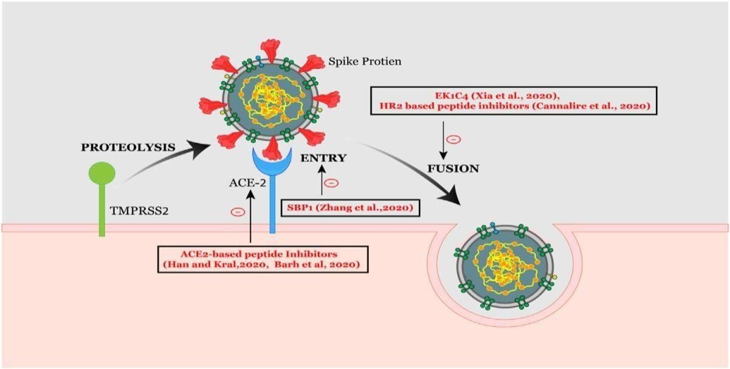
Figure 1. SARS-entrance CoV-2's and fusion mechanism is depicted in this diagram. Peptide molecules that have been identified as being involved in the entry and fusion of the coronavirus are depicted.
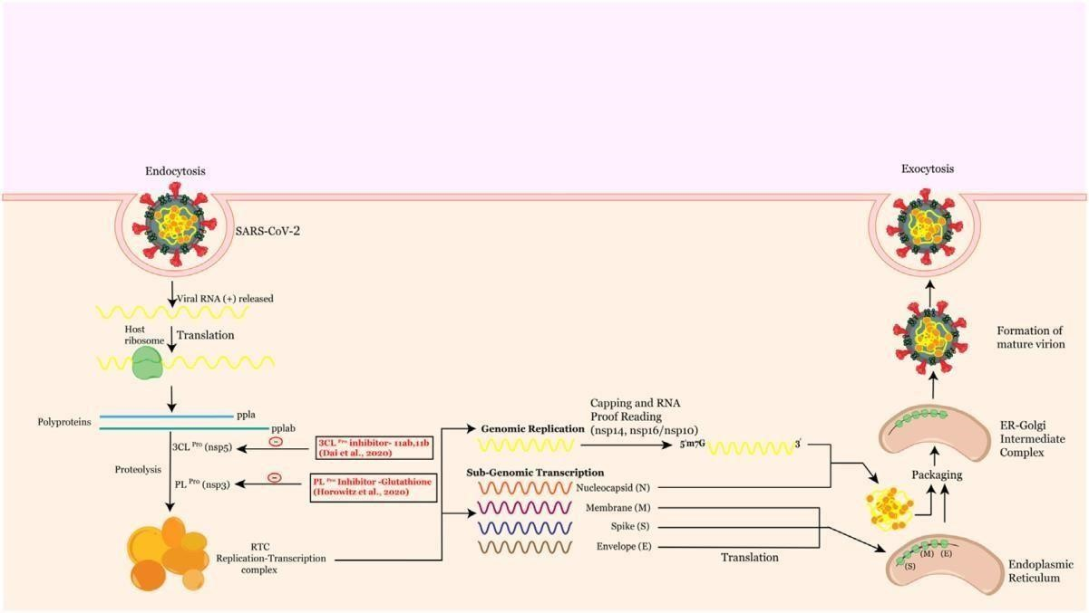

Figure 2. A graph depicting SARSCoV2 replication and maturation mechanism, highlighting peptide treatments. The viral replicase, a large protein complex produced by the 20-kb replicase gene, coordinates both continuous and discontinuous RNA production. These proteins form membranebound replication-transcription complexes with other viral and perhaps cellular proteins (RTC). Nsp12 (RNA dependent RNA polymerase/RdRp) is the principal target for remdesivir, a nucleoside analogue antiviral inhibitor currently utilised for SARSCoV-2. Remdesivir has antiviral action against various viruses, including Ebola, Nipah, RSV, SARS-CoV, and MERS-CoV. In the three coronaviruses, this chemical may impact viral RNA production by delaying chain termination (MERS-CoV, SARS-CoV and SARS-CoV-2). Remdesivir is now being evaluated in numerous countries for COVID-19 emergency treatment.
In a recent randomised placebo-controlled experiment, remdesivir was found to reduce respiratory tract infection in COVID-19 adult patients.
SARS-CoV-2 Nsp12 shares significant homology with SARS-CoV, indicating a conserved mechanism of action validated by cryo-EM structural analyses. Nsp12 has a nidovirus RdRp-associated nucleotidyl transferase architecture and a right hand RdRp domain. Nsp12 may help synthesise viral RNA with Nsp7 and Nsp8 as cofactors. The Nsp7-Nsp8 complex boosts Nsp12's RNA binding and RdRp enzymatic activity by synthesising a 6-nucleotide primer for RdRp RNA production. The Nsp12-Nsp8 interaction offers tremendous therapeutic potential.
Nsp9 is thought to be involved in viral replication, pathogenicity, and viral genomic RNA reproduction. Selinexor, a synthetic peptide, is an inhibitor of CRM1 (Chromosome region maintenance protein), also known as exportin 1 (XPO1), involved in nuclear export. Currently, low oral dosages of this peptide are being evaluated against COVID19. In addition to inhibiting adipogenesis, the mushroom-derived Ternatin 4-N-methylated cyclic hexapeptide also inhibits the translation machinery. Because ternatin 4 affects host translation, it is included as a potential SARS-CoV-2 preclinical compound.
Epigenetic modifications that govern chromatin rearrangement have been linked to viral pathogenesis. The role of epigenetic regulators in SARS-CoV research has been emphasized. Recently, DNA methylation studies of ACE2 expression shed light on SARS-CoV-2 epidemiology. ACE2 expression is regulated by BET proteins, which are epigenetic readers. Gordon et al discovered a BRD4-SARSCoV-2 E protein interaction, raising the prospect of peptide-based bromodomain inhibitors as SARS-CoV2 treatments. An interaction between HDAC2 and the viral protein Nsp5 was discovered in the SARS-CoV-2 interactome investigation. Nucleus transport of HDAC2 is thought to be inhibited by Nsp5. We propose exploring for Nsp5 peptide inhibitors, as this appears to be the switch in COVID-19. Also, HDAC inhibitors may be used to prevent COVID-19. Epigenetic therapies such as epidrugs may be useful therapeutic or preventative tools. Intriguingly, Apicidin was discovered by using a cyclic 3-tetrapeptide scaffold, a method that can be applied to find other anti-coronaviral peptide inhibitors [69-73].

RNA processing

Besides RNA polymerase, RNA helicase, and protease capabilities, the coronavirus replicase utilises a range of RNA processing enzymes not found in other RNA viruses. This is followed by ribose 2-O-methylation of the cap, which allows viruses to avoid detection by the host immune system. These include Nsp13, an RNA/NTP triphosphate triphosphatase and helicase; Nsp14, an RNA cap N7 methyltransferase; and Nsp16, an RNA cap ribose-O methyltransferase and an unknown guanylyl translocator. The N7-Methyltransferase domain of Nsp14 is an intriguing antiviral target because it differs from cellular methyltransferases in its fold. The methyltransferase of coronaviruses is an attractive and promising antiviral therapeutic target [74-78]

Virus maturation

The RTC employs negative-stranded intermediates to generate progeny genomes and subgenomic mRNAs. Translation of these mRNAs results in the structural proteins S, M, E, and N. The SARS-CoV-2 E protein is involved in many steps of viral life cycle, including envelope production, pathogenicity, budding, and assembly. Unlike the other key structural proteins, N is the only one that binds to the CoV RNA genome, forming the nucleocapsid. SARS-N CoV-2's protein is substantially similar to SARS- CoV's. Cascarina et al. Recently reported that the SARS-CoV-2 N protein can regulate Biomolecular interactions with RNA and critical host cell proteins. The N protein interacts to stress granule proteins, triggering the host immunological response. Manipulation of stress granules may be effective in reducing coronavirus replication. The N protein interacts with G3BP1, which limits the RNA virus replication [79-81].

Peptides that act as immune modulators

Once within the target cell, the virus triggers an innate or adaptive immune response. The SARS-CoV-2 virus enters the nose and mouth, then enters the lungs, infecting ACE2 receptor-expressing cells. These viruses evade innate immune cells, resulting in the unrestricted virus reproduction. Activated macrophages and other immune cells produce cytokines [82]

Innate immune response
Acute respiratory syndrome (ARS) is caused by SARS-CoV-2 infection of the upper and lower respiratory tracts. A patient with severe ARDS caused to COVID-19 pneumonia was successfully treated with the compstatin-based complement C3 peptidic inhibitor AMY-101. Combining an interleukin-1 receptor antagonist with remdesivir reduces the pathogenic immune response to SARS-CoV-2 [83].
To fight viral infection, NK cells lyse infected cells. The peripheral blood of COVID-19 patients has a lower amount of NK cells. In a SARS-CoV mouse model, enhanced chemokine production linked with increased NK cell migration into the lungs. The elevated expression of chemokines in COVID-19 patients' lungs may also help NK cells migrate from the blood to the lungs. A transcriptome signature suggested NK cell penetration into lungs, potentially via the CXCR3 pathway. Because chemokines recruit NK cells to remove the virus, peptide inhibitors that block chemokine receptors are prospective SARSCoV-2 treatments. Furthermore, peptide antagonism is a well-established mechanism for NK cell activation, so new peptide treatments are needed here [84].
Adaptive immune response
Antibody response and immunological memory are critical for vaccination effectiveness. An successful vaccine should stimulate antigen-specific B-cells, CTLs, or T helper cells. Antibodies, CD4+ T cells, and CD8+ T cells are produced in response to SARSCoV-2 infection. As a result of this recognition, T cells produce cytokines. Others present SARS-CoV peptides to CD4+ T cells. Effective vaccines should be designed to stimulate immune responses against the target infection. Through computational screening of possible epitopes present on HLA class I molecules, Kiyotani et al., found 781 HLA class I and 418 Class II peptide epitopes for SARS-CoV-2. The SARS-CoV-2 proteome was studied immunologically and an epitope with HLA allele binding affinity, ITLCFTLKR, was discovered as a vaccine candidate. When using envelope protein as an immunogenic target, peptides binding to MHC class I and II were attractive epitope-based peptide vaccine candidates. Ten epitopes based on structural proteins created by molecular docking against MHC-I were discovered as possible SARSCoV-2 peptide vaccine epitopes. Epitopes are immunogenic components that can be utilised to discover new vaccines. Because traditional experimental methods are costly and time consuming, in silico approaches are chosen [85-88].
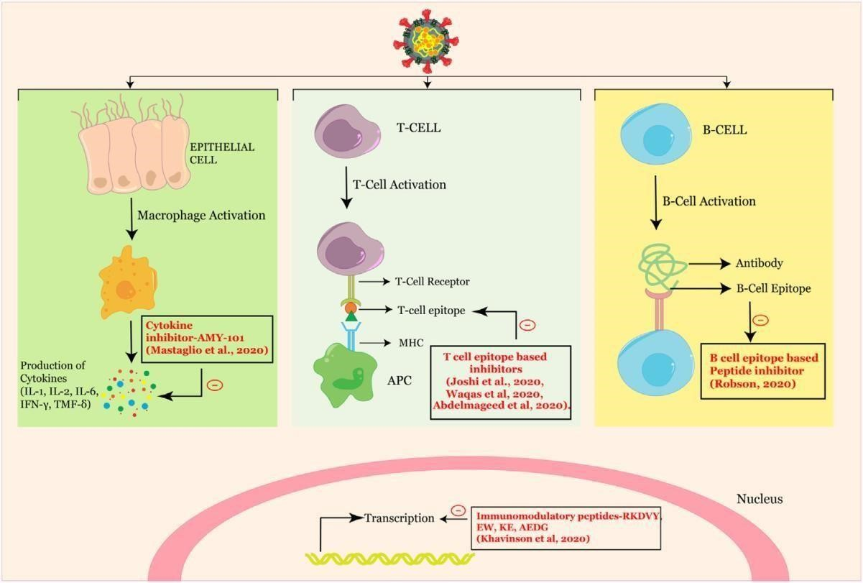Figure 3. Graphical representation of how SARS-CoV-2 changes the immune system, with peptide therapeutics in the foreground.

Conclusion
The poor ADME (absorption, distribution, metabolism, and elimination) performance of peptide therapies makes their development problematic. In spite of this, pharmaceutical corporations are contemplating it. The facts in this review highlight the need for more research and innovative therapeutic approaches to address COVID-19. The insights gained from treating SARSCoV may help improve this procedure. However, this evaluation will be essential in speeding up the development of fresh solutions for COVID-19.

Author contributions

All authors contributed to manuscript revision, read and approved the submitted version.

Conflicts of interest

The authors declare that they have no conflicts of interest.

Consent to participate

Not applicable

Consent to publication

“Not applicable.

REFERENCE
1. Gaunt ER, Hardie A, Claas ECJ, Simmonds P, Templeton KE. Epidemiology and clinical presentations of the four human coronaviruses 229E, HKU1, NL63, and OC43 detected over 3 years using a novel multiplex real-time PCR method. Journal of Clinical Microbiology. 2010;48:2940-7.
2. Al-Hajjar S. SARS: Challenge of the new century. In: King Faisal Specialist Hospital and Research Centre; 2003, p. 116-7. (ISBN No. 0256-4947)
3. Chafekar A, Fielding BC. MERS-CoV: understanding the latest human coronavirus threat. Viruses. 2018;10:93.
4. Marty AM, Jones MK. The novel coronavirus (SARS-CoV-2) is a one health issue. One Health. 2020;9.
5. Chan JFW, Kok KH, Zhu Z, Chu H, To KKW, Yuan S, et al. Genomic characterization of the 2019 novel human-pathogenic coronavirus isolated from a patient with atypical pneumonia after visiting Wuhan. Emerging Microbes and Infections. 2020;9:221-36.
6. Morse JS, Lalonde T, Xu S, Liu WR. Learning from the Past: Possible Urgent Prevention and Treatment Options for Severe Acute Respiratory Infections Caused by 2019-nCoV. ChemBioChem. 2020;21:730-8.
7. Neerukonda SN, Pathogens UK, undefined. A review on SARS-CoV-2 virology, pathophysiology, animal models, and anti-viral interventions. mdpicom.
8. Parasher A. COVID-19: Current understanding of its pathophysiology, clinical presentation and treatment. Postgraduate medical journal. 2021;97:312-20.
9. Zhu N, Zhang D, Wang W, Li X, Yang B, Song J, et al. A Novel Coronavirus from Patients with Pneumonia in China, 2019. New England Journal of Medicine. 2020;382:727-33.
10. Zhu Y, Yu D, Yan H, Chong H, He Y. Design of Potent Membrane Fusion Inhibitors against SARS-CoV-2, an Emerging Coronavirus with High Fusogenic Activity. Journal of Virology. 2020;94.
11. Gorbalenya AE, Baker SC, Baric RS, de Groot RJ, Drosten C, Gulyaeva AA, et al. Severe acute respiratory syndrome-related coronavirus: The species and its viruses–a statement of the Coronavirus Study Group. BioRxiv. 2020.
12. Astuti I. Severe Acute Respiratory Syndrome Coronavirus 2 (SARS-CoV-2): An overview of viral structure and host response. Diabetes & Metabolic Syndrome: Clinical Research & Reviews. 2020;14:407-12.
13. Chen L, Zhong L. Genomics functional analysis and drug screening of SARS-CoV-2, Genes Dis.(2020). In.
14. Hatmal MmM, Alshaer W, Al-Hatamleh MA, Hatmal M, Smadi O, Taha MO, et al. Comprehensive structural and molecular comparison of spike proteins of SARS-CoV-2, SARS-CoV and MERS-CoV, and their interactions with ACE2. Cells. 2020;9:2638.
15. Premkumar L, Segovia-Chumbez B, Jadi R, Martinez DR, Raut R, Markmann AJ, et al. The receptor-binding domain of the viral spike protein is an immunodominant and highly specific target of antibodies in SARS-CoV-2 patients. Science immunology. 2020;5:eabc8413.
16. Tomaszewski T, DeVries RS, Dong M, Bhatia G, Norsworthy MD, Zheng X, et al. New pathways of mutational change in SARS-CoV-2 proteomes involve regions of intrinsic disorder important for virus replication and release. Evolutionary Bioinformatics. 2020;16:1176934320965149.
17. Ganesh B, Rajakumar T, Malathi M, Manikandan N, Nagaraj J, Santhakumar A, et al. Epidemiology and pathobiology of SARS-CoV-2 (COVID-19) in comparison with SARS, MERS: An updated overview of current knowledge and future perspectives. Clinical epidemiology and global health. 2021;10:100694.
18. Zumla A, Chan JF, Azhar EI, Hui DS, Yuen K-Y. Coronaviruses—drug discovery and therapeutic options. Nature reviews Drug discovery. 2016;15:327-47.
19. Chan JF, Chan K-H, Kao RY, To KK, Zheng B-J, Li CP, et al. Broad-spectrum antivirals for the emerging Middle East respiratory syndrome coronavirus. Journal of Infection. 2013;67:606-16.
20. De Wilde AH, Jochmans D, Posthuma CC, Zevenhoven-Dobbe JC, Van Nieuwkoop S, Bestebroer TM, et al. Screening of an FDA-approved compound library identifies four small-molecule inhibitors of Middle East respiratory syndrome coronavirus replication in cell culture. Antimicrobial agents and chemotherapy. 2014;58:4875-84.
21. Dyall J, Coleman CM, Venkataraman T, Holbrook MR, Kindrachuk J, Johnson RF, et al. Repurposing of clinically developed drugs for treatment of Middle East respiratory syndrome coronavirus infection. Antimicrobial agents and chemotherapy. 2014;58:4885-93.
22. Mohammadi Pour P, Fakhri S, Asgary S, Farzaei MH, Echeverria J. The signaling pathways, and therapeutic targets of antiviral agents: focusing on the antiviral approaches and clinical perspectives of anthocyanins in the management of viral diseases. Frontiers in Pharmacology. 2019;10:1207.
23. Smith MC, Gestwicki JE. Features of protein–protein interactions that translate into potent inhibitors: topology, surface area and affinity. Expert reviews in molecular medicine. 2012;14.
24. Cretich M, Gori A, D’Annessa I, Chiari M, Colombo G. Peptides for infectious diseases: From probe design to diagnostic microarrays. Antibodies. 2019;8:23.
25. Cunningham AD, Qvit N, Mochly-Rosen D. Peptides and peptidomimetics as regulators of protein–protein interactions. Current opinion in structural biology. 2017;44:59-66.
26. Di L. Strategic approaches to optimizing peptide ADME properties. The AAPS journal. 2015;17:134-43.
27. Lee AC-L, Harris JL, Khanna KK, Hong J-H. A comprehensive review on current advances in peptide drug development and design. International journal of molecular sciences. 2019;20:2383.
28. Madhavan M, Mustafa S. En route to peptide therapeutics for COVID 19: harnessing potential antigenic mimicry between viral and human proteins. Transactions of the Indian National Academy of Engineering. 2020;5:411-5.
29. Chowdhury SM, Talukder SA, Khan AM, Afrin N, Ali MA, Islam R, et al. Antiviral Peptides as Promising Therapeutics against SARS-CoV-2. Journal of Physical Chemistry B. 2020;124:9785-92.
30. Ahmed A, Siman-Tov G, Hall G, Bhalla N, Narayanan A. Human antimicrobial peptides as therapeutics for viral infections. Viruses. 2019;11:704.
31. Vilas Boas LCP, Campos ML, Berlanda RLA, de Carvalho Neves N, Franco OL. Antiviral peptides as promising therapeutic drugs. Cellular and Molecular Life Sciences. 2019;76:3525-42.
32. Agarwal G, Gabrani R. Antiviral Peptides: Identification and Validation. International Journal of Peptide Research and Therapeutics. 2021;27:149-68.
33. Fosgerau K, Hoffmann T. Peptide therapeutics: current status and future directions. Drug discovery today. 2015;20:122-8.
34. Mustafa S, Balkhy H, Gabere MN. Current treatment options and the role of peptides as potential therapeutic components for Middle East Respiratory Syndrome (MERS): a review. Journal of infection and public health. 2018;11:9-17.
35. Kiplin Guy R, DiPaola RS, Romanelli F, Dutch RE. Rapid repurposing of drugs for COVID-19. Science. 2020;368:829-30.
36. Harrison C. Coronavirus puts drug repurposing on the fast track. Nature biotechnology. 2020;38:379-81.
37. Khavinson V, Linkova N, Dyatlova A, Kuznik B, Umnov R. Peptides: Prospects for Use in the Treatment of COVID-19. Molecules. 2020;25:4389.
38. Mousavi Maleki MS, Rostamian M, Madanchi H. Antimicrobial peptides and other peptide-like therapeutics as promising candidates to combat SARS-CoV-2. Expert Review of Anti-Infective Therapy. 2021;19:1205-17.
39. Cherian SS, Agrawal M, … ABTIjo, undefined. Perspectives for repurposing drugs for the coronavirus disease 2019. ncbinlmnihgov.
40. Chen YW, Yiu C-PB, Wong K-Y. Prediction of the SARS-CoV-2 (2019-nCoV) 3C-like protease (3CL pro) structure: virtual screening reveals velpatasvir, ledipasvir, and other drug repurposing candidates. F1000Research. 2020;9.
41. Li G, De Clercq E. Therapeutic options for the 2019 novel coronavirus (2019-nCoV). Nat Rev Drug Discov. 2020;19:149-50.
42. Elfiky AA. Anti-HCV, nucleotide inhibitors, repurposing against COVID-19. Life sciences. 2020;248:117477.
43. Zhou Y, Hou Y, Shen J, Huang Y, Martin W, Cheng F. Network-based drug repurposing for novel coronavirus 2019-nCoV/SARS-CoV-2. Cell discovery. 2020;6:1-18.
44. Han DP, Penn-Nicholson A, Virology MWC, undefined. Identification of critical determinants on ACE2 for SARS-CoV entry and development of a potent entry inhibitor. Elsevier.
45. Huang Y, Zhao R, Luo J, Xiong S, Shangguan D, Zhang H, et al. Design, synthesis and screening of antisense peptide based combinatorial peptide libraries towards an aromatic region of SARS-CoV. Journal of Molecular Recognition. 2008;21:122-31.
46. Guo Y, Tisoncik J, McReynolds S, Farzan M, Prabhakar BS, Gallagher T, et al. Identification of a new region of SARS-CoV S protein critical for viral entry. Journal of molecular biology. 2009;394:600-5.
47. Chu LHM, Chan SH, Tsai SN, Wang Y, Cheng CHK, Wong KB, et al. Fusion core structure of the severe acute respiratory syndrome coronavirus (SARS-CoV): In search of potent SARS-CoV entry inhibitors. Journal of Cellular Biochemistry. 2008;104:2335-47.
48. Struck A-W, Axmann M, Pfefferle S, Drosten C, Meyer B. A hexapeptide of the receptor-binding domain of SARS corona virus spike protein blocks viral entry into host cells via the human receptor ACE2. Antiviral research. 2012;94:288-96.
49. Lu W, Wu X-D, Shi MD, Yang RF, He YY, Bian C, et al. Synthetic peptides derived from SARS coronavirus S protein with diagnostic and therapeutic potential. FEBS letters. 2005;579:2130-6.
50. Yuan K, Yi L, Chen J, Qu X, Qing T, Rao X, et al. Suppression of SARS-CoV entry by peptides corresponding to heptad regions on spike glycoprotein. Biochemical and biophysical research communications. 2004;319:746-52.
51. Bosch BJ, Martina BEE, Van Der Zee R, Lepault J, Haijema BJ, Versluis C, et al. Severe acute respiratory syndrome coronavirus (SARS-CoV) infection inhibition using spike protein heptad repeat-derived peptides. Proceedings of the National Academy of Sciences of the United States of America. 2004;101:8455-60.
52. Xia S, Yan L, Xu W, Agrawal AS, Algaissi A, Tseng C-TK, et al. A pan-coronavirus fusion inhibitor targeting the HR1 domain of human coronavirus spike. Science advances. 2019;5:eaav4580.
53. Jr BS, Mossel EC, Gallaher WR, Research WCWV, undefined. Inhibition of severe acute respiratory syndrome-associated coronavirus (SARS-CoV) infectivity by peptides analogous to the viral spike protein. Elsevier.
54. Liu I-J, Kao C-L, Hsieh S-C, Wey M-T, Kan L-S, Wang W-K. Identification of a minimal peptide derived from heptad repeat (HR) 2 of spike protein of SARS-CoV and combination of HR1-derived peptides as fusion inhibitors. Antiviral research. 2009;81:82-7.
55. Zhu GX, Tao H, He W, Tien P, Shan GFM, Tang J, et al. Screening and identification of severe acute respiratory syndrome-associated coronavirus-specific CTL epitopes. Am Assoc Immnol. 2022;177:2138-45.
56. He Y, Zhou Y, Siddiqui P, Niu J, Jiang S. Identification of immunodominant epitopes on the membrane protein of the severe acute respiratory syndrome-associated coronavirus. Journal of Clinical Microbiology. 2005;43:3718-26.
57. Choy W-Y, Lin S-G, Chan PK-S, Tam JS-L, Lo YD, Chu IM-T, et al. Synthetic peptide studies on the severe acute respiratory syndrome (SARS) coronavirus spike glycoprotein: perspective for SARS vaccine development. Clinical Chemistry. 2004;50:1036-42.
58. Hu H, Li L, Kao RY, Kou B, Wang Z, Zhang L, et al. Screening and identification of linear B-cell epitopes and entry-blocking peptide of severe acute respiratory syndrome (SARS)-associated coronavirus using synthetic overlapping peptide library. Journal of Combinatorial Chemistry. 2005;7:648-56.
59. Tai W, He L, Zhang X, Pu J, Voronin D, Jiang S, et al. Characterization of the receptor-binding domain (RBD) of 2019 novel coronavirus: implication for development of RBD protein as a viral attachment inhibitor and vaccine. Cellular & Molecular Immunology 2020 17:6. 2020;17:613-20 .
60. Barh D, Tiwari S, Silva Andrade B, Giovanetti M, Almeida Costa E, Kumavath R, et al. Potential chimeric peptides to block the SARS-CoV-2 spike receptor-binding domain. F1000Research 2020 9:576. 2020;9:576.
61. Han Y, Král P. Computational Design of ACE2-Based Peptide Inhibitors of SARS-CoV-2. ACS nano. 2020;14:5143-7.
62. Xu Y, Zhu J, Liu Y, Lou Z, Yuan F, Liu Y, et al. Characterization of the heptad repeat regions, HR1 and HR2, and design of a fusion core structure model of the spike protein from severe acute respiratory syndrome. ACS Publications. 2004;43:14064-71 .
63. Xia S, Zhu Y, Liu M, Lan Q, Xu W, immunology YWm, et al. Fusion mechanism of 2019-nCoV and fusion inhibitors targeting HR1 domain in spike protein. naturecom.
64. Tang T, Bidon M, Jaimes JA, Whittaker GR, Daniel S. Coronavirus membrane fusion mechanism offers a potential target for antiviral development. Antiviral research. 2020;178:104792.
65. Cannalire R, Stefanelli I, Cerchia C, Beccari AR, Pelliccia S, Summa V. SARS-CoV-2 entry inhibitors: Small molecules and peptides targeting virus or host cells. mdpicom. 10.3390/ijms21165707.
66. ul Qamar MT, Alqahtani SM, Alamri MA, Chen L-L. Structural basis of SARS-CoV-2 3CLpro and anti-COVID-19 drug discovery from medicinal plants. Journal of pharmaceutical analysis. 2020;10:313-9.
67. Yang H, Xie W, Xue X, Yang K, Ma J, Liang W, et al. Design of wide-spectrum inhibitors targeting coronavirus main proteases. PLoS Biology. 2005;3.
68. Dai W, Zhang B, Jiang XM, Su H, Li J, Zhao Y, et al. Structure-based design of antiviral drug candidates targeting the SARS-CoV-2 main protease. Science. 2020;368:1331-5.
69. Corley MJ, Ndhlovu LC. DNA Methylation Analysis of the COVID-19 host cell receptor, Angiotensin I Converting Enzyme 2 gene (ACE2) in the Respiratory System Reveal Age and Gender Differences. 2020;10.20944/preprints202003.0295.v1.
70. Qiao Y, Wang XM, Mannan R, Pitchiaya S, Zhang Y, Wotring JW, et al. Targeting transcriptional regulation of SARS-CoV-2 entry factors ACE2 and TMPRSS2. Proceedings of the National Academy of Sciences of the United States of America. 2020;118.
71. Takahashi Y, Hayakawa A, Sano R, Fukuda H, Harada M, Kubo R, et al. Histone deacetylase inhibitors suppress ACE2 and ABO simultaneously, suggesting a preventive potential against COVID-19. Scientific Reports 2021 11:1. 2021;11:1-9 .
72. Pruimboom L. Methylation Pathways and SARS-CoV-2 Lung Infiltration and Cell Membrane-Virus Fusion Are Both Subject to Epigenetics. Frontiers in Cellular and Infection Microbiology. 2020;10:290.
73. Olsen CA, Ghadiri MR. Discovery of potent and selective histone deacetylase inhibitors via focused combinatorial libraries of cyclic α3 β-tetrapeptides. Journal of Medicinal Chemistry. 2009;52:7836-46.
74. Mousavizadeh L, Ghasemi S. Genotype and phenotype of COVID-19: Their roles in pathogenesis. Journal of Microbiology, Immunology and Infection. 2021;54:159-63.
75. Daffis S, Szretter KJ, Schriewer J, Li J, Youn S, Errett J, et al. 2′-O methylation of the viral mRNA cap evades host restriction by IFIT family members. Nature 2010 468:7322. 2010;468:452-6 .
76. Viswanathan T, Arya S, Chan SH, Qi S, Dai N, Misra A, et al. Structural basis of RNA cap modification by SARS-CoV-2. Nature Communications 2020 11:1. 2020;11:1-7.
77. Chen Y, Cai H, Pan Ja, Xiang N, Tien P, Ahola T, et al. Functional screen reveals SARS coronavirus nonstructural protein nsp14 as a novel cap N7 methyltransferase. Proceedings of the National Academy of Sciences. 2009;106:3484-9.
78. Wang Y, Sun Y, Wu A, Xu S, Pan R, Zeng C, et al. Coronavirus nsp10/nsp16 Methyltransferase Can Be Targeted by nsp10-Derived Peptide In Vitro and In Vivo To Reduce Replication and Pathogenesis. Journal of Virology. 2015;89:8416-27.
79. Haan CAMd, research PJMRAiv, undefined. Molecular interactions in the assembly of coronaviruses. Elsevier.
80. Cascarina SM, Ross ED. A proposed role for the SARS-CoV-2 nucleocapsid protein in the formation and regulation of biomolecular condensates. FASEB Journal. 2020;34:9832-42.
81. Yang W, Ru Y, Ren J, Bai J, Wei J, Fu S, et al. G3BP1 inhibits RNA virus replication by positively regulating RIG-I-mediated cellular antiviral response. Cell Death & Disease 2019 10:12. 2019;10:1-15.
82. Gallenga CE. Induction of pro-inflammatory cytokines (IL-1 and IL-6) and lung inflammation by COVID-19: anti-inflammatory strategies. Article in Journal of Biological Regulators and Homeostatic Agents. 2020;10.23812/CONTI-E.
83. Franzetti M, Pozzetti U, Carugati M, Pandolfo A, Molteni C, Faccioli P, et al. Interleukin-1 receptor antagonist anakinra in association with remdesivir in severe COVID-19: A case report. International Journal of Infectious Diseases. 2020;97:215-8.
84. Fadda L, Borhis G, Ahmed P, Cheent K, Pageon SV, Cazaly A, et al. Peptide antagonism as a mechanism for NK cell activation. Proceedings of the National Academy of Sciences of the United States of America. 2010;107:10160-5.
85. Liu J, Wu P, Gao F, Qi J, Kawana-Tachikawa A, Xie J, et al. Novel Immunodominant Peptide Presentation Strategy: a Featured HLA-A*2402-Restricted Cytotoxic T-Lymphocyte Epitope Stabilized by Intrachain Hydrogen Bonds from Severe Acute Respiratory Syndrome Coronavirus Nucleocapsid Protein. Journal of Virology. 2010;84:11849-57.
86. Joshi A, Joshi BC, Mannan MAu, Kaushik V. Epitope based vaccine prediction for SARS-COV-2 by deploying immuno-informatics approach. Informatics in Medicine Unlocked. 2020;19:100338.
87. Robson B. Computers and viral diseases. Preliminary bioinformatics studies on the design of a synthetic vaccine and a preventative peptidomimetic antagonist against the SARS-CoV-2 (2019-nCoV, COVID-19) coronavirus. Computers in Biology and Medicine. 2020;119:103670.
88. Palatnik-de-Sousa CB, Soares IdS, Rosa DS. Editorial: Epitope discovery and synthetic vaccine design. Frontiers in Immunology. 2018;9:826.

