Orchid Biodiversity in Darjeeling Himalaya of West-Bengal and It's Biotechnological Approach for Genetic improvements.
Dipayan Bandyopadhyay¹ and Dipan Adhikari²

1= Post-Graduate Student, Department of Botany, University of Kalyani, Kalyani- 741235 Nadia, West Bengal, India. banaerjeedipayan@gmail.com
2= Associate Professor of Botany, Department of Botany (UG & PG), Hooghly Mohsin College, Chinsurah- 712101 Hooghly,West Bengal, India. dipanadhikari@gmail.com
Abstract

Although cryptogams and phanerogamous plants are abundantly grow here and there but orchids are very rare. They are distributed throughout the world in temperate and tropical regions where the majority of the genus are epiphytes and terrestrial. The largest genera of orchids are Vanda, Dendrobium, Cypripedium, Spiranthes, Bulbophyllum , Habenaria etc. In our country, 1600 species are found in Himalayas and other hill areas.There are many saprophytic orchids like Corallorhiza, Neottia nidus-avis ( Bird's nest orchid ) etc. Orchids are aesthetically and commercially very important and demandable for it's amazing beauty, medicinal importance and productivity. But due to climate change and extreme anthropogenic activities for civilization, this plant groups lost their diversity and distribution. Even a large amount of orchid genera are already IUCN red listed now. For the progress of Biotechnology and Plant breeding, scientists are able to produce some new intergeneric hybrid of orchids to sustain the ecology of this plant group. This present study mainly focused on the diversity of mostly common orchids found inDarjeeling district of West Bengal and some biotechnological approach for their future existence in nature.

Keywords : - Orchids, Biodiversity, IUCN, Intergeneric hybrids, Biotechnology, Germplamsm preservation.

Introduction: - Orchids are a unique group of flowering plants under Orchidaceae family. The Orchid has evolved so successfully and considered the most advanced family among Monocotyledons. They are perennial herbs, epiphyte,saprophyte or terrestrial monocot with bisexual , epigynous and zygomorphic flowers . Perianth 6 in two whorls of which posterior median member of the inner whorl is larger in size forming labellum. Orchids have some salient features:

Most orchids have only one stamen. Stamens and pistil are partly or completely unitedwhich is called Gynoecium or column. A modified stigma called rostellum plays a role in transfer of pollen grains. Pollen grains are in mass to form a sac, which is called pollinia [1]. The orchid is recognized as an exotic plant and has an obsession of many avid gardeners. Orchid hybrids are naturally occuring as well and breed by enthusiasts. The ability of the orchid to evolve means that it is continuously changing, it is possible that there are orchid hybrids formed and lost faster than man can record them. Orchids are valued not only their attractive flowers but many of them have been used for therapeutic purpose [2].

Darjeeling Himalaya :- Darjeeling, the biodiversity enriched district of the northern part of West Bengal and constituent of Eastern Himalayaand a well known place of tourist interest for its pleasant weather, greenery landscape, and glistening snow peak, the mountain Kanchanjunga . The region is well known for its green vegetation and one of the richest in India [3]. About 1300 Orchid species among 140 genera found in India with temperate Himalayas as their natural home [4].Darjeeling is a part of the Eastern Himalayan zoogeographic zon [5].Darjeeling lies between 26 31’ and 27 31’ north latitude and between 87 59’ and 88 53’ east longitude in the
eastern Himalayan region of India. This district has two tropographical features. Darjeeling, Kurseong and Kalimpong form the hill areas and Siliguri railway station is situated at the foothill in the vast sketch of this
plane. Darjeeling is a triangular shaped district with 3254.7 sq.km area among them the hilly region covers 2320 sq.km and remaining is 934.7sq.km of the area falls in the Terai and Planes. This geographical region is rich in a good number of Orchid species. Present paper deals with the diversity and distribution of some specific Orchid species (mainly focus on IUCN status, 2018) in Darjeeling district with their botanical name, habitat, place of occurrence, altitude, and flowering time with special reference on their biotechnology and breeding approach for future conservation.
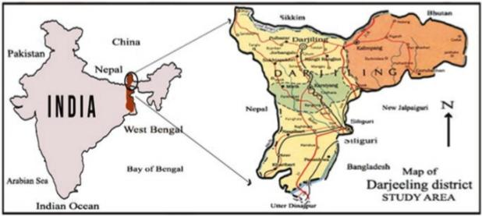

Fig.1.1 Map of study area : Darjeeling Himalaya[6]

Phytogeography of Darjeeling Himalaya :-Phytogeographically, the Darjeeling Himalaya is a part of the Eastern Himalayan Province that in turn is one of the thirteen provinces of the Eastern Asiatic regional centre of endemism [7]. Floristically, The Eastern Himalaya is one of the richest regions in the world and literally considered as Botanist's paradise and thus attracted botanists during the last three centuries [8]. Physiographic, climatic, edaphic as well as biotic factors are responsible for such varieties of enrichment. The natural forest of Darjeeling district broadly divided into five main types: (a) tropical semi evergreen forest, (b) tropical moist deciduous forest, (c) subtropical hill forest, (d) Eastern Himalayan wet temperate forest and (e) alpine forest.

Depending upon the various forest types of Darjeeling, the orchid habitat broadly categorized into five zones. They are :-
1. Tropical Zone (between 400-1200m) :- In this zone, most common orchids are Acampe rigida,Acanthephippium sylhetense, Aerides multiflorus,Anoectochilus roxburghii, Arundina graminifolia, Bulbophyllum andersonii, B. roxburghii, B. leptanthum, B. tortuosum, Cymbidium aloifolium, Dendrobium aphyllum, D. farmerii, D. formosum, D. moschatum,Galeola cathcarti, Goodyeria hispida, G. procera, Nervillea macroglossa , N. plicata, Paphiopedilumvenustum ,Papilionanthe teres, Phalaenopsis lobii, P. mannii, Tropidia angulosa, Vanda testacea, Zeuxine affenis, etc.
2. Subtropical Zone (between 1200-2200m) :- Here, the available orchids are Anthogonium gracile, Bulbophyllum guttulatum, B. hirtum, B. reptens, Calanthe mannii, C.plantaginera, C.puberula, Coelogyne crystata, C.elaka, C.flacida, Cymbidium macrorhizon, Dendrobium chrysanthemum, D.densiflorum, D.moschatum, Diplomeris hirsuta, Eria confusa, E.graminifolia, Gastrochhilus affinis, G.calceolaris, Goodyera clavata, G.procera, Malaxis acuminate, Nervilia gamieana, N.hookeriana, Oberonia auriculata, O.micrantha, O.plachyaris, Ornithochilus difformis, Paphiopedilum fairrieanum, P.venustum, Podochilus khasianumetc.
3. Temperate Zone (between 2200-3200m) :-Some interesting orchids in this zone are Aphyllorchis montana, A.alpiana, Bulbophyllum eublepharum, B.hymenanthum, B.reptans, Cephalantheropsis longipes, Galeola lindleyana, Gastrochilus distichus, Pleione humilis, Spiranthes sinensis, Stigmatodactylus paradoxus, etc.
4. Upper Temperate Zone (between 3200-3600m) :- Orchid varieties in this zone are Bulbophyllum dyeranum, B.griffithii, B.hymenanthum, Calanthe alpina, C.tricarinata, Eria pusilla, Habenaria stenopetala, Liparis perpusilla, Neottia listeroides, Satyrium nepalense etc.
5.Alpine Zone (between 3600-6200m) :- In this high altitude, orchid genera are Aorchis spathulata, Androcorys puioniformis, Chusua mana, Diphyllax urceolata, Goodyera fusca, Gymnadenia orchiodes, Habenaria diphylla, Herminium orbiculare, H.josephi and H.macrophyllum. [9].

Though Darjeeling flora contains a good percentage of orchids [9] but among them very few are already IUCN ( International Union for the Conservation of Nature and Natural Resources) red listed. We discuss some of them in the following :-
- Paphiopedilum fairrieanum (Lindl.) Stein, orchid-Buch : 467.1892
Habitat : Terrestrial
Flowering & fruiting time : October-March
Locality of their availability : Llyod Botanical Garden, Darjeeling Duras (BTR)
Altitudinal Range : 850-2200m.

- Paphiopedilum hirsutissimum (Lindl.ex Hook.) Steein, orchideenbuch,470.1892
Habitat : Terrestrial
Flowering & Fruiting time : February-October
Locality of their availability :Agricultural Research, Darjeeling Campus and Llyod Botanical Garden, Darjeeling.
Altitudinal range: 850-2300m.

- Paphiopedilum insigne (Wall.ex Lindl.) pfitz.,Morph. Stud. Orchideenbl.11.1886
Habitat :Terrestrial
Flowering& Fruiting time : November – January
Locality of their availability : Llyod Botanical Garden, Darjeeling, General distribution.
Altitudinal range : 850-2300m.

- Paphiopedilum venustum (Wall.) Pfitz.ex Steein, Jahrb.wiss.Bot.19:165.1888
Habitat :Terrestrial
Flowering & Fruiting time : February – January
Locality of their availability : Kalimpong, duars (BTR)
Altitudinal range : 850-2300m.

- Dendrobium aphyllum (Roxb.) C.E.C.Fischer in Gamble, FI. Madras 3:1416.1928
Habitat : Epiphytic
Flowering and Fruiting time : March-August
Locality of their availability : Terari to Middle Hills; Kochbehar, Duras (BTR)
Altitudinal range : Up to 1600m.

- Bulbophyllum leopardinum (wall.) Lindl.ex wall.,Numer.List 1981 1829
Habitat : Epiphytic
Flowering & Fruiting time : June – October
Locality of their availability : Kurseong
Altitudinal range : 1200-2200m.

- Vanda tessellata(Roxb.) Hook.ex.G.Don, Hort Brit. 372.1830
Habitat : Epiphytic
Flowering & Fruiting time : April – July
Locality of their availability :More or less every corner of the state.
Altitudinal range : upto 1200m.

- Geodorum densiflorum(Lamk.) Schltr. Var.kalimpongense Rajendra Yonzone, D.Lama, R.B.Bhujel and Samuel Rai, McAllen Int.Orch.Soc.J.13(6)5 – 10.12.
Habitat : Terrestrial
Flowering & Fruiting time : June – September
Locality of their availability : Dello hill.
Altitudinal range : 750-1300m.

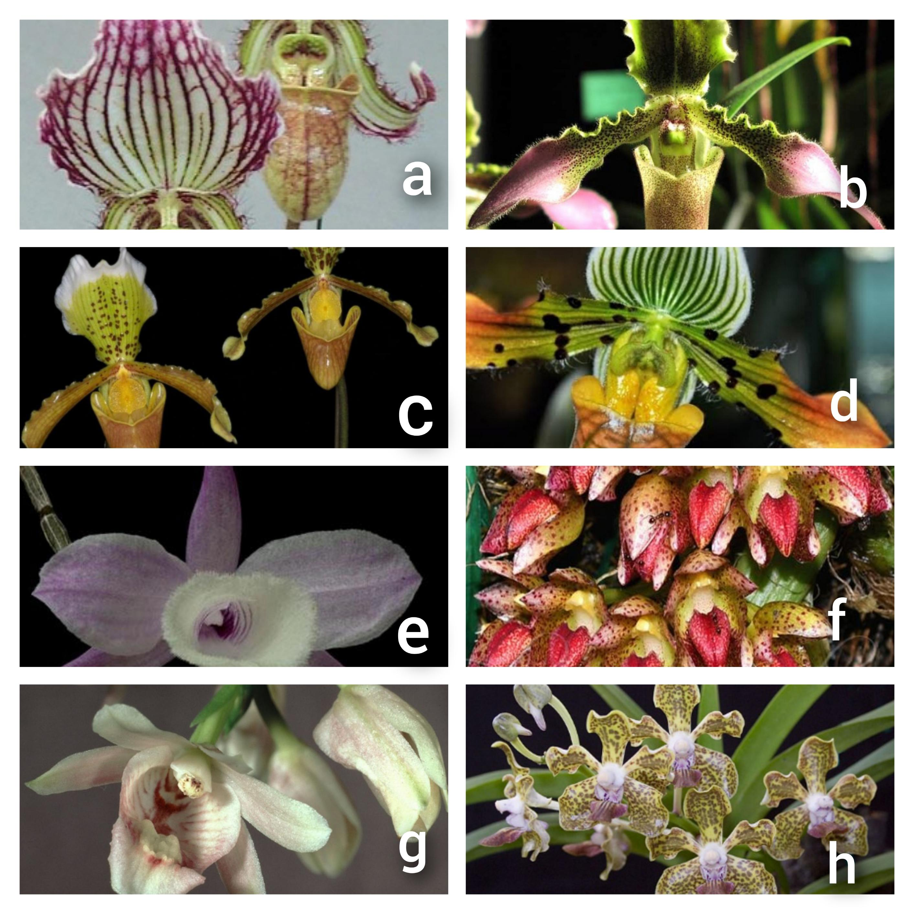
Fig.1.2 (a) Paphiopedilum fairrieanum (b) Paphiopedilum hirsutissium (c) Paphiopedilum insigne (d) Paphiopedilum venustum (e) Dendrobium aphyllum (f) Bulbophyllum leopardinum(g) Geodorum densiflorum (h) Vanda tesellata. [9]

BIOTECHNOLOGICAL APPROACH ON ORCHID FOR FUTURE CONSERVATION:-
Now, Biotechnology is the modern field of study with advanced tools and techniques. Orchid biotechnology can play a crucial role in the conservation of endangered orchid species through tissue culture, cryopreservation, seed banking and habitat restoration [10, 11, 12].Techniques such as genetic engineering and RNA interference are currently being applied to modify the growth and development of orchids and improve their environmental stress factors such as temperature, humidity and light [13]. Advanced biotechnological intervention such as cell suspension culture, metabolic engineering and synthetic biology were envisaged as biotechnological tools to enhance secondary metabolite production which could further help in reducing the production cost of these essential biomolecules.[14, 15, 16, 17].
CONSERVATION OF ORCHIDS :-
Orchids are one of the most threatened plant groups across the globe due to their specialzed habitat and life cycle. So, in this present scenario, orchid conservation is a Universal concern. First of all, finding out the causes of orchid biodiversity loss is the preliminary step. National Research Centre of Orchids, Sikkim has been designated as an active Germplasm site for Orchids under National Active Germplasm Systems (NAGS) for sustainable conservation and use of orchid germplasm.
GERMPLASM CONSERVATION:-
There are a number of advanced techniques devised to conserve orchids : seed bank development, slow growth conservation, and cryopreservation of seeds, meristem , tissue culture, shoot primordia, immature leaves, somatic embryos, callus and other explants; [18, 19]. Cryopreservation is a well known conservation technique for rare, threatened and endangered orchid species enlisted in IUCN red data book. Conservation through establishing botanic gardens, orchid biosphere reserves, orchid corridors will help for sustainable utilisation for future generations [20]. Conservation of plant genetic resources are (PGR) mainly catagorized into (A) Ex-situ conservation (B) In-situ conservation. There are many examples of Ex-situ conservations like Botanical Gardens , Orchidarium, Field Gene Banks etc.
In-situ conservation method is the another strategy of orchid preservation, growth and development through plant tissue culture techniques that have assumed high priority role in the preservation of species threatened with extinction. There is a need for genetic stability studies to avoid somaclonal variants and slow growth cultures for long storage duration to avoid frequent transfer [21].
CRYOPRESERVATION :-
Cryopreservation (Greek, kratos – frost) literally means preservation in the frozen state. The principle involved in cryopreservation is to bring the plant cell and tissue cultures to a zero metabolism or non-dividing state by reducing the temperature in the presence of cryoprotectants. Cryopreservation techniques can be used for plant germplasm storage[22].For the recovery of germplasm after cryostorage, rapid rewarming is usually required to avoid recrystallization [23].
Classical cryopreservation methods are mainly used for freezing undifferentiated cultures such as cell suspensions and calluses.Cryopreservation at ultralow temperature (- 196°c) is comprehensive alternative for long term storage of orchid genetic resources and achieved by freezing of tissue at the temperature of liquid nitrogen (-196°c) or gaseous phase (-140°c) that suspends all metabolicactivities. To avoid the genetic alternations that may occur in long tissue cultures storage, cryopreservation has been developed [24, 25, 26]. Scientists studied the methods of cryopreservation and tissue culture techniqueon Orchids using seeds, pollen, shoot tip, meristematic tissues, aerial root tip, embryoids, protocorms, floral parts etc. Many scientists and researchers are working on the conservation strategy of orchids by using cryopreservation methods and try to discover new species of orchids through biotechnological approach includingtissue culture, somaclonal variation, DNA recombination and cell suspension culture [24, 25].
ORCHID BREEDING: RECENT ADVANCEMENT IN BIOTECHNOLOGY
Orchidaceae family is the most advanced monocot family in the angiosperms group of plants. This plant group is very demandable for it's aesthetic beauty, significant ornamental and economical valuebut most of the members lost their diversity due to global climate change for environmental pollution and anthropogenic activities. Among them some are already threatened, endangered and enlisted in IUCN ( International Union For The Conservation Of Nature and Natural Resources ) red data book and CITES ( Convention On International Trade In Endangered Species Of Wild Fauna and Flora ). So, this is the accurate time to think about the proper conservation methods and breeding strategy of orchids to prevent the loss of genetic diversity and biodiversity from the Globe.Advances in molecular breeding, several attempts have been made to use emerging molecular and omics methods to accelerate the breeding process in certain of the commercially valuable orchids.
Besides, the biodiversity &conservation view, this review also consolidates some recent breeding variety of orchids and discuss their ornamental and commercial applications for future.
OBJECTIVES :-
- Production of huge amount of plantlets through biotechnology.
- Discovery of different colour variation of new varieties.
- Improvement of virus resistant orchid variety.
- Development of new variety easily than the convention method.
- To prevent the loss of genetic diversity and secure endangered species.
- To boost up the economy of the country.
BREEDING TECHNOLOGY AND METHODS:-
With the development of Economic globalization, the market demand of orchids in quantity and variety has increased year by year, forcing scientists and plant breeders to develop new varieties with novel appearances, improve resistance and quality characteristics [27].
Some breeding methods are discussed below:-
- Micropropagation.
- Polyploidy breeding.
- Mutation breeding.
- Genetic transformation.
Micropropagation :-
Micropropagation ( or in vitro clonal propagation ) is a method of plant tissue culture which involves the vegetative propagation of large number of true-to-type or clonal plantlets , i.e. genetically identical plantlets from a small piece of plant tissue ( selected genotype/ selected donor plant/ selected mother plant ) and used as an explants grown under controlled and sterile conditions in a periodic , cyclic and exponential increase of the number of plants in small period. The method [28] was discovered way back in 1960 to produce virus-free progenies by meristemculture in Cymbidium. He estimated that four million plants per year could be achieved from one single explants of Cymbidium. Developed the concept of developmental stages [29] in cultures in vitro are as follows:
Stage I : Explant establishment.
Stage II : Multiplication of propagule.
Stage III : Rooting and hardening for planting into soil.
Vegetative propagation of elite Phalaenopsis [30]

Polyploidy breeding:-
Polyploidy means more than two pair sets of chromosome in per cells of plants. It is mainly responsible for increases in cell size , a characteristics that leads to larger vegetative and reproductive organs.Now, polyploid breeding has been successfully conducted in many endangered orchid species including Cymbidium [31] Dendrobium [32], Oncidium[33] and Phalaenopsis [33, 34]. Polyploidy is mainly done by Chromosome doubling by applying chemicals like colchicine (C22H25NO6) and Oryzalin(C12H18N4O6S) [35] and the researcher treated the hybrid with colchicine to obtain tetraploid plants which develops thicker leaves, roots and rhizome as well as deep stem colour and slow growth rate.
Mutation breeding:-
Mutation breeding,including both natural and artificial mutations is well suited for ornamental plant breeding because many species can be propagated easily, facilitating the production of spontaneous and induced mutants [36]. Mutation breeding permanently change the genetical trait of the any group of plants. Over the years, mutation breeding has been used to produce orchids with phenotypic trait, higher content of medicinal ingredients, and greater adaptability and resistance [37].
Mutating agents that helps in mutation breeding to form mutant breed :-
- X ray
- Gamma ray
  - a type of ionizing radiation.
  - Produce free radicals in cell which damage or modify the DNA of plant cells and affect differently on morphology.
However, unpredictable mutation can occur throughout the genome and typically single changes are obtained [38]. In addition, mutation breeding depends on the factors such as the explant type, an appropriate genotype, the induction-mutation method, and the optimal dose.
Genetic transformation:-
Genetic transformation is one of the most current technique to form new breed of plant species through the exchange of desirable genetic material by plasmid DNA.
This process is mainly done by two methods :-
- Agrobacterium mediated gene transfer.
- Microprojectile bombardment / Particulate Bombardment/ Biolistic / Gene gun method.

I -:Agrobacterium mediated gene transfer :-
Step : 01 - Signal recognition by Agrobacterium tumifaciens / rhizogenes .
Step : 02 - Attachment to the plant cell surface.
Step : 03 - Induction of Vir gene.
Step : 04 - T strand production.
Step : 05 -Transfer of TDNA (Transfer DNA) out of the bacterial cell.
Step : 06 - Transfer of TDNA and virprotein into the nucleus of the plant cell. [39].
II. Microprojectile bombardment / Particulate Bombardment / Gene gun method / Biolistic :-
This method involves the coating of 1micrometer diameter particles of Gold (Au)( called microprojectile or microcarrier) with DNA at high speed and pressure into an evacuated chamber containing the target plant tissues.
DNA coated microprojectile penetrate through the cell wall releasing DNA from projectile with gets integrated genome of the plant.
Procedure :-
- Preparation of microcarriers :- 1micrometer diameter tungsten particle + washing with ethanol and sterile distilled water + DNA + spermidin + calcium chloride + Ethanol.
- Preparation of plant tissue :- Generally 2 weeks old embryonic callus is used. It is present in high conc.of moltose atleast 4 hours. [39].

Some new intergenic hybrids of orchid developed through breeding method:-

- Ascocentrum × vanda = Ascocenda
- Arachnis × vanda = Aranda
- Aerides × vanda = Aeridovanda
- Brassovola × cattleya = Brassocattleya
- Phalaenopsis × vanda = vandanopsis
- Cattleya × Laelia = Laeliocattleya
- Cattleya × Sophronities = Sophrocattleya [40]

Commercial value of orchids :-
- The use of vanilla (vanillin) extracted from the pods of Vanilla panifolia is used as flavouring agent in chocolates and ice creams.
- The popular beverage called ‘Faham' or ‘Madagascar tea' on the islands of Madagascar is prepared from the orchid Jumellea fragrans [41].
- Medicinal orchid Geodorum densiflorumused to prepare many drugs for treatment purpose.
- Some orchid species used as colouring agent.
- Dendrobium, Cymbidium, Vanda, Paphiopedilum orchids are mainly used in decorations for their aesthetic beauty.
- There are many wild orchid species which are being used as food by the tribal people of North East India [42]
- The new shoots of Cymbidium are used as cereals to prepare sauce, the pseudobulbs of their orchids in combination of common vegetables such as potato, tapioca etc. [43]
- Pseudobulb, root and rhizome of many orchid species are reported to use as foodsviz. Habenaria acuminata , H.sussanae, Orchis latifolia , Pholidata articulata, Satyrium species are used as foods which play an important role in thenutrition of the people in Nagaland region. [44, 45].
Conclusion:-
Flowers have captured a remarkable place in modern culture. So, there is a latest demand for flowers especially with regards to orchids as they keep very well and a plethora of choices in flowers from odour to colour. Conservation, sustainable utilisation and management of orchids is the key feature to ensure the natural growth and proliferation of these beautiful members of the plant kingdom as they are diminishing alarming at low levels.
References
- Dressler, L. Robert, 1989 : The Orchids natural History and Classification ; Harvard University Press – ISBN : 0-674-87525-7
- Handa,S.S.1986, Orchids for drugs and chemicals ,Pages 89-100 in S.P.vij(ed.), Biology : conservation and culture of orchids, East West Press, New Delhi.
- Bhujel,R.B (1996) : Studies on the dicotyledonous Flora of Darjeeling District, Ph.D. thesies, University of North Bengal, Raja Rammohanpur , Darjeeling.
- Yonzone, Rajendra and Karman, A. 2008 : Ethnobotanical uses of orchids . Abstract in an International Seminar, “Multidisciplinary Approaches in Angiosperms Systematics “ Kalyani University, West Bengal.
- Negi SS (1992) Himalayan Wildlife, habitat and conservation. Indus Publishing p 207. ISBN : 978-81-85182-68-1
- Orchid Biology : Recent Trends and challengeshttps://www.researchgate.net/publication/338962123.
- Hooker,J.D.1896: List of trees, shrubs and climbers found in Darjeeling District, Bengal, second edition, Calcutta.
- Don.D.,1821: Description of several taxa from the kingdom , taken from specimens preserved in the herbarium of A.S.Lamb.
- www.orchidspecies.comInternet Orchid species Encyclopedia.
- Bhattacharyya,P., Kumaria,S., Diengdoh,R., Tandon,P., 2014. Genetic stability and phytochemical analysis of the in vitroregeneratedplantsof Dendrobium nobile Lindl., an endangered medicinal orchid. Meta gene 2, 489-504.
- Bhattacharyya, P., Kumar, V., Van Stadeen,J. 2017 Assessment of genetic stability amongst micropropagated Ansellia africana , a vulnerable medicinal orchid species of Africa using SCoT markers. South African J.Bot. 108, 294-302.
- Bose, B.,Kumaria, S., Choudhury, H., Tandon, P.2017b. Insights into nuclear DNA content, Hydrogen Peroxide and antioxidative enzyme activity during transverse thin cell layer organogenesis and ex vitroacclimatization of Malaxis wallichii , a threatened medicinal orchid. Physiol.Mol.biol. https://doi.org/10.1007/s12298-017-0474-3
- Chang, L., Tzean, Y., Hsin,K.T.,Lin,C.Y., Wang, C.N., Yeh, H.H.,2022. Stress associated protein coordinate the activation of comprehensive antiviral immunity in Phalenopsis orchids. New Phytol 233, 145-155.
- Gallage, N.J.,Moller.,2015. Vanillin- bioconservation and bioengineering of the most popular plant flavor and its de novo biosynthesis in the Vanilla orchid. Mol Plant 8, 40-57.
- Bose, B.,Choudhury,H.,Tandon.P.,Kumaria.S.,2017a. Studies on secondary metabolite profiling , anti-inflammatory potentials , in vitro photoprotective and skin-agingrelated enzyme inhibitory activities of Malaxis acuminata, a threatened orchid of nutraceutical importance. J.Photochem.Photobiol.B Biol.173, 686-695.
- Gantait,S.,Das,A.,Mitra,M.,Chain.J.T., 2021: Secondary metabolites in Orchids : Biosynthesis, medicinal uses and Biotechnology. South African J.Bot. 139, 338-351.
- Ghai ,D.,Kaur ,A.,Kahlon,P.S.,Pawar,S.V.,Semvi, J.K.,2022. A walk through the maze of secondary metabolism in orchids : A transcriptomic approach . Front. Plant Sci. 13, 837563.
- Hirano T, Godo, T, A.E., Miyoshi K, Æ Keiko Ishikawa Æ Masaya Ishikawa Æ Masahiro Mii, (2009), Cryopreservation and low-temperature storage of seeds of Phaius tankervilleae, Plant Biotechnol Rep (2009) 3:103–109 DOI 10.1007/s11816-008-0080-5.
- Seaton PT, Hu H, Perner H and Pritchard HW. 2010. Ex situ conservation of orchids in a warming world. Bot Rev 76: 193-203.
- Dixon K.W., Kell S.P., Barrett R.L., and Cribb P.J. (eds) 2003. Orchid Conservation. pp. 1–24. Natural History Publications, Kota Kinabalu, Sabah.
- Chang WC (2007) In vitro morphogenesis and micropropagation of orchids. In H.H.Chen and WH Chen(eds) Orchid biotechnology. World Scientific Publishing Co. Pte. Ltd., Singapore.
- Engelmann F, (2010), Use of biotechnologies for the conservation of plant biodiversity, In Vitro Cell.Dev.Biol.—Plant DOI 10.1007/s11627-010-9327-2.
- Towill L. E.; Walters C. (2000), Cryopreservation of pollen. In: Engelmann F.; Takagi H. (eds) Cryopreservation of tropical plant germplasm—current research progress and applications. JIRCAS, Tsukuba, pp 115–129.
- Reed B. M.; DeNoma J.; Chang Y. (2000), Application of cryopreservation protocols at a clonal genebank. In: Engelmann F.; Takagi H. (eds) Cryopreservation of tropical plant germplasm—current research progress and applications. JIRCAS, Tsukuba, pp 246–249;.

- Reed B. M.; Engelmann F.; Dulloo M. E.; Engels J. M. M. (2004), Technical guidelines for the management of field and in vitro germplasm collections. Handbook for Genebanks N 7. IPGRI/SGRP, Rome;
- Reed B. M.; Uchendu E. Controlled rate cooling. (2008) In: Reed B. M. (ed) Plant cryopreservation: a practical guide. Springer, Berlin, pp 77– 92;
- Chakraborty R. (2019), Floriculture in Northern West Bengal of India- A Dream Sunrise is on Wait". EC Agriculture 5.2
- Morel, G., (1960). Producing virus-free cymbidiums. Am. Orchid Soc. Bull. 29, 495–497
- Murashige, T. Plant Propagation through Tissue Cultures. Annu. Rev. Plant Physiol. 1974, 25, 135–166.
- Trevor A. Thorpe and Edward C. Yeung (eds.), Plant Embryo Culture: Methods and Protocols,Methods in Molecular Biology, vol. 710, DOI 10.1007/978-1-61737-988-8_20,© Springer Science+Business Media, LLC 2011.
- Wang, S.Y., Lee, P.F., Lee, Y.I.,Hsiao, Y.Y., Chain,Y.Y., Pan, Z.J., Lilu, Z.J., Taai.,W.C., 2011b. Duplicated C- class MADS box gene reveals distinct role in gynostemium development in Cymbidium ensifolium ( Orchidaceae). Plant Cell Physiol, 52 : 563-577.
- Zheng S, · Hu Y., Zhao R., Yan S., Zhang X, Zhao T and ·Chun Z, (2018) Genome-wide researches and applications on Dendrobium, Planta , 248:769–784 https://doi.org/10.1007/s00425-018-2960-4.
- Cui G. R., Zhang Zi. Xue, Zhang C.Yu., Hu N. B., Sui Yi. Hu., Li . J. Q. (2010), Polyploidy induction and identification of Oncidium. Acta Prataculturae Sinica 2010 Vol.19 No.1 pp.184-190.
- Huang J, Lin C, Cheng T, Huang Y, Tsai Y, Cheng S, Chen Y, Lee C, Chung W, Chang BC, Chin S, Lee C, Chen F. 2016. The genome and transcriptome of Phalaenopsis yield insights into floral organ development and flowering regulation. PeerJ 4:e2017 https://doi.org/10.7717/peerj.2017.
- Manzoor A, Ahmad T, Bashir MA, Hafiz IA, Silvestri C. Studies on Colchicine Induced Chromosome Doubling for Enhancement of Quality Traits in Ornamental Plants. Plants (Basel). 2019 Jun 28;8(7):194. doi: 10.3390/plants8070194. PMID: 31261798; PMCID: PMC6681243.
- Yamaguchi H., (2018) Mutation breeding of ornamental plants using ion beams, Breeding Science 68: 71–78 . doi:10.1270/jsbbs.17086.
- Li C., Dong Na, Zhao Y., Wu S., Liu Z. and Zhai J (2021), A review for the breeding of orchids: Current achievements and prospects, Horticultural Plant Journal, 7(5), Pp- 380-392
- Su J., Jiang J, Zhang F, Liu Ye, Ding Li, Chen Su, and Chen F., (2021) Current achievements and future prospects in the genetic breeding of chrysanthemum: a review. Horticulture Research, Volume 6, 2019, 109, https://doi.org/10.1038/s41438-019-0193-8.
- https://www.slideshare.net/sakthivelRamar/agrobacterium-mediated-gene-transfer-80094201.
- https://www.slideshare.net/Utpaldas2015/orchids-48741974.
- Die Orchideen Schlechter 1915; AOS Bulletin Vol 28 No 5 1959.
- Tsering J., Tam N., , Hui Tag H., Gogoi B. J., Apang O, (2017) )MEDICINAL ORCHIDS OF ARUNACHAL PRADESH: A REVIEW. Bulletin of Arunachal Forest Research, Vol. 32(1&2), 1-16.
- Medhi RP, Chakrabarti S (2009) Traditional knowledge of NE people on conservation of wild orchids. Indian J. TraditKnowl.8:11-16.
- Deb CR (2013) Orchids of Nagaland, propagation, conservation and sustainable utilization : a review. Pleione 7(1) : 52-58.
- Cribb PJ, Kell SP, Dixon KW, Barrett RL(2003) Orchid conservation : a global perspective. In:Dixon KW, Kell SP, Barrett RL, Crib PJ(eds) orchid conservation. Natural History Pub , Kotakinabalu, pp1-4.

