MOLECULAR DOCKING AND ADME PREDICTIONS OF SYNTHESIS OF NOVEL PYRIMIDINE DERIVATIVES AND THEIR POTENT ANTIMICROBIAL STUDIES
¹M.R.Ezhilarasi, ¹P.Kavitha, ¹R.Menaka and ²M.Makeswari
1. Assistant Professor, Dr.N.G.P.Arts and Science College, Coimbatore -641 048, Tamil Nadu, India
2. Assistant Professor, Sree Saraswathi Thyagaraja College, Pollachi -642 107, Tamil Nadu, India

Email: mrezhilarasi@gmail.com, saikavi.88@gmail.com, menu.chem@gmail.com & makeshvu3@gmail.com
Abstract
A series of novel pyrimidine derivatives was designed and chemically synthesized in useful yields. The synthesized compounds were structurally characterized by the usual characterization techniques like IR spectra, NMR spectra, Antimicrobial studies and Elemental analysis. Finally, molecular docking studies were conducted to investigate those probable binding conformations of these anticancer agents and ADME properties were calculated to predict pharmacokinetics and toxic properties of the target compounds. All the compounds showed the good docking score values. Especially compound BCT-7 and 8 have the similar and better docking score value of 8.3 kcal/mol.
Key words: Pyrimidine derivatives, spectral characterization, Molecular docking studies, ADME predictions, 1OQA protein.
1. INTRODUCTION
Now a day, there has been a growing interest to synthesis of bioactive compounds in the field of organic chemistry. The chalcones and their derivatives are important intermediates inorganic chemistry [1-4]. The most important function of chalcones is to build up a variety of heterocyclic compounds of physical importance. Due to the presence of enone functionality in chalcone, moiety confers antimicrobial [5-7], anti-inflamatory [8], antimalarial [9, 10], antileithshmanial [11], antioxidant [12], antitubercular [13, 14], anticancer [15-17] and their biologicalactivities [18,19]. Heterocyclic compounds widely occur in nature and play a vital role in metabolism because their
structural sub-units are present in many natural products, including vitamins, antibiotics, hormones, and alkaloids as well as agrochemicals dyes [20].Pyrimidine and their fused derivatives play an essential role in several biological processes and have considerable chemical and pharmacological importance. In particular, pyrimidine nucleus can be found in a broad variety of antibacterial and antitumor agents, as well as in agrochemical and veterinary products [21]. Pyrimidine, which is a highly deficient aromatic heterocycles, can therefore be used as electron withdrawing part in push pull molecules [22, 23]. Moreover, the intramolecular charge transfer along the molecule backbone can also induce luminescence properties [24]. Recent reports exhibits pyrimidine derivatives is a good nonlinear material [25].
Molecular docking may be defined as an optimization problem, which would describe the “best-fit” orientation of a ligand that binds to a particular protein of interest and is used to predict the structure of the intermolecular complex formed between two or more molecules. The most important interesting case is the protein ligand interaction, because of its applications in medicines. Ligand is a small molecule, which interact with protein binding sits. There are several possible mutual conformations in which binding may occur. These are commonly called binding modes [26-28]. In modern drug designing, molecular docking is routinely used for understanding drug receptor interaction. Molecular docking provides useful information about drug receptor interactions and is frequently used to predict the binding orientation of small molecule drug candidates to their protein targets in order to predict the affinity of the small molecule.
The QSAR/QSPR community has, for a good number of years, developed models for the prediction of physiochemical properties of interest in ADMET (absorption, distribution, metabolism, excretion and toxicity). These include partition coefficient, aqueous solubility [29], absorption and permeability [30], blood brain barrier (BBB) penetration [31], plasma protein binding [32], metabolism [33], hERG inhibition [34], excretion [35], P-glycoprotein (P-gp) efflux, physiologically based pharmacokinetic (PBPK) modelling and toxicity [36,37]. In addition of course, pharmacophore and homology modelling have also proceeded, to allow improve prediction of metabolism and toxicity [38, 39]. Today, the tests that make up ADMET evaluation are low throughput and apparently not informative or accurate enough to predict drugs probability of success; given the high failure rate of compounds at all stages of development [40]. Drug discovery companies are therefore seeking to reorganize the ADMET process, advancing the chain of early discovery. The objectives is to predict, early in the process perhaps even before the compounds are synthesized, which compounds pass the test for the good drug. Over the past few years, much software has been developed for the properties and toxicity of ADME-based organism [41, 42, 43]. We have to predict the ADME properties for the online software swiss ADME and Molinspiration online toolkit. The main focus of this work is design and synthesis of novel Pyrimidine derivatives, which have not been previously reported. The target compounds structure was elucidated using FT-IR, 1H NMR, 13C NMR spectral data and elemental analysis. Finally, all of them have to investigate their biological evaluation and ADME prediction. In-silico Molecular docking study was carried out using BC protein and bacterial protein.
2. EXPERIMENTAL METHODS
2.1. Instruments
The MELT-TEMP apparatus used to determine the melting points of the synthesized compounds and Schimadzu FT-IR spectrometer used to record the Infra-red spectral values. BRUCKER 400 MHz NMR spectrometer used to record the proton and carbon NMR of synthesized compounds, during recording the CDCl₃ is used as the solvent along with internal standard TMS. The TLC plates coated with silica gel used for monitored the reactions. The silica gel and all other laboratory grade chemicals, solvents were purchased and used.
2.2. General Procedure for the synthesis of 3-((4-aryl) biphenyl-2-yl)-1-phenylprop-2-en-1-one chalcones (BC 1-8)
The 250ml Erlenmeyer flask taken with 3g of NaOH immersed in the 40 ml of ethanol keeps the mixture in the stirrer and stirred for till the NaOH completely dissolved in the ethanol. Then the same mole of substituted aldehydes and 4-acetyl biphenyl weighed. The aldehyde poured into the Erlenmeyer flask make complete dissolve in the ethanol solution and then added the acetophenone in that mixture and stirred it for 3 hours under ice-cold condition. The reaction completion monitored by thin layer chromatographic plates coated with silica-gel. The yellow mass precipitate obtained were poured into 500 ml beaker contained crushed ice and kept it overnight at room temperature. Finally, the precipitate filtered, washed with water, dried and purified from ethanol.
2.3. General Procedure for the synthesis of 4-(5-(4-aryl)-6-biphenyl -2-yl)-3, 4-dihydropyrimidin-2-(1H)-thiones (BCT 1-8)
The 0.01 mol of BC derivatives dissolved in the 60ml of ethanol, and then add 0.01 mol of sodium acetate and 0.50 M of thiourea and the mixture refluxed for 10-12 hours in the heating mantle. The completion of the reaction monitored by thin layer chromatography plate, then the mixture allowed to cooled and transferred into the beaker contained crushed pieces of ice. The beaker kept aside for overnight at room temperature. The resultant precipitate BCT was filtered, dried and re-crystallized from ethanol. The Purity of the compounds was also checked by using thin layer chromatography plate with the P.E. & EA (9:1) solvent mixture.
2.4. Computational (in-silico) Studies
ADME Prediction
The ADME values of the synthesized FCPR compounds predicted by using swissadme online tool. The satisfactory values in the ADME study of the synthesized compounds theoretically showed up the pharmacological property of the synthesized BCTs and also lead the compounds to next level studies. This study gave the basic information of the compounds such as MW, Hy-A, Hy-D, Log p o/w, Log S, TPSA, M.Ref., bioavailability score and other information to understand the pharmacological activity of the synthesized FCPR compounds. The above given properties can influences the pharmacological effect of the FCPR compounds. Other than that the percentage of absorption of the synthesized compounds were calculated by using the following mathematical expression.
% of Abs = 0.345-(109*TPSA)
The other medicinal parameters values of the synthesized compounds also findout by swissadme tool. The parameters are absorption in BBB, p-substrate, cytochrome P-450 enzymes, PAINS and Brenk filters and also gave information about the five basic rules Lipinski, Ghose, Verber, Egan and Muegge. These rules are theoretical era to find out the pharmacological activity of the synthesized compounds. At final it also gave the information about Leadlikeness capability of the compounds.
2.5. Molecular Docking Studies
The molecular docking studies of the BCT 1-8 Compounds were done by using Autodock version 4.2.5.1 docking software. The docking studies used to find out the binding efficiency of our synthesized compounds with the selected proteins from pathogenic origin. Here, we analysis the binding efficacy of BCT 1-8 compounds with one breast cancer protein (1OQA). Docking study also gave information about H-bonding interactions along with bond length values, hydrophobic interactions and other bonding interactions (carbon hydrogen bond, pi-alkyl, van der Waals, pi-cation).
2.6. Biological (in-vitro) Screening
Antimicrobial screening: Antimicrobial study was carried out for synthesized BCT 1-8 derivatives using agar disk diffusion method. The various bacterial strains viz. S. aureus, E. coli, P. aeruginosa, S. pyogenes and Candida albicans were used in this study. This activity was carried out with the sample concentration of 1mg/mL and the zone of inhibition measured. The antimicrobial screening procedure was carried out by literature survey method [17].
3. RESULTS AND DISCUSSION
3.1. Chemistry
The synthetic strategies adopted to obtain the intermediate and target compounds are depicted in Scheme-1, the key intermediate chalcones BC 1-8 were synthesized in excellent yields by condensing substituted aromatic aldehyde with the 4-biphenyl acetophenone in the presence of sodium hydroxide under Claisen-schmidt reaction conditions. These chalcones were subjected to cycloaddition condensation reactions using Thiourea in the presence of catalytic amount of sodium hydroxide to give the corresponding 4-(5-(4-aryl)-6-biphenyl -2-yl)-3,4-dihydropyrimidin-2-(1H)-thiones derivatives BCT 1-8 in good yields.
Scheme-1

The chemical structure of the thio pyrimidine compounds were elucidated using Infra-red, Proton and Carbon NMR spectral studies and CHN analysis. Elemental analysis of compound BCT 1 C_{obs}=70.11, C_{cal} =70.01: H_{obs} = 4.55, H_{cal} = 4.53:N_{obs} = 7.43, N_{cal} = 7.45: S_{obs} = 8.51, S_{cal} = 8.60 : Cl_{obs} = 9.41, Cl_{cal} = 9.39) are consistent with the proposed molecular formula (C₂₂H₁₇ClN₂S). The physical properties of the BCT 1-8 compounds are given in the Table-1.
Table 1: Physical properties of BCT (1-8)
Compound | Substitution | Molecular Formula | Molecular Weight | Melting Point in ºC | Yield in % | Colour | Elemental Analysis value in %
BCT-1 | 4-Cl | C₂₂H₁₇ClN₂S | 376.90 | 152-154 | 57 | Yellow | C_{obs}=70.11, C_{cal} =70.01: H_{obs} = 4.55, H_{cal} = 4.53:N_{obs} = 7.43, N_{cal} = 7.45: S_{obs} = 8.51, S_{cal} = 8.60 : Cl_{obs} = 9.41, Cl_{cal} = 9.39
BCT-2 | 4-Br | C₂₂H₁₇BrN₂S | 421.35 | 112-114 | 52 | Yellow | C_{obs}=62.71, C_{cal} =62.61: H_{obs} = 4.07, H_{cal} = 4.12:N_{obs} = 6.65, N_{cal} = 6.62.48: S_{obs} = 7.61, S_{cal} = 7.59: Br_{obs} = 18.96, Br_{cal} = 18.95
BCT-3 | 4-F | C₂₂H₁₇FN₂S | 360.45 | 128-130 | 56 | Dark Yellow | C_{obs}=73.31, C_{cal} =73.25: H_{obs} = 4.75, H_{cal} = 4.75:N_{obs} = 7.77, N_{cal} = 7.79: S_{obs} = 8.90, S_{cal} = 8.85: F_{obs} =5.27, F_{cal} = 5.31
BCT-4 | 4-H | C₂₂H₁₈N₂S | 342.46 | 152-154 | 64 | Dark Yellow | C_{obs}=77.16, C_{cal} =77.64: H_{obs} = 5.30, H_{cal} = 5.02:N_{obs} = 8.18, N_{cal} = 8.10: S_{obs} = 9.36, S_{cal} = 9.32
BCT-5 | 4-CH₃ | C₂₃H₂₀N₂S | 356.48 | 126-128 | 60 | Yellow | C_{obs}=77.49, C_{cal} =77.69: H_{obs} = 5.65, H_{cal} = 5.23:N_{obs} = 7.86, N_{cal} = 7.76: S_{obs} = 8.99, S_{cal} = 8.46
BCT-6 | 4-OCH₃ | C₂₃H₂₀N₂OS | 372.48 | 162-164 | 62 | Yellow | C_{obs}= 74.16, C_{cal} = 74.63: H_{obs} = 5.41, H_{cal} = 5.26:N_{obs} = 7.52, N_{cal} = 7.90 : O_{obs} = 4.30, O_{cal} = 4.76 : S_{obs} = 8.61, S_{cal} = 8.63
BCT-7 | Furan | C₂₀H₁₆N₂OS | 332.42 | 114-116 | 66 | Yellow | C_{obs}= 72.26, C_{cal} = 72.98: H_{obs} = 4.85, H_{cal} = 4.84:N_{obs} = 8.43, N_{cal} = 8.75: O_{obs} = 4.81, O_{cal} = 9.65: S_{obs} = 18.55, S_{cal} = 9.61
BCT-8 | 2,3-Cl | C₂₂H₁₆Cl₂N₂S | 411.35 | 144-146 | 62 | Yellow | C_{obs}= 64.24, C_{cal} = 64.21: H_{obs} = 3.94, H_{cal} = 3.38:N_{obs} = 6.81, N_{cal} = 6.80: S_{obs} = 7.80, S_{cal} = 7.78

3.2. Spectral Analysis
IR Spectral results
The FT-IR spectrum of the compound BCT-1 shows (Fig-1) a strong absorption frequency at 3295.56 cm⁻¹and the presence of NH₂ group of pyrimidine moiety. The strong absorption frequency at 1569.41 cm⁻¹is due to the presence of C=N in pyrimidine moiety. The C-N stretching frequency gives sharp absorption at 1353. 83cm⁻¹. The C=S stretching frequency in thiourea moiety has been found around 1180 cm⁻¹ which is in fair agreement with the value calculated for thioformaldehyde. In the case of the thiocarbonyl derivatives where the C=S group is linked to elements other than nitrogen, the stretching frequency is generally found in the region 1025–1225 cm⁻¹. The absorption at 3056.78 and 2961.18 is due to the presence of aromatic and aliphatic CH stretching frequency respectively. The FT-IR spectrum values of the other compounds of these derivatives are given below Table-.
Table 2: FT-IR Spectral values of the synthesized compounds BCT 1-8
Entry | NH₂ stretching | C=N stretching | C-N stretching | C=S stretching | Aliphatic C-H stretching | Aromatic C-H stretching | Aromatic ring stretching
BCT-1 | 3295.56 | 1569.41 | 1353. 83 | 1180 | 2961.18 | 3056.78 | 645,743,810
BCT-2 | 3293.60 | 1559.95 | 1360.65 | 1175.50 | 2918.46 | 3052.78 | 685,748,810
BCT-3 | 3398.60 | 1571.12 | 1354.06 | 1171.67 | 2997.12 | 3049.66 | 695.25,748.68,792.10
BCT-4 | 3190.20 | 1559.08 | 1378.50 | 1196.55 | 2958.24 | 3045.58 | 656.39,746.87,793.81
BCT-5 | 3201.45 | 1584.55 | 1377.189 | 1197.92 | 2982.06 | 3051.13 | 653.30,699.71,794.19
BCT-6 | 3201.84 | 1584.36 | 1377.40 | 1198.19 | 2961.09 | 3048.14 | 700.17,793.96
BCT-7 | 3198.10 | 1583.70 | 1377.07 | 1196.47 | 2960.26 | 3045.52 | 656.56,700.26,726.22
BCT-8 | 3198.10 | 1583.70 | 1377.07 | 1196.47 | 2960.26 | 3045.82 | 656.56,700.26,726.22

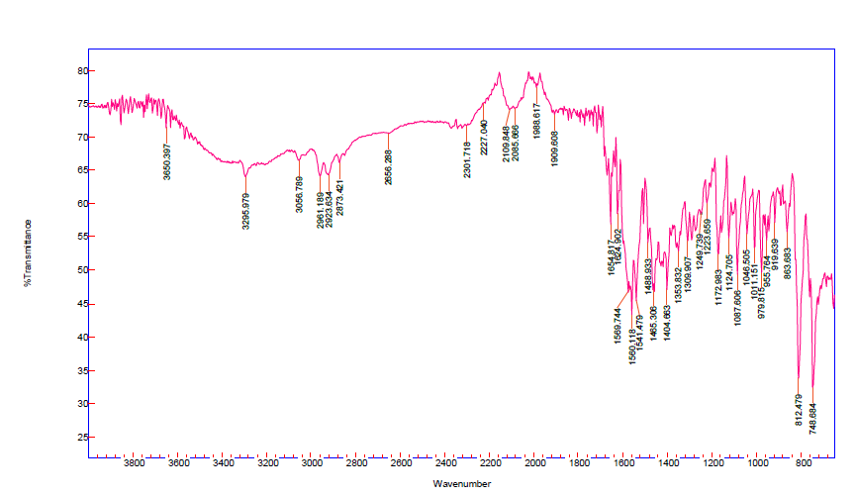 Fig 1: FT-IR Spectrum of the Compound BCT-1
The Proton NMR results
The structures of the BCT 1-8 compounds were further confirmed by ¹H NMR Spectra. ¹H NMR spectrum of the compound BCT-1 shows that the signal at 6.280 ppm, and it is attributed to H₅ proton of pyrimidine moiety. The NH proton appeared at 3.035 ppm. The aromatic protons appear at 6.799 ppm to 8.182 ppm. The¹H NMR spectrum of compound BCT-1 is given below.
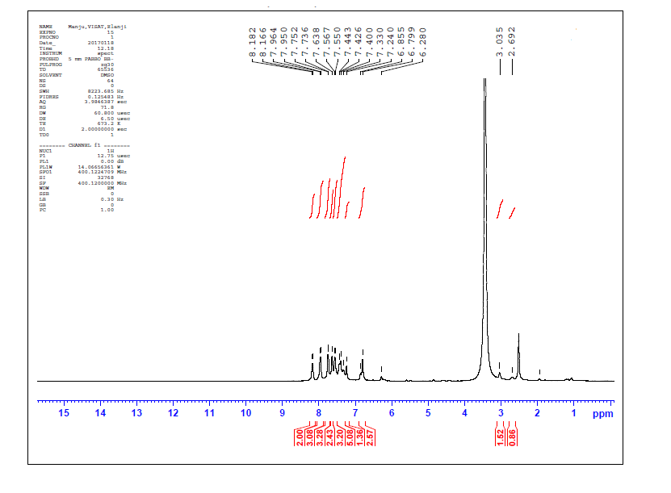
Fig 2: ¹H NMR spectrum of the compound BCT-1
Table 3: ¹H NMR spectral values of the synthesized compound BCT 1-8
Entry | H-5 of pyrimidine moiety | NH proton | Aromatic protons
BCT-1 | 6.280 | 3.035 | 6.799-8.182
BCT-2 | 6.182 | 3.102 | 6.281-7.882
BCT-3 | 6.232 | 3.088 | 7.286-8.484
BCT-4 | 6.134 | 3.098 | 7.276-7.987
BCT-5 | 6.242 | 3.034 | 6.862-7.991
BCT-6 | 6.381 | 3.044 | 7.284-7.886
BCT-7 | 6.252 | 3.036 | 7.045-7.883
BCT-8 | 6.241 | 3.022 | 7.791-7.886

The Carbon NMR results
The¹³C NMR spectrum of compound BCT-1 (5a)showed The ¹³C resonance in the downfield (shielded) region of 163.58 ppm is due to the presence of C-4 carbon of pyrimidine ring.The ¹³C resonance at 188.43 ppm is assigned to C=S carbon. The ¹³C resonance at 113.93 ppm is attributed to C-5 carbon of pyrimidine ring. The ¹³C resonance at 55.05 ppm is assigned to benzylic carbon. The aromatic carbons appear in the region of 122.32 ppm to 130.94 ppm. The Ipso carbons appear at 144.48, 136.20 pm, 133.61 ppm. Therefore, with reference to FT-IR, ¹H NMR, ¹C NMR spectral studies in compound BCT-1, the tentative assignments made for the title compounds are confirmed. The¹³C NMR spectrum of compound BCT-1 is given below.

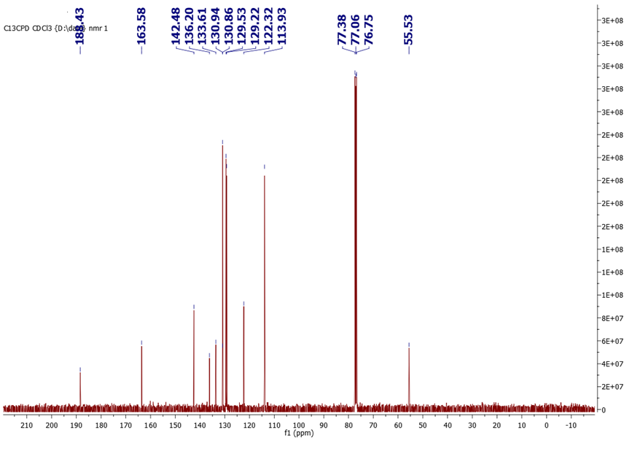
Fig 3: ¹³C NMR spectrum of the compound BCT-1

Table 4: ¹³C NMR Spectral values of the synthesized compounds BCT 1-8
Entry | C=S | C-4 carbon of pyrimidine | C-5 carbon of pyrimidine | benzylic carbon | Aromatic carbons | Ipso carbons | Substitutions
BCT-1 | 188.43 | 163.58 | 113.93 | 55.05 | 122.32 - 130.94 | 144.48, 136.20, 133.61 | -
BCT-2 | 190.45 | 164.89 | 115.67 | 55.78 | 127.98-130.10 | 143.28, 132.20, 131.61 | -
BCT-3 | 200.01 | 166.56 | 115.78 | 56.05 | 123.98-129.10 | 142.48, 134.20, 133.56 | -
BCT-4 | 189.34 | 165.12 | 114.28 | 56.98 | 126.94-129.67 | 143.46, 136.45, 133.57 | -
BCT-5 | 192.98 | 163.98 | 117.32 | 56.78 | 122.68-129.10 | 142.48, 134.78, 133.86 | 21.86
BCT-6 | 186.99 | 164.24 | 112.78 | 56.11 | 120.82-130.24 | 141.48, 136.20, 132.65 | 55.06
BCT-7 | 197.89 | 167.66 | 116.01 | 55.89 | 121.68-130.78 | 144.24, 136.32, 133.46 | -
BCT-8 | 200.04 | 169.55 | 117.98 | 55.94 | 121.98-129.89 | 140.48, 136.20, 134.24 | -

3.3. Insilico Studies Result
Determinations of ADME parameters of the synthesized (BCT 1-8) were done using Swiss ADME online software. The success of a drug is determined not only by good efficacy but also by an acceptable ADME (absorption, distribution, metabolism and excretion) profile. In the present study, we have calculated log p0/w, solubility (log S), molecular weight, TPSA (topological polar surface area), drug-likeness, hydrogen bond acceptor, hydrogen bond donor, molar refractivity, drug score and pharmacokinetics study of GI absorption, BBB (blood brain barrier), P-gp substrate, cytochrome P450 family and sub-family members and log Kp (skin permeation), Lipinski’s violation, Ghose filter, Veber, Egan, Muegge and Bioavailability score, Pains, Brenk, Lead-likeness and synthetic accessibility were carried using Swiss ADME online tool. All the compounds (BCT 1-8) were subjected to ADME property prediction with the help of Swiss ADME online software. This insilico method plays a major role in the pharmacokinetics property of the new molecules. All the target compounds obey the Lipinski rule of five and also exhibit good solubility and absorption values. Especially, compound BCT-7 shows better TPSA values compared than other compounds. The compound also exhibits good log P value. The ADME prediction values of other compounds are shown in Table-4.

TABLE 5: ADME PREDICTION VALUES OF BCT 1-8 USING Swiss ADME ONLINE TOOL
Compound | R |  | log P | log S | M.W | TPSA | Hy-A | Hy-D | Molar refractivity
Rule | - |  | <5 | - | <500 | - | <10 | <5 | -
BCT-1 | Cl |  | 3.7 | -5.99 | 376.9 | 56.15 | 0 | 2 | 120.119
BCT-2 | Br |  | 3.81 | - 6.31 | 421.35 | 56.15 | 0 | 2 | 122.88
BCT-3 | F |  | 3.39 | -5.4 | 342.46 | 56.15 | 0 | 2 | 115.18
BCT-4 | H |  | 3.39 | - 5.4 | 342.46 | 56.15 | 0 | 2 | 115.18
BCT-5 | CH3 |  | 3.73 | -5.7 | 356.48 | 56.15 | 0 | 2 | 120.15
BCT-6 | OCH3 |  | 3.69 | -5.47 | 372.48 | 65.38 | 1 | 2 | 121.67
BCT-7 | FURAN |  | 3.19 | -4.74 | 332.42 | 69.29 | 1 | 2 | 107.45
BCT-8 | 2,3 DICHLORO |  | 3.81 | -6.58 | 411.35 | 56.15 | 0 | 2 | 125.2
R(Substitution); Log S (solubility); M.W (molecular weight); TPSA (topological polar surface area); Hy-A (hydrogen acceptor); Hy-D (hydrogen donor)
TABLE 6: PHARMACOKINETICS STUDY FOR THE SYNTHESIZED COMPOUND (BCT-1-8) BY Swiss ADME
Compound | GI  absorption | BBB | P-gp substrate | CYP1A2 inhibitor | CYP2C19 inhibitor | CYP2C9 inhibitor | CYP2D6 | CYP3A4 | log Kp (cm/s)
BCT-1 | High | Yes | No | Yes | Yes | Yes | No | Yes | -4.65
BCT-2 | High | Yes | No | Yes | Yes | Yes | No | Yes | -4.88
BCT-3 | High | Yes | No | Yes | Yes | Yes | No | Yes | -4.89
BCT-4 | High | Yes | No | Yes | Yes | Yes | No | Yes | -4.89
BCT-5 | High | Yes | No | Yes | Yes | Yes | No | Yes | -4.72
BCT-6 | High | Yes | Yes | Yes | Yes | Yes | No | Yes | -5.09
BCT-7 | High | Yes | Yes | Yes | Yes | Yes | Yes | Yes | -5.49
BCT-8 | High | Yes | No | Yes | Yes | Yes | No | Yes | -4.42
CYP1A2-Cytochrome P450 family 1 subfamily A member 2(PDB: 2H14); CYP2C19- Cytochrome P450 family 2 subfamily C member 19(PDB); CYP2C9-Cytochrome P450 family 2 subfamily C member 9(PDB); CYP2D6- Cytochrome P450 family 2 subfamily D member 6(PDB: 5TFT); CYP3A4-Cytochrome P450 family 3 subfamily A member 4(PDB); GI absorption- Gastro intestinal absorption; BBB- Blood brain barrier; P-gp substrate- P-glycoprotein substrate; log Kp- Skin permeation.

TABLE 7: DRUG LIKENESS PROPERTIES FOR THE SYNTHESUZED COMPOUNDS (BCT 1-8) BY SwissADME
Compounds | Lipinski’s | Ghose | Veber | Egan | Muegge | Bioavailability
BCT-1 | Yes;1 v  iolation: MLOGP>4.42 | No;0 violation: WLOGP>4.48 | Yes | No;0 violation: WLOGP>4.48 | No;1 violation: XLOGP3>5.56 | 0.55
BCT-2 | Yes;1 violation: MLOGP>4.52 | No;0 violation: WLOGP>4.59 | Yes | No;0 violation: WLOGP>4.59 | No;1 violation: XLOGP3>5.62 | 0.55
BCT-3 | Yes;0 violation MLOGP>3.94 | No;0 violation: WLOOGP>3.83 | Yes | No;0 violation: WLOGP>3.83 | No;0 violation XLOGP3>4.93 | 0.55
BCT-4 | Yes;0 violation: MLOGP>3.94 | No;0 violation: WLOOGP>3.83 | Yes | No;1 violation: WLOGP>5.88 | No;0 violation: XLOGP3>4.93 | 0.55
BCT-5 | Yes;1 violation: MLOGP>4.15 | No;0 violation: WLOGP>4.14 | Yes | No;0 violation: WLOGP>5.29 | No;1 violation: XLOGP3>5.29 | 0.55
BCT-6 | Yes;0 violation: MLOGP>3.54 | No;0 violation: WLOGP>3.84 | Yes | No;0 violation: WLOGP>3.84 | No;0 violation: XLOGP3>4.9 | 0.55
BCT-7 | Yes;0 violation: MLOGP>2.65 | No;1 violation: WLOGP>5.6 | Yes | No;1 violation: WLOGP>3.42 | No;0 violation: XLOGP3>3.99 | 0.55
BCT-8 | Yes;1 violation MLOGP>4.9 | No;0 violation: WLOOGP>5.13 | Yes | No;0 violation: WLOGP>5.13 | No;1 violation: XLOGP3>6.18 | 0.55

TABLE 8: MEDICINAL CHEMISTRYPROPERTIES FOR THE SYNTHESUZED COMPOUNDS (BCT 1-8) BY SwissADME
Compound | Pains | Brenk | Leadlikeness | Synthetic Accessiility
BCT-1 | 0 alert | 1 alert | No;2 violation: MW>376.9, XLOGP3>5.56 | 3.97
BCT-2 | 0 alert | 1 alert | No;2 violation: MW>421.35, XLOGP3>5.62 | 4.02
BCT-3 | 0 alert | 1 alert | No;1 violation: MW>342.46, XLOGP3>4.93 | 4.01
BCT-4 | 0 alert | 1 alert | No;1 violation: MW>342.46, XLOGP3>3.5 | 4.01
BCT-5 | 0 alert | 1 alert | No;2 violation: MW>356.48, XLOGP3>5.29 | 4.11
BCT-6 | 0 alert | 1 alert | No;2 violation: MW>372.48, XLOGP3>4.9 | 4
BCT-7 | 0 alert | 1 alert | No;1 violation: MW>332.42, XLOGP3>3.99 | 4.15
BCT-8 | 0 alert | 1 alert | No;2 violation: MW>411.35, XLOGP3>6.18 | 4.09

The Pharmacokinetics’ and Drug-likeness prediction of the synthesized compounds (BCT 1-8) were carried out by Swiss ADME online tool and the data’s are given in Table. According to pharmacokinetic properties, most of the synthesized compounds showed high Gastro intestinal absorption. In Blood Brain Barrier (BBB), all the compounds have No permeability values expect the compounds BCT6 and 7 . However, most of them BCT 1-8 showed inhibition to Cytochrome P450 isomers (CYP2C19). Similarly, Cytochrome P450 isomers (CYP3A4) inhibit all the synthesized compounds. Skin permeation values ie log K_{p} values appeared in the range of -4.42 to -4.65. The drug-likeness prediction was also conducted depending on the selected Lipinski’s, Ghose, Veber and Bioavailability score. All the compounds have the similar bioavailability score. All the synthesized compounds BCT-1-8 was obey the Lipinski’s rule of five. In ghose filter all five compound have one violation WLOGP>5.9. All of them obey veber rules there is no violation. Most of the synthesized compounds probably accept the Muggee and Egan rules. All the compounds BCT 1-8 have the bioavailability score of 0.55. Medicinal Chemistry Properties also carried out by swissadme software. In these study they have no alert in Pains and violations occur in the Brenk filter, In leadlikeness properties all the synthesized compounds BCT 1-8 showed two violations like Molecular weight >350, and XLOGP3>3.5. All the compounds have the synthetic ability value between 3.03-3.34. From these values of synthetic ability the compounds (BCT 1-8) is obeyed the medicinal chemistry property. The values are given in Table-4 and 5.
3.4. Molecular Docking Studies
The In-silico studies were predicted for amino pyrimidine derivatives (BCT 1-8) using Breast cancer protein 1OQA. The bacterial protein 1OQA was involved in the cell wall synthesis mechanism. This protein was downloaded from Protein Data Bank file. The docking results are given in Table-6 . From the result of In-silico studies, the compound BCT-7 shows excellent docking score (-8.3) compared with ciprofloxacin (-7.8 kcal/mol). Compound BCT7 and 8 have one conventional hydrogen bond interactions with the amino residues, which are GLN A:104, and this compound shows four hydrophobic interaction with amino residue HIS A:69, PRO A: 103,PRO A:59 and ILE:102. From the result of docking studies, eight BCT 1-8 shows high docking score (kcal/mol) compared with ciprofloxacin. Rest of the cyclohexanone derivatives’ interactions are given in Table .The 2D and 3D images and Docking score of the compound BCT 1-8 are shown in Table and figure .The procedures were adopted by literature survey method [12].
Table 9: Docking Score of the synthesized compounds BCT 1-8
Entry | Docking Score
BCT-1 | -7.5
BCT-2 | -7.3
BCT-3 | -7.6
BCT-4 | -7.6
BCT-5 | -7.4
BCT-6 | -7.4
BCT-7 | -8.3
BCT-8 | -8.3

Table 10: The 2D and 3D images of the synthesized compounds BCT 1-8
Entry | 2D images | 3D images
BCT-1 | 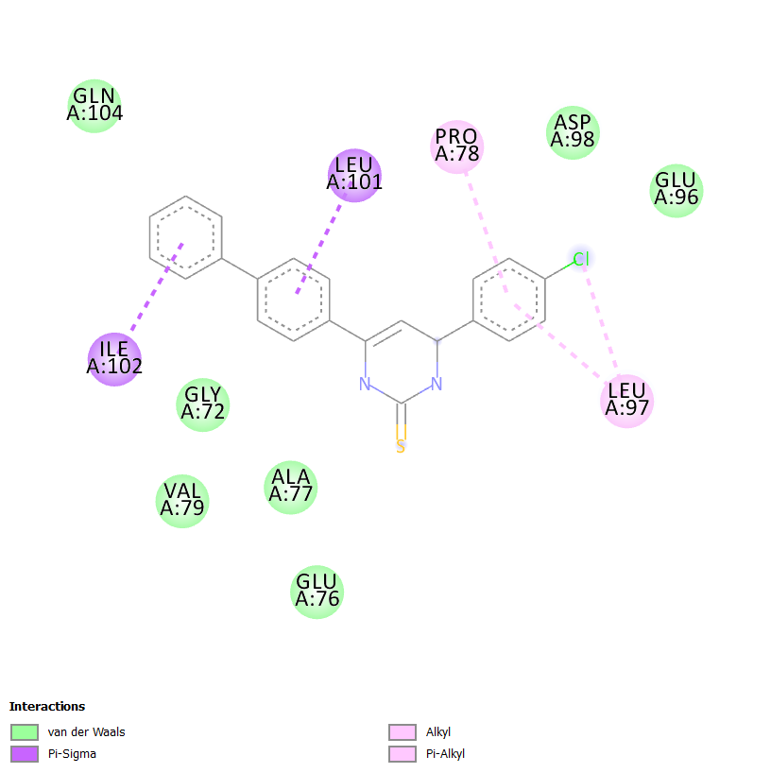 | 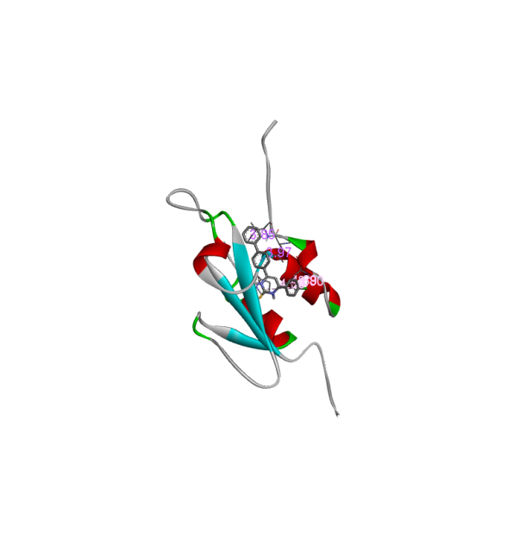
BCT-2 | 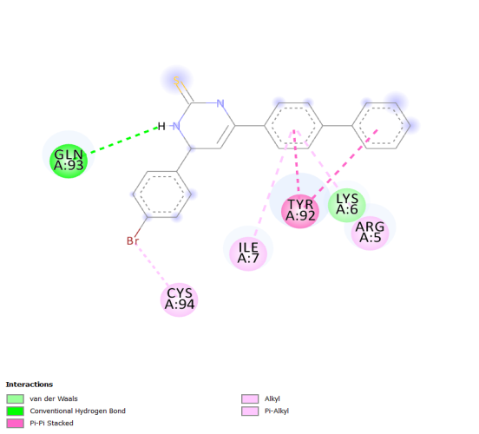 | 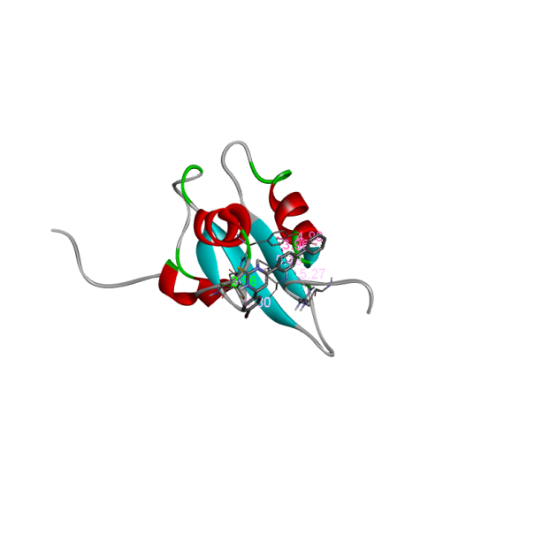
BCT-3 | 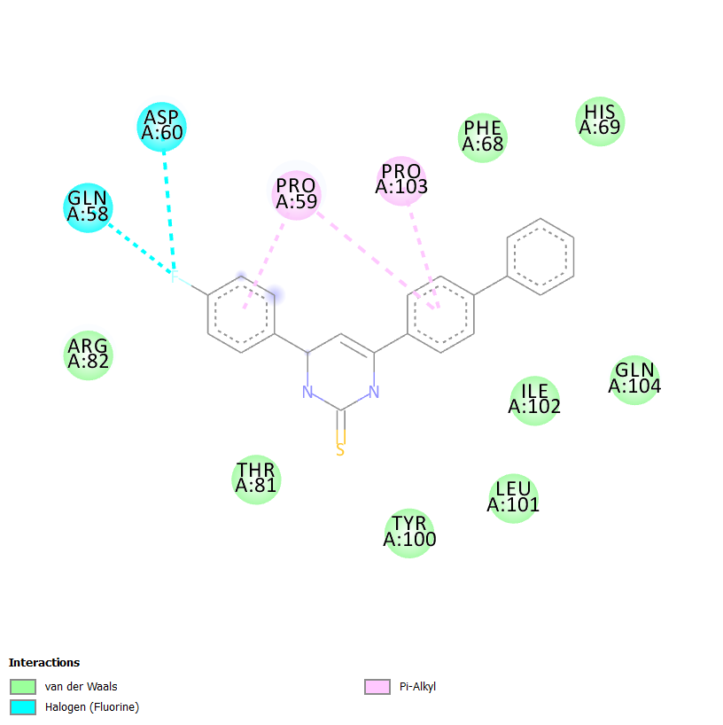 | 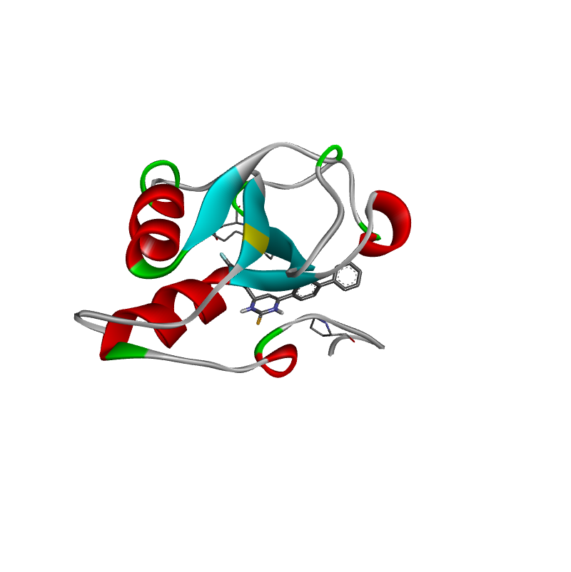
BCT-4 | 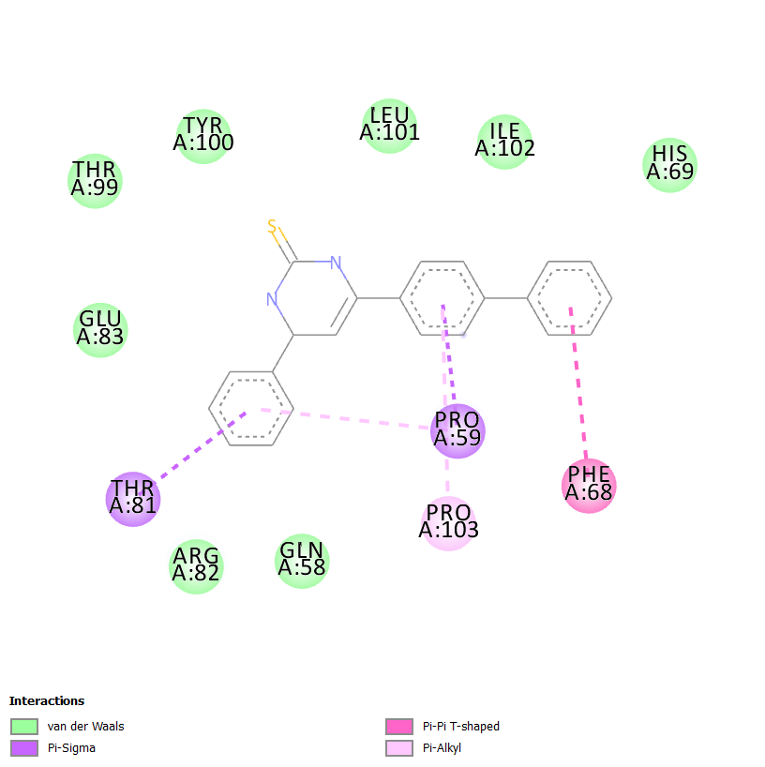 | 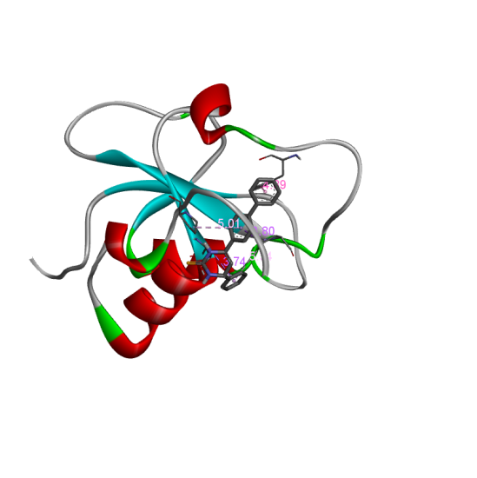
BCT-5 | 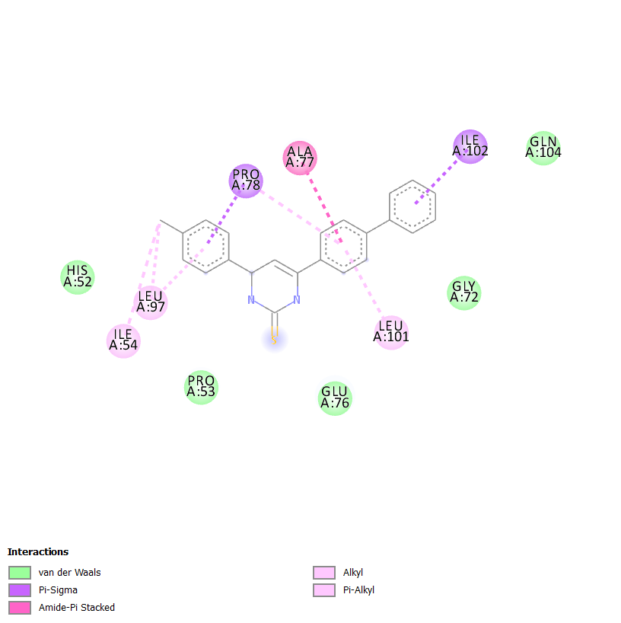 | 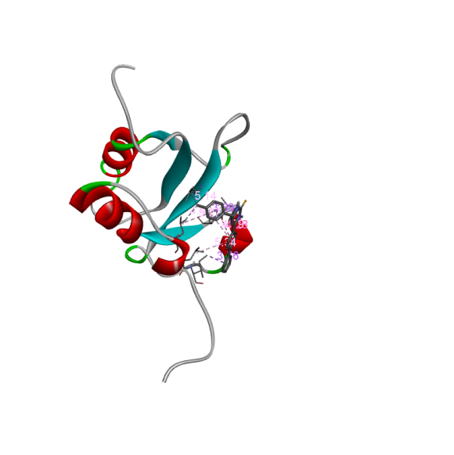
BCT-6 |  | 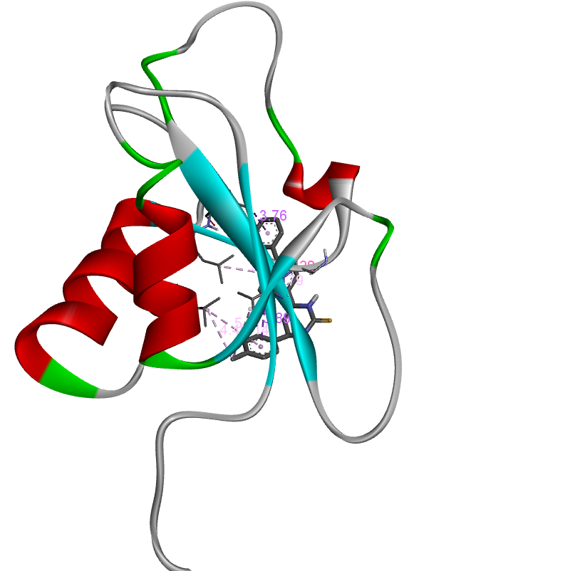
BCT-7 | 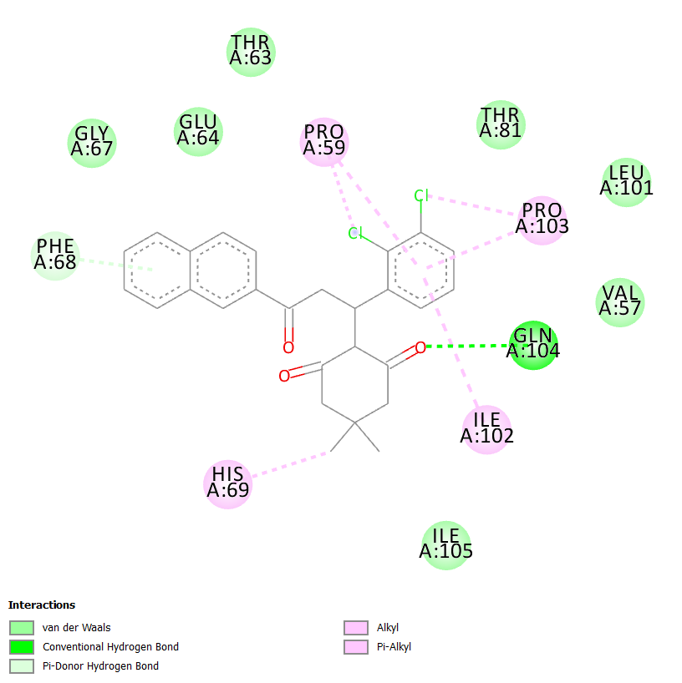 | 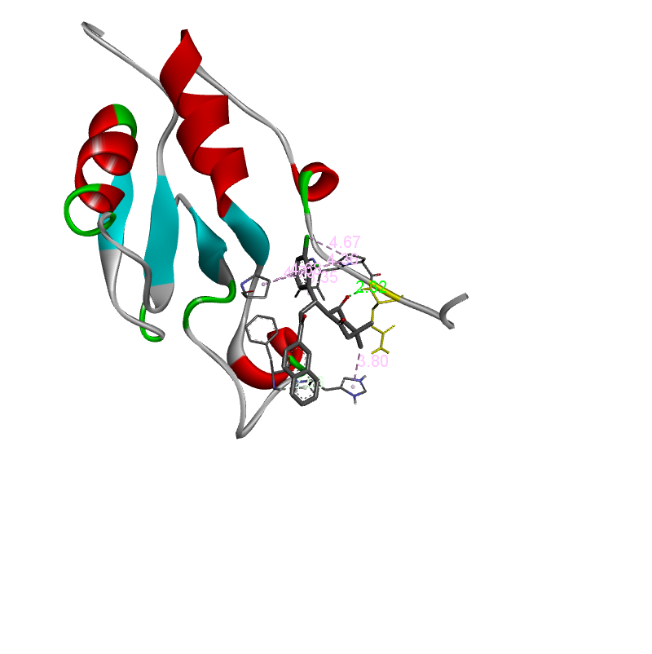
BCT-8 |  | 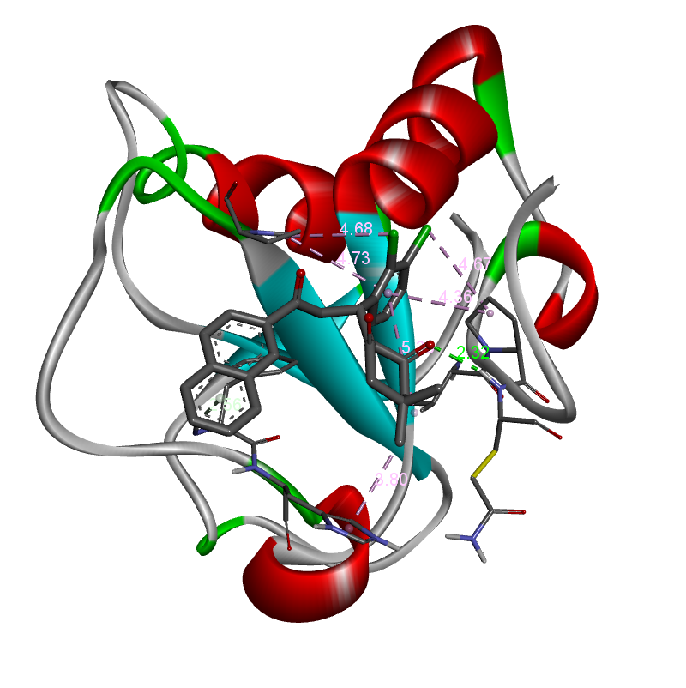

3.5. Antimicrobial activity:
Antibacterial activity
Antibacterial screening of synthesized derivatives (BCT 1-8) against Gram positive bacterial species: Staphylococcus aureus, Streptococcus pyogenes and gram negative species Escherichia coli, Pseudomonas aeruginosa. Antibacterial activity results (Table-6) particularly; compound BCT-3 (Fluoro substitution) exhibited good zone of inhibition (20 mm) against Staphylococcus aureus and Compound BCT-2 (Bromo substitution ) exhibited excellent zone of inhibition (24 mm) as compared with standard drug ciprofloxacin against Streptococcus pyogenes. Compound BCT-3 (Fluoro substitution) exhibited excellent zone of inhibition (24 mm) as compared with standard drug ciprofloxacin against E.coli. Compound BCT-3 has excellent zone of inhibition (25 mm) compared with standard drug against Pseudomonas aeruginosa. Finally, the antibacterial result, the electronegativity group (F & Br) has excellent activity. The reason is due to the presence of electronegativity group directly attached with Pyrimidine moiety of compound BCT-3 and BCT-4.The electron withdrawing group attached on the pyrimidine portion increased the antibacterial potential against S.pyogenes.
Antifungal activity
Antifungal screening of synthesized derivatives (BCT) against candida albicans species was done by agar disk diffusion method. Antifungal results indicated (Table-7) particularly compound BCT-3 shown more promising antifungal activity (14 mm) as compared with standard drug Clotrimazole (24 mm) while other derivatives are moderately active. The electron withdrawing group directly attached with Pyrimidine ring portion of compound BCT-3 increased the antifungal potential against C.albicans.

Table 11: Antibacterial activity of isolated compound (5a-5h) at 1.0 mg/ml.
Entry | Substituents | Bacterial strains |  |  |  | Fungal Strain
Entry | Substituents | Staphylococcus aureus | Streptococcus pyogenes | Escherichia  Coli | Pseudomonas aeruginosa | Candida albicans
BCT-1 | Cl | 15 | 21 | 18 | 16 | -
BCT-2 | Br | 14 | 24 | 16 | 17 | 14
BCT-3 | F | 20 | 22 | 24 | 25 | 16
BCT-4 | H | 16 | 24 | 20 | 16 | 13
BCT-5 | CH3 | 16 | 19 | 18 | - | -
BCT-6 | OCH3 | 17 | 18 | 17 | 16 | -
BCT-7 | FURAN | 16 | 16 | 17 | 20 | 11
BCT-8 | 2,3 DICHLORO | 16 | 17 | 16 | 10 | 10
Ciprofloxacin/Chlotrimazole | - | 26 | 17 | 19 | 22 | 24

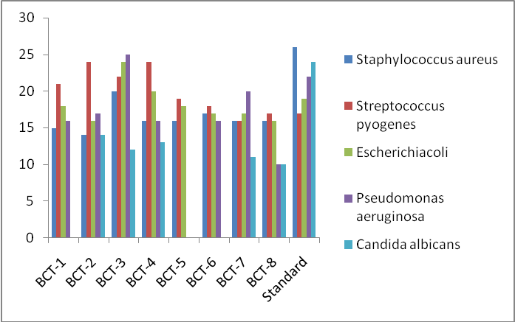
Figure 5: Antimicrobial activity of isolated compounds BCT 1-8
4. CONCLUSION
The structurally diverse compounds BCT 1-8 were synthesized using the cyclization method. The synthesized compounds were characterized by spectral data, and it was found in good agreement with the assigned molecular structures of the target compounds. The in vitro studies of synthesized compounds indicated that compound BCT-3 exhibited excellent activity against antibacterial and antifungal strains. The insilico docking studies were carried for the compounds BCT 1-8, and the result indicated that compound BCT-7 and 8 was the most active compound and have the maximum docking score value 8.3 kcal/mol. The in-silico ADME predictions were carried out for eight amino pyrimidine derivatives. These results confirmed that Lipinski rule of five were obeyed for the amino pyrimidine derivatives. So, we conclude that the compounds BCT 1-8 are lead compounds and are suitable to be drugs.

REFERENCES
1. Y.H. Zaki, M.S. Al-Gendey and A.O. Abdelhamid, Chem. Cent. J., 12,70 (2018);
https://doi.org/10.1186/s13065-018-0439-9
2. T.S. Straub, Tetrahedron Lett., 36, 663 (1995);https://doi.org/10.1016/0040-4039(94)02346-D
3. E.D. Bergmann, D. Ginsburg and R. Pappo, Michael Reaction, The Organic Chemistry, Wiley (1959).
4. S.R. Sandlar and W. Karo, Organic Functional Group Preparations, Elesvier: New York, edn 2 (2013).
5. Y.R. Prasad, A.L. Rao and R. Rambabu, J. Chem., 5, 461 (2008); https://doi.org/10.1155/2008/876257
6. S.N. López, M.V. Castelli, S.A. Zacchino, J.N. Domínguez, G. Lobo,J. Charris-Charris, J.C.G. Cortés, J.C. Ribas, C. Devia, A.M. Rodríguez and R.D. Enriz, Bioorg. Med. Chem., 9, 1999 (2001); https://doi.org/10.1016/S0968-0896(01)00116-X
7. B. Baviscar and S. Patel, Asian Res. Chem., 1, 67 (2008).
8. F. Herencia, M.L. Ferrandiz, A. Ubeda, J. Dominguez, J.E. Charris, G.M. Lobo and M.J. Alcaraz, Bioorg. Med. Chem. Lett., 8, 1169 (1998); https://doi.org/10.1016/S0960-894X(98)00179-6
9. X. Wu, P. Wilairat and M.-L. Go, Bioorg. Med. Chem. Lett., 12, 2299 (2002);
https://doi.org/10.1016/S0960-894X(02)00430-4
10. A. Agarwal, K. Srivastava, S.K. Puri and P.M.S. Chauhan, Bioorg. Med.Chem. Lett., 13, 6226 (2005);https://doi.org/10.1016/j.bmc.2005.06.052
11. T. Narender, T. Khaliq, Shweta, Nishi, N. Goyal and S. Gupta, Bioorg.Med. Chem., 13, 6543 (2005);https://doi.org/10.1016/j.bmc.2005.07.005
12. J.-H. Cheng, C.-F. Hung, S.-C. Yang, J.-P. Wang, S.-J. Won and C.-N.Lin, Bioorg. Med. Chem., 16, 7270 (2008); https://doi.org/10.1016/j.bmc.2008.06.031
13. Y.-M. Lin, Y. Zhou, M.T. Flavin, L.-M. Zhou, W. Nie and F.-C. Chen,
Bioorg. Med. Chem. Lett., 10, 2795 (2002); https://doi.org/10.1016/S0968-0896(02)00094-9
14. P.M. Sivakumar, S.P. Seenivasan, V. Kumar and M. Doble, Bioorg. Med.
Chem. Lett., 17, 1695 (2007); https://doi.org/10.1016/j.bmcl.2006.12.112
15. M.Z. Gibson, M.A. Nguyen and S.K. Zingales, Med. Chem., 14, 333
(2018); https://doi.org/10.2174/1573406413666171020121244
16. U.M. Kocyigit, Y. Budak, M.B. Gurdere, F. Erturk, B. Yencilek, P. Taslimi, I. Gülçin and M. Ceylan, Arch. Physiol. Biochem., 124, 61 (2018); https://doi.org/10.1080/13813455.2017.1360914
17. V. Kanagarajan, M.R. Ezhilarasi and M. Gopalakrishnan, J. KoreanChem. Soc., 55, 256 (2011);https://doi.org/10.5012/jkcs.2011.55.2.256
18. K. Vijayakumar, M.R. Ezhilarasi and M. Goplakrishnan, Org. Med. Chem. Lett., 1, 8 (2011);
https://doi.org/10.1186/2191-2858-1-8
19. C. Zhuang, Wen Zhang, C. Sheng, W. Zhang, C. Xing and Z. Miao, Chem Rev., 117, 7762 (2017); https://doi.org/10.1021/acs.chemrev.7b00020
20.. A. Ansari, A. Ali, M. Asif and S. Shamsuzzaman, New J. Chem., 41, 16 (2017);
https://doi.org/10.1039/C6NJ03181A
21. D.J. Brown, Pyrimidines and their benzo derivatives, in: A.R. Katritzky, C.W. Rees (Eds.), Comprehensive Heterocyclic Chemistry, vol. 3, Pergamon Press, Oxford, 1984, pp. 57-155, http://dx.doi.org/10.1016/B978-008096519-2.00035-7.
22. S. Achelle, N. Ple, Pyrimidine ring as building block for the synthesis of functionalized-conjugated materials, Curr. Org. Synth. 9 (2012) 163-187, http://dx.doi.org/10.2174/ 157017912799829067.
23. A Attanasi Orazio, Domenico Spinelli, Targets in Heterocyclic Systems vol. 17, Italian Society of Chemistry, 2013, pp. 1e37. https://hal-univ-rennes1.archives-ouvertes.fr/hal-01059402.
24. Sylvain Achelle, Samia Kahlal, Alberto Barsella, JeanYves Saillard, Xiaoyang Che, et al., , Elsevier 113 (2015) 562-570, http:// dx.doi.org/10.1016/j.dyepig.2014.09.028. .
25. S. Ebtehal, Y. Al-Abdullah, C. Sheena Mary, Yohannan Panicker, Nasser R. El-Brollosy, Ali A. El-Emam, Christian Van Alsenoy, Abdulaziz A. Al-Saadi, Spectrochim. Acta Part A Mol. Biomol. Spectros. 133 (2014) 639-650, http://dx.doi.org/ 10.1016/j.saa.2014.06.042.
26. A.R. Ali, E.R. El-Bendary, M.A. Ghaly and I.A. Shehata, Eur. J. Med.Chem., 75, 492 (2014); https://doi.org/10.1016/j.ejmech.2013.12.010
27. R. Chinnamanayakar, E. Mr, P. B and K. M, Asian J. Pharm. Clin. Res.,12, 311 (2019);
https://doi.org/10.22159/ajpcr.2019.v12i3.30481
28. A.M. Vijesh, A.M. Isloor, S. Telkar, T. Arulmoli and H.-K. Fun, Arab.J. Chem., 6, 197 (2013); https://doi.org/10.1016/j.arabjc.2011.10.007
29. E. Ashry, Z. Din, Z. Soomro, W. Rahman, M. Shah, Y. Kilany, L.Naesens and A. Boraei, Lett. Org., 11, 168 (2014); https://doi.org/10.2174/1570178610666131118222358
30. J.C. Dearden, Exp. Op. Drug Disc., 1, 31 (2006); https://doi.org/10.1517/17460441.1.1.31
31. F. Lombardo, E. Gifford and M. Shalaeva, Mini Rev. Med. Chem., 3,861 (2003); https://doi.org/10.2174/1389557033487629
32. S. Kulkarni, J. Zhu and S. Blechinger, Xenobiotica, 35, 955 (2005);
https://doi.org/10.1080/00498250500354402
33. J. Gola, O. Obrezanova, E. Champness and M. Segell, QSAR Comb.Sci., 25, 1172 (2006);
https://doi.org/10.1002/qsar.200610093
34. S.R. Johnson and W. Zheng, AAPS J., 8, 27 (2006); https://doi.org/10.1208/aapsj080104
35. J.C. Dearden, J. Comput. Aided Mol. Des., 17, 119 (2003); https://doi.org/10.1023/A:1025361621494
36. D.F.V. Lewis, Y. Ito and P.S. Goldfarb, Drug Dev. Res., 66, 19 (2005);
https://doi.org/10.1002/ddr.20040
37. C. de Graaf, N.P.E. Vermeulen and K.A. Feenstra, J. Med. Chem., 48,2725 (2005);
https://doi.org/10.1021/jm040180d
38. J.C. Dearden, Expert Opin. Drug Metab. Toxicol., 3, 635 (2007);
https://doi.org/10.1517/17425255.3.5.635
39. A. Ali, M. EI Badawy, R. Shah, W. Rehman, Y. EI kilany, E.S.H. EI Ashry and N. Tahir, Der Chemica Sinica, 8, 446 (2017).
40. Molinspiration Cheminformatics Brastislava, Slovak Republic, available from: http://www.molinspiration.com/egibin/properties,2014.
41. M.H. Shaikh, D.D. Subhedar, L. Nawale, D. Sarkar, F.A.K. Khan, J.N.Sangshetti and B.B Shingate, Med. Chem. Commun., 6, 1104 (2015);https://doi.org/10.1039/C5MD00057B
42. Y.H. Zhao, M.H. Abraham, J. Le, A. Hersey, C.N. Luscombe, G. Beck,B. Sherborne and I. Cooper, Pharm. Res., 19, 1446 (2002); https://doi.org/10.1023/A:1020444330011
43. S. Singh, A.K. Gupta and A. Verma, Res. J. Pharm. Biol. Chem. Sci., 4,
876 (2013).

