Integration of Renewable Energy and Electric Vehicles

V.V.Sai Santoshi
Department of EEE
Vignan’s Institute of Engineering for Women
Visakhapatnam, India
santo.appi@gmail.com

P.Suresh Kumar
Department of EEE
Vignan’s Institute of Information Technology
Visakhapatnam, India
suresh0260@gmail.com

ABSTRACT
This paper presents the benefits of EV’s with conventional IC vehicles. Along with that we discuss about various Motor drive technologies (MDT), Battery charging technologies (BCT),Energy source technologies, configurations of EV’s and HEV’s. Based on the dynamic modeling of EV’s we reduce the tractive effort on the Electric vehicles.
Keywords— Electric vehicles (EV’s), Hybrid Electric Vehicles (HEV’s), Internal Combustion Engine (IC Engine).

INTRODUCTION

Globally, it appears that the population has been growing, and in 2050, it will be over 10 billion. And if every single one of these vehicles has an I.C. engine, then severe air pollution and smog will be present in every city. According to the Air Research Board, this causes health harm and causes almost 9000 deaths in California each year from small air dust particles. So, adopting EVs and HEVs is the only viable method to lower this. So, in light of the advantages of EVs, we research dynamic modeling of electric vehicles in order to create an effective hybrid electric vehicle that uses less energy, is more efficient, and emits less pollutants.
Depending on the energy sources, propulsion systems, and energy carriers that are used to transport energy from the energy sources to the propulsion systems, electric vehicles can be divided into many types.

Classification of EV’s based on different input methods

Table1: Classification of EV’s

The below table shows the classification of various Electric Vehicles based on the input given
 | Propulsion type | Energy carriers | Energy sources
Micro Hybrid EV’S | IC Engine + motor | Liquid fuel+ Electricity | Liquid fuels+ Battery
Mild Hybrid EV’S | IC Engine + motor | Liquid fuel+ Electricity | Liquid fuels+ Battery
Full Hybrid EV’S | IC Engine + motor | Liquid fuel+ Electricity | Liquid fuels+ Battery
Plug in Hybrid EV’s | IC Engine + motor | Liquid fuel+ Electricity | Liquid fuels+ Battery
Range Extended EV’s | IC Engine + motor | Liquid fuel+ Electricity | Liquid fuels+ Battery
Battery EV’s | Electric motor | Electricity | Battery
Ultra fly wheel EV’s | Electric motor | Electricity | Ultra fly wheel
Ultra capacitor EV’s | Electric motor | Electricity | Ultra  capacitor
Fuel cell and Battery EV’s | Electric motor | Hydrogen | Fuel cell

The below-shown diagram explains the general layout of a battery-electric vehicle. A battery bank in a BEV is charged using a battery charger directly from the grid. An electric drive, which comprises of a power converter and an electric machine through a transmission gear system, transmits the electrical energy stored to the wheels. To be able to regenerate power from the wheels when braking, the power converter is built to carry bidirectional power flow. Additionally, not needed in a BEV is a clutch mechanism.
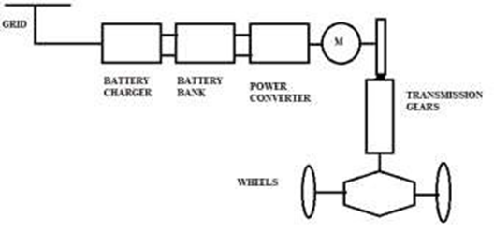
Fig 1: Typical Battery Electric Vehicle
A fuel cell that is coupled to a hydrogen tank serves as the energy source for the fuel cell electric vehicles (FCEVs) in this design. In order to increase the voltage output from the fuel cell and charge the battery, a boost converter is needed. The purpose of the battery bank in this scenario is to support the transient mechanical energy needs of the EVs while enabling fuel cells to operate at their maximum efficiency. Due to the regenerative braking mechanism, it stores energy during braking.
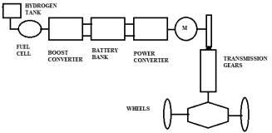

Fig 2: Typical Battery Electric Vehicle with Fuel cell

Fig 2: Typical Battery Electric Vehicle with Fuel cell

The mechanical energy is transferred to a conventional IC-based engine vehicle in motor drive technology. IC engines need a clutch and multiple gear transmission system to achieve varied speeds at variable torques because they cannot function at their own speed and torques directly. Therefore, when the clutch is engaged, the gear box helps transfer energy from the IC engine to the wheel. The clutch is disengaged and the gears are altered to accommodate varying speeds and torques. The image below depicts a typical IC engine-based car.

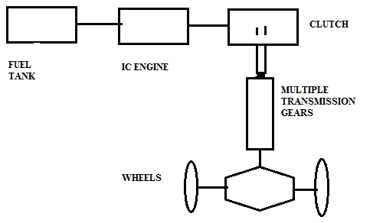
Fig 3: Motor Drive Technology
As can be seen from the force-speed characteristics of a five-gear IC engine, the torque is greater at low gear while the speed is lower, and the opposite is true at high gear when the torque is lower and the speed is greater.
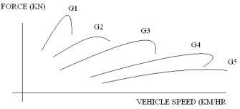

Fig 4: Force-speed characteristics of a 5 gear IC Engine
The force-speed characteristics of a battery-electric vehicle with a fixed gear system demonstrate that the electric motor readily provides high torque at startup and permits high speed in the zone of low torque. No gearing or clutch system is necessary to complete this process.

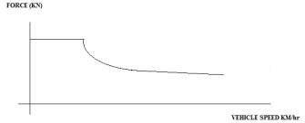
Fig 5: Force-speed characteristics of a BEV
High torque density, high power density, a wide speed range at constant torque and power regions, high efficiency, dependability, and robustness are the main requirements for an EV.
Batteries, ultracapacitors, ultra-flywheels, and fuel cells are among the different energy sources employed by electric and hybrid cars. In contrast to batteries, which are electrochemical devices that store energy in electrical form, ultra capacitors, whose capacitance values are extremely high, store high levels of energy in electrostatic form. A high-speed electric motor that stores energy as kinetic energy is employed in ultra fly wheels. Hydrogen is used as the fuel in fuel cells, which then store energy as electricity.
Batteries of all kinds, including lead acid, nickel cadmium, nickel zinc, zinc air, sodium nickel chloride, lithium ion, and others, are used in electric vehicles. Our comparison of these batteries is therefore based on their specific energy, specific power, life cycle, cost, and safety.
In order to compare energy source technologies the ideal technique to plot specific energy vs specific power is using a Ragone plot, where specific energy represents the driving range per charge and specific power represents the vehicle's acceleration rate.

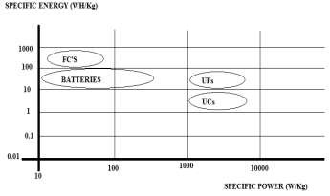
Fig 6: Ragone plot
Electric vehicle (EV) charging can be done using four basic techniques, which mostly depend on the voltage, current, power, and charging time levels. In typical charging techniques, a single phase system with voltage ranges of 110 to 240V, current ratings of 13 to 20Amps, and power levels of 2 to 4kW is used. Usually, homes, garages, and residential parking spaces employ this kind of system. Charge time ranges from five to eight hours.
Opportunity charging is a different sort of charging that uses a three-phase system with voltages of 110 to 240V, current ratings of 32 to 80 Amps, and power ranges of 8 to 20kW.
A method for charging EVs that uses a DC system with voltage levels of 200 to 450 volts, current ranges of 80 to 200 amps, and power levels of 30 to 90 kW is known as fast charging. The charging process takes 20 to 30 minutes.
Conductive type charging and wireless charging are the two different ways to charge batteries. The wired way of charging is straightforward, inexpensive, and very effective, but a major drawback is that cables must be carried and there is a risk of electric shocks. Therefore, we chose wireless charging, which has a high installation cost but is convenient and shockproof. There are two main approaches to wireless power transfer: far field strategies and near field strategies.
According to Newton's second rule, if a vehicle is moving dynamically, a variety of forces will operate on it, causing it to move dynamically. The traction and propulsion units provide the vehicle's main driving forces. Air friction, gravitational force, and wheel friction are a few of the forces that prevent a vehicle from moving. As a result, the vehicle's final acceleration is determined by the mass of each component and its traction component. Vehicle dynamics is a crucial and essential component of vehicle design, so we use a two-level approach because the system is complex and enormous. Thus, modeling vehicle dynamics is an iterative process that may be done in two different ways: longitudinal vehicle dynamics and lateral vehicle dynamics.
The longitudinal dynamics of the vehicle must be determined while it is moving in one dimension, but the lateral dynamics of the vehicle must be calculated when it is moving in many dimensions. It is sufficient to comprehend the first, or longitudinal, vehicle dynamics, for a low-speed vehicle. For good vehicle control and road handling, however, while we are aiming for very high-speed operation, we also need to understand the lateral vehicle dynamics.
The drive axel and wheels convey the force that is pushing the car forward to the ground. So let's imagine a vehicle with mass M that is traveling at speed v while sloping at an angle theta. The force needed to overcome rolling resistance, which is the resistance provided by the resistance of the road and the resistance of the tires, is thus equivalent to the normal electric tractive effort that must be achieved.

Aerodynamic drag is another obstacle the vehicle must overcome. Hence, this is the air pressure-related opposing force. Thirdly, everyone is aware that when traveling up a slope, such as a flyover or a hill, the bulk of the vehicle will work against the driving power. The motion is therefore opposed by something akin to a gradient force, which must also be overcome. Furthermore, the tractive effort must produce the necessary forces if the vehicle wants to accelerate. As a result, this force is not present while the vehicle is moving at a constant speed.
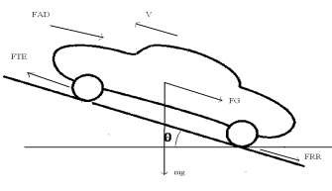
The total tractive effort which we will denote as F_{TE} is equal to the gradient force because of the weight of the vehicle which is F_{G}
F_{G}= mg sinθ
The opposing force due to air which is coming from the front of the vehicle because of the velocity of the vehicle that is moving up is known as force due to air drag or aerodynamic drag.
Also, the vehicle has to provide force due to tire friction or road friction which is generally termed as Frr or F rolling resistance. So, this tractive effort F_{TE} has to support all these forces that is Fg which is forced to gradient, Frr which is force due to rolling resistance, F_{AD} which is force due to aerodynamic drag and also acceleration if there is a change in vehicle speed.
The resistive force acting on the vehicle when it is moving at a velocity through air is called Aerodynamic Drag F_{AD} .
F_{AD} = 0.5 ρC_{D} A(V+V_{Air})²
Where F_{AD} = Aerodynamic drag force
ρ = Density of air
C_{D} = Aero dynamic drag coefficient
V= Forward velocity of air
V_{Air} = opposing air velocity
A= Frontal Area
Aero dynamic drag coefficient depends upon the shape of the vehicle so the design of electric vehicle is important for reducing drag coefficient
The aero dynamic drag power required
P_{AD} = F_{AD} *V
The aero dynamic drag Energy
E_{AD} α V²
Rolling resistance force (F_{RR}) the effect of the tire resistance and the road resistance on electric vehicle this force is due to the deformation of the tire on the road surface when the vehicle is moving
F_{RR} = µ_{RR} mgcosθ
Where µ_{RR} = coefficient of rolling resistance
m = mass of the vehicle
g = gravitational force
The gradient force acting on the vehicle when it is moving up the hill is
F_{G} = mg sinθ

Force due to linear acceleration
F_{LA} = ma
Force due to Angular acceleration
F_{AA} = Ja/r²
The total Tractive effort of the vehicle is given as
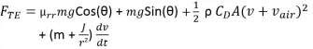
F_{TE} = F_{RR} + F_{R} + F_{AD} + F_{LA} + F_{AA}

III. Integration of Renewable Energy with Electric Vehicles

The effort to reduce the emissions of greenhouse gases that are warming the planet and to save fossil fuels, which are becoming more and more valuable, has prompted a significant increase in the installation of renewable energy installations in recent years. Additionally, the price of photovoltaic systems is getting cheaper every year. As a result, it is predicted that photovoltaic power will become more affordable in the future.
The widespread use of EVs has the potential to have a variety of effects and advantages, including the ability to help integrate renewable energy into the existing electrical grids.

Vehicles and Energy Sources
A massive battery will be utilized to store the electricity from the grid, which will then be used to power the electric vehicle (BEV). The performance of ICEVs using conventional gasoline is 15–18%, whereas the performance of BEVs is 60–70%. Compared to ICEVs, EVs consume substantially more resources. Another sort of electronic vehicle are fuel cell vehicles (FCVs), which produce power in a fuel cell stack using an electric method. FCVs can either be equipped with hybrid batteries like those seen in HEV or PHEV with an onboard fuel source like diesel or hydrogen, or they can be completely reliant on the pump. If hydrogen is produced by electrical electrolysis of water by RE or biomass sources, then the renewable sources are used for FCVs. Future hydrogen economic visions also involve the transportation of FCVs. There are still several obstacles preventing the development of a sustainable hydrogen economy, despite the fact that the vast majority of hydrogen produced worldwide is created from fossil fuels. Additionally, even though hydrogen produced through electrolysis represents a sizable future application of renewable energy, the transition to a hydrogen economy is a complex topic that is beyond the scope of this essay. If sustainable biofuels can replace conventional transportation fuels like ethanol and biodiesel, HEVs can also be produced from RE sources. Both PHEVs and BEVs may utilize all of the renewable energy from the grid, enabling PHEVs to use biofuels in their internal combustion engines.

Grid Connections and Charging system
The numerous grid-based charging options can be used to recharge an electric vehicle's battery. A gadget with a basic or unrestricted charge plan allows the vehicle to begin charging before connecting to the grid right away.
A charging schedule that staggers by, say, three hours will counteract the battery charge. When charging at night, the intention is to suspend the process when power costs are lower and batteries are fully charged in the morning. The utility or device operator controls the intelligent charging of vehicles intelligently. Either direct charging or indirect charging is possible.
When charging is done intelligently, the vehicle begins when it is most advantageous. And this might happen after there is extra capacity, little demand, and low electricity prices. The driver-set parameters may affect the rate, but the main constraint is that the vehicle must be fully charged by morning.
A V2G enabled EV is one that has the ability to store energy or return it to the electrical grid. The intriguing idea of Power V2G was first put up by Kempton or Letendre. The authors suggested that if power is used to provide beneficial services to the grid in such circumstances, V2G can be used to make a profit for owners. When there is a need, a V2G-capable electrical system will re-enter the grid and store the renewable energy from the low demand.

Conclusion
If the right technology is used, the introduction of EVs may expect a specific range of positive consequences, such as cheaper vehicle operating costs, lowered CO2 emissions, as well as supporting and increasing grid power and stability. The ability of EVs to aid in the integration of RE sources into the power grid, however, is perhaps significant. Carbon emissions from either energy production or transportation could be decreased as a result. It should be noted that while though EVs can greatly lessen the negative effects of widespread RE, other techniques & technologies are likely needed to account for the high level of the RE penetration. The grid could gain from EVs' potential benefits as well as the addition of intermittent RE sources. It is important to comprehend the potential, constraints, and effects of combining the transport sector with the production of electricity from renewable sources. This will have an impact on policies and infrastructure development to maximize the environmental and economic benefits of these breakthroughs while lowering global greenhouse gas emissions and fossil fuel dependence. PEV benefits system providers, car owners, and the environment. If given enough on-board power, energy storage connections, and digital charger control circuitry, PEVs can function as tools for storing energy and as a reservoir for the prevention of unplanned outages. It promotes the use of PEVs faster and is better for the environment.

REFERENCES

[1] IEA(2009).Technology Roadmap – Electric Vehicles and plug-in hybrid electric vehicles. Report 2009.
[2] SANDIA REPORT Energy Storage for the Electricity Grid: Benefits and Market Potential Assessment Guide. A
Study for the DOE Energy Storage Systems Program, 2010
[3] Daimler, RWE (2009).Communication Protocol between Electric Vehicles and Charging Units.
[4] N.Rotering, M.Ilic: “Optimal Charge Control of Plug-In Hybrid Electric Vehicles in Deregulated Electricity Markets”, IEEE Transactions on power systems, August 2011
[5] Jones , W.D., "Hybrids to the rescue [hybrid electric vehicles]", IEEE Spectrum, Vol. 40(1) , 2003, pp. 70 - 71.
[6] Jones, W.D., "Take this car and plug it [plug-in hybrid vehicles]", Spectrum, IEEE, Vol. 42, Issue 7, July 2005, pp.10 – 13
[7] Chan, C.C. The Present Status and Future Trends of Electric vehicles, Science and Technology Review , Vol. 23, No.4, Feb 2005
[8] K.W.E.Cheng, "Tapped inductor for switched-mode power converters", 2 Int. Conference on Power Electronics Systems and Applications, 2006, pp. 14-20

