Kallikrein related peptidases as Angiogenic targets for Breast and Prostate Cancer
Bandi Jyothi
Assistant professor, Department of chemistry
Govt. Degree College for Women Autonomous, Nalgonda, 508001
Telangana State, India
b.jyothi8790@gmail.com

Navaneetha Nambigari
Assistant professor, Department of chemistry
University College of science, Saifabad, Osmania University, Hyderabad, 500007
Telangana State, India
nitha379@gmail.com, navaneeta@osmania.ac.in

ABSTRACT
The largest cause of death and a serious global public health issue, according to research, is cancer. Cancer is characterized by unrestricted tumor cell growth. The growth and metastasis (penetration and proliferation) of malignant tumors depend on angiogenesis, the sprouting of new blood vessels from pre-existing ones. Endothelial cells move and develop during this process as angiogenic factors interact with receptors to release enzymes that break down the endothelial cell matrix. As a result, angiogenic elements continue to create new blood vessel networks. It is found that Kallikrein related peptidases KLK-12, KLK-14 and KLK-15 proteins are considered as novel targets against tumor angiogenesis. They act through cleavage of Extra Cellular Matrix (ECM) proteins directly or indirectly through Matrix Metallo Proteinases (MMPs) activation via the Urokinase Plasminogen Activator/ uPA Receptor (uPA/ uPAR) signaling pathway. Angiogenesis is the primary driver of malignant development. In an effort to develop a cancer treatment, researchers from all around the world are currently focused on tumor angiogenesis. Thus kallikrein related peptidases are considered as the angiogenic targets against various cancers.
Keywords—Angiogenesis, Prostate cancer, Kallikrein related peptidases

- INTRODUCTION
Angiogenesis, a biological process in which new blood vessels are created from pre-existing ones, has been connected to the growth and development of tumors [1, 2]. Researchers are investigating at innovative routes to stop tumor angiogenesis because blood circulation is a requirement for nutrition supply and tumor development. A number of mechanisms that initiate and maintain the growth of tumors have been connected to abnormal blood vessel development [3-5]. Numerous disorders, including tumor growth and cancer, are linked to aberrant angiogenesis. Cancer, rheumatoid arthritis, diabetic retinopathy, psoriasis, and AIDS complications are caused by excessive angiogenesis. Stroke, heart disease, ulcers, scleroderma, and infertility are caused by insufficient angiogenesis [6–13].
Cancer metastasis requires angiogenesis. In malignant tumors, angiogenesis is crucial to the spread of cancer [14]. A series of signaling processes involving biomolecules including vascular endothelial growth factors (VEGFs), kallikreins (KLKs), and several other angiogenesis factors are crucial in the development of tumor angiogenesis [15, 16].
The angiogenic signaling molecules activate the endothelial cells in the vicinity, encouraging the development of new capillaries and speeding up the growth of vascular endothelial cells, which helps supply the tumor with nutrients and oxygen [17, 18]. During the tumor angiogenesis process, the tissues basement membrane is breached, hypoxia results. Endothelial cells are then activated, which causes them to proliferate through the over expression of angiogenesis factors [19–21]. Thus angiogenesis plays a significant role in tumor formation, and makes for an intriguing approach to the development of new cancer drugs [22].In the US, 1.9 million additional cases and 609,360 cancer-related deaths are anticipated by 2022, or over 1,670 fatalities every day [23].Cancer therapy refers to the use of surgery, radiation, drugs, and other therapies to treat or slow the spread of cancer. There are several cancer treatment options at hand. One treatment or a combination of treatments may be given to a patient, depending on their unique circumstances. Chemotherapy, surgery, radiation, and targeted therapy are only a few of the procedures used today to treat cancer [24].
Chemotherapy is a process in which chemical substances are utilized to destroy all dividing cells. It is not intended to replace any particular medication. It can cause exhaustion, vomiting, diarrhea, nausea, anemia, infections, loss of taste, and a breakdown in the immune system [25-27]. It continues to be a well-liked therapeutic choice for cancer patients. The purpose of surgery is to remove a tumor or an entire organ [28]. Surgery's drawback is that the patient must be in good physical and mental health, able to endure the procedure and anesthesia despite minor health issues, and not allowed to use certain medications. Radiation therapy uses a higher-energy proton beam to destroy tumor cells. Both malignant and healthy cells are harmed by radiation [29–31]. Despite advances in anticancer drugs for a range of cancers, resistance to both conventional chemotherapy and targeted therapies continues to be a major worry. Drug resistance, which can be innate or acquired, is what leads to treatment failure and tumor progression. Drug resistance may develop as a result of actions taken by specific cancer cells or by tumor microenvironment-related mechanisms [32]. Drugs that inhibit angiogenesis can promote the tumor vasculature's restoration to normal operation. At the moment, scientists all around the world are focusing on tumor angiogenesis in the hopes of finding a cure for cancer [33]. In order to increase the efficacy of cancer therapy, new potent, target-specific cancer drugs are urgently required [34]. Finding lead compounds that target cancer yet have few negative effects on the body's healthy cells is essential.
Drugs were discovered the conventional method after years of research, either by discovering the active site in conventional medicines or by chance, and the creation of new drugs is based on a blind screening process [35]. Because of the limitations of conventional drug discovery techniques, rational approaches to drug identification have been developed. The area of medicinal chemistry depends heavily on the discovery of novel drugs and therapeutic molecules. It is necessary to identify and target novel therapeutic targets, such as cancer-causing proteins, and to explore novel biochemical pathways. Computer-aided drug design (CADD) has become increasingly popular in pharmaceutical research and development, to design and develop innovative drugs for varying medical conditions [36-42].
Based on the abnormal biological activity compared to that of a normal cell, angiogenesis-targeted treatments have been identified focusing on certain receptors [43]. Two potential benefits of anti-angiogenic therapy over conventional chemotherapy include the absence of drug resistance and negligible adverse effects on normal tissues. People nevertheless experience the symptoms of the sickness despite certain promising chemotherapeutic medications, prompting to the development of modern remedies.
Current cancer treatments either fail to stop the growth of tumors or are extremely harmful to both healthy and cancerous cells. Since anti-angiogenic drugs are not intended to kill cells but rather to prevent the growth of blood vessels, they have advantages over conventional chemotherapeutics [44].

- KALLIKREIN RELATED PEPTIDASES (KLK’s) AS THE ANGIOGENIC ACTIVATORS FOR CANCER
Angiogenesis, the sprouting of new blood vessels from pre-existing surrounding blood vessels, is essential for the growth and metastasis of cancerous tumors [45, 46]. As a result of inputs from the tumor cells and their surrounds, activator molecules control angiogenesis. This is essential because the development of cancer depends on an adequate supply of nutrients and oxygen, which is made possible by newly created blood vessels [47]. For the purpose of developing medications to treat cancer, the process underlying the growth of tumors must be understood. By forming new blood vessels through a number of different mechanisms, angiogenic activator proteins play a significant role in a number of malignancies. Kallikrein Related peptidases (KLK’s) are acting as the angiogenic activator proteins [48]. KLK proteins play a key role in various cancers by the formation of new blood vessels involving various pathways. The drug design method using KLK protein as drug targets is a novel strategy in cancer research.
The two forms of kallikrein proteins found in the human body are tissue and plasma kallikreins. The pathological angiogenesis is aided by the tissue kallikreins (KLKs). Genetic material located on chromosome 19q13.4 encodes KLKs. It's interesting to note that the genetic region (known as KLKB1) that codes for the plasma kallikrein enzyme is found on chromosome 4q34-35. Despite not being a member of the KLK family, this enzyme is still referred to as plasma kallikrein [49].
The symbols for the kallikrein gene and protein are KLK (italicized) and KLK (standard font), respectively [50]. There are 15 different proteases that can be found in tissue kallikreins (KLK-1 TO KLK-15). The 15 KLKs are single proteins with 244–282 amino acid residues that are said to share 40% of their amino acid sequences with other KLKs. The first tissue kallikrein to be fully understood was designated as KLK-1; the remaining kallikrein-related proteases are represented as KLK-2 to KLK-15 [51, 52]. The 15 human KLKs are pre-pro enzymes that are conserved serine peptidases. An amino-terminal signal as Pre sequence; Pro indicates a pro-peptide as an inactive zymogen; and a serine-peptidase domain, which is responsible for its biological activity [53, 54].
The human tissue kallikreins KLK-12, KLK-14, and KLK-15 proteins are regarded as novel proteins in the current study against tumor angiogenesis. These serine proteases are known to express in numerous cancer forms. Kallikrein proteins promote angiogenesis and tumor growth through direct or indirect biological pathways. Through direct cleavage of Extra Cellular Matrix (ECM) proteins, KLKs cause tumor angiogenesis. Or by activating Matrix Metallo Proteinases (MMPs) through the Urokinase Plasminogen Activator/ uPA Receptor (uPA/ uPAR) signaling pathway, they can also indirectly stimulate tumor growth [55, 56]. Therefore, inhibiting angiogenesis through the KLK cascade may offer a potential clinical diagnosis to increase cancer patient survival. Figure 1 depicts the general biochemical route used by KLK proteins.
KLK-12 Protein:
Kallikrein related peptidase -12 (KLK-12), is a protein that resembles kallikrein, was found to be highly expressed in breast cancer tissues [57]. It is a trypsin-like serine peptidase. By cleaving signaling proteins linked to the Extra Cellular Matrix, angiogenesis is initiated. Figure 2 shows that the Cysteine Rich Angiogenic Inducer 61 (CYR61) protein, a component of the ECM, is destroyed through the action of the KLK-12 protein. CYR61 then causes angiogenesis by releasing Vascular Endothelia Growth Factor (VEGF), Fibroblast Growth Factor -2 (FGF-2), and Transforming Growth Factor beta(TGF-β) intact from its complex [58]. Experimentally, it was discovered that blocking KLK-12's biological function reduced the production of new blood vessels by microvascular endothelial cells [59, 60]. Because of this, the study identified the KLK-12 protein as an unique target for finding new, tiny molecules that may be a lead in the fight against angiogenesis [61].
KLK-14 Protein:
Kallikrein related peptidase -14 (KLK-14) protein is one of 15 KLK homologues, is discovered to be expressed in the breast, ovarian and prostate cancer tissues [62]. By degrading Fibronectin, a sizable multidomain ECM glycoprotein, KLK-14 promotes angiogenesis [63, 64]. As illustrated in Figure 3, this results in a drop in fibronectin expression or an increase in fibronectin degradation, which activates VEGF and stimulates angiogenesis. In order to interrupt the process of angiogenesis, the study focused on finding inhibitors that prevent KLK-14 from interacting with the fibronectin substrate [65].
KLK-15 Protein:
Prostate cancer tissues have been discovered to express the Kallikrein-like peptidase-15 (KLK-15) protein [66]. Pro-uPA is affected by KLK-15, which makes inactive pro-uPA into active uPA (Urokinase-type Plasminogen Activator). Plasminogen is transformed into plasmin, an active proteolytic enzyme, through the activation of uPA and its receptor, uPAR (Urokinase-type Plasminogen Activator Receptor). This plasmin release by KLK-15 is mainly responsible for supporting ECM degradation through the MMP pathway and playing a role in cancer angiogenesis [67, 68]. Figure 4 depicts the metabolic route of KLK-15protein.
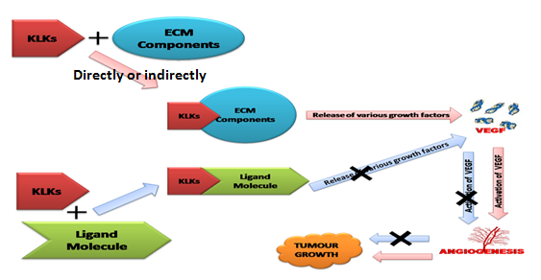
Figure 1: The role of the KLK family of proteins in the development of tumors: The KLK proteins either directly or indirectly hydrolyze the ECM components, releasing a variety of growth factors that, when activated, cause tumor angiogenesis. A promising approach to cancer medication discovery is the inhibition of growth factor secretion and function.

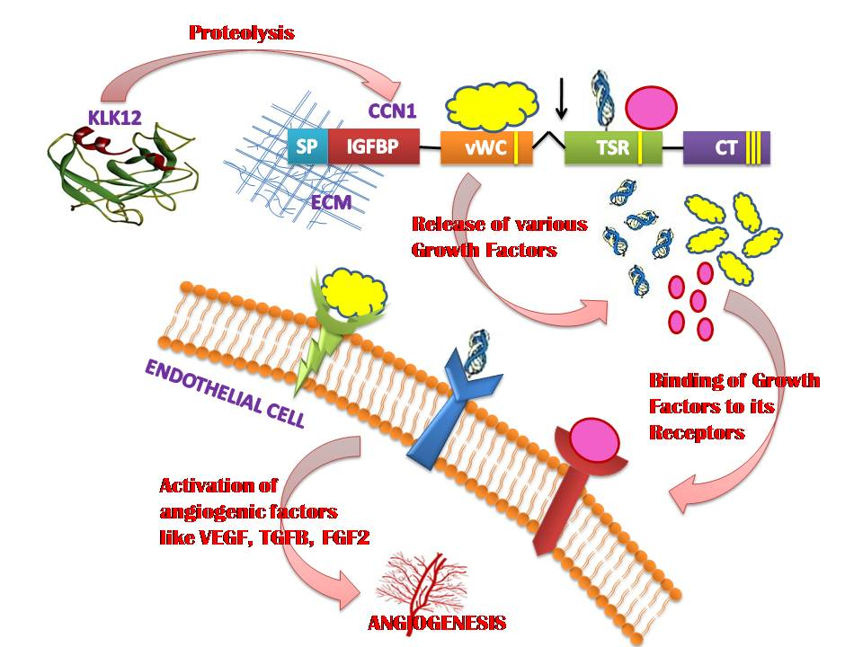
Figure 2: KLK-12 protein's biochemical route: VEGF, TGFβ, and FGF2 are released and activated as a result of the proteolytic activity of the KLK-12 protein on CCN1 (CYR61). Tumor angiogenesis is caused by the activation of these growth factors. vWC: von Willebrand type C domain, TSP: Thrombospondin domain, CT: Cysteine knot domain, FGF2: Fibroblast Growth Factor2, VEGF: Vascular Endothelial Growth Factor, ECM: Extracellular Matrix, and TGF: Transforming Growth Factor Beta are the abbreviations used in this acronym.

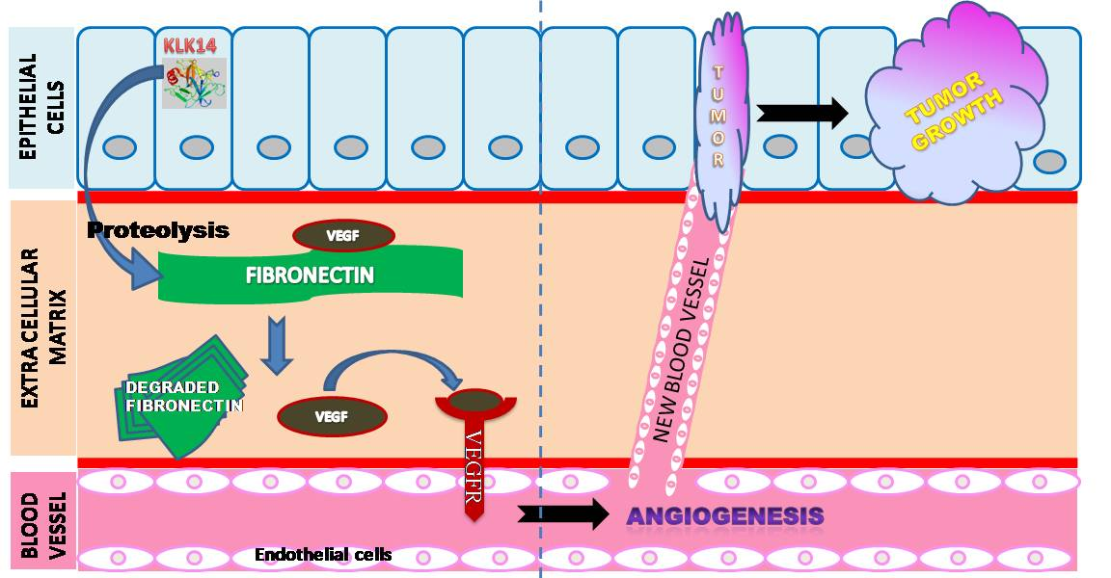
Figure 3: KLK-14 protein's biochemical route: The KLK-14 protein breaks down fibronectin, which activates VEGF and VEGFR and encourages angiogenesis.

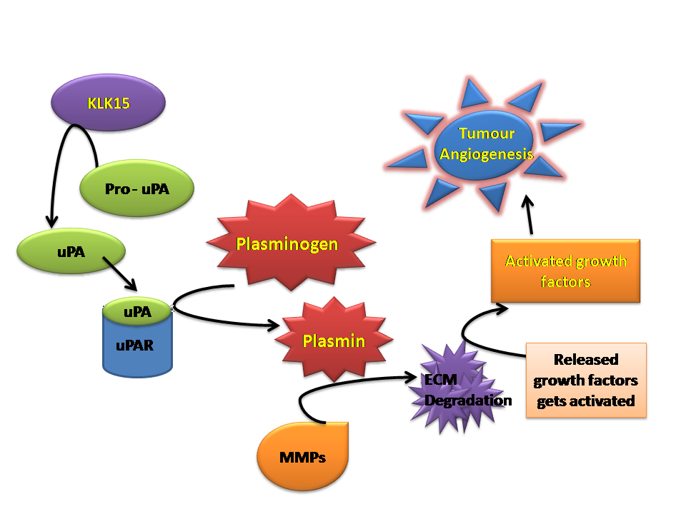
Figure 4: The biochemical pathway of the KLK-15 protein: Plasmin is activated by KLK-15 via uPA and uPAR activation, which causes MMPs to degrade ECM components to control tumor angiogenesis.
- CONCLUSIONS
The peptidases KLK-12, KLK-14, and KLK-15, which are related to kallikrein, are connected to tumor angiogenesis. The prevention of cancer begins with the inhibition of angiogenesis. The extracellular matrix (ECM) components are directly degraded by the kallikreins. Additionally, they are indirectly stimulating angiogenesis through the MMP activation route or the uPA/uPAR pathway. The study's objective is to develop KLK protein competitive inhibitors against ECM breakdown to stop angiogenesis and halt cell cycle progression and tumor development. By using computer assisted drug design techniques, the KLK proteins KLK-12 [61], KLK-14[65], and KLK-15 are considered as novel targets to find new compounds. It is possible to assess the biological activity when the indicated compounds are produced. These lead compounds should exhibit potent anti-cancer properties.
- REFERENCES
[1] Carmeliet, P. (2005). Angiogenesis in life, disease and medicine. Nature, 438(7070), 932-936.
[2] Rivera, L. B., & Bergers, G. (2015). Tumor angiogenesis, from foe to friend. Science, 349(6249), 694-695.
[3] De Palma, M., Biziato, D., & Petrova, T. V. (2017). Microenvironmental regulation of tumour angiogenesis. Nature reviews. Cancer, 17(8), 457–474.
[4] Chung, A. S., Lee, J., & Ferrara, N. (2010). Targeting the tumour vasculature: insights from physiological angiogenesis. Nature reviews. Cancer, 10(7), 505–514.
[5] Jacobs, J. (2007). Combating cardiovascular disease with angiogenic therapy. Drug discovery today, 12(23-24), 1040-1045.
[6] Folkman, J. (1995). Angiogenesis in cancer, vascular, rheumatoid and other disease. Nature medicine, 1(1), 27-30.
[7] Carmeliet, P., & Jain, R. K. (2000). Angiogenesis in cancer and other diseases. Nature, 407(6801), 249-257.
[8] Hummers, L. K., Hall, A., Wigley, F. M., & Simons, M. (2009). Abnormalities in the regulators of angiogenesis in patients with scleroderma. The Journal of rheumatology, 36(3), 576–582.
[9] Creamer, D., Sullivan, D., Bicknell, R., & Barker, J. (2002). Angiogenesis in psoriasis. Angiogenesis, 5(4), 231–236.
[10] Simons, M., & Ware, J. A. (2003). Therapeutic angiogenesis in cardiovascular disease. Nature reviews Drug discovery, 2(11), 863-872.
[11] Ware, J., Simons, M. (1997). Angiogenesis in ischemic heart disease. Nat Med., 3, 158–164.
[12] Gariano, R. F., & Gardner, T. W. (2005). Retinal angiogenesis in development and disease. Nature, 438(7070), 960-966.
[13] Szekanecz, Z., & Koch, A. E. (2007). Mechanisms of Disease: angiogenesis in inflammatory diseases. Nature clinical practice. Rheumatology, 3(11), 635–643.
[14] Tonini, T., Rossi, F., & Claudio, P. P. (2003). Molecular basis of angiogenesis and cancer. Oncogene, 22(42), 6549–6556.
[15] Ferrara, N., Gerber, H. P., & LeCouter, J. (2003). The biology of VEGF and its receptors. Nature medicine, 9(6), 669–676.
[16] Emami, N., & Diamandis, E. P. (2008). Utility of kallikrein-related peptidases (KLKs) as cancer biomarkers. Clinical chemistry, 54(10), 1600–1607.
[17] Coultas, L., Chawengsaksophak, K., & Rossant, J. (2005). Endothelial cells and VEGF in vascular development. Nature, 438(7070), 937–945.
[18] Goel, H. L., & Mercurio, A. M. (2013). VEGF targets the tumour cell. Nature reviews. Cancer, 13(12), 871–882.
[19] Weis, S. M., & Cheresh, D. A. (2011). Tumor angiogenesis: molecular pathways and therapeutic targets. Nature medicine, 17(11), 1359–1370.
[20] Hillen, F., & Griffioen, A. W. (2007). Tumour vascularization: sprouting angiogenesis and beyond. Cancer metastasis reviews, 26(3-4), 489–502.
[21] Gurtner, G. C., Werner, S., Barrandon, Y., & Longaker, M. T. (2008). Wound repair and regeneration. Nature, 453(7193), 314–321.
[22] Albini, A., Tosetti, F., Li, V. W., Noonan, D. M., & Li, W. W. (2012). Cancer prevention by targeting angiogenesis. Nature reviews. Clinical oncology, 9(9), 498–509.
[23] American Cancer Society. (2022). Cancer Facts & Figures 2022. Atlanta: American Cancer Society.
[24] Potente, M., Gerhardt, H., & Carmeliet, P. (2011). Basic and therapeutic aspects of angiogenesis. Cell, 146(6), 873–887.
[25] Wang, Z., Dabrosin, C., Yin, X., Fuster, M. M., Arreola, A., Rathmell, W. K., Generali, D., Nagaraju, G. P., El-Rayes, B., Ribatti, D., Chen, Y. C., Honoki, K., Fujii, H., Georgakilas, A. G., Nowsheen, S., Amedei, A., Niccolai, E., Amin, A., Ashraf, S. S., Helferich, B., Jensen, L. D. (2015). Broad targeting of angiogenesis for cancer prevention and therapy. Seminars in cancer biology, 35, S224–S243.
[26] Folkman J. (2007). Angiogenesis: an organizing principle for drug discovery?. Nature reviews. Drug discovery, 6(4), 273–286.
[27] Kerbel, R. S., & Kamen, B. A. (2004). The anti-angiogenic basis of metronomic chemotherapy. Nature reviews. Cancer, 4(6), 423–436.
[28] Sullivan, R., Alatise, O. I., Anderson, B. O., Audisio, R., Autier, P., Aggarwal, A., Balch, C., Brennan, M. F., Dare, A., D'Cruz, A., Eggermont, A. M., Fleming, K., Gueye, S. M., Hagander, L., Herrera, C. A., Holmer, H., Ilbawi, A. M., Jarnheimer, A., Ji, J. F., Kingham, T. P., Purushotham, A. (2015). Global cancer surgery: delivering safe, affordable, and timely cancer surgery. The Lancet. Oncology, 16(11), 1193–1224.
[29] Baskar, R., Lee, K. A., Yeo, R., & Yeoh, K. W. (2012). Cancer and radiation therapy: current advances and future directions. International journal of medical sciences, 9(3), 193–199.
[30] Haikerwal, S. J., Hagekyriakou, J., MacManus, M., Martin, O. A., & Haynes, N. M. (2015). Building immunity to cancer with radiation therapy. Cancer letters, 368(2), 198–208.
[31] Prise, K. M., & O'Sullivan, J. M. (2009). Radiation-induced bystander signalling in cancer therapy. Nature reviews. Cancer, 9(5), 351–360.
[32] Ravindran Ankathil. (2019). The mechanisms and challenges of cancer chemotherapy resistance: A current overview. European Journal of Molecular & Clinical Medicine, 6(1), 26-34.
[33] Bergers, G., & Benjamin, L. E. (2003). Tumorigenesis and the angiogenic switch. Nature reviews. Cancer, 3(6), 401–410.
[34] Holohan, C., Van Schaeybroeck, S., Longley, D. B., & Johnston, P. G. (2013). Cancer drug resistance: an evolving paradigm. Nature reviews. Cancer, 13(10), 714–726.
[35] Bleicher, K. H., Böhm, H. J., Müller, K., & Alanine, A. I. (2003). Hit and lead generation: beyond high-throughput screening. Nature reviews. Drug discovery, 2(5), 369–378.
[36] Macalino, S. J., Gosu, V., Hong, S., & Choi, S. (2015). Role of computer-aided drug design in modern drug discovery. Archives of pharmacal research, 38(9), 1686–1701.
[37] Kapetanovic I. M. (2008). Computer-aided drug discovery and development (CADDD): in silico-chemico-biological approach. Chemico-biological interactions, 171(2), 165–176.
[38] Ferreira, L. G., Dos Santos, R. N., Oliva, G., & Andricopulo, A. D. (2015). Molecular docking and structure-based drug design strategies. Molecules (Basel, Switzerland), 20(7), 13384–13421.
[39] Ng, L. Y., Chong, F. K., & Chemmangattuvalappil, N. G. (2015). Challenges and opportunities in computer-aided molecular design. Computers and Chemical Engineering, 81, 115-129.
[40] Cavasotto, C. N., & Phatak, S. S. (2009). Homology modeling in drug discovery: current trends and applications. Drug discovery today, 14(13-14), 676–683.
[41] Schenone, M., Dančík, V., Wagner, B. K., & Clemons, P. A. (2013). Target identification and mechanism of action in chemical biology and drug discovery. Nature chemical biology, 9(4), 232–240.
[42] Cao, D., Wang, J., Zhou, R., Li, Y., Yu, H., & Hou, T. (2012). ADMET evaluation in drug discovery. 11. PharmacoKinetics Knowledge Base (PKKB): a comprehensive database of pharmacokinetic and toxic properties for drugs. Journal of chemical information and modeling, 52(5), 1132–1137.
[43] Hait, W. N., & Hambley, T. W. (2009). Targeted cancer therapeutics. Cancer research, 69(4), 1263–1267.
[44] Samant, R. S., & Shevde, L. A. (2011). Recent advances in anti-angiogenic therapy of cancer. Oncotarget, 2(3), 122–134.
[45] Hanahan, D., & Weinberg, R. A. (2011). Hallmarks of cancer: the next generation. Cell, 144(5), 646–674.
[46] Liotta, L. A., & Kohn, E. C. (2001). The microenvironment of the tumour-host interface. Nature, 411(6835), 375–379.
[47] Nishida, N., Yano, H., Nishida, T., Kamura, T., & Kojiro, M. (2006). Angiogenesis in cancer. Vascular health and risk management, 2(3), 213–219.
[48] Emami, N., & Diamandis, E. P. (2007). Human tissue kallikreins: a road under construction. Clinica chimica acta; international journal of clinical chemistry, 381(1), 78–84.
[49] Kalinska, M., Meyer-Hoffert, U., Kantyka, T., & Potempa, J. (2016). Kallikreins - The melting pot of activity and function. Biochimie, 122, 270–282.
[50] Diamandis, E. P., Yousef, G. M., Clements, J., Ashworth, L. K., Yoshida, S., Egelrud, T., Nelson, P. S., Shiosaka, S., Little, S., Lilja, H., Stenman, U. H., Rittenhouse, H. G., & Wain, H. (2000). New nomenclature for the human tissue kallikrein gene family. Clinical chemistry, 46(11), 1855–1858.
[51] Yousef, G. M., & Diamandis, E. P. (2002). Human tissue kallikreins: a new enzymatic cascade pathway?. Biological chemistry, 383(7-8), 1045–1057.
[52] Koumandou, V. L., & Scorilas, A. (2013). Evolution of the plasma and tissue kallikreins, and their alternative splicing isoforms. PloS one, 8(7), e68074.
[53] Lilja H. (1985). A kallikrein-like serine protease in prostatic fluid cleaves the predominant seminal vesicle protein. The Journal of clinical investigation, 76(5), 1899–1903.
[54] Webber, M. M., Waghray, A., & Bello, D. (1995). Prostate-specific antigen, a serine protease, facilitates human prostate cancer cell invasion. Clinical cancer research: an official journal of the American Association for Cancer Research, 1(10), 1089–1094.
[55] Borgoño, C. A., Michael, I. P., & Diamandis, E. P. (2004). Human tissue kallikreins: physiologic roles and applications in cancer. Molecular cancer research: MCR, 2(5), 257–280.
[56] Borgoño, C. A., Michael, I. P., Komatsu, N., Jayakumar, A., Kapadia, R., Clayman, G. L., Sotiropoulou, G., & Diamandis, E. P. (2007). A potential role for multiple tissue kallikrein serine proteases in epidermal desquamation. The Journal of biological chemistry, 282(6), 3640–3652.
[57] Yousef, G. M., Magklara, A., & Diamandis, E. P. (2000). KLK12 is a novel serine protease and a new member of the human kallikrein gene family-differential expression in breast cancer. Genomics, 69(3), 331–341.
[58] Guillon-Munos, A., Oikonomopoulou, K., Michel, N., Smith, C. R., Petit-Courty, A., Canepa, S., Reverdiau, P., Heuzé-Vourc'h, N., Diamandis, E. P., & Courty, Y. (2011). Kallikrein-related peptidase 12 hydrolyzes matricellular proteins of the CCN family and modifies interactions of CCN1 and CCN5 with growth factors. The Journal of biological chemistry, 286(29), 25505–25518.
[59] Puente, X. S., Sánchez, L. M., Overall, C. M., & López-Otín, C. (2003). Human and mouse proteases: a comparative genomic approach. Nature reviews. Genetics, 4(7), 544–558.
[60] Clements, J. A., Willemsen, N. M., Myers, S. A., & Dong, Y. (2004). The tissue kallikrein family of serine proteases: functional roles in human disease and potential as clinical biomarkers. Critical reviews in clinical laboratory sciences, 41(3), 265–312.
[61] Jyothi Bandi., Navaneetha Nambigari. (2021). Identification of Novel Anticancer Agent by insilico Methods for Inhibition of KLK-12 Protein. Asian J. Org. Med. Chem., 6(1), 13-23.
[62] Borgoño, C. A., Grass, L., Soosaipillai, A., Yousef, G. M., Petraki, C. D., Howarth, D. H., Fracchioli, S., Katsaros, D., & Diamandis, E. P. (2003). Human kallikrein 14: a new potential biomarker for ovarian and breast cancer. Cancer research, 63(24), 9032–9041.
[63] Richard O Hynes. (1990). Fibronectins. Springer-Verlag. 1-559.
[64] Wijelath, E. S., Rahman, S., Namekata, M., Murray, J., Nishimura, T., Mostafavi-Pour, Z., Patel, Y., Suda, Y., Humphries, M. J., & Sobel, M. (2006). Heparin-II domain of fibronectin is a vascular endothelial growth factor-binding domain: enhancement of VEGF biological activity by a singular growth factor/matrix protein synergism. Circulation research, 99(8), 853–860.
[65] Bandi, J., Malkhed, V. & Nambigari, N. (2022). An insilico study of KLK-14 protein and its inhibition with curcumin and its derivatives. Chem. Pap., 76, 4955–4966.
[66] Yousef, G. M., Scorilas, A., Jung, K., Ashworth, L. K., & Diamandis, E. P. (2001). Molecular cloning of the human kallikrein 15 gene (KLK15). Up-regulation in prostate cancer. The Journal of biological chemistry, 276(1), 53–61.
[67] Takayama, T. K., Carter, C. A., & Deng, T. (2001). Activation of prostate-specific antigen precursor (pro-PSA) by prostin, a novel human prostatic serine protease identified by degenerate PCR. Biochemistry, 40(6), 1679–1687.
[68] Borgoño, C. A., & Diamandis, E. P. (2004). The emerging roles of human tissue kallikreins in cancer. Nature reviews. Cancer, 4(11), 876–890.

