Mathematical Model of Cancer Cell Growth and Proliferation: A Comprehensive Insight
Sweta Singh¹, Salini Das^{2*}
¹Department of Zoology, AISECT University, Jharkhand, India
²Chittaranjan National Cancer Institute, Kolkata, India.
*Correspondence: salinidas1992@gmail.com

Abstract: Mathematical modelling of cell growth pattern is absolutely necessary to determine the robustness in proliferative potency of cancer. Till date several approaches have been taken to model the proliferative pattern of cancer cells and thereby predictive analysis of tumor mass has been made possible. Such matrices not only foresee the early stages of carcinogenesis but also have declared the regulative changes of cancer cells at the advanced stages which are often influenced by extrinsic and/or intrinsic factors of the tumor microenvironment. This chapter summarizes the predominant models of cancer cell growth along with therapy predictions.

Keywords: Tumor, cancer, deterministic model, stochastic model, predictive analysis
Introduction:
Elucidating the nature of tumor cell growth and proliferative extremities includes a range of physiological scales; such as genetic classification of the responsive proliferative molecules, analysis of stress parameters triggering to cellular signaling responsible for uncontrolled cell division (1). Predictive analysis is therefore required to understand the process of tumor initiation, progression and accordingly the therapeutic response status of individual patients. Besides the development of biological research and advanced therapeutic discoveries, the domain of predictive analysis of tumor growth relies on a wide range of mathematical modelling that acts as an essential tool (2). These mathematical models can guide the oncologists to design the treatment regimen. Since uncontrolled cell proliferation is the key event of carcinogenesis, predictive proliferation models are useful in this regard.
‘Proliferation’ can be defined as the net change in the cellular number per unit time (3). In order to design such proliferation model of cancer, the key parameters which are required to be considered are mechanism of cellular proliferation to the reorganization of tissue and cellular population like avascular growth and treatment, mechanical effect of growth, availability of nutrients as well as consumption efficiency, potential immune evasion along with efficient response towards tumor signaling molecule. Keeping all these things in mind the aim of this manuscript is to present the strategic insights of mathematical modeling of cancer, mechanistic perspectives of tumor growth with special reference to tumor microenvironment and clinical areas of implementing such models.
To understand the dynamic changes in cancer cell number and thereby to predict the tumor size and to optimize the treatment regimen mathematical models are necessary. The uncontrollable environmental factors such as cellular metabolisms, requirement of energy, endocrine oscillatory changes, respiratory factors, body mass index, genetic predisposition and social and etiological impacts must be recognized (4). Following are the discussions of the mathematical models pertinent to the cancer growth.
Deterministic Model:
There are seven models in deterministic form that discusses about the behaviour of cancer cells in terms of growth and proliferation; naming, Mendelsohn, Logistic, Linear, Surface, Gompertz and Bertalanffy model. A detailed feature of these models along with its key equations is tabulated below:
Model | Equation | Key feature
Exponential  Mendelsohn  Logistic  Linear  Surface  `  Gompertz  Bertalanffy | V˙=αV  V˙=_{α}V^{b}  V˙=αV (1-V/b)  V˙=αV/(V+b)  V˙=αV/(V+b)^{1/3}  V˙=αV ln b/(V+c)  V˙=αV^{2/3}−bV | Used to predict early stages of tumor Growth, Cells divide regularly creating a pair of daughter cells. Growth is proportional to population. ‘α,’ the proportionality constant signifies the growth rate of the tumor.  A generalized exponential model developed by Mendelsohn where growth is proportional to the power b of the population.  Also known as the Pearl-Verhulst model named after the discoverer Pierre Francois Verhulst. The model explains that population growth is limited by carrying capacity (b). The equation assumes that the population growth rate decreases linearly along with size and becomes zero after` attaining the carrying capacity.  This model useful for predicting cancer cell colonies, assumes that the initial exponential growth that changes to growth is constant over time. The initial exponential growth rate is α/b and the constant growth is α.  This model maps the tumor in terms of proliferative capability assuming the fact that cellular growth is confined only a thin layer of cancer cells at the surface while the core of the tumor is unreproductive in nature.  Benjamin Gompertz explained human mortality curve in this model. This model best fits with the growth trends of the Breast and Lung cancer cells. The model is a generalization of Logistic model with sigmoidal curve which is asymmetrical to the inflection point.  According to Ludwig Bertlanffy, this model assumes that tumor cell growth is indeed a phenomenon of restricted cellular growth at the tumor surface, however this is also assumed that the loss of tumor volume also occurs due to cell death.

Table 1: A brief tabular representation of the existing deterministic models of cancer cell growth. (5)
In this model one can determine the doubling time of tumor cell by the equation
DT=ln2/ λ
Where, λ is considered as the initial growth rate of tumor. The rapidity of tumor growth can be determined by calculating the doubling time (5).
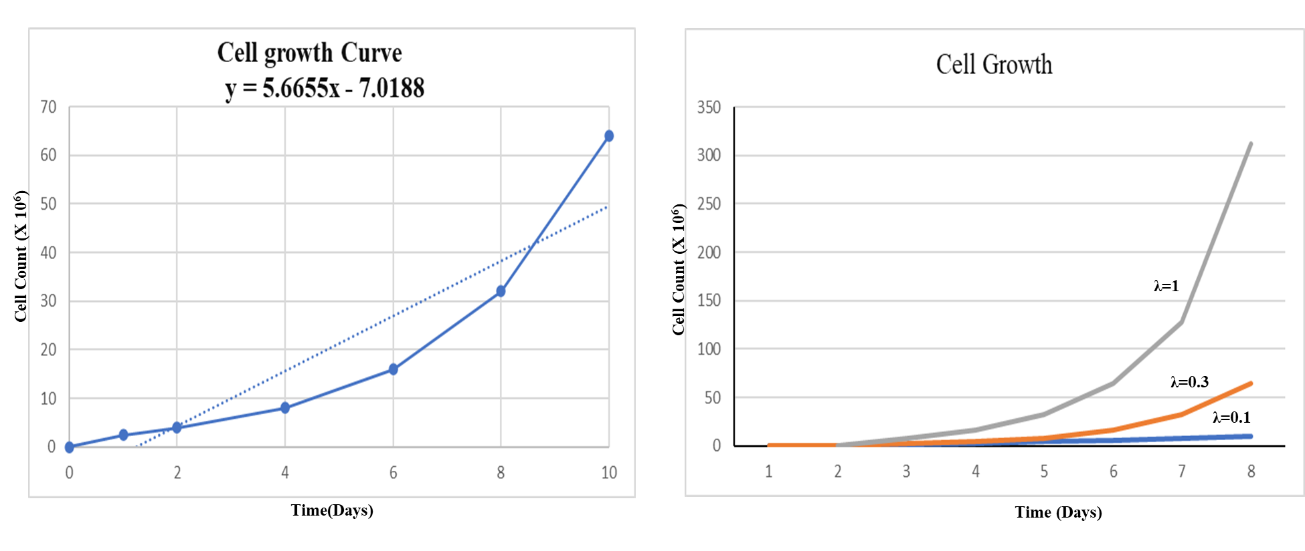
Fig. 1: Left: Mock population growth curve as derived from in vitro experimentations. Right: Mathematical model of cell growth at different values of λ.

The cellular dynamics of tumor cell population is represented by the Ordinary Differential Equations (ODEs). The basic assumptions of these models consider the fact that the occurrence of the reaction follows a well-mixed condition and the abundance of the reaction is not too low. The laws of mass balance are the primary foundation of such equations and the rate of change of a species (dC/dt) is expressed in terms of production and utilization as:
dC/dt = Production – Utilization.
The formulation of such models is analytically of two types 1) Dynamic and, 2) Steady-state analytical model. Dynamic analysis requires fluxes as non-linear functions. The output of such ODE systems is represented in time course of concentration values. On the other hand, in steady state analysis requires the specification of objective function as well as the constraints parameters. In this type of analysis the ODE system is reduced to simple linear system and the optimal flux values are represented as the output of such analytical systems. Such ODE models have been effective in describing the oscillatory behavior of p53 and Mdm2 during DNA damage response (6).
Although the Deterministic models do provide a lot of predictive information about cancer cell growth, these models are unable to predict the long-term growth pattern of tumor. Since cancer is a complex disease with prolonged proliferative nature, the actual growth pattern at the advanced stages is absolutely necessary to get modelled. Unfortunately, the information provided by the deterministic model is inadequate to serve this purpose. Therefore, Mathematicians had inclined towards more realistic approach using the stochastic model of Cancer cell growth. Only Logistic and Gompertz models have been optimized to Stochastic Differential Equation (SDE) (7).
Stochastic Model of Cancer cell growth:
The basis of Stochastic model in cancer relies on the hypothesis that ‘Each cell in the tumor mass has the potentiality to divide and propagate tumor mass.’ This hypothesis is contrary to the previously discussed hierarchy model where it is assumed that ‘only a few cells with oncogenic potential can proliferate and differentiate.’ This model considers that tumor is biologically homogeneous and the behavior of cancer cells is influenced by the unpredicted environmental factors such as nutrient availability, metabolic need, hormonal cycle etc. This model is derived as a diffusion approximation of a continuous-time density dependent branching process (8). For such diffusion process, both the conditional probabilities of extinction (reaching a size C) and doubling time are calculated along with the expected time of such events.
The number of tumor cells N(t) is generally considered as a measurement of tumor size. Therefore the tumor growth models are evaluated by the following equation:
dN/dt (t) = N g (N)
‘g’ is considered as the specific growth rate and the output relies on the nature of ‘g’. If ‘g’ is constant, the growth follows density independent and exponential pattern. While in case of g= g(N), the growth is density dependent in nature. In general, the specific growth rate g is inversely proportional to N. Now, as per stochastic model, the corrective version of this model is represented as:
dN/dt = bN ln (K/N)
Here K is the largest tumor size and l/b is the length of required time for specific growth rate to reduce by a factor of 1/e i.e. e folding time. The solution of this equation when N=0 is as follows:
N(t) = N(0) exp[ln(K/N(0))(1-e^{-ht})]
The graphical output of this equation is a sigmoid curve that approaches K as t increases.
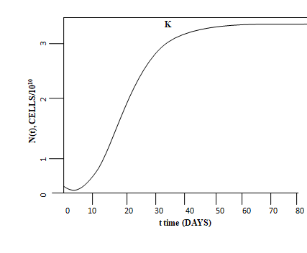
Fig. 2: Graphical representation of sigmoid curve of density dependent growth and approaches K as t ∞.
Stochastic Gompertz model:
This model is widely accurate in predicting Breast and Cervical cancer compared to the deterministic model. This model formulation is based on the following equation:
dV(t)=(αV(t)- bV(t)lnV(t))dt+σV(t)dW(t)
The growth rate parameter α is perturbed by a Wiener Process W(t) having Gaussian distribution and mean zero. Where σ>0 and variance dt is given by the increment of time, t. The uncontrolled factors influencing the tumor growth pattern can be explained through this model.
Stochastic Logistic model:
This particular model deals with the conventional Logistic Model with random perturbations. This perturbation is caused by the random process W(t) through the intrinsic growth rate parameter α. The equation of this model is provided below:
dV(t)=(αV(t)- bV(t)) dt+σV(t)dW(t)
Where, σ>0 is the diffusion constant. Cell proliferation pattern of cervical cancer can be predicted through this model (8, 9).
These models therefore assumes that intrinsic and/or extrinsic factors which are otherwise difficult to control shapes the cellular growth pattern and tumor morphology. Traditionally these models are accountable for predicting the mutational pattern and the transitions of these mutations. These transitions follow a directional trend of achieving benign to invasive property. This model also reveals that Cancer cells have the ability to proliferate extensively and not only replicate phenotype complexity.
Cancer Stem Cell Concept:
The cancer stem cell model implies the hierarchical cellular organization inside the tumor. In this model one single cell completely recapitulate the heterogeneous parental tumor phenotype. The difference between the stochastic model and the cancer stem cell model has been depicted in the following illustration.
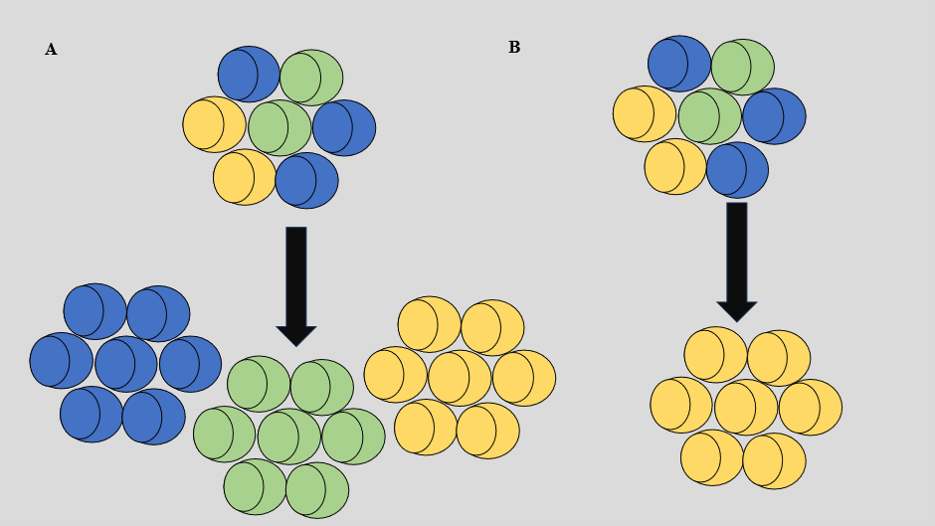
Fig. 3 : Comparative pattern of cell growth as per Stochastic (A) vs Cancer Stem Cell (B) concept. In stochastic model the heterogeneous nature of cancer is retained and the clone of each cells constituents the tumor mass. However Cancer Stem cell concept shows a single type of transformed cells that has both self renewal and proliferative capacity and leads to generation of the clonal character in the tumor (10).
Asymmetric cell division is the key strategy for the expansions of stem cells. In a tumor cell population there are asymmetrically dividing stem cells called cancer stem cells (CSC), there are self renewing cells (P) and there are differentiating cells (D). Therefore, in order to obtain the division dynamics of CSC, P and D cells with an initial population of CSC₀, P₀ and D₀ respectively following equation has been derived:
CSC= CSC₀e^{αt}
P = CSC₀[β/(α-χ)e^{αt} +[P₀- CSC₀ β/(α-χ)]e^{αt}
D =δ e^{αt} + ε e^{αt} + (D₀-δ-ε) e^{-kgt}
Where α, β and χ are specific growth rates at their respective k, and the total number of cells in a tumor (N) is the sum of all cell types.
N (cells) = CSC+P+D
There are certain assumptions of this model that includes that tumor cells grow at a constant cellular density, no nutrient limitation exists and the space constraints are insignificant (11).
Modelling Cancer treatment:
The modelling of cancer treatment relies on dual strategies- 1) A gross reduction in tumor volume by amount of cell death. This can be modelled by the following equation
dc/dt= −λc log(c/K)− ξc
2) decrasing the tumor support via reduction of carrying capacity.
dK/dt= ϕc -ψKc^{2/3} -vKg(t)

In order to kill the tumor cells by using the conventional anticancer methods line chemo or immunotherapy, the strength must be 0≤ξ≤1. Thus, even treatment regimen can be repatterned using mathematical model of therapeutic approaches (12).

Conclusions:
This Chapter comprehensively gives insight into the different conentional models of cancer cell growth. These growth patterns are required to predict the tumor growth time and tumor morphology. Moreover, recent advancements in the treatment approaches enlightens the therapeutic strategy of such cancer cases using mathematical models. Novel algorithms can be developed from such models which will improve cancer prognosis and treatment.
References:
1. Nagase, M., Aksenov, S., Yan, H., Dunyak, J., & Al-Huniti, N. (2020). Modeling Tumor Growth and Treatment Resistance Dynamics Characterizes Different Response to Gefitinib or Chemotherapy in Non-Small Cell Lung Cancer. CPT: Pharmacomet. Syst. Pharmacol, 9(3), 143–152.
2. Enderling H, Chaplain MA. (2014). Mathematical modeling of tumor growth and treatment. Curr Pharm Des, 20(30), 4934-40.
3. Jarrett, A. M., Lima, E. A. B. F., Hormuth, D. A., 2nd, McKenna, M. T., Feng, X., Ekrut, D. A., Resende, A. C. M., Brock, A., & Yankeelov, T. E. (2018). Mathematical models of tumor cell proliferation: A review of the literature. Expert Rev. Anticancer Ther, 18(12), 1271–1286.
4. Cumsille, P., Godoy, M., Gerdtzen, Z. P., & Conca, C. (2019). Parameter estimation and mathematical modeling for the quantitative description of therapy failure due to drug resistance in gastrointestinal stromal tumor metastasis to the liver. PloS one, 14(5), e0217332. 5. Murphy, H., Jaafari, H., & Dobrovolny, H. M. (2016). Differences in predictions of ODE models of tumor growth: a cautionary example. BMC cancer, 16, 163.
6. Blair RH, Trichler DL, Gaille DP. (2012). Mathematical and statistical modeling in cancer systems biology. Front Physiol, 28;3:227.
7. Yin, A., Moes, D. J. A. R., van Hasselt, J. G. C., Swen, J. J., & Guchelaar, H. J. (2019). A Review of Mathematical Models for Tumor Dynamics and Treatment Resistance Evolution of Solid Tumors. CPT: Pharmacomet. Syst. Pharmacol, 8(10), 720–737.
8. Tabassum S. et al (2019) Mathematical Modeling of Cancer Growth Process: A Review J. Phys.: Conf. Ser. 1366 012018.
9. Irana Ira, J.; Islam, M.S.; Misra, J.C. (2020). Kamrujjaman, M. Mathematical Modelling of the Dynamics of Tumor Growth and its Optimal Control. Preprints, 2020040391
10. Wang W, Quan Y, Fu Q, Liu Y, Liang Y, Wu J, Yang G, Luo C, Ouyang Q, Wang Y. (2014). Dynamics between cancer cell subpopulations reveals a model coordinating with both hierarchical and stochastic concepts. PLoS One, 9;9(1):e84654.
11. Molina-Peña R, Álvarez MM. (2012). A simple mathematical model based on the cancer stem cell hypothesis suggests kinetic commonalities in solid tumor growth. PLoS One, 7(2):e26233.
12. Roma-Rodrigues C, Mendes R, Baptista PV, Fernandes AR. (2019). Targeting Tumor Microenvironment for Cancer Therapy. Int J Mol Sci, 15;20(4):840.

