Diminishing Anxiety using Neuro-Linguistic Programming in Public Speaking for Tertiary Level Students

Nallamuthu. P¹
¹Research Scholar, Department of English, School of Social Sciences and Languages, Vellore Institute of Technology, Vellore, India. nallamuthu.p@vit.ac.in

Dr. Gandhimathi S.N.S^{2*}
^{2*}Assistant Professor, Department of English, School of Social Sciences and Languages, Vellore Institute of Technology, Vellore, India. gandhimathisns@vit.ac.in

ABSTRACT

Neuro-linguistic Programming (NLP) is a pseudoscientific approach that intends to study the brain and linguistic processes involved in human thinking. It indicates the reduction of profound phobias, especially among university students, while speaking in public. The present study employs NLP techniques to reduce anxiety while speaking in public. It aims to comprehend how anxiety affects speakers' performance and identify mind-simulating NLP techniques to reduce anxiety. NLP helps students accomplish professional objectives and boost productivity by de-stigmatising anxiety in public speaking. The study has included qualitative and quantitative research methods. Scholarly articles have been analysed to carry out qualitative method whereas for quantitative study a questionnaire comprising 7 demographic details is administered to the undergraduate students at Vellore Institute of Technology (VIT). The current research has reviewed research papers published in the field of NLP to analyse the strategies that are used to help anxious adolescents to speak in public and take examinations. The researchers have encompassed various NLP approaches in the questionnaire to evaluate their applicability in public speaking skills across several academic disciplines and degree levels. The research has found consistent and divergent perspectives by comparing their responses. The study examines whether NLP can be used with stage performers, players in sports, people with speech difficulties and employees of private and public sectors. It is identified that NLP significantly lowers anxiety when speaking in public.

Keywords - Neuro-Linguistic Programming; Public speaking; Anxiety; NLP techniques; Presentation; University.

- INTRODUCTION

Neurolinguistic programming (NLP) is a psychological approach including several components, such as interpersonal communication, personal growth, and psychotherapeutic interventions. It establishes a link among concepts, expressions, and behavioural patterns in which individuals have acquired through specific outcomes. Acquiring proficiency in NLP may be equated to developing skills in the language of one's thinking. Currently, it is used as a kind of psychotherapy and complementary medicine. As individuals residing within the interconnected global community, it is imperative that we engage in meaningful interactions with other members of society. They may include public speaking techniques in the form of casual or formal meetings, speeches, etc. In order to succeed as an efficient public speaker, it is essential to establish an individual speaking style. People may use NLP strategies to enhance the effectiveness of their communication, enabling them to convey their personality and viewpoints with clarity and confidence. Neglecting to adhere to this need results in anxiety, frustration, and an extensive range of societal issues. The use of NLP is now being investigated as a potential therapeutic approach in various fields. The following investigations are grounded on qualitative and quantitative findings on the use of NLP within therapeutic contexts. This analysis evaluates how the issue has been effectively addressed and the various approaches used to mitigate it. According to several sources, NLP facilitates the establishment of a systematic methodology, enabling people to communicate confidently in the context of significant gatherings. The study has also included using NLP in several domains, including education and social communication. The key objective of this research is to evaluate the effectiveness of NLP strategies, including stage anchoring, focusing on 'How' instead of 'WHAT', using sensory-based vocabulary, utilising two-minute narrative, employing positive and negative gestures, preferences for data collection, and the use of sensory-based language. The previously mentioned techniques have been included in the questionnaire. The current study has examined the different techniques of NLP that students can implement to overcome their anxiety concerning public speaking.

- REVIEW OF LITERATURE

Kushwaha (2021) explicates that NLP may help teachers and students change their language learning behaviour, thinking style, and attitude by adopting anchoring, future pacing, swish, visual kinesthetics dissociation, part integration, reframing, and well-formed results. Most prior research has examined how NLP may boost skiers' attention, concentration, observation, and decision-making, which are essential to success. NLP may assist athletes and teams in handling stress and anxiety (Grosu et al., 2014). Hotel (2005) has found that NLP might help advanced English learners express themselves. Consequently, explain how NLP may help learners identify their preferred representational system—how they acquire and remember sensory information—and choose words and phrases that match it.
Grosu et al. (2013) have examined how communication and cognitive-behavioural skills improve athletic performance. In addition, the study addresses Romania's Olympic judo team's favourite communication channel and sub-modal differences questionnaire. Using visual, auditory, and kinaesthetic channels, NLP may also improve training and sports performance. Since NLP significantly reduces social and performance anxiety, the research suggests it may be utilised to treat social anxiety disorder and other anxiety disorders. Abdivarmazan & Sylabkhori (2016) have conducted a meta-analysis of 12 studies on NLP or NLP-based psychotherapy (NLPt) for psychological and social disorders. Zaharia et al. (2015) has done research on how NLPt lowers clinical symptoms, enhances quality of life, and modifies allergy sensitivity. The research examined 24 teacher-led action research case studies that used NLP to improve behaviour, achievement, relationships, and teacher effectiveness. Controlling and assessing NLP development and practice in education requires ethical principles, transparency, accountability, and public knowledge and education (Carey et al., 2011).
Grieve et al. (2021) suggest that universities detect public speaking fear in certain students and provide additional aid in oral presentation tests. Many college students fear public speaking and oral presentations, which affects their study and well-being. Judging, physical issues, and subject ambiguity are students' main anxieties. The study suggests that practice and preparation reduce anxiety, but students need greater institutional assistance. Researchers explore how language affects communication and cognition and the importance of neurolinguistics, which studies the brain and language. The researchers describe their 10-year neurolinguistic study on phonological and lexical problems and patient speech therapy models (Sastra et al., 2019). The researchers have conducted an NLP-based counselling program for grade 9 females to reduce test anxiety and improve academic achievement. The NLP programme showed substantial differences in students' pre- and post-test test anxiety and academic performance evaluations (Daw, 2013).
Ilieva-koleva & Vazov, (2014) believe that NLP may improve communication, influence, and convince, overcome negative ideas and emotions, and model excellence from successful speakers. Weldani & Muhammad (2015) define that NLP reduces class X students' straddle jump fear. Indeed, it helps students to improve self-communication and decrease anxiety about straddle jumping, a difficult physical feat. Additionally, it encodes, organises, and conveys students' internal worldviews through verbal and nonverbal language abilities. NLP in counselling is widely explored for increasing communication, lowering anxiety, and managing negative emotions. Using NLP to address client difficulties and improve counselling may be helpful (Kusuma, 2018). Neuro-linguistic Programming (NLP) is used to advise students in elementary schools with learning disabilities. Hadi (2015) describes how NLP can control and form thinking processes to help students in learning. The report examines NLP's usefulness in counselling, methods, tactics, and scope. Imah & Purwoko (2018) suggests some potential strategies for enhancing the efficacy and the potential of NLP counselling, including the use of dynamic and empirical language, encouragement of both individual and team sports, increased awareness of the necessity of changing negative behaviour, consideration of the timing of pre- and post-tests, and teacher effectiveness promotion. Additionally, NLP is beneficial for language learners to establish better communication, strengthen the educational environment, and achieve higher academic performance (Hedayat et al., 2020)
Based on the Neuro-Linguistic Programming (NLP) method, the article explains the fundamental communication and interpersonal skills needed to communicate information in a persuasive and engaging manner. The researchers have explained university students' social anxiety using attachment and emotion control theories. The model has shown that social rejection expectations, emotion management difficulties, and abandonment fear from unstable attachment patterns predicted social anxiety. Women experienced higher social anxiety, rejection expectations, and emotion regulation concerns than men, reducing model variance(Morán et al., 2018). Keezhatta (2019) NLP-trained language teachers say it enhances teaching, creates relationships, changes the classroom environment, and accelerates learning. NLP promotes academic and professional knowledge, career advancement, emotional control, communication, and behaviour.
Raja (2017) has found reasons and answers for anxiety in public speaking among undergraduate students. The research suggests that students should practice, rehearse, stop, seek feedback, set objectives, and join public speaking forums to lessen public speaking phobia. Liliweri (2017) examines how Indonesian Nusa Cendana University students think and learn impact their communication. Apart from the creator and doer types, there are distinctions in how male and female students think, learn, and interact with one another. The interactive virtual audience condition, which transmits nonverbal audience input, was more interesting, demanding, and successful than the direct feedback condition, which presents a colour-coded speaker performance gauge, or the control condition, which utilises a passive audience. Participants appreciated employing the virtual audience for public speaking training and would use it again (Chollet et al., 2015)
NLP helps students and professionals build emotional intelligence, self-awareness, motivation, and communication skills for public affairs leadership and performance. Case studies, simulations, and practical learning could incorporate NLP into public affairs and human resources development courses (Rooyen, 2018). A significant change in self-confidence between experimental and control groups after NLP instruction. There is no significant difference in self-confidence between Sekolah Menengah Pertama (SMP) which is equivalent to junior high school or middle school and Sekolah Menengah Atas (SMA) which is equivalent to senior high school or high school in Indonesia. Zahro (2018) recommends NLP training for practice and policy since it enhances adolescent self-confidence. In a study conducted by Imah and Purwoko (2018), it has been demonstrated that the use of NLP techniques enhances several factors such as motivation, achievement, anxiety, stress, communication, self-confidence, and problem-solving skills.

- METHODOLOGY

This survey aims to determine the impact of NLP in reducing anxiety in public speaking. A mixed method, including both qualitative and quantitative analysis, has been adopted in this. During this research, the researcher applied the exploratory methodology with a qualitative approach based on the academic article review method. The qualitative study has involved collecting and analysing non-numerical data found in scholarly articles to understand NLP's concepts, opinions, or experiences in presentations and public speaking.
The primary technique for data collection is a questionnaire. The research has produced important results about the efficacy of NLP in enhancing teachers' aptitudes and perspectives. Open-ended questions have been included in the questionnaire to elicit meaningful, rich, and analytical responses. The researcher has framed the question to let participants respond based on their perspectives. The researcher has sent the questionnaire digitally to the students of VIT and several other college students, all of whom were chosen at random from a variety of colleges and two hundred and twenty-six responses has been received. The analysis has used simple statistical methods, such as percentage and frequency. The survey results have been analysed and presented in the report using tables, graphs, and charts in detail.

- RESULT AND DISCUSSIONS

The survey findings are presented in the tables, graphs, and charts in this section. An analysis of the data accompanies each of the given data. The researcher administered questionnaire using Google Forms and it contains a total of 16 questions. In order to collect data about the different kinds of symptoms presented by individuals while experiencing anxiety during public speaking interactions, a questionnaire with a checklist design has been used.
All the 226 responses received, a significant majority of 77% have been provided by respondents aged between 16 and 23 years. According to the gender consensus, the population consisted of 51.8% females and 47.8% men. The remaining individuals choose not to disclose their gender. The survey respondents mainly consisted of students enrolled in undergraduate and postgraduate programs, while the remaining participants have diverse professional backgrounds, were categorised together as "others". The given below responses have been acquired by examining participants ' familiarity with Neuro-Linguistic Programming (NLP) techniques.

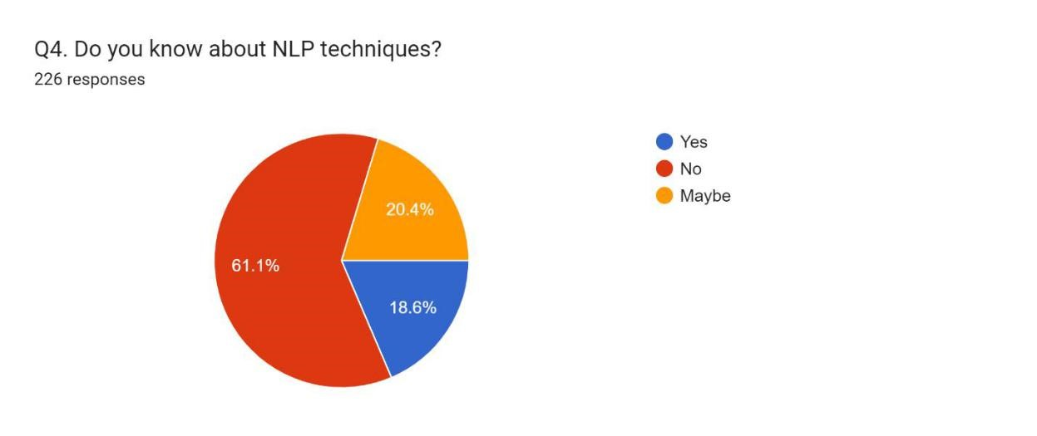
Figure 1 Awareness on NLP techniques responses

As shown by the data, a mere 18.6% of people know the field of NLP. In order to ensure participants' appropriate engagement with the questionnaire, it has been determined that it is essential to provide them with an understanding of the many approaches associated with NLP. Participants were first instructed to indicate their experiences of anxiousness while public speaking by selecting the relevant check boxes.

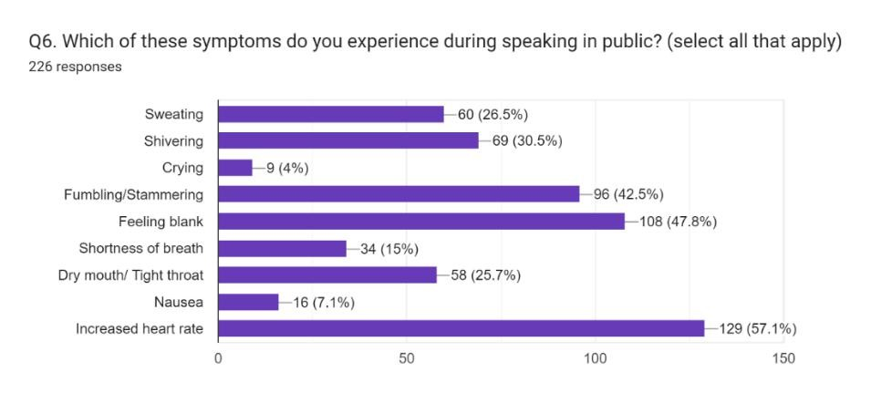
Figure 2 Symptoms experienced in public speaking.

The symptoms most often mentioned are shivering, sweating, and dry mouth.
Nevertheless, the symptoms that received the highest levels of popularity among participants are stumbling (42.5%), feeling blank (47.8%), and an elevated heart rate (57.15%). Consequently, it has been determined that the provision of NLP methods to individuals in question is necessary to reduce their symptoms associated with anxiety successfully. As part of our main examination, seven NLP strategies are offered (in brief paragraphs). Afterwards, people are asked to evaluate the effectiveness of the techniques in reducing anxiety before engaging in public speaking. The participants are asked to rate their degree of agreement with the dissatisfaction with the specified approach on a scale ranging from 1 to 5.

Table 1: The following techniques are implemented and assessed.

S. No | NLP Techniques | Meaning
1 | 2 Minute Stories | Imagine yourself effectively accomplishing a task, such as giving a presentation or scoring every possible score on an exam. Imagine that you are comfortable, focused, and confident.
2 | Using Sensory Based | These words have been intentionally selected to elicit a sensory experience, such as colours, material sensations like roughness or smoothness, vivid scenarios, etc.
3 | Stage Anchoring | You may anchor the performance by stating every negative aspect on one side of the stage and the positive aspects on the other. After requesting the audience's permission, adopt a positive stance.
4 | Gesturing Positives and Negatives | Face away from the audience and yourself when addressing anything negative; face the audience or yourself while talking about something positive.
5 | Gesturing to Engage | While speaking, use your hands to enact what you are saying physically. This grabs the viewer’s attention visually and appeals to their unconscious.
6 | Preferences for Gathering Data: | Some students learn best via their visual, olfactory, auditory, and kinaesthetic. Make sure you convey your message in more ways than just speaking. However, show objects or pictures and allow people to converse or participate in an activity.
7 | Focus on the “How” Your Speech Will Inspire and not on “What” You will say. | Presenters and lecturers focus more on the message they wish to convey during public speaking than on how audience members take in information. Your speech will improve if you concentrate more on the how of learning than the what.

Table 2: NLP techniques responses scores
NLP TECHNIQUES | RESPONSES
2 Minute Stories: | 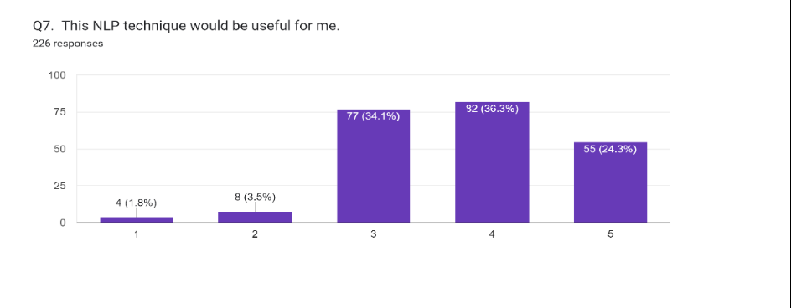
Using Sensory  Based Words: | 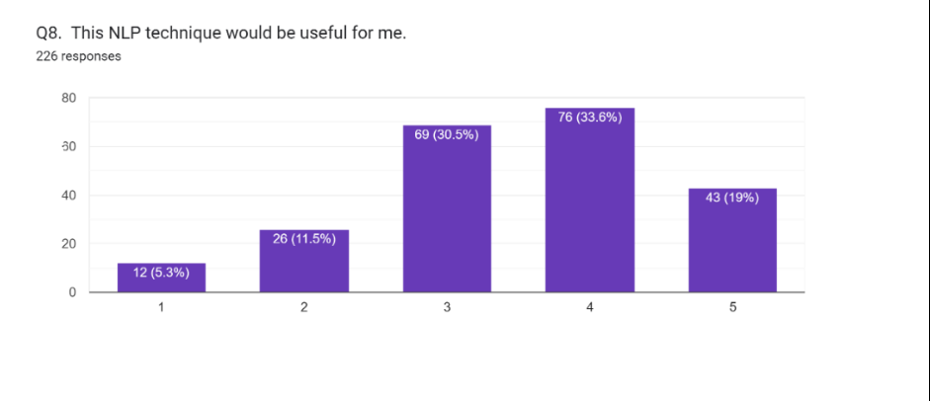
Stage Anchoring: | 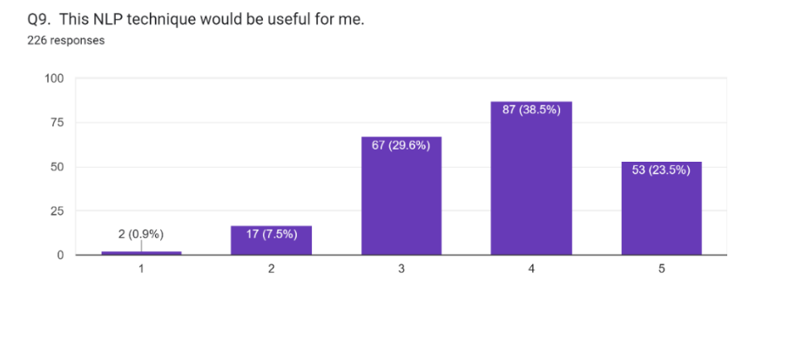
Gesture Positive and Negatives? | 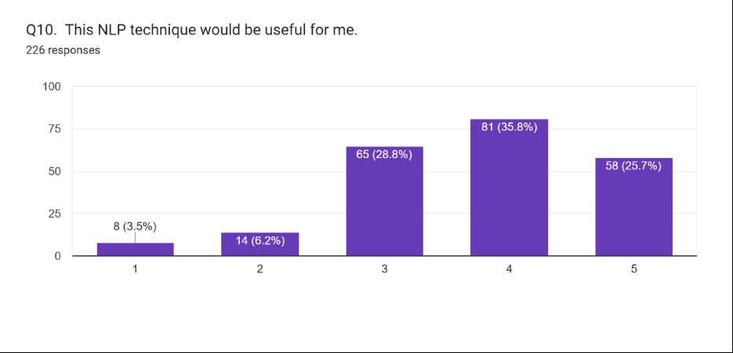
Gesturing to  Engage: | 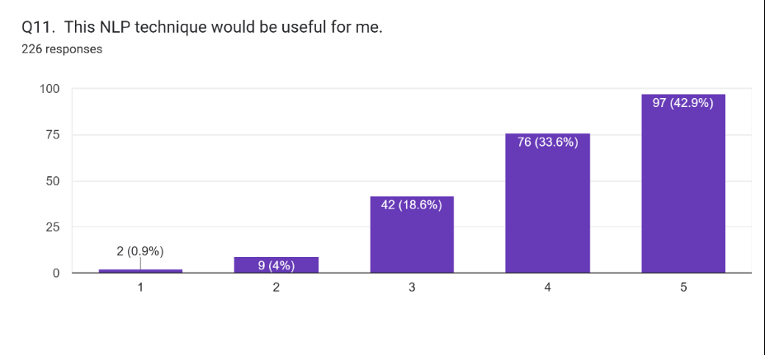
Preferences for  Gathering Data: | 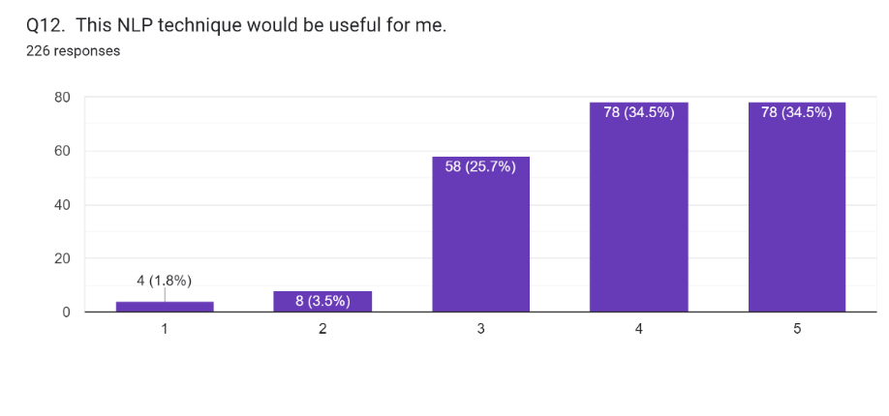
Focus on the “How” Your Speech Will Inspire and not on “What” You are going to Say: | 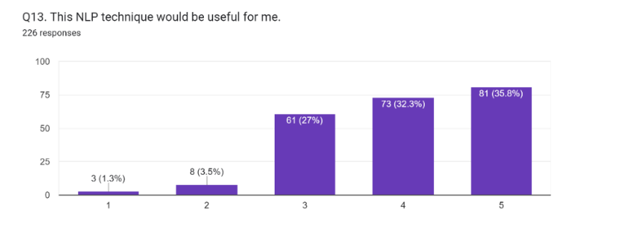

The majority of respondents have picked "agree" or "strongly agree" for most techniques, and they think doing so would help them feel less worried, according to the graphic tabular data. The "gesturing to engage" approach produced the highest number of responses indicating strong agreement; however, none of the NLP techniques had a proportion of strongly disagree responses above 5.3%.
Examining the participants' responses correlates mainly with the findings obtained from reviewing existing scholarly works. One of the most often stated observations is that enhancing trust and supportive interaction between speakers and listeners lowers anxiety and increases audience receptivity during presentations. It can be improved by adding "a two-minute story, whoosh, jam session, stage fixation, and gestures to incorporate technique."
According to many studies, students who participated in NLP workshops have reported less nervousness, which helped them perform better on stage or even do better in examinations by applying the numerous NLP approaches discussed above. Many Experimental evidence suggests that NLP is an effective approach in public speaking to lessen anxiety. The "Preferences for Collecting Data" NLP approach is the lone departure from the assessed articles on responses to the questionnaire. This approach promotes using several sensory components to effectively captivate the audience during spoken communication. Research at the institute of sports aims to evaluate the association between coaches and athletes, revealing a significant correlation between vision and kinesthetics. However, no considerable connection is seen between these factors and the senses of smell and taste. Alternatively, there are no documented instances of contradicting replies.
As previously indicated, the last question is open-ended and asked participants to describe how NLP might benefit them in about 50 words. People revealed that these methods clear the speaker's thoughts, boost confidence and content while speaking, enhance professional connections via effective communication, and considerably increase presentation skills. Many people encounter stage fright or anxiety, and using such techniques is the first step towards reducing such apprehensions. The following responses are provided. -
“Mental health professionals use NLP by itself or with other types of therapy, like talk therapy or psychoanalysis, to help treat depression and anxiety. NLP teaches you how to reframe your current beliefs by applying different meanings to behaviours, situations in life and to new beliefs that you would like to have.”
“Yes, it is useful. Public speaking is a skill that is used a lot in professional settings; for students, it is used during j-component reviews and competitions. But it needs to be taught for it to be used in the right way.”
“Yes, NLP techniques are particularly useful for building skills like public speaking, sales and negotiation, team building and leadership. Its action-oriented nature and focus on growth mean that neuro-linguistic programming and coaching go hand in hand.”

Hence, this comprehensive analysis of the correlation between the previously mentioned survey and already published findings confirms the practical efficacy of NLP methodologies in the realm of student life and other contexts that need streamlined communication. The provision of consistent mentorship has been shown to reduce anxiety successfully and provide students with the necessary confidence to achieve their maximum potential.

V. FINDINGS

The major findings of the current research may help the NLP practitioners, teachers, and students. Most respondents, namely 61.1%, has indicated a lack of awareness of NLP approaches based on the responses to the questionnaire. It is found that a total of 48 people has expressed high levels of agreement with the notion of having anxiety while engaging in public speaking. While delivering a public speech, many people, namely 57.1%, reported an increase in heart rate. This physiological response is accompanied by a sense of mental blankness, experienced by 47.8% of participants, and stammering, seen in 42.5% of the sample. The symptom of crying is reported by just 4% of participants, indicating it is the least often seen symptom. It may be argued that there is no equivalence between any two symptoms. A little 1.8% of the sample size, namely 4 people out of 226, have expressed the belief that using the 2-minute storytelling approach would not benefit their circumstances. Approximately 82% of people have believed that using sensory-based language as a strategic approach would be beneficial within the range of 3 to 5. The concept of stage anchoring has received strong agreement from 23.5% of participants, whilst just 0.9% of individuals strongly disagreed with this notion. The efficacy of using positive and negative gestures in communication is less advantageous for a larger proportion of people than the practice of utilising stage anchoring. The most effective strategy is denoting toward communication, as supported by 97 out of 226 individuals, or 42.9% of the total sample.

- CONCLUSION

The findings of the research indicate that NLP serves a dual purpose by effectively resolving verbal ambiguity and providing significant quantitative structure to the data. There are several downstream applications, like text analytics and speech recognition, that may get advantages from it as well. The use of this tool in the field of education has shown significant benefits. The efficient management and conquering of anxiety difficulties arising from verbal communication obstacles may be achieved. Affirming the adage " The largest dread in public speaking arises from not knowing if (or how) the audience is going to understand the idea one is trying to deliver". NLP is well recognised as a therapeutic approach for addressing anxiety associated explicitly with public speaking skills. Several proposed NLP strategies may enhance the probability of effectively conveying a message.

- Recommendations

In the historical context of India, there aren't many research projects being undertaken on this topic. Furthermore, it is important to point out that there exists a limited body of research related to the education of home-schooled children. Public speaking vs non-homeschooled children is a complex topic because of the various variables at play, including the opportunity to interact with others with different points of view and the fact that the ‘mentors' in both scenarios are distinct. The assessment of presentational skill variations would be fascinating between going to public school versus homeschooling. Furthermore, "virtual viewers" must be widely accessible and affordable to transfer effectively. Without them, you lose crucial public speaking tools. Moreover, it may aid people in challenging circumstances, such as the COVID-19 pandemic, where the ability to engage in public performances before enormous crowds is not feasible. Individuals can provide their recommendations for enhancing the fundamental notion.

B. Limitations of the Study

The focus of our study is limited to students currently pursuing studies in institutions of higher education, including a diverse range of ages. Mentors play a vital role in the implementation of NLP approaches. In a classroom context, the teacher may use NLP skills to provide guidance to students. However, the collecting of data from 'mentors' is not feasible within the scope of our study due to limitations imposed by time and workload restrictions. The previously mentioned essential information has the potential to be used as an essential foundation for future research endeavours, facilitating the expansion of existing reservoirs of knowledge within the field of study.

REFERENCES

Abdivarmazan, M., & Sylabkhori, Z. (2016). Effectiveness of Training of Neuro-Linguistic Programming (NLP) Strategies on Reducing Social Anxiety. World Scientific News, 60(January 2016), 67–77.
Carey, J., Churches, R., Hutchinson, G., Jones, J., Tosey, P., Blanchet, N., Burns, T., Causer, L., Charlton, R., Coull, R., Dobson, J., Fuhr, H., Hogg, G., Holland, L., Hurst, N., Kidd, S., Lightley, L., Loader, E., Lorimer, J., … Woods, J. (2011). Neuro-linguistic programming and learning: teacher case studies on the impact of NLP in education. CfBT - Education Trust, 1–113.
Chollet, M., Wörtwein, T., Morency, L. P., Shapiro, A., & Scherer, S. (2015). Exploring feedback strategies to improve public speaking: An interactive virtual audience framework. UbiComp 2015 - Proceedings of the 2015 ACM International Joint Conference on Pervasive and Ubiquitous Computing, September 2016, 1143–1154. https://doi.org/10.1145/2750858.2806060
Daw, F. M. S. S. (2013). Neuro linguistic techniques effectiveness in reducing test anxiety and improving students achievement performance. The 13th European Congress of Psychology, July.
Grieve, R., Woodley, J., Hunt, S. E., & McKay, A. (2021). Student fears of oral presentations and public speaking in higher education: a qualitative survey. Journal of Further and Higher Education, 45(9), 1281–1293. https://doi.org/10.1080/0309877X.2021.1948509
Grosu, V. T., Grosu, E. F., & Dobrescu, T. (2014). The New Dimension of Educational Leadership - Modelling Excellence Through Neuro–Linguistic Programming Techniques. Procedia - Social and Behavioral Sciences, 141, 500–505. https://doi.org/10.1016/j.sbspro.2014.05.087
Grosu, V. T., Rusu, A. C., & Grosu, E. F. (2013). Neurolinguistic programming techniques in sports training for enhancing performance capacity Tehnicile de programare neuro-lingvistică în antrenamentul sportiv pentru creşterea capacităţii de performanţă. 14(3), 212–218.
Hadi, M. F. Z. (2015). Pemanfaatan Konseling Neuro Linguistic Programming. Jurnal RISALAH, 26(4), 174–182.
Hedayat, N., Raissi, R., & Asl, S. A. (2020). Neuro-linguistic programming and its implications for english language learners and teachers. Theory and Practice in Language Studies, 10(9). https://doi.org/10.17507/tpls.1009.19
Hotel, M. (2005). From Frustration to Satisfaction: Using NLP to Improve Self-Expression. EA Education Conference, Pilgrims, 8. http://eprints.qut.edu.au/48755/
Ilieva-koleva, D., & Vazov, R. (2014). Neuro-Linguistic Programming Techniques for Perfecting Presentation Skills. Selected Papers Presented At 3Rd M-Sphere International Conference for Multidisciplinarity in Science and Business, October 2014, 30–37.
Imah, M. T., & Purwoko, B. (2018). Studi Kepustakaan Penerapan Konseling Neuro Linguistic Programming (NLP) Dalam Lingkup Pendidikan. Doctoral Dissertation, State University of Surabaya, 274–282.
Keezhatta, M. S. (2019). The Impact of Neuro-Linguistic Programming on English Language Teaching: Perceptions of NLP-Trained English Teachers. International Journal of English Linguistics, 9(6), 454. https://doi.org/10.5539/ijel.v9n6p454
Kushwaha, S. S. (2021). Neuro-Linguistic Programming in English Teaching Classroom. Shiksha Shodh Manthan, 7(1), 141–145.
Kusuma, R. (2018). Studi Kepustakaan Mengenai Landasan Teori Dan Praktik Konseling Neuro Linguistic Programming (Nlp) Library Research of the Basic Theory and Practice of Neuro Linguistic Programming Counseling. https://id.wikipedia.org/wiki/Pemrogra
Liliweri, A. (2017). An Analysis on the Relationship of Thinking and Learning Styles with Communication Style. International Journal of School and Cognitive Psychology, 04(02). https://doi.org/10.4172/2469-9837.1000192
Morán, V. E., Olaz, F. O., Pérez, E. R., & Del Prette, Z. A. P. (2018). Emotional-evolutional model of social anxiety in university students. International Journal of Psychology and Psychological Therapy, 18(3), 315–330.
Raja, F. (2017). Anxiety Level in Students of Public Speaking: Causes and Remedies Journal of Education and Educational Development. Journal of Education and Educational Development, 4(1), 94–110.
Rooyen, E. Van. (2018). Developing Tomorrow’s Leaders: Applying Neuro-Linguistic Programming Techniques in Public Affairs Education and Human Resources Development. July, 309–317. http://ulspace.ul.ac.za/handle/10386/2252
Sastra, G., Haq, M. S., & Handoko, H. (2019). The Role of Neurolinguistics for Language and Speech Disorders. Jurnal Arbitrer, 6(2), 147. https://doi.org/10.25077/ar.6.2.147-154.2019
Weldani, F., & Muhammad, H. N. (2015). Penerapam Terapi NLP (Neuro Linguistic Programming) Untuk Menurunkan Kecemasan Dalam Melakukan Lompat Kangkang Pada Siswa Kelas X. Jurnal Pendidikan Olahraga Dan Kesehatan, 03(02), 303–307.
Zaharia, C., Reiner, M., & Schütz, P. (2015). Evidence-based Neuro linguistic psychotherapy: A meta-analysis. Psychiatria Danubina, 27(4), 355–363.
Zahro, N. K. (2018). Pelatihan Neuro Linguistic Programming (NLP) untuk Meningkatkan Kepercayaan Diri. Persona:Jurnal Psikologi Indonesia, 6(1), 40–51. https://doi.org/10.30996/persona.v6i1.1629
Zamfir, C. M. (2019). Effective Strategies for Successful Presentations: An NLP Analysis. XIX(1), 6.

