**Cloud Computing, Internet of Things, and its future Perspectives**

Dr. Ashish Tiwari Vidhu Chaudhary Ashutosh Gupta

Computer Science & Engineering Computer Science & Engineering Computer Science & Engineering

Amity University Lucknow, India Amity University Lucknow, India Amity University Lucknow, India

[Atiwari3@lko.amity.edu](mailto:Atiwari3@lko.amity.edu) [vidhuchaudhary7@gmail.com](mailto:vidhuchaudhary7@gmail.com) [reetagupta828@gmail.com](mailto:reetagupta828@gmail.com)

Rohit Srivastava

Computer Science & Engineering

Amity University Lucknow, India

[rohitsrivastava10156@gmail.com](mailto:rohitsrivastava10156@gmail.com)

## ABSTRACT

Cloud computing refers to the delivery of computing services, including storage, databases, software applications for IoT, and processing power, over the internet. Instead of relying on local servers or personal computers to handle data and perform tasks, cloud computing allows users to access and utilize shared resources hosted on remote servers. These servers, located in data centers, are managed by cloud service providers. The Internet of Things (IoT) refers to a network of interconnected physical devices, objects, and systems that have embedded sensors, software, and connectivity capabilities, enabling them to collect and exchange data over the internet in the form of cloud system. These devices can range from everyday objects like household appliances and wearables to industrial machinery and smart city infrastructure. Both cloud computing and IoT are rapidly evolving technologies that continue to reshape industries and drive innovation. Their convergence enables scalable, connected solutions that leverage the power of cloud resources and real-time data from IoT devices to transform businesses and improve our daily lives.

**Keywords**—Cloud service, Cloud parameters, Cloud Architecture, Internet of Things, Management of Cloud services.

## INTRODUCTION

Cloud computing is a technology that allows users to access computing resources over the internet. These resources include software, storage, and processing power. Cloud computing has become increasingly popular in recent years due to its many benefits, including cost savings, scalability, and flexibility. The concept of cloud computing dates back to the 1960s when computer scientist John McCarthy proposed that computing resources could be shared as a public utility. However, it wasn't until the late 1990s and early 2000s that cloud computing began to take shape as a viable technology. With the advent of virtualization technology and the growth of the internet, cloud computing became a reality. In the world of computers and networked communication, technology has been progressing at an astonishing rate, enabling us to reach new heights in terms of connectivity and user experience. One such technology is the Internet of Things (IoT), which has revolutionized the world of computing by connecting smart devices together and enabling them to exchange data and control instructions in a seamless and integrated way. In the following article, we will discuss the concepts behind IoT, the protocols that enable it, and the applications that are being developed around it. As the name suggests, the Internet of Things is a network of interconnected devices that communicate with each other using standard protocols and wireless networks. These devices can be anything from sensors that measure environmental data like temperature, humidity, light, and sound, to actuators that control machinery, appliances, and robotics. The idea behind IoT is to enable smart devices to collect data from their environment or users, analyze it, and generate a response that serves a purpose. The concept of IoT is not new, dating back to 1999 when the term was first coined by Kevin Ashton of Procter & amp, Gamble. However, it was not until recent advancements in wireless technology that IoT has become a reality. The emergence of low-cost sensors, microcontrollers, and wireless networks has made it possible to develop IoT-enabled solutions that are both affordable and practical. IoT faces challenges like data privacy, security vulnerabilities, interoperability between different IoT platforms and devices, scalability, and the management of diverse IoT ecosystems. Addressing these challenges requires collaboration among stakeholders, standardization efforts, and robust security measures. The Internet of Things (IoT) is a trending term for connecting everyday objects, like appliances and gadgets, to the internet so they can talk to each other. This technology has the potential to change the way we live and work. In this document, we'll learn what IoT is, how it works, and how it can be useful in web development. IoT means connecting things like your phone, refrigerator, and even your car to the internet, so they can send and receive information. IoT devices have special sensors that collect data, like temperature or motion. This data is sent over the internet to other devices or computer systems. IoT allows devices to work together and make our lives easier.

**Figure 1: Cloud Computing service system.**

For example, the figure 1 shows the cloud computing services using your smart thermostat can learn when you're home and adjust the temperature automatically. IoT devices use wireless technologies like Wi-Fi and Bluetooth to connect to the internet without any wires. IoT devices have tiny computers inside them that control their functions. These computers are called microcontrollers. IoT devices send their data to big computers in the cloud, where it can be stored, processed, and analyzed. This helps us make sense of all the information collected by IoT devices.

## MANAGEMENT OF CLOUD SERVICES

There are three main types of cloud computing: public cloud, private cloud, and hybrid cloud. A public cloud is a type of cloud computing in which services are provided over the internet by third-party providers. Public clouds are typically used for applications that are not mission-critical or require high levels of security. Examples of public clouds include Amazon Web Services (AWS), Microsoft Azure, and Google Cloud Platform. A private cloud is a type of cloud computing in which services are provided over a private network by an organization's IT department. Private clouds are typically used for applications that require high levels of security or compliance. Examples of private clouds include VMware VCloud and OpenStack. A hybrid cloud is a type of cloud computing that combines elements of both public and private clouds. Hybrid clouds allow organizations to take advantage of the scalability and cost savings offered by public clouds while also maintaining control over their data through a private cloud. Hybrid clouds offer several advantages, including greater flexibility and the ability to choose the best deployment model for each application or workload. With a hybrid cloud, businesses can choose to run some applications in a public cloud while keeping others in a private cloud.

Key features of cloud computing include:

1. On-Demand Self-Service: Users can access and provision computing resources as needed without requiring human intervention from the service provider.

2. Broad Network Access: Cloud services are accessible over the internet via various devices such as laptops, smartphones, or tablets.

3. Resource Pooling: Resources, such as storage, processing power, and memory, are pooled together to serve multiple users simultaneously, dynamically allocating them based on demand.

4. Rapid Elasticity: Computing resources can be scaled up or down quickly to accommodate fluctuating workloads or user demands.

5. Measured Service: Users pay for cloud services based on usage, typically on a pay-as-you-go basis, allowing for cost optimization.

Cloud computing offers numerous benefits, including increased scalability, flexibility, cost efficiency, and reduced infrastructure maintenance. It enables organizations and individuals to focus on their core tasks while relying on the cloud for their computing needs.

To facilitate communication between IoT devices, there are several protocols that have been developed. Let's take a look at some of the commonly used protocols: MQTT stands for Message Queue Telemetry Transport and is a lightweight messaging protocol designed for IoT. The protocol uses a publish-subscribe model to connect devices, making it ideal for applications that require real-time communication with low bandwidth. MQTT is widely used in industrial automation, home automation, and smart grid applications. CoAP stands for Constrained Application Protocol and is another lightweight protocol that is ideal for devices with limited power and computing resources. The protocol was developed by the Internet Engineering Task Force (IETF) and is designed to run on low-power networks like Zigbee, Bluetooth, and 6LoWPAN. CoAP is commonly used in smart home automation, asset tracking, and monitoring applications. HTTP stands for Hypertext Transfer Protocol and is a communication protocol used by the World Wide Web. However, it can also be used for IoT applications where data needs to be transmitted over web-based networks.

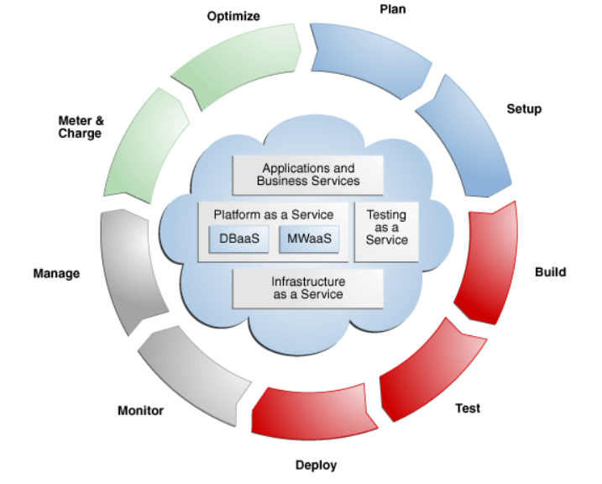

**Figure 2: Management system of Cloud life cycle.**

The protocol is widely used in figure 2 for managing the cloud life cycle .

Key aspects of IoT include:

1. Connectivity: IoT devices are equipped with technologies like Wi-Fi, Bluetooth, or cellular networks to establish connections with each other or the internet.

2. Data Collection: IoT devices collect data from their surroundings using built-in sensors, which can include information about temperature, humidity, location, movement, and more.

3. Data Analysis: The collected data is processed and analyzed to extract meaningful insights, monitor conditions, and trigger automated actions or alerts.

4. Automation and Control: IoT allows for automation and remote control of devices, enabling actions based on predefined rules or user commands.

5. Interoperability: IoT devices and systems often need to communicate and interact with each other, requiring standard protocols and compatibility.

## PARAMETERS EFFECTING CLOUD COMPUTING

The various parameters effecting the cloud computing are like Scalability: One of the biggest advantages of cloud computing is its scalability. Cloud platforms allow businesses to easily scale their computing resources up or down based on their needs. This eliminates the need for upfront investments in expensive hardware and infrastructure and enables organizations to quickly adapt to changing demands. Cost Savings: Cloud computing can significantly reduce costs for businesses. By eliminating the need for on-premises hardware, maintenance, and upgrades, organizations can save on capital expenditure. Cloud providers typically offer flexible pricing models, allowing businesses to pay only for the resources they use. This cost efficiency is particularly beneficial for startups and small businesses with limited budgets. Flexibility and Accessibility: Cloud computing provides users with the flexibility to access their data and applications from anywhere, using any device with an internet connection. This enables remote work, collaboration, and seamless integration across multiple locations. Additionally, cloud platforms often provide APIs and development tools that enable businesses to build and deploy custom applications tailored to their specific needs. Reliability and High Availability: Cloud service providers offer robust infrastructure and redundancy measures to ensure high availability of services. They typically have multiple data centres located in different regions, allowing for failover and disaster recovery capabilities. This means that even if one server or data centre goes down, the services remain accessible, minimizing downtime and ensuring business continuity. Security: Cloud providers invest heavily in security measures to protect customer data. They employ advanced encryption techniques, access controls, and monitoring systems to safeguard sensitive information. Additionally, by storing data in the cloud, businesses can minimize the risk of data loss due to hardware failures, theft, or natural disasters, as data is replicated and backed up across multiple servers and locations. Collaboration and Productivity: Cloud computing enhances collaboration and productivity by providing real-time access to shared documents and applications. Multiple users can work on the same document simultaneously, making it easier to collaborate and streamline workflows. Cloud-based project management and communication tools further enhance team collaboration and efficiency. Automatic Updates and Maintenance: Cloud service providers handle regular software updates, patches, and maintenance tasks, relieving businesses from the burden of managing these activities in-house. This ensures that applications and services are always up to date with the latest features and security enhancements, without requiring additional effort from the users. Disaster Recovery and Backup: Cloud computing offers robust disaster recovery and backup capabilities. Data stored in the cloud is automatically replicated and backed up across multiple servers and locations. This protects against data loss and enables businesses to quickly recover from unexpected events such as hardware failures, power outages, or natural disasters. Environmental Sustainability: Cloud computing promotes environmental sustainability by optimizing resource utilization. Instead of each organization running its own servers, cloud providers can consolidate resources and achieve higher server utilization rates. This reduces energy consumption, carbon footprint, and e-waste generation, contributing to a greener IT infrastructure. Innovation and Agility: Cloud computing empowers organizations to innovate and experiment with new technologies without significant upfront investments. Businesses can leverage cloud-based platforms and services such as machine learning, artificial intelligence, and big data analytics to gain insights, make data-driven decisions, and drive innovation within their operations. Deployment Models: Cloud computing offers different deployment models, including public cloud, private cloud, hybrid cloud, and multi-cloud. Public cloud services are provided by third-party vendors and are accessible to the general public over the internet. Private clouds are dedicated to a single organization, offering enhanced security and control. Hybrid clouds combine public and private cloud environments, allowing organizations to leverage the benefits of both. Multi-cloud involves using multiple cloud providers to meet specific requirements. Service Models: Cloud computing provides different service models: Infrastructure as a Service (IaaS), Platform as a Service (PaaS), and Software as a Service (SaaS). IaaS offers virtualized computing resources like servers, storage, and networks. PaaS provides a platform and tools for developing, testing, and deploying applications. SaaS delivers software applications over the internet, eliminating the need for local installation and maintenance. Cloud Security: Cloud computing providers employ robust security measures to protect data and resources. They implement encryption, access controls, regular security audits, and compliance with industry standards. However, data security is a shared responsibility, with the provider securing the underlying infrastructure, while users are responsible for securing their applications and data.

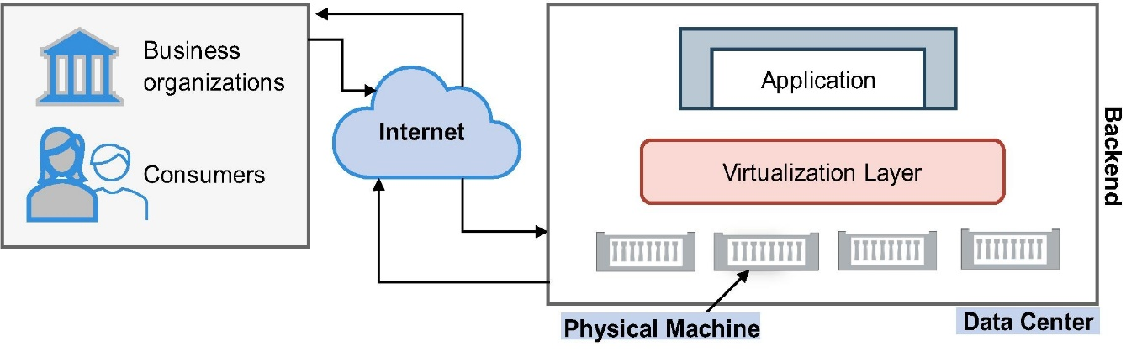

**Figure 3: Parameters affecting computing system.**

Internet of Things (IoT) device connectivity Technologies: IoT devices use various connectivity technologies, such as Wi-Fi, Bluetooth, Zigbee, NFC (Near Field Communication), cellular networks (3G, 4G, and 5G), and Low-Power Wide-Area Networks (LPWANs) like LoRaWAN and NB-IoT. The choice of connectivity depends on factors like range, power consumption, data rate, and deployment scenario. Data Analytics and AI: IoT generates vast amounts of data, and leveraging advanced analytics and artificial intelligence (AI) techniques is crucial to derive valuable insights. IoT data can be processed in real-time or stored in the cloud for later analysis, enabling predictive maintenance, intelligent decision-making, and optimization of operations. Edge Computing: Edge computing is an approach where data processing and analysis occur closer to the source, near the IoT devices or sensors, instead of relying solely on cloud resources. This helps reduce latency, manage bandwidth, and address privacy concerns by processing critical data locally. Industry Applications: IoT finds applications across numerous industries. For example, figure 3 forms the healthcare, IoT enables remote patient monitoring, wearable devices, and smart medical equipment. In transportation, IoT facilitates fleet management, traffic monitoring, and autonomous vehicles. Industrial IoT (IIoT) optimizes manufacturing processes through connected machinery and predictive maintenance, while smart cities leverage IoT for efficient infrastructure management and resource utilization.

## APPLICATION OF THE TECHNOLOGY

The application indicates the importance of the newly developed technology in the field of research.Healthcare: Cloud computing is being used in healthcare to store patient data securely and make it accessible to healthcare providers from anywhere. This allows healthcare providers to access patient information quickly and easily, which can improve patient outcomes. Education: Cloud computing is being used in education to provide students with access to educational resources from anywhere with an internet connection. This allows students to learn at their own pace and on their own schedule. Finance: Cloud computing is being used in finance to provide secure storage for financial data and enable remote access to financial applications. This allows financial institutions to operate more efficiently and securely. E-commerce: Cloud computing is being used in e-commerce to provide scalable and flexible infrastructure for online stores. This allows e-commerce businesses to quickly respond to changes in demand without having to worry about investing in new hardware or software.

Gaming: Cloud computing is being used in gaming to provide gamers with access to high-performance gaming servers from anywhere with an internet connection. This allows gamers to play their favorite games without having to worry about the limitations of their own hardware. Manufacturing: Cloud computing is being used in manufacturing to provide real-time data analytics and insights into production processes. This allows manufacturers to optimize their operations and reduce costs. Marketing: Cloud computing is being used in marketing to provide real-time data analytics and insights into customer behavior. This allows marketers to create more targeted and effective marketing campaigns. Government: Cloud computing is being used by governments around the world for a variety of purposes, including disaster response, citizen services, and data management.

One of the critical applications of IoT is in the healthcare sector, where it has revolutionized patient care. IoT devices help doctors and healthcare professionals to monitor patient health remotely, collect valuable data and analyse it to make informed decisions. These devices can automatically collect vital signs, such as blood pressure, heart rate, and blood sugar levels, and transmit them to the medical personnel for better patient monitoring. IoT technology is also used in the agriculture industry, where it can aid farmers in optimizing their yield. IoT-powered sensors can monitor soil health, detect weather changes, and adjust irrigation systems accordingly. These sensors can also alert farmers about potential pest infestations or other problems affecting crop growth, allowing for proactive measures to be taken.

The transportation industry is another area where IoT-powered devices have found considerable applications. Smart sensors and telematics systems in cars can help track and monitor vehicles' performance, detect maintenance issues, and route drivers more efficiently. Similarly, logistics companies are using IoT to optimize their supply chain operations, allowing for better tracking of goods and inventory, reducing theft, and minimizing delivery times. Smart homes are another area where IoT technology is making considerable inroads. With IoT-powered voice assistants and home automation systems, homeowners can control all the devices in their home from a single device. Smart thermostats and lighting systems can learn homeowners' behaviour, adjust temperatures and light levels accordingly, and manage energy usage, resulting in significant cost savings. The IoT is also making a significant contribution to the manufacturing industry, which uses IoT-powered devices in the form of sensors to monitor equipment and production lines. These sensors collect data that is analysed to optimize production, prevent equipment breakdowns and improve efficiency. IoT-powered robots are also used in manufacturing processes to automate tasks, reducing costs and eliminating the need for human labour in hazardous conditions. Retail is another industry where IoT technology is making a big impact. IoT-powered beacons and sensors can help retailers understand customer behaviour, improve the in-store experience, and personalize marketing campaigns. For example, beacons can alert customers to relevant in-store promotions when they are in the vicinity of the product, increasing the chances of a sale. Retailers can also collect data from in-store traffic flow and adjust the store layout accordingly for better customer traffic. Better User Experience: IoT can make websites and applications more interactive and personalised. For example, an e-commerce website can recommend products based on your past purchases. Automation and Control: IoT allows web developers to create applications that can control physical devices remotely. For instance, you can use a web app to turn off the lights in your home from anywhere. Data Insights: IoT devices generate a lot of data, and web developers can use that data to understand user behaviour and improve their websites or apps. Real-Time Monitoring: Web developers can build applications that collect and display real-time data from IoT devices. For example, a weather website can show you live updates from weather sensors placed around the city.

## CONCLUSION AND FUTURE USE

In conclusion, cloud computing provides businesses with scalable and cost-effective solutions, enhanced flexibility and accessibility, improved security and reliability, and opportunities for innovation. It has transformed the way organizations store, process, and access data, revolutionizing the digital landscape. The benefits of IoT include increased efficiency, improved safety, and enhanced data collection and analysis. IoT is transforming the world by connecting devices and leveraging data to enhance efficiency and simplify tasks. Its massive potential is far from fully realized, and as IoT systems become more sophisticated, the benefits for businesses and society will only continue to grow. However, security concerns and interoperability challenges must be addressed to ensure that IoT achieves its full potential in a safe and reliable manner. IoT applications are diverse, spanning various sectors such as smart homes, healthcare, agriculture, transportation, manufacturing, and energy management. By enabling connectivity and data exchange between devices and systems, IoT aims to enhance efficiency, productivity, and convenience in both personal and industrial contexts. Cloud computing often serves as the backbone for data storage, processing, and analytics in IoT ecosystems, facilitating the seamless integration and management of large-scale IoT deployments. IoT is an exciting technology that connects everyday objects to the internet, making them smarter and more useful. In web development, IoT can enhance user experiences, automate tasks, and provide valuable insights. By leveraging IoT, web developers can create more interactive and personalized applications that make our lives easier and more connected.

## REFERENCES

1. Buyya, R., Yeo, C. S., Venugopal, S., Broberg, J., & Brandic, I. (2009). Cloud computing and emerging IT platforms: Vision, hype, and reality for delivering computing as the 5th utility. Future Generation computer systems, 25(6), 599-616.
2. Gubbi, J., Buyya, R., Marusic, S., & Palaniswami, M. (2013). Internet of Things (IoT): A vision, architectural elements, and future directions. Future generation computer systems, 29(7), 1645-1660.
3. G. Eason, B. Noble, and I.N. Sneddon, “On certain integrals of Lipschitz-Hankel type involving products of Bessel functions,” Phil. Trans. Roy. Soc. London, vol. A247, pp. 529-551, April 1955. (references)
4. Buyya, R., Yeo, C. S., & Venugopal, S. (2008, September). Market-oriented cloud computing: Vision, hype, and reality for delivering it services as computing utilities. In 2008 10th IEEE international conference on high performance computing and communications (pp. 5-13). Ieee.
5. Tiwari, A., & Garg, R. (2022). A Optimized Taxonomy on Spot Sale Services Using Mathematical Methodology. International Journal of Security and Privacy in Pervasive Computing (IJSPPC), 14(1), 1-21.
6. Kushwah, R., Batra, P. K., & Jain, A. (2020, March). Internet of things architectural elements, challenges and future directions. In 2020 6th International Conference on Signal Processing and Communication (ICSC) (pp. 1-5). IEEE.
7. Buyya, R., Broberg, J., & Goscinski, A. M. (Eds.). (2010). Cloud computing: Principles and paradigms. John Wiley & Sons.
8. Tiwari, A., & Garg, R. (2022). Adaptive Ontology-Based IoT Resource Provisioning in Computing Systems. International Journal on Semantic Web and Information Systems (IJSWIS), 18(1), 1-18.
9. Buyya, R., & Srirama, S. N. (Eds.). (2019). Fog and edge computing: principles and paradigms. John Wiley & Sons.
10. Rochwerger, B., Vázquez, C., Breitgand, D., Hadas, D., Villari, M., Massonet, P., ... & Galán, F. (2011). An architecture for federated cloud computing. Cloud computing: principles and paradigms, 391-411.
11. Aversa, R., Di Martino, B., Rak, M., Venticinque, S., & Villano, U. (2011). Performance prediction for HPC on clouds. Cloud Computing: Principles and Paradigms, 437-456.
12. Bose, S., Pasala, A., Ramanujam A, D., Murthy, S., & Malaiyandisamy, G. (2011). Sla management in cloud computing: A service provider's perspective. Cloud Computing: Principles and Paradigms, 413-436.
13. Bowen, J. A. (2011). Legal issues in cloud computing. Cloud Computing: Principles and Paradigms, 593-613.
14. Tiwari, A., & Garg, R. (2022). Reservation System for Cloud Computing Resources (RSCC): Immediate Reservation of the Computing Mechanism. International Journal of Cloud Applications and Computing (IJCAC), 12(1), 1-22.