Comparative Study of Strength among Athletics, Basketball and Kabaddi Players
Dhananjay Singh
¹Assistant Professor, Department of Physical Education R.B.S. College, Agra, U.P.
Email: dhananjaysingh862@gmail.com
Abstract

Purpose: This research aimed to compare the strength among athletics, basketball and kabaddi players.
Methods: A total of 90 participants were randomly recruited for the research, with thirty individuals representing each of the sports disciplines of basketball, kabaddi, and athletics The age group spanning from 18 to 28 years. This research examined specific motor components among college students, including arm and leg strength. The data were gathered on the performance of chin up test and standing broad jump test. Analysis of variance was used to compare the strength among different sports groups.
Result: Results indicate a notable disparity in arm strength between the basketball and kabaddi groups and between the athletics and basketball groups. There is no significant difference in strength seen between athletics and kabaddi groups. The results indicate significant mean differences in leg strength between athletics and basketball and between athletics and kabaddi.
Conclusion: The 'F' test for data analysis showed a significant variation between the athletics, basketball, and kabaddi groups in all of the motor fitness variables of arm and leg strength.
Keywords: arm strength, leg strength

- INTRODUCTION
In contemporary discourse, there has been an assertion that the phrase "a sound mind in a sound body" succinctly encapsulates a comprehensive depiction of a state of contentment within our universe. Individuals with these two attributes would find little desire beyond this harmonious combination. (John E. Nixon and Ann E. Jewett, 1969)
Sports and games are widely recognized and acknowledged as significant cultural phenomena. There is a persistent effort to attain elevated levels of performance. Consequently, contemporary sports and games need optimal physical conditions and the utmost level of performance. The use of marks has facilitated the development of physical capabilities in current youth beyond the boundaries of conception. The realm of sports has seen a significant rise in competitiveness, with performances consistently being exceeded regularly.
Every person on the planet desires to achieve physical fitness to do their daily responsibilities and activities effectively. The range of activities engaged in by individuals spans from sedentary office labor to participation in competitive sports. The physical fitness levels of these persons are contingent upon the nature of the work, and conversely, the heart of the task is contingent upon their physical fitness levels. (H. Harrison Clarke, 1957). The significance of physical fitness in the performance of various sports and team games is well acknowledged. The term "fitness" has been extensively examined and elucidated by physical educators, coaches, and medical professionals in many contexts, including its impact on athletic performance and overall physiological well-being. The concept of "Fitness" is subject to several interpretations throughout the literature.
Each specialist mentioned above considers their expectations about the human body and formulates their distinct definition of "fitness." Various terminologies such as "Motor Fitness," "Physical Fitness," "Total Fitness," "General Fitness," "Athletic Fitness," "Organic Fitness," and "Health Related Physical Fitness" are often used.
Motor fitness, particularly in team sports, is widely recognized as a crucial element, even when the team comprises individuals with exceptional technical abilities, high levels of knowledge, and extensive experience. Motor fitness is assessed by performance, influenced by several aspects, including strength, endurance, power, speed, agility, and flexibility. Specific characteristics have a more significant influence than others, exhibiting a stronger correlation with motor fitness. Scholars and experts in the field have posited that an athlete's anthropometric measures and physical attributes significantly contribute to their overall performance. In addition to the technical and tactical aspects, a player or squad's biological and physiological characteristics contribute considerably to enhancing their performance. According to Warren R. Johnson and E.R. Buskirv (1974), most games need individuals to possess elevated levels of speed, strength, endurance, flexibility, coordination, and overall physical fitness to achieve optimal performance.
General motor ability pertains to an individual's proficiency in various tasks within a moderate difficulty level. The concept has been conceptualized as a multifaceted amalgamation of several personal attributes, including but not limited to strength, endurance, power, speed, agility, response time, and coordination. Several characteristics serve as the foundation for performance in numerous motor complexes. According to H. Harrison Clarke (1976), to attain correct and efficient movement in motor performance, certain qualities must work in a coordinated way and follow an effective sequence. This applies to many activities, such as a single effort like a golf drive or a succession of complicated and quickly changing movements, as seen in basketball.
The attainment of specialized motor fitness is crucial for athletes participating in elite-level events. The development of particular physical fitness necessitates the suitable allocation of motor talents to the demands of the respective sport. The precise effect of motor fitness is paramount in attaining enhanced performance outcomes in games and sports.

- METHODOLOGY
A total of 90 participants were randomly recruited for the research, with thirty individuals representing each of the sports disciplines of basketball, kabaddi, and athletics. A total of 30 basketball players who had previously participated in the district-level basketball competition in Kanpur District were picked. Similarly, a group of 30 kabaddi players who had previously participated in the district-level kabaddi tournament were chosen from Kanpur District. Additionally, a group of 30 athletics players who had previously competed in the district-level athletics competition were also picked. This research focused on selecting significant and influential motor fitness components to compare the sports of Basketball, Kabaddi, and Athletics. The chosen variables about motor fitness components include strength.
The researcher collects data for each variable for the present study. The study participants were individually approached, and their genuine cooperation will be sought. The subjects or players were contacted at Kanpur University. Before administering the test for each variable, the individual was provided with the appropriate instructions for testing. Once the participants had comprehended the instructions, they were instructed to carry out the specific examination. A further investigation was carried out on another variable after full recovery. The exercise known as 'chin-ups' involves the individual gripping an overhead bar with an under. The Standing Broad Jump test was used to assess the motor fitness component of arm and leg strength.

- RESULTS AND DISCUSSION
Arm Strength:
Analysis of variance (ANOVA) was applied to examine the variations across sports groups about the variable of Arm strength. The findings of this analysis have been reported in Table 1.

TABLE: 1 Analysis of Variance Between Sports Groups on Arm Strength

Source of variance | Degree of Freedom | Sum of Square | Mean Sum of Square | Obtained F-value | Required F-ratio
Between group | 3-1=2 | 466.03 | 233.01
 |  |  |  | 24.65* | 3.103
Within Group | 90-3=87 | 822.3 | 9.45
N=90
*Significance at 0.05 level
Upon analyzing Table 1, it becomes evident that a significant difference exists between the various sports groups. This fact supports the derived F-value of 24.65, which surpasses the tabular value of 3.103 necessary for significance at a 0.05 level. The 'F' ratio observed among the sports groups was 24.65, which exceeded the critical 'F' value of 3.103 for establishing statistical significance. The results suggest the presence of a statistically significant difference among the chosen sports groups. Scheffe's post-hoc test determined the critical differences between the matched sports. The findings related to this are shown in Table 2.
TABLE: 2 Ordered Paired Means and Significance of Difference between Means of Sports Groups on Arm Strength

Athletics | Basketball | Kabaddi | Mean Diff. | Critical Difference
10.01 | -- | 9.76 | 0.34 | 1.96
10.1 | 5.13 | -- | 4.97* | 1.96
 | 5.13 | 9.76 | 4.63* | 1.96

Table 2 presents the results indicating significant mean differences seen in arm measurements between athletics and basketball (mean difference = 4.97) and between basketball and kabaddi (mean difference = 4.63). These mean difference values are above the critical difference value of 1.96, the threshold for statistical significance. The calculated mean difference (M.D.=0.34) between athletics and kabaddi was lower than the critical difference value of 1.96, which is necessary for establishing statistical significance. It suggests no significant difference in arm strength between athletics and kabaddi. The athletics group had the most fabulous paired mean value (10.1) among the three sports groups, while the basketball group displayed the lowest (5.13).
The research findings indicate a notable disparity in arm strength between the basketball and kabaddi groups and between the athletics and basketball groups. There is no significant difference in strength seen between athletics and kabaddi groups. This disparity may be attributed to the inherently more demanding nature of the game played by kabaddi athletes than basketball players. In sports, the strength component significantly influences performance more than in basketball. Hence, there are notable disparities. The performance of athletes was superior to that of kabaddi players in terms of scoring. Although the observed difference was not statistically significant, this outcome may be attributed to the nature of the game that necessitates arm strength, and both groups included players with varying levels of power, which could have influenced their overall performance.

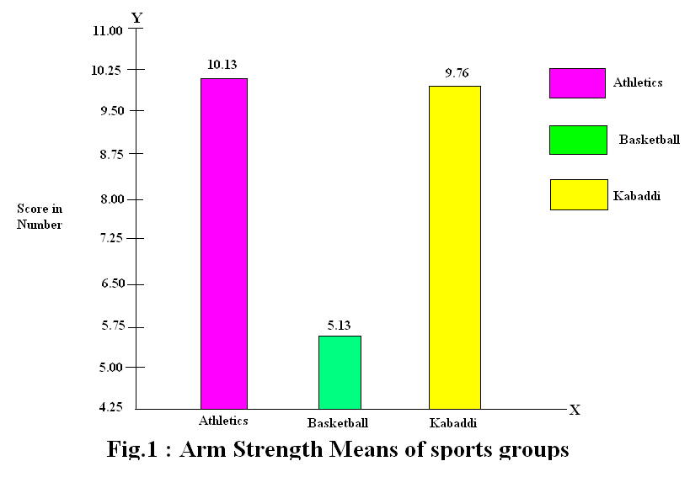
Fig1: Mean of arm strength among sport groups

Leg Strength
Analysis of variance (ANOVA) was applied to examine the variations across sports groups about the variable of Leg strength. The findings of this analysis have been reported in Table 3.

TABLE: 3 Analysis of Variance between Sports Groups on Leg Strength

Source of variance | Degree of Freedom | Sum of Square | Mean Sum of Square | Obtained F-value | Required F-ratio
Between Group | 3-1=2 | 8652.4 | 4321.2
 |  |  |  | 10.79* | 3.103
Within Group | 90-87 | 34835.2 | 400.40
N=90
*Significance at 0.05 level
Upon careful analysis of Table 3, it becomes evident that a notable disparity exists between the various sports groups. This conclusion is supported by the fact that the calculated F-value of 10.79 surpasses the critical value of 3.103, which is necessary to establish statistical significance at a confidence level of 0.05. The 'F' ratio for the sports groups was found to be 10.79, which is above the critical 'F' value of 3.103. This indicates that there is a considerable difference between the chosen sports groups. To further analyze the differences, the Scheffes post-hoc test was conducted. The findings related to this issue are shown in Table 4.
TABLE: 4 Ordered Paired Means and Significance of Difference between Means of Sports Groups on Leg Strength

Athletics | Basketball | Kabaddi | Mean Diff. | Critical Difference
234.4 | 219.8 | -- | 14.6* | 12.79
234.4 | -- | 210.6 | 23.8* | 12.79
-- | 219.8 | 210.6 | 9.2 | 12.79

The results presented in Table 4 indicate significant mean differences in leg strength between athletics and basketball (mean difference = 14.6) and between athletics and kabaddi (mean difference = 23.8). These differences were considered significant since the mean difference was above the critical difference value of 12.79, which is the threshold necessary for statistical significance. The mean difference (M.D.=9.2) between basketball and kabaddi was lower than the critical difference value of 12.79, which is required for statistical significance. This suggests no significant difference in leg strength between basketball and kabaddi among the three sports groups. Among these groups, the athletics group had the highest paired mean value of 234.45, while the kabaddi group had the lowest paired mean value of 210.6. This may be attributed to the nature of athletics performance which is more of explosive in nature as compare to basketball and kabaddi players. Basketballers scored higher kabaddi players. Though the difference was not significant. This may be due to the factor that explosive strength was not the dominating factor for better performance in both the games.
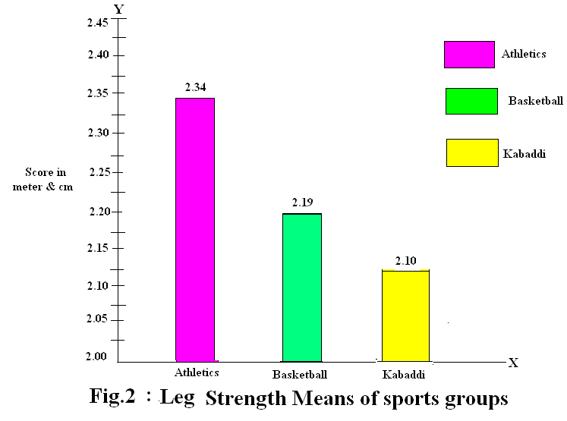
Fig1: Mean of leg strength among sport groups

- CONCLUSION
The 'F' test for data analysis showed a significant variation between the athletics, basketball, and kabaddi groups in all of the motor fitness variables of arm and leg strength that were investigated.

REFERENCES-
- Nixon, J. E., & Jewett, A. E. (1969). An introduction to physical education, W. B. Saunders, Michigan
- Clarke, H. Harrison (1976). Application of Measurement to Health in Physical Education, Vth Ed., Englewood Cliffs, N.J. Prentice Hall Inc.
- Johnson, Warren R. and Buskirv E.R. (1974). Science and Medicine of Exercise and Sports, Harper and Brothers Publications, New York.
- Clarke, H. H. (1976). Application of measurement to health and physical education, Prentice-Hall, Inc., Englewood Cliffs, New Jersey
- Fleshman, Edwin A. (1966). The Structure and Measurement of Physical Fitness, Englewood Cliffs N.J. Prentice Hall Inc.

