IMPORTANCE OF MULTIUNIT FLOATING DRUG DELIVERY SYSTEM
FOR MANAGEMENT OF PEPTIC ULCER DISEASE

¹Pradeep Singh, ²Pragati Singh, ³Apurwa Singh, ⁴Avinash Kumar Rao, ⁵Priya Jaiswal and ⁶*Vikash Kumar Chaudhri

¹Sultanpur Institute of Pharmacy, Saifullaganj, Sultanpur-Faizabad Bypass,
Sultanpur-228119, Uttar Pradesh, India.
^{2,3}Shri Ramswaroop Memorial University, Lucknow-Deva Road, Barabanki-225003,
Uttar Pradesh, India.
⁴Madhyanchal Professional University, Bhopal-462044, Madhya Pradesh, India.
⁵Gautam Buddha College of Pharmacy, Lucknow-226008, Uttar Pradesh, India.
⁶*Faculty of Pharmacy, Dr. A.P.J. Abdul Kalam Technical University,
Lucknow-226031, Uttar Pradesh, India.

ABSTRACT: Peptic ulcer disease is a condition in which painful sores or ulcers develop in the lining of the stomach or the first part of the small intestine (the duodenum). Normally, a thick layer of mucus protects the stomach lining from the effect of its digestive juices. But many things can reduce this protective layer, allowing stomach acid to damage the tissue. Now a day many types of drug delivery systems are available for the treatment of peptic ulcer but Multiunit floating drug delivery system is a suitable system for the treatment of peptic ulcer because it removes the probability of dosage dumping and non floatability of single unit system. It also increases the bioavailability, patient compliance and decrease the frequency of administration.
Keywords:- Peptic ulcer disease, Multiunit floating drug delivery system, non floatability of single unit system, bioavailability, dosage dumping.

INTRODUCTION
Multiunit Floating Systems
The purpose of designing multiple-unit dosage form is to develop a reliable formulation that has all the advantages of a single-unit dosage form and also is devoid of disadvantages of single-unit formulations. In pursuit of this endeavor many multiple-unit floatable dosage forms like microspheres, microbeads, and microcapsules etc. have been designed. Microspheres have high loading capacity and many polymers have been used such as albumin, gelatine, starch, polymethacrylate, polyacrylamine, and polyalkylcyanoacrylate. Spherical polymeric microsponges, also referred to as “microballoons,” have been prepared. Microspheres have a characteristic internal hollow structure and show an excellent in vitro floatability. In carbon dioxide–generating multiple-unit oral formulations several devices with features that extend, unfold, or are inflated by carbon dioxide generated in the devices after administration have been described in the recent patent literature. These dosage forms are excluded from the passage of the pyloric sphincter if a diameter of ~12 to 18 mm in their expanded state is exceeded Reports have been found on the development of both non-effervescent and effervescent multiple unit systems [1,2].
Examples- Floating microspheres/Micro balloons, Alginate beads/Floating beads.
Advantages of multiunit floating systems
Multiunit system provides constant and prolonged therapeutic effect, which will reduce the dosing frequency and thereby improve the patient compliance. They could be injected in to the body due to the spherical shape and smaller size [3]. Better drug utilization will improve the bioavailability and reduce the incidence or intensity of adverse effects. It was reported that multiunit system reduces the GI toxic effects, exhibit sustained action and of course increase patient and therapeutic compliance. Microencapsulation for oral use has been employed to sustain the drug release, and to reduce or eliminate gastrointestinal tract irritation. In addition, multiparticulate delivery systems spread out more uniformly in the gastrointestinal tract. This results in more reproducible drug absorption and reduces local irritation when compared to single-unit dosage forms such as non disintegrating, polymeric matrix tablets [4,5].

Potential drug candidates for multiunit floating systems-
1. Narrow absorption window in GI tract e.g. riboflavin, levodopa and furosemide etc [6].
2. Drug those are unstable in the intestinal or colonic environment e.g. captopril, metronidazole, ranitidine HCl etc [6].
3. Drug that disturb normal colonic bacteria, e.g. Antibiotic against Helicobacter pylori [6].
4. Drug that act locally in the stomach, e.g. antacid and misoprostol.
5. Primarily absorb from stomach and upper part of GI tract e.g. calcium supplement, chlordiazopoxide etc [6].
6. Drug that exhibit low solubility at high pH value e.g. diazepam, chlordiazepoxide, virapamil HCl etc [6].

Unsuitable Drug Candidates for multiunit floating systems
1. Drug that have very limited acid solubility e.g. phenytoin.
2. Drug that degrade in gastric environment e.g. erythromycin.
3. Drug intended for selective release in the colon e.g. 5-amino salicylic acid etc. [7].

Factor affecting gastric retention of multiunit floating systems
The most important parameter that affect the gastric retention time of oral dosage form include; density, size and shape of dosage form, food intake and its nature, caloric content and frequency of intake ,posture, gender, age, sex, sleep, body mass index physical activity and disease state of individual (e.g. chronic disease, diabetes etc.) [8].

1. Density of Dosage Form
Dosage form having a density lower than the gastric content can float on surface, while high density system sink to bottom of stomach [9]. Density of 1.0gm/cm 3 is required to exhibit floating property [10].

2. Shape and Size of the Dosage Form
Dosage form having a diameter of more than 7.5mm show a better gastric residence time compared with one having 9.9 mm [11]. Ring shaped and tetrahedron shaped device have a better gastric residence time as compared with other shape [12].

3. Effect of Gender Posture and Age
Generally female have slower gastric emptying rate than male. The effect of posture does not have any significant difference in the mean gastric retention time (GRT) for individual in upright, ambulatory and supine state. In case of elderly person gastric emptying is slowed down [13].

4. Food Intake and Its Nature
Food intake, viscosity and volume of food, caloric value and frequency of feeding have a profound effect on the gastric retention of dosage form. Usually the presence of food in the gastrointestinal tract (GIT) improves the gastric retention time (GRT) of the dosage form and thus, the drug absorption increase by allowing its stay at absorption site for long period. Increase in acidity and caloric value shows down gastric emptying time (get) which can improve the gastric retention of dosage form [14].

Peptic Ulcer Disease
Peptic ulcer disease is a condition in which painful sores or ulcers develop in the lining of the stomach or the first part of the small intestine (the duodenum). Normally, a thick layer of mucus protects the stomach lining from the effect of its digestive juices. But many things can reduce this protective layer, allowing stomach acid to damage the tissue.

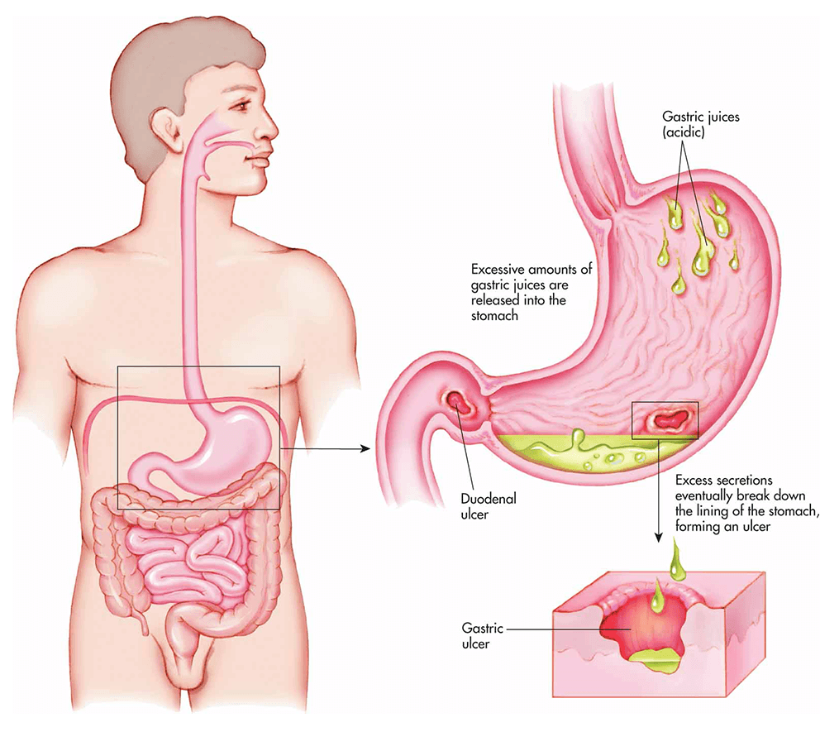

A peptic ulcer is classified into two types they are:
- Types of inducers in peptic ulcer
- H-pylori induced peptic ulcer
- NSAID induced peptic ulcer
- Stress-related mucosal damaged ulcer

- Types of peptic ulcer depending on sites
- Gastric ulcers:which appear in the stomach lining
- Oesophageal ulcer: which appears in the long tube-like structure that connects the stomach with the mouth.
- Duodenal ulcers: Appearing in a small intestine section called the duodenum

METHODS OF MICROSPHERES PREPARATION
Following are various methods of microspheres preparation;

1.9.1 Single Emulsion Technique
The floating microspheres of natural polymers like proteins and carbohydrates are prepared by single emulsion technique. The natural polymers are dissolved or dispersed in aqueous medium then it dispersed in non-aqueous medium like oil with the help of cross linking agent [15, 16].

1.9.2 Double Emulsion Technique
Double emulsion method of microspheres preparation involves the formation of the multiple emulsions or the double emulsion such as w/o/w. This method can be used with the natural as well as synthetic polymer [15,16].

1.9.3 Phase separation coacervation technique
This process is based on the principle of decreasing the solubility of the polymer in organic phase to affect the formation of polymer rich phase called the coacervates. In this method, the drug particles are dispersed in a solution of the polymer and an incompatible polymer is added to the system which makes first polymer to phase separate and engulf the drug particles. Addition of non-solvent results in the solidification of polymer [15,16].

1.9.4 Spray Drying and Spray Congealing
These methods are based on the drying of the mist of the polymer and drug in the air. The polymer is first dissolved in a suitable volatile organic solvent such as dichloromethane, acetone, etc. The drug in the solid form is then dispersed in the polymer solution under high speed homogenization. This dispersion is then atomized in a stream of hot air. The atomization leads to the formation of the small droplets or the fine mist from which the solvent evaporates instantaneously leading the formation of the microspheres in a size range 1-100 μm. Depending upon the removal of the solvent or cooling of the solution, the two processes are named spray drying and spray congealing respectively [15, 16].

1.9.5 Emulsion solvent evaporation
This method involves removal of the organic phase by evaporation of the organic solvent. The method involves water miscible organic solvents such as isopropanol. Organic phase is removed by evaporation with water. In order for the microsphere to form, the organic solvent must first diffuse into external phase and then evaporate at the water air Interface [15, 16]. As solvent evaporation occurs, the microspheres harden and free flowing microspheres can be obtained after suitable filtration and drying. This process decreases the hardening time for the microspheres.
The rate of solvent removal by evaporation method depends on the temperature of water, ratio of emulsion volume to the water and the solubility profile of the polymer [17].

1.9.6 Ionic gelation
Gonzalez-Rodriguez ML et al. reported alginate/chitosan particulate systems for Diclofenac sodium release by ionic gelation (Ca²⁺ and Al³⁺). 25% w/v of the drug was added to 1.2% w/v aqueous solution of sodium alginate. The solution was stirred till a complete solution was formed. This solution was added drop wise to a solution containing Ca²⁺ or Al³⁺ and chitosan solution in acetic acid which results into formation of microspheres [18].

1.9.7 Hot melt encapsulation method
Lin WJ and Kang WW compared the performance of Indomethacin microparticles and their release properties after coating with chitosan and gelatin, respectively. Here the poly (epsilon-caprolactone) (PCL) microparticles were prepared by the hot-melt encapsulation method. This method is having a disadvantage that thermo-labile substances cannot be used [19].

EVALUATION PARAMETER OF FLOATING MICROSPHERES
- Particle size determination
The particle size of the microspheres was determined with an optical microscope under regular polarised light, and mean particle size was calculated by measuring 100 microspheres with the help of a calibrated oculometer [20].

2 . Tapped density
Tapping method was used to calculate tapped density. The volume of a weighed quantity of the microspheres was determined, after 100 taps, using a tapped density apparatus.
DT = MT/VT
Where DT = tapped density, MT is mass of microspheres and VT = volume of microspheres after tapping.
3. Carr’s (Compressibility) index

This parameter was calculated from bulk density (the ratio of weighed quantity of microspheres to its volume), Compressibility index = (DT – DP)/DTx100

4. Angle of repose
The angle of repose, Tan Ɵ, of the microspheres, which measures resistance to particle flow, was determined by the fixed funnel method 14 and calculated as
Tan Ɵ = S/D
Where S = surface area of the free standing height of the microspheres heap and D = diameter of the heap.

5. Scanning electron microscopy
Scanning electron microscopy (SEM) studies were performed to determine the porous/hollow nature of the microspheres Surface morphology of microspheres was also noted.

6. Drug loading
The drug content of the floating microspheres was carried out by dissolving the microspheres in a small amount of suitable solvent in a separating funnel and extracting the drugs into 0.1N HCl by evaporating the solvent. Determination of drug loading was carried out suitable analytical technique.

7. In vitro floatability
In vitro floatability studies on floating microspheres were carried out using USP XXIV dissolution apparatus II [21]. The microspheres were placed in 0.1M hydrochloric acid containing 0.02 %v/v Tween 80 with the paddle rotating at 100 rpm for 12 h. The purpose of adding Tween 80 is to mimic the effect of natural surfactants in the stomach. The floating and the settled portions of the microspheres were filteredred separately, dried and weighed. Buoyancy (floatability) was calculated as
Buoyancy (%) = Qf / (Qf + Qs) x 100
Where Qf and Qs are the weights of the floating and the settled microspheres, respectively.
This parameter was calculated from bulk density (the ratio of weighed
quantity of microspheres to its volume),
Compressibility index = (DT – DP)/DTx100

8. In vitro drug release studies
Drug release studies were carried out in a six-basket USP XXIV dissolution apparatus type I rotating at 100 rpm in 0.1M hydrochloric acid as dissolution medium (900 ml) maintained at 37±0.5⁰C. At specific time intervals, up to 12 h, aliquots were withdrawn and analysed by suitable analytical technique spectrophotometrically after suitable dilution. The withdrawn volume was replaced with an equal volume of fresh 0.1N hydrochloric acid to maintain sink conditions. All experiments were performed in triplicate. The drug release data were fitted to Zero order (cumulative % drug release versus time), First order (log cumulative % drug retained versus time) and Higuchi models (cumulative % drug released versus square root of time) to assess the kinetics of drug release and determine the release mechanism of the drug from the floating microspheres.

CONCLUSION
Multiunit floating drug delivery system is a suitable system for the treatment of peptic ulcer because it removes the probability of dosage dumping and non floatability of single unit system. It also increases the bioavailability, patient compliance and decrease the frequency of administration.

REFERENCES
- Soppimath KS, Kulkarni AR, Rudzinski WE, Aminabhavi TM. (2001) Microspheres as floating drug delivery system to increase the gastric residence of drugs. Drug Metab Rev. 33:149Y160.

- Ichikawa M, Watanabe S, Miyake Y. (1991) A new multiple unit oral floating dosage system. I: Prepration and in vitro evaluation of floating and sustained-release kinetics. J Pharm Sci. 80:1062Y1066.

- United States Patent 6217911, Sustained release non-steroidal, anti-inflammatory and lidocaine PLGA microspheres.

- Alexander Florence, (1994) Novel Oral Drug Formulations: Their Potential in Modulating Adverse Effects, Drug Safety 10 (3): 233-266.

- Sjoegren, J., Prescott, L.F., Nimmoe W.S., (1985) Rate Control in Drug Therapy, Churchill Livingstone, Edinburgh, pp38-47.

- Vyas SP, Khar RK. (2006), Gastroretentive systems. In: Controlled drug Delivery. Vallabh Prakashan, Delhi, India. p. 197-217.

- Nayak Amit kumar, Maji Ruma, Das Biswarup (2010) Gastroretentive drug delivery systems: a review, Asian Journal of Pharmaceutical and Clinical Research, Vol.3 Issue 1, Page 4.
- Streubel A, Siepmann J, Bodmeier R. (2006) Drug delivery to the upper small intestine window using Gastroretentive technologies. Curr Opin Pharmacol, 6: 501-8.

- Dubernet C. Syste`mes a` liberation gastrique prolonge`e.In: Falson-Rieg F, Faivre V, Pirot F, editors. Novelles formes me`dicamenteuses. Editions Me`dicales Internationales. Editions TEC and DOC. Cachan. 2004. p.119-33.

- Arrora S, Ali J, Khar RK, Baboota S. (2005) Floatng drug delivery systems: A review. AAPS Pharm Sci Tech, 6(3):372-90.

- Garg S, Sharma S. (2002) Gastroretentive drug delivery systems. Business Briefing: Pharmatech: 160-66.

- Mojaverian P, Vlasses PH, Kellner PE, Rocci Jr ML. (1988) Effects of gender, posture and age on gastric Residence time of an indigestible solid: Pharmaceutical considerations. Pharm Res, 10: 639-44.

- Khosla R, Feely LC, Davis SS. (1989) Gastrointestinal transit of non-disintegrating tablets in fed subjects. Int J Pharm; 53: 107-17.

- Soppimath KS , Kulkarni AR, Aminabhavi TM. (2001), Drug Dev. Ind Pharm;27(6): 507-15
- Alagusundaram.M, Madhusudana CC, Umashankari.K, Attuluri VB, Lavanya.C, Ramkanth S. (2009), Microspheres As A Novel Drug Delivery Sysytem - A Review, International Journal of Chemical Technology and Research 1(3):52534.

- O’Donnell PB, Mc Ginity JW. (1997)Preparation of Microsphere by Solvent Evaporation Technique. Adv Drug Deliv Rev.,28: 25-42.

- Mathew TS, Devi SG, Prasanth VV, Vinod B. (2008) NSAID As Microspheres. The Internet Journal of Pharmacology; 6(1).

- Mathew TS, Devi SG, Prasanth VV, Vinod B. (2010) NSAID as Microspheres. The Internet Journal of Pharmacology; 8(3).

- Martin A. (1993) Micromeritics. Physical Pharmacy, fourth ed. Lea Feiger, Philadelphia,: 431-432.

- Sinha VR, Agarwal MK, Kumaria R. (2005) Influence of formulation and excipients variables on the pellet properties prepared by extrusion spheronization. Curr. Drug Delivery; 2: 1-8.

- The United State Pharmacopoeia XXIV, (2000) United state Pharmacopoeial Convention, Rock Ville: pp 1941-1943.

