**AUGMENTED REALITY AND VIRTUAL REALITY**

**IN THE TECH WORLD**

*ARAVINDHAN B, DEEPAKKUMAR A, GOKUL S, VISHNUVARMA R,*

*M.Sc. Computer Science,*

*Department of Computer Science, Dr.N.G.P. Arts and Science College, Coimbatore-48*

**Abstract**

*Here we are in the trendy technology world where we can feel any place from a small device like VR headsets. VR is that Virtual Reality we are able to view an artificial world with our creativity. The AR that is Augmented Reality where we are able to view the real product in the real time world. VR is used in many fields like education, medicine, VR gaming, VR movies, entertainment and so on as well as the AR is used in many fields such as education and gaming and more.*

**Keyword**

Augmented Reality- Virtual Reality-Mixed Reality-Digital World-Technology

**Introduction**

The term AR - Augmented Reality was coined in 1990 by Boeing researcher Tom Codell. This AR technology is one of the first commercial uses of this technology in television that seems to be entertainment and in the military sector. As the world is moving towards the new technology the AR is being grown now, AR became an important tech in multiple fields, drawing its connection towards the interactive concept. As the technology develops day by day they also emerge several new trends in Augmented Reality.

Virtual reality VR is a simulation-based environment which can provide a new experience in 3 Dimensional environments that can experience near-eye displays to give the user an immersive feel of a virtual world using a simple device. Some of the uses of Virtual Reality are entertainment (particularly video games), education sector (such as medical or military training) and business meetings (such as virtual meetings). Some more types of VR based technology include augmented reality which is said as AR and mixed reality, sometimes referred to as extended reality which is now said as XR.

**VR - Virtual Reality**

In 1968, Ivan Sutherland and his student, Bob Sproull, created the first lens that connected to an Ultimate Display that is used for both AR/VR.

Jaron Lanier is the person who coined the new term as VR - Virtual Reality, he is the founder of VPL Research, and he also created the EyePhone head-mounted display and Dataglove as his invention.

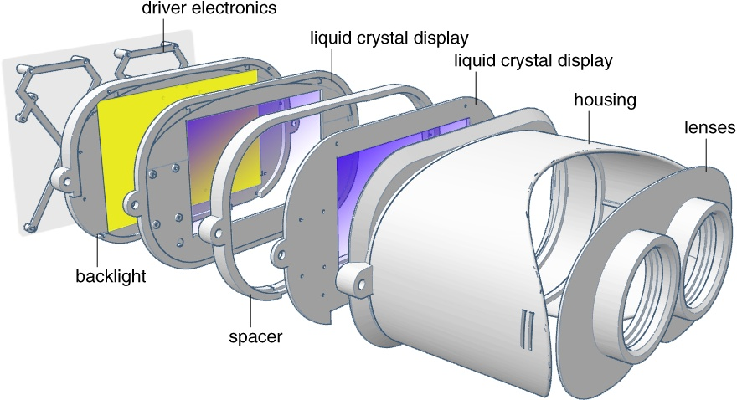

The VR includes a display, motion sensors and controllers that are used to track the movements and gestures of the users in real-time. The software involves creating a digital environment in 360 degree using computer-generated graphics(CG), audio are also thrown toward the 360 degree that gives an 360 entertainment , and other sensory inputs to simulate a fully immersive experience to the user

**Advantage of VR**

* Enhanced learning experience
* Realistic training
* Entertainment
* Remote Collaboration
* Therapy and rehabilitation

**Disadvantage of VR**

* Health Risks
* Addiction
* Social isolation
* Cyber security risks
* Health and safety risks

**Importance of VR**

Therapeutic Benefits:

This VR can be used to provide a safe and controlled exposure to triggering stimuli, thus the VR is used in therapy(treatment) and also helps to get back from some addiction at a wide range of conditions, such as PTSD, anxiety, phobias and physical injuries.

**AR- Augmented Reality**

The father of computer graphics Ivan Sutherland invented the AR - Augmented Reality in 1968 in Harvard innovation labs.

The Ar is an interactive segment of technology that can also enhance the real world with the help of computer generated natural and sensory things in the environment. By using some applications and software or a Hardware like AR glasses that is easy to view the augmented reality object overlays digital content onto real-life environments and objects.

AR glasses are the combination of an accelerometer, a gyroscope, and a magnetometer to reduce the error occurrence and quickly produce accurate results, that also enables a system to track the head and body motion and position.

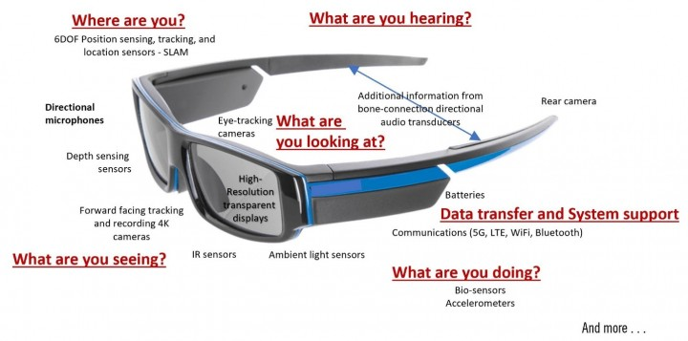

**Advantages of AR**

* Enhanced Experience
* Educational Advantages
* Improved Technology

**Disadvantage of AR**

* Unaffordable
* Promote Risky Behaviour
* More health issues

**Mixed Reality**

The mixed reality is that the combination of both Augmented Reality and Virtual Reality

Mixed reality is able to provide both augmented and virtual reality experience in one device. This is also used in entertainment, design, training in military, health care and in robots as remotely controlled.

The Microsoft HoloLens is also a mixed reality. Whereas the HoloLens 2 is only for act as the AR headset is developed for the business purpose.



HoloLens

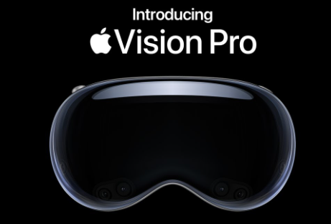

Apple Vision Pro

**Conclusion**

Thus, the world moves towards the new technology that also makes us learn in an easy way. AR and VR are used in entertainment, educational, gaming, architecture, 3D modelling, health care. The students are now able to learn new things using the AR and VR. Till 2018 nearly 24 million AR and VR devices are sold. AR and VR are two different concepts but they are a good technology to grow. The Augmented Reality enhances our real world by adding an object to it, whereas the Virtual Reality create an complete immersive digital environment that replace the real environment

**Reference**

1.Azuma, R. T. (1997, August). A survey of augmented reality. In Presence: Teleperators and Virtual Environments, 6(4), 355-385.

2.Azuma, R., Baillot, Y., Behringer, R., Feiner, S., Julier, S., & MacIntyre, B. (2001). Recent advances in augmented reality. Computers & Graphics, 1-15.

3.Behzadan, A. H. (2008). ARVISCOPE georeferenced visualization of dynamic construction processes in three-dimensional outdoor augmented reality. Department of Civil and Environmental Engineering, The University of Michigan. Doctor of Philosophy: 282.

4.Oculus VR. EVE: Valkyrie, Open Source Hardware, and the Best

Practices Guide. Feb. 5, 2014. (Feb. 11, 2014) http://www.oculusvr.com/blog/eve-valkyrie-open-source-hardwareand-the-best-practices-guide/

5.Oculus VR. Oculus Rift. (Feb. 9, 2014) http://www.oculusvr.com/rift/

6.Oculus VR. Oculus Rift Development Kit Version 1.1. (Feb. 9, 2014)