LINKAGE BETWEEN CLIMATE CHANGE- GLOBAL WARMING AND BIODIVERSITY

Dr.L Malleswara Rao¹, Dr. APV Appa Rao¹, P Ramakrishna Rao¹,

Ch. Sundar Singh^{*2} Ch. Kanaka Rao² & S. Soma Sekhar³

¹Lecturers in Physics, ²Lecturer in Electronics, ³Lecturer in History,

Sri.Y.N.College (A), Narsapur
*Corresponding Author: sundarsinghchodagiri@gmail.com
ABSTRACT: The variety of living creatures on Earth, or biodiversity, is an essential indicator of the planet's health. Climate change mitigation necessitates the preservation of biodiversity levels and functional ecosystems; however, climate change is expected to cause significant disruption to the Earth's natural ecosystems, resulting in biodiversity loss and a significant decrease in the products and services available to humanity. Increased warmth and biodiversity loss may have an immediate effect on water availability, food safety, soil nutrients, and human health. Conservation measures must be implemented; the land use pattern may be detected via remote sensing, which is especially useful for identifying change due to systematic coverage. Climate change has emerged as the world's most serious environmental issue. It is both a threat and a point of contention. Climate change is expected to have a detrimental impact on important economic sectors and sustainable development. Climate change is expected to have a greater effect on emerging countries across all industries. One of the sectors that are expected to be badly damaged is biodiversity. Changes to India's current climate system may have an influence on several ecosystems, as well as vital sectors such as water resources, agriculture, natural ecosystems including forestry, health, and industrial sectors.
I. Introduction
Introduction of Climate Change, Global Warming and Biodiversity
The word "climate" refers to the average weather conditions in a particular region on the globe. Typically, climate is stated in terms of expected temperature, rainfall, and wind conditions based on historical data. Climate change is defined as a long-term shift in the average climatic or climate variability. Changes in the Earth's orbit, the sun's energy output, volcanic activity, the geographic distribution of the Earth's landmasses, and other internal and external events have always caused fluctuations in the Earth's climate. Scientists refer to this kind of long-term climate change as "natural climate change." Natural climate change caused periodic frigid periods in the past, when glaciers covered significant areas of the Earth's surface. Warmer periods on Earth have also occurred, with sea levels much above average. Climate change will have a significant impact on the ecosystem, as well as the socioeconomic and related sectors of water resources, agricultural production, public health, terrestrial ecosystems and biodiversity, and coastal zones, according to the United Nations Framework Convention on Climate Change (UNFCCC, 2007). The main cause of global warming is the increase in temperature induced by greenhouse gas trapping. Among them are carbon dioxide, methane, nitrous oxides, and chlorine and bromine-containing compounds. The concentration of these gases in the atmosphere changes the radioactive balance of the environment. Greenhouse gases absorb part of the Earth's outgoing radiation and re-radiate it back to the surface, causing the Earth's surface and lower atmosphere to warm. Changes in rainfall patterns are expected to result in drought and floods. Flooding and soil erosion may occur as a consequence of glacier melt. Rising temperatures may cause agricultural growing seasons to shift, threatening food security.
The average temperature of the Earth's surface rose by an estimated 0.6oC during the twentieth century, and according to the most current Intergovernmental Panel on Climate Change (IPCC) forecasts, it might climb by 1.4 to 5.8oC over the 1990 average by 2100. The impacts of such a temperature rise might include: more frequent extreme high maximum temperatures and fewer severe low minimum temperatures.
- A reduction in snow cover: satellite data indicate that the area of the world covered by snow is shrinking.
- Snowfall has already decreased by 10% during the 1960s.
- A rise in sea levels
- A rise in climatic variability, including variations in both the frequency and intensity of storms
- Severe weather conditions and
- Changes in the spread of some infectious illnesses
According to India's National Action Plan on Climate Change (IPCC), multi-model averages predict that temperature rises between 2090 and 2099 may range from 1.1 to 6.4oC, with sea level rise ranging from 0.18 to 0.59 metres. These might have ramifications for freshwater supply, ocean acidification, food production, coastal flooding, and a rise in the burden of vector-borne and water-borne illnesses related with severe weather events. Surface air temperatures have increased by -0.4oC at the national level during the last century. Warming has been recorded throughout the west coast of India, as well as in central India, the interior peninsula, and north-eastern India. However, cooling tendencies have been noted in regions of north-west India and south India. A trend of increasing monsoon seasonal rainfall has been observed along the west coast, northern Andhra Pradesh, and northwestern India (+10% to +12% of the normal over the last 100 years), while a trend of decreasing monsoon seasonal rainfall has been observed over eastern Madhya Pradesh, north-eastern India, and parts of Gujarat and Kerala (-6 percent to -8 percent of the normal over the last 100 years). The occurrence of severe storms along the coast has been rising at a rate of 0.011 incidents per year. While West Bengal and Gujarat have recorded growing trends, Orissa has reported a fall. According to simulations by the Indian Institute of Tropical Meteorology (IITM), Pune, annual mean surface temperature rises by the end of the century will range from 3 to 5oC under the A2 scenario and 2.5 to 4ºC under the B2 scenario of the IPCC, with warming more pronounced in the northern parts of India. According to certain models conducted by the IITM in Pune, summer monsoon strength may rise starting in 2040 and by 10% by 2100 under the IPCC A2 scenario.
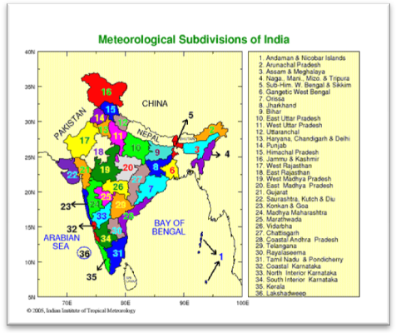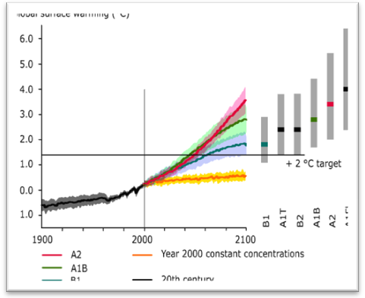
Fig. 1. Meteorological subdivisions of India Fig. 2. Past and projected change in global surface temperatures.

II. Types of Biodiversity:
Biodiversity has three interconnected hierarchical levels: genetic diversity, species diversity, and community or ecosystem diversity.

1. Genetic diversity
It covers the differences in the amount and kinds of genes, as well as the number of chromosomes found in various species. The level of variation in a species' genes rises as its size and environmental conditions of the habitat change. Individuals and sexually reproducing creatures develop genetic variety via gene and chromosomal mutation, and it spreads in the community through recombination of genetic materials during cell division after sexual reproduction.

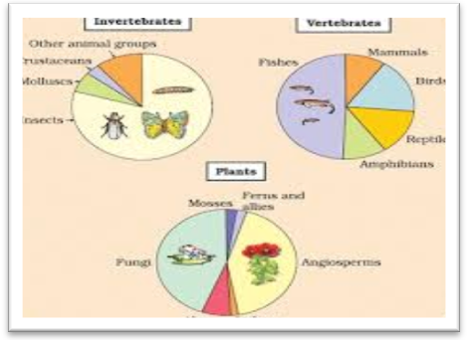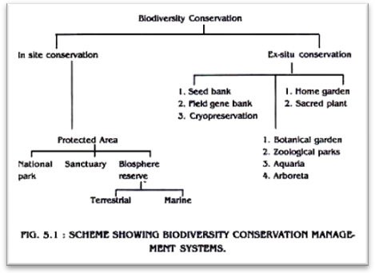

Fig. 3. Invertebrates and Vertebrates Fig. 4. Biodiversity Conservation Management System
2. Species variety
It indicates the diversity and richness of spices found in a certain location. The number of species per unit area may be used to calculate species richness. The richness of a species reveals the degree of a site's biodiversity and allows for comparison of other places. The diversity of species is heavily influenced by climatic circumstances. Species evenness or species equitability is represented by the number of individuals of various species within an area. A region's species diversity is determined by the product species richness and species evenness. Endangered species are those that are completely limited to a certain location.
3. Biodiversity of ecosystems
It addresses the aggregation and interaction of spices residing in a certain location, as well as the physical environment. It connects many habitats, biotic communities, and ecological processes throughout the biosphere. It also describes the variety of the environment. Land escape diversity is so named because it comprises the location and magnitude of distinct ecosystems. The variety of niches, trophic levels, and ecological processes such as nutrient cycling, food webs, energy flow, the function of dominant species, and numerous associated biotic interactions contribute to ecosystem diversity. Such variety may result in more productive and stable ecosystems or communities that can withstand many sorts of pressures, such as drought and flooding.
III. Biodiversity's Importance
The living species on Earth are varied, existing in various environments and exhibiting diverse features. They are essential to human survival, supplying food, shelter, clothes, medicines, and so on.

i. Productive qualities
Biodiversity generates a variety of natural goods that are offered in commercial marketplaces. Indirectly, it gives economic advantages to individuals such as water quality and soil protection, climatic equalization, environmental monitoring, scientific research, leisure, and so on.
ii. Consumptive worth
Consumptive value may be attributed to things such as fuel woods, leaves, forest products, and so on those are used locally but do not have a national or international market value.
iii. Social worth
The loss of biodiversity has a direct impact on the social life of the nation, potentially via impacting ecological functioning (energy flow and biogeochemical cycle). This may be clearly understood by looking at the negative impacts of global warming and acid rain, which produce an undesirable change in logical processes.
iv. Aesthetic worth
Aesthetic qualities such as the refreshing aroma of flowers, the taste of berries, the softness of moss, the musical voices of birds, and so on drive humans to conserve them. The earth's natural beauty, with its colours and hues, deep forests, and beautiful species, has motivated humans since their inception to take the necessary efforts to preserve it. Similarly, botanical and zoological gardens conserve biodiversity while also providing aesthetic value.
v. Legal principles
Because the planet is the home of all living species, everyone have an equal right to dwell on its surface and enjoy all of its advantages. It will be impossible to safeguard species from extinction unless some legal value is assigned to biodiversity.
vi. Ethical significance
Biodiversity must be seen as having ethical worth. Because man is the most intellectual of all living species, it should be his primary duty and moral obligation to protect and conserve other organisms that will directly or indirectly benefit man's survival.
vii. Ecological worth
Biodiversity has high ecological importance since it is required to preserve ecological equilibrium. Any disruption in the precisely crafted ecological equilibrium maintained by many creatures may cause significant issues, perhaps endangering human life.

viii. Economic worth
Biodiversity has significant economic worth since economic progress is dependent on the efficient and cost-effective management of biotic resources.
In everyday life, humans sustain their lifestyle at the expense of neighbouring species, which include a diverse range of plants and animals fighting for survival.
As a result, it is essential for humans to care for their surrounding species and make the most use of their services in order to achieve greater economic growth. As it is properly said, man's existence is dependent on the biosphere's survival.
IV. Global Warming Effects on Different Seasonal Procedure of Plants and animals
Many seasonal processes are also affected by global warming. We are starting to witness:
- Earlier leaf production by trees.
- Earlier greening of vegetation.
- Changed timing of egg-laying and hatching.
- Changes in migration patterns of birds, fish and other animals.
Reductions and re-distributions in populations of algae and plankton; this threatens the existence of fish and other animals that rely on algae and plankton for food. In its most recent assessment, the IPCC re–iterates that 20-30% of species assessed so far are likely to be at increased risk of extinction if increases in global average warming exceed 1.5-2.5oC (relative to 1980-1999) and as global average temperature increase exceeds about 3.5oC, model projections suggest considerable extinctions (40-70% of species assessed) around the globe.
V. Impact of Climatic Change-Global Warming on Biodiversity
Climate change refers to any change in the environment caused by human activity or natural causes. Human-caused greenhouse gas pollution has greatly contributed to global warming. Industrialization, vehicles, and agricultural operations are emitting enormous amounts of greenhouse gases into the atmosphere, including carbon dioxide, methane, and nitrous oxide. Through the greenhouse effect, greenhouse gases warm the near-surface global temperature. When the concentration of greenhouse gases rises, so does global temperature. The earth's surface has warmed 0 by around 0.6 C over the last century, and if present rates of greenhouse gas emissions continue, global air temperature 0 might climb to 1.5 to 4.5 C very soon. The melting of snow, glaciers, and polar ice caps, as well as the accompanying rise of sea levels and flooding of coastal regions, all contribute to an increase in disease transmission. Plants, animals, and microbes are affected by global warming in two ways: by altering their habitats and by the direct influence of temperature. Temperature increases drive the pace of several physiological processes, such as photosynthesis in plants, to their maximum. Each creature, plant, or animal has a certain level of tolerance. Extreme temperatures may be damaging when they exceed a plant's or animals physiological limitations. Global warming has had a physiological impact on a number of animals.
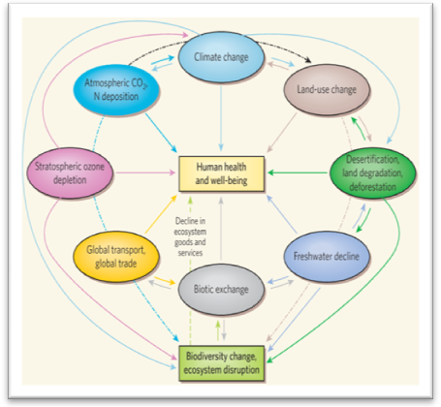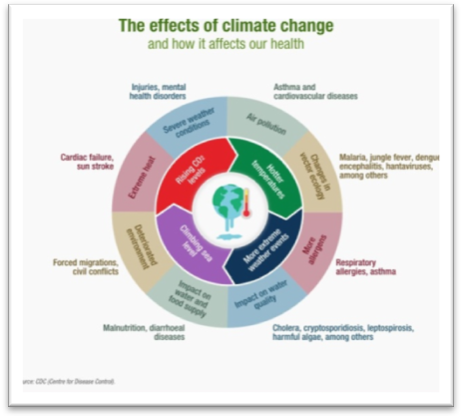
Fig. 5. Effects of Climate Change on Biodiversity
1. Climate Change on Biodiversity
Climate change is one of the primary drivers of biodiversity loss. In conjunction with other elements, environmental circumstances play an important role in determining the function and spread of organisms. Climate change has had massive influence on biodiversity patterns in the past and will continue to be a significant driver of biodiversity patterns in the future. Climate change is examined as a result of overpopulation, overexploitation of natural resources, deforestation, and other factors. Climate change has a huge influence on biodiversity and ecosystems. The negative effects on ecosystems are projected to worsen as climate change worsens. Extinction hazards, floods, droughts, population decreases, and disease outbreaks are predicted to increase as a result of climate change. Climate change, such as rising temperatures in certain areas, has influenced species ranges, population levels, and the timing of reproduction and migratory events, as well as the frequency of pest and disease outbreaks. Climate change and its consequences may become the primary direct cause of total biodiversity loss by the end of the century. Many plant and animal species are going extinct as a result of habitat loss, overexploitation, pollution, overcrowding, and the danger of global climate change. Rapid climate changes may cause a rise in illnesses, landslides, and forest fires, resulting in the annihilation of animals and vegetation. Every organism is suited to a certain set of physical and chemical circumstances. Climate change has put the fate of hundreds of plants and animals in jeopardy. Changes in environmental circumstances are likely to have an influence on all species, not just directly but also indirectly via interactions with other species. Indirect effects are as significant in influencing plant responses to climate change.
2. Global Warming on Biodiversity
Global warming not only causes flora to "gasp for breath," but it also causes animal habitat loss. This is particularly problematic for vulnerable species. The destruction of these ecosystems results in the extinction of amphibians that rely on these woods for life. Many species may be severely harmed by the spread of viruses and bacteria that flourish in warmer environments. Global warming has already jeopardized the viability of the Rocky Mountain alpine meadows. Mangroves and tropical montane are also threatened with extinction in the future as a result of global warming. The melting of arctic ice has already had an impact on penguin and polar bear populations. Coral reefs are also under danger from global warming. The greenhouse effect is the warming of near-surface global temperatures caused by greenhouse gases. The average global temperature has risen by 0.6°C since the mid-nineteenth century and is expected to climb by 1.4-5.8°C by 2100. Global warming has an impact on plants, animals, and microbes by altering their environments and directly impacting their physiological systems. Climate change has caused a rise in temperature of roughly 5°C above normal, resulting in the melting of glaciers and an increase in sea level, which is affecting endemic species.
Bleaching of coral reefs: Coral bleaching is another significant effect of rising temperatures. When corals are harmed by rising temperatures and other climatic challenges, their brilliant colours fade and become white. Rising sea temperatures have a severe influence on corals, leading in the disappearance of reefs, which are regarded to be one of the most bio-diverse ecosystems.
Water Resources: Water supplies are impacted by climate change due to rising evaporation rates. Water resources are predicted to be reduced in several areas due to increased evaporation rates. The biggest shortfalls are projected in the summer, resulting in decreasing soil moisture levels and more frequent and severe agricultural dryness.
VI. Conservation Measures
Biodiversity is essential for ecosystem function and services on which people depend, and it is inextricably tied to the economic, social, and environmental domains of sustainability; climate change has contributed to biodiversity loss. To avert biodiversity loss, special conservation measures will need to be implemented. The conservation of biodiversity is concerned with the preservation of all kinds of life on Earth, as well as the functioning and health of natural ecosystems. This encompasses biological diversity components' conservation, maintenance, long-term use, rehabilitation, and promotion. Whereas conservation is the ethical use of resources, which involves both protection and exploitation, preservation is the act of conserving something without changing or modifying it. Sustainable development is another complicated aspect of biodiversity protection. This refers to development that satisfies the expectations of the present generation without risking future generations' capacity to satisfy their own. Simply said, intergenerational equality promotes biodiversity conservation when there is a balance between the environment, development, and society.
VII. Conclusions
Biodiversity is a fundamental component of existence, not an afterthought in human affairs. The protection of biodiversity adapted to changing climatic circumstances is critical not only for the adaptation of species and ecosystems, but also for climate change mitigation. Stopping biodiversity loss is a tremendous task, especially in light of climate change, which will aggravate many of the negative factors. Climate change is the most serious environmental concern of the decade. Carbon reduction necessitates a substantial increase in understanding of greenhouse gas emissions from energy, as well as its influence on water resources, human health, wildlife, and agricultural practices. Climate change has an impact on biodiversity and other components of nature. Since then, biodiversity has come to refer to the variety of all forms of life, from genes to ecosystems. Changes in the basics of biodiversity will have a wide influence on biodiversity and its natural environment. These consequences have had a substantial influence on the natural environment, including plants, animals, soil nutrients, and all other components. Soil biota affects climate by storing carbon and producing and absorbing greenhouse gases. As a consequence, conservation measures to conserve the area's forest and animal populations might be enacted. Maps of natural ecosystems are created using remote sensing technology, which is often based on a map that identifies various plant cover or land uses. Combining remote sensing with rapidly rising data on species distributions to identify future fronts of extinction and adjusting conservation practices to help alleviate the consequences of climate change. Climate change affects a range of soil processes, particularly those linked to soil fertility. By monitoring land change cover in the region, soil degradation may be recognised and soil productivity can be maintained by adopting efforts to fulfil world demand for crops and food. These strategies aid in the mitigation of climate change and the reduction of global warming.
VIII. References
1. IPCC (2014a). Climate Change (2014). Synthesis Report. Contribution of working groups I, II and III to the fifth assessment report of the intergovernmental panel on climate change. [Core Writing Team, R.K. Pachauri and L.A. Meyer (eds.)]. IPCC, Geneva, Switzerland, 151 pp.
2. Subodh K. Sharma and Lokesh Chandra Dube (2017), Climate Change and India: Impacts on Biodiversity Chapter 11,indd 497-519
3. Cicerone R.J., (2006). Finding Climate Change and being Useful. 6th National Conference on Science, Policy and the Environment, National Council for Science and the Environment, Washington, DC
4. Kannan R. and James D. A., (2009). Effect of climatic change on global biodiversity: A review of key literature. Tropical Ecology, 50(1): 31-39.
5. Rawat, U.S. and Agarwal, N.K. (2015). Biodiversity: concept, threats and conservation. Environment Conservation Journal, 16(3): 19-28.
6. Rathore A. and Jasral Y.T. (2013), Biodiversity: Importance and Climate change Impacts. Inter. J. Sci.Res. Pub. 3(3): 1-5.
7. Sadguru Prakash and Seema Srivastava (2009), Impact of Climate Change on Biodiversity: An Overview, International Journal of Biological Innovations, IJBI 1 (2), (December 2019) 60-65.
8. Ananya Mishra1, Rohitashw Kumar2 and Rishi Richa (2021), Biodiversity conservation to mitigate the impact of climate change on agro-ecosystems, Biological Diversity: Current Status and Conservation Policies Volume 1, DOI: 10.26832/aesa-2021-bdcp-06.
9. Sharma And J.K. Mishra (2011), Impact of Environmental Changes on Biodiversity Indian J.Sci.Res.2 (4): 137-139.
10. Vinod Kumar and A.K.Chopra (2009), Impact of climate change on biodiversity of India with special reference to Himalayan region-An overview, Journal of Applied and Natural Science 1(1): 117-122

