Integrated Multi Trophic Aquaculture (IMTA): a Way Forward towards Sustainable Aquaculture
Dr. Naresh Raj Keer^{1*}, Md. Idrish Raja Khan², Chetan Kumar Garg¹, Dr. Showkat Ahmed Dar¹, Dr. Abhiman¹
¹College of Fisheries, BASU, Kishanganj-855107, Bihar
²College of Fisheries, Central Agricultural University, Lembucherra, Tripura, India-799210
³College of Fisheries, Karnataka Veterinary Animal and Fisheries Science University, Mangalore, Karnataka, India-575002
4ICAR- Research Complex for Eastern Region, Patna, India-800014
Abstract
The development of sustainable culture practices needs to minimize environmental degradation with intent towards horizontal and vertical expansion of aquaculture system. Integrated multi-trophic aquaculture (IMTA) is a novel integrated slant similar as polyculture system that involves the culture of two or more species together. IMTA is the exercise that integrates the suitable proportions of fed aquaculture species cultivation (finfishes/shrimps) with organic extractive aquaculture species (shellfishes/herbivorous fishes) and inorganic extractive aquaculture species (seaweed). IMTA stands as a fully sustainable technology with environmental benefits. Mainly, this chapter highlighted the introduction, history, present status, concept behind the integration, advantages and disadvantages, design and nutrients flow and future prospective of IMTA. The technology ensures the eco-biological balance by controlling the organic and inorganic pollution in the cultural environment. In conclusion, the IMTA can be an eco-friendly and sustainable technology that can be done in open water (marine and freshwater) to benefit the farmers as additional revenue.
Keywords: IMTA, Seaweed, Cobia, Eco-friendly, Eco-biological Balance, Polyculture System

Introduction
Globally, aquaculture growth involves a sharp increase in cultivation area, and high density-based aquaculture systems require greater use of formulated feed resources. These aquaculture systems need to be managed regularly, but it will negatively affect the aquatic environment and production system when the farmers fail to manage.So aquaculture needs to involve novel technologies that must be socially acceptable and environmentally, economically sustainable andshould have an option to culture multiple species. Integration of aquacultural fish along with plants and vegetables has been practiced for centuries. From the decade, many researchers have studied how to improve productivity and environmental sustainability in cultural practices. The study includes inspecting the economic and ecological benefits by growing various species together, including finfish, shellfish, and plants or algae in the water. This idea has come up as an integrated multi-trophic aquaculture (IMTA). IMTA is based on ecosystem slants for aquaculture (EAA), promoting higher efficiency to use nutrients from the ecosystem and creating an opportunity to diversify the tropical aquaculture system towards sustainability (FAO, 2009).The main aim of this review chapter was to describe IMTA in an easy way.
Background and present scenario
John Ryther reignited the interest in IMTA systems in the 1970s, in which advantages of synergistic interfaces among species and environment were assessed. He is considered as the grandfather of modern IMTA for his influential work on integrated waste-recycling marine polyculture systems. He combined polyculture, ecologically engineered aquaculture, ecological aquaculture and integrated mariculture/aquaculture. Moreover in 2004, Jack Taylor combined integrated aquaculture and multi-trophic aquaculture into the term IMTA (Johnson et al., 2019).
In the last few decades, only some countries have been practicing the IMTA system near to the commercial level viz. Canada, China, Ireland, South Africa, Chile, the United Kingdom of Great Britain and Northern Ireland (primarily Scotland) and the United States of America. Portugal, France and Spain have running research projects related to the expansion of IMTA. The countries of Scandinavia, specially Norway, have tried some individual groundwork toward evolving IMTA, despite owning an extensive finfish aquaculture linkage (Barrington et al., 2009). In India, ICAR-CMFRI has magnificently established IMTA under hands-on mode with a group of fishermen at Munaikadu in Palk Bay of Ramanathapuram district of Tamil Nadu state India by the integration of seaweed Kappaphycus alvarezii with Cobia (Rachycentron canadum) farming in a cage. However, seaweed culture is being widely practiced and adopted in many places of Tamilnadu coast, hence, addition of seaweed with cobia farming in a cage was initially endeavoured (Johnson et al., 2019). Nearly hundred fishers in Ramanathapuram district of Tamilnadu are practicing IMTA in various locations.
What is IMTA and its basic concept?
IMTA system is similar to a polyculture system where two or more organisms farmed together (Johnson et al., 2019). In IMTA, multiple aquatic species are farmed together in an integrated manner with efficient waste utilization and ecosystem niches. IMTA is the practice that assimilates the suitable proportions of fed aquaculture species (e.g., finfishes/shrimps) with organic extractive aquaculture species (e.g., shellfishes/herbivorous fishes) and inorganic extractive aquaculture species (e.g., seaweeds). This IMTA is a balanced system for the environment (bio-mitigation), economic (product divergence and risk drop) and social (better managing practices) sustainability (Shah et al., 2017). Design and concepts of IMTA are presented in Figure 1 and Figure 2.
Criteria for selection of species combinations in IMTA
The selection of co-culture species in the IMTA is based on a number of following conditions.-
- Based on their corresponding roles with other species in the IMTA.
- Based on the adaptableness of species correspondence to the habitat.
- Based on the culture technics and site ecological conditions.
- Based on the aptitude of species to offer both effectual and unceasing bio-mitigation.
- Based on the market ultimatum for the species and valuing as raw material or their derived products.
- Based on their commercialization prospective.
- Based on their contribution to improved environmental performance.
Nutrient flow in IMTA
There are several prospects for nutrient lessening from IMTA systems between nutrient loading and its sequestration in the biomass of co-cultured species (Figure 1 and Figure 2).
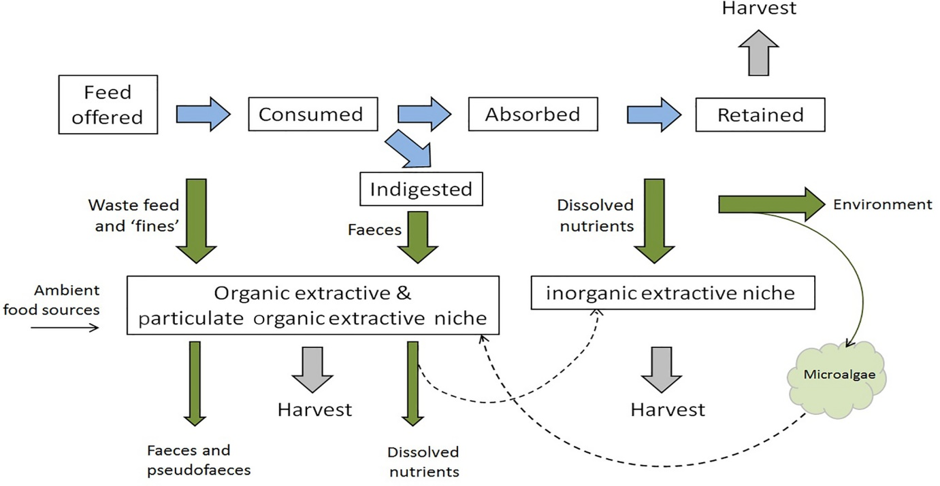
Figure 1: Flowchart of the nutrients from fed tropic species to extractive species. Blue arrows are on behalf of the nutrient and energy flow within the fed tropic level. Green arrows are demonstrating the losses potentially accessible to culture extractive niches or input for non-culture species. Ambient food sources will also be offered to organic extract niches. The dashed arrows are on behalf of a potential two-step transfer, such as growth enhancement of microalgae and uptake by the particulate organic extractive niches. Grey arrows are on behalf of nutrient sequestered in culture biomasses that are removed system upon harvest (Reid et al., 2020).
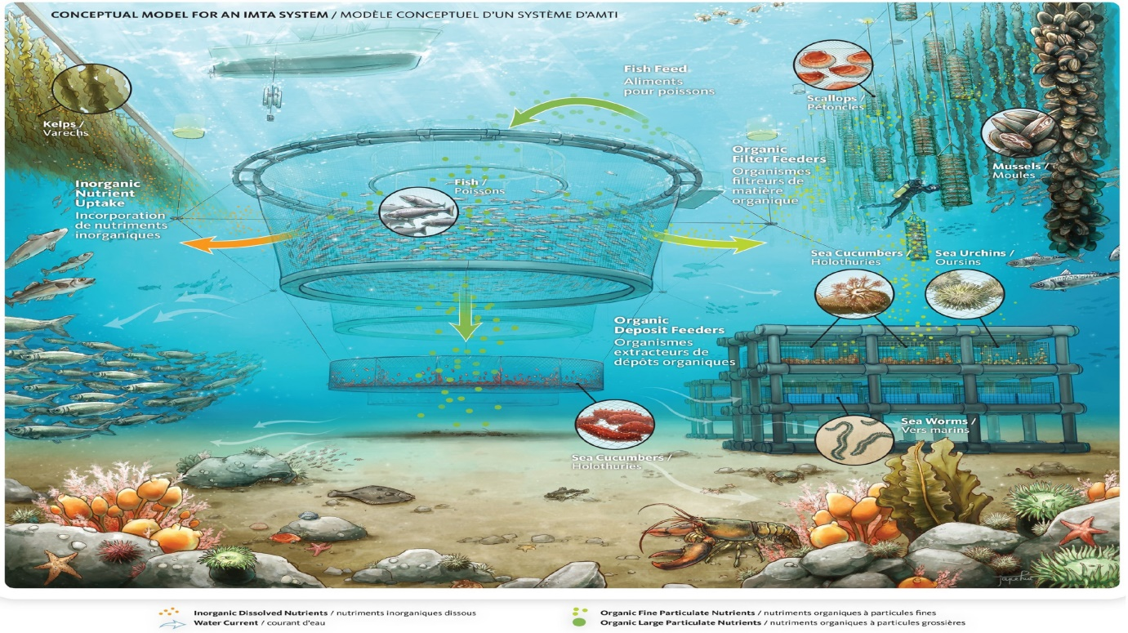
Figure 2: Intangible illustration of an open-water IMTA. Nutrient portions will flow to cultured niches / into the environment for natural micro- or macro-species (Reid et al., 2020). Image courtesy of Fisheries and Oceans Canada.
Advantages of IMTA
- It is based on nutrient recycling in the ecosystem (particularly in closed systems).
- Ultimatum of feed from pelagic maritime fisheries and terrestrial crops will be reduced.
- Ecologically sustainable and improves environmental condition through Effluent bio-mitigation.
- IMTA increases farm productivity.
- This technology can be applied to various environmental conditions (example: land-based or marine-based).
- It increases profit through species diversification in aquaculture.
- Increased profits through obtaining premium prices (through eco-labeling or organic certification programs on the products)
- It produces healthful food (protein, Omega-3 etc.)
Disadvantages/challenges of IMTA
- It lacks a thorough understanding of environmental influences.
- Presently emphasizes only high-value foodstuffs and thus less likely to contribute to world food needs (except seaweeds).
- It shifts nutrient flows in the environment to diminish natural production.
- It is complex in operations, risks: structural, operations, disease and seed supply.
- It has site-specific criteria (because of numerous species): current, temperature, salinity, etc.
- It needs more significant capital costs for a start-up.
- It has complexity in regulatory.
- It has some conflict of use (e.g., water, space etc.).
Co-culture species in the such system can be characterised into three diverse niches based on the consumption of nutrient waste flows including species groups that can extract their diet from settled/suspended organic particles and seaweeds/plants that can captivate soluble nutrients (Table 1).
Table 1: Species groups in cultured extractive niches and nutritional inputs in IMTA based ecosystem (Reid et al., 2020).
Extractive Niches | Extractives species group | Targeted nutrients | Property of Nutrients
Inorganic | Seaweeds and aquatic plants | Soluble inorganics | Soluble inorganic end-products of metabolism, for instance ammonium (NH₄⁺), nitrate (NO₃⁻), phosphate (PO₄³⁻) and carbon dioxide(CO₂)
Organic | Detritus feeders and grazers such as polychaetes, sea urchins and sea cucumbers | Organic solids | Large particulates that can settle. Typically, high organic content solids from the fed trophic level viz. waste feed and faeces and lower organic content solids from non-fed species viz. bio-deposits from suspension feeders).
Particulate organic | Suspension and filter feeders such as shellfish | Suspended organic solids | ‘Fines’ from waste feed and small faecal particulates, in addition to natural or IMTA- promoted microalgae
Several following steps should be taken for the expansion of IMTA
- Establishment of the economic and environmental value of systems and their co-products.
- Selection of the right species, appropriate to the habitat, available technologies, and the environmental and oceanographic conditions, complementary in their ecosystem functions, growing to significant biomass for efficient bio-mitigation.
- Promotion of effective government legislation/regulations and incentives to facilitate the development of IMTA practices and the commercialization of IMTA products.
- Reorganization of the benefits of IMTA and educating stakeholders about this practice.
A case study: IMTA by CMFRI (Johnson et al., 2019)
Demonstration of IMTA (integration of Seaweed cobia cages)
Sixteen bamboo rafts (12× 12 feet), each contains 75 kg of seaweed were integrated with one cobia cages (seaweed farming= 4 cycles; cobia farming= 180 days, 180 days need to produce four cycle of sea weed farming). The seaweed raft were kept in a semi-circular manner 15 feet away from the cobia cage therefor seaweed is enable to utilise the inorganic nutrient wastes arising from the cobia cage, which moves along with the water current from the cage. A 6 m dia GI cage and 3.5 m depth with 750 fingerlings of cobia was integrated with the seaweed raft (Figure 3a). The cobia fingerlings were fed twice a day @ 5% of total biomass with chopped low-valued fishes like sardine, lesser sardine, rainbow sardine, etc. Based onthe assessment of fouling on the net of cage, nets were changed periodically in order to ensure sufficient circulation of water through the cage. The cropping period for cobia was 180days. A separate set of seaweed rafts of the same number and size were cultivated as a control on different locations without integration of cobia cage or any cage (Johnson et al., 2019).
Economic benefits of Seaweed production cultivated under IMTA (Johnson et al., 2019)
A seaweed production cycle of 40-45 days was performed. At the end of the cycle, the rafts are pushednear the shore to harvest the seaweed. A 75 kg of yield was retained as a seed material for the upcoming crop and the remaining was kept to dry in the sun light for three days and sold out in the dried form. The harvested seaweed’s average weight was only 10% of the total wet weight. After harvesting within 2-3 days the rafts were again seeded and integrated with the cobia cage. In 180 days, four cycle of seaweed were cultivated. The average yield from per raft (12 x 12 feet) without the integration was 150 kg while it was 260 kg in the raft integrated with cobia cage. After four cycles, 576 kg of seaweeds was produced without integration, while 1280 kg was produced with the integration of rafts with cobia cage. Thus 704 kg of seaweed was an additional production with the integration of cobia cage farming.
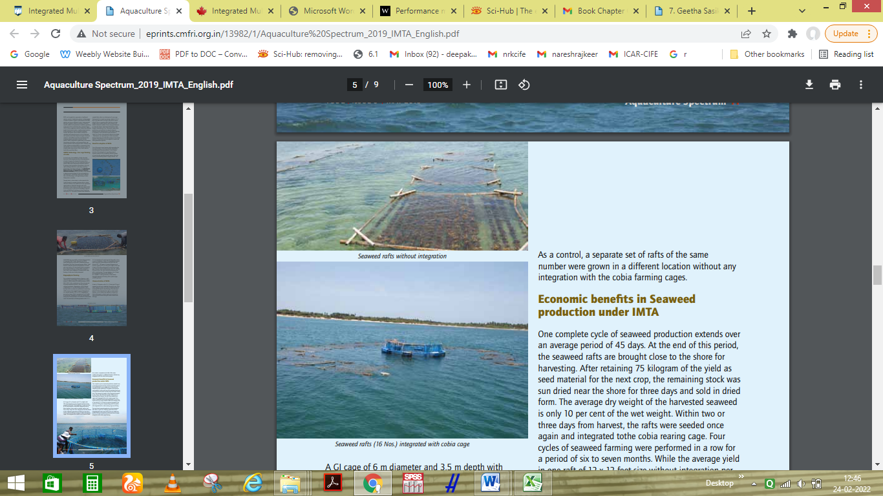
a
b
Figure 3: Seaweed raft integrated with cobia cage (a) and seaweed raft without integration (b) (Johnson et al., 2019)
The rafts integrated with cobia culture had a unique advantage as an increased number (90-100) of newly emerged apical portion/tips in harvested seaweed (bunch) from the integrated raft due to effective utilization of organic waste in IMTA. The apical tips were lesser (30- 40) in numbers for the rafts that were not integrated with the IMTA system. When used for replanting, the bunches having more and less numbers of newly emerged apical portion / tips were ready for harvest early (within 40 days) and late (around 54 days), respectively. The additional revenue generation / additional net profit of Rs. 26,400 with an increased profit of 41% through integration of seaweed rafts to cobia cages with thesame operational cost for the rafts was notable (Johnson et al., 2019).
Table 2: Comparison of cost and returns of seaweed cultivation in IMTA (16 rafts / one cage / 4 cycle) and without IMTA (Johnson et al., 2019)
Particulars | In IMTA | Without IMTA | Difference
Production of dried seaweed (4 cycles, 16 rafts) | 1280 kg | 576 kg | 704 kg
Price of dried seaweed (Rupees / kg) | 37.50 | 37.50 | -
Revenue (Rupees) | 48,000 | 21,600 | 26,400
Costs (Rupees) | 16,000 | 16,000 | -
Net Profit (Rupees) | 32,000 | 5,600 | 26,400
Profit Margin (%) | 67 | 26 | 41
Economic advantageof cobia production under IMTA
The integration of seaweed rafts with cobia cage producedgood returns. In one crop (180 days) of cobia the yield was produced 1220 kg and 960 kg with integration and without integration of seaweeds (four-cycle), respectively. The gross revenue from the cobia yield was 3,53,800 and 2,78,400 rupees for the integrated and non-integrated cages (average weight of cobia was 2.2 kg and the rate was Rs. 290/ kg). Integrated cobia cages had an additional income of 75,400 rupees.
Table 3: A comparative economics of sea cage farming of cobia with and without IMTA (one crop in one cage; 180 days duration)(Johnson et al., 2019)
S.No | Particulars | In IMTA (Rs) | Without IMTA (Rs.) | Difference
750 cobia seeds were stocked in a 6m dia and 3.5m depth GI cage
1. | Fixed cost of a cage | 61600 | 61600 | Nill
2. | Total operating cost of a cage | 130000 | 130000 | Nill
3. | Total cost of production (180 days) | 191600 | 191600 | Nill
4. | Yield of farmed cobia in kg (in 180 days; average weight- 2.2 kg) | 1220 | 960 | 260
5. | Gross revenue in Rs. (@ Rs. 290 per kg) | 353800 | 278400 | 75400
6. | Net income | 162200 | 86,800 | 75400
7. | Net operating income (Income over operating cost) | 223800 | 1,48,400 | 75400
8. | Farm gate Price (Rs.) | 290.00 | 290.00 | Nill
9. | Capital Productivity (Operating ratio) | 0.37 | 0.47 | Nill
10. | Cost of production Rs. per kg | 157 | 199 | 42
 | Profit Margin (%) | 85 | 45 | 40
Future prospective
India has a vast opportunity to establish the IMTA set up at various reservoirs and as well as marine water. IMTA can be applied in open water or land-based aquaculture system as well as in marine or freshwater aquaculture systems. IMTA can also be set up in intensive land-based tank culture. The design of the IMTA can vary and depend on the choices based on different climatic, environmental, chemical, biological, physical, economic, societal, historical, political and governance conditions, prevailing in the parts of the world where they operate. Organism in IMTA must be chosen based on their complementary functions in the ecosystem and economic potential from different tropic levels. Normally, fed species viz. finfish or shrimp are cultured with extractive species viz. seaweeds and aquatic plants that utilise inorganic dissolved nutrients, and shellfish and other invertebrates that utilise organic particulate nutrients.
There is a huge opportunity to use marine micro-algae as bio-filters in IMTA and process them as a product with a higher commercial value. However, only a few countries are practicing IMTA at the commercial level. Most of the seaweed cultivation is taken up as open water monoculture in Asia South America, South Africa and East Africa (Johnson et al., 2019).
Conclusion
This review briefly provides a better understanding about the integrated multi-trophic aquaculture (IMTA) system. IMTA is an eco-friendly and sustainable integrated system that can mitigates organic and inorganic pollution in the open water and provides additional income through the surplus production of multi species. This technique can also generate a heightened business hobby as soon as high-cost seaweeds species may be cultured as biofilters producing novel human meal products. Still, aquaculture needs to implement the IMTA in the available open water resources as the units of IMTA are significantly less in numbers. This chapter recommends incorporating the IMTA to make the open water productive, sustainableand pollution free by utilising the ecosystem’s niche.
References
Johnson, B., Nazar, A.K.A., Jayakumar, R., Tamilmani, G., Sakthivel, M., Ramesh Kumar, P., Anikuttan, K.K., Samal, A.K. and Sankar, M. (2019). Integrated multitrophic aquaculture (IMTA): A technology for uplifting rural economy and bio-mitigation for environmental sustainability. Aquaculture Spectrum. 2(5): 9-18.
Shah, T.K., Nazir, I., Arya, P. and Pandey, T. (2017). Integrated multi-trophic aquaculture (IMTA): An innovation technology for fish farming in India. International Journal of Fauna and Biological Studies. 4(1): 12-14.
Reid, G.K., Lefebvre, S., Filgueira, R., Robinson, S.M., Broch, O.J., Dumas, A. and Chopin, T.B. (2020). Performance measures and models for open‐water integrated multi‐trophic aquaculture. Reviews in Aquaculture. 12(1): 47-75.
Barrington, K., Chopin, T. and Robinson, S. (2009). Integrated multi-trophic aquaculture (IMTA) in marine temperate waters. Integrated Mariculture: a Global Review. FAO Fisheries and Aquaculture Technical Paper. 529: 7-46.
Johnson, B., Nazar, A.K.A., Jayakumar, R., Tamilmani, G., Sakthivel, M., Ramesh Kumar, P., Anikuttan, K.K., Samal, A.K. and Sankar, M. (2019). Integrated Multitrophic Aquaculture (IMTA): A technology for uplifting rural economy and bio-mitigation for environmental sustainability. Aquaculture Spectrum. 2(5): 9-18.
F.A.O. (2009). The State of World Fisheries and Aquaculture 2008. FAO of the United Nations, Rome, xvi + 176 p.

