An Assistive System for Physically Disabled People using Nose and Eye Movements

Prof. Sunil B. Hebbale
Assoc. Prof,, CSE Dept.
KLE College of Engineering ang Technology
Chikodi, Dist – Belagavi, Karnataka, India
sunilkbh2@gmail.com

Prof. Ashwini V. Gavali
Asst. Prof., CSE Dept.
KLE College of Engineering ang Technology
Chikodi, Dist – Belagavi, Karnataka, India
ashwini_gavali@yahoo.com

ABSTRACT

The system presents a novel algorithm for cursor movement on a computer screen using the nose and eye movements. By accurate detection of the position of iris and mapping to a specific position on the computer screen, the algorithm enables physically disabled people to control the cursor movement on the computer screen to the left, right, up and down. The algorithm also enables the people to open and close folders or files or applications through a click mechanism. The growing population with disabilities in the world must be accompanied by the growing of research and development of tools that help these users on basic computer activities. Our project aims at developing a system that allows the use of personal computers using nose and eye movements.
For the development of this system, the most efficient techniques in previous works are collected, studied and analyzed, and new ones were developed in order to build a system with high performance and precision, ensuring the physically challenged people to have an effective communication with the computer. The system described here presents a hand-free interface between human and computer. Generally, the physical mouse which is used by people is replaced in a new way that is virtual mouse, which uses nose and eye movements for the mouse operations.
Keywords: Human Computer Interaction (HCI), Haar-Cascade (line detection) algorithm, Dlib (Kaggle’s) algorithm, grayscale, OpenCV.

INTRODUCTION

Initially, text processing and mathematical computations were done on personal computers. But in later years, computers have grown to be essential in all aspects of our daily lives. These activities include both work-related applications and more private applications like shopping, chat with friends, and perusing the Internet. Computers are easily accessible by normal individuals. Yet, using a computer might be difficult for people with severe physical disabilities such as cerebral palsy or amyotrophic lateral sclerosis.
To improve the user's contact with the computer system, numerous research studies on Human Computer Interface (HCI) have been conducted. The majority of these only apply to average people. A touch-sensitive screen, speech recognition technology, and many more approaches are among these interfaces. Despite the success of these approaches, people with physical disabilities could not use them. Several researchers have attempted to create techniques that would enable people with disabilities to communicate with computers using signals from the brain, such as electroencephalography (EEG), electromyography (EMG), and electro oculography (EOG). Other techniques include the use of contact lenses, the limbus, pupil and eye/eyelid tracking, corneal, pupil reflection connection, and head movement measurement. These techniques are impractical since they call for the application of attachments and electrodes to the head. Some cutting-edge approaches to computer control that rely on infrared tracking of eye and nose movements are extremely expensive and beyond the reach for people who need them.
The people with disabilities can now use computer facilities because of nose movement and eye tracking detection. This is significant because it ensures that they are not left out of this new technology. Many organizations with an interest in related subjects have looked into using an eye mouse as an essential tool for eye tracking to enable computer use for people with disabilities. A well-designed virtual mouse operates by allowing the user's eyes to control the computer. This was created using a computer and a web camera that produced amazing effects. It is possible to create a system for assisted movement using an eye-control technique based on electro oculography (EOG), Some Human Machine Interfaces (HMI) based on EOG are commented on the study of guiding and controlling a wheel chair for the disabled, where the control is genuinely influenced by eye movements.

II. Literature Survey

The creation of assistive technology for those with disabilities and the advancement of conventional systems have increased significantly during the past several years. Also, the increasing use of computers for business and play has prompted the creation of PC-related handling applications, most of which employ graphic user interfaces. In this way, the conventional means of human-machine interaction (joystick, mouse, or keyboard), which depend on specific control motors from the users, are complemented with alternatives that enable their usage for people with severe disabilities.
Voice recognition and visual data must be mentioned among these new techniques. For instance, voice recognition is used in "speech and spell" apps to write text or to operate various devices or programmed using simple voice commands.
Additional methods include using an electro oculographic mouse to move the pointer on a screen, video oculography or infrared oculography for detecting gestures or eye movements, an infrared head-operated joystick for detecting head movements, or even infrared oculography based on the retina. The standing corneal-retinal potential that results from the hyper polarizations and depolarization that exist between the cornea and the retina is what gives EOG its name, which stands for electro oculogram. EOG uses a variety of guidance approaches, including eye instructions, automatic or semiautomatic scanning procedures, and direct access guidance. The systems were created utilizing ideas and methods that have been shown to be effective, and they offer high processing performance, improving the user experience.

Methodology

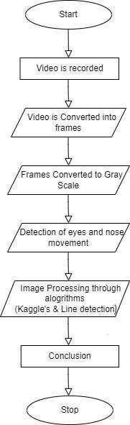
Figure 1: Functional Flow Diagram

The image processing operations carried out in the system include,
- Using the web camera the video is recorded initially.
- Frames from the recorded video are extracted.
- The frames are changed into grayscale images and processed further.
- After processing, it takes the picture of the face which is already converted into gray scale image to find the edges in the image.
- Processing the values, converting image to gray scale and detecting the edges of the face are done with the help of Line detection algorithm.
- From edges, it detects eyes and nose in the frame. Resulting we also figure out the aspect ratio of the eye.
- Finally, eye blink and nose movement are detected by Kaggle’s Algorithm.

A. Line Detection Algorithm:
The task of collecting the pixel values from an image, converting it into a gray scale image and detecting the edges of face are done by this algorithm.
The face detection is the key element of the proposed system, and it strongly affects system performance. OpenCV library performs the search for the user’s face. Here an entire image is converted to grayscale image and an image face is detected based on different shadow values inside. This process is shown in below figures.

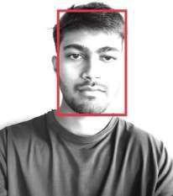



Regular RGB image | Conversion of RGB image to gray scale image | Detection of face structure using different shadow values | Detected face with removed background

B. Kaggle’s Dataset and Dlib libraries Algorithm:
It accepts output produced by The output (grayscale image with edge) of line detection algorithm is fed to Kaggle's algorithm to detect the nose and eye. And it is further used to perform the movements such as click, scroll, right, left, up and down movements. This dataset contains about 7198 face images for image processing.

C. Face landmarks detection using Dlib Libraries algorithm:
The system needs more information than just the face location to perform operating system commands. Hence, it is important to search for additional components that enable the system to recognize the location of the face and other facial features like the eyes, mouth, and nose. The suggested approach estimates the position of the face using face landmarks. These details also reveal information regarding the position of them out hand eyes.
The Dlib package, which offers an algorithm for face landmark detection based on the algorithm presented by Kazemi and Sullivan, 2014, and was used to carry out the implementation of this feature. This algorithm employs regression trees to estimate the position of facial landmarks. This algorithm searches for 68 face landmarks proposed by Saonas et al.(2013) in the area where face have been recognized, as shown below.

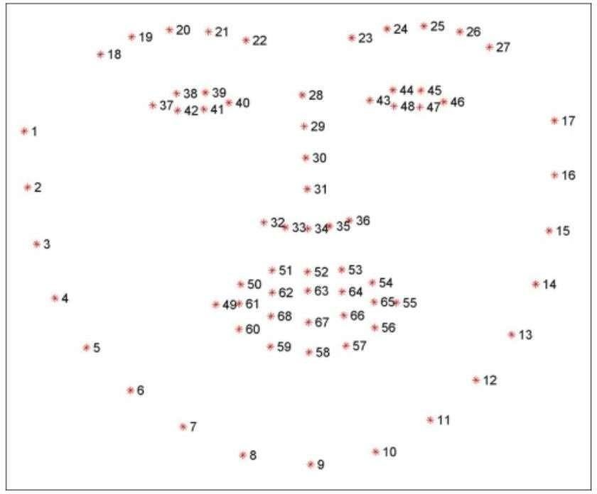

Figure 2: Facial landmarks detected by Dlib’s library

EXPERIMENTAL RESULTS

As our project involves identifying the elements of the nose and eyes movement and projecting them to the computer cursor, our primary goal is to create user-friendly human and computer interaction to perform the webcam turn on and start recording the video. The actual process starts as soon as the webcam is turned on, where we extract every frame from the recorded video. The frame passes through a number of procedures, such as turning each frame into a grayscale images and detecting the edges of face. After processing frames, the facial landmarks from image are detected and these facial landmarks are further used to detect the features of the face such as shape of nose, aspect ratio of eyes and many more.

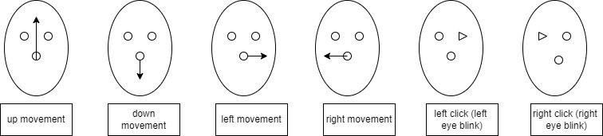

Figure 3: Results

Conclusion

We have developed a Human Computer Interface (HCI) that utilizes machine learning algorithms to interpret the eyes and nose movements for navigation and to perform click operations which is a unique and innovative way to interact with the computer. The main goal of developing this system is to provide hand free cursor which reduces the dependency on the physical mouse. The developed system uses computer vision techniques to track the movements of the nose and eyes in real-time and then maps those movements to specific commands. To achieve this, we have used a combination of facial landmark detection, feature extraction, and classification algorithms to accurately recognize and interpret the movements of eyes and nose.
This design has the potential to be useful for those individuals who have limited mobility or weak motor control in their hands or arms. By using the nose and eyes, which are less affected by certain disabilities or injuries, this mouse design can provide a new level of accessibility and ease the interaction. This design can provide more natural and intuitive interface for interacting with the computer. Additionally, this system has the potential to adapt and use in other applications, such as virtual reality or augmented reality environments.
Our project demonstrates the possibilities of combining technological advancements with a consideration for accessibility that needs to create a new and innovative solution. This mouse design will inspire further exploration into alternative input methods for computers and other devices. This system will be very helpful for physically challenged people for accessing the mouse and performing its actions.

REFERENCES

- May Phu Paing, Aniwat Juhong and Chuchart Pintavirooj,“Designand Development of an Assistive System Based on Eye Tracking”(2022).
- International Research Journal of Engineering and Technology (IRJET) by Pavithra S, Rakshitha K, RamyaV, Vikas Reddy S.(2021).
- International Journal of Trend in Scientific Research and Development (IJTSRD) by K.Vijitha, P Narendra Babu and D. Suneetha “Implementaion of Eye-Controlled Mouse Cursor for Physically Disabled Individual”(2020).
- S. Shriram, B. Nagaraj, J. Jaya, S. Shankar, and P. Ajay “Deep Learning-Based Real-Time AI Virtual Mouse System Using Computer Vision to Avoid COVID-19 Spread”,(2021).
- Cagdas Esiyok, Ayhan Askin, Aliye Tosun, Sahin Albayrak, “Novel hands-free interaction techniques based on the software switch approach for computer access with head movements”,(2020).
- K. H. Shibly, S. KumarDey, M. A. Islam and S. Iftekhar Showrav, “Design and Development of Hand Gesture Based Virtual Mouse”, 2019 1st International Conference on Advances in Science, Engineering and Robotics Technology (ICASERT), Dhaka, Bangladesh, 2019, pp. 1-5,doi:10.1109/ICASERT,2019.8934612.
- International Journal of Innovative Technology and Exploring Engineering (IJITEE) byArathi Boyanapalli and Rohini Patil, “Assistive Technology using IoT for Physically Disabled People”(2019).
- S. Ram Kumar, K. Sathesh Kumar, T. Dhiliphan Raj Kumar, M. Ilayaraja and K.Shankar “A Review-Classification of Electrooculogram Based Human Computer Interfaces” (2018).
- Mohamed Nasor, K K Mujeeb Rahman, Maryam Mohamed Zubair, Haya Ansari, Farida Mohamed “Eye-controlled mouse cursor for physically disabled individual”, 2018
- XuebaiZhang, XiolongLiu, Shyna-MingYuanandShu-FanLin, “Eye Tracking Based Control System for Natural Human-Computer Interaction”(2017).
- Cechand Soukupova,“Real-Time Eye Blink Detection using Facial Landmarks”, Center for Machine Perception, February(2016).
- Andréia Sias Rodrigues, Vinicius da Costa, Márcio Bender Machado, Angélica Lacerda Rocha, Joana Marini de Oliveira, Marcelo Bender Machado, Rafael Cunha Cardoso, Cleber Quadros & Tatiana Aires Tavares “Evaluation of the Use of Eye and Head Movements for
Mouse-like Functions by Using IOM Device”(2016).
- International Journal of Computer Science and Mobile Computing by Snehal Dongre and Sachin Patil, “A Face asa Mouse for Disabled Person”(2015).
- International Journal of Engineering Research and Technology (IJERT) by Anandhi. P
and Ms. V. Gayathri. M.E “New Technology Input Device by Eyes and Nose Expressions Using Ensemble Method”(2013).
- Frederic Maire, Frank Loewenich “Hands-Free Mouse-Pointer Manipulation Using Motion-Tracking and Speech Recognition”(2007).
- Margrit Betke, James Gips and Peter Fleming,“The camera Mouse: Visual Tracking of Body Features to Provide Computer Access for People with Severe Disabilities”(2002).
- Book by Wilhelm Burger and Mark J. Burge, “Principles of Digital Image Processing”.
- Allen B Downey, “Think Python: How to Think Like a Computer Scientist”, 2nd edition (O’Reilly,2015).
- Sommerville“Software-Engineering-9th-Edition-by-Ian”.
- RichKnightNair,“ArtificialIntelligence”,publishedbyMcGrawHillEducationpublications. Rafael C. Gonzalez and Richard E. Woods, “Digital Image Processing”, published by Pearson publications.
- https://youtu.be/k3PcVruvZCs
- https://youtu.be/e0OCfVuHsgg
- https://youtu.be/ot6LWpZjTXo
- https://stackoverflow.com/questions/72211167/how-to-label-eyes-detected-using-media

