Cisgenic and intragenic is an alternative approach to transgenic for crop improvement

Rajesh D Vekariya¹ and Amit V. Malviya⁴
Wheat Research Station
Navsari Agricultural University
Bardoli, Gujarat, India
¹rajesh@nau.in
⁴malviyaamit111@gmail.com

Arpita A Patel²
Department of Agricultural Biotechnology
Centre of Excellence in Biotechnology
Anand Agricultural University
Anand, Gujarat, India
arpitapatel26393@gmail.com

Hardik Patel³ and Rajesh J Panchal⁵
Department of Genetics and Plant Breeding
Navsari Agricultural University
Navsari, Gujarat, India
³patelhardy97@gmail.com
⁵rajpanchal1993@yahoo.com

*Corresponding Author email: rajesh@nau.in

ABSTRACT

Cisgenesis and intragenesis are innovative biotechnological strategies for enhancing crops while mitigating concerns associated with traditional genetic modification techniques like transgenesis. These approaches harness genes from closely related species or the same species to instill desired traits into crops, differentiating them from transgenic methods that incorporate genes from unrelated organisms. These methodologies offer the potential to develop crops with enhanced traits, such as disease resistance, stress tolerance, or improved nutritional content. Additionally, they aim to address apprehensions among consumers and regulatory bodies regarding genetically modified organisms (GMOs).

Keywords:Cisgenic; Intragenic; transgenic; marker free tchnology: crop improvement

I. INTRODUCTION

Crop improvement has advanced through two groundbreaking techniques: cisgenic and intragenic approaches.
Cisgenic: This method entails transferring genes from crossable plants, facilitating the introduction of desired traits without the hindrance of linkage drag. It closely resembles traditional breeding and exempting it from current GMO regulations. Cisgenic plants closely resemble traditionally bred plants, which enhances their acceptance [Telem et al. 2013].
Intragenic: Intragenesis represents a transformation concept that harnesses the plant's own genetic material or material from closely related species capable of intercrossing. This approach empowers the combination of specific genetic elements from plants within the same sexually compatible gene pool, streamlining the development of cassettes with desired traits. Intragenesis significantly contributes to sustainable crop improvement efforts [Ahmad et al. 2020].
Both cisgenic and intragenic approaches address concerns related to combining genetic elements from different crossable plant species and the presence of foreign sequences in genetically engineered crops. These methods offer potential solutions for sustainable crop improvement and can simplify approval processes, increasing the acceptance of genetically engineered crops in agriculture [Cabrera-Ponce et al.2022].
Cisgenesis and intragenesis are advanced biotechnological approaches for improving crops that aim to address some of the concerns associated with traditional genetic modification methods like transgenesis. These methods utilize genes from closely related species or the same species to introduce desirable traits into crops. In summary, while transgenic crops involve the introduction of genes from unrelated species or organisms, cisgenic crops use genes from related species, and intragenic crops further narrow it down to genes or genetic elements within the same species. These techniques hold promise for developing crops with improved traits while addressing consumer and regulatory concerns about genetically modified organisms (GMOs). However, it's essential to evaluate each approach carefully based on its specific benefits and potential risks in a given agricultural context. Let's explore both of these approaches in detail with examples.

A. Transgenic Approach:
Definition: Transgenic refers to the process of introducing genes from one species into the genome of another species, including unrelated species. This often involves genes from bacteria, viruses, or even unrelated plants or animals.
Process: Transgenic crops are created through the insertion of foreign genes into the plant's DNA. This can be achieved using techniques like Agrobacterium-mediated transformation or gene gun technology.
Advantages: Transgenic crops can exhibit traits such as resistance to pests, tolerance to herbicides, improved nutritional content, and enhanced shelf life.
Concerns: Public concerns surrounding transgenic crops often revolve around potential ecological impacts, allergenicity, and the use of antibiotic resistance genes in the transformation process.

B. Cisgenic Approach:
Definition: Cisgenic refers to the transfer of genes from one variety or subspecies of a crop to another variety or subspecies of the same crop, using natural breeding processes or advanced genetic techniques. The concept of cisgenesis was introduced by Dutch researchers Schouten, Krens, and Jacobsen (2006).
Schouten et al. (2006) give the definition of ‘cisgenic plant’ “A crop plant that has been genetically modified with one or more genes (containing introns and flanking regions such as native promoter and terminator regions in a sense orientation) isolated from a crossable donor plant”. i.e.: It has all the necessary regulatory elements of a natural gene (Espinoza et al., 2013)
Process:
- Identifying Desired Traits: The first step is to identify specific traits or desired genes that can improve the target crop. These desired traits could include resistance to pests, tolerance to environmental stress, improved nutritional content, herbicide tolerance or enhanced crop yield.
- Selecting Genes from the Same Species: Unlike transgenesis, where genes from unrelated species are introduced, cisgenesis exclusively uses genes or genetic elements naturally present within the same species or its closely related species.
- Transformation: introduction of isolated cisgene with their native promoters from crossable species or from the crop plant itself and introduced into the target crop using various biotechnological methods, such as Agrobacterium-mediated transformation or gene gun technology. A cisgene is a natural gene, coding for an agricultural trait, from the crop plant itself or from a sexually compatible donor plant that can be used in conventional breeding.
- Selection and Breeding: Once the desired genes are successfully integrated into the crop's genome, plant breeders use traditional breeding techniques to cross the modified plants with existing commercial varieties to develop new cultivars with the desired traits.

Examples:
- Potato: In the case of potatoes, cisgenesis has been used to transfer genes for late blight resistance from wild potato varieties into commercial potato cultivars. Late blight is a devastating disease that caused the Irish potato famine in the 1840s. Cisgenic potatoes with improved resistance to late blight can reduce the need for chemical pesticides.
- Apple: Cisgenesis has been applied to develop apples with enhanced resistance to diseases like apple scab and fire blight. Genes responsible for disease resistance from wild apple varieties are introduced into cultivated apple varieties to create disease-resistant apples without altering their essential characteristics.
  - Advantages: Cisgenic crops often circumvent some of the public concerns associated with transgenic crops, as they involve genes from related species that could potentially interbreed naturally.
  - Concerns: Despite being seen as a more "natural" approach, cisgenic crops can still raise some concerns about the potential spread of unwanted traits to wild relatives or other related crops.

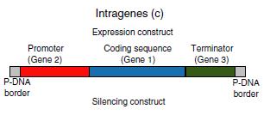
C. Intragenic Approach:
Definition: An alternative to transgenics, just like cisgenics. Specifically involves the transfer of genes or genetic elements found within the same species or population of the crop. Unlike cisgenes, intragenes are hybrid genes. i.e. they can have genetic elements from different genes & loci, thus Coding regions of 1 gene can combine with the promoters and terminators from different genes of the sexually compatible gene pool (Fig. 1). Hence, there is the possibility of new gene recombinations by in vitro rearrangements of functional genetic elements [Holme et al. (2013)].
Figure 1: Cassette of gene arrangement in intragenic approach before transformation

Process:
- Gene Selection: The process begins with the identification of specific genes or genetic elements naturally occurring within the same species or population of the target crop.
- Isolation and Modification: These selected genes are isolated, and if necessary, they may undergo modifications to enhance their effectiveness in providing the desired traits.
- Transformation: The modified genes or genetic elements are introduced into the target crop using biotechnological methods.
- Breeding: As with cisgenesis, intragenic crops are further developed through traditional breeding techniques, crossing the modified plants with commercial varieties.
Examples:
- Wheat: Intragenesis has been applied to develop wheat varieties with improved resistance to fungal diseases such as rust and powdery mildew. Genes responsible for resistance are sourced from within the same wheat species or closely related varieties.
- Rice: In the case of rice, intragenesis has been used to enhance the crop's tolerance to abiotic stresses like drought and salinity. Genes responsible for stress tolerance are obtained from rice varieties adapted to such conditions.
Advantages: Intragenic crops are seen as even more "natural" than cisgenic crops because they exclusively involve genes or sequences naturally occurring within the crop's gene pool.
Concerns: Concerns associated with intragenic crops are generally lower compared to transgenic crops, but some concerns about unintended effects or ecological impacts may still apply.

II. COMPARISON OF CISGENIC AND INTRAGENIC APPROACHES WITH TRADITIONAL BREEDING AND TRANSGENIC BREEDING

A. Cisgenesis vs. Traditional breeding
Cisgenesis is the one-step introgression of a relevant gene from a crossable species into an existing cultivar, equivalent to five or six generations of backcrosses in a conventional breeding program. Cisgenics only contain gene(s) of interest, unlike crops that have been modified by classical breeding, which contain undesired genetic elements. Application of cisgenesis would produce results in only a few years of experimentation whereas traditional breeding would take decades to reach a cultivar with desirable traits. E.g: Breeding of apple for scab resistance took 50 years (Hou et al., 2014). Cisgenesis offers several benefits over traditional breeding methods in crop improvement:
Precision: Cisgenesis allows for the precise transfer of desired genes from sexually compatible organisms. This precision minimizes the inclusion of unwanted genes, making it more targeted than traditional breeding methods [Telem et al. 2013].
Faster Crop Improvement: Cisgenesis accelerates the development of new crop varieties. Traditional breeding can take decades to achieve desired traits, whereas cisgenesis can achieve similar results more rapidly [Telem et al. 2013] (Fig. 2 and 3).
Reduced Genetic Complexity: Cisgenic plants closely resemble traditionally bred plants. They do not introduce foreign genes from unrelated species (overcome linkage drag), reducing regulatory concerns and potential public skepticism [Schouten et al. 2006] (Fig. 2 and 3).
Preservation of Desired Traits: Cisgenesis preserves the desired traits of the recipient plant while introducing only specific and targeted genes for enhancement, ensuring the retention of favorable characteristics. The genetic makeup of the original cultivar is preserved except for one or a few genes added (Fig. 2 and 3).
Enhanced Disease Resistance: Cisgenesis can be used to introduce disease-resistance genes, which can be more challenging to achieve through traditional breeding. This can lead to more resilient crop varieties [Hou et al. 2014].
Reduced Environmental Impact: Cisgenesis may reduce the need for chemical pesticides and fertilizers, contributing to more sustainable and environmentally friendly agriculture [Ahmad et al. 2020].
In summary, cisgenesis offers a promising alternative to traditional breeding, providing a quicker, more precise, and environmentally friendly approach to crop improvement while preserving the genetic characteristics of desirable plants. Especially important for outbreeding, vegetative propagated plants (apple, potato, sugarcan, etc.).
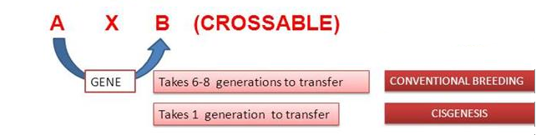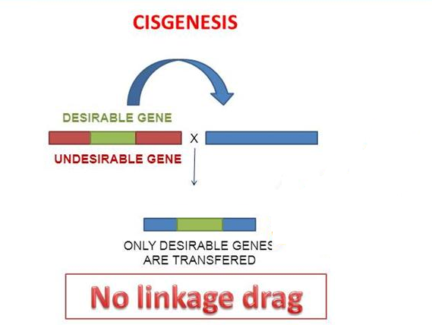
Figure 2: Advantages of cisgenic over traditional breeding

B. Cisgenesis vs. Intragenesis
Cisgenesis offers several advantages over intragenesis in crop improvement:
Precision: Cisgenesis involves the transfer of genes from the same or closely related species. It allows for the precise incorporation of specific genes, minimizing unintended genetic changes. In contrast, intragenesis can involve gene transfer from unrelated species, potentially leading to unexpected genetic alterations [Espinoza et al. 2013].
Reduced Regulatory Hurdles: Cisgenic plants are often subject to fewer regulatory restrictions compared to intragenic plants. This is because cisgenesis typically maintains genetic characteristics found within the same species, making it more similar to traditional breeding practices, whereas intragenesis may introduce genes from different species [Schouten et al. 2006].
Improved Consumer Acceptance: Cisgenesis is generally perceived as more natural because it mimics conventional breeding by introducing genes from the same species. In contrast, intragenesis may involve genes from unrelated species, which can raise concerns among consumers and regulators [Espinoza et al. 2013].
In summary, cisgenesis offers advantages in terms of precision, regulatory ease, consumer acceptance, and similarity to traditional breeding when compared to intragenesis, making it a valuable approach in crop improvement.

C. Cisgenesis vs. Transgenesis
Cisgenesis offers several advantages over transgenesis in genetic modification:
Reduced Regulatory Hurdles: Cisgenesis typically involves the transfer of genes within the same or closely related species, making it more similar to traditional breeding practices. As a result, regulatory approval for cisgenic plants may be less complex and time-consuming than for transgenic plants, which involve genes from unrelated species [Schouten et al. 2006].
Enhanced Public Acceptance: Cisgenesis is often perceived as more natural and safer by the public and regulatory authorities because it does not introduce foreign genes from unrelated species. This can lead to greater acceptance of cisgenic products in agriculture and food production [Schouten et al. 2006].
Preservation of Desired Traits: Cisgenesis allows for the precise transfer of specific marker-free genes, which are responsible for desirable traits while maintaining the genetic background of the recipient plant as such. This ensures that valuable traits are preserved, which is essential in crop improvement [Telem et al. 2013]. Cisgenic plants can harbor one or more cisgenes and do not contain any transgenes. No foreign DNA, such as selection marker genes and vector-backbone sequences, should not remain in the final cisgenic plant, because it would be removed by marker-free technology.
Simplified Risk Assessment: The similarity between cisgenic plants and traditionally bred plants simplifies risk assessments. Researchers and regulators can leverage existing knowledge and methods from conventional breeding for safety evaluations. In the transgenic approach, the generation of these new ‘unnatural’ gene combinations is regarded as both unethical and having potential long-term risks for health and the environment. (non-targeted organisms/soil ecosystems) Den Nijs et.al., 2004.
Faster Development: Cisgenesis can expedite the development of improved crop varieties by introducing beneficial genes more efficiently and with fewer unintended genetic changes. This can lead to quicker results compared to transgenesis [Hou et al. 2014].
In summary, cisgenesis offers advantages in terms of regulatory ease, public acceptance, trait preservation, risk assessment, and speed of development when compared to transgenesis, making it a valuable tool in genetic modification for agriculture and crop improvement.

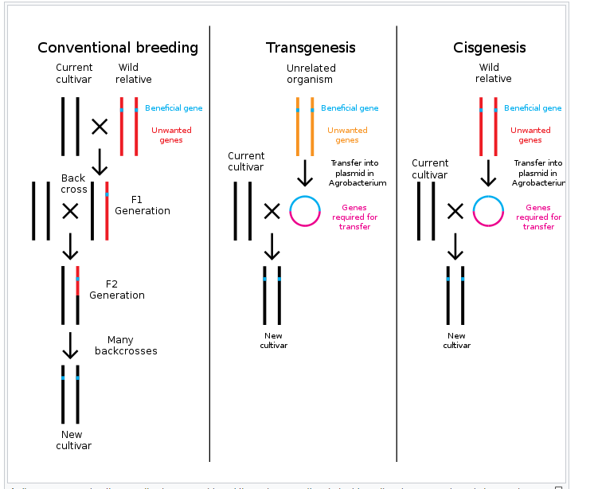
Figure 3: Difference between traditional breeding, transgenic, and cisgenic breeding methods for crop improvement

III. THE KEY STEPS INVOLVED IN PRODUCING A CISGENIC AND INTRAGENIC PLANT

Select the Target Crop and Gene of Interest: Choose the plant species you want to modify and identify the gene(s) of interest. Ensure that the gene(s) come from a sexually compatible species to facilitate successful gene transfer.
- Clone the Gene: Isolate and clone the desired gene(s) from the donor plant. This involves using molecular biology techniques to extract and replicate the gene(s) in a suitable vector, such as a plasmid.
- Select the Recipient Plant: Choose a suitable recipient plant of the same species or a closely related species that is sexually compatible with the donor plant. This ensures that the gene transfer can occur naturally through cross-breeding.
- Generate Transgenic Plants: Introduce the cloned gene(s) into the recipient plant's genome. This can be achieved through various methods:
- Agrobacterium-Mediated Gene Transformation: Use Agrobacterium tumefaciens or Agrobacterium rhizogenes to transfer the gene(s) into the plant tissue.
- Direct Gene Transfer: Utilize biolistics (gene gun) or electroporation to introduce the gene(s) directly into plant cells.
- Select cisgenic Plants: Identify and select the cisgenic plants that have successfully integrated the cisgene(s) into their genome. This is typically done through molecular analysis by using gene-specific primers (e.g., PCR) to confirm the presence of the gene(s).
- Screen for Single-Copy Insertions: It is desirable to select plants with single-copy insertions of the cisgene(s) to minimize the potential for undesirable genetic effects. Molecular techniques, such as Southern blot analysis can be used for this purpose.
- Evaluate Expression: Assess whether the cisgene(s) are being expressed in the transgenic plants. This can be done through gene expression analysis, such as RT-PCR, EST (Expression Sequenced Tagged) Markers or protein assays.
- Backcrossing and Breeding: To reduce the impact of linked genes or undesirable traits, backcross the transgenic plants with the parent crop to create a cisgenic plant with the desired gene(s) and minimal genetic alterations.
- Field Testing and Regulatory Approval: Conduct field trials to evaluate the performance and safety of the cisgenic plant under real-world conditions. Seek regulatory approvals if necessary, depending on the country's regulations regarding genetically modified organisms (GMOs).
- Commercialization: If the cisgenic plant performs well and receives regulatory approval, it can be commercialized and introduced into agriculture.
- Continued Monitoring: Continuously monitor the cisgenic plant in the field for its performance and potential environmental impacts.

IV. PRE-REQUISITES FOR CISGENESIS AND INTRAGENESIS

A. Sequence information of the recipient plant: Obtaining sequence information for the recipient plant is a crucial step in cisgenic plant development. This information is necessary for several purposes, including selecting appropriate target genes, designing genetic constructs, and ensuring the compatibility of the introduced genes with the recipient plant's genome. Here are the steps involved in obtaining sequence information for the recipient plant:
- Choose the Recipient Plant Species and Cultivar: Select the plant species and specific cultivar that you intend to genetically modify using cisgenic methods. This choice should be based on your research objectives and the plant's agronomic characteristics.
- Isolate Genomic DNA: Begin by isolating high-quality genomic DNA from the chosen recipient plant. This can typically be done using commercially available DNA extraction kits or laboratory protocols specific to your plant species.
- Perform Whole Genome Sequencing (WGS): For comprehensive sequence information, perform whole genome sequencing (WGS) on the isolated genomic DNA. WGS provides a complete picture of the plant's genome, including its coding and non-coding regions. This can be outsourced to specialized sequencing service providers or conducted in-house if you have the necessary equipment and expertise.
- Sequence Assembly and Annotation: After sequencing, assemble the generated sequence data into a complete genome using bioinformatics tools. This process involves aligning and organizing the short sequencing reads into longer sequences, known as contigs. Once assembled, the genome can be annotated to identify genes, regulatory regions, and other genomic features.
- Identify Promoters, Enhancers, and Regulatory Elements: Identify the regulatory elements within the genome, such as promoters and enhancers, that can be used to drive the expression of the cisgene(s). Understanding these elements is crucial for designing effective genetic constructs.
- Select Target Genes for Cisgenesis: Based on the annotated genome and your research objectives, identify the specific target gene(s) or trait(s) you want to introduce or modify in the recipient plant. Ensure that the selected genes are functionally relevant and compatible with the recipient plant's genetic background.
- Design Genetic Constructs: Design the genetic constructs that will be used to introduce the cisgene(s) into the recipient plant. These constructs should include the regulatory elements, the cisgene(s), and any additional sequences required for proper gene expression.
- Verify Sequence Compatibility: Before proceeding with transformation and plant regeneration, verify that the designed genetic constructs are compatible with the recipient plant's genomic sequence. This ensures that the introduced genes will integrate seamlessly into the plant's genome.
- Transformation and Plant Regeneration: Use the designed constructs to transform the recipient plant using suitable transformation methods (e.g., Agrobacterium-mediated transformation, biolistics). Regenerate transgenic plants from the transformed tissue.
- Confirm Integration and Expression: Confirm that the cisgene(s) have integrated into the recipient plant's genome and are expressing the desired trait(s) through molecular analyses such as PCR, Southern blotting, and gene expression assays.

B. Sequence information of the donor plant
Obtaining sequence information for the donor plant, from which you intend to isolate genes for cisgenic plant development, is an essential step in the process. This information allows you to identify, isolate, and characterize the genes of interest for transfer into the recipient plant. Here are the steps involved in obtaining sequence information from the donor plant:
- Select the Donor Plant: Choose the plant species or variety that contains the desired genes or traits you want to introduce into the recipient plant. Ensure that the donor plant is a close relative or cross-compatible with the recipient plant.
- Isolate Genomic DNA: Begin by isolating high-quality genomic DNA from the chosen donor plant. This can typically be done using commercially available DNA extraction kits or laboratory protocols specific to your plant species.
- Identify the Genes or Traits of Interest: Determine the specific genes or traits within the donor plant's genome that you wish to transfer to the recipient plant. These genes should confer the desired characteristics or traits (e.g., disease resistance, drought tolerance) that you want to introduce into the cisgenic plant.
- Perform Targeted Gene Sequencing: Perform targeted gene sequencing (often referred to as gene-specific PCR or Sanger sequencing) to obtain the nucleotide sequences of the genes of interest. These sequences should cover the coding regions as well as any relevant regulatory elements.
- Sequence Analysis: Analyze the obtained sequences to verify their accuracy and quality. Use bioinformatics tools and software to assemble and align the sequencing data and identify coding sequences, regulatory regions, and any known functional motifs.
- Gene Annotation: Annotate the identified genes to understand their functions, including the proteins they encode and their roles in plant physiology. This step can provide insights into the potential impact of introducing these genes into the recipient plant.
- Design Genetic Constructs: Based on the sequence information obtained from the donor plant, design genetic constructs that include the regulatory elements, the gene(s) of interest, and any other necessary sequences for proper gene expression. These constructs will be used for cisgenic transformation.
- Transformation and Plant Regeneration: Use the designed genetic constructs to transform the recipient plant using suitable transformation methods (e.g., Agrobacterium-mediated transformation, biolistics). Regenerate transgenic plants from the transformed tissue.
- Confirm Integration and Expression: Confirm that the cisgene(s) have integrated into the recipient plant's genome and are expressing the desired trait(s) through molecular analyses such as PCR, Southern blotting, and gene expression assays.
By obtaining sequence information from the donor plant and identifying the relevant genes or traits, you can precisely engineer the recipient plant to exhibit the desired characteristics while minimizing the introduction of unrelated genetic material. This approach is a fundamental aspect of cisgenic plant development.

C. Clean vector transformation technology/ marker-free cisgenic plants
Clean vector technology aims to produce cisgenic plants with only the gene of interest as newly introduced gene functions without any selectable or scorable markers gene sequences. Primarily, the goal is to avoid the use or the continued presence of antibiotic resistance genes as selectable markers.

Four approaches to achieve this can be followed:
a. Co-transformation: Based on Agrobacterium- or biolistic mediated transformation in which a selectable marker gene (SMG) and gene of interest are on the separate construct (Fig. 4).
- Two T-DNA in separate Agrobacterium
- Two T-DNAs carried by different replicons within the same Agrobacterium
- Two T-DNAs located on the same replicon within an Agrobacterium
In all these three methods SMGs can subsequently be removed from the plant genome during segregation and recombination and select segregates plants had a only gene of interest.
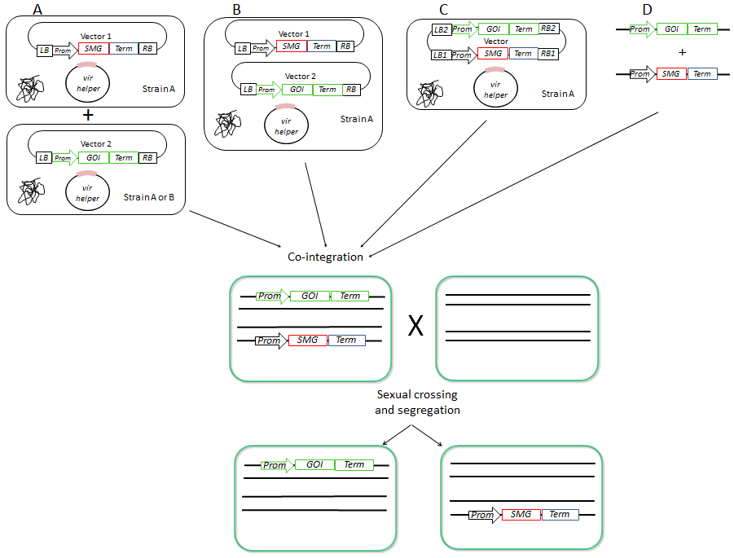
Figure 4: Co-transformation based marker-free gene transformation methods in which an SMG and gene of interest (GOI) are on separate construct
b. Site-specific recombination: It takes place only between defined excision sites in the phage and in the bacterial chromosome. Positions of the site-specific recombination in the bacterial and phage DNA are called the bacterial and phage attachment sites, respectively (Fig. 5).
Thee different site-specific recombination systems that might be useful for the production of marker-free transgenic plants
- Cre/loxP system (bacteriophage P1)
- FLP/FRT system (Saccharomyces cerevisiae) and
- R/RS system (Zygosaccharomyces rouxii)
were, Cre: Causes recombination, loxP : locus of X-over P1, FLP: flippase, FRT: Flippase recognition target
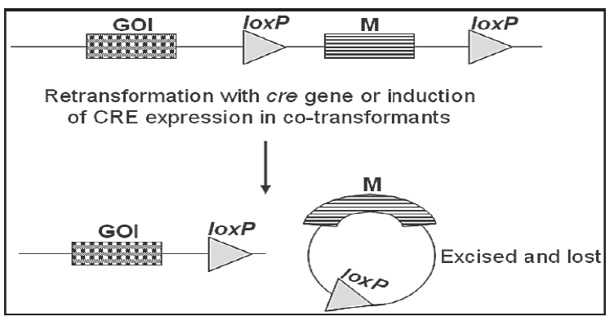

Figure 5: Cre/loxP recombination system (M: marker gene and GOI: gene of interest) Source: Darbani et al., 2007

c. Transposon-based marker method: Transposable elements can also be used to produce marker-free transgenic plants (Fig. 6). Use of transposable elements for marker gene removal involves several steps: (i) insertion of the marker gene onto a transposon, a segment of DNA that “hops” around in the plant’s genome; (ii) co-transformation with gene of interest; and (iii) segregation of the marker gene (Darbani et al., 2007). In the 1940s, Barbara McClintock made an astonishing discovery. She detected two factors of DNA transposition in maize: a Ds (disassociation factors) element that was located at a chromosome break site and an unlinked genetic factor Ac (Association factors) that was required to activate the breakage of chromosome 9. SMG place between Ac and Ac factors is excised by Ds factors. So, during segregation SMG are removed and only GOI remain.
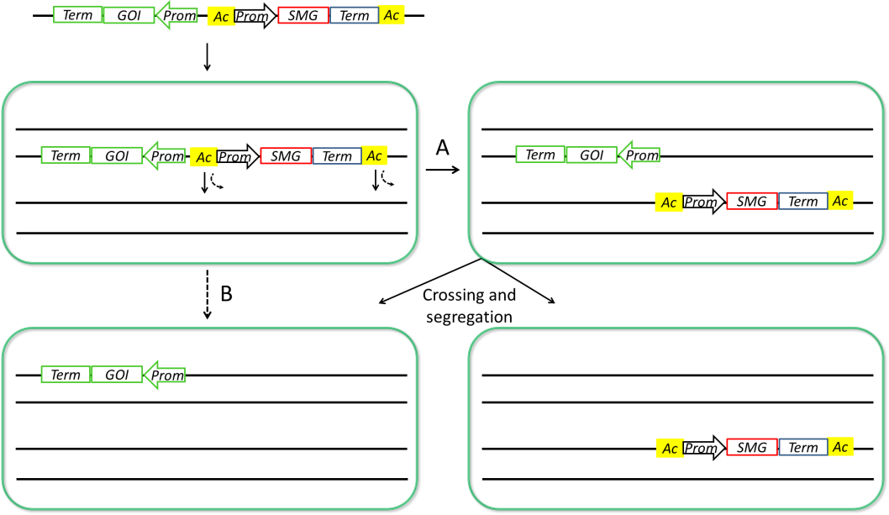
Figure 6: Ac transposon-based expelling of nuclear marker genes (M: marker gene and GOI: gene of interest)

d. Chloroplast marker gene: Chloroplast transformation vectors are designed with homologous flanking sequences on either side of the transgene. In addition, chloroplast engineering overcomes the challenges of gene silencing, position effects, and multi-step engineering of multiple genes, which are current limitations of nuclear transformations plastid genomes are used for the development of marker-free transgene (Darbani et al., 2007). a construct co-integration system followed by a homologous recombination event between single homologous regions in vector and plastome was developed (Fig. 7). SMG are placed between two homologous terminator sequences and after recombination, co-integrates are inherently unstable because of direct repeats. Therefore, subsequent loop-out recombination events create either the stable integration of a transgene of interest or loss of the integrated vector, which then yields a marker-free cisgenic plants.
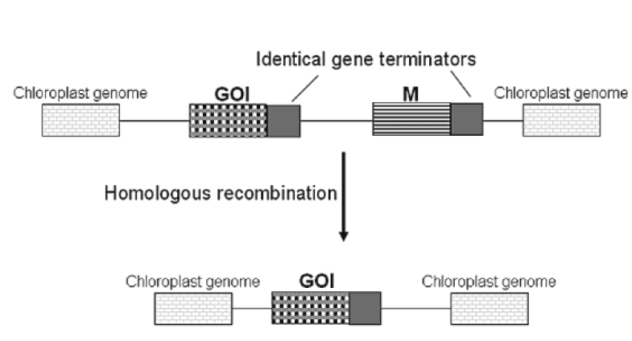
Figure 7: Co-integrated based marker excision method for generation of marker-free plastid transformants (M: marker gene, GOI: gene of interest) source [Darbani et al., 2007]

D. The steps for the production of marker-free cisgenic/intragenic plants:
Producing marker-free genetically modified (GM) plants involves creating plants with the desired genetic modifications while eliminating any selectable marker genes that were initially used in the transformation process which are mentioned in section IV (C). Here are the steps for the production of marker-free GM plants:
- Select the Target Crop and Trait of Interest: Choose the plant species you want to modify and identify the specific trait you aim to introduce or enhance.
- Select the Appropriate Transformation Method: Determine the most suitable transformation method for your target crop. Common methods include Agrobacterium-mediated transformation, biolistics (gene gun), and electroporation.
- Introduce the Transgene with a Selectable Marker: In the initial transformation, introduce the transgene of interest along with a selectable marker gene, such as a gene conferring resistance to an antibiotic or herbicide. This marker gene will help identify transformed plants.
- Select Transgenic Plants: After transformation, identify and select the transgenic plants that carry the transgene of interest along with the selectable marker gene. This selection is typically done by exposing the plants to the corresponding selective agent (e.g., antibiotics or herbicides).
- Characterize Transgenic Plants: Confirm that the selected plants indeed contain the desired transgene by performing molecular analyses such as PCR, Southern blotting, and gene expression assays.
- Cross-Transgenic Plants with Non-Transgenic Plants: Cross the selected transgenic plants with non-transgenic plants of the same species to create a segregating population.
- Screen for Marker-Free Progeny: In the segregating population, screen for progeny plants that have inherited the transgene of interest but lost the selectable marker gene. This can be achieved through additional molecular analyses which are mentioned in section IV (C).
- Backcrossing and Selfing: Backcross the marker-free progeny with non-transgenic plants to increase the genetic purity and stability of the marker-free trait. Selfing (self-pollination) can also be performed to create homozygous marker-free lines.
- Confirm Marker Elimination: Thoroughly verify that the selected plants are indeed marker-free through extensive molecular testing to ensure that no traces of the selectable marker gene remain.
- Characterize Marker-Free Plants: Assess the performance and phenotype of the marker-free plants to confirm that they exhibit the desired trait without any unwanted effects.
- Field Testing and Regulatory Approval: Conduct field trials to evaluate the performance and safety of the marker-free GM plants under real-world conditions. Seek regulatory approvals as required by local regulations.
- Commercialization: If the marker-free GM plants perform well and meet regulatory standards, they can be considered for commercialization and integration into agriculture.

V. APPLICATION OF CISGENESIS AND INTRAGENESIS TO IMPROVE TRAITS IN RELEVANT CROP

Several traits have been incorporated into relevant crops by cisgenic or intragenic approaches. The first intragenic potato was developed to produce high amylopectin content (de Vetten et al., 2003). This approach was based on the silencing of the granule-bound starch synthase gene (GBSS), which is responsible for the synthesis of amylose in potatoes (Espinoza et al. 2013). The starch composition in potatoes is an important trait, and currently, it is difficult to obtain cultivated tetraploid potatoes with the desired content of amylose and amylopectin. Thus, strategies to silence either amylose or amylopectin synthetic genes open the possibility of obtaining tetraploid cultivars that contain all the desired traits present in the original cultivar (Holme et al., 2013).
Other intragenic approaches have addressed potato processing qualities. For instance, enzymatic browning was diminished by the silencing of a polyphenol oxidase gene (PPO), which catalyzes the oxidation of cytoplasmatic polyphenols causing the precipitation of black melanin and compromising tuber quality during storage (Rommens et al., 2004).
Another important potato trait is cold-induced sweetening, which is caused by high starch degradation triggered by low temperature during storage (Espinoza et al. 2013). To prevent this, intragenic potatoes silenced in two genes involved in starch degradation, water dikinase (R1) and amyloplast-targeted phosphorylase-L (PhL) were constructed (Kawchuk et al., 1999). Subsequently, the PPO, R1, and PhL genes were all silenced in potatoes, producing tubers with remarkable properties (Rommens et al., 2006).
Induction of tolerance to the most important potato disease, late blight caused by the oomycete Phytophthora infestans, is one of the main challenges in potato research. To develop a late blight-resistant variety, introduce several R-genes from wild potatoes, with their native regulatory sequences, into cultivated potatoes (Holme et al., 2013). This cisgenic approach also considered the use of marker-free technologies (de Vetten et al., 2003; Haverkort et al., 2009, Espinoza et al. 2013).
Espley et al. (2012) develop cisgenic red flesh apples, most of the apples fruit have white or off-white fruit flesh. However, natural mutations have led also to apples that have red fruit flesh. This is caused by anthocyanin production in the fruit. Because of the high level of anthocyanin in the fruit flesh, the apples have both an appealing appearance and a health-promoting effect through the enhanced high antioxidant capacity. Red colouration in apple fruit is due to the activity of the MYB transcription factor, MdMYB10. Scientists are using cisgenesis to transfer the MdMYB10 gene, which is responsible for the red color in apple fruit, from one apple variety to Royal Gala. This genetic modification is likely intended to create a Royal Gala apple variety with red flesh, similar to the original variety from which the gene was sourced. This can have potential applications in apple breeding to create new varieties with desirable traits. Avoids the use of any foreign selectable marker genes; only the gene-of-interest is integrated between the T-DNA border sequences, flanked by its native promoter and terminator. They used the MdMYB10 gene from a red-fleshed apple coding for a transcription factor involved in regulating anthocyanin biosynthesis. Red plantlets were obtained and the presence of the cisgene was confirmed. Plantlets were grafted and grown in a greenhouse. After 3 years, the first flowers appeared, showing red petals.
All cultivated apples are susceptible to apple disease is scab, which is caused by the ascomycete Venturia inaequalis, and recently the HcfVf1 and HcrVf2 gene present in the scab resistance locus Vf was introduced in apple cv. Gala (Vanblaere et al., 2011). The transferred gene contains its own regulatory sequences, i.e. promoter and terminator and in fact, this study claims to be the first report of the generation of a “true cisgenic plant” (Vanblaere et al., 2011 and Joshi et al. 2011).
Kost et al. (2015) developed a cisgenic apple of the cultivar 'Gala Galaxy' with increased resistance to fire blight (Erwinia amylovora). A cisgenic apple line C44.4.146 was regenerated using the cisgene FB_MR5 from wild apple Malus ×robusta 5 (Mr5), and the previously established method involving A. tumefaciens-mediated transformation of the fire blight susceptible cultivar ‘Gala Galaxy’ using the binary vector p9-Dao-FLPi. Line C44.4.146 was shown to carry only the cisgene FB_MR5, controlled by its native regulatory sequences, and no transgenes were detected by PCR or Southern blot following heat-induced recombinase-mediated elimination of the selectable markers. The same regulatory sequences were shown to effectively regulate the function of FB_Mr5 in transgenic lines developed by Broggini et al. 2014, Engineering fire blight resistance into the apple cultivar 'Gala' using the FB_MR5 CC-NBS-LRR resistance gene of Malus x robusta 5.
Holme et al. (2012) developed cisgenic barley with improved phytase activity so increasing the bioavailability of phosphate in barley grain. In barley, 70-80% of the phosphate reserves in seeds are bound as phytic acid. Phytic acid can only be degraded by specific enzymes such as phytase. Phytase is activated at germination to ensure the supply of phosphate to the developing plantlet. Phytic acid inhibits the uptake of zinc, calcium, and iron absorbed by animals. HvPAPhy_a is preferentially synthesized during seed development and stored as preformed phytase in the mature grain, HvPAPhy_b is preferentially synthesized during germination. Therefore, the HvPAPhy gene is a candidate for a cisgenic approach.

VI. CONCLUSION

Despite the success, the Classical methods of alien gene transfer have disadvantages and difficulties, particularly linkage drag, that require time-consuming backcrosses and simultaneous selection steps. Cisgenesis and intragenesis both are single-step gene transfer without linkage drag. Cisgenesis and intragenesis are a biotechnological modern tool in the hands of plant breeders that gives smile to farmers. Future developments regarding the generation and commercialization of intragenic and cisgenic crops will depend on application of less stringent regulation to these crops worldwide. Cisgenic crops are acceptable to a greater number of people than transgenic crops.

References

Ahmad S., M. L. Jakhar, Dalip, S. Maurya and Hari Ram Jat. Cisgenesis and Intragenesis in Modern Plant Breeding. Int.J.Curr.Microbiol.App.Sci. 2020; 11: 3989-3998.
Broggini GAL, Wöhner T, Fahrentrapp J, Kost TD, Flachowsky H, Peil A, et al. Engineering fire blight resistance into the apple cultivar 'Gala' using the FB_MR5 CC-NBS-LRR resistance gene of Malus x robusta 5. Plant Biotechnol J. 2014;12(6):728–33.
Cabrera-Ponce, J.L., A. Barraza, R. Alvarez-Venegas. Cisgenic Crops: Major Strategies to Create Cisgenic Plants Based on Genome Editing. In: Chaurasia, A., Kole, C. (eds) Cisgenic Crops: Potential and Prospects. Concepts and Strategies in Plant Sciences. Springer, Cham.2022; DOI:10.1007/978-3-031-06628-3_11
Darbani, B., A. Eimanifar, C. N. Stewart, and W.N. Camargo. Methods to produce marker-free transgenic plants. Biotechnol. J. 2007, 2: 83–90. DOI:10.1002/biot.200600182
De Vetten N., W. A., K. Raemakers, V. D. Meer, T. R. Stege, E. Heeres, P. Heeres, and R. Visser (2003) A transformation method for obtaining marker-free plants of a cross-pollinating and vegetatively propagated crop. Nat Biotechnol, 2021;21;439-442.
Den Nijs, C. M. Hans, D. Bartsch, and J. Sweet, eds. Introgression from genetically modified plants into wild relatives. CABI, 2004.
Espinoza C., R. Schlechter, D. Herrera, E. Torres, A. Serrano, C. Medina, P. Arce-Johnson. Cisgenesis and intragenesis: new tools for improving crops. Biol Res. 2013;46(4):323-31. DOI:10.4067/S0716-97602013000400003.
Espley, R. V., Bovy, A., Bava, C. M., Jaeger, S. R., Tomes, S., Norling, C., … & Allan, A. C. (2012). Analysis of genetically modified red-fleshed apples reveals effects on growth and consumer attributes. Plant Biotechnology Journal,2012;11(4);408-419. DOI:10.1111/pbi.12017
Ewen M., B. Jean-Louis, D. Tamas, C. D. Ian, M. M. Epstein, L. G. Firbank, P. Guerche, J. Hejatko, F. J. Moreno et al., Updated scientific opinion on plants developed through cisgenesis and intragenesis. EFSA Journal. 2022;20(10):7621.
G. Eason, B. Noble, and I.N. Sneddon, “On certain integrals of Lipschitz-Hankel type involving products of Bessel functions,” Phil. Trans. Roy. Soc. London,
Haverkort A. J., P. C Struik, R.G.F. Visser and E. Jacobsen. Applied Biotechnology to Combat Late Blight in Potato Caused by Phytophthora Infestans. Potato Research, 2009;52; 249-264
Holme I. B, T. Wendt and Holme P. B. (2013) Intragenesis and cisgenesis as alternatives to transgenic crop development. Plant Biotechnol J, 2013;11;395-407.
Holme I. B., G. Dionisio, H. Brinch-pedersen, T. Wendt, C.K. Madsen, E. Vincze and P.B. Holm. Cisgenic barley with improved phytase activity. Plant Biotechnol J, 2012;10;237-247.
Hou, H., N. Atlihan, Z. Lu, New biotechnology enhances the application of cisgenesis in plant breeding. Frontiers in Plant Science, 2014;5;85909. DOI:10.3389/fpls.2014.00389.
Joshi S. G., J. G. Schaart, R. Groenwold, E. Jacobsen, H. J. Schouten, F. A. Krens. Functional analysis and expression profiling of HcfVf1 and HcrVf2 for development of scab-resistant cisgenic and intragenic apples. Plant Mol. Biol. 2011;75;579–591. DOI:10.1007/s11103-011-9749-1
Kawchuk L.M., J.D. Armstrong, D.R. Lynch, and N. R. Knowles. Potatoes having improved quality characteristics and methods for their production. US patent application. US 5998701, 1990.
Kost T.D., C. Gessler, M. Jänsch, H. Flachowsky, A. Patocchi, et al. Development of the First Cisgenic Apple with Increased Resistance to Fire Blight. PLOS ONE. 2015;10(12);e0143980. DOI:10.1371/journal.pone.0143980
Rommens C.M., J. Ye, and K. Swords. Improving potato storage and processing characteristics through all-native DNA transformation. J Agric Food Chem,2006;54;9882-9887.
Rommens C.M., J.M. Humara, J. Ye, H. Yan, C. Richael, L. Zhang, R. Perry and K. Swords (2004) Crop improvement through modification of the plant’s own genome. Plant Physiol, 2004;135;421-431.
Schouten H. J., F. A. Krens, E. Jacobsen, Cisgenic plants are similar to traditionally bred plants: international regulations for genetically modified organisms should be altered to exempt cisgenesis. EMBO Rep. 2006;7(8):750-3. DOI: 10.1038/sj.embor.7400769
Telem R.S., S.H. Wani, N.B. Singh, R. Nandini, R. Sadhukhan, S. Bhattacharya, N. Mandal. Cisgenics - a sustainable approach for crop improvement. Curr Genomics. 2013;14(7):468-76. DOI:10.2174/13892029113146660013.
Vanblaere T., I. Szankowski, J. Schaart, H. Schouten, H. Flachowsky, G. A. Broggini and C. Gessler.The development of a cisgenic apple plant. J Biotechnol, 2011;154;304-311.

