ANTENNA TRENDS IN THz COMMUNICATION
Rajarajeshwari k c, Saravanakumar N, Poornima T, Gokul Anand K.R
1,4 Assistant professor, Department of ECE,Dr Mahalingam College of Engineering and Technology, Pollachi, Tamilnadu.
2, Associate Professor, Department of ECE,Dr Mahalingam College of Engineering and Technology, Pollachi, Tamilnadu.

3,Lead Wireless Engineer, Wireless Systems Solutions,USA.

ABSTRACT
Terahertz range lies between microwave band (<100GHz) to far Infra-Red band (>10THz) range. The actual range of Terahertz is 0.3 to 3THz and the radiation occurs about 1millimeter, hence called as sub-millimetre band/wave which are usually short wavelengths. Normal antenna designs can be made as per our requirement, but coming to THz antenna the case is entirely different. It has to be designed, constructed, and fabricated with lot of limitations and constraints. They have many challenges related to high performance like high data rates (Tbps), proper spectrum allocation, high gain, high bandwidth, compact (sub mm size), low profile, low cost, uninterrupted data transfer, suppressed buffer, improved latency etc... Usually, horn antennas give better performance compared to all antenna structures because of its properties like low losses, high radiation, etc... Many horn antennas like diagonal horn, Pickett potter horn, corrugated horn is used for their high efficiency nature. Many other antennas like lens antenna, rectangular horn, conical horn, micro strip antenna, planar antennas, reflector antennas and arrays can be used. Another mainly used antenna type is Photo conductive antenna (PCA), Bow tie antennas because of their prolific nature. Coming to simulation process which is mandatory before fabrication we have to choose proper software’s with that much memory to support THz range. Some common software’s to simulate THz antennas are HFSS, CST studio, Ads, etc... Substrates usually used are Fr-4, Rogers-5880 and when it comes to THz antenna special attention must be given to substrates also. Some commonly used substrates for THz antennas are meta-materials, Resonant Graphene (for its conductivity), meta/mesa surface antenna, GaAs, InGaAs/InAlAs. Since these antennas are miniature sized, portable they find various applications like body antenna, defence sector and bio medical. Finally, there is need for improvement in antenna structures with accurate main lobes and suppressed side lobes. MIMO can also be used for THz to overcome losses, improving gain, confined directivity, long distance radiation [1].
Key words – THz , Vivaldi antenna, Reflector, THz antenna array.
1 INTRODUCTION TO THz ANTENNA
The main objective of this chapter is to brief the challenges and limitations in designing and fabricating the THz antenna with the help of existing antenna trends. Terahertz antenna should be designed very precisely to fulfil many criteria’s supporting this high frequency, reduced size, outspread bandwidth, outrageous data rate. Another important aspect taken into account is considering the losses this is due to travelling in high frequency range. As we are moving over the THz range, there will be a lot of losses including path loss, material loss, and surface loss in antenna. We can eliminate these losses with at most care in designing the antenna, choosing the conductors and substrates. In this chapter we are going to explore various antennas which can be used for terahertz range. There are major applications of THz are in many fields like biomedical, transportable antenna (body wearable), space (NASA, ESA) etc... The commonly used antenna for terahertz communication is the family of microstrip, horn, Lens, parabolic, planar antennas, reflector antennas and arrays. Normal antennas working at low frequency are even suitable for THz range but design and fabrication have certain limitations. The size of the antenna being used in various space, imaging, radar, oceanography, biomedical applications are not compact and it becomes a major drawback. Hence, a solution for this have been found named miniaturized antenna or THz antenna.

When we want improved gain, directivity, efficiency properties undoubtedly the size and feed length of antenna increases tremendously which further increases cost, size, reduced uses in real time applications. This can be overcome by THz antenna which are compact, high frequency range, fits to all real time applications. These miniaturized THz antennas can be fabricated on a single integrated chip called on-chip antenna (OCA) technology using CMOS and SiGe. Best way to increase gain and beamforming is array antenna which is applicable at THz range also but with the limitation of size. System on chip antenna arrays can be constructed with the reduced size of about 10-100 times of normal array antenna with simple IC fabrication and assembling all device component in a single chip. In this chapter we are going to discuss about various antennas suitable for working under THz communication. Main antenna under our discussions is microstrip, lens, reflector, horn, on chip antenna, metamaterial and graphene-based antennas.

1.1 NEED FOR TERAHERTZ COMMUNICATION:
As the technology is growing and the world is changing rapidly with these improving technology the need for improved communication becomes an incumbent one. Traffic data rates are augmented around 12 times within past 5 years. This clearly shows the exigency for high-speed data rate which almost occupies the entire band of bandwidth spectrum. The reason for this is increased user for mobile phone, multimedia services, online working platforms (especially during pandemic situation like Covid), etc... An interesting truth is around 23billion people around the world are connected to internet using various devices and it will solidly get tripled within 2-3years. The recent trend at present ruling the world which an unavoidable one for everyone is 5G. Whenever there is an invention the expectation of the improvised version will arises so that 6G came into our minds. The major reason for the birth of sixth-Generation (6G) is the demand for increased bandwidth spectrum, surfing the internet with high speed and zero buffering, transmission and reception of bulk data within our eye blink, internet multimedia calls without time delay, speed, non-synchronous and so on. Thus, a promising technology beyond the present 5G era with unimaginable speed, high quality communication, extremely suppressed buffer etc... are achieved in the next generation 6G communication which is a greater blessing for everyone. The data rate has been increased from Gbps (5G) to tera bits per second (Tbps) 6G communication which is in millimetre wave. Hence terahertz communication is also known as millimetre or sub-millimetre wave communication. To support millimetre and THz range of frequency, we need antennas which supports these high frequency range (0.3 to10 THz). Day by day the need for THz high speed macro and nano applications like surveillance, multimedia, defence, military, biomedical, scanning and imaging are increasing and therefore the invention of antenna supporting these high-speed THz applications is gaining much importance. We know that gain is directly proportional to frequency and hence if we move over higher frequency like mm and THz the gain of the antenna also increases tremendously [2]. In this chapter we are going to discuss various antennas which can be used for terahertz range.

1.3 SELECTION AND DESIGNING OF ANTENNA FOR THZ APPLICATIONS:
The selection part may look of less important but it plays crucial part in antenna design. The selection has to be made in many steps to make the antenna a successful product in the market. All antenna requires this step but additional care has to be given in this selection of THz antenna. THz antenna works at super high frequency range but when frequency increases the antenna becomes larger and losses becomes unavoidable one. Hence, antenna must be chosen based on requirement of THz range which includes certain limitations like
- Miniaturized (reduced size)
- Reduced side lobes
- Supressed noise at receiver
- Very low or no cross polarization
- Low losses
- Achieving beam formation

Designing a completely new antenna fitting this frequency is somewhat a tedious process but we can modify the existing antenna based on its size, substrate used, introducing corrugation in antenna or substrate, changing feed length, introducing notch and so on. Metamaterial substrate and some new metals are being popular for THz range because of their low losses. THz antenna design simulation also has certain limitations mainly memory size of the system or tool. Normal antenna can be simulated using many antenna tools like ADS, HFSS, EESOF, etc… But when we simulate THz even if the same simulation platforms support there are some challenges like memory requirement will be high, time taken to simulate the antenna will also be longer and the system should be capable to support such high frequency antenna. At most care should be given for fabrication and testing. Normal antenna can be tested using network analyser but THz antenna testing requires some more additional components and precautions because of its high frequency range. The overall process is given as schema chart in Fig1. For better understanding the process involved in selection and designing of THz antennas.
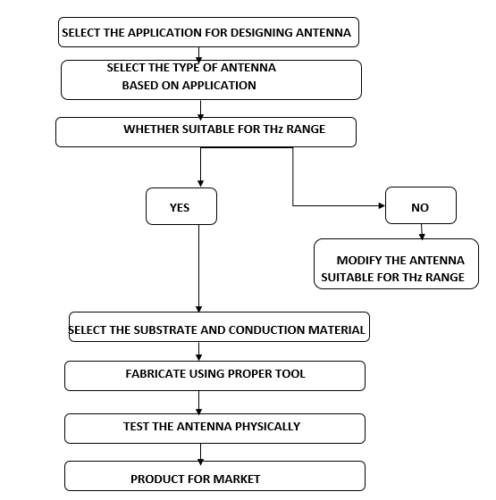
Fig. 1. Schema involved in selection of THz antenna
2 DIPOLE ANTENNAS FOR THz:
Dipole antenna is the basic and uncomplicated antenna with simple structure and design. Usually, a dipole antenna consists of a linear conductor (mostly copper) with an incision at centre. As the name suggests it has two poles with various lengths. The commonly used dipoles are 1/2λ length dipole, 1/4λ length dipole, folded dipole, resonant dipoles, dual dipole etc... But these normal antennas cannot be used as it is for THz radiation. For THz and 6G communication we need antennas with gross gain and broader bandwidth. Hence a simple dipole antenna is not sufficient and that much effective, hence we have to do some modification in dipole antennas like adding reflectors and directors to dipole, by choosing proper conductors and substrates, modifying the shapes and distance to be placed. Dipoles are generally used as a feed for the main antenna in THz and high frequency range.
2.1 DIPOLES WITH REFLECTORS / DIRECTORS:
In order to make the signal stronger and improving gain we can add horizontal or vertical reflectors to the antenna with spacing of 0.15λ to 0.25 λ. To maintain bandwidth, we can add directors along with reflectors. We can increase the number of directors gradually to attain high gain or desired range of gain. Coming to the substrate Gold will provide better results but considering cost efficiency we can go for alternate material like photoconductive, graphene... These are well suited for sub-terahertz range of operation i.e., around 0.1-0.3THz [3].
Yagi-Uda antenna in Fig2. is best example for dipole with director and reflectors. It is a simple end fire parasitic array antenna with many driven elements. These are high gain and directional antennas working at high frequency range will be suitable for THz communication. These are commonly used in TV broadcasting and Radar communication. When we use normal silicon substrate it produces unavoidable mismatches which can be replaced by thin metamaterials or dielectric substrate like GaAs or InP to avoid this mismatch. The next modification in design can be made by changing the driven element shape of Yagi array. We can make driven elements as straight line and make many iterations to achieve desired gain and bandwidth or we can change the shape of driven element (dipole) into U or inverted-U shape element. The reflector length can be ≤ 5% larger than the dipole or driven element whereas the directors should be ≤5% smaller than the dipole. The frequencies used for calculating length should be in THz.
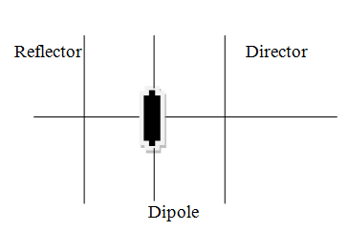
Fig. 2. Dipole antenna with directors and reflector or 3 element Yagi-Uda Antenna
The length and width of driven element plays a major role in deciding gain and efficiency. The length can be calculated using the formulae given below.
Length of driven element = 475/f_{THz} metres
Length of reflector = 500/f_{THz} metres
Length of director = 455/f_{THz} metres
Like length the spacing between each element also plays a major role and the spacing can be made as normal Yagi array. The main advantage of Yagi antenna is it provides extremely high directive gain and the directivity can be increased just by adding more elements to the array.
2.3 DIPOLE ANTENNA BASED ON MATERIALS
At present in antenna industry the most uttered word is ‘Graphene’ material especially in THz range and nano-scale. We can attain our desired /required gain with these graphene antennas by tuning its chemical properties. Graphene is mainly used to reduce the size of antenna which is the most challengeable thing in THz (miniature size). Hence nano antennas can be produced using this graphene material for mm wave range because of its unique properties and its flexibility. Thus copper, gold, silver metals are successfully replaced by graphene. Graphene is not only used for dipoles it can also be used for other antennas like microstrip, Vivaldi, etc...
Next one is photoconductive materials importance in THz antenna design. The input will be of short pulse (in the range of < picoseconds) which is fed to Photoconductive antenna (PCA). It consists of normal dipole antenna and when the pulse ignites the PCA it produces photo carrier inside the Photo conductor of PCA. These carriers in turn produce current and the remaining is the same working principle of all antennas. Photoconductive antennas are used to improve the conduction of electric fields by igniting to EM waves. These usually takes up the EM waves (visible, IR, UV, gamma etc...). photoconductive antennas play a crucial role in THz range because it operates between microwave and infrared range of frequencies. These antennas provide high gain, improved overall efficiency, beam shaping (due to its hemispherical substrate), high directivity, high output power etc... There are many shapes used in common like T-shape, I-shape, H-shape, L-shape, and Bowtie shape etc...
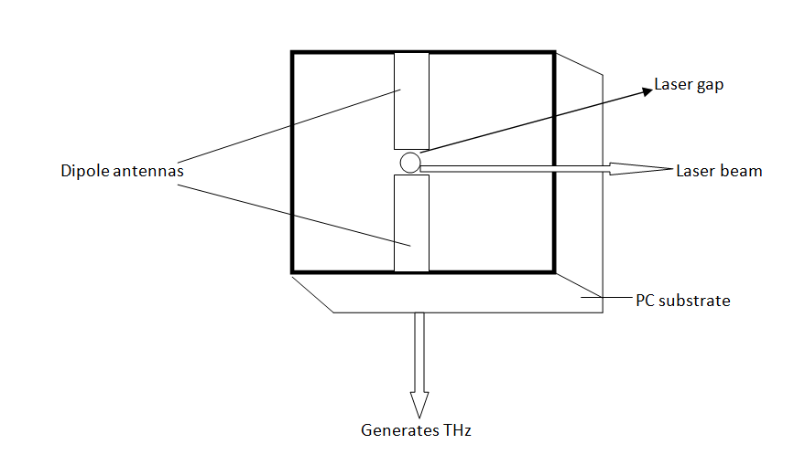
Fig. 3. Photoconductive dipole antenna
In the above fig3. two metal conductor strips are separated by small gap which is called as laser gap which act as input node. A laser or photoconductive source hits the laser gap and reacts with metal to generate THz wave into space. Silicon substrate are mainly used in PCA antenna to increase directivity but it produces some losses. Hence Si substrate must be replaced by InAlP or some metamaterials to give distortion less THz wave. Some commonly used photoconductive materials are PbS, ZnO, PbSe, InSb, GaAsSb and many others. Some commonly used laser wavelengths for THz PCA are 800nm, 1060nm, 1550nm (also mixing of two wavelengths). The substrates mostly used for PCA antennas are silicon lens with the shape of hemisphere. PCA are mainly used in spectroscopy, screening and imaging applications.
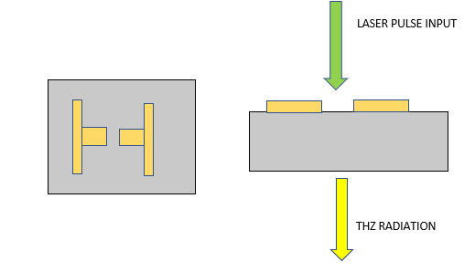
Fig. 4 (a) Top view of H-shape Photo conductive dipole (b) THZ radiation from PCA
3 MICROSTRIP PATCH ANTENNA:
It is one of the oldest and most used antennas for microwave and radio frequency. It can also be widely used for THz antenna design with modification in its size, shape, substrate material, substrate thickness, slot shapes, length of the feed, conductor materials and so on. Strip antennas can be used to cover various bands of THz frequency range. The main aim of THz communication is to miniaturize antenna (by capacitive or inductive loading), reduced weight, increased efficiency and vast are coverage. All these structural, electrical, manufacturing performance are satisfied by microstrip antenna which is required for THz communication. In strip antenna one important factor is matching the internal impedance and load impedance by which we can supress the losses. It has narrow bandwidth which can be overcome by using bulk surface substrates. Using strip antenna, we can achieve wide range of frequency coverage (multi-Band antennas) covering multiple bandwidths.

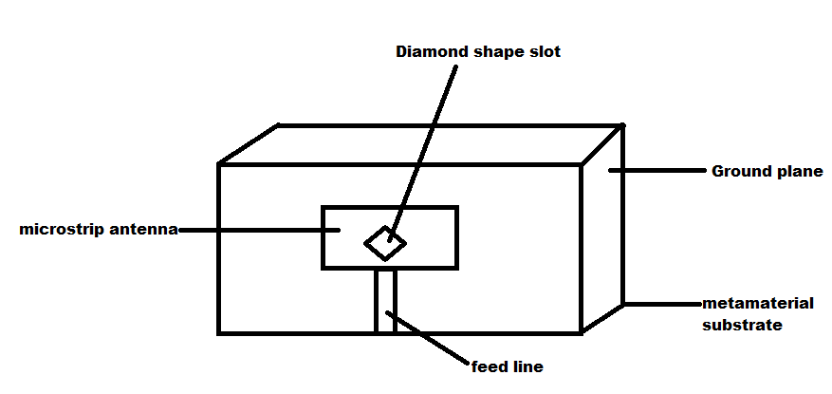
Fig. 5. Simple microstrip antenna with diamond shape notch for THz range.
The performance like radiation efficiency, gain, directivity can be further increased by creating notch/slot in existing antenna as given below. Many slots like U-shape, T- shape, Inverted T/U – shape, L-shape and other random shapes can be used based on the main antenna and its applications. The parameters of the notch shape can be varied according to gain, directivity and efficiency [4].
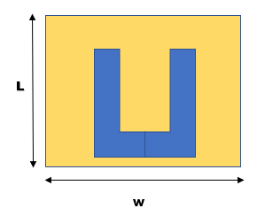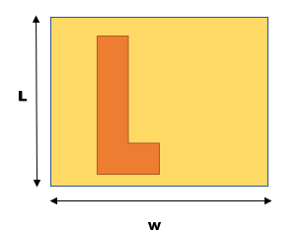
Fig. 6. U-Slot and L- slot in microstrip antenna
To enhance further radiation property is we can change the shape, size, thickness, materials of the substrate. Nowadays metamaterials are most widely used for THz range of frequency. For size reduction we can for high dielectric constant surfaces which results in vigorous wave modes. All these changes are being made because we are moving from lower to higher frequency but there is a major drawback introducing ohmic losses. We can also use split ring patch, photoconductive patch antenna and graphene-based patch antenna as we used in previous antenna design. Another important point on using strip antenna is for making arrays. For long distance radiation normal antenna is not sufficient hence more than one antenna with matched feed must be used. This is called as arrays and strip antenna is most suitable for antenna arrays. Gain improvement can be achieved by adding lens of various shapes like spherical, elliptical, conical, hemispherical for normal frequencies used by strip antennas but for THz range a reflector in addition can make better gain improvement.
Fractal antennas are majorly used nowadays for its advantages of compact size, maximum efficiency, intensifying the transmission or receiving material length within the given boundary or antenna surface which are being used in currently in cell phones and RFID. Fractal are mirror image shapes existing in antenna world long back and there are some fixed fractal benchmark shapes like Koch, Minkowski and Hilbert fractals. Increased gain, multi-bandwidth, reduced side lobes are achieved far better than normal antenna with 50-70% reduction in traditional antennas. We can include this fractal shape as notch for microstrip antennas to cover multiband and to cover THz frequency range. These fractals can be made as per rules by standard fractal fractals like Koch, Hilbert and multiple iterations are done to improve the quality to meet THz communication or we can design a random fractal by multiple attempts.
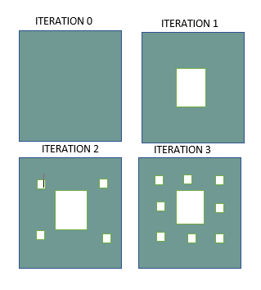
Fig. 7. Simple fractal antenna with 4 iteration
The above given fractal antenna is a kind similar to sierpinski fractal antenna in which 4 iteration is made. We can further increase the number of iterations till we achieve desired range of gain or directivity. These can also be used as notch in strip antenna to improve the bandwidth and gain.
4 HORN ANTENNA
Horn antennas are mostly preferable for THz range of frequency because it usually works at UHF and SHF also because of its supressed losses and outstanding performance. In horn antenna the gain is directly proportional to the frequency of operation hence when we go for higher frequency like THz the gain will be better but size may increase. E & H- planes can be anticipated accurately using Horn antenna. In horn antenna the energy is converted into radiating field so, the losses are much reduced. Normally to enhance the directivity we make flaring on waveguides with specified flaring angle. Pyramidal horn (TE₁₀) and conical horn (TE₁₁) works on their dominant mode. Pyramidal horn produces unacceptable side lobes and conical horn will have cross polarization hence, we move on multi-modal horn. Corrugated horn gives the best result compared to all other horn but it is difficult to fabricate at such high THz range. Multimode horn and diagonal horn are best for THz but they also have some limitations [5]. Diagonal horn gives best result when fed by IMPATT diode source. It gives Gaussian beam shape and gain around 20dB. In this multi-layer usually of silicon can be introduced to improve the performance. But the main drawback is around 10% of power is wasted in cross-polarization.
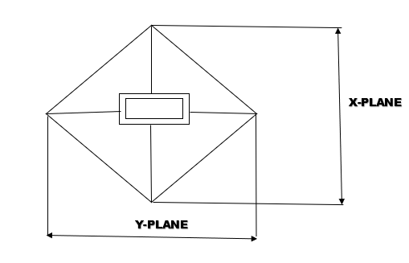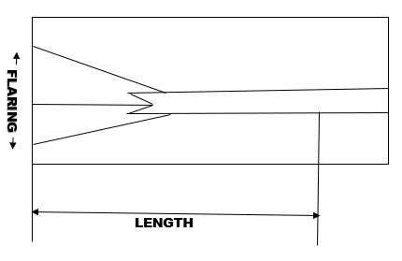
Fig. 8. Front and cross-sectional view of diagonal horn antenna for THz
The beam width of Horn antenna can be calculated with THz frequency range.
Beamwidth = 70λ / D or
= 70/ f_{THz} * D, where D -antenna diameter.
The next type of horns is corrugated horn where the inner walls of the horn are not smooth and it has serrations or parallel slots. It which gives supressed cross polarization and reduced side lobes and also produces hybrid mode HM₁₁ which is a hybrid of TE₁₁ and TM₁₁ modes [6]. Variable modes such as variable-depth-slot mode converter, ring-loaded-slot mode converter and variable-pitch-to-width-slot mode converter are used to improve the bandwidths in THz range of frequencies. Further there are different shapes as circular or pyramidal corrugated horn depending on the need. If we excite a TE mode from the waveguide and pass it to corrugated horn it produces TM mode. Hence both modes produce low cross polarization. These are mainly used as feeds for reflector antennas in space applications [7].

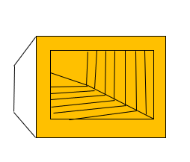
Fig. 9. Front view of Corrugated Horn antenna
Multi-Flare angle horns are mostly used for arrays because of their simple fabrications compared to corrugated horn and other types. It also avoids spill leakage and minor lobes covering multiple modes with supressed side lobes [8].
There are also horns like cass-horn to increase gain and beamwidth can be used instead of parabolic antenna. THz antennas are size constraints hence large size parabolic antennas can be replaced by such horns. Hog-Horn is a combination of parabolic and pyramidal horn can be used at THz range usually to reduce size and noise. Hog-Horn rotates at 360⁰ but the apex which receives the input remains constant this is major advantage for THz antennas as it is used mainly for imaging, surveillance, scanning, defence applications.
4 VIVALDI ANTENNA
We have seen many planar antennas like patch, leaky wave and bowtie used at THz range and this is one such planar structure finding great applications for THz range. These are metallized plates one end opening into air and other end sealed. This antenna is suitable for all range of frequencies which is one main advantage. At one end the input is fed from co-axial cable or from microstrip line and the excited wave radiates into the free space. Broadband and multiband frequencies are covered by Vivaldi antenna structure. Vivaldi antennas are classified into coplanar, Antipodal and balanced antipodal Vivaldi antenna [9]. They have linear polarization and usually lower gain (≤ 10 dBi). To improve gain and efficiency we can introduce single tapered slot, double tapered slot, loop, covering the metal end with dielectric and other modification in Vivaldi structure. Vivaldi can achieve same gain, directivity, efficiency similar to fractal and log antennas with reduced complexity in design and fabrication.
In the below given fig.10, a simple Vivaldi antenna structure is fed from a laser source or photoconductive material which is the major source for THz antennas. Once the light pulse reaches the conductive surface generating electric field which in turn produces magnetic field and hence EM wave in THz range is generated from the other flared end. This is one simplest antenna (both design and fabrication) for generating THz wave compared to all.

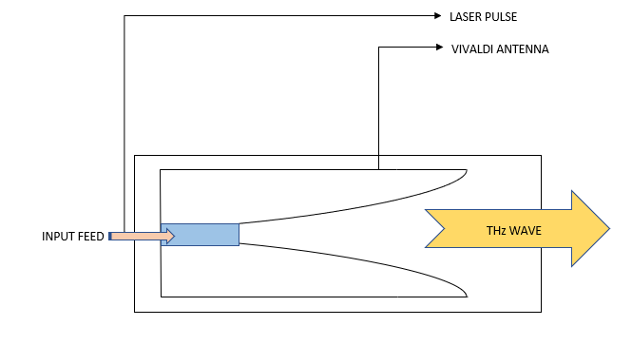
Fig. 10. A simple Vivaldi antenna structure
5 REFLECTOR ANTENNAS
Even though Horn antenna provides better performance at THZ frequency range we have a major limitation of losses. When we want to achieve high gain and directivity, we have to increase the length of horn which in turn increases the loses and makes the fabrication tedious one. This will break the miniaturization need of THz antenna. Thus, we move over reflection and lens antenna. Reflector antennas exist in communication domain since 1887 and still one of the most promising antennas to cover multiband and space applications. Reflector antennas like planar, corner, curved, parabolic with a feed and reflecting surface are some common types which we know. There are some upgraded reflected antennas like dual feed reflectors, mesh reflector and trihedral reflectors which gives improved performance than classical reflectors. The common principle involved in transmitter side of reflector antenna is the signal from feed hits the reflector and the wave gets converted into parallel wavefront which gets transmitted. Here the feed antenna commonly used is horn antenna. At receiver the process gets reversed where the receiver absorbs the wave hitting reflector and it is given to the feed. Since it has many properties like multiband, high frequency coverage, space & astronomy applications it can be used for THz range but with some limitations like reducing the size [1].
5.1 LENS ANTENNA
One most important antenna to be discussed in this chapter is lens antenna which are broadly used at high frequency applications. These are glass made antennas where the transmission and reception take place at the curved surface and the major principle involved are convergence and divergence. Some modifications on lens can be made to supress losses like adding dielectric on lens surface or by adding anti reflection layer above the antenna gives improved efficiency.
On transmission side a source of light or photon is illuminated on the focal point of lens which results as collimated wave front and vice versa on receiver end. This is due to antenna’s reciprocity theorem. Lens antenna can be used along with planar antenna to reduce losses.
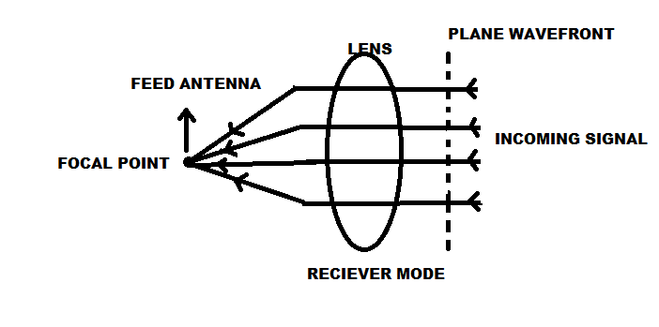
Fig. 11. working of Lens antenna at receiver side.

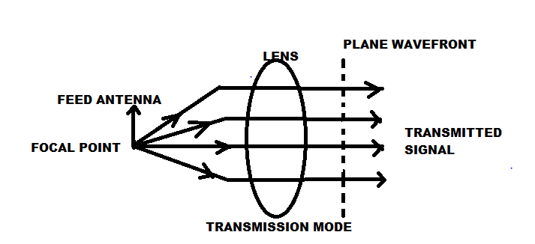

Fig. 12. working of Lens antenna at transmission side.
5.2 LEAKY WAVE (SLOTTED) FED LENS ANTENNA:
There is various type of lens antenna like H/E-plane metal lens, dielectric lens, metallic lens, leaky wave lens etc… The most used lens for THz range of communication is leaky wave fed lens antenna because of various advantages. Unlike horn antenna leaky wave fed lens produces extremely low or no cross polarization which is most wanted for high frequency communication like THz also, they have high directivity due to diminished amplitude and phase dispersion. We all know the concept of generation of leaky wave in which a waveguide or metal will have some slots [10]. If we pass some input wave through them, they produce some leakage through the slots or holes of waveguide which will be further used as input for some antenna. Leaky wave concepts can be used for all antenna structure here we discuss about leaky wave lens antenna. In the given Fig.13. It consists of leaky wave gap between the feed and lens through which the generated leaky wave passes into silicon lens gets reflected and produces THz wave. In this slotted waveguide is used to produce leaky wave. Other added advantages like better impedance matching, frequency independence, increased bandwidth (over octave) makes leaky wave lens antenna perfect for THz communication. Comparing to horn antenna this fabrication is simpler using photolithographic method. To reduce losses and to increase directivity we can add anti reflection layer above the silicon lens.
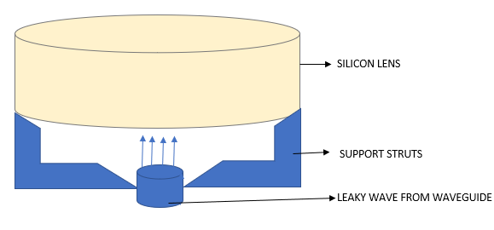
Fig. 13. Silicon lens with input as Leaky wave
6 INVERTED ANTENNAS
Inverted V antenna is one best type for THz since it requires less space. The maximum radiation occurs at its centre since the centre (≤ λ/4) is pointed and placed between two vertical transmission lines as shown in the Fig.14. The angle between the legs is called tilt angle and an angle of 90⁰ or 120⁰. It has many advantages like unidirectional pattern, no standing wave, high gain and low losses which are more required for THz frequency range.
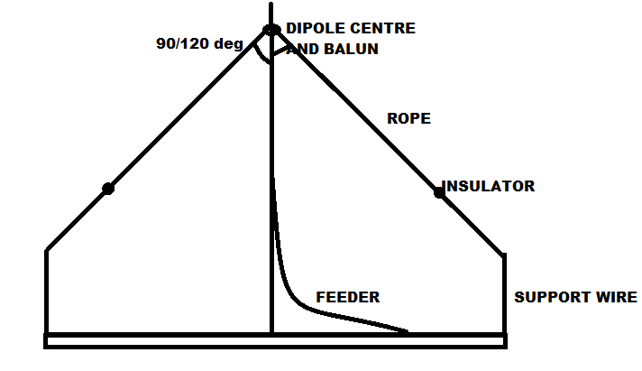
Fig.14 Inverted V antenna design for THz communication.
There are many more microstrip based inverted antennas like Inverted K, Inverted U, Inverted E, and so on as given below. These modified antennas are used to improve the antenna properties like gain, Bandwidth, low losses, high directivity and so on. Hence these antennas can also be implemented for THz frequency ranges after testing and further modifications can be made to match the required parameters. Based on Band (X-band, Ku-band, S-Band) there are many existing inverted antennas in which we can do slight modification like tilting angle, changing dimensions supporting THz, changing Si substrate to metamaterials, reducing size and so on to invent new inverted THz antennas.
7 ON-CHIP ANTENNAS:
On-chip antennas are used for millimetre(mm) wave and THz transceivers. On chip antennas are used for their low cost, easy to fabricate, large arrays in small areas and low size. From the beginning of this chapter, we focused on miniaturized antenna for THz applications and perfect solution for it is on chip antenna which can be integrated into IC chip. Arrays are having major scope for THz and even high range of communications which can be easily achieved with the help of on chip antennas. Large arrays can be made under very small areas since they are stacked on on-chip board which reduces area of array around 70-80% of normal arrays [11].
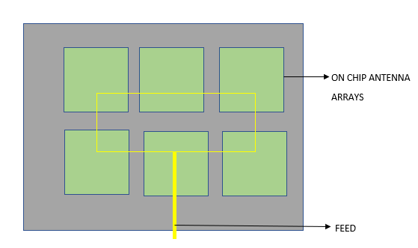
Fig.15 On-chip antenna arrays
We use anti reflection lens and offset reflectors to reduce loss and to achieve high gain, directivity, suppressing side lobes but the drawback was its size which can be replaced by on-chip antennas without degrading its performance. When we use horn or microstrip antenna it makes transmission feeding line losses which can be eradicated using on chip antennas. System on chip (SOC) antenna is most preferred antenna which are made by CMOS technology and SiGe. SOC antennas are very compact and small which are best suited for THz applications on aircraft, space, biomedical which are size concern. Hence a major transformation took place from system on board (SOB) to system on chip (SOC) where all discrete components are placed on a single chip. The chip size ranges from few mm² to 100 mm². Using SOC antennas we can reduce the size around 100-1000x, weight of 10-100x, power of 10-100x and 10x cost compared to normal antenna. We can also increase effective isotropic r*adiated power (EIRP) and radiated power effectively.
One method commonly used in SOC is silicon substrate CMOS process because of abundance nature and low-cost property of silicon. But it is not much efficient in THz antenna due to its bulk nature. Hence, we can use two to multi-layer stacking in which top is metal layer, next is dielectric, bottom is substrate. We place on chip antenna at top layer because it is best for mm & THz antenna since it supresses all losses and skin effect. Passivation layer is added at topmost for protection purpose.

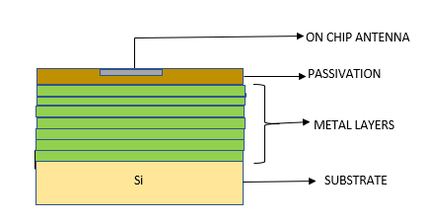
Fig. 16. Stacking layers of On-chip antenna

8 ANTENNA ARRAYS
Antenna arrays are used for increasing the antenna performance like gain, directivity, supressing side lobes and covering long distance. It is also used for beam forming which is most required thing in THz communication. The concept of array is simple that instead of single antenna we are using multiple antennas of same type with single feed point to achieve high gain, high directivity, low losses, low power wastage, low side lobes and high signal strength to travel long distance. A simple array is shown in fig.15 where multiple antenna element is fed on a single point. Phased arrays give better results because of supressed side lobes and losses.
When coming to high frequencies like THz normal arrays like horn and reflector lens arrays cannot be used because of the following reasons.
- Large area required for installation
- Increased size when frequency increases
- More expensive due to size
- Maintenance becomes a difficult job
Arrays in Rf region is different from THz region because they suffer strong losses in phase array due to semiconductor materials used in THz antennas. One best method to avoid this is we have to perform phase shift before frequency shift. Microwave and mm wave arrays can also be used for THz range. Metamaterial and new metals play major role in antenna arrays which is an emerging technology in THz arrays. perovskite material is one such promising metamaterial which gives best performance in arrays. perovskite material is one which has crystal structure of perovskite metal made of calcium titanium oxide (CaTiO3) [12]. The performance can be further improved when perovskite material is merged with gold metal as conducting surface and a substrate like polyethylene naphthalate (PEN) substrate which is of low cost. This is a promising array structure for THz.
In on chip array the array can be of homogeneous or heterogeneous array. Homogeneous arrays are mainly used for beam steering and narrow beamwidth application. This is because they are made of same material antenna in homogeneous array and will perform in a same manner with high radiated power and in same direction. Hence these can be used in high directivity and high-power application. But in heterogeneous array they are of different materials or mixed material and form broadside array properties. These can find application requiring high parallel EM sensing and energy efficient applications.
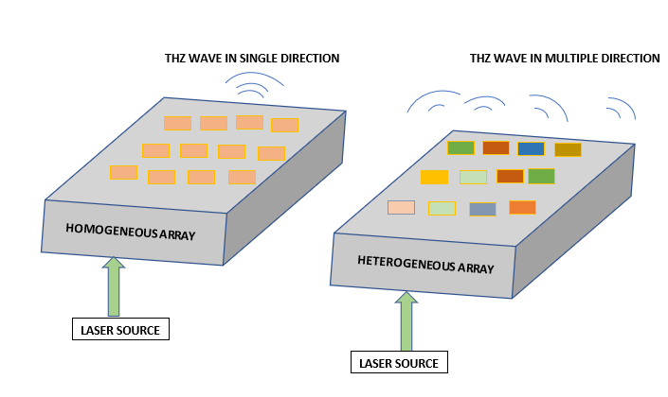
Fig. 17. On-Chip homogeneous and heterogeneous Array antenna
In the above figure the structure of homogeneous and heterogeneous array is given clearly. Homogeneous arrays are made of same antenna materials and fed by THz source which produces THz wave in unidirectional whereas heterogenous consists of antenna made of different materials which produces parallel beam of THz wave in multiple direction [7].
9 PROPOSEDTHZ ANTENNA DESIGN USING FRACTAL NOTCH
The given method is proposed based on hybrid of microstrip and fractal antenna and have been made with different fractal shapes.
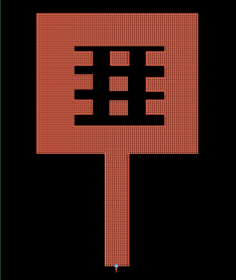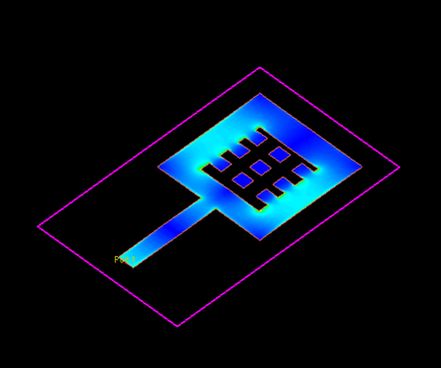
Fig. 18. Proposed Design of Fractal notched microstrip for THz antenna

At first diamond shape fractal was made and the gain was not sufficient and then tree shape fractal with 5iteration were made and it could not get sufficient return loss. Finally, an microstrip antenna with radiating fractal shape was made with 5iteration and promising results were obtained on 6th iteration which is given below. It was simulated in HFSS and CST studio. In CST studio gain of 4dB was obtained at 11.7THz and return loss of 33.4dB was obtained at same frequency and coming to HFSS gain of 3.9dB was obtained at 11.7THz and return loss of 34dB was obtained.
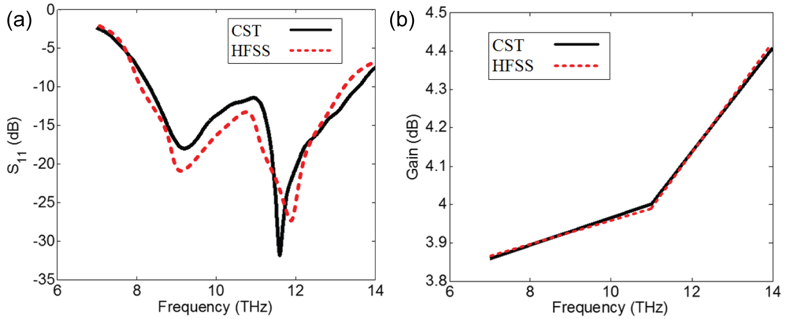
Fig. 19. Results showing Gain and S₁₁ (dB) in CST and HFSS

Table 1. Dimensions of proposed Methods
Patch
Width w | 14.8 mm
Length l | 10 mm
98 Ωfeedline (λ/4 transformer)
Width w | 0.214085 mm
Length l | 5.690830 mm
Horizontal slot | Length:6.8mm  Width:0.8mm
Vertical slots | Length:6.8mm  Width:1.8mm

The dimensions used for proposed method is given in Table1 in which the slot lengths are equal and these types of antennas can be used for THz applications.

9 CONCLUSION
In this chapter a whole new concept of THz antenna trends was discussed and there are still many findings in this field yet to glow. The major findings in this chapter are
- The antenna must be of very small or miniature to support the THz application
- THz antenna should be free from cross polarization
- THz Antenna should have radiation pattern with low or no sidelobes
- Use substrate and materials suitable for high frequency range and to avoid losses
- Free from amplitude and phase dispersion

Though there are these much limitations and advantages on THz antenna there are some disadvantages and one such is transmission range. They can transmit at rapid speed but can cover only around 10meteres which is much less than GSM and LTE. For this we have to place repeaters or antenna boosters with some distance to overcome this drawback. Another finding in THz antenna is they require special substrate material and source for generation of THz waves. New material and meta materials like photonic crystals are used because they act as bandpass filter passing THz frequency range. Photo mixers and photonic lasers are mainly used as source for THz antennas. Application of THz is also becoming more popular in medical imaging, surveillance and defence sector because of their unique wave properties with added advantage of simple structure and low-cost THz antennas.

Table 2. Comparison of Various THz antenna parameters

Antenna type | Dipole Antenna | Microstrip  Antenna | Horn Antenna | Vivaldi  Antenna | Reflector Antenna | On Chip  Antenna
Complexity | Low | Low | High | Low | High | Medium
cost | Low | Based on Material | High due to increased size | Low | High for THz | Low
Size | Smallest | Small | Large for THz range | Medium | Large | Very small

REFERENCES
- H. Elayan, O. Amin, B. Shihada, R. M. Shubair, and M. Alouini, “Terahertz band: The last piece of RF spectrum puzzle for communication systems,” IEEE Open J. of the Commun. Soc., vol. 1, pp. 1–32, 2020
- I. F. Akyildiz, J. M. Jornet, and C. Han, “Terahertz band: next frontier for wireless communications,” Physical Communication, vol. 12, pp. 16–32, 2014.
- W. Choe and J. Jeong, “Broadband THz CMOS on-chip antenna using stacked resonators,” in 2017 IEEE International Symposium on Radio-Frequency Integration Technology (RFIT), pp. 208–210, Seoul, South Korea, 2017.
- R. Gonzalo, Peter de Maagt, and M. Sorolla, “Enhanced patch antenna performance by suppressing surface waves using photonic band gap substrates,” IEEE Transactions on Microwave Theory and Techniques, vol. 47, no. 11, Nov. 1999.
- T. S. Bird and C. Granet, “Profiled horns and feeds” in L. Shafai et al., “Handbook of Reflector Antennas and Feed Systems: Volume 2 - Feed Systems,” Artech House, 2013.
- A. Love, Electromagnetic horn antennas, IEEE Press, 1976.

- P. Clarricoats and A. Olver, Corrugated Horns for Microwave Antennas. P. Peregrinus, 1984.

- J. F. Johansson and N. D. Whyborn, “The diagonal horn as a sub-millimeter wave antenna,” IEEE Trans. Microw. Theory Tech., vol. 40, no. 5, pp. 795–800, May 1992.

- Fei, P., Y. C. Jiao, W. Hu, and F. S. Zhang, "A miniaturized antipodal Vivaldi antenna with improved radiation characteristics," IEEE Antennas and Wireless Propagat. Lett., Vol. 10, 127-130, 2011.

- A. Neto, “UWB, Non Dispersive Radiation From the Planarly Fed Leaky Lens Antenna— Part 1: Theory and Design,” IEEE Trans. Antennas Propag., vol. 58, no. 7, pp. 2238-2247, Jul. 2010.

- Y. P. Zhang and D. Liu, "Antenna-on-Chip and Antenna-in-Package Solutions to Highly Integrated Millimeter-Wave Devices for Wireless Communications," IEEE Transactions on Antennas and Propagation, vol. 57, no. 10, pp. 2830-2841, 2009, doi:10.1109/TAP.2009.2029295.

- H. Chu, Y. Guo, T. Lim, Y. M. Khoo, and X. Shi, "135-GHz Micromachined On-Chip Antenna and Antenna Array," IEEE Transactions on Antennas and Propagation, vol.60, no. 10, pp. 4582-4588, 2012, doi:10.1109/TAP.2012.2209855.

- Gianvittorio, J.P.; Rahmat-Samii, Y. Fractal antennas: A novel antenna miniaturization technique, and applications. IEEE Antennas Propag. Mag. 2002, 44, 20–36.
- Anguera, J.; Puente, C.; Borja, C.; Soler, J. Fractal-Shaped Antennas: A Review. Encyclopedia of RF and Microwave Engineering; Chang, K., Ed.; Wiley: Chichester, NY, USA, 2005; Volume 2, pp. 1620–1635.
- Werner, D.H.; Ganguly, S. An overview of fractal antenna engineering research. IEEE Antennas Propag. Mag. 2003, 45, 38–57.
- Minervino, D.R.; D’Assunçâo, A.G.; Peixeiro, C. Mandelbrot Fractal Microstrip Antennas. Microw. Opt. Technol. Lett. 2016, 58, 83–86.
- Silva Neto, V.P.; D’Assunção, A.G. Iterative full-wave analysis of Mandelbrot-inspired fractal patch antenna on textile substrate for UWB applications. Int. J. Antennas Propag. 2017, 2017.

