AI Chatbots for Depression Assistance: A Review of Mobile Mental Health Apps

1*Harsh Pratap Singh, 2Mradul Kumrawat, 3Nandini Laddha, 4Nihar Kushwah

1,2,3,4Medicaps University

Indore (M.P), India

1[drharshprataps@gmail.com](mailto:drharshprataps@gmail.com)

2[mradulkumrawat2000@gmail.com](mailto:mradulkumrawat2000@gmail.com)

3nandiniladdha1@gmail.com

4niharkushwah@gmail.com

***Abstract* — This abstract presents a proposed system for a mental health android app aimed at improving mental health outcomes and promoting well-being. The app uses a client-server architecture with various modules, offering personalized treatment plans and self-care strategies based on evidence-based practices. It also includes features such as tracking and monitoring of mood, stress, and sleep patterns, peer support, and the option to connect with healthcare providers. The success of the app will depend on user engagement, adoption, and privacy and data security. This paper demonstrates the potential of mobile health android apps to support mental health and well-being, offering a promising solution for improving access to mental health services and empowering individuals to take control of their own health.**

***Index Terms*—Mental Health, AI techniques, ML algorithms, Mobile Applications.**

1. INTRODUCTION

A mental health Android app is a software application designed to provide resources, tools, and support to individuals seeking to manage their mental health. The app can be downloaded onto a smartphone or tablet, making it easily accessible to users. The purpose of the app is to offer users a convenient and discreet way to address their mental health concerns.

The app may include features such as a self-help resources, guided meditations, stress reduction techniques, relaxation exercises, and cognitive behavioral therapy (CBT) techniques. Additionally, some mental health apps may connect users with mental health professionals, allowing them to receive counseling or therapy sessions virtually.

The introduction of a mental health Android app can have several benefits, including increased accessibility to mental health resources, reduced stigma around seeking mental health support, and improved mental health outcomes for users. It can also provide a cost-effective alternative to traditional mental health services, making it more affordable and accessible to individuals who may not have access to in-person therapy or counseling.

Overall, a mental health Android app can be a valuable tool for individuals seeking to improve their mental health and well-being. By providing a range of resources and tools, it can help users manage their mental health and achieve their mental health goals.

Our emotional, cerebral, and social well- being are all corridor of our internal health. It influences our studies, feelings, and actions. also, it influences how we respond to stress, interact with others, and make good opinions. Every period of life, from nonage and nonage to maturity, is vital for internal health.

Your internal health may increase if you concentrate more on the then and now. This encompasses your body, your studies and passions, as well as the terrain. This mindfulness is occasionally appertained to as" awareness." You may have further fun in life and learn further about yourself by rehearsing awareness.

When circumstances come exorbitantly stressful, demanding, and delicate to handle, your internal health may begin todeteriorate.However, the situation may worsen and lead to a serious condition similar as major depression or an anxiety attack, If you ignore the warning signals. still, the secret to achieving peak internal heartiness is comprehending your study patterns. It's important to put everything on hold and liberate yourself from the situation as soon as you start to see specific pointers of stress developing and reflecting in the way you're acting.

The following are warning signals of poor mental health that you should watch out for:

1. YOU FIND IT DIFFICULT TO REMAIN PRESENT

Your thoughts wander, and you long to be somewhere else. You can experience a sense of urgency and move quickly from one task to the next. Additionally, you observe yourself doing pointless things.

2. YOU REFUSE COMMUNITY EVENTS

If your mental health is poor, you could withdraw more frequently than usual. You can set up barriers in your interactions with loved ones and exhibit apathy in them.

3. YOU SABOTAGE YOURSELF

You progressively put yourself in unhealthy circumstances and seek out improper partnerships. You start rationalising your actions and find it difficult to express your thoughts.

1. ALGORITHM
2. *Supervised Learning*

ChatGPT is trained using a massive amount of text data, and the process involves supervised learning techniques. The model learns to predict the next word in a sequence based on the input text and the target output.

Supervised learning is the types of machines learning in which machines are trained using well "labelled" training data, and on basis of that data, machines predict the output. The labelled data means some input data is already tagged with the correct output. In supervised learning, the training data provided to the machines work as the supervisor that teaches the machines to predict the output correctly. It applies the same concept as a student learns in the supervision of the teacher.

Supervised learning is a process of providing input data as well as correct output data to the machine learning model. The aim of a supervised learning algorithm is to find a mapping function to map the input variable(x) with the output variable(y).

In the real-world, supervised learning can be used for Risk Assessment, Image classification, Fraud Detection, spam filtering, etc.

*How Supervised Learning Works?*

In supervised learning, models are trained using labelled dataset, where the model learns about each type of data.

Once the training process is completed, the model is tested on the basis of test data (a subset of the training set), and then it predicts the output.

The working of Supervised learning can be easily understood by the below example and diagram:

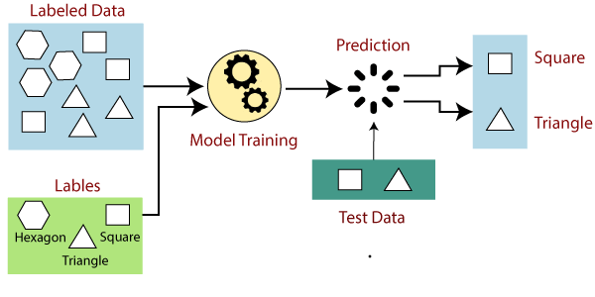

Figure 1. Supervised learning

Suppose we have a dataset of different types of shapes which includes square, rectangle, triangle, and Polygon. Now the first step is that we need to train the model for each shape.

* + If the given shape has four sides, and all the sides are equal, then it will be labelled as a Square.
  + If the given shape has three sides, then it will be labelled as a triangle.
  + If the given shape has six equal sides then it will be labelled as hexagon.
  + Now, after training, we test our model using the test set, and the task of the model is to identify the shape.

The machine is already trained on all types of shapes, and when it finds a new shape, it classifies the shape on the bases of a number of sides, and predicts the output.

1. *Backpropagation*

Backpropagation is a key algorithm used in training deep neural networks like ChatGPT. It involves calculating the error in the model's output and propagating it back through the layers of the network to adjust the model's parameters.

Backpropagation is one of the important concepts of a neural network. Our task is to classify our data best. For this, we have to update the weights of parameter and bias, but how can we do that in a deep neural network? In the linear regression model, we use gradient descent to optimize the parameter. Similarly, here we also use gradient descent algorithm using Backpropagation.

For a single training example, Backpropagation algorithm calculates the gradient of the error function. Backpropagation can be written as a function of the neural network. Backpropagation algorithms are a set of methods used to efficiently train artificial neural networks following a gradient descent approach which exploits the chain rule.

The main features of Backpropagation are the iterative, recursive and efficient method through which it calculates the updated weight to improve the network until it is not able to perform the task for which it is being trained. Derivatives of the activation function to be known at network design time is required to Backpropagation.

Now, how error function is used in Backpropagation and how Backpropagation works? Let start with an example and do it mathematically to understand how exactly updates the weight using Backpropagation.

1. *Gradient Descent*

Gradient descent is an optimization algorithm used to find the optimal set of parameters for a machine learning model. It is used to update the parameters of the neural network during training.

The Gradient Descent is an optimization algorithm which is used to minimize the cost function for many machine learning algorithms. Gradient Descent algorithm is used for updating the parameters of the learning models.

Following are the different types of Gradient Descent:

**Batch Gradient Descent:** The Batch Gradient Descent is the type of Gradient Algorithm that is used for processing all the training datasets for each iteration of the gradient descent. Suppose the number of the training dataset is large, the batch gradient descent will be comparatively expensive. Hence, if the number of the training dataset is large, the users are not advised to use batch gradient descent. Instead, they can use mini-batch gradient descent for a large training dataset.

**Mini-Batch Gradient Descent:** The mini-batch gradient descent is the type of gradient descent that is used for working faster than the other two types of gradient descent. Suppose the user has 'p' (where 'p' is batch gradient descent) dataset where p < m (where 'm' is mini-batch gradient descent) will be processed per iteration. So, even if the number of 'p' training dataset is large, the mini-batch gradient descent will process it in batches of 'p' training datasets in a single attempt. Therefore, it can work for large training datasets with fewer numbers of iterations.

**Stochastic Gradient Descent:** Stochastic gradient descent is the type of gradient descent which can process one training dataset per iteration. Therefore, the parameters will be updated after each iteration, in which only one dataset has been processed. This type of gradient descent is faster than the Batch Gradient Descent. But, if the number of training datasets is large then also, it will process only one dataset at a time. Therefore, the number of iterations will be large.

1. *Fine-tuning:*

Fine-tuning is a technique in which a pre-trained model is further trained on a specific task. ChatGPT is pre-trained on a large corpus of text data and fine-tuned on a specific chatbot task to improve its performance.

Fine tuning is a process of adjusting the neural network

weights to better fit the training data. This can be done by

increasing or decreasing the learning rate, or by changing the network architecture. Fine tuning is often used to improve the performance of a neural network on a specific task or dataset.

There are many benefits to fine tuning your deep learning models. For one, it can help you achieve more accurate results.

Additionally, it can help you better understand how your model works and identify potential improvements. Finally, fine tuning can also help you build more robust models that are less likely to overfit on your data.

Much like a photographer needs the right lens, lighting, and

settings to take a great picture, you need to configure your

deep learning model correctly to get the best results.

Configuration includes things like choosing the right data, pre-processing steps, hyper-parameter values, and more. If any of these things are off, your results will be less than optimal.

This process of finding the right configuration settings for your model is known as fine tuning. In this article, we’ll discuss what you need to know in order to fine tune your deep learning models. By the end, you’ll be able to improve your model’s performance by making sure it’s configured correctly. Deep learning models are powerful tools for data analysis, but they can be complex and difficult to work with. If you’re not careful, you can easily introduce errors into your models that can decrease their accuracy.

III. PROPOSED SYSTEM

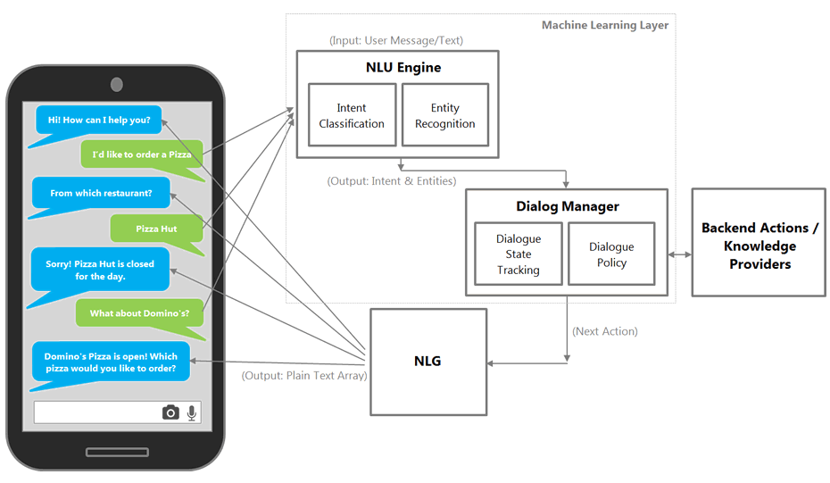Figure 2. Machine Learning Layer

The proposed system is a mental health Android app that aims to improve the mental health and well-being of its users. The app will provide users with a range of features and resources that are designed to support mental health, including self-care strategies, coping tools, mental health assessments, and resources and referrals to mental health professionals.

**User Interface and Experience Design**

The app's user interface and experience design will prioritize user privacy, ease of use, and accessibility. The design will be intuitive, visually appealing, and provide clear navigation to enable users to quickly access the app's features and resources. Users will be able to create personalized profiles and access their mental health data, as well as connect with mental health professionals and other users for support and community.

**Mental Health Assessment Tools**

The app will include standardized mental health assessment tools that enable users to self-assess their mental health and identify areas of concern. These tools will include questionnaires and symptom checklists for common mental health conditions, as well as mood tracking features that enable users to monitor their mental health over time.

**Self-Care and Coping Strategies**

The app will provide users with evidence-based self-care and coping strategies that they can use to manage their mental health. These strategies will include meditation exercises, breathing techniques, CBT tools, and other evidence-based strategies that have been shown to improve mental health outcomes. The app will also provide personalized recommendations based on user data and preferences.

**Resources and Referrals**

The app will provide users with information about mental health resources and referrals to mental health professionals, such as therapists, counselors, and psychiatrists. The app will also provide users with information about community resources, such as support groups, crisis hotlines, and other mental health services.

**Data Analytics and Personalization**

The app will incorporate data analytics and personalization features that enable it to adapt to the individual needs and preferences of its users. The app will use user data to provide personalized recommendations for self-care strategies, resources, and mental health professionals. The app will also use data analytics to monitor user engagement and identify trends in mental health and well-being.

**Technical Aspects**

The app will be developed using a secure coding framework that prioritizes user privacy and data protection. The app will be compatible with a range of Android devices and operating systems, and will use cloud-based storage to ensure that user data is accessible and secure. The app will also comply with relevant data protection regulations and best practices.

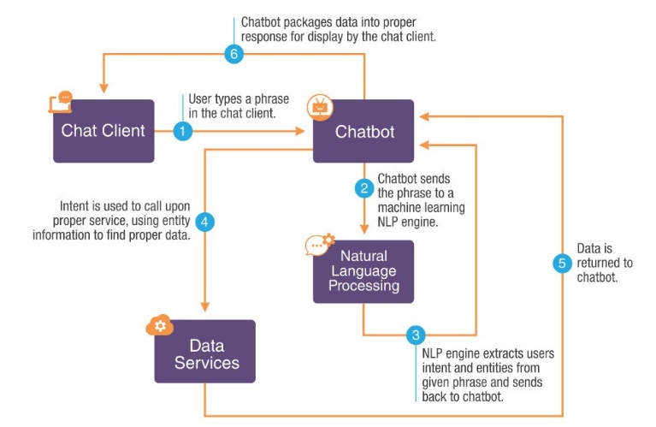

Figure 3. Data Flow Digram

**Security and Data Protection**

The app is developed using a secure coding framework that prioritizes user privacy and data protection. The app incorporates encryption and other security measures to ensure that sensitive user data is protected. The app also enables users to control their data, allowing them to delete or export their data as needed.

IV. WORKING

The working of a mental health Android app involves several components and features that are designed to support the mental health needs of users.

**User Interface Layer**

The user interface layer is the visual interface that users interact with when using the app. It includes screens for logging in, setting up a user account, accessing mental health assessment tools, and accessing self-care resources. The user interface layer is designed to be user-friendly and intuitive, enabling users to easily navigate and access the features they need.

**Business Logic Layer**

The business logic layer is responsible for the core functionality of the app. It includes features for mental health assessment, data analytics, and personalized recommendations. The mental health assessment tools are used to identify areas of concern and provide personalized recommendations for self-care strategies. The data analytics component enables the app to analyze user data and provide personalized recommendations based on that data.

**Backend Layer**

The backend layer is responsible for the storage and processing of user data. It includes a database for storing user profiles, mental health assessment data, and self-care recommendations. The backend layer also includes APIs for accessing mental health resources and referrals to mental health professionals.

The backend layer is designed to be secure and scalable, enabling the app to handle large volumes of user data and requests.

**Data Analytics Layer**

The data analytics layer is responsible for analyzing user data to generate personalized recommendations for self-care strategies. It uses machine learning algorithms to analyze user data and identify patterns and trends that can be used to generate personalized recommendations. The data analytics layer is designed to be scalable and adaptable, enabling it to evolve and improve over time as more data is collected.

**Security Layer**

The security layer is responsible for ensuring the privacy and security of user data. It includes encryption and other security measures to protect sensitive user data from unauthorized access. The security layer is designed to be robust and adaptable, enabling it to evolve and improve over time as new security threats emerge.

**Support Layer**

The support layer is responsible for providing user support and feedback. It includes features for user feedback and support, enabling users to provide feedback and connect with support if they have any questions or concerns. The support layer is designed to be responsive and adaptable, enabling it to provide timely and effective support to users.

Overall, the working architecture of a mental health app is designed to provide a comprehensive and effective mental health support system that is personalized to the individual needs and preferences of each user. By incorporating evidence-based strategies, personalized recommendations, and secure data protection measures, the app can effectively support the mental health needs of its users and improve their well-being.

V. DISCUSSION

Mental health apps have emerged as a promising tool for supporting mental health and well-being. These apps offer a range of features and resources that can help users manage their mental health and improve their quality of life. In this discussion, we will explore the benefits and limitations of mental health apps, as well as the potential for future development and innovation in this field.

**Benefits of Mental Health Apps:**

*Accessibility*: Mental health apps are easily accessible to anyone with a smartphone or tablet, making them a convenient and affordable option for people who may not have access to traditional mental health services.

*Personalization*: Mental health apps can be personalized to the individual needs and preferences of each user, providing a customized experience that can be tailored to their unique mental health challenges and goals.

*Evidence-based strategies*: Many mental health apps incorporate evidence-based strategies for improving mental health, such as cognitive-behavioral therapy, mindfulness meditation, and stress reduction techniques.

*Tracking and monitoring*: Mental health apps can help users track and monitor their mental health over time, providing valuable insights into their progress and identifying areas of concern that may require additional support.

*Peer support*: Many mental health apps offer peer support features, such as online forums and chat groups, which can provide a sense of community and connection for people who may be struggling with mental health issues.

**Limitations of the Mental Health Apps:**

*Lack of personal interaction*: While mental health apps can provide valuable resources and support, they cannot replace the personal interaction and connection that comes with traditional mental health services.

*Privacy concerns*: Mental health apps collect sensitive personal data, raising concerns about privacy and data security. It is important for developers to prioritize data protection and encryption to ensure that user data is secure and confidential.

*Limited efficacy*: While many mental health apps incorporate evidence-based strategies, there is limited research on the efficacy of these apps in improving mental health outcomes.

*User engagement*: One of the biggest challenges facing mental health apps is user engagement. Many users download the app but may not use it regularly, limiting the effectiveness of the app in improving mental health outcomes.

|  |  |  |  |
| --- | --- | --- | --- |
| Paper Name | Authors | Disadvantage | Overcome |
| **Mental Health: Detection & Diagnosis** | G. Parimala; R. Kayalvizhi; S. Nithiya  31 March 2022 | Execution process time for query is slow. | Faster Execution process time for query. |
| **Mobile Mental Health Apps** | Shalini Saini; Dhiral Panjwani; Nitesh Saxena  18 August 2022 | Local Data Storage | Cloud Data Storage |
| **Mental Health Monitoring System using AI** | Vidhi Mody; Vrushti Mody  12 March 2020 | Small Data Set & low Query responding | Large Data Set & high-Speed Response Time |

Table 1. (Comparision)

**Future Development and Innovation:**

Despite the limitations of mental health apps, there is great potential for future development and innovation in this field. Here are some areas where mental health apps could be further developed and improved:

*Integration with traditional mental health services:* Mental health apps could be integrated with traditional mental health services, providing a seamless and comprehensive support system for people struggling with mental health issues.

*Artificial Intelligence (AI) and Machine Learning (ML)*: AI and ML can be used to analyze user data and provide personalized recommendations for self-care strategies.

*Virtual Reality (VR) and Augmented Reality (AR)*: VR and AR can be used to create immersive experiences that help users manage stress and anxiety in real-time.

*Gamification*: Gamification can be used to increase user engagement and motivation, making mental health apps more effective in improving mental health outcomes.

VI. CONCLUSION

In conclusion, mobile health android apps have the potential to transform healthcare by offering convenient, accessible, and personalized health management solutions. This paper has presented a detailed overview of the proposed system for a mental health android app, highlighting the features and functionalities that can support users in managing their mental health and improving their overall well-being.

The proposed system uses a client-server architecture with various modules, such as the user module, doctor module, chat module, and tracking module. The app offers personalized treatment plans and self-care strategies based on evidence-based practices, along with features such as tracking and monitoring of mood, stress, and sleep patterns. The app also offers peer support and resources, as well as the option to connect with healthcare providers for further support.

However, like any mobile health app, the success of this app will rely on user engagement, adoption, and privacy and data security. Future research can further evaluate the efficacy of mental health android apps in improving mental health outcomes and explore ways to increase user engagement and adoption.

Overall, this paper demonstrates the potential for mobile health android apps to support mental health and well-being, offering a promising solution for improving access to mental health services and empowering individuals to take control of their own health.

VII. REFERENCES

[1] World Health Organization: http://www.who.int/whr/2001/media_centre /press_release/en/,06/10/2022

[2] Very Well Mind, https://www.verywellmind.com/using- artificial/intelligence-for-mental-health-4144239, 02/10/2021

[3] Analytics Vidhya, https://www.analyticsvidhya.com/blog/2017/09/understaing- support/vector-machine-example-code/, 5/10/2022

[4] NDSU Repository, https://library.ndsu.edu/ir/handle/10365/23048, 8/10/2018

[5] Tutorials Point, https://www.tutorialspoint.com/ artificial_intelligence/

artificial_intelligence_expert_systems.htm, 13/10/2020.

[6] J. jin Zhang et al., “Clinical characteristics of 140 patients infected with SARS-CoV-2 in Wuhan, China,” Allergy Eur. J. Allergy Clin. Immunol., vol. 75, no. 7, pp. 1730–1741, 2020.

[7] I. I. Haider, F. Tiwana, and S. M. Tahir, “Impact of the COVID-19 pandemic on adult mental health,” Pakistan J. Med. Sci., vol. 36, no. COVID19-S4, pp. S90–S94, 2020.

[8] J. Shigemura, R. J. Ursano, J. C. Morganstein, M. Kurosawa, and D. M. Benedek, “Public responses to the novel 2019 coronavirus (2019-nCoV) in Japan: Mental health consequences and target populations,” Psychiatry Clin. Neurosci., vol. 74, no. 4, pp. 281–282, 2020.

[9] C. S. Ho, C. Y. Chee, and R. C. Ho, “Mental Health Strategies to Combat the Psychological Impact of COVID-19 Beyond Paranoia and Panic,” Ann. Acad. Med. Singapore, vol. 49, no. 1, pp. 1–3, 2020.

[10] W. Kawohl and C. Nordt, “COVID-19, unemployment, and suicide,” The Lancet Psychiatry, vol. 7, no. 5, pp. 389–390, 2020.

[11] Dongkeon Lee, Kyu-Joong Oh, Ho-Jin Choi, “The Chatbot Feels You- A Counseling Service Using Emotional Response Generation”, Big Comp 2017

[12] Rozia Yati Masri, Hajar Mat Jani, “Employing Artificial Intelligence Techniques in Mental Health Diagnostic Expert System”,2012 International Conference on Computer & Information Science (ICCIS).

[13] Luciano Comin Nunes, Placido Rogerio Pinheiro, Tarcisio Cavalcante Pequeno, “An expert System Applied to the Diagnosis of Psychological Disorders”, published 2009 IEEE.

[14] David D Luxton, “Artificial Intelligence in Psychological Practice: Current and Future Applications and Implications”, American Psychological Association. Public Domain, DOI: 10.1037/a003