Tuward J. Dweh Word count: 11,513
Bidyanagar, Mahura, Janla
Bhubaneswar, Odisha, India -752054

RECOMBINANT DNA TECHNOLOGY

By: Tuward J. Dweh
Corresponding email ID: tjosephdweh23@gmail.com
Post Graduate Student, C.V. Raman Global University, Bhubaneswar, Odisha-752054

Abstract
Recombinant DNA technology joins genetic materials from different organisms through genetic engineering, enabling scientists to modify DNA, create transgenic organisms, and produce therapeutic proteins. It begins with the background, acknowledging the foundational discoveries of ligases, vectors, restriction enzymes, plasmids, and host organisms with techniques such as TALENs, mega-nucleases, zinc finger nucleases, and CRISPR-Cas9, which are acknowledged as influential tools in genetic engineering. Genetically modified organisms (GMOs) are utilised to improve crop traits such as increased yields, resistance to pests and herbicides, and tolerance to environmental stresses. The Flavr-Savr tomato is highlighted as one of the pioneering genetically engineered crops that demonstrated extended shelf life and resistance to spoilage through gene silencing. beyond agriculture and into biomedical applications, notably in the production of therapeutic proteins. Different hosts, including bacteria, yeast, insect cells, and plant cells, are employed to produce commercial products with improved qualities. The focus is on mammalian cell lines in the biopharmaceutical industry for creating high-quality proteins, such as monoclonal antibodies, used in therapies for various diseases and vaccine production. The insertion of specific antigens of pathogens into harmless vectors stimulates an immune response, leading to the production of neutralising antibodies against targeted pathogens, which offers a safe and effective means of disease prevention and control, particularly in veterinary medicine for diseases like bovine viral diarrhoea and respiratory syncytial virus. Two types of gene therapies are widely used in gene delivery: somatic and germline gene therapy. Engineered bacteria, fungi, and plants are employed to degrade pollutants in the environment, making waste treatment more effective and sustainable. The future prospects of recombinant DNA technology are promising, and the technology is involved in ongoing advancements in health, agriculture, and environmental management.
⁠
KEYWORDS: Genetic engineering, therapeutic proteins, Recombinant DNA, GMO, Gene, vectors, therapies, Agriculture, Health, Environmental management, CRISPR-ca9

AKNOWLEDGEMENT
I am deeply grateful for the unwavering guidance and encouragement provided by Dr. Jyoti Prakash Sahoo, whose mentorship was instrumental in shaping the success of this chapter.

CONFLICT OF INTEREST
The author herein declares no conflict of interest.

- Introduction
The word recombinant is the adjective of “recombination” which means to “to join together” while DNA is the shorten form for deoxyribonucleic acid which a molecule containing all genetic codes that make an organism, hence recombinant DNA is the joining of two or more genetic materials, from the same organism or different organisms (Figure 1). Let’s for a moment think of the body as a big machine with different parts coordinating different functions to allow the machine function properly. If a certain part gets extracted, if for instance, the blade of an excavator- the machine may move but will no long have the ability to clean the road, by this, one can understand the special function of the blade on the machine. Sometimes, if the blade gets damaged, it is replaced by a blade from another machine of the same kind or a different one. This is the same way recombinant DNA technology works. With the use of recombinant DNA technology, scientists are able to modify and mix DNA molecules from various sources. It is sometimes referred to as genetic engineering or gene splicing. In order to develop new genetic combinations, DNA fragments are cut and rejoined. By changing an organism’s gene, scientists can improve crop harvests, create useful medications, and investigate the genetic causes of illnesses. When an organism’s gene is altered or manipulated, it is termed as “transgenic organism. The development of genetically modified organisms (GMOs), the manufacturing of therapeutic proteins, and the investigation of gene control and function are all made possible by this technology. The power to alter DNA holds great potential for solving major world problems including food safety, healthcare, and sustainability in the environment.
In admiration of the great potential of the technology, scientists are also concerned about its potential threats to human and the environment from three main angles: the worry of off-target effects, the selectivity of edits (edits may take up some cells), and the editing of germline which could have impact on future generations. This insecurity became more tensed when the latest and most promising technique, CRISPR-cas9 technology, developed in 2012 was utilized by Dr. He Jiankui of China and his team to modify the germline of two infants in an effort to confer resistance to HIV infection. As a result, the biosecurity law on genome editing was proposed. The goal of this chapter is to provide readers a thorough grasp of recombinant DNA technology, including its historical development, methodologies, numerous uses, and related ethical and safety issues

Figure 1. A diagrammatic illustration of Recombinant DNA
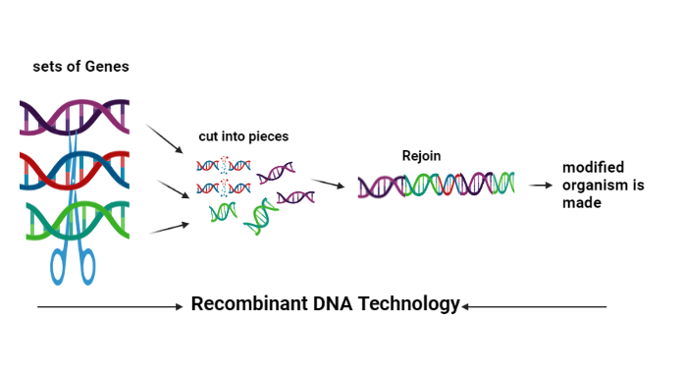

- Background of Recombinant DNA
Because DNA forms the basis of contemporary genetics, many scholars have cited James Watson and Francis Crick's discovery of the DNA molecule in the early 1950s as the inception of recombinant DNA technology. However, given that we are discussing Recombinant DNA, invents involving the development/discovery of ligases (molecular glues), vectors (molecular vehicles) restriction enzymes, plasmids and host organisms are key in discussing the rise of Recombinant DNA.
The first Recombinant DNA was created in the late 1960s and early 1970s through the collaborative efforts of Gelbert, Lehman, Richardson and Hurwitz laboratories. Subsequently, Werner Arber, in 1968 hypothesized the presence of restriction enzyme. This hypothesis was validated in an experiment involving the isolation two restriction enzymes from E. coli. The first site-specific type-II Restriction enzyme, known as Haemophillus influenzae (Hind II), was also successfully purified by Hamliton Smith and his colleagues in 1972 ("History of Genetic Engineering & the Rise of Genome Editing Tools"). During this same era, Stanley Cohen and Herbert N. Boyer jointly developed the first recombinant plasmid known as pSC101 in 1973. According to (“Science History Institute”, n.d), In a joint meeting between the United States and Japan on plasmids, both men presented their research. They discussed the characteristics of DNA ends produced by EcoRI cleavage and the steps involved in plasmid uptake by bacteria. This milestone in molecular biology was followed by the development of a technique called Southern Blotting named after sir Edwin M. Southern who invented it. It allows for the detection and analysis of specific sequence in a DNA sample (Ashwathi, n.d) The English scientist Frederick Sanger and his colleagues created the Sanger's sequencing method, often known as the "chain termination method," in 1977. This technique is used to identify the arrangement of nucleotide bases in a fragment of DNA that is typically smaller than 1,000 base pairs in length. Sanger sequencing is regarded as the "gold standard" for verifying DNA sequences since it has a 99.99% base accuracy rate (cdamin, 2020) (Figure 2)
Prior to the invention of method that can create multiple copies of DNA molecule, according to (Singh et al.,2014) in 1971 Kjell Kleppe, a researcher in Khorana’s laboratory, described the replication of a segment of DNA by a two-primer system. The method for DNA amplification known as Polymerase chain reaction “PCR” invented by Kary Mullis is the easiest, highly efficient and most promising technique use in laboratories DNA fragments of varying lengths. It uses a thermal cycler to manipulate DNA molecule and is based on the principle that DNA denatures at a certain temperature and anneal at a given temperature. Recombinant DNA has many applications including the creation of Genetically modified organisms (GMOs) and many techniques are discovered from this evolution. These techniques include: Transcription Activator-Like nucleases (TALEN), mega-nucleases, zinc fingers nucleases (ZFN) and Cluster regularly inter-spaced palindromic repeats (CRISPR) and its associated proteins, cas9 (Khali, 2020). Thoroughly explained in this chapter are fundamental ideas, methods, uses, importance in genetic engineering, and recent developments in recombinant DNA technology.

Figure 2. Brief history of DNA Technology
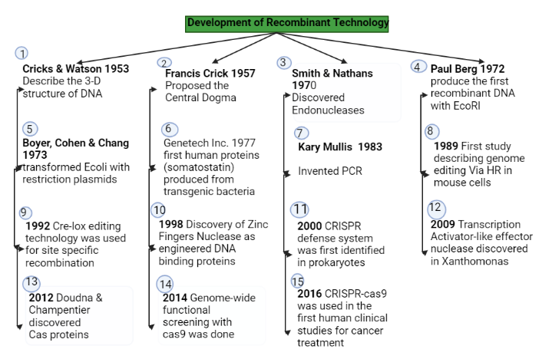

Figure 2: (Jytoti Prakash Sahoo & The University of Texas Southwestern Medical Center)
- Technical Resources used in recombination of DNA
Several techniques are used to enhance recombinant DNA technology. Restriction enzymes and ligases are common tools and techniques in these processes (Glick et al 2017, p-143).
  - Restriction Enzymes
In order to manipulate a DNA molecule, we need to cut, remove and insert. Cutting of the molecule is the function of enzymes known as Restriction enzymes. As the name suggests, a restriction enzyme is restricted to cut at a designated location on the molecule hence, the location is termed “Restriction site” since the discovery and isolation of the first restriction enzyme in 1972 many different restriction enzymes have been discovered with each having its own restriction site.
All restriction enzymes carries unique nucleotide sequences which are the primary composition of DNA molecule subunits i.e. Adenine(A), Guanine(G), Cytosine(C) and Thymine(T) and each is made of four or six base pairs that are arranged in such a way that when read back and forth it produces the same sequences. This type is arrangement is referred to as palindromic (Figure 3). That restriction enzymes are isolated from bacteria and it is evidenced that they exist in the bacteria genome as adaptive immunity. Restriction enzymes are extracted from bacteria genomes and use in laboratories to manipulate a DNA fragment.
The names of restriction enzymes are written based on their background. For instance; EcoRI is the name of restriction enzyme derived from Escherichia coli bacteria, where “E” indicates the genus name, “co” indicates the species name, “R” represents the specific strain of the bacteria and “I” denotes the order of discovery. Both genus and species names are indicated in Italics.
Figure 3. Palindromic sequences and Nomenclature of Restriction and Enzymes
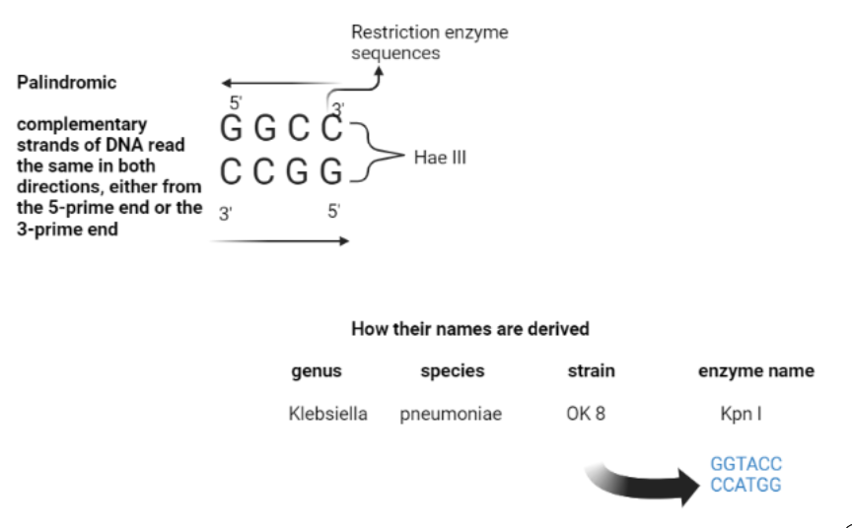
Figure 3: Palindromic sequences and Nomenclature of Restriction and Enzymes

  - Understanding Restriction Enzymes' Actions
Only one or a few restriction sites are recognized by each restriction enzyme. A restriction enzyme will create a double-stranded cut in the DNA molecule once it locates its target sequence. The cut often occurs in a neat, regular pattern at or near the restriction point. (Khan Academy, 2023). As stated by Britannica (2023b), In a process known as hydrolysis, a restriction endonuclease that recognizes a sequence cut through the DNA molecule by breaking a chemical connection by adding a water molecule to the bond between adjacent nucleotides. Bacteria disguise their recognition sequences to stop this kind of DNA degradation from happening to their own DNA. In the recognition sequence, methylases add methyl groups (—CH3) to adenine or cytosine bases as a way of shielding the restricted region from endonucleases. The restriction-modification system of a bacterial species is made up of the restriction enzyme and its related methylase.
  - Pattern of Cleavage
Endonucleases or restriction enzymes cut DNA in a staggered manner to form "sticky ends" or cohesive ends. They can also produce "Flush ends," also known as blunt ends or non-coherent ends. Sticky ends are produced when a restriction enzyme splits the two DNA strands at various points, often two or four nucleotides apart, leaving short single-stranded overhangs at each end of the DNA fragments. These are known as sticky or cohesive ends(Figure 4) because when base pairing between them is revealed, it can reassemble the DNA molecule. Some sticky-end cutters (such as Bam HI) provide 5′ overhangs, whereas others only leave 3′ overhangs (such as PstI). Flush or blunt end is an end of a double stranded DNA molecule where both strands terminate at the same nucleotide position with no single-stranded extension (e.g. HpaI) (Brown TA, 2022.).

Figure 4. Sticky and blunt ends cleavage
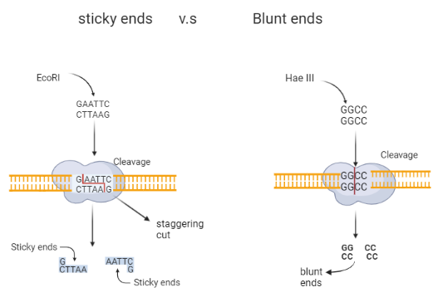
Figure 4. Sticky and blunt ends cleavage

  - Types of Restriction enzymes
The New England Biolab inc. (2023) asserted that on the basis of subunit composition, cleavage location, sequence specificity, and cofactor requirements, restriction enzymes are often divided into four kinds. Though there may be more from the perspective of molecular biologists. They are grouped into type I, II, III and IV traditionally
Type I enzymes are complex, multi-subunit, combination restriction-and-modification enzymes that cut DNA at random about 1000bp away from recognition site and possess methylase activities as well. These enzymes have the recognition sequences of about 15 bp length. They require Mg++ ions and ATP for their functioning. Such types of restriction endonucleases cleave the DNA about 1000 bp away from the 5′-end of the sequence TCA.
Type II enzymes cut DNA at specific spots near or inside their recognition sequences (Table 1). They are the most frequent category used in the lab for regular DNA examination and gene copying because they produce separate restriction pieces and recognizable gel striping designs. Type II enzymes are a collection of unrelated proteins of multiple different types, not a single group of connected proteins. (New England Biolab inc, 2023). Type III endonucleases are not employ by genome cloning does not. They are the intermediary restriction endonucleases between Type-I and Type-II enzymes. They cleave the DNA at certain locations near recognition sequences, and need Mg++ ions and ATP to do it.

Table 1. Mostly Used Type II Restriction Enzymes
Type |  | Description |  |  | Co factor(s)
Type I Restriction enzymes |  | - First to be identified  - Holds little relevance since they do not generate efficient fragmentation of DNA  - They are multifunctional and have 3 subunits (DNA recognition, DNA cleavage and an ATP-dependent translocation)  - Cleave up to 1000 bp away from recognition sequence |  |  | AdoMet, ATP & Mg²⁺ ions
Type II Restriction enzymes |  | - Cleavage occurs at both digestion & restriction sites  - Utilize Mg²⁺ as co factor  - Make blunt & sticky ends  - one subunit |  |  | Utilize Mg²⁺ as co factor
TypeIII Restriction enzymes |  | - Cleaves 25 bp away from recognition site  - They are multifunctional and have 2 subunits for modification, restriction digestion and methylation |  |  | Use AdoMet and ATP for restriction
No | Microorganism |  | Enzyme | Recognition sequences |  | Types of cuts
1. | Escherichia coli RY13 |  | EcoRI | GAATTC |  | Sticky ends
2. | Haemophilus influenzae Rd |  | Hin dIII | AAGCTT |  | Sticky ends
3. | Klepsiella pneumonae OK 8 |  | KpnI | GGTACC |  | Sticky ends
4. | Bacillus amyloliqueaciens |  | BamHI | GGATCC |  | Sticky ends
5. | Escherichia coli Restriction enzyme V |  | EcoRV | GATATC |  | Blunt ends
6. | Serratia marcescens I |  | Smal | CCCGGG |  | Blunt ends
7. | Providencia stuartii |  | PstI | CTGCAG |  | Sticky ends
8. | Nocardia otitidis |  | NotI | GCGGCCGC |  | Sticky ends
9. | Streptomyces achromogenes I |  | SacI | GAGCT |  | Sticky ends

- Chemical Glue
Ligase joins broken pieces of DNA covalently through the catalysis of phospohdiester bond formation between nucleotides that make up the DNA molecule in an energy driven manner. It is otherwise referred to as molecular glue due to its similarity in function as a “glue”. To repair DNA molecule, a bond is formed by ligase between the sugar-phosphate backbones. The functions of ligase include repair, replication and joining of DNA.
Isolation of ligase is done in-vitro to create recombinant DNA (Sharma, 2022). According to Bajpai (2023), since the discovery of ligase from Ecoli in 1967 independently by the Gellert, Lehman, Richardson, and Hurwitz Institute, DNA ligase has become an important tool in molecular biology and hence, several others were discovered the years after from different organisms. With DNA ligase, only identical DNA segments with complimentary ends may be linked. Okazaki fragments are linked together naturally throughout the replication process by a process called ligation.
  - The Building Block and Working Process of DNA Ligase
Having the knowledge of the basic mechanisms of ligase gives insights into its role in recombinant DNA technology and application in genetic engineering. Ligase enzyme seals the nicks on duplex DNA through the catalysis of phosphodiester bond between 5’ to 3’ hydroxyl terminal. It is a cofactor in DNA repair pathways and functions in base excision repair, nucleotide excision repair, double stranded break and joining of Okazaki’s fragments found on the lagging strand. Ligase interact with nucleotide cofactor to form a covalent enzyme nucleoside monophosphate through ATP or NAD⁺ . The full mechanisms can be found in a review by (Allan et al. 2006) where they explained four major phases and are summarize as thus; 1. Adenylation of DNA ligase 2. DNA binding and acetylation transfer 3. Phosphodiester bond formation and 4. AMP release and DNA ligation.
Firstly, during the initiation, a phosphoamide bond (P-N) is formed between an active site lysine and 5’ phosphate of AMP of DNA and RNA ligases, or GMP of mRNA capping enzymes. In phase 1, nicotamide mononucleotide (NMN) is produced by NAD+ while inorganic pyrophosphate is generated by the catalysis of nucleotide-triphosphate. A pyrophosphate linkage is created at one end of the process when the 5' phosphate group of nicotamide mononucleotide phosphate is transferred from an active site lysine to a phosphorylated DNA 5' end. Phase 2 of the process is completed when the 5'AMP activates the DNA substrate's 5' phosphate, resulting in the creation of phosphodiester bonds. Phase 3 and involves the breaking of the 5' phosphorylated DNA end by the hydroxyl group nearby the DNA strand, which displaces AMP and covalently joins the strands. (Nandakumar, et al. 2007)
  - Ligases Classification
Base on the need of ATP or NAD⁺ as cofactors, ligases are divided in two groups. Those working with the use of ATP are referred to as ATP-dependent while those using NAD⁺ are NAD⁺ dependent (Sharma, B. 2022). As the name implies ATP-dependent DNA ligases use ATP as energy source, they variation among them in substrate specificity due to diversity in cellular functions. Beside ATP, they may require additional coenzymes such as Mg²⁺ or Zn²⁺ (Table 1) The transfer of AMP moiety from ATP to one of the substrates leads to pyrophosphate leads to pyrophosphate (ppi) and covalent bond formation resulting in phosphodiester bond. Members of this category includes: DNA ligase I, II, III, IV, LagA, LagB, T4 Ligase and T7 Ligase. According Dias et al (2021), in mice with BRCA1-deficient mammary tumours, LIG3 deletion also increases PARPi's effectiveness, indicating LIG3 as a possible therapeutic target. Also, Simsek D & Jasin M, (2011) said due to its catalytic role in mitochondria.
DNA ligase III (Lig3) has been shown to be essential for cell survival. Joshi R et al. (2022) revealed in their work that DNA ligase IV (Lig4) catalyzes the final step of DNA end ligation in non-homologous ends joining DNA repair pathway and further disclosed that Drosophila melanogaster DNAlig4 mutant strains exhibited shorter lifespans and decreased resilience to food restriction. Lu G, et al (2016) revealed the multiple presence of complexes containing DNA ligases involved in A-EJ by using CRISPR-cas9 system to construct a mouse CH12F3 cell lines in which the absence of Lig4 was compensated by the removal of either Lig1 or nuclear Lig3. These cell lines contained only one type of DNA ligase (Lig3 or Lig1) within their nuclei but surprisingly discovered that both Lig1 and Lig3 complexes were proficient in facilitating A-EJ for class switching recombination (CSR) at the IgH locus, as well as chromosomal deletions between double-strand breaks (DSBs) induced by CRISPR/Cas9 within the same chromosomes.
  - T4 and T7 Ligase (ATP-dependent)
T7 are the most extensively used DNA ligase is one that was developed from the T7 bacteriophage. It weighs 41KDa and possess two domains namely: a six alpha helices surrounding three antiparallel beta sheets known as ATP binding site and another containing antiparallel beta sheets and an alpha helix (Figure 5) (Sharma, B 2022). According (“nzytech”, 2023) the enzyme does not perform blunt end ligations thus, the enzyme discriminates between cohesive (active) and blunt (not active) fragment DNA ligations, as it only performs sticky end ligations. Tong Yu, et al (2022) indicated that because of their short genome, easily comprehended functional genomics, speedy life cycle, and high potential for bio-application, modified T7 phages can be created using techniques which includes explicit genetic modification in vitro, CRISPR, and recombineering.
T7 DNA Ligase requires ATP for activity. T4 bacteriophage is the source of T4 ligase. Although ligation in RNA molecules is low, it has great fidelity, can effectively combine blunt and cohesive ends, and fixes single-stranded nicks in duplex DNA or DNA/RNA hybrids. T4 can be utilised in TA cloning, adapter ligation cloning, and restriction cloning. three basic steps are involved with T4 ligase:
Firstly, the addition of adenosine monophosphate (AMP) molecule to the ligase from a high-energy co-factor like ATP or NAD⁺ in a process called Enzymatic adenylation. secondly, the AMP molecule is then moved to the 5' phosphate at the location of a nick and finally, 3' OH engages in a nucleophilic attack on the 5' phosphate in order to create a phosphodiester bond since AMP is present on it, this is termed Nucleophilic assault on the 5' terminus.
Figure 5. ATP-dependent DNA ligases
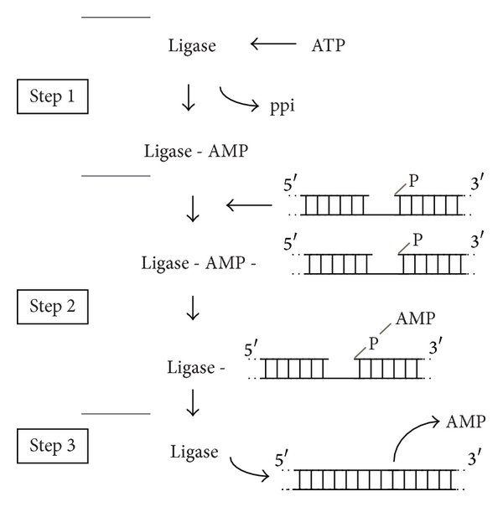
Figure 5. The figure illustrates a three-step procedure using ATP-dependent DNA ligases. AMP is transferred to a lysine residue in step 1, followed by the 5′-PO4 end in step 2. In step 3, a second DNA strand's 3′-OH end attacks the 5′-PO4, releasing AMP and producing the ligated DNA product (Tanabe, M. et al. 2015).

  - NAD⁺ Dependent DNA Ligases
While ATP dependent ligases are considered ubiquitin, NAD⁺ dependent ligases ligases are found in bacteria, some entomopox viruses and mimi virus (Dwivedi, N. 2008). NAD+-dependent DNA ligases have two functional domains: an N-terminal cofactor binding domain and a C-terminal DNA-binding domain. According to Le, Y. et al. (2010), Ecoli DNA ligases, which employ NAD+, is frequently used tools in recombinant DNA technology alongside T4 ligases (ATP dependent).

- DNA Ligase in Repair and Replication
Unwanted events can occasionally cause abrupt changes in DNA molecule, causing mismatches, base removals, and base insertions which subsequently leads to mutation. Thankfully, the cell uses ligase enzymes to repair itself in both single stranded break (SSB) and double stranded break (DSB) situations, depending on the extent of the damage. Most species employ ATP-dependent ligases in these activities, but Eubacteria requires NAD for repair (Timson, DJ. 2000).
As was indicated by Gong, C et al (2005), In eukaryotes, single stranded breaks may be repaired via both homologous recombination (HR) and non-homologous ends-joining (NHEJ) mechanisms, however in bacterial cells, only homologous recombination is used. Cells use several mechanisms including, mismatch repair (MMR), DNA damage repair pathway (Nucleotide excision repair (NER) or Base excision repair (BER)) (Khan Academy). With the exception of directly undoing DNA damage, two DNA repair pathways - base excision repair (BER) and nucleotide excision repair (NER) - involve successive activity of several repair proteins (T. Izumi, I. Mellon, 2016. p-275). In DNA recombinant technology, these functions of the cell are manipulated to introduce a foreign gene in the organisms’ genome. For instance, in homologous direct repair (HDR), scientists introduce two mechanisms, after CRISPR-cas9 cleavage: (1) synthesis dependent strand annealing (SDSA) and double strand break repair (DSBR).

- How Ligases are Applied in Recombinant Technology
Ligation is a fundamental step in DNA cloning and Recombinant technology. A ligated DNA fragment may have cohesive or blunt ends relative vector to which it is applied. According to Anupama, S. (2022), a vector, often described as "molecular vehicle," is used to transport segment(s) of DNA into a host cell. A vector can exist as a plasmid, Bacteriophage, Cosmids, Phagemids, Bacteria Artificial chromosome (BAC), Yeast Artificial chromosome (YAC) and depending on the process, it can be classified as cloning vector, expression vector or integration vector.
A fragment is ligated as foreign DNA which is then transformed into a host such as bacteria. The transformed bacteria are cultured and used to construct a gene library as in Genomic or cDNA libraries. Both types of gene libraries preserve genes for long-term applications such as gene delivery, and genetic engineering purposes. In order to study protein interaction and develop therapeutic agents for Biotechnological and Biomedical research purposes, a combination of several DNA fragments encoding different proteins domains or entire proteins are enhanced. In a technique known as Site-Directed mutagenesis a modification by insertion of foreign piece of DNA is made in the genome of an organism in the overlapping region with the aid of polymerase chain reaction (PCR). Ligation of DNA fragments are used in sequencing methods such as Sanger’s sequencing and are also utilize as adapters for Next Generation sequencing (NGS) library collections.
- Factors Influencing the Activities of DNA Ligases
Bitesize Bio (2022) outlined there are five main factors accountable for ligation optimization to improve efficiency:
- The first is temperature: the DNA ligase enzyme can function best by lowering the temperature, and while the optimal temperature for the DNA ligase enzyme is 25°C, reducing it to 4°C can further improve efficiency despite the longer time required.
- The second factor is the buffer solution: to prevent degradation of ATP in the ligase buffer, which is crucial for DNA ligation, it is recommended to aliquot the buffer from each new DNA ligase stock, as repeated freeze-thaw cycles can break down ATP.
- The third step is heating at a proper temperature: when performing cohesive-ended ligation, combine the vector and insert fragments first, and subject the mixture to a 5-minute heat treatment at 65°C. This step disrupts any potential interference from cohesive-end interactions within the vector or insert, thus improving the efficiency of the desired vector/insert interaction.
- The fourth step involves pH: the best pH range for DNA ligation is between 7.6 and 8.0. The mixture may deviate from this range based on the DNA fragments' preparation method. To verify the pH, pipette around 0.2 µL of the mixture onto narrow-range pH paper. The pH can be changed by adding 0.2 µL droplets of either 1 M HCl or 2 M Tris base if necessary.
- The fifth step requires that the restriction enzyme should be added before ligation: in cases where the vector fragment obtained during the preparative digest, adding the corresponding restriction enzyme to the ligation reaction will selectively digest any remaining intact vector, effectively preventing its transformation and enabling the intended insert to be successfully integrated. To avoid this, the addition of 1 µL of the enzyme, made 5-10 minutes before the transformation, is adequate.
- Recent Advancements in Ligase Research
  - Enhanced DNA Ligases
DNA ligase holds a strong place in molecular techniques. Of recent, researchers have modified ligases to improve their activity and efficiency in joining DNA fragments. Engineering ligase for improvement is necessary, some have huge limitations in joining double stranded breaks for instance T4 ligases.
According to Robert, H. 92013) modified T4 ligase enzyme fusing T4 DNA ligase with 7 different DNA-binding proteins, the researchers were able to significantly enhance its performance in joining DNA fragments with cohesive or blunt ends. Using agarose gel-based screens evaluated the activity of the engineered ligases. They observed that engineered Ligase-cTF out-performed the normal T4 DNA ligase by ∼160% in blunt end ‘vector + insert’ cloning assays, and p50-ligase showed an improvement of a similar magnitude when it was used to construct a library for Illumina sequencing.
Additionally, Winn, M (2021) investigated the ability of coronafacic acid ligases (CfaLs) to catalyze the coupling of coronafacic acid to amino acids. CfaL enzymes can produce jasmonyl-L-isoleucine (JA-Ile) (a mimic of the plant hormone), despite having low similarity to the plant enzyme Jar1, which is responsible for the ligation of JA and L-Ile in plants. suggests that Jar1 and CfaL evolved independently to catalyze similar reactions: Jar1 producing a compound essential for plant development, and the bacterial ligases (CfaL) producing analogues that are toxic to plants. They proved that CfaL enzymes can be utilized to synthesize a diverse range of amides without the need for protecting groups and employed structure-guided mutagenesis to engineer improved variants of CfaL.
Similarly, the study of Tomkinson AE (2020) described three ligases, DNA ligases I, III, and IV, have distinct functions within the nucleus and mitochondria that help to seal nick in the backbone to ensure genome stability. Mutations in the LIG1 and LIG4 genes have been linked to rare DNA ligase deficiency syndromes, with DNA ligase I associated with increased proliferation, DNA ligase III indicating reliance on an alternative DNA repair pathway, and DNA ligase IV conferring radio resistance through enhanced repair of DNA double-strand breaks. An enhanced DNA inhibitors in future researches could help minimize the inefficiency. The enhanced ligases give scientists more dependable and effective tools for working with DNA fragments, decreasing the likelihood of experiment failure and enabling more exact and precise genetic engineering.
- Recombinant DNA Techniques and Tools
  - Background of Gene Cloning, Importance and Techniques
Making many, exact copies of a specific segment of DNA is known as DNA cloning. The gene or other DNA fragment of interest is first extracted using a conventional DNA cloning method and then put into a circular piece of DNA known as a plasmid. Most often, a particular restriction enzyme is used to create sticky ends on the extracted DNA fragment and plasmid to ensure adequate compatibility (Figure 6).
The beginning of gene cloning can date as far back as in 1953 when Francis Crick and James Watson describe the structure of DNA as being double helical and its function in genetics. This was a breakthrough in molecular biology that give light about the possibility manipulation of DNA. John Gurdon showcased the feasibility of cloning an organism by successfully cloning South African frogs. He achieved this by utilizing the nucleus of fully developed adult intestinal cells. This groundbreaking experiment provided evidence that cells maintain their genetic potential even after they specialize, aligning with Spemann's hypothesis in 1962 (Mandrich, L. 2013).
In the early in 160s Werner Arber discovered restriction enzyme and made a hypothesis of how they bind to DNA and this postulation was validated by Hamilton smith who purified a restriction enzyme from a bacterial and shoed how they cut DNA base on sequence matching. This idea was first applied genetics and show the importance of restriction enzymes in genetic maps construction. For this work, all three won the shared the Nobel Prize in physiology in 1978. This event was followed by the discovery of first DNA ligase (T4 Ligase) by Gellert, Lehman, Richardson, and Hurwitz laboratories in 1967. Berg P, Mertz JE (2010) was a Stanford university Biochemist that discovered the first recombinant DNA in 1972. This was followed by the development of plasmid by Herbert Boyer and Stanley Cohen in mid 1970s. From this experiment, plasmids became the most widely used tool for gene cloning and not so long after this, Karry Banks Mullis, an American Biochemist discovered a technique called Polymerase Chain Reaction (PCR) – a method used to rapidly amplify DNA molecules. It was and still is one of the biggest achievements in molecular biology. PCR is the most widely used technique today.
In 1996, the first mammal, Dolly (a sheep) was cloned A cell from a six-year-old Finn Dorset sheep's mammary gland and an egg cell from a Scottish Blackface sheep. Today, there are several methods developed from early discoveries are available for DNA cloning. It is conceivable to isolate a single area of a genome, make almost endless copies of it, and overnight figure out the nucleotide sequence.
When the Human Genome Project was at its peak, enormous facilities with automated machinery were continuously producing DNA sequences at a rate of 1000 nucleotides per second. By using comparable approaches, an isolated gene may be freely modified (engineered) and returned to the animal or plant's germ line to become a useful and heritable component of the genome (Alberts, B. et al 2002).

Figure 6. Gene cloning
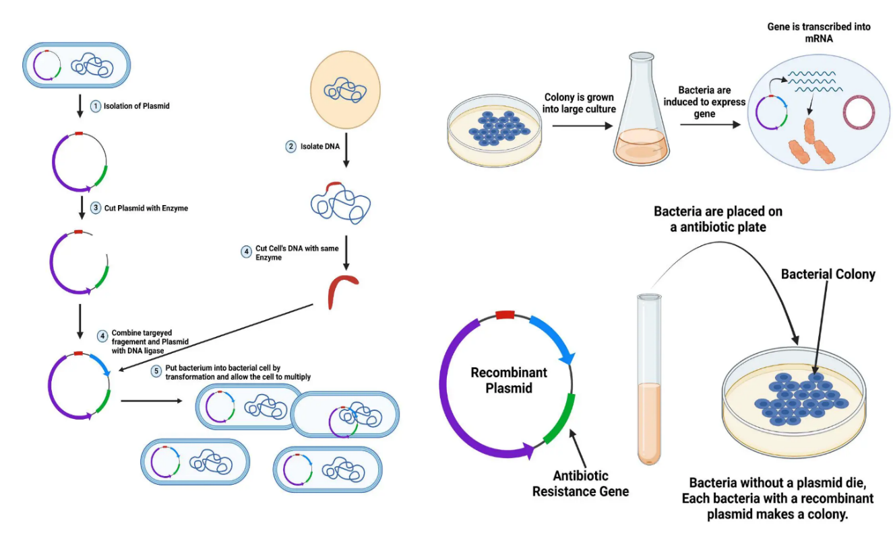
Figure 6. Diagram of Gene cloning ((Gene Cloning - Steps, Definition, Applications, 2022)

  - Vectors and Types
A vector is a DNA molecule that contains the desired gene and transports it to the host cell. It is also known as a molecular vehicle. There are several molecular vehicle types used in cloning, and the choice of a particular type depends on the number of copies of the gene, the cloning technique, or the size of the insert. For instance, depending on the technique used, a bigger gene of interest with a high copy number will require a vector with a high carrying capacity, such as a BAC. To make many copies, the recombinant DNA is often introduced artificially into the host organism. Certain criteria are considered when selecting a vector, there are listed below:
- Multiple cloning sites unique for Restriction enzymes
- Possess selectable markers genes
- Should easily be separated from host organism when needed
- Self-replicative
- Origin of Replication
A detailed description of these features is seen in (Figure 7) . Six types of vectors are described below:
    - Plasmids
Plasmids are genetic materials found in bacteria. They are circular, extra-chromosomal DNA present in each cell in approximately 1-20 copies. Plasmids can replicate independently without using the host cell’s machineries and its molecular weight ranges from 106 to 108, and 40 to 50 genes may be encoded by it (Karki, G. 2021). Plasmids come in several varieties. They may be divided into two categories based on their capacity to interchange genetic material, namely: those that can transmit genetic material across bacterial cells are known as conjugative, and those that cannot are referred to as non-conjugative. Non-conjugative plasmids are transferred into bacterial cells with the aid of conjugative plasmids. Regardless of their ability to conjugate, they are also self-replicative. The table below describes the types under each plasmid type under discussion.
Figure 7. Vector structure
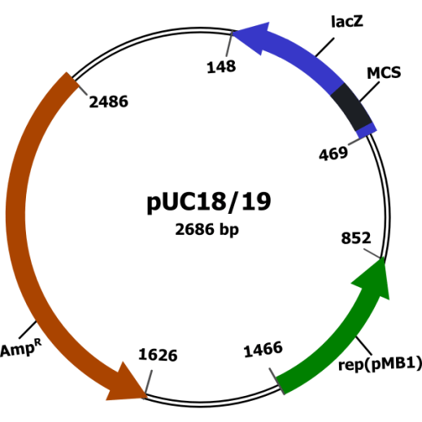
(Hasini, A 2023)

    - Bacteriophages
Bacteriophages are group of viruses that infect bacteria and Archaea. Also known as Phages which when translated from Greek means ‘to eat’ i.e., bacteriophages are bacteria eaters. Upon infection, they insert their genomes within the bacteria cell which becomes a part of the bacteria genomes and function as a surveillance system. Phages are small, straightforward creatures made up mostly of genetic material (nucleic acid) that is encased in a protein cap. They are grouped into several viral families such as Siphoviridae, Myoviridae, Ackermannviridae and Podoviridae. The basic structure of a phage entails: filamentous form, icosahedral head with tail, and icosahedral head without tail (Figure 8).
Figure 8. Life Cycles of Bacteriophage
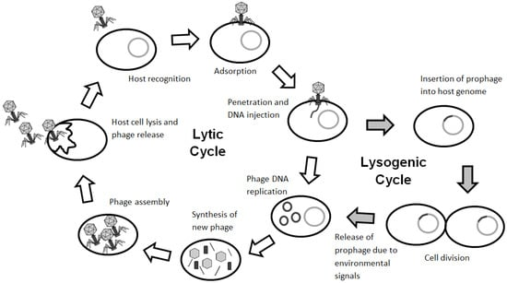
Figure 8. LYTIC and Lysogenc cycles of Bacteriophage (Doss, J et al. 2017)

    - Cosmids
A cosmid is a hybrid plasmid with a bacterial "ori" and lambda phage-derived "cos" sequence. It is a vector that combines linearized DNA plasmid ends with cos-sites of λ DNA, forming a circular structure. Cosmids lack lambda DNA structural and regulatory genes, preventing DNA breakdown or incorporation into host cells. Cosmid DNA consists of two single-stranded sections, creating a duplex. It does not encode phage proteins or host cell lysis and relies on plasmid DNA for independent replication. It has cloning sites and selectable marker genes. Cosmid DNA is tightly packed inside the bacteriophage's protein coat to create dormant phage particles.

    - Bacteria Artificial Chromosome (BAC)
BAC vectors are plasmids with E. coli F factor replication origin, storing up to 300 kb of DNA fragments per cell. The BAC system is a large insert cloning technology used to create DNA libraries for genetic data processing. It transforms and clones bacteria, typically E. coli, using a fertility plasmid (F plasmid). BAC inserts generally range from 150 to 350kbp, although current sequencing techniques like Shotgun and Next Generation sequencing have mostly supplanted them. BAC possess the following key characteristics:
- Bacterial artificial chromosomes (BACs) are ideal for cloning and altering large gene sequences.
- stable maintenance: enabling the retention of cloned genes during propagation
- low copy numbers: BACs often live-in bacterial cells in low copy numbers, reducing the danger of gene overexpression or toxicity during gene cloning research.
- F-factor origin of replication: enabling autonomous cloning and efficient insertion and modification of target genes.

    - Yeast artificial chromosomes (YAC)
are enhanced cloning vectors derived from human DNA and are used to clone sequences in yeast cells. enable comprehensive examination of DNA spans from 50 to 2000 kb, enabling restriction mapping, physical mapping, and gene or coding sequence analysis. Upon insertion into the yeast cell, multiple copies of the DNA are produced as the yeast cell grows and divides. YACs are essential for cloning entire sequences of large genes or complexes larger than traditional bacterial cloning vectors like plasmids, bacteriophages, and cosmids. The components of YAC vectors are:
- Centromere Region: A region in yeast that enables proper vector segregation during cell division as along with selected marker genes.
- Autonomous Replication Sequences (ARS): These are the sequences that allow the YAC to make multiple copies of itself within the yeast cell.
- Telomere sequences: prevent YAC DNA degradation and fusion.
- Selectable Markers: Genes that provide antibiotic resistance or enable yeast cells to grow rapidly under certain conditions.
- Multiple Cloning Site: a region having restriction enzyme recognition sites to facilitate the incorporation of DNA fragments.
Other major types of cloning vectors are described in (Table 2)

Table 2. Different Types of Vectors and their Features
Vector | Insert size | # of clones required in Library | Special characters
Plasmid | Up to 15kb | 2.13 x 10^5 | Versatile and easy to manipulate
Lambda λ | ^{20kb} | 5 x 10⁵ | Stable inserts and easy to construct library
Cosmid | 45kb | 2 x 10⁵ | Easy to construct libraries (combination of plasmids and phage)
Yeast Artificial Chromosome (YAC) | 1Mb | 10⁴ | Maintains large DNA inserts in yeast cells
P1-derived Artificial Chromosome (PAC) | 120kb | 10⁵ | Large DNA insert capacity.
Bacteria Artificial Chromosome (BAC) | ˃500 | 2 x 10⁴ | Accommodates large genomic DNA fragments
OPO® TA Vector | 3kb | 10⁶ | Topoisomerase I-based cloning method

  - DNA Isolation and Purification Techniques
The first step involved in accessing a specific DNA of interest is extraction (“to draw out” all DNA components) follow by isolation (“to set apart” the specific DNA of interest). There are many Five general steps are followed in DNA isolation and purification:
- Lysing of cell structure: this is done to expose the cellular components and can be done using physical methods (e.g., free-thaw cycles, homogenization, sonication, vertexing), chemical methods using detergents (e.g., SDS or CTAB) and enzymatic methods such as lysozyme for bacterial cell, cellulase for plants or chitinase for fungus cell depending on the starting materials, there are more enzymes used.
- Separation of Soluble DNA from cell debris: Cellular lysates requires debris removal before nucleic acid purification to minimize unwanted materials like proteins, lipids, and saccharides. Clearing is typically achieved through centrifugation, filtration, or bead-based methods.
- Precipitation: The supernatant includes dissolved DNA that must be concentrated before it can be purified. Usually, the is DNA is made to precipitate in ethanol or isopropanol, generating a visible pellet out of solution.
- Washing: To eliminate any leftover contaminants and residual salts, the DNA pellet is washed with ethanol or isopropanol. Washing ensures that the DNA sample is clean.
- Resuspension: involves resuspending purified DNA in a suitable buffer for downstream applications like PCR, sequencing, and cloning, ensuring it is ready for use in various genetic analyses such as PCR, sequencing, cloning etc.,
A diagram of this protocol is seen in (Figure 9) and other methods are in (Table 3)

NOTE: these steps are general and may vary from depending on the isolation protocol and source of DNA.

Figure 9. Gene Isolation and Purification process
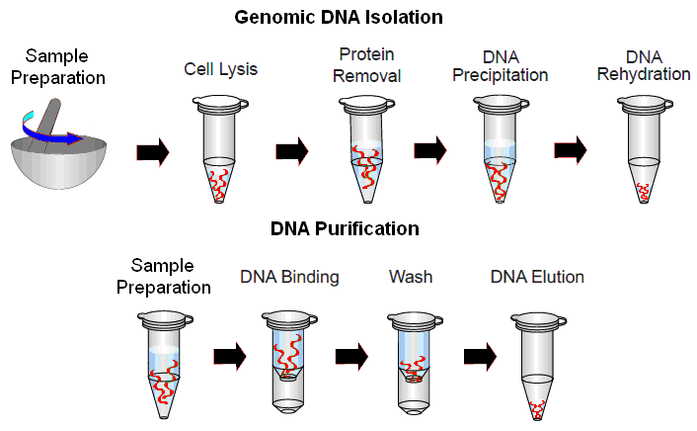
Figure 9. https://www.toppr.com/ask/question/what-is-elution-in-the-process-of-separation-of-dna/#:~:text=DNA%20fingerprinting%20etc.-,Was,-this%20answer%20helpful

Table 3. Methods of Gene Isolation.
NO | Method | Description
 | CTAB DNA extraction | Cetyl Trimethyl Ammonium Bromide is a chemical for plant extraction. It is Liquid-liquid based
 | SDS DNA extraction | sodium dodecyl sulfate is an anionic detergent that digests nuclear and cell membrane proteins
 | Silica-gel-based techniques | silica gel as a solid phase is immobilized in a tub used to digest samples and help separate it in solid phase
 | Paper DNA extraction | Utilizes organic substances such as phenol and chloroform.
 | Magnetic bead DNA extraction | Selective DNA purification method (molecules that have an affinity for DNA (such as silica or paramagnetic particles), are added to the lysed sample)
Table 3. Various methods of DNA extraction

  - DNA sequencing and amplification methods
The process of determining order arrangement of sequences in a genome is called sequencing while amplification is to make multiple exact copies of a DNA molecule. The most widely used amplification method is known as polymerase chain Reaction (PCR). PCR involves a series of repeated temperature dependent cycle that allows exponential amplification of targeted DNA segment. PCR is a crucial step because it increases the copies of the desired gene to make the process more feasible. It consists of 20-30 cycles per round of PCR. The first step is to design two primers flanked by sequences of gene of interest and follow the following steps:
- Denaturation: high temperature is used to separate the double stranded DNA molecule into single stands. A temperature between 94-98º C is enough to break the H-bonds between complimentary base pairs.
- Annealing: lowering the temperature between 50-65º C allows the primers to bind to the complimentary sequences on each single stand creating an origin of replication for DNA polymerase (e.g., Tag polymerase) to synthesized new strands.
- Elongation: When the temperature is increased to 72º C, DNA polymerase begins to lay down new nucleotides using the primers as template in 5’ to 3’ direction resulting in two double stranded molecules per cycle.
- Termination: lowering the temperature to 4°C∞ help to hold the DNA and maintain stable temperature.
Variations occur in the annealing temperature is due to the following reasons factors:
- Length and GC content of primers
- Presence of secondary structures such as hairpin loops, self-complementarity
PCR is carried in a a machine called thermal cycler. In normal PCR, DNA Tag polymerase is often used due to its ability to withstand Temperature as high as 95º C and function at a low temperature compare to other enzymes. See the list of PCR cocktail mixture in (Table 4). Other types of PCR include reversed transcription PCR (RT-PCR), and Real-time PCR (qPCR).
Table 4. Materials Require for PCR Process
Primers (forward 5’ and reversed 3’) | Building of new nucleotides and are 20 – 25 nucleotides in long
Deoxynucleotidyl phosphate (dNTPs) | Aid in strand extension (usually beyond 20-25 nt)
MgCl₂ | Promote correct positioning nucleotides by catalyzing the formation of phosphodiester bond b/w nt during synthesis
DNA polymerase 80⁰ C (e.g., Tag polymerase) | Build new nucleotides to grow new strands
Cocktail mixture volume | 25mL
Double distilled water (H₂O) | Use for storage of mixture to avoid impurities
Template DNA | Original DNA from which new ones are synthesized
Table 4. PCR cocktail mixture
    - RT-PCR
Reversed transcription PCR is a two steps PCR process that utilize an enzyme called reversed transcriptase which converts mRNA template into ds cDNA followed by amplification. This reaction occurs at 37º C for an hour (Shomu’s Biology, 2013). RT-PCR is use in cancer research, forensic science, Gene expression analysis, DNA fingerprinting, detection of diseases etc.
    - Quantifying DNA with the use of Real TIME PCR
Real-Team PCR, referred to as quantitative PCR (qPCR), like other techniques is use in the detection and quantification of DNA. Here the techniques allow the measurement of starting amount of DNA. As the process progresses, short labeled segments of DNA known as fluorescence probes are added to the growing strands, so that when it binds to complimentary sequences on the template strand during elongation, it is cleaved by the DNA polymerase, resulting in the separation of the fluorescent dye from the quencher while the florescence release its intensity to be measured after each cycle. During Real-Time PCR, the amplification process is monitored throughout.
Cycle threshold (ct) is the cycle at which the significant amount of DNA has be amplified. It is a value used to quantify the initial amount of target DNA in the sample. Two reactions are observed during detection in qPCR:
- SYBR Green dye – this dye does not emit fluorescence when in a free state. It produces fluorescence when bind to double stranded DNA in a sample solution. The intensity of fluorescence is proportional to the amount of ds DNA present.
- TagMan – is also a probe-based method named after Tag polymerase are single stranded DNA hydrolysis probes containing 5’ reporter dye and 3’ quencher designed to be used in conjunction with PCR primers. They are labeled with reporter fluorophore such as FAM, HEX or VIC and are about 18-22bp.
RT/qPCR is faster, accurate, and uses DNA probes with fluorescent, chemiluminescent, colorimetric, or radioactive markers to identify amplicons.
    - Sequencing
Genome sequencing is carried out to know the level of communication among chemical bases (A, T, G, C) that makeup the gene. For instance, which stretch of nucleotides produce genes responsible for regulation. Without sequencing, researchers wouldn’t have been able to tell that the Human genome is composed of 3 billion base pairs and how they connect to create human being as whole. Sequencing was a challenge during the peroid known as the first-generation era as traditional methods could not cater for large DNA and accurate results, and as well as cost-effectiveness.
Technologies improvement had it that the Human genome which cost over 3 billion and 13 years to finish, can now be done for about $1,000 dollars within a day. DNA sequencing is the highest resolution method for determining complex gene families, such as the HLA (Human Leukocyte Antigen system) genes in tissue transplant patients and donors. Databases with donor sequences can be used to construct virtual crossmatches with unrelated donors. A single primer creates copies of one strand of DNA, but full-length copies cannot determine the sequence. To determine the sequence, specific nucleotides, termed dideoxynucleosides, are used in the mix. UK Prime Minister David Cameron's 100,000 Genomes initiative in 2012 quickly achieved its goal, creating Genomics England, surpassing the initial initiative of 2003.
    - Sanger sequencing
Sanger sequencing, developed by Nobel Laureate Frederick Sanger and his friends in 1977, is a method for determining DNA nucleotide order. It is also referred to as chain termination method, carried out by means of automatic machine or manually and the protocol requires three basic steps, namely; chain termination, gel electrophoresis and analysis.
- chain termination using PCR
It is based on the use of the modification of nucleotides with dideoxynucleoside phosphate (ddNTPs). ddNTPs lack the 3’-OH that plays a key role in extension during replication. Because of this characteristic, during the normal PCR process, when ddNTP is added to the growing strand, it inhibits the extension process, leaving the chain at a specific location, hence the term "chain termination". A low amount of ddNTP is enough to stop the stretch and is capable of producing millions to billions of base pairs.
- Gel electrophoresis
After chain is termination, the DNA is separated based on sizes using a technique called gel electrophoresis. Electrophoresis use electric current to run the DNA in a gel. It has a positive (+) end and a negative (-) end and wells to pour the mixture. Since DNA is a negatively charged molecule, the gel migrates from the negative end to positive end and the rate of migration is based on size. The smaller fragments migrate faster due to less friction compare to larger fragments. The resulting DNA fragments are arranged and observed from smallest to largest.

- analysis and sequence detection
The last step comprises examining the gel to identify the sequence of the input DNA. As DNA polymerase only rely on synthesizing DNA in the 5' to 3' orientation, originating at a specific primer, each terminal ddNTP will correspond to a particular nucleotide in the initial sequence. For instance, the shortest fragment will finish at the first nucleotide from the 5' end, the second-shortest fragment will terminate at the second nucleotide from the 5' end, and so on. And so, reading the band from small fragments to largest helps to derive the original strand sequences in the 5’ to 3’ direction. Manually, Manual Sanger sequencing involves reading all four gel lanes simultaneously to determine terminal ddNTP identity while each band is read in automated to determine each ddNTP identity (Figure 10).

Figure 10. Gel Electrophoresis
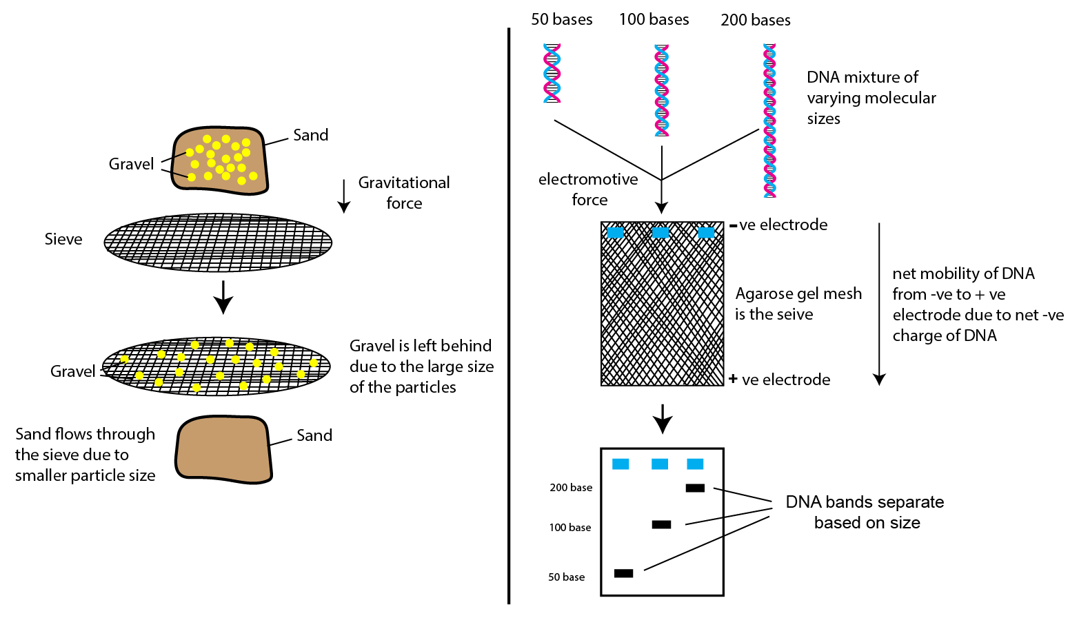
Figure 10. Diagram of gel electrophoresis (Chakravarty PR. n.d)

- Applications of recombinant DNA technology
Recombinant DNA technology has improved lots of things for our comfort. The usefulness of genes can be expressed in almost every aspect of human wellbeing, including the improvement of biopharmaceutical industries, vaccines, genetically modified organisms (GMOs) and crops with enhanced traits for better yield and so on. It offers sustainable solutions for problems of environmental pollution and climate change. Recent advancements of Recombinant DNA technology in Agriculture, medicines and environmental science are discussed below.
  - Recombinant DNA technology in crops
Genetically modified organisms such as Agrobacterium tumefacien, Baculoviruses, etc., are used to produce genetically modified crops. Crops are modified to give high yields, resistance to pests and herbicides and also phytophthora-resistance. Flavr Savr tomato pioneered this milestone by being the first crop to be engineered in 1994. To achieve this, researchers silenced the gene responsible to produce polygalacturonase, an enzyme naturally found in tomato that break down a substance known as pectin that holds plant cell together which when becomes overproduced in the tomato leads to spoilage.
The antisense RNA was used to control the expression of polygalacturonase in ripening tomato conferring prolong flavor, delayed ripening and resistance to herbicides. GM crops have advanced in many areas abiotic stress tolerance etc., (Table 5). According to (Verma, R et al. 2016), 88% of corn and 93% of soybeans are genetically modified in the United States. Additionally, Bt genes obtained from bacterium thuringiensis were used to modify GM food crop known as Bt-bringal, making it a pest resistant crop (Robinson AW, 2016).
No. | Modified crops | Traits | Use
1 | Apple | Delayed browning | food
2 | Potato | Reduced acrylamide  Blackspot bruise tolerance  Late blight resistance | food
3 | Sweet pepper | Virus resistance | Food
4 | Rice | Insect resistance | Food
5 | Sugar Cane | Drought tolerance | Food
6 | Soybean | increased oleic acid production  Stearidonic acid production | Animal feed  Soybean oil
7. | Maize | Animal feed  high-fructose corn syrup  corn starch | food
Table 5. Some commonly used engineered crops (“List of Genetically Modified Crops - Wikipedia”2016)

  - Production of therapeutic proteins
Recombinant DNA (rDNA) technology greatly influences biomedical applications, notably in the production of mutant proteins derived from native ones. This is performed by altering the appropriate gene to boost protein synthesis, allowing the creation of commercial products with better qualities.
Therapeutic applications usually entail exploiting human genes produced in diverse hosts like bacteria (e.g., Escherichia coli), yeast (e.g., Saccharomyces cerevisiae, Pichia pastoris), Insect cells (e.g., Sf9 cells) or Plant cells (e.g., Nicotiana benthamiana) within a cultured environment. To acquire a pure gene, mRNA is turned into cDNA. Bacteria are generally selected by researchers owing to their Familiar Genes, Fast Growth and High Yield, affordability and ease of handling. However, proteins that require post-transcriptional changes, such as the addition of phosphate (phosphorylation) or sugar molecules to proteins or lipids (glycosylation), demand the use of eukaryotic vectors.
Mammalian cells, such as HEK293 (Human Embryonic Kidney 293), CHO (Chinese Hamster Ovary) and PER.C6 (Human Retinal Pigment Epithelium) cell lines are widely used in the biopharmaceutical industry for the production of therapeutic proteins, including monoclonal antibodies and other complex biologics since they have the aptitude to create high-quality proteins mimicking natural ones. Recombinant proteins providing a better understanding of critical biological processes and play a significant role in laboratory procedures like ELISA, western blot, and immunohistochemistry, enabling the design of enzymatic assays and studying cellular reactivity to stress and illness. They are used as therapies for various diseases like diabetes, cancer, and infectious diseases, and creating vaccines like the FDA-approved Hepatitis B vaccine.
  - vaccines production
Recombinant vaccines play a crucial role in preventing and controlling various diseases in both animals, such as cattle, and humans, offering valuable tools for disease management and eradication efforts. vaccines, including those for bovine viral diarrhea (BVDV) and bovine respiratory syncytial virus (BRSV), utilize genetic engineering to insert specific antigens of the pathogens into harmless vectors. These vectors, such as DNA-based or RNA-based constructs, efficiently deliver the genetic materials encoding the antigens to the host cells, stimulating an immune response and inducing the production of neutralizing antibodies against the targeted pathogens. This approach offers a safe and effective means of disease prevention and control in cattle and other animals, demonstrating the potential of recombinant vaccines in veterinary medicine.
Scientists choose the target antigens for vaccines based on the pathogens responsible for causing clinically and economically significant diseases in the target species, such as cattle. In the case of cattle, pathogens like bovine viral diarrhea virus (BVDV), bovine respiratory syncytial virus (BRSV), Leptospira sp., E. coli, Clostridia sp., and others are common targets for vaccination. The selection is based on their crucial role in disease development and vaccinating against them can offer protection and prevent infection. Genetic engineering has also been exploited manufacture in large quantities pharmaceuticals such as insulin, human growth hormones, follistim (used to treat infertility), human albumin, monoclonal antibodies, antihemophilic factors, vaccinations, and many more. Mouse cells, hybridomas cells fused together to produce monoclonal antibodies have been transformed to produce human monoclonal antibodies.
  - Gene therapy
Gene therapy refers to the method wherein a genetic defect is treated by inserting a functional gene or section of DNA in cells. The functional gene inserted into an individual or an embryo compensates for the non-functional gene present. The newly inserted DNA corrects the effect of the mutated gene. The two types of gene therapy are somatic and germline therapy:
  - Somatic gene therapy
Here the desired gene is transferred to a somatic cell. The somatic gene therapy targets body tissues. Therapeutic DNA is transferred to a somatic cell, which is any cell other than gametic cells, Example of cells include muscle cells, liver brain etc. In somatic gene therapy, gene delivery is carried out in two ways:
- Ex-vivo therapy refers to treatments or interventions that are conducted outside the living organism, typically in a laboratory setting. In this approach, cells, tissues, or organs are removed from the patient's body, treated or modified in some way, and then reintroduced back into the patient's body.
- In-vivo therapy refers to treatments or interventions that are performed inside a living organism, typically within the body of the patient. This means that the therapy is applied directly to the patient, and the effects occur within the patient's body. It involves administering drugs, procedures, or therapies that target and affect the patient's organs, tissues, or cells while they are still in their natural physiological environment.
  - Germline gene therapy
Targets germinal or reproductive cells. These cells produce male and female gametes therefore the inserted gene passes to the future generations. The transfer can also be done during early embryonic development. E.g., during in-vitro fertilization, then the desired gene can be inserted in all the cells of a developing embryo.
See table 8
- Gene augmentation therapy – Here a functional gene is introduced, which produces sufficient levels of proteins to compensate for non-functional genes.
- Gene inhibition therapy – This is used when a gene activity is altered and needs to be suppressed
Table 5. Common methods of gene delivery
Methods of Gene Delivery
Viral vectors systems | Direct methods
Retroviral  - 7-10kb in size | Micro-injection
Adeno virus  - About 36kb  - Linear genome & double stranded | Gene gun
SV40 vector  - Approximately 5kb | Electroporation

  - Bioremediation and waste management
The use of genetically modified organisms (GMOs) to degrade or remove pollutants from the environment, making them more environmentally friendly and sustainable. Recombinant DNA technology allows scientists to engineer these microorganisms to enhance their ability to degrade specific pollutants.
- Oil-Eating Bacteria: Certain bacteria can naturally break down hydrocarbons found in oil spills. researchers can enhance the metabolic pathways in these bacteria, making them more efficient in breaking down and digesting oil. Some examples are Pseudomonas putida, Acinetobacter baylyi, Alcanivorax borkumensis
- Heavy Metal-Absorbing Plants: Introducing genes responsible for metal-binding proteins into plants, scientists can create GMOs with improved abilities to remove heavy metals from contaminated soil. This group includes, Arabidopsis thaliana, Brassica juncea (Indian mustard) - engineered Brassica juncea to express metal-binding proteins, such as metallothioneins, and Populus spp – can degrade organic pollutants, such as trichloroethylene (TCE), a common groundwater contaminant.

  - waste management
Engineered microorganisms can also be employed in waste treatment processes to break down organic waste more effectively or produce valuable byproducts. Some examples include:
- Sewage treatment: Certain bacteria and fungi can degrade organic matter present in sewage. Some Examples are:
- Phage-Assisted Continuous Bioprocessing – scientist are studying the use of bacteriophages to target and control the growth of specific bacteria in sewage treatment systems.
- Modified Algae for Nutrient Removal - Algae play a vital role in nutrient removal from wastewater, especially for nitrogen and phosphorus
- Biodegradable waste: Engineered bacteria are used to produce biodegradable plastics, such as polyhydroxyalkanoates (PHA). These GMOs can be used to treat organic waste, and once they have accumulated sufficient PHA, they can be harvested, providing a sustainable source of bioplastics.

- Future prospects of Recombinant DNA
DNA technology is likely to have profound effects on society. Its applications have shown continuous improvement in health, agriculture, and environmental management since its birth in the 1950s. In agriculture, the use of genetically modified bacteria, plants, or fungi for phytoremediation or bioremediation has been instrumental in preventing crop loss due to drought, pests, and diseases.
Similarly, recombinant DNA techniques have broadened our understanding of disease mechanisms, leading to adapted solutions for various illnesses, including diabetes, cancer, and pandemics. A notable current progress is the harnessing of phytochemicals as radioprotectors to be used alongside radiation therapy. This advancement may increase the chances of patient survival for cancer types that have proven to be radio-resistant while minimising side effects. The completion of the Human Genome Project (HGP) stands as one of the most significant advancements in Recombinant DNA technology, providing much more detailed insight into gene variation. The technology keeps evolving, enabling scientists to continuously explore new ideas through the manipulation of three billion base pairs.
- Pricised gene editing - gene editing techniques like CRISPR-Cas9, holds great promise in treating genetic diseases caused by specific faulty genes. The ability to precisely edit genes within an individual's genome can potentially correct genetic mutations responsible for inherited disorders, offering a potential cure or long-term therapeutic relief. Some off-target activity can lead to mutation of this techniques can be develop highly specific and efficient gene-editing tools that can accurately target and correct disease-causing mutations without causing unintended side effects.
- Synthetic Biology and Bioengineering - Recombinant DNA technology holds promising potentials for advancements in synthetic biology and bioengineering. systems and organisms with tailored functions to address various challenges, including biodegradation of pollutants, production of biofuels, and synthesis of complex molecules.

Conclusion
Recombinant DNA technology has emerged as a powerful tool with diverse applications in various fields, revolutionizing biopharmaceuticals, agriculture, vaccines, gene therapy, and environmental management. In the biopharmaceutical industry, mammalian cells like HEK293, CHO, and PER.C6 have paved the way for the production of high-quality therapeutic proteins, enabling better disease management and improved laboratory procedures. Genetically modified crops have demonstrated increased yields, pest resistance, and enhanced traits, contributing to food security and sustainability.
Vaccines developed through genetic engineering offer effective prevention and control of diseases in both animals and humans. Recombinant vaccines utilize harmless vectors to deliver specific antigens, stimulating immune responses and the production of neutralizing antibodies against targeted pathogens. This approach shows promise in veterinary medicine, particularly in controlling diseases in cattle. Gene therapy holds the potential to treat genetic disorders by inserting functional genes into somatic cells, compensating for non-functional ones. It offers hope for targeted and long-term therapeutic relief for patients with inherited disorders. Additionally, the future prospects of precise gene editing techniques like CRISPR-Cas9 offer the possibility of accurately targeting disease-causing mutations without unintended side effects, further enhancing the potential of gene therapy.
Moreover, recombinant DNA technology contributes to environmental management by utilizing genetically modified microorganisms for bioremediation and waste treatment. These organisms efficiently degrade pollutants, making them more environmentally friendly and sustainable.

References
- NA Ligation: 6 easy tips to improve your reactions. (2022, May 16). Bitesize Bio. https://bitesizebio.com/10279/how-dna-ligation-works/
- Khan Academy. Overview: DNA cloning. Available at: https://www.khanacademy.org/science/ap-biology/gene-expression-and-regulation/biotechnology/a/overview-dna-cloning#:~:text=PolicyCookie%20Notice-,Overview%3A%20DNA%20cloning,-Google%20Classroom. Accessed 3rd July 2023
- Mandrich, L. (2013). DNA Cloning: The History of The Future. Institute of Protein Biochemistry, National Research Council, Italy. DOI: 10.4172/2168-9849.1000106
- https://www.nobelprize.org/prizes/medicine/1978/press-release/#:~:text=Medicine-,The%20Nobel%20Prize%20in%20Physiology%20or%20Medicine%201978,-Press%20Release
- Berg P, Mertz JE. Personal reflections on the origins and emergence of recombinant DNA technology. Genetics. 2010 Jan;184(1):9-17. doi: 10.1534/genetics.109.112144. PMID: 20061565; PMCID: PMC2815933.
- Alberts B, Johnson A, Lewis J, et al. Molecular Biology of the Cell. 4th edition. New York: Garland Science; 2002. Isolating, Cloning, and Sequencing DNA. Available from: https://www.ncbi.nlm.nih.gov/books/NBK26837/
- https://dolly.roslin.ed.ac.uk/facts/the-life-of-dolly/index.html#:~:text=Contact-,The%20Life%20of%20Dolly,-GO
- Muthuramalingam, P.; Shin, H.; Adarshan, S.; Jeyasri, R.; Priya, A.; Chen, J.-T.; Ramesh, M. Molecular Insights into Freezing Stress in Peach Based on Multi-Omics and Biotechnology: An Overview. Plants 2022, 11, 812. https://doi.org/10.3390/plants11060812
- (McGuffie et. al., 2023) analyze the sequences of over 50,000 engineered plasmids using depositor metadata and a metric inspired by the natural language processing field.
- the need for an integrated multi-OMICs approach in microbiome science in the food system Ilario Ferrocino, Kalliopi Rantsiou, Ryan McClure, Tanja Kostic, Rafael Soares Correa de Souza, Lene Lange, Jamie FitzGerald, Aicha Kriaa, Paul Cotter, Emmanuelle Maguin 2023 https://doi.org/10.1111/1541-4337.13103
- Sharma, S., Ray, B., & Mahapatra, S. K. (2022). Genomic and Proteomic: Their Tools and Application. Asian Journal of Research in Biosciences, 4(1), 48–61. Retrieved from https://www.globalpresshub.com/index.php/AJORIB/article/view/1413
- History of Genetic Engineering and the Rise of Genome Editing Tools. Available at: snythego.com. Assessed on 15th June 2023
- Khalil, A.M. The genome editing revolution: review. J Genet Eng Biotechnol 18, 68 (2020). https://doi.org/10.1186/s43141-020-00078-y
- Walker, J. Frederick Sanger (1918–2013). Nature 505, 27 (2014). https://doi.org/10.1038/505027a
- A critical review on PCR, its types and applications Jagtar Singh1 , Niti Birbian2 , Shweta Sinha2and Akshra Goswami2 (2014)
- Britannica, T. Editors of Encyclopaedia 2023,. restriction enzyme. Encyclopedia Britannica. Available at: https://www.britannica.com/science/restriction-enzyme. Assessed on 18th June 2023
- Brown TA. Genomes. 2nd edition. Oxford: Wiley-Liss; 2002. Chapter 4, Studying DNA. Available from: https://www.ncbi.nlm.nih.gov/books/NBK21129/
- Sharma, B (2022). DNA Ligase- Definition, Structure, Types, Functions. Available at: https://thebiologynotes.com/. Accessed on 18th June 2023
- Bajpai, P. (2023). Developments and Applications of Enzymes from Thermophilic Microorganisms,
- DNA Ligases: Structure, Reaction Mechanism, and Function Alan E. Tomkinson, Sangeetha Vijayakumar, John M. Pascal, and Tom Ellenberger Chemical Reviews 2006 106 (2), 687-699 DOI: 10.1021/cr040498d
- Nandakumar, J. et al. (2007). Last Stop on the Road to Repair: Structure of E. coli DNA Ligase Bound to Nicked DNAdenylate.DOI:https://doi.org/10.1016/j.molcel.2007.02.026
- Joshi R, Banerjee SJ, Curtiss J, Ashley AK. DNA ligase IV mutations confer shorter lifespan and increased sensitivity to nutrient stress in Drosophila melanogaster. J Appl Genet. 2022 Feb;63(1):141-144. doi: 10.1007/s13353-021-00637-0. Epub 2021 Nov 24. PMID: 34817771; PMCID: PMC8755683.
- Paes Dias M, Tripathi V, van der Heijden I, Cong K, Manolika EM, Bhin J, Gogola E, Galanos P, Annunziato S, Lieftink C, Andújar-Sánchez M, Chakrabarty S, Smith GCM, van de Ven M, Beijersbergen RL, Bartkova J, Rottenberg S, Cantor S, Bartek J, Ray Chaudhuri A, Jonkers J. Loss of nuclear DNA ligase III reverts PARP inhibitor resistance in BRCA1/53BP1 double-deficient cells by exposing ssDNA gaps. Mol Cell. 2021 Nov 18;81(22):4692-4708.e9. doi: 10.1016/j.molcel.2021.09.005. Epub 2021 Sep 22. PMID: 34555355; PMCID: PMC9098260.
- Simsek D, Jasin M. DNA ligase III: a spotty presence in eukaryotes, but an essential function where tested. Cell Cycle. 2011 Nov 1;10(21):3636-44. doi: 10.4161/cc.10.21.18094. Epub 2011 Nov 1. PMID: 22041657; PMCID: PMC3266004.
- Lu G, Duan J, Shu S, Wang X, Gao L, Guo J, Zhang Y. Ligase I and ligase III mediate the DNA double-strand break ligation in alternative end-joining. Proc Natl Acad Sci U S A. 2016 Feb 2;113(5):1256-60. doi: 10.1073/pnas.1521597113. Epub 2016 Jan 19. PMID: 26787905; PMCID: PMC4747774.
- https://www.sigmaaldrich.com/IN/en/product/sigma/kem0020?&msclkid=09c6c88a1cd018e1ac86ac0523a85d3b&utm_source=bing&utm_medium=cpc&utm_campaign=all%20substances_dsa_WW_(bing%20ebizpfs)&utm_term=product%20aldrich%20&utm_content=all%20substances&gclid=09c6c88a1cd018e1ac86ac0523a85d3b&gclsrc=3p.ds#:~:text=KEM0020,T4%20DNA%20Ligase,-Ultra%2Dpure%20enzymehttps://goldbio.com/articles/article/overview-of-T4-DNA-ligase#:~:text=Overview%20of%20T4,Kroemer%2C%20Ph.D.
- Bilotti, Katharina & Potapov, Vladimir & Pryor, John & Duckworth, Alexander & Keck, James & Lohman, Gregory. (2022). Mismatch discrimination and sequence bias during end-joining by DNA ligases. Nucleic Acids Research. 50. 10.1093/nar/gkac241.
- Tong Yu, Zhe Sun, Xiangyu Cao, Qiuxiang Pang, Hongkuan Deng, Recent trends in T7 phage application in diagnosis and treatment of various diseases,International Immunopharmacology,Volume 110,2022,109071,ISSN 1567-5769, https://doi.org/10.1016/j.intimp.2022.109071
- Dwivedi N, Dube D, Pandey J, Singh B, Kukshal V, Ramachandran R, Tripathi RP. NAD(+)-dependent DNA ligase: a novel target waiting for the right inhibitor. Med Res Rev. 2008 Jul;28(4):545-68. doi: 10.1002/med.20114. PMID: 18080330.
- Yilin Le, Jingjing Peng, Jianjun Pei, Huazhong Li, Zuoying Duan, Weilan Shao,Properties of an NAD+-dependent DNA ligase from the hyperthermophile Thermotoga maritima and its application in PCR amplification of long DNA fragments, Enzyme and Microbial Technology, Volume 46, Issue 2, 2010, Pages 113-117, ISSN 0141-0229, https://doi.org/10.1016/j.enzmictec.2009.08.015
- Gong, C., Bongiorno, P., Martins, A. et al. Mechanism of nonhomologous end-joining in mycobacteria: a low-fidelity repair system driven by Ku, ligase D and ligase C. Nat Struct Mol Biol 12, 304–312 (2005). https://doi.org/10.1038/nsmb915
- Timson DJ, Singleton MR, Wigley DB. DNA ligases in the repair and replication of DNA. Mutat Res. 2000 Aug 30;460(3-4):301-18. doi: 10.1016/s0921-8777(00)00033-1. PMID: 10946235.
- https://www.khanacademy.org/
- T. Izumi, I. Mellon,Chapter 17 - Base Excision Repair and Nucleotide Excision Repair Editor(s): Igor Kovalchuk, Olga Kovalchuk, Genome Stability, Academic Press, 2016,Pages 275-302,ISBN 9780128033098,
- Sapkota, A (2022). Vector- Definition, Features, Types, Examples, Applications, Limitations. Acessed on 25th June 2023.
- Robert H. Wilson and others, Engineered DNA ligases with improved activities in vitro, Protein Engineering, Design and Selection, Volume 26, Issue 7, July 2013, Pages 471–478, https://doi.org/10.1093/protein/gzt024
- Winn, M., Rowlinson, M., Wang, F. et al. Discovery, characterization and engineering of ligases for amide synthesis. Nature 593, 391–398 (2021). https://doi.org/10.1038/s41586-021-03447-w
- Tomkinson AE, Naila T, Khattri Bhandari S. Altered DNA ligase activity in human disease. Mutagenesis. 2020 Feb 13;35(1):51-60. doi: 10.1093/mutage/gez026. PMID: 31630206; PMCID: PMC7317150.
- Ashwatthi, P. Recombinant DNA Technology: Definition and History (Genetics). <="" div="" style="margin: 0px; padding: 0px; border: 0px; outline: 0px; font-size: 16px; vertical-align: bottom; background: transparent; max-width: 100%;">. Acessed on 25th June 2023
- cdadmin (2020). Sanger Sequencing: Introduction, Principle, and Protocol. Acessed on 25th June 2023
- Bernard R et al. (n.d). Molecular biotechnology : principles and applications of recombinant DNA /. Accessed on 25th June 2023.
- Alberts, B., Johnson, A., Lewis, J., Raff, M., Roberts, K., & Walter, P. (2002, January 1). Isolating, Cloning, and Sequencing DNA - Molecular Biology of the Cell - NCBI Bookshelf. Isolating, Cloning, and Sequencing DNA - Molecular Biology of the Cell - NCBI Bookshelf. https://www.ncbi.nlm.nih.gov/books/NBK26837/#:~:text=One%20of%20the%20most%20important,(Figure%208%2D42).https://www.ncbi.nlm.nih.gov/books/NBK26837/#:~:text=One%20of%20the%20most%20important,(Figure%208%2D42).
- Aryal, S. (2021). Cloning Vectors- Definition, Characteristics, Types, Uses. Microbes Notes. Available at: Cloning Vectors- Definition, Characteristics, Types, Uses (microbenotes.com) Accessed on July 21, 2023.
- Karki, G. (2021, May 23). Plasmid: characteristics, types, functions and host range - Online Biology Notes. Online Biology Notes. https://www.onlinebiologynotes.com/plasmid-characteristics-types-functions-and-host-range/
- Balaji (2023, February 12). Plasmid: Types of Plasmid, Functions, Characteristics. BYJU’S Exam Prep. https://byjusexamprep.com/upsc-exam/plasmid-and-its-types
- Britannica, T. Editors of Encyclopaedia (2023, February 2). bacteriophage. Encyclopedia Britannica. https://www.britannica.com/science/bacteriophage
- Sarkar, D (n.d). COSMIDS. Accessed on July 21, 2023. Available at: http://vidyamandira.ac.in/pdfs/e_learning/ds_microbio/COSMID%20VECTORS%20MCBA%20P7%20T.pdf
- Bacterial Artificial Chromosome - Javatpoint. (n.d.). www.javatpoint.com. https://www.javatpoint.com/bacterial-artificial-chromosome
- Ramsay, M. Yeast artificial chromosome cloning. Mol Biotechnol 1, 181–201 (1994). https://doi.org/10.1007/BF02921558
- Yeast Artificial Chromosome (YAC). (2023, July 20). Genome.gov. https://www.genome.gov/genetics-glossary/Yeast-Artificial-Chromosome
- What are the components of yeast artificial chromosomes? (n.d.). What Are the Components of Yeast Artificial Chromosomes? https://www.vedantu.com/question-answer/are-the-components-of-yeast-artificial-chromo-class-12-biology-cbse-615fc409db87cf15af7aef3d
- DNA Purification | DNA Extraction Methods | Promega. (n.d.). DNA Purification | DNA Extraction Methods | Promega. https://www.promega.in/resources/guides/nucleic-acid-analysis/dna-purification/#:~:text=There%20are%20five%20basic%20steps,to%20a%20purification%20matrix%2C%2
- Nucleic Acid Amplification & Sequencing | Molecular Biology. (n.d.). Nucleic Acid Amplification & Sequencing | Molecular Biology. https://molecular-biology.coe.hawaii.edu/lessons/nucleic-acid-amplification-sequencing/
- PCR types. (2013, October 26). YouTube. https://www.youtube.com/watch?v=fl3_ttDa89g
- DNA Sequencing Fact Sheet. (2023, June 27). Genome.gov. https://www.genome.gov/about-genomics/fact-sheets/DNA-Sequencing-Fact-Sheet
- Sanger Sequencing Steps & Method. (n.d.). Sanger Sequencing Steps & Method. https://www.sigmaaldrich.com/IN/en/technical-documents/protocol/genomics/sequencing/sanger-sequencing
- Uses of Recombinant DNA in Agriculture. (2017, April 25). Sciencing. https://sciencing.com/uses-recombinant-dna-agriculture-8383532.html
- Sivaganesh, V., & Mohamed Salique, S. (2016, December 18). http://www.ijarbs.com/pdfcopy/dec2016/ijarbs7.pdf. International Journal of Advanced Research in Biological Sciences (IJARBS), 3(12), 63–70. https://doi.org/10.22192/ijarbs.2016.03.12.008
- Robinson AW, T. (2016, December 29). Application of Recombinant DNA Technology (Genetically Modified Organisms) to the Advancement of Agriculture, Medicine, Bioremediation and Biotechnology Industries. Journal of Applied Biotechnology & Bioengineering, 1(3). https://doi.org/10.15406/jabb.2016.01.00013
- Restriction Enzymes. (n.d.). VEDANTU. https://www.vedantu.com/biology/restriction-enzymes
- In-Text Citation: (Restriction Enzymes, n.d.)
- Why do we need Recombinant Proteins? (n.d.). Why Do We Need Recombinant Proteins? - Enzo Life Sciences. https://www.enzolifesciences.com/science-center/technotes/2020/january/why-do-we-need-recombinant-proteins?/
- Vaccine Development Using Recombinant DNA Technology (2008). Cast science Issue Paper 28. Accessed on 27th July 2023. Available at: https://www.cast-science.org/wp-content/uploads/2018/12/CAST-Vaccine-Development-Issue-Paper-FINAL-REV153.pdf
- The University of Texas Southwestern Medical Center is a public academic health science center in Dallas, Texas. https://www.utsouthwestern.edu/edumedia/edufiles/education_training/programs/stars/holland-dnatech-history.pdf
- Sargent, B. (2016, May 4). The CRISPR/Cas9 System and its Applications. Cell Culture Dish. https://cellculturedish.com/the-crispr-cas9-system-and-its-applications/
- ene Cloning - Steps, Definition, Applications. (2022, August 13). Microbiology Note – Online Biology Notes. https://microbiologynote.com/gene-cloning-steps/
- A, Hasini. “What Is the Difference Between Cloning Vector and Plasmid Vector - Pediaa.Com.” Pediaa.Com, 26 Mar. 2023, pediaa.com/what-is-the-difference-between-cloning-vector-and-plasmid-vector
- Doss J, Culbertson K, Hahn D, Camacho J, Barekzi N. A Review of Phage Therapy against Bacterial Pathogens of Aquatic and Terrestrial Organisms. Viruses. 2017; 9(3):50. https://doi.org/10.3390/v9030050
- “7 Different DNA Extraction Methods - Praxilabs.” PraxiLabs, 24 Aug. 2022, blog.praxilabs.com/2022/08/24/7-different-dna-extraction-methods.
- Julia Paxson (2019). Polymerase Chain Reaction Test Interpretationwww.vetfolio.com/learn/article/polymerase-chain-reaction-test-interpretation.
- Pallabi Roy Chakravarty (n.d) DNA Gel Electrophoresis Introduction & Overview |Retrieved 27th July 2023. At: https://goldbio.com/articles/article/DNA-Gel-Electrophoresis-Introduction-Overview
- “List of Genetically Modified Crops (2016) - ” List of Genetically Modified Crops Wikipedia:https://bio.libretexts.org/Bookshelves/Microbiology/Microbiology_(Boundless)/07%3A_Microbial_Genetics/7.24%3A_Transgenic_Organisms/7.24A%3A_Genetically_Engineered_Vaccines#:~:text=7.24A%3A-,Genetically%20Engineered%20Vaccines,-7.24%3A%20Transgenic%20Organisms
- U.S. National Library of Medicine. ClinicalTrials.gov. https://clinicaltrials.gov/. Accessed April 30, 2023
- 2. Aubourg P (2016) Gene therapy for leukodystrophy: progress, challenges and opportunities. Expert Opin Orphan Drugs 4(4):359–367

