IMPACT OF THYROID UNDULATION ON FETO-MATERNAL OUTCOMES DURING PREGNANCY
Dr.R.E.Ugandar¹*, Dr. J. Karthiki², Dr. Tanuja², P.Keerthi Priya¹, N. Sai Kavya¹,C.Bhargav Reddy¹, A.Sai Keshava Reddy¹, Battula Pradeep, K.Anusha¹, M.Swapna¹ and Venkata Sai Krishna Setlem¹
¹Department of Pharmacy Practice, Santhiram College of Pharmacy, Nandyal.-518112. Andhrapradesh. India.

²Department of Obstetrics and Gynaecology, Santhiram Medical College and General Hospital, Nandyal.-518112. Andhrapradesh. India.

ABSTRACT
The study interpreted the feto-maternal outcomes among antenatal women with Hypo, Hyper, and Euthyroidism. To correlate the maternal outcomes with TSH levels among pregnant women. To correlate fetal outcomes with maternal TSH levels. To analyze the pattern of thyroid hormone replacement therapy in antenatal women. To assist the patients in improving medication adherence through patient counseling. A prospective hospital-based observational study was conducted in the Santhiram Medical College & General Hospital, Nandyal from November 2021 to April 2022. A total of 150 study subjects were included in the study with their informed consent. Parity, residency, and socioeconomic background had no bearing on who was chosen. Women with known cases of thyroid disorder and any pre-existing medical conditions were excluded. Examination of Vitals, GRBS, medication history, medical history, menstrual pattern, obstetrics history, hematological parameters, estimation of T3, T4 & TSH, Antenatal scan, delivery details, birth weight, APGAR score, Medication adherence rating score, medication chart, lifestyle was done. Patients with deranged thyroid profiles were subsequently assessed for maternal and fetal outcomes. Preterm delivery, oligohydramnios, polyhydramnios & post-partum hemorrhage, were the maternal study variables. Asphyxia, Low birth weight, fetal distress, & decreased fetal movements were the fetal study variables. Patterns of thyroid hormone replacement therapy, medication adherence, and lifestyle were examined throughout their gestation period. In our study, 18% of women were found with thyroid dysfunction during their gestational period. The prevalence of maternal & fetal complications in euthyroidism, subclinical hypothyroidism, overt hypothyroidism & subclinical hyperthyroidism was found to be 27.64%, 56%, 100% & 100% & 27.64%, 36%, 100%, 0% respectively. The "r" value obtained indicates a modest positive correlation between thyroid dysfunction and feto-maternal complications obtained.

- INTRODUCTION
Thyroid dysfunction is one of the most common endocrine disorders in pregnancy, with 2-3% and 4.8 -11% incidence rates globally & within India respectively¹. Its functioning status is classified into euthyroidism, subclinical hypothyroidism, overt hypothyroidism, subclinical hyperthyroidism, and overt hyperthyroidism. Euthyroidism is described as normal thyroid function accompanied by normal TSH and T4 levels in the blood. According to the Endocrine Society, TSH levels should be kept between 0.2 and 2.5 mIU/L in the first trimester and between 0.3 and 3 mIU/L in the subsequent trimesters². SCH is defined as an elevation of circulating TSH level with normal fT4 levels³. The presence of an elevated TSH and a decreased serum FT4 concentration during pregnancy is generally defined as primary overt maternal hypothyroidism, with both concentrations outside the (trimester-specific) reference ranges. Subclinical hyperthyroidism is defined by a low or undetectable serum thyroid-stimulating hormone level, with normal free thyroxine and total or free tri-iodothyronine levels. Overt hyperthyroidism is a type of hyperthyroidism that is characterized by a low TSH and a high T4 level⁴. Thyroid dysfunction leads to detrimental maternal complications including miscarriage, anemia, preeclampsia, gestational hypertension, placental abruption, preterm delivery, an increased rate of cesarean section, and postpartum hemorrhage. Preterm birth, neonatal respiratory distress syndrome, low birth weight (LBW), perinatal morbidity and mortality, increased NICU admission, and neuropsychological and cognitive impairment are all fetal outcomes of thyroid dysfunction⁵. The thyroid hormone is essential for a developing fetus's brain. If congenital hypothyroidism is not diagnosed and treated early, it can cause serious cognitive, neurological, and developmental problems in children⁶. HCG and estrogen are the two most pivotal determinants of the thyroid gland hyperplasia observed during pregnancy. In the first trimester of pregnancy the placental hormone HCG, a structural analog of TSH, has a stimulatory effect on the thyroid gland and brings about a 2-3 fold increase in total T3 and T4 levels. Whereas the female sex hormone, estrogen is amenable for an increase in biological Half-Life, hepatic synthesis of TBG and increases renal clearance of iodine and reduces Iodine bioavailability, which in turn, leads to hypothyroidism^{6.} Hyperthyroidism involves TRAbs that bind the TSH receptor and impact the production of thyroid hormones. These antibodies can be stimulatory or inhibitory. In hyperthyroidism, the net effect of TRAbs is stimulatory, causing a pathologic increase in free T4 that usually requires medical management⁷. To prevent the growing embryo from being rejected, pregnant women undergo immunosuppression. Antibody titers, particularly TRAbs, decline throughout the pregnancy, notably in the second and third trimesters. The immune system returns to its pre-pregnancy state in the postpartum period, and antibody titters rise. This increases the risk of relapse of another condition known as postpartum thyroiditis⁸.
To our knowledge, in our hospital, the study correlating feto-maternal outcomes with thyroid profile was not conducted. So we decided to analyze the feto-maternal outcomes and the thyroid function during pregnancy, thereby correlating the outcomes with TSH among thyroid dysfunction women. This study aims to interpret the feto-maternal outcomes in antenatal women with hypothyroidism, hyperthyroidism, and euthyroidism. The objectives of this study are to correlate the maternal outcomes with TSH level, to correlate fetal outcomes with maternal TSH level, to analyze the pattern of thyroid hormone replacement therapy among antenatal women & to improve medication adherence through patient counseling.
- METHODOLOGY:

This prospective hospital-based observational study is carried out at santhiram medical college and general hospital, Nandyal, Andhra Pradesh, India. This study included a total of 150 subjects attending the obstetrics department. Informed consent was obtained from all subjects. Pregnant women who are willing to participate in the study given with informed consent, antenatal women irrespective of their parity, socioeconomic status, attending to OPD without any co-morbidities, & those diagnosed with thyroid dysfunction during their pregnancy are included in the study. Antenatal women who are unwilling to participate in the study, antenatal women with pre-existing thyroid dysfunction, and medical disorders of pregnancy/ co-morbidities like diabetes mellitus, hypertension, seizures, and severe anemia are excluded from the study. This project involves two sets of study variables, i.e. maternal & fetal study variables. Maternal study variables include preterm delivery (gestational age < 37 weeks), oligohydramnios (Amniotic fluid index < 8 cm), polyhydramnios ( amniotic fluid index > 22 cm) & post-partum hemorrhage (hemoglobin < 9.5 g/dl). Fetal study variables include asphyxia (APGAR score < 7), low birth weight (Neonatal birth weight < 2500gm), fetal distress (fetal heart rate < 110 bpm) & decreased fetal movements. Bivariate analysis is carried out to know the correlation between thyroid dysfunction & the study variables. After obtaining the results of estimated TSH, T4 & T3 values, the study population was categorized into groups of euthyroidism, subclinical hypothyroidism, overt hypothyroidism, & subclinical hyperthyroidism. The cut-off values used were those indicated by the American thyroid association. First trimester: 0.1 – 2.5 mIU/ml (TSH), 7.31-15.0 mcg/dl (T4), 81- 90 ng/dl (T3); second trimester: 0.2 -3.0(TSH), 8.92-17.3(T4), 110-260ng/dl(T3); third trimester: 0.3-3.0(TSH), 7.98–17.70(T4), 100-260(T3). Subsequently, the population groups were evaluated for the study variables. Antenatal women with high TSH & normal T4 are included in the population group of subclinical hypothyroidism; those with high TSH & low T4 are included in the overt hypothyroidism group & those with low TSH & normal T4 are included in subclinical hyperthyroidism group. The statistical tool used for the study variables is Pearson's correlation. The study protocol was approved by the institutional ethics committee.
- RESULTS:

Of the 150 antenatal women screened 25 (18%) presented with thyroid dysfunction. The prevalence of subclinical hypothyroidism, overt hypothyroidism & subclinical hyperthyroidism was 16.66% (n=25), 0.67% (n=1) & 0.67% (n=1) respectively. From this, it is clear that the prevalence of subclinical hypothyroidism was high among antenatal women. The mean TSH (mIU/ml), FT4 (mcg/dl) & FT3 (ng/dl) values obtained from euthyroid, subclinical hypothyroid, overt hypothyroid & subclinical hyperthyroid populations groups were 1.825, 6.614, 5.93, 0.01; 10.47, 11.994, 2.52, 14.5; 126.25, 136.6, 149, 174 respectively (Table.No:1).

Table.No:1 Distribution of thyroid profile among antenatal women

Thyroid status | (%) | Thyroid profiles
Thyroid status | (%) | Mean TSH  (mIU/L) | Mean Ft4  (mcg/dl) | Mean Ft3  (ng/dl)
Euthyroidism | 82 | 1.825 | 10.47 | 126.25
Subclinical hypothyroidism | 16.66 | 6.614 | 11.994 | 136.6
Overt hypothyroidism | 0.67 | 5.93 | 2.52 | 149
Subclinical hyperthyroidism | 0.67 | 0.01 | 14.5 | 174

The prevalence of preterm delivery, oligohydramnios, polyhydramnios & PPH in antenatal women with euthyroidism, subclinical hypothyroidism, overt hypothyroidism & subclinical hyperthyroidism was 8.13, 21.13, 1.626, 5.96; 24%, 32%, 4%, 12%; 0%, 0%, 100%, 100%; & 0%, 0%, 0% & 100% respectively (Table.No:2). When a correlation graph was constructed between the maternal study variables (preterm delivery, oligohydramnios, polyhydramnios, & Postpartum hemorrhage) and TSH of thyroid dysfunction women, the “r” value of 0.856, 0.55, 0.9766, 0.539 was obtained respectively (Figure.Numbers:1,2,3 & 4). The prevalence of asphyxia, Low birth weight (LBW), fetal distress & decreased fetal movements in antenatal women with euthyroidism, subclinical hypothyroidism, overt hypothyroidism & subclinical hyperthyroidism was 8%, 24%, 18.185, & 0%; 100%, 100%, 0% & 0%; 0%, 0%,0% & 0% respectively (Table.No :3). When a correlation graph was constructed between the fetal study variables (Asphyxia, low birth weight, fetal distress) and TSH of thyroid dysfunction women the “r” value of 0.923, 0.9822, 0.937 obtained respectively (Figure.Numbers:5,6 & 7).

Table.No:2 Prevalence of maternal complications among antenatal women
Maternal complications | Prevalence (%)
Maternal complications | Pre-term delivery | Oligohydramnios | Polyhydramnios | PPH
Euthyroidism | 8.13 | 21.13 | 1.626 | 5.96
Subclinical hypothyroidism | 24 | 32 | 4 | 12
Overt hypothyroidism | 0 | 0 | 100 | 100
Subclinical hyperthyroidism | 0 | 0 | 0 | 100

Table No: 3 Prevalence of fetal complications among antenatal women
Fetal complications | Prevalence (%)
Fetal complications | Asphyxia | LBW | Fetal distress | Decreased fetal movements
Euthyroidism | 8.94 | 13.82 | 11.38 | 0.81
Subclinical hypothyroidism | 8 | 24 | 18.18 | 0
Overt hypothyroidism | 100 | 100 | 0 | 0
Subclinical hyperthyroidism | 0 | 0 | 0 | 0
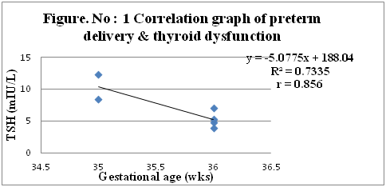

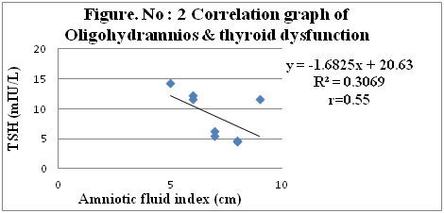

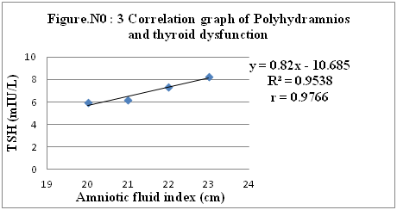
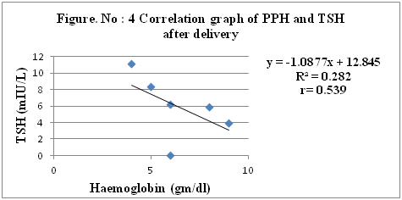

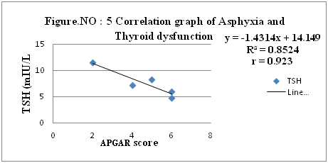
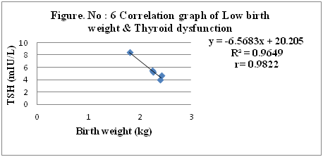
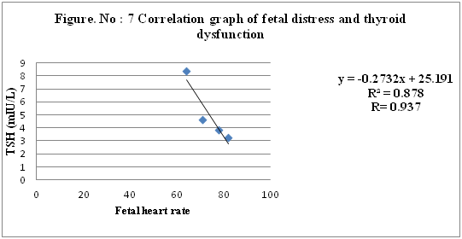

Table. No: 4 Causes for the maternal complications observed among euthyroid women
BMI | No. of women | Maternal complications |  |  |  | Obstetrics history
BMI | No. of women | Preterm  delivery | Oligohydramnios | Polyhydramnios | PPH | Primi | No.of women with multiple pregnancies
Normal(18.5-24.9) | 5 | 3 | 2 | 0 | 2 | 2 | 3
Overweight  (25-29) | 16 | 3 | 12 | 1 | 4 | 3 | 13
Obese class -1(30-34.9) | 9 | 1 | 8 | 0 | 1 | 2 | 7
Obese class -2(35-40) | 2 | 1 | 1 | 1 | 0 | 1 | 1
Obese class 3 (>40) | 3 | 1 | 2 | 0 | 0 | 1 | 1

From above it is clear that antenatal women with abnormal BMI and with multiple pregnancies are presented with more complications than antenatal women with normal BMI. The complications observed among antenatal women with normal BMI may be due to the multiple pregnancies, or the effect of their abnormal lifestyle (Table.No:4).
Table. No: 5 Causes for the fetal complications observed among euthyroid women
BMI | No.of women | Fetal complications |  |  |  | Obstetrics history
BMI | No.of women | Asphyxia | LBW | Fetal distress | Dec fetal movement | Primi | Multiple pregnancies
Normal(18.5-24.9) | 5 | 2 | 2 | 1 | 1 | 1 | 4
Overweight  (25-29) | 13 | 2 | 5 | 7 | 0 | 6 | 7
Obese class -1(30-34.9) | 13 | 3 | 6 | 6 | 0 | 6 | 7
Obese class -2(35-39.9) | 3 | 2 | 1 | 0 | 0 | 1 | 2
Obese class 3  (>40) | 1 | 0 | 1 | 0 | 0 | 0 | 1

From above it is clear that fetal complications are more common among antenatal women with abnormal BMI and with multiple pregnancies than antenatal women with normal BMI. The fetal complications observed among antenatal women with normal BMI may be due to the multiple pregnancies or the effect of their abnormal lifestyle (Table.No:5)
Table No: 6 Thyroid hormone replacement therapy
Given Levothyroxine dose  (mcg) | Total number | % of women received | The observed range of TSH of women receiving Levothyroxine
12.5 | 4 | 16 | 3.1 – 4.1
25 | 2 | 8 | 3.85 -4.1
25 | 4 | 16 | 4.2 -5.2
50 | 10 | 40 | 5.3 – 8.4
62.5 | 2 | 8 | 8.5 – 10.2
75 | 2 | 8 | 10.3 – 11.7
100 | 1 | 4 | 21.25

Levothyroxine doses of 12.5mcg, 25mcg, 50mcg, 62.5 mcg, 75mcg, 100mcg were given to hypothyroid women with TSH(mIU/L) range of 3.1 – 4.1, 4.2 -5.2, 5.3 – 8.4, 8.5 -10.2, 10.3 - 11.7, 21.25. For those patients whose abnormal TSH was not controlled with 12.5 mcg, their dose was increased to 25 mcg. The treatment was as per the guidelines of the American thyroid association.

Table. No: 7 Medication adherence rating score
No.of Patients | MARS Before counseling | MARS After counseling
40 | 03 | 09
35 | 06 | 08
22 | 05 | 09
20 | 07 | 10
17 | 08 | 09
16 | 10 | 10

The total medication adherence rating score ranges from 0 to 10, with a higher score indicating better adherence. After counseling there was a significant improvement in medication adherence with a p-value of 0.00 with mean and standard deviation of 5.84 ± 2.2, 9.006 ± 0.6902 before and after counseling respectively.

- DISCUSSION:
This study included 150 antenatal women attending the Obstetrics & Gynecology department of the tertiary care teaching hospital. Patient Proforma includes different parameters like patient demographic details, medication history, medical history, menstrual history, obstetrics history, vitals, thyroid profile, US scan, hemoglobin, GRBS, mode of delivery, APGAR score, medication chart & MARS scale.

Out of 150 antenatal women screened, the percentage of women with euthyroidism was 82% with a mean TSH, mean Ft4 & mean Ft3 of 1.825 mIU/L, 10.27 mcg/dl, and 126.25 ng/dl respectively. The prevalence of thyroid dysfunction was 18%. The prevalence of subclinical hypothyroidism was 16.66% with mean TSH, Ft4, and Ft3 of 6.614, 11.994, and 136.6 respectively. The prevalence of overt hypothyroidism was 0.67% with mean TSH, Ft4, and Ft3 of 5.93 mIU/l, 2.52 mcg/dl & 149 ng/dl. The prevalence of subclinical hyperthyroidism was 0.67% with mean TSH, Ft4, and Ft3 of 0.01 mIU/l, 14.5 mcg/dl, and 174 ng/dl. On observing the data it was clear that the occurrence of subclinical hypothyroidism was highest among the antenatal women with thyroid dysfunction.

To study the feto-maternal outcomes among the included subjects, they were evaluated for maternal complication variables like pre-term delivery, oligohydramnios, polyhydramnios & post-partum hemorrhage throughout their gestation period. The prevalence of maternal complications in euthyroidism, subclinical hypothyroidism, overt hypothyroidism & sub-clinical hyperthyroidism was found to be 27.64%, 56%, 100% & 100% respectively.

The prevalence of preterm delivery, oligohydramnios, polyhydramnios & PPH in antenatal women with euthyroidism was 8.13%, 21.13%, 1.626%, and 5.96% respectively. Although there were no co-morbidities and the function of the thyroid gland was normal, these complications were noted. After a thorough observation of the data obtained, we found that abnormal BMI, unhealthy lifestyle of the antenatal women, & multiple pregnancies may be the main reason for the occurrence of complications among euthyroid pregnant women. So a healthy lifestyle also plays an important role during pregnancy.
The scatter plot of gestational age vs TSH indicates that as TSH approaches the normal range, the gestational age of the pregnant women also approaches normal value i.e. as the thyroid dysfunction normalizes the chances of term delivery increase. The obtained Pearson's "r" value i.e. 0.856 & p-value of 0.02 suggests that there is a significant strong positive correlation between thyroid dysfunction and preterm delivery. The scatter plot of the amniotic fluid index and TSH indicates that as TSH approaches to the normal range, the amniotic fluid index of the pregnant women also approaches to normal value(10-19cm) i.e. as the thyroid dysfunction normalizes the chance of occurrence of oligohydramnios decreases. The obtained Pearson's "r" value i.e. 0.55 & p-value of 0.01 suggests that there is a significant moderate positive correlation between thyroid dysfunction and oligohydramnios. The scatter plot of the amniotic fluid index and TSH indicates that as TSH approaches the normal range, the amniotic fluid index of the pregnant women also approaches to normal value (10-19cm) i.e as the thyroid dysfunction normalizes the chance of occurrence of polyhydramnios decreases. The obtained Pearson's "r" value i.e. 0.976 & with a p-value of 0.02 suggests that there is a significant strong positive correlation between thyroid dysfunction and polyhydramnios.The scatter plot of hemoglobin and TSH indicates that as TSH approaches the normal range, the hemoglobin of the pregnant women also approaches to normal value (>9.5 g/dl) i.e. as the thyroid dysfunction normalizes the chance of occurrence of PPH also decreases. The obtained Pearson's "r" value i.e. 0.539 & with a p-value of 0.002 suggests that there is a significant moderate positive correlation between thyroid dysfunction and PPH.
These 150 antenatal women were also evaluated for fetal complications like asphyxia, low birth weight (LBW), fetal distress & decreased fetal movements. The prevalence of fetal complications in euthyroid, subclinical hypothyroidism, overt hypothyroidism, and subclinical hyperthyroidism was 27.64%, 36%, 100% & 0% respectively.

The prevalence of asphyxia, Low birth weight (LBW), fetal distress & decreased fetal movements in antenatal women with euthyroidism was 8.94%, 13.82%, 11.38%, & 0.81%. To know the reason for the occurrence of fetal complications among women with normal thyroid function and with no other co-morbidities, the data was thoroughly read out. Abnormal BMI, unhealthy lifestyle, & multiple pregnancies may be the main reason for the occurrence of complications among euthyroid pregnant women.
The scatter plot of the APGAR score and TSH indicates that as TSH approaches the normal range, the APGAR score of the newborn also approaches to normal value(>7/10) i.e as the thyroid dysfunction normalizes the chance of occurrence of Asphyxia also decreases. The obtained Pearson's "r" value i.e 0.923 & p-value of 0.025 suggests that there is a significant strong positive correlation between thyroid dysfunction and Asphyxia. This scatter plot indicates that as TSH approaches the normal range, the birth weight of the neonate also approaches to normal value (2500gm) i.e as the thyroid dysfunction normalizes the chance of occurrence of low birth weight among neonates also decreases. The obtained Pearson's "r" value i.e 0.9822 & p-value of 0.0028 suggests that there is a significant strong positive correlation between thyroid dysfunction and low birth weight. The scatter plot of fetal heart rate and TSH indicates that as TSH approaches to the normal range, the fetal heart rate also approaches to normal value(110 -160 bpm) i.e as the thyroid dysfunction normalizes the chance of occurrence of fetal distress also decreases. The obtained Pearson's "r" value i.e. 0.9822 & with a p-value of 0.04 suggested that there is a significant strong positive correlation between thyroid dysfunction and fetal distress.

Treatment of hypothyroidism among antenatal women was as per American Thyroid Association (ATA) guidelines. The dose of 12.5mcg, 25mcg, 50mcg, 62.5mcg, 75mcg, and 100mcg of levothyroxine was prescribed for antenatal women with hypothyroidism. For those whose TSH levels were not normalized with a dose of 12.5 mcg, a dose of 25 mcg was prescribed. In total, for antenatal women with TSH of range 3.1 -5.2mIU/L levothyroxine of dose 12.5mcg – 25 mcg was prescribed. For women prescribed with dose of 50mcg, 62.5mcg, 75mcg & 100mcg with TSH of range 5.3 – 8.4mIU/L, 8.5 – 10.2mIU/L, 11.2 – 11.7mIU/L & 21.25mIU/L respectively (Table. No: 6).

A medication adherence rating score (MARS) was used to measure medication adherence. MARS was noted before and after counseling the antenatal women about the usage of medication. Paired t-test was performed to know whether the counseling was effective or not. The alpha value was set to 0.05 and the obtained p-value (0.00) was less than 0.05, indicating there was a significant improvement in medication adherence after counseling. We found that medication adherence was significantly improved after counseling.

- CONCLUSION
From this study, we conclude that thyroid dysfunction among pregnant women is significantly correlated with fetal-maternal complications. So identifying and treating it in time would prevent the occurrence of detrimental outcomes. Analyzing the pattern of thyroid hormone replacement therapy we found that the given treatment was as per American thyroid association guidelines. Our counseling showed a significant improvement in the medication adherence of pregnant women.

REFERENCES

1) Saraladevi R, Nirmala Kumari T, Shreen B, Usha Rani V. Prevalence of thyroid disorder in pregnancy and pregnancy outcome. IAIM. 2016;3(3):1
2) Zhang D, Cai K, Wang G, Xu S, Mao X, Zheng A, Liu C, Fan K. Trimester-specific reference ranges for thyroid hormones in pregnant women. Medicine. 2019 Jan; 98(4).
3) Taylor PN, Lazarus JH. Hypothyroidism in pregnancy. Endocrinology and Metabolism Clinics. 2019 Sep 1;48(3):547-56.
4) Brent GA. Maternal hypothyroidism: recognition and management. Thyroid. 1999 Jul;9(7):661-5.
5) Tudosa R, Vartej P, Horhoianu I, Ghica C, Mateescu S, Dumitrache I. Maternal and fetal complications of the hypothyroidism-related pregnancy. Medical. 2010 Apr;5(2):116.
6) Alexander EK, Pearce EN, Brent GA, Brown RS, Chen H, Dosiou C, Grobman WA, Laurberg P, Lazarus JH, Mandel SJ, Peeters RP. 2017 Guidelines of the American Thyroid Association for the diagnosis and management of thyroid disease during pregnancy and postpartum. Thyroid. 2017 Mar 1;27(3):315-89.
7) Kankanamalage OM, Zhou Q, Li X. Understanding the pathogenesis of Gestational Hypothyroidism. Frontiers in Endocrinology. 2021;12.
8) Sorah K, Alderson TL. Hyperthyroidism in pregnancy. InStatPearls [Internet] 2021 Jul 26. StatPearls Publishing.
9) Lazarus JH. Hyperthyroidism during pregnancy: etiology, diagnosis, and management. Women's Health. 2005 Jul;1(1):97-104.

