Artificial Intelligence Based Medical Sensors for Health Care

Ms.N.Kavitha

Assistant Professor, Department of EIE

Hindusthan College of Engineering and Technology

Coimbatore, India

kavitha.eie@hicet.ac.in

Dr.P.Moniya

Assistant Professor, Department of EIE

Hindusthan College of Engineering and Technology

Coimbatore, India

moniya.eie@hicet.ac.in

ABSTRACT

The traditional medical order has been disrupted by the aging population and the presence of infectious diseases, greatly increasing the strain on healthcare and adversely affecting the socio-economic system. Artificial intelligence (AI)-based medical sensors offer novel perspectives on how to gather information for modern medicine to track changes in the environment and people's health. The status of AI-enabled medical sensors for off-body detection, near-body monitoring, disease prediction, and clinical decision support systems is briefly reviewed in this paper, along with the ongoing difficulties and possible solutions for moving from concept to implementation. Breakthroughs in the integration of medical sensors and AI algorithms are anticipated to open the door to early detection and clinical decision support as well as increase the accuracy and effectiveness of medical diagnosis in the very near future.

Keywords—Artificial Intelligence;Sensors;Machine Learning Algorithms;Clinical decision support sytem

# INTRODUCTION

Life span and quality of lives have been substantially enhanced in recent years due to advancements in biomedical science and micromachining technologies. Modern medical testing still struggles with reactive, preventive, and non-timely issues, which obstruct efficient and dependable real-time monitoring, diagnosis, and treatment. Currently, the most widely used techniques for keeping track of an individual's health continue to rely on clinical observation and self-reported questionnaires for the diagnosis and classification of diseases. A 30% decrease in misdiagnosed costs could be made in the global healthcare budget. In order to accurately anticipate and diagnose disease in its early stages, before symptoms manifest, with dependable and economical real-time monitoring techniques, it is necessary given the current aging population and COVID-19 world pandemic. The focus of medical testing must become more proactive and individualized.

Due to the tremendous workload placed on doctors who must care for many patients as well as their propensity to put off patient diagnosis and treatment, clinical observation is ineffective. On the other hand, the self-reported questionnaires necessitate a high level of patient focus, attention, and current mental state. People with impairments, infants, and the elderly are prominent examples of these restrictions. These issues result in a significantly increased likelihood of misdiagnosis, which negatively affects patients' health and financial burden in addition to degrading the doctor-patient relationship. Statistics show that one in seven diagnoses are incorrect globally, which has an impact on about one million people annually. Taking care of misdiagnosis might release 30% of the overall budget for global healthcare.

The combination of medical sensors and artificial intelligence (AI) has attracted a wide range of interest. Medical sensors, which can be categorized into off-body detection and near-body monitoring, transform biological factors into easily measured signals like electricity and light. In order to increase the efficiency and accuracy of illness diagnosis, off-body detection is mostly carried out by medical liquid sensors, gas sensors and imaging equipment to detect bodily fluids (blood, saliva, urine, etc.), exhaled breath, and medical images. The use of wearable devices placed directly on various body parts of the skin to quickly gather vital data regarding the wearer's health opens up new opportunities for telemedicine and continuous monitoring. There are many application scenarios, such as disease, motion, and mental status monitoring, due to the features of continuity, minimally invasive, and multi-indicator.

AI algorithms have advanced significantly in their ability to increase the effectiveness and precision of medical sensors' diagnosis and therapy. Support vector machines (SVM), principle component analyses (PCA), decision trees (DT), long short-term memories (LSTM), artificial neural networks (ANN), recurrent neural networks (RNN), and convolutional neural networks (CNN) are examples of common techniques at the moment. There may be greater potential for proactive, contemporary, and personalized medicine as a result of the massive amount of data that sensing gadgets collect and AI algorithms analyze. Typically, the structure of medical data is relatively complex, it is developing quickly, and it is rich. In order to analyze the internal structure of the ocean of medical big data, identify patterns of disease conditions, and get around the general access restrictions to local datasets, machine learning (ML) techniques can combine medical datasets from millions of patients, including diagnostic profiles, imaging records, and wearable information. The most recent developments in AI for clinical diagnosis from three angles, including CDSS, disease prediction, near-body monitoring, and off-body detection as in Figure 1

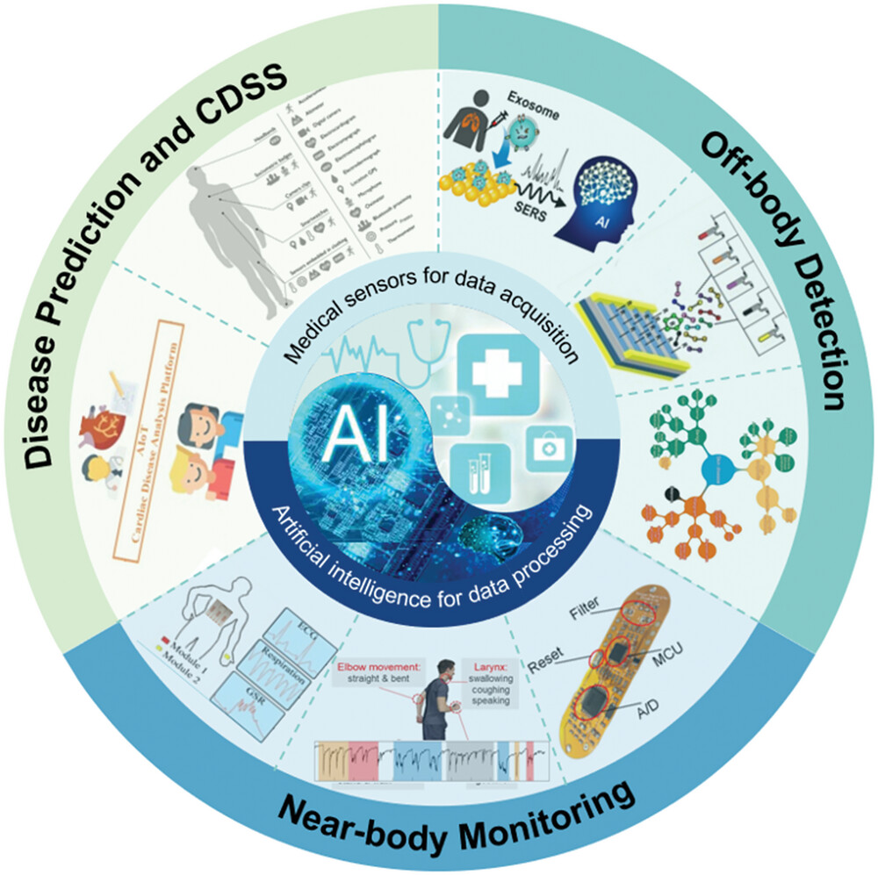

**Figure 1: Conceptual Diagram of the Combination of Medical Sensors and AI Algorithms**

# ARTIFICIAL INTELLIGENCE IN HEALTH CARE

## **Off Body Detection through Liquid Sensor**

Body fluids, such as blood, saliva, and urine, include a few biochemical markers that can be found in liquid sensors that help assess a person's health. These indicators include proteins, nucleic acid-based biomarkers, lipid metabolites, and other small molecules. However, some of challenges that modern medical sensors confront include interference from unrelated chemicals, short sample quantities, and dilution of biomarkers. Combining medical liquid sensors with an AI algorithm can successfully prevent these issues. In order to diagnose early-stage lung cancer, Shin et al. used Surface-Enhanced Raman Spectroscopy (SERS) based on deep learning. They extracted exosomes from human plasma samples and then gathered SERS signals using a plate coated in gold nanoparticles (GNP). Then, without learning insufficient human data, they used deep learning to investigate the characteristics of plasma exosomes and determine their similarity. The potential of deep learning-based SERS techniques for lung cancer diagnosis as a routine prescreening tool is demonstrated by the supervised model trained with SERS signals, which successfully classified the exosome data into two clusters and predicted lung cancer patients and healthy controls with accuracy of 95% and 90.7%, respectively. However, the examination of biomarkers found in blood extracts is intrusive and necessitates lengthy pre-processing procedures. Micro fluidic devices are prominent in clinical diagnostics because they may deliver comprehensive health information with little sample requirements and have advantages of miniaturization, high throughput, and automation.

## **Detection through Image**

When diagnosing a clinical ailment, imaging examination is frequently utilized to find alterations in the structure and blood flow of pathogenic tissues. With probabilistic and statistical methodologies, AI has been used on datasets of various sizes in the imaging industry. Radiologists can make diagnoses as accurately as feasible to cut down on diagnostic time and expense with the use of imaging feature processing and machine learning (ML)-based categorization or prediction. Furthermore, it enables radiologists to focus on areas of interest to detect cancer that might otherwise go unreported. In order to forecast the likelihood of developing lung cancer, Ardila et al. devised a deep learning method that analyzed a patient's recent and old computed tomography volumes. To find 3D cancer candidate regions, they built a 3D CNN model and trained a CNN region-of-interest (ROI) model. They ultimately created a cancer risk prediction model based on this to provide a case-level malignancy score. The model performs at the cutting edge for 6716 cases from the National Lung Cancer Screening Trial, 94.4% of the area under the curve (AUC), which is comparable to a separate validation sample of 1139 cases. The model outperforms all six radiologists in terms of accuracy, consistency, and adoption improvement for lung cancer screening without the use of prior computed tomography imaging, with absolute reductions of 11% in false positives and 5% in false negatives. Images are a promising detection approach for the currently widespread COVID-19 in addition to cancer diagnosis.

## **Near Body Disease Monitoring**

The ability to simultaneously monitor several physiological indications and biomarkers for illness monitoring is a major advantage of skin-based wearable technology. One of the most prevalent chronic diseases is diabetes, which requires regular monitoring of the patient's blood glucose levels. Based on functionalized CVD graphene, Lee et al. combined monitoring and treatment into a single wearable device. The electrochemical activity, sensitivity, and selectivity of the biochemical sensors were improved for the detection of human sweat biomarkers using the solid-state Ag/AgCl counter electrodes. A heating element could be activated to facilitate feedback dosing when a high glucose concentration was detected. The monitoring and therapeutic device was then created using a thin polyimide (PI) substrate, which facilitates integration and industrialization. The two loadable medications might achieve, respectively, gradual suppression and quick regulation of blood glucose levels. The innovative integrated solution offers significant improvements in stress- and pain-free diabetes care. Levodopa (L-dopa) levels in sweat can be used for Parkinson's disease medication dosage monitoring in addition to diabetes diagnosis. In the framework of a stress monitoring system, Riera et al. combined electromyography (EMG) and electroencephalography (EEG) to produce the analyzed data. Information on emotional states that are most closely related to stress was extracted using EEG. The monitoring system's resilience was increased using EMG. The classification rate may be effectively increased using the data fusion method from 79% to 91.7%, which is a fantastic result for a real-time system. Though models for monitoring mental state have come a long way, there has not been much progress made in the development of AI that can explain mental health issues.

## **Mental Status Monitoring**

Monitoring and assessing mental health are challenging tasks. One potential approach to the monitoring and recognition issue is the use of wearable technology to moment-by-moment measure a person's everyday activities. When AI is used, it is possible to intervene in patients' mental states in a timely manner to prevent disasters.ML, a subset of AI, has significant advantages in the merging of data from several biosensors and in the interpretation of that data. According to Zeng et al., epidermal electronics systems (EES) that use machine learning (ML) algorithms to categorize and forecast mental fatigue levels can simultaneously monitor numerous physiological signs. The EES comprises of two modules: the first module is attached to the chest for the purpose of monitoring the ECG and respiration rate, and the second module is attached to one palm for the purpose of detecting galvanic skin response. Then, three different types of machine learning (ML) algorithms (SVM, KNN, and DT) gathered features from the induced signals and created a predictive model to identify the level of weariness. The accuracy of the forecast can reach up to 89% and is based on six different physiological variables. The development of epidermal multifunctional sensors can be advanced with the use of this technology, which is reasonably easy to construct. Generalized anxiety disorder is a more severe ailment than mental tiredness and is considerably more difficult to monitor and assess.

# AI ASSISTED DESIGN OF BIOSENSORS

Electro-physiological and electrochemical signals from the body are measured by wearable biosensors. ECG, EMG, and Electro-Dermal Activity (EDA) are examples of electrical activities originating from different biological processes in the body that can be extracted from diagnostic devices or wearable sensors and provide important information about one's health conditions. The physiological signals can be analyzed to extract time and frequency domain properties using techniques including principal component analysis, discrete cosine transforms, auto-regressive methods, and wavelet transformations. In the real world, wearable sensors like smart phones or smart watches can be used to passively collect medical signal data. Gel electrodes positioned on the body have been the conventional method of signal acquisition. Recent developments in fabrication and electronics have enabled the integration of bio-sensing electrodes in additional devices such as eyeglasses, VR head-mounted displays, and textiles in addition to the use of conventional wearables like smart watches and fitness trackers.

## **Electrochemical Biosensor**

These are a common variety of biosensor. Ni and Kokot examined the use of conventional chemometrics in combination with EC biosensors in 2008.The application of cutting-edge ML techniques in modern EC biosensors, however, is still in its infancy. Although a wide range of signals can be described by the very complex theoretical foundations of electrochemistry, EC biosensors are not very repeatable or reliable in real sample detection. Numerous interferants may be present in real samples throughout a wide range of ionic strength, temperature, pH, and other factors. The electrode or modified electrode used in EC biosensors fouls over time, which is another factor. Therefore, sensitive signals that are significantly linked with the type and quantity of analytes cannot be acquired using one-dimensional data analysis. The potential for integrating ML with EC biosensors to investigate how ML may be used to increase sensor accuracy and reliability in real sample measurements is highlighted by this.

## **SERS and other Spectra based Biosensors**

A complex matrix can be used to obtain intrinsic fingerprint information about an analyte using surface enhanced Raman spectroscopy (SERS).One of the most promising analytical techniques for quick, label-free, on-site, and nondestructive detection is SERS sensing. However, the spectra of many analytes and the material in the matrix are comparable or overlap. Manually differentiating them is difficult or impossible. Hopefully, the use of ML will considerably increase SERS's efficacy. For ML approaches to work, the enhancement factor of the SERS substrate must be uniform because big data set variance increases prediction variance, which restricts the methods to semiquantitative or quantitative analysis. With medium or big data sets, CNN consistently displays higher prediction accuracy than other ML techniques. As a result, CNN is currently the most widely used for spectral analysis. For the purpose of identifying oligonucleotide (OND) damage on a gold grating substrate, a CNN-assisted SERS biosensor was created. Different operators used a portable spectrometer to gather the SERS spectra of OND without first optimizing the test settings (such as the best placement on the substrate, the strongest laser, the length of the acquisition, and manual baseline correction). A novel method of feature extraction known as binary stochastic filtering (BSF) was included in their CNN structure. In order to pinpoint significant regions in the original spectrum, BSF would assess the relevance of each item that was entered. The suggested SERS-CNN approach can locate extremely minute DNA damage that is rarely detectable by current methods. Their findings demonstrated that the OND damage categorization was up to 98% accurate, with a confidence level of greater than 95%.

## **Fluorometric and Colorimetric Biosensors**

Significant attention has been generated by the automatic classification of colors and their intensity from these biosensing photos. One kind of fluorometric biosensor is the digital polymerase chain reaction (dPCR). As colorimetric biosensors, we also include lateral flow assay (LFA), paper-based vertical flow assay (VFA), and other colorimetric strips. A promising method for diagnosing genes is fluorescence imaging-based dPCR. For the dPCR to be used in the actual application, it must be possible to recognize the positive reaction chamber in the fluorescent image accurately and quickly. The analysis of the photos has made use of conventional techniques such threshold segmentation, numerical clustering, and grid placement. Threshold segmentation is the most widely used image processing technique. In each analysis, the threshold segmentation's settings must be adjusted. Additionally, it is restricted to the analysis of photos with uneven brightness brought either by subpar camera imaging or irregular lighting. In the actual testing environment, the distribution of light intensity is never even. A low accuracy of the affirmative reaction chamber recognition may result from this circumstance.

A vertical flow assay (VFA)-based colorimetric sensor powered by deep learning was reported for C-Reactive Protein (CRP) detection. The deep learning method was used to optimize the configuration of immune reaction spots and predict the concentration of CRP. The CNN-aided colorimetric sensor can read the result fast and avoid the usage of large instruments.

## **Biosensors in Microfluidic Bioassay**

A quick diagnosis of a disease can be made with the use of blood cell counting. There have been several reports of ML-based microfluidic cytometers. For a lens-free blood cell counting system that integrates a microfluidic channel and a complementary metal oxide semiconductor (CMOS) image sensor, extreme learning machine based super-resolution (ELMSR) and CNN based super-resolution (CNNSR) were tested. Four times the cellular resolution was increased, and compared to the ELMSR, CNNSR displayed a 9.5% higher quality.

The quartz crystal microbalance (QCM)-based biosensor is one type of attractive sensing device which is gravimetrically sensitive and can detect analyte at sub-nanogram resolution. The SVM classification/regression algorithm was applied to discriminate/quantify trypsin and plasmin based on frequency shift data generated by QCM. Multi-biosensor synchronous measurement is important for practical applications. Fusion of sensing data from multiple biosensors directly impacts application performance. Wearable biosensors have gained remarkable interest owing to their huge potential in noninvasive monitoring of human physiology by multifarious biological fluid.

# MACHINE LEARNING ALGORITHMS IN DISEASE PREDICTION

In general, the collecting and processing of complex biological signals for disease prediction can be done using a combination of medical sensors and ML algorithms. The ML algorithms used in this scenario are typically supervised. In supervised learning, predictions are made using sample inputs from well-known classes. The fixed, in advance-provided data used to develop the models has the same statistical characteristics as the actual data used in the models. Regression-based ML algorithms, SVM, and CNN are a few examples of ML techniques that are frequently utilized in clinical management and disease prediction.

A continuous output variable can be predicted using one or more variables via regression-based ML models by fitting a linear or nonlinear function. Its main applications are in time series modeling and the identification of causal links between variables. To incorporate physiological and/or laboratory parameters for early clinical deterioration prediction, Zhai et al. created a logistic regression algorithm based on the Electronic Health Record. The approach outperforms published models by achieving 84.9% sensitivity, 85.9% specificity, and 91.2% of the AUC. Regression-based models provide a straightforward and intuitive method for classifying and predicting medical data by considering correlations based on well-known statistical concepts, but they also call for more exacting presumptions.

As a supervised machine learning algorithm, SVM can split multiclass issues into a few binary problems in order to address the "multiclassification" and "one-to-one predictive" challenges.SVM builds one or a collection of hyperplanes in high-dimensional spaces to partition the input dataset into candidate classes. The margin distance, which is the separation between the support vectors and the hyperplane divider line, reveals the precision of the classification outcomes. SVM offers a desirable solution for problems like categorizing patient symptoms based on clinical data.

Based on the combination of features, Sun et al. developed SVM for the prediction of severe/critical COVID-19 cases. As of March 12, 2020, 336 patients infected with COVID-19 in Shanghai were split into training and test datasets for this investigation. To find clinical indications linked to severe or critical symptoms and create a prediction model, 220 clinical and laboratory observations or records were also gathered. A total of 36 clinical markers, such as thyroxine, immune-related cells, age, and others, were found. In the training and test datasets, respectively, the optimum combinations of attributes achieve 99.96% and 97.57% of the area under the receiving operating curve (AUROC). The study shows that SVM is reliable and efficient in disease prediction, with high potential for early detection of severe/critical cases and resource conservation.

# ARTIFICIAL INTELLIGENCE IN CLINICAL DECISION SUPPORT SYSTEM

Healthcare providers are looking for quicker and less expensive ways to provide medical care. The standard hospital-based healthcare system prioritizes diagnosis above therapy. These days, the emphasis is turning to a big data-based, individual-centered healthcare system that emphasizes early risk factor detection, early diagnosis, and early preventative treatment. On the one hand, AI algorithms have the capacity to combine in-depth analysis with potent predictive abilities, offering quick disease forecasts for future data through extensive processing of medical data and model training. On the other side, CDSS supports decision-makers and healthcare systems in their efforts to enhance their access to information, insights, and settings. To accomplish the goals, a CDSS paired with AI, for instance, can take into consideration individual heterogeneity in environment, way of life, and genetic make-up. In a real-world setting, the tool's use will advance health assessments' capacity to identify and anticipate diseases, separate disease subcategories and genetic traits, and keep track of disease development and therapeutic procedures.

### **Table 1: AI in disease prediction and clinical decision support systems**

| **Sensor Types** | **Software/Hardware** | **Algorithm** | **Application** |
| --- | --- | --- | --- |
| Textile based Sweat Sensor | Chem Office Software | ANN | Prediction of stress for health evaluation |
| Surface EMG and inertia sensor | MATLAB | Support Vector Regression | Quantitative assessment of muscle spasticity |
| Wearable ECG patch sensor | IoT Hardware | CNN | Prediction of cardiac disease |
| Photoplethysmography Sensor | Tensorflow | CNN | Recognition of human activity |
| Clinical indicators  (GSH,Protein,etc.) | R Platform | SVM | Critical symptom of  COVID 19 |

# CONCLUSION

The healthcare industry is transforming from acute, reactive, and preventative healthcare to pro-active healthcare as a result of the development of AI-enabled medical sensors. Different physical and biochemical markers can be employed for diagnosis and clinical decision-making with the use of AI and sensing technologies. detection of diseases continuously and non-invasively using a comprehensive set of novel tools, allowing for both inpatient and remote patient monitoring in a choice of ways.AI algorithms combined with medical sensors have generated a lot of interest recently and have made major advancements. However, only a small number of novel discoveries are completely utilized in clinical applications and are commercialized. To enhance the market and medical value of biosensors, challenges must be solved.AI-enabled medical sensors will still present numerous new potentials in health monitoring, disease detection, and prediction despite difficulties in commercialization and practical use. With the combined efforts of researchers from around the world, it is anticipated that the use of medical sensors and AI algorithms will create a new platform for more accurate and efficient clinical decision-making in the future, with the potential to enhance almost every aspect of healthcare administration.

##### REFERENCES

1. S. A. Basit, R. Qureshi, S. Musleh, R. Guler, M. S. Rahman, K. H. 1077 Biswas, and T. Alam, “Covid-19base v3: Update of the knowledgebase 1078 for drugs and biomedical entities linked to covid-19,” Frontiers in 1079 Public Health, vol. 11, 2023.
2. L. Zhang, J. Wang, S. Wang, L. Wang, M. Wu, *J. Mater. Chem. C* 2022, 10, 4327.
3. R. Qureshi, M. Zhu, and H. Yan, “Visualization of protein-druginteractions for the analysis of drug resistance in lung cancer,” IEEE Journal of Biomedical and Health Informatics, vol. 25, no. 5, pp. 1839– 1190 1848, 2020.
4. H. Haick and N. Tang, “Artificial intelligence in medical sensors for clinical decisions,” ACS nano, vol. 15, no. 3, pp. 3557–3567, 2021.
5. I. Dayan, H. R. Roth, A. Zhong, A. Harouni, A. Gentili, A. Z. Abidin,A. Liu, A. B. Costa, B. J. Wood, C.-S. Tsai, et al., “Federated learningfor predicting clinical outcomes in patients with covid-19,” Naturemedicine, vol. 27, no. 10, pp. 1735–1743, 2021.
6. S. B. Junaid, A. A. Imam, M. Abdulkarim, Y. A. Surakat, A. O. Balo gun, G. Kumar, A. N. Shuaibu, A. Garba, Y. Sahalu, A. Mohammed, et al., “Recent advances in artificial intelligence and wearable sensors in healthcare delivery,” Applied Sciences, vol. 12, no. 20, p. 10271,2022.
7. R. Qureshi, S. A. Basit, J. A. Shamsi, X. Fan, M. Nawaz, H. Yan, and T. Alam, “Machine learning based personalized drug response 1 prediction for lung cancer patients,” Scientific Reports, vol. 12, no. 1, p.18935, 2022.
8. P. Rajan Jeyaraj and E. R. S. Nadar, “Smart-monitor: patient monitoring system for iot-based healthcare system using deep learning,” IETE Journal of Research, vol. 68, no. 2, pp. 1435–1442, 2022.
9. O. Sadak, F. Sadak, O. Yildirim, N. Iverson, R. Qureshi, M. Talo, C. P.Ooi, U. R. Acharya, S. Gunasekaran, and T. Alam, “Electrochemical biosensing and deep learning-based approaches in the diagnosis of covid-19: A review,” IEEE Access, 2022.
10. W. Ahmad, H. Ali, Z. Shah, and S. Azmat, “A new generative 1374 adversarial network for medical images super resolution,” Scientific 1375 Reports, vol. 12, no. 1, p. 9533, 2022.
11. H. Shin, S. Oh, S. Hong, M. Kang, D. Kang, Y.-g. Ji, B. H. Choi, K.-W. Kang, H. Jeong, Y. Park, S. Hong, H. K. Kim, Y. Choi, *ACS Nano* 2020, 14, 5435.
12. D. Ardila, A. P. Kiraly, S. Bharadwaj, B. Choi, J. J. Reicher, L. Peng, D. Tse, M. Etemadi, W. Ye, G. Corrado, D. P. Naidich, S. Shetty, *Nat. Med.* 2019, 25, 954.
13. C. T. Arsene, R. Hankins, and H. Yin, “Deep learning models for denoising ecg signals,” in 2019 27th European Signal Processing Conference (EUSIPCO), pp. 1–5, IEEE, 2019.
14. P. Kumari, L. Mathew, and P. Syal, “Increasing trend of wearablesand multimodal interface for human activity monitoring: A review,” Biosensors and Bioelectronics, vol. 90, pp. 298–307, 2017.
15. H. Lee, T. K. Choi, Y. B. Lee, H. R. Cho, R. Ghaffari, L. Wang, H. J. Choi, T. D. Chung, N. Lu, T. Hyeon, S. H. Choi, D.-H. Kim, *Nat. Nanotechnol.* 2016, 11, 566.