Local Village Tourism: An In-depth Analysis of the Entrepreneurial Opportunities and Community-based Tourism in Manger Village, Haryana

Ms. Jyoti Sehrawat

School Coordinator and Assistant Professor

Jyotisherawat@krmangalam.edu.in

School of Hotel Management and Catering Technology

K. R. Mangalam University

Gurgaon

Dr. Anjana Singh

Dean and Professor

Singhanjana@gmail.com

School of Hotel Management and Catering Technology

K. R. Mangalam University

Gurgaon

Abstract: The tourism industry in Haryana has a lot of room to grow thanks to the state's diverse array of attractions. One such new attraction point is the Mangar Village in Faridabad, located in the South Delhi Ridge of the Aravalli Mountain, Mangar Bani is a paleolithic archaeological site and sacred grove hill forest next to the Mangar village on the Delhi-Haryana border. The site and the stone tools found from this area date back to 100,000 years ago, and the cave paintings some 20,000-40,000 years ago(Indian Express, 2023)

Due to the increased number of tourists in the Mangar area; thanks to its naturescopic views and mountains, local tourism is flourishing, and with that, the local hotels, restaurants, and dhabas are setting a rise in revenue, the present study examines the rise of entrepreneurship spheres in the field of Hospitality in Mangar. This study will also focus on community-based tourism and aimed to understand the villager’s view on local sustainable Community-based Tourism in Mangar Village, Haryana.

Keywords: Local Tourism, Entrepreneurship, Hospitality, Mangar, community-based tourism

INTRODUCTION

The world is getting smaller day by day as people are traveling to farfetched destinations easily now, something that felt like a dream two decades back is now an easy reality for the travelers.

Some individuals travel to take advantage of economic possibilities, others do so for medical care, yet others do so to fulfil social commitments, still others go in quest of serenity and fulfilment, and many travel simply to survive. Whatever the cause, it is undeniable that individuals of all ages, socioeconomic classes, and nationalities are constantly on the go. Yet, the rise of tourism in our culture is not a relatively new development that followed the invention of the travel agency. The truth is that tourism has its roots at least as far back as Ancient Greece, when spectators from Europe and the Middle East congregated on Mount Olympus to compete in the inaugural Olympic Games. And now Tourism has grown into a sector with significant social and economic significance, and its impacts vary from local to global in scope (Mill and Kurec, 1980).
Till the year 2019, Tourism was one of the major contributors to our country’s GDP, over 17.9 million foreign tourists arrived in India in 2019 compared to 17.4 million in 2018, representing a growth of 3.5%. “In 2022, the Travel & Tourism sector contributed 7.6% to global GDP; an increase of 22% from 2021 and only 23% below 2019 levels”(WTTC, 2022). Due to Corona a sudden dip happened in Tourism not just in India but all over the world, and the moment the lockdown was lifted, people started traveling again giving birth to the term “Revenge Tourism”. But restrictions still prevailed in different parts of the country due to which people preferred to travel to nearby destinations, giving rise to Mangar Village as a tourist destination. Mangar Village in Faridabad, located in the South Delhi Ridge of the Aravalli Mountain, Mangar Bani is a paleolithic archaeological site and sacred grove hill forest next to the Mangar village on the Delhi-Haryana border.

Community-Based Tourism in developing countries is usually located in rural areas. The Tourism Policy of 2002 of the Government of India reflected the underlying forces of rural and community-based tourism and introduced the concept of rural tourism to showcase the rich cultural rural life of the Indian countryside to customers (Saayman and Giampiccoli, 2016). Since then, the scheme has been implemented in 107 villages across the country and the results have been mixed, but the success stories indicate that wherever successful; host communities‟ involvement was an important factor (Ministry of Tourism, Government of India, 2012).

Due to the increased number of tourists in the Mangar area; thanks to its naturescopic views and mountains, local tourism is flourishing, and with that, the local hotels, restaurants, and dhabas are setting a rise in revenue,

Given that there has never been research done on Mangar Village, it may be said that this work is the first of its kind and can, in a respectful way, serve as the basis for any future research that might be done on the topic.

Objectives of the study:

1.To identify the untouched tourism potential of Mangar Village

2.To identify the Hospitality Entrepreneurship opportunities in Mangar Village

3.To analyze the challenges faced due to the promotion of tourism by the local residents of the village.

LITERATURE REVIEW:

According to Gee et al. (2008), keeping consumers is a crucial concern for businesses in the current global marketplace. A company needs to establish enduring relationships with profitable clients in order to keep customers. Yet given that the market is a buyer's market today and that consumers are becoming more demanding because they want value for their money, it is a very challenging endeavour. When a marketer fails to provide value for the customers' hard-earned money, it also loses those customers' hard-earned business. In the tourism sector, the process of producing tourism includes visitors. They interact with destinations and supply networks. A tourist's satisfaction might be characterized by his or her emotional state following the trip (Baker and Crompton, 2000). Guests frequently find it difficult to assess services before making a purchase, but they do form expectations. According to Miller (1977), there are four different types of expectations that can be compared based on the level of desire: the minimum tolerable level (must be), the deserved level (should be), the expected level (will be), and the ideal level. The contentment of the guest/tourist is positively and significantly influenced by his or her opinion of quality (Campo and Yague, 2009).

According to Asher (1989), customer happiness is the ultimate goal, and full customer satisfaction is only attainable when all parties who can have an impact on how the customer's needs are met have access to complete knowledge about those needs. Fornell (1992) argues that measuring customer happiness is crucial for marketers because it enables managers to improve services, which in turn enables performance comparisons between organisations and locations (Kotler, 1994). According to Alegre and Cladera (2009), contentment and the number of prior visits both have a favorable impact on the intention to return. Based on the interactions between many first-order elements, tourist expectations are a second-order component (i.e. past experience, external communication, word-of-mouth communication and destination image). Additionally, it is possible to say that a destination's image is what mostly determines traveler expectations (Bosque et. Al, 2009).

As the basis of a tourist’s experience, the principal attractive characteristic is tourism resources which establish the main factor of destination services. Based on a refined and systematic synthesis of previous research work, Murphy et al. (2000) hypothesized destination services as a combination of two sets of factors. The first is service infrastructure including leisure and attraction, lodging, transport, food, travel, and shopping services. And the second is the destination ambiance and environment involving the natural environment, political, economic, technological, social, and cultural factors. The sum combination of these elements’ experiences will impact tourist perception of the destination experience. The research study of Murphy et al. (2000) explained the significance of service infrastructure to overall destination experience (both destination quality perception and trip value perception). The outcomes indicated that attractions are the fundamental elements to pull tourists to the destination. But this will be insufficient without appropriate and unique adequate activities to create an authentic tourist experience during their visit. This is also entirely consistent with the classic notion of Jefferson and Lickorish (1988) which assumes that tourism products and services must be conceptualized from two perspectives: i) a set of physical and service features as well as symbolic connotations which are supposed to realize the needs and wants of the tourists and; ii) as satisfying engagement activities at a preferred destination. Thus, while tourist behavior-based rationale contends that the core attributes are attractions in most cases, tourism product-based rationale argues that core attractive attributes are attractions themselves to be value-added through service activities associated with attractions.

Community Based Tourism (CBT) can be defined as “tourism conceived, managed and supplied by the local communities of a given territory” (Terencia, 2018, p.26). In a more comprehensive perspective, CBT was defined as “tourism that is planned, developed, owned and managed by the community for the community, guided by collective decision making, responsibility, access, ownership and benefits” (Tasci et al, 2013). CBT constructs up its potential by empowering and encouraging the community to be involved in planning, evaluating, and controlling resources for tourism development (Giampiccoli, 2018).

Although the term CBT is conceptualized in different ways, it has still three common attributes: the community is the main beneficiary of tourism development, the community is a co-producer of tourism operations and the community is a planning maker and supervisor of tourism development of the destination where they live in (Asker et al, 2010). In order to impart a sense of ownership to the community various programs would be planned such as convergence with the ‘Adopt a Heritage’ and ‘YUVA Tourism Clubs’ initiatives of the Ministry. Further local Colleges and Universities have been encouraged to ‘Adopt a Destination’. Celebrities and Diaspora rooted to the destination will also be leveraged for active branding and promotion.

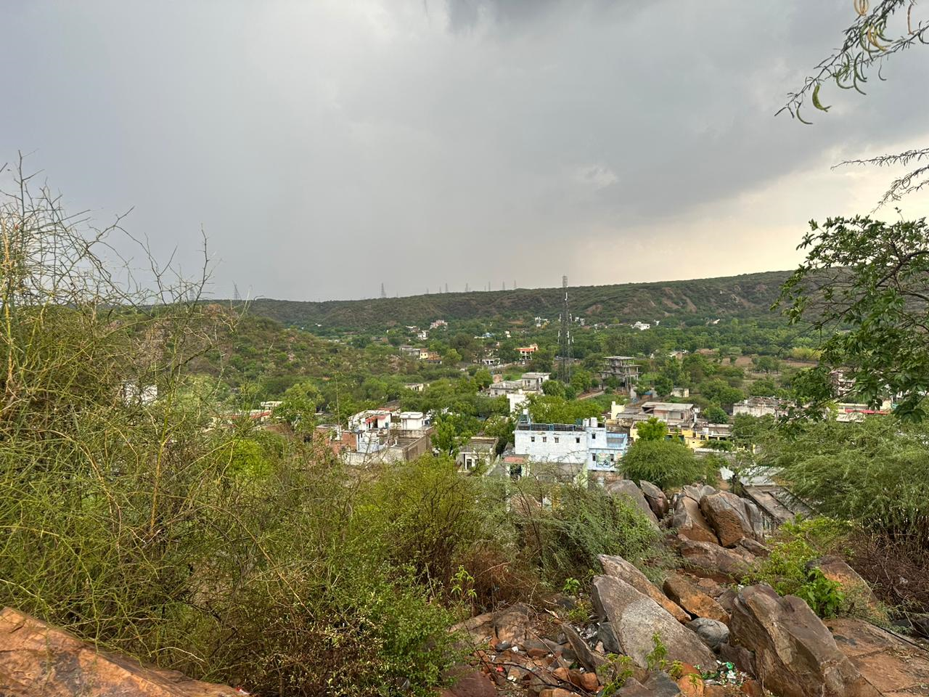
Mangar Bani is a sacred forest, which is located in Faridabad on the border of Delhi Haryana, next to Mangar village. Mangar Bani, a paleolithic archaeological site and sacred grove hill forest next to the Mangar village on the Delhi-Haryana border, which is dominated by Gurjar community; is in the South Delhi of Aravili mountain range in Faridabad district in the Indian state of Haryana. Mangar Bani has been studied by biologists who found it to be a high-diversity zone. It is one of the last remaining natural tropical forest in the Aravalli range. It has more than 30 native tree species thriving along with 100 native shrubs and herbs, all of which provide shelter to wildlife, animals and rare birds, and leopards. (Hindustan Times, 2015)

Methodology

The study has been developed with the case study approach and for that documentary research was carried out. Firstly, essential data was collected from scholarly works on local tourism community-based tourism, tourist entrepreneurship and related areas and then data from the website of local tourism and CBT destinations, field surveys were implemented because of better physical accessibility. These research areas are unique in nature and do not have much literature available. In this survey, observation and unstructured personal interviews were proceeded and this research has qualitative features, so convenience sampling was used. The choice of which CBT practices for the research, both by field surveys and documentary research, is based on the following criteria: Sustainable viability: the selected CBT practices are supposed to have lasting tourist appeal, improve continuously the livelihood of the community, encourage the long-term participation of the community. Frequently, qualitative research requires a smaller sample size than quantitative research. According to Morse (1994), an effective sample size should be 30-50 while Creswell (1998)’s suggestion is 20-30. The main data are the foundation of this study article. After gathering the data, it was analyzed with the aid of tables to make them easier to interpret. For the purpose of research, an exploratory cum descriptive study was carried out amongst a limited sample of 35 respondents, 10 local Dhaba owners, 10 local inn/hotel owners, 10 transport providers and 05 village residents.

FINDING AND ANALYSIS

PROFILE OF THE RESPONDENTS

S.  No. | Characteristics | Percentage of the respondents
1. | Respondent’s Gender | Male: 94%, Female: 6%
2. | Age | 30-35: 58%, 35-40: 28% , 40 and above 14%
3. | Respondent’s Occupation | Dhaba/Restaurant owners: 29%,Inn/Hotel owners:29%, Transport providers: 28%, Village Residents:14%

Table: 1.1

FINDINGS:

More than 245 species of birds, 20 species of mammals, and around 300 species of trees have been recorded here, and Sunil tells me the forest cover has increased since mining within the forest stopped in 2007. “Nature is self-repairing,” he says, “The forest is resurrecting itself and the population of wildlife is increasing, but the land-use change in the surrounding areas needs to be controlled.” The conversion of forest land to real estate is a serious concern and is damaging the biodiversity and geology of the Aravalli ranges.

The region was declared a no-construction zone in 2016, which has helped, but the encroachment of land for construction activities continues to plague the Aravalli Hills around Mangar Bani. Cara Tejpal, head of the Sanctuary Nature Foundation’s Mud on Boot’s Project that supports Sunil’s work, explains: “The very vulnerable forest of Mangar is subject to degradation, encroachment, and ‘development’ interests, despite being one of very few green patches that provide invaluable ecosystem services to the horrifically polluted National Capital Region.” She points out that Sunil’s work is in the interest of the citizens of Delhi and Faridabad. “Sunil is a home-grown conservationist, and his relentless efforts to restore and protect the forest is inspiring,” she says.

Identify the untouched potential of Mangar Village:

Post the corona period as there has been a rise of visitors in Mangar Village, the village still does not have any hotels or restaurants inside and since the village is covered majorly in the Forest area, tourists only prefer to visit the outskirts of the village as it is considered to be the habitat of leopards, bear, deer, civets and 90 species of butterfly, besides the rare species of birds and peacocks, these statistics show that Mangar has huge hidden tourism Potential.
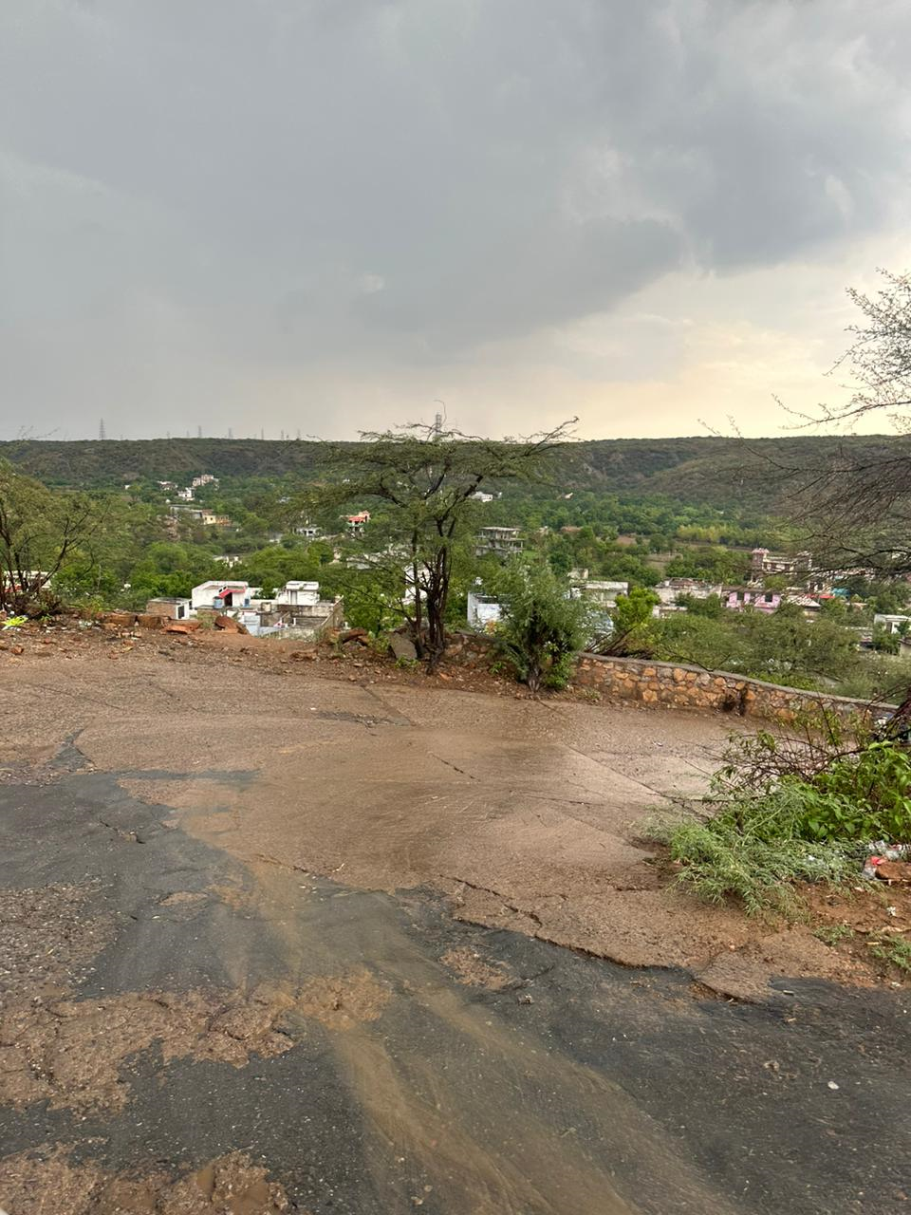

Identify the Hospitality Opportunities in Mangar Village:

The road leading to the village has around 10 dhabas, 12 hotels/inns/home-stays, however, there are no restaurants/eateries inside the village apart from that the village does not house any other kind of businesses like a Shopping Mart, Clothing store or even a flower shop for that matter, which proves that as Tourism increases the need for Eateries and Inns will increase as well. The Anupama Mangar, boutique property which was opened somewhere in 2017 is closed probably due to COVID. We need more simple, easily accessible properties which promote community-based tourism for guests to enjoy Mangar Village and Local Tourism. The locals have been protective about ecological conservation and respect the forest and have banned tree-cutting and grazing.

To analyze the challenges faced due to the promotion of tourism by the local residents of the village:

An increase in Tourism leads to the depletion of natural resources and an increase of pollution, vehicles etc, after speaking to one of the oldest residents of the village Mrs. Gyanwati Baisoya, a story was discovered about a sage named Gudariya Baba, It is said that the ghost of a local sage by the name of Gudariya Baba guards the forest of Mangar Bani. According to legend, a hermit by the name of Gudariya Baba visited the community many years ago and found enlightenment in a cave deep within this forest. After that, it became common knowledge that anyone who cuts down a tree for fuel, kindling, or livestock would suffer a curse. The inhabitants still zealously protect the forest, and not a single tree is chopped down or even manicured. As a result, in addition to unique bird species and peacocks, the forest is now home to leopards, bears, deer, civets, and 90 different types of butterflies! Bani is home to a lovely Dhau tree that formerly thrived widely throughout Rajasthan but is now all but extinct. The locals are constantly reminded of the vow made and the tradition upheld by a temple to Gudariya Baba that is tucked away in the middle of the forest. Locals from villages around Mangar visit the temple often.

The road to the temple itself is a very picturesque view as it is nestled in the forest covering the village.

The villagers do believe that the promotion of Tourism will bring in more people who would love to see the local destinations of the village.

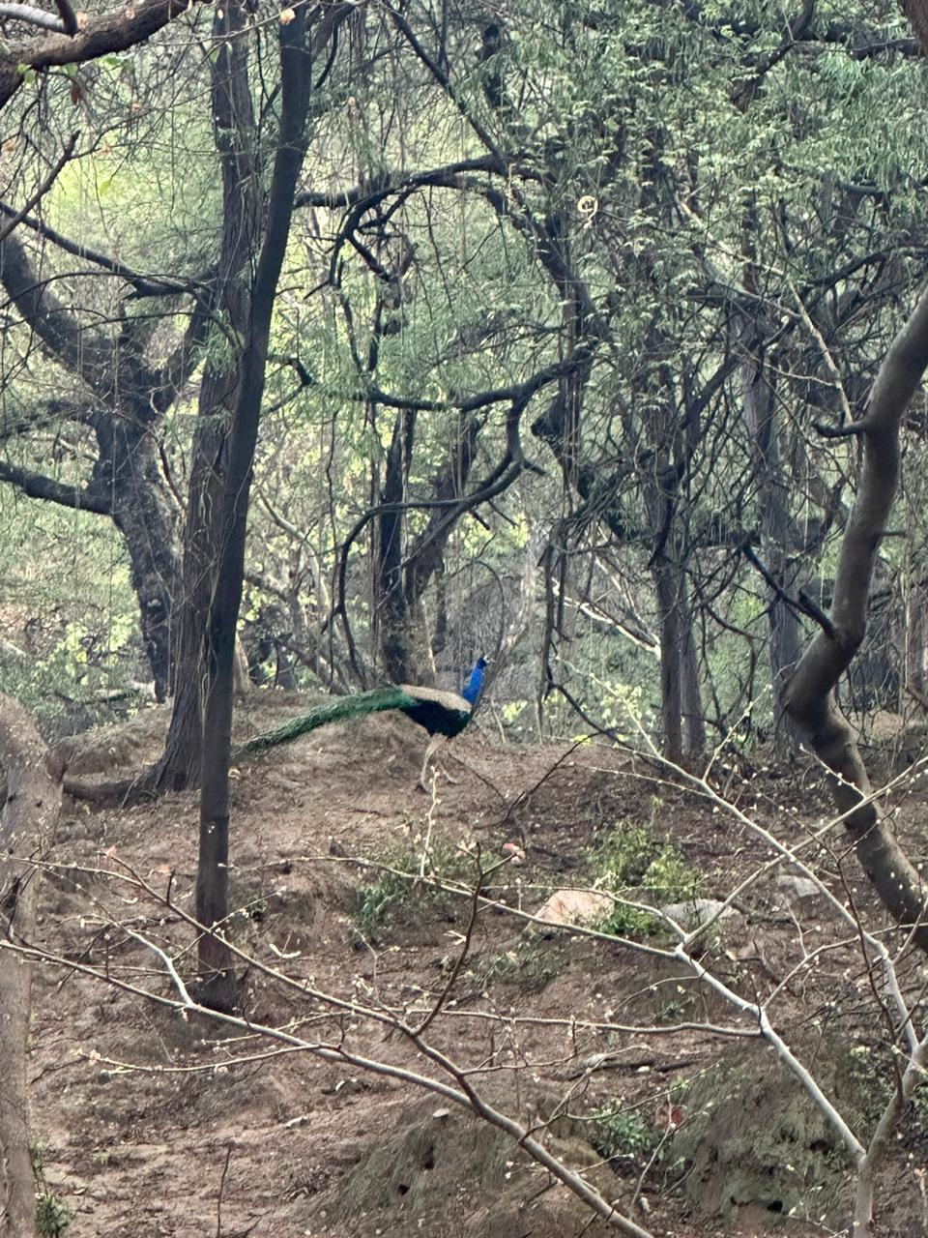

CONCLUSION:

One of India's industries with the quickest growth is tourism. Because of its infrastructure and history as a leader in tourism, Haryana is lucky. Haryana as a state is very rich in every aspect for the development of Tourism. The Haryana Tourism Board has put into practice numerous cutting-edge techniques and policies that have drawn tourists and increased state revenue. The board is always trying to realize the full potential of the tourist industry, which is viewed as a very significant sector. Although the private Dhabas, Themes Resorts and some multinational Franchises are fierce competitors for the Haryana state-run tourist attractions, these local attractions also have their own charm that helps them draw large numbers of visitors. In addition, they provide such a wide range of travel packages that no private player can match. With its variety of attractions, Haryana may be inferred to have enormous potential for expansion in the tourism industry.

The State wants to take advantage of tourism's direct and indirect benefits on boosting the economy, reducing poverty, and empowering women while maintaining the environment. A friendly climate for private sector investment in the tourism industry is being created.

Most of the places of Haryana are already saturated with tourists like Chandigarh, Gurugram, Ambala etc. However Mangar still has the potential to grow a lot more and become one of the most loved Tourist destinations in the near future. It will also help in the growth of entrepreneurial opportunities, jobs and will bring in more funds for the development of the village as well.

REFERENCES:

- Alegre Joaquin and Cladera Magdalena (2009). Analysing the effect of satisfaction and previous visits on tourist intentions to return. Europeans Journal of Marketing. 43(5/6). 670-685.
- Asher Mike (1989). Measuring Customer Satisfaction. The TQM Magazine. 1(2)
- Baker, D A., & Crompton, J. L. (2000). Quality, S and Behavioral Intentions, Annals of Tourism Research, 27(3), 785-804.
- Bowie David and Chang Jui Chi (2005). Tourist Satisfaction: A view from a mixed international guided package tour. Journal of Vacation Marketing. 11(4) 303-322.
- Fornell C. (1992). A National Customer Satisfaction Barometer: The Swedish Experience. Journal of Marketing, 56(1), 6–21.
- Ganapathy V. (2008): India, a Great Tourism Brand: Are we doing justice in marketing it? : Advertising Express: Volume: VIII, Issue: 10.
- Gnoth Juergen, Andreu Luisa, Kozak Metin (2009). Advances in tourism marketing research: Introduction to a special issue on consumer behavior in tourism destinations.
- Gro¨nroos, C. (1990) Service Management and Marketing – Managing Moments of Truth in Service Competition. Lexington, MA: Lexington Books.
- Ignacio Rodriguez del Bosque, Hector San Martin, Jesus Collado, Maria del Mar Garcia de los Salmones (2009). A framework for tourist expectations. International Journal of Culture, Tourism and Hospitality Research. 3(2) 139-147
- Joseph K. V (2008, December). Can Tourism Foster The Development Of Indian Economy? The ICFAI University Journal of Governance and Public Policy: Volume III, Issue: 4, 65 - 74.
- Kotler, P. (1994). Marketing Management: Analysis, Planning, Implementation and Control (8th ed.). Englewood Cliffs NJ: Prentice-Hall International.
- Miller, J. A. (1977) „Studying Satisfaction, Modifying Models, Inciting Expectations, Posing Problems and Making Meaningful Measurements‟, in Hunt,
- H. K. (ed.) Conceptualization and Measurement of Consumer Satisfaction and Dissatisfaction, pp. 72-91 Cambridge, M.A: Marketing Science Institute.
- Normann Richard (1978). Service Management: Strategy and Leadership in Service business, 2d ed. (Chichester, UK: Jhon Wiley, 1991), 16-17.
- Prof. Robert Christie-Mill, Tony Kurec (1980). Limits to the development of Tourism. Tourism Review. 35(4) 5-7
- Robert Gee, Graham Coates, Mike Nicholson (2008). Understanding and profitably managing customer loyalty. Marketing Intelligence & Planning. 26 (4) 359 – 374.
- Sara Campo, Maria Jesus Yague (2009). Exploring non-linear effects of determinants on tourists' satisfaction. International Journal of Culture, Tourism and Hospitality Research. 3(2) 127-138.
- Lovelock Christopher, Wirtz Jochen, Chatterjee Jayanta (2007). Service Marketing People, Technology, Perspective: A south Asian View (5th ed). Pearson Education.
- Singh, Praveen K (2008). Haryana grants industry status to hotel sector. Retrieved November 25, 2009, from http://www.expresshospitality.com/ 20080215/ market 01.shtml.
- Singh Anand (2005). Tourism in Ancient India. Serials Publications.
- WTTC (2022) Economic Impact Reports, (online). Available at Travel & Tourism Economic Impact | World Travel & Tourism Council (WTTC)
- Calderon, H., I. Gil, and M. G. Gallarza (2002) Destination Image: Towards a Conceptual Framework, Annals of Tourism Research, Vol. 29, No. 1, pp. 56-78,
- Donald Getz (1994) Residents' attitudes towards tourism: A longitudinal study in Spey Valley, Scotland, Tourism Management Vol. 15, Issue 4, pp 247–258
- Echtner, C. M., and J. R. B. Ritchie (2003) The Meaning and Measurement of Destination Image, The Journal of Tourism Studies Vol. 14, No. 1, pp. 33-48
- Saayman, M.; Giampiccoli, A. (2016) Community-based and pro-poor tourism: Initial assessment of their relation to community development. Eur. J. Tour. Res. 2016, 12, 145–190
- Ministry of Tourism, Government of India, (2012) India Tourism Statistics (online). Available from https://tourism.gov.in/sites/default/files/2020-04/India%20Tourism%20Statics%282012%29%20new.pdf
- Terencia, N. M. (2018). Community Based Tourism and Development in Third World Countries: The Case of the Bamileke Region of Cameroon. World Academy of Science, Engineering and Technology, International Journal of Social and Tourism Sciences, 12(1), 26-30.
- Tasci, A. D. S., Semrad, K. J., & Yilmaz, S. S. (2013). Community based tourism finding the equilibrium in COMCEC context: Setting the Pathway for the Future. Ankara: COMCEC Coordination Office
- Giampiccoli, A., & Mtapuri, O. (2020a). Towards a coalescence of the community-based tourism and ‘Albergo Difusso’ tourism models for Sustainable Local Economic Development. African Journal of Hospitality, Tourism and Leisure, 9(1), article 64:1-20. Retrieved from https://www.ajhtl.com/uploads/7/1/6/3/7163688/article_64_vol_9_1__2020_ukzn-dut. pdf

Hindustan Times (2015) Mangar Bani forest: Preserve biodiversity to ensure ecological security (online) Cited from Mangar Bani forest: Preserve biodiversity to ensure ecological security - Hindustan Times

- Morse, Janice M. (1994). Designing funded qualitative research. In Norman K. Denzin & Yvonna S. Lincoln (Eds.), Handbook of qualitative research (2nd ed., pp.220-35). Thousand Oaks, CA: Sage.

