**Chapter Title: Unveiling the Future: Emerging Trends in IoT**

R. Sujitha

AP/CSE

aecsujitha@gmail.com

9500551910

Annapoorana Engineering College, Salem

T.Geetha

AP/CSE

[geetha@vmkvec.edu.in](mailto:umamageswari6@gmail.com)

9952262419

Annapoorana Engineering College, Salem

R.Umamaheswari

AP/CSE

[umamageswari6@gmail.com](mailto:umamageswari6@gmail.com)

9629298728

Annapoorana Engineering College, Salem

**INTRODUCTION:**

The way we engage with technology has been transformed by the Internet of Things (IoT)., connecting devices, sensors, and systems to enable seamless communication and data exchange. As we delve into the future, the potential of IoT expands beyond imagination, shaping a world of interconnected devices, smart environments, and intelligent systems. This chapter explores the futuristic trends on IoT, shedding light on the transformative technologies and innovations that will reshape our lives.

**History**: The earliest days of computing can be used to trace the origins of the Internet of Things (IoT)., when scientists and engineers began to explore ways to connect devices and systems together. One of the earliest examples of an IoT device was a Coca-Cola vending machine that was modified in the 1980s to track its contents remotely.

British technologist Kevin Ashton originally used the term "Internet of Things" in 1999. Ashton was working at Procter & Gamble at the time, and he proposed using RFID the use of tags to follow products through the supply chain.

In the early 2000s, the IoT began to gain traction as the cost of sensors and wireless networking technology decreased. By the mid-2000s, there were already millions of IoT devices in use around the world.

The IoT has continued to grow rapidly in recent years, and it is now estimated that there are over 50 billion IoT devices in use worldwide. The IoT is being used in a wide variety of industries, including manufacturing, healthcare, transportation, and retail.

The future of the IoT is very bright. We may anticipate seeing even more ground-breaking and revolutionary IoT applications in the years to come as the technology advances.

The following are some significant turning points in IoT history:

1982: A Coca-Cola vending machine at Carnegie Mellon University is modified to track its contents remotely.

1999: Kevin Ashton coins the term "Internet of Things."

2000: The first smart home devices are introduced.

2004: The first RFID-enabled toll road opens in Texas.

2007: The first iPhone is released, which helps to popularize mobile IoT devices.

2010: The first connected car is released.

2015: Over 10 billion IoT devices are in use worldwide..

2020: The number of IoT devices in use worldwide exceeds 50 billion.

The IoT is still a relatively new technology, but it having the capacity to revolutionize many industries and improve our lives in a number of ways. We can expect to see even more innovative and transformative IoT applications in the years to come.

**CURRENT STATE OF IOT:**

IoT, or the "Internet of Things," is a technology that is having a major impact on many industries. The current state of IoT is characterized by:

* Massive growth: The expected number of IoT devices in use globally to be over 50 billion, and by 2025, it's projected to reach over 100 billion.
* Widespread adoption: IoT is being used in a wide variety of industries, including manufacturing, healthcare, transportation, and retail.
* Innovative applications: IoT is being used to create innovative new applications like smart houses connected cars, and predictive maintenance.
* Challenges: The IoT also faces some challenges, such as security, privacy, and interoperability.

Overall, the current state of IoT is very promising. The Technology is advancing quickly and being embraced by a large variety of industries, and it is being used to create innovative new applications. However, there are also some issues that need to be resolved before IoT can reach its full potential.

**EMERGING TRENDS IN IOT:**

**Artificial Intelligence and IoT Synergy:** In the future, the fusion of Artificial Intelligence (AI) and IoT will be a game-changer. AI will enhance the capabilities of IoT devices by enabling them to analyze, interpret, and respond to vast amounts of data in real-time. This synergy will empower IoT systems to make intelligent decisions, automate processes, and optimize resource utilization. IoT data collection by devices can be analyzed by AI to find trends and make predictions. This can be used to increase operational effectiveness, optimize resources, and prevent problems. For example, AI can be used to analyze data from smart sensors in a factory to identify potential problems with equipment before they cause a breakdown. This can help to prevent costly downtime and improve productivity.

AI can also be utilized to give users more tailored experiences. For example, AI may be used to examine information from wearable devices to track a user's fitness goals and provide personalized coaching. This can help users to stay motivated and achieve their goals.

**Here are some examples of how AI and IoT are being used together:**

* Smart homes: AI and IoT are being used to build smart houses with automatic lighting, temperature, and other setting adjustments to optimize comfort and energy efficiency.
* Connected cars: AI and IoT are being used to create connected cars that can collect data about driving conditions and provide drivers with real-time alerts. This can help to prevent accidents and improve fuel efficiency.
* Healthcare: AI and IoT are being used to create connected medical devices that can collect data about patient health and provide personalized care plans. This can help to improve patient outcomes and reduce costs.

The synergy between AI and IoT is still developing, but it has the potential to completely transform several industries. As these technologies advance, we can anticipate seeing even more novel and transformative applications in the years to come.

**Edge Computing:** Empowering IoT at the Edge: Edge computing will take center stage as IoT devices become more powerful and sophisticated. Edge computing lowers latency by processing data closer to the source., enhances security, and enables real-time analytics. In the future, edge computing will empower IoT devices to operate autonomously, improving efficiency and enabling rapid decision-making.

**Examples of edge computing:**

Smart city applications: Edge computing can be used to power smart city applications, such as traffic management, pollution monitoring, and public safety. For example, edge computing can be used to analyze data from traffic sensors to optimize traffic flow and reduce congestion.

Industrial automation with edge computing power industrial automation programs like preventative maintenance and machine learning. Edge computing, for instance, can be utilized to analyze data from sensors on industrial equipment to anticipate equipment failure times.

Healthcare: Edge computing can be used to power uses in the field of medicine, such as remote patient monitoring and medical imaging. For example, edge computing can be used to examine information from wearable technology to monitor a patient's health remotely.

Retail: Edge computing can be used to power retail applications, such as shelf inventory monitoring and customer analytics. Edge computing, for instance, can be utilized to analyze data from sensors on store shelves to track inventory levels and optimize product placement.

**5G Connectivity:** Enabling a Hyperconnected World: The advent of 5G technology will fuel the growth of IoT by providing faster and more reliable connectivity. With its low latency and high bandwidth, 5G will enable a hyperconnected world where billions of devices seamlessly communicate and share data. This trend will unlock new possibilities for smart cities, autonomous vehicles, remote healthcare, and industrial automation.

**Examples of 5G Connectivity:**

* Smart cities: 5G can be used to power applications for smart cities, like traffic management pollution monitoring, and public safety. For example, 5G can be used to connect a network of sensors to monitor traffic flow and optimize traffic signals.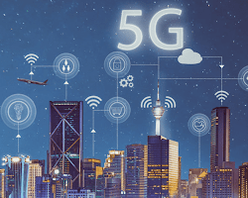

Smart cities 5G connectivity

* Industrial automation: 5G can be used to power industrial automation applications, such as predictive maintenance and machine learning. For example, 5G can be used to connect a network of sensors to monitor industrial equipment and predict when equipment is likely to fail.

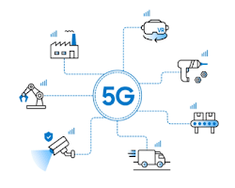

Industrial automation 5G connectivity

* Healthcare: 5G can be used to power healthcare applications, such as remote patient monitoring and medical imaging. For example, 5G can be used to connect a network of wearable devices to monitor a patient's health remotely.



* Entertainment: 5G can be used to power entertainment applications, such as virtual reality and augmented reality. For example, 5G can be used to stream high-definition VR content to users without any lag or buffering.
* Gaming: 5G can be used to power gaming applications, such as online multiplayer gaming and cloud gaming. For example, 5G can be used to provide gamers with a lag-free gaming experience.

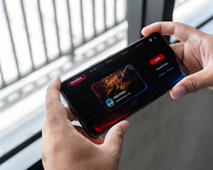

Gaming 5G connectivity

These are just a few examples of 5G connectivity. As technology advances, we may anticipate seeing ever more creative and transformative applications in the upcoming years. Here are some of the benefits of 5G connectivity:

* Faster speeds: 5G can provide speeds that are 100 times more quickly than 4G. The ability to download files, watch streaming videos, and play games much faster.

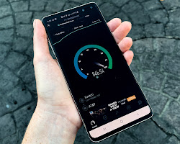

Faster speeds 5G connectivity

* Lower latency: 5G has lower latency than 4G. Therefore, there is a shorter lag time between a user's request and the network's response. This is crucial for real-time communication-dependent applications like online gaming and remote surgery.

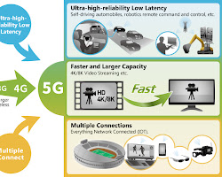

Lower latency 5G connectivity

**Blockchain:** Enhancing Security and Trust: Blockchain technology will play a significant part in securing IoT ecosystems. By decentralizing data storage and establishing transparent, tamper-proof records, blockchain will enhance the security and trustworthiness of IoT networks. In the future, blockchain will enable secure device-to-device communication, establish provenance in supply chains, and facilitate peer-to-peer transactions.

**Examples**

• Bitcoin: The most well-known blockchain example is bitcoin. It is a cryptocurrency that keeps track of transactions using blockchain technology.

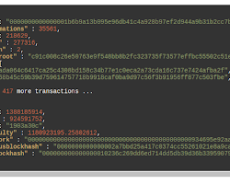

Bitcoin blockchain example

* Ethereum: Ethereum is a blockchain development environment that enables the creation of decentralized apps.

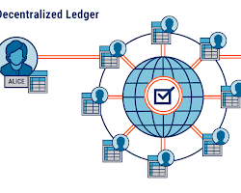

* Supply chain management: Blockchain can be used to monitor how products are moved along a supply chain. This might aid in confirming the authenticity of the goods and their lack of tampering.
* 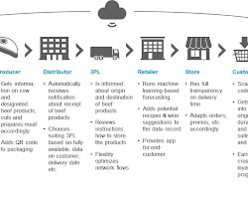

Supply chain management blockchain example

* Healthcare: Blockchain can be used to store medical records in a secure and tamper-proof way. This can help to improve the quality of care and protect patient privacy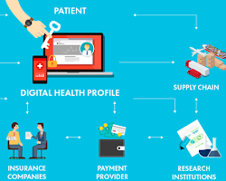

Healthcare blockchain example

* Voting: A voting system that is both transparent and safe can be created using blockchain. This can assist in prevent voter fraud and ensure that the votes are counted correctly.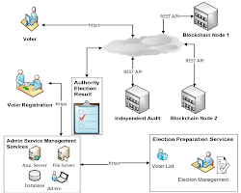

Voting blockchain example

**Human-Machine Interface and Wearable IoT:** Advancements in human-machine interfaces and wearable IoT devices will reshape how we interact with technology. From brain-computer interfaces to augmented reality glasses, these futuristic interfaces will enable seamless integration between humans and IoT systems. Gesture-based controls, voice commands, and biometric sensors will become commonplace, enhancing user experiences and improving accessibility.

**Examples**

Smartwatches: Smartwatches are wearable devices that can be used to interact with a variety of IoT applications. For example, smartwatches can be used to control smart home devices, track fitness goals, and receive notifications.

**Virtual reality (VR) headsets:** VR headsets can be employed for developing training-related immersive experiences, entertainment, and education. For example, VR headsets can be used to train surgeons on how to perform surgery, provide entertainment, and educate students about different subjects.

**Wearable sensors:** Wearable sensors can be used to collect data about the wearer's heart rate, activity level, and other physiological information.This information can be utilized to keep tabs on health and fitness objectives, and provide personalized healthcare recommendations

**Sustainability and Green IoT:** The future of IoT will be strongly influenced by sustainability and environmental concerns. Green IoT initiatives will emerge, focusing on energy-efficient devices, renewable energy integration, and responsible manufacturing practices. IoT systems will play a crucial role in optimizing resource utilization, reducing waste, and promoting sustainable living.

**Examples:**

**Smart agriculture:** IoT sensors can be used to track the temperature, soil moisture, and other environmental conditions in agricultural fields. Utilizing this information will improve irrigation., fertilization, and other agricultural strategies that can increase crop yields and decrease water use.

**Smart buildings:** The usage of IoT sensors for monitoring energy usage in buildings. This information can be used to pinpoint regions that energy can be saved, such as by turning off lights in unoccupied rooms or adjusting the temperature of the building based on occupancy.

**Green IoT devices: There are some IoT gadgets that are made expressly to be more eco-friendly and energy-efficient. Smart thermostats, for instance, may automatically alter a home's temperature based on occupancy, and** there are smart light bulbs that can dim or turn off when they are not in use.

**IoT in Healthcare: Revolutionizing Patient Care:** IoT will revolutionize the healthcare industry by enabling remote patient monitoring, personalized treatment plans, and preventive care. In the future, wearable health trackers, smart medical devices, and real-time data analytics will empower healthcare professionals to deliver proactive and efficient care, enhancing patient outcomes and cutting back on healthcare expenses.

**IoT devices can be used for remote patient monitoring, which involves keeping an eye on patients' vital signs and other health information. This can aid in early detection of potential issues and prompt intervention. For instance, people with chronic diseases like diabetes or heart disease can monitor their blood sugar levels or heart rates using wearable technology. Healthcare professionals can use this information to monitor the patient's status and modify the patient's treatment plan as necessary.**

**Wearable devices:** Wearable technology, like fitness trackers and smartwatches, can be used to gather information on a patient's physical activity, sleep habits, and other health-related variables. This information can be used to follow progress towards fitness goals, identify areas where lifestyle changes could be made, and monitor for potential health problems

**Conclusion:** The future of IoT is filled with transformative possibilities that will reshape industries, improve our daily lives, and address pressing global challenges. As AI, edge computing, 5G connectivity, blockchain, human-machine interfaces, sustainability, and healthcare applications converge, the potential of IoT becomes limitless. Embracing these futuristic trends will require collaboration, innovation, and a commitment to ethical and responsible IoT deployment. By harnessing the power of IoT, we can create a connected world that enhances efficiency, sustainability, and the overall well-being of humanity.