SYNTHESIS AND APPLICATION OF POLYMER CLAY NANOCOMPOSITES
Ramesh S^{1 *} and Anthuvan Babu S²
¹Department of Chemistry, R.M.D Engineering College, Kavaraipettai 601206, Tamilnadu, India.
²Department of Chemistry, Adhiyamaan College of Engineering, Krishnagiri, Tamilnadu, India.

ABSTRACT
Polymer nanocomposites (PNC) are a new class of composites for which at least one dimension of the dispersed particles is in the nano range 10-100 nm. They combine the concepts of both composites and nanometer size materials. Since nanometer size grains, fibers and plates have dramatically increased surface area compared to their conventional size materials, the properties of these nanosized materials are altered compared to conventional materials. They often have properties that are superior to conventional microscale composites because of the strong interaction between components and can be synthesized using simple and inexpensive techniques. Nowadays, clay minerals or layered-silicates are extensively used as reinforcing materials for improving many properties of the polymer. The main benefits of clay minerals as reinforcing materials are their low density, abundant availability, low cost, high aspect ratio and large specific surface area, which causes great enhancement in the properties of polymers. The detoxification of chromium from industrial effluents at various levels (ppb to μg) assumes considerable importance. In the present work, we report the synthesis and various application of organic polymer (Polyurethane, Poly (ethylene-co-vinyl acetate)) clay nanocomposites.
Keywords: Nanocomposites, Montmorillonite, Clay, Polyurethane, Poly (ethylene-co-vinyl acetate), Gas permeability, Fire retardant.

1.1. Introduction to Polymer Nanocomposites
Polymers are large molecules which are made up of covalently bonded smaller units, that is called monomers or repeating units. The interesting mechanical properties of polymeric materials depends on this specific molecular structure. For the last few decades, the elements such as wood, metals, and ceramics have been replaced by the increased extensive use of polymers [1]. This is mainly due to the polymers have offered more advantages over conventional materials, like productivity, ease of processing, and cost reduction [2]. The polymeric materials are highly resistant to meet the high demands on stiffness and strength for many applications in automotive, aerospace, electrical, infrastructure, microelectronics, construction, chemical, and medical industries [3, 4]. The use of thermoplastic polymers such as polyurethane, poly(ethylene-co-vinyl acetate), and polystyrene have received much commercial and academic attention in the past.
Generally, the term polymer encompasses a large group of synthetic and natural materials along with a broad variety of properties. In our everyday life, polymeric materials are ubiquitous and plays an essential role because of the extraordinary variety of properties. Based on physical nature and the scale at which the property is defined, the polymer properties are mainly classified into many types. The uniqueness of its component monomers is the most fundamental property of a polymer. The arrangement of these repeating unit within the polymer at the scale of a mono chain which describes the microstructure of polymer properties. The behaviour of continuous macroscopic material of polymer is determined by these basic structural properties, which play a critical role in determining the polymer with bulk physical properties. At the macroscopic level, how the polymer chains interact through various physical forces, and how the bulk polymer interacts with other solvents and chemicals which express the chemical properties of the polymer.
Nowadays, many scientists have focused on nanoscale structural materials such as nanoclusters, nanotubes, nanowires, and nanocomposites due to their size-dependent properties and low dimensionality and which are different from those conventional and bulk counterparts. They are enabled to alter for a broad range of applications. The suitable combinations of two or more nanosized objects or nanoparticles form a particular class of materials which is called nanocomposites. These are obtained by some proper technique, which results in materials having unique physical properties and broad potential application in various areas. The different sizes and nature of inorganic nanoparticles have been combined with the polymers, which form a host of nanocomposites with interesting, unique physical properties along with wide potential application. Based on the combination of the different nanoscale materials, such as hybrid organic-inorganic materials show potential systems for different applications because of their extraordinary properties. During the last few years, have attracted more attention towards the combination of organic polymers with nanoscale inorganic moieties which have a high potential for future applications. The two moieties are combined in countless different ways and there many methodologies to combine them into one material.
The properties of the resulting nanocomposite are controlled by the size of filler, the synthesis techniques, and the characteristics of the inorganic materials. The need for unpolluted surrounding the researcher is focussed on the development of polymer nanocomposite (PNC) materials because of their increasing concern for the environment. When the mechanical properties of heterogeneous composites are compared the PNCs materials are an emerging class of composite materials. The PNCs are specifically economic with environmental benefits and are fully recyclable. The great challenge in the fabrication of PNCs is the small difference in the melting temperature between the inorganic fillers and the polymer matrix.
Inorganic filler and organic polymer composite materials are more important because of their unexpected properties which occur from the synergism between components of the properties. These materials are obtained through several routes, but probably the most important one is the insertion of inorganic fillers in organic polymers matrix. These materials have due to the extraordinary change in properties such as thermal, mechanical, magnetic, and electrical compared to pure organic polymers, which has gained much interest [5].
1.2. Formation of Nanocomposite from the Constituents

Nanocomposites are classified into many types based upon the nature of combination between the organic and inorganic components, (Figure 1.1 a-c). In the first type the inorganic particle is embedded with an organic matrix. The second one is the confinement of organic polymer into an inorganic template. Moreover, in the above case the composite formation are only some encapsulation or entrapment rather than simple mixing or blending. The organo-inorganic hybrid materials such as the coating of transition metal oxide nanomaterial over conducting polymers are attractive for electrochemical applications due to they improve the electronic conducting properties. When inorganic materials are incorporated with polymer, the chemical interactions between the two moieties depends on, weak (hydrogen-bonds, Vander Waals force, hydrophilic-hydrophobic balance); strong (ionic covalent, coordination) bond of the two components., such as ease of handling and better performance of the final product [6]. Generally, the dispersion of inorganic nanoparticles in monomers, the in situ polymerization method has better advantages and a superior performance of the final product.
In order to get good dispersion in the polymer matrix or increase the interaction between the polymers and the inorganic nanoparticles is done by modifying the functional groups of the inorganic nanoparticles (Figure 1.1a). The introduction of nanofiller is that the inorganic nanoparticles are mixed into the matrix conducting polymer as shown in Figure 1.1b. The most interesting synthesis of nanocomposites is the encapsulation of various metal and metal oxide nanoparticles into the conducting polymers matrix. The properties such as chemical, physical, thermal, mechanical, and biological of these materials differ from those conventional polymers (Figure 1.1c). The solution and melt blending techniques are the simplest method in which the direct addition of the nanofiller into the polymer can be done. However, the biggest challenge is to fully disperse inorganic nanoparticles into the polymer matrix because of agglomeration of nanoparticles have strong tendency. In general, to enhance the dispersion of the inorganic nanoparticles into a polymer matrix is done by surface modification of the inorganic nanoparticles which gives strong interfacial interaction between the nanoparticles and polymer (Figure 1.2).
The Composite is solid multiphase materials, which are made up of more than one component. It is formed through a combination of physical, structural chemical of properties of materials. These composite materials have different properties than other multi- component systems like blends and alloys. Composites materials have properties such as weight, strength, stiffness, permeability, electrical, biodegradability, and optical properties which are a challenge to separate into individual component. Generally, the dispersed phase is implanted with the matrix phase to make it a composite, which has superior properties than the individual phase. To meet the specific properties for engineering application, the preparation process and optimal designing of composite material are very essential.

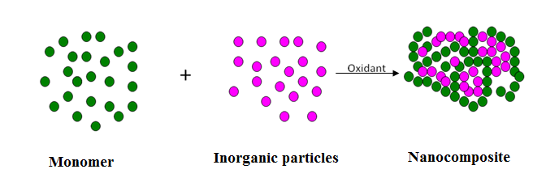
Figure 1.1. (a) Formation of polymer nanocomposite via insitu Polymerisation.
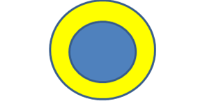
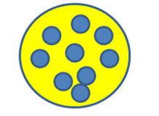
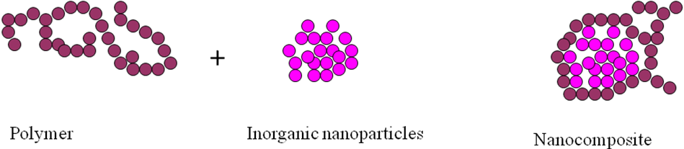
Figure 1.1. (c) Organic polymer is confined to an organic template.
Figure 1.1. (b) Inorganic particles are embedded in a polymer matrix.

Figure 1.2. Polymer nanocomposite formed using polymer and inorganic nanoparticles.
Polymer nanocomposite material is constructed by the combination of polymer and natural (or) synthetic inorganic filler typically 10 Å – 100 Å. It is used as a filler to improve the significant properties of polymer or reduce the cost of materials. The conventional filler like talk, fibber, CaCl₂ requires applying a more quantity in the polymer matrix to improve the composite properties such as brittleness or loss of opacity. The properties like electrochemical, mechanical, thermal are depended on the aspect ratio of the filler [7]. The nanofiller with high aspect ratio such as clay, nanofibers, nanotubes have great attention today, because of their unique functional properties. Filler having nanoscale dimensions and high aspect ratio dispersed in polymer matrix leads to the dramatic improvement in polymer properties at low volume fraction filler.
1.3. Chemistry of Chromium
Nowadays, the existence of heavy metal in the surrounding is a significant concern because of their affinity to bioaccumulate and toxicity at low concentration in the food chain. The collection of metalloids and metals having with greater than 6 g cm⁻³ of atomic density is the termed as ‘Heavy metals’. Most of the heavy metals are known as primary concern pollutants and causing possible long-term and short-term undesirable effects in the environment. In industries, the heavy metals are used in various applications and it has resulted in water bodies the amount of metal pollution was increased [8]. Generally the elements like Cr, Cu, Cd, Hg, Pb, Zn and Ni which are recognized as high atomic density elements create pollution, toxicity problems in the environment [9].
In 1797, the French chemist Nicholas-Louis Vauquelin isolated chromium oxide of the element from Siberian mineral crocoite (PbCrO₄). He hypothesized chromium as a distinct and separate element. In 1798, Vauquelin heated chromic oxide with charcoal and isolated the metallic Cr. He invented Chromium as a new periodic element which has a unique colour and distinct properties. The metal Chromium is called as a transition element with atomic number 24. Chromium is present in-group 6B in the periodic table, which is the sixth most abundant transition metal and the earth’s 21st most abundant element about 122 ppm [10]. Chromium metal is a glossy, silvery, and rigid as well as brittle in nature. The metal Cr has a density of around 7.19 g cm⁻³ and its melting point, the boiling point is around 2180K and 2944K respectively, which is comparatively low when compared to other transition elements in the periodic table. Chromium has a wide range of oxidation state from –2 state to +6 state.
The most important ore of chromium is chromite FeCr₂O₇. Cr (VI) is known as a highly sensitive, as it causes various human health effects. When it is compound with leather products, it can cause skin rash problems. Further when Cr(VI) is breathed can cause nose irritation and nose bleeds. The other health problems such as ulcer, respiratory problems, kidney and liver damage, lung tumour, and finally death are caused by chromium VI metal element. The metal chromium is both valuable and harmful. The mammalian metabolism that occurs in the body is an essential trace element is Chromium(III). In addition to insulin, it is used to control diabetes, and it is responsible for reducing glucose levels in the blood. Chromium(III) is obtained from a mixture of foods like cheese, liver, Brewer’s yeast, cereals, whole grain items of bread, and broccoli. Metallic Cr compounds are widely employed in electroplating, pigments, leather tanning, metal finishing, catalysis, wood protection, electronic and electrical types of equipment. Through Cr (V) undergo oxidation again by OH radicals that are speculated to be caused by molecules of hydrogen peroxide that are close within the cell [11].
1.4. Chemistry of Heavy Metals, Toxicity and their Remediation Methods
Heavy metals are in naturally occurring elements that originate throughout the earth’s crust and have a higher density than a water molecule. Metals and metal-containing compounds are used in anthropogenic activities like mining, smelting operations, industrial production, domestic and agricultural product. The human contact of this process affects the health and contaminates the environment. Many studies have established that reactive oxygen species production and oxidative stress play a key role within the toxicity and carcinogenicity of metals like arsenic, cadmium, chromium, lead, and mercury. Due to their high degree of toxicity, these five elements rank among the primary concern metals that are of substantial municipal health consequence. Even at lesser levels of revelation, they are all general toxicants that are known to induce multiple organ damage.
Mercury exists in several forms: organic mercury compounds, inorganic mercury compounds, and Elemental or metallic mercury. The exposed elemental mercury evaporates at room temperature to be changed into a toxic vapour. Mercury have three oxidation states: Hg (0), (+1) and (+2) respectively [12]. Mercury is used in the medical filed like dental fillings and scientific products like manometers, thermometers, and barometers. The main application use of mercury is in electrical equipment sectors such as fluorescent lamps, and preparation of mercury batteries [13]. The methyl group attached with mercury have more chemical properties which accumulate in flora and fauna. It is very toxic to the central and peripheral nervous system. The mercury vapour inhalation results in harmful effects on the nervous, digestive, and immune systems. Copper is an important co-factor for many oxidative stress-related enzymes together with catalyse, peroxidase, superoxide dismutase, cytochrome c oxidizes, ferroxidases and monoamine oxidize. The property of copper is that it makes potentially toxic due to the transitions between Cu(II) and Cu(I) that result within the generation of superoxide and hydroxyl radicals. Further, excessive exposure to copper has been correlated to cellular damage resulting in Wilson disease in humans.
The environmental production agency of US has recommended the permitted level of Chromium in wastewater and industrial process. The wastewater coming out from homes and industries should be less than 2 ppm and 100 ppm respectively. It has also recommended the permitted level of mercury in drinking water should be less than two micrograms per litre. Generally, heavy metal of human poisoning are treated by chelating agents which convert heavy metals to chemically inert forms. These chelates can be excreted without interaction and remove beneficial minerals from the body, and there is no side effect [14]. Heavy metals contaminated by soil can be remediated by the following techniques. They are isolation, extraction, immobilization, and toxicity reduction, which are varied depending on the contaminant and characteristics of the heavy metals. In the isolation process, caps, ground barrier, and membranes are used to quarantine the soil contamination. The mobility of heavy metal contaminants have used in the immobilization process to hinder and change the properties of the soil. The highly toxic heavy metal ions are converted into less toxic metals by chemical redox reaction, which is used in the toxicity reduction method. Extraction or physical separation method is a mechanical separation of heavy metal contaminant. This process uses corresponding chemicals, temperature, electrolysis to extract heavy metal contaminants from the soil.
Due to the consumer and industrial waste, the heavy metal may enter into water bodies which breakdown the soil. They release contaminated heavy metals into rivers, lakes, streams, and underground water bodies. Because as the metal solubility increases the metal particle become more mobile when the pH value of the water bodies fell. Hence soft water containing metals are more toxic. Some elements like V, Mn, Fe, Co, Cu, Zn are essential for human health. The above metal deficiency may increase the weakness of heavy metal poisoning. Nowadays the adsorption of heavy metal from water and soil has created an interest in many researchers as it can be produce green environment revolution.
1.5. Clay Minerals
Clay minerals are also known as layered silicates or phyllosilicates because of their structure which is composed of 1 nm thick silicate layers comprising alumina sheets with various proportions and interlayer distance. These clay nanoparticles have additional benefits over conventional macro, or microparticles (eg: glass, carbon fibbers) because of their surface area and more aspect ratio enhanced adhesion between clay and polymers and also the low quantity of loading to attain similar properties [15]. Clay which has layered silicates are hydrophilic in nature.
The silica and alumina sheet undergo condensation in a particular ratio and result in three different types of clay minerals which are ,1:1 type, 2:1 type and 2:2 type.
(i) 1:1 Type Clay Minerals
This 1:1 type of clay minerals are made up of condensation of one tetrahydral silica sheet with one octahydral alumina sheet in the ratio of 1:1 (Figure 1.3). It is otherwise called as two sheet or dimorphic minerals. The hydroxyl group of alumina sheet are held by hydrogen bonding with oxygen of silica sheet in the layer. These sheet do not have isomorphic substitution, hence does not have any charge on it. The water molecule are occupied the space between the cation and anion of alumina and silica sheets. The common example of this group is Kaolinite, perlite, Hallosite (Figure 1.4).
(ii) 2:1 Type Clay Minerals
This 2:1 type of clay minerals is made up of one octahedral alumina sheet combined with two tetrahedral silica sheets in the ratio of 2:1. It is otherwise called as trimorphic or three sheet minerals which comes under smectite family. These two layers are held by Vander Waals force. Each layer in this type is negative charged due to isomorphic substitution of aluminium ion with iron, manganese, lithium ion in octahedron sheet and silica ion with aluminium ion in tetrahedron sheet. The metal ion present in interlayer space is balanced by negative ion present in layers. eg: Montmorillonite, Hectorite, Saponite.
(iii) 2:2 Type Clay Minerals
The 2:2 type structure is called as tetramorphic four sheet minerals. It is formed by alternate condensation of alumina or magnesium octahedron sheets and silica tetrahedron sheets. A well known example is chlorite minerals.
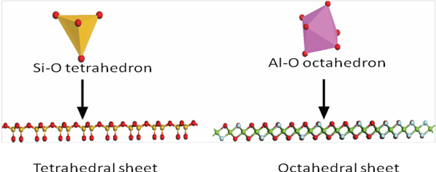

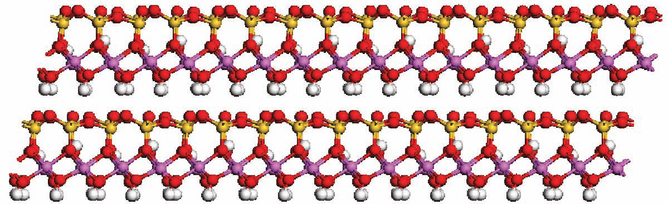
Figure 1.3. Tetrahedral sheet of Silica and octahedra sheet of Alumina.

Figure 1.4. Kaolinite of 1:1 Type clay minerals structure.
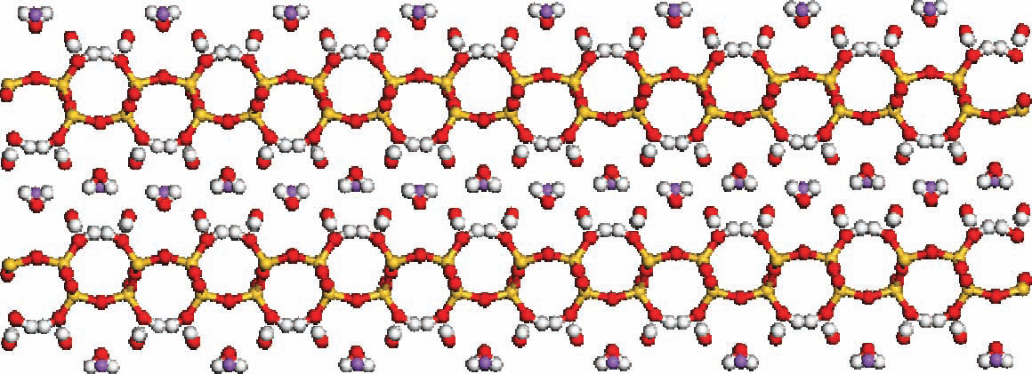

Figure 1.5. Kanemite of Layered silicic acids structure.
(iv) Layered Silicic Acids
Layered silicic acids are natural clay minerals. This type of clay minerals is made up of many layers of silicon tertahedron which are very thick. The fundamental structure of layered silicate contains hydrated alkali metal cations in the interlayer space. The interlayer regions contain silanol group which support organic modified functional group in that interlayer regions (Figure 1.5). This type of clay minerals have superior intercalation properties like smectite clay, which is one of the potential member for the synthesis of polymer based nanocomposites. The chemical formula, examples of various clay and characteristic parameter of different types of clay are given in Table 1.1.
1.6. Montmorillonite (MMT)
Montmorillonite is one of the important 2:1 type clay layered mineral. This layered structure is formed by combination of two tetrahedral silica sheet with one aluminium octahedral sheet. The tetrahedral silica sheet contains oxygen atom to share octahedral aluminium sheet which provide negative charge to overall lattice structure (Figure 1.6). The surface of MMT structure is negative charged which attract cations like Na⁺, Ca⁺, Fe⁺ ions from other chemicals. These layers are held by Vander Waals force. The MMT of the silicate layer is planar structure, rigid in nature about 1 nm in thickness with large active surface area (700-800 m²/g) and high aspect ratio. The amount of single layer thickness and the interlayer is known as d-spacing or basal spacing. The cation exchange capacity of clay minerals is referred as the sum quantity of the absorbed cations (K⁺, Na⁺, Ca²⁺, and Mg²⁺) in the inter gallery of clay layers at pH value of 7. It is calculated by the unit mill mol/100g of layered silicate. Higher the amount of negative charge, the stronger is the capacity for hydration, swelling, and dispersion [16].
MMT is one of the most important clay for synthesising polymer clay nanocomposites when compare with other clay due to irregular structure, cation exchange capacity and the ability to swelling character. MMT have significant attention as a greener catalyst in many organic synthesis process. MMT is used in chemical waste reduction, control waste hazard, reduced energy consumption, reduced raw materials and also to reduce the process cost. It is used as adsorption of toxic heavy metals including As, Co, Cr, Pb, Mn, Ni and Cd. It is also used in improving the drug delivery system, adsorption of dyestuff, resistance to tooth decay, support of health and growth, water adsorption, heat resistance and cation exchange capacity.

Table 1.1. Classification of different types of Clays minerals.
S. NO. | Clay Minerals | Chemical Formula | CEC  (mequiv/100 gm) | Particle length (nm) | Substitution/  Charge
1 | 1:1 clay  Kaolinite  Halloysite | Al₂Si₂O₅(OH)₄  Al₂Si₂O₅(OH)₄.2H₂O | 1-10  1-30 | 30-40  30-40 | Neutral  Neutral
2 | 2:1 clay  Montmorillonite  Hectorite | M_{x}(Al_{4−x}Mg_{x})Si₈O₂₀(OH)₄  M_{x}(Mg_{6−x}Li_{x})Si₈O₂₀(OH)₄ | 120  130 | 110-160  210-310 | Octahedral/ Negative  Octahedral/ Negative
3 | 2:2 Clay  Chlorite | (Mg, Fe)₄Al₄Si₂O₁₀(OH)₈ | 10-40 | 1-100 | Tetrahedral/ Negative
4 | Layered silicic acid  Kanemite | Na₂Si₄O₉·5H₂O | 10-100 | 1-100 | Tetrahedral/ Negative
5 | Organo modified clay  Cloisite 25 A | 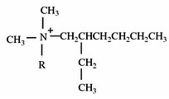 | 95 | 1-100 | Tetrahedral/ Negative

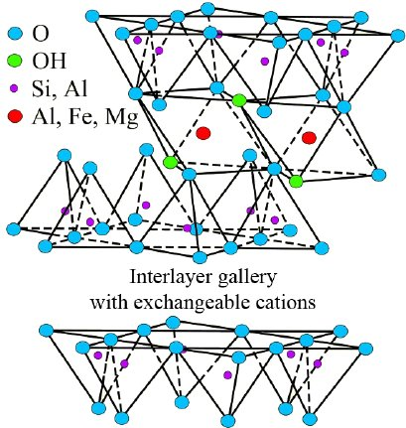

Figure 1.6. Structure of montmorillonite.

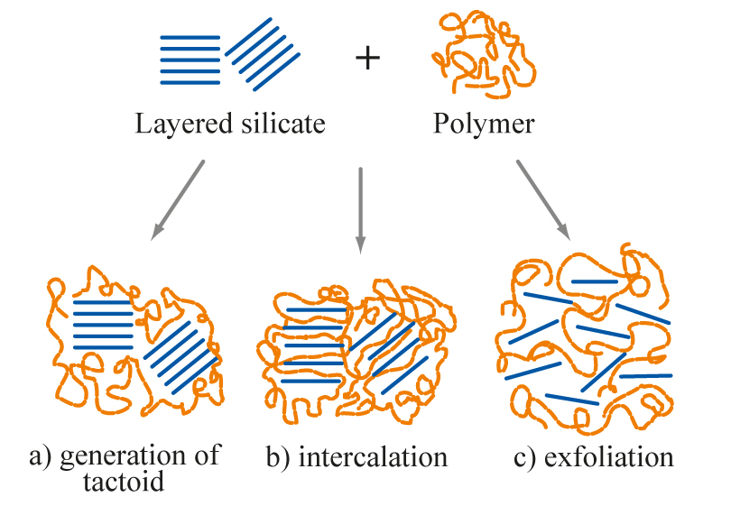

Figure 1.7. Intercalated and exfoliated nanocomposites from layered silicates and polymers.
1.7. Surface Modification of clay
Montmorillonite (MMT) bedded clay mineral has drawn immense significance because of its distinctive cationic changes intercalation and enlargement capacities. MMT belongs to 2:1 type of mineral phyllosilicates group with the crystal structure created from a nanometer thick layer of Al polyhedron octahedron sheet sandwiched between two silicon tetrahedron sheets. These clay nano particles have more advantages than the traditional macro or micro particles (eg: glass, carbon fibers) due to their high aspect ratio and surface area enhanced adhesion between clay and polymers, with a lower amount of loading to achieve similar properties. Bedded silicates of clay area unit are deliquescent in nature.
Most of the organic polymer are hydrophobic. Dispersion of clays in most polymers is not easily achieved due to its intrinsic incompatibility of hydrophilic layered silicates and hydrophobic organic polymers. So as to create an unbeaten compound polymer clay nano composite, it's necessary that the surface of the natural clay minerals ought to be customized in order to be compatible with organic polymers. This modification is completed through particle - exchange reaction of inter layer cations with quaternary group alkyl Al or alkyl phosphonium cations. This modification increases the d-spacing and diffusion of compound polymer into the inner layer space [17].
1.8. Organic modification of clays
The organically modified pyllosillicate is known as organoclay which is obtained from natural clay minerals. The original inter layer cations such as Al³⁺ present in the clay exchange to polymer produced organophillic surface is made up of polymer organic moieties with covalent bond. The inter layer spacing of clay is reduced due to the ion exchange which changes the chemical characteristic of clay that is mixed with polymer through in-situ or mixing polymerization. If the alumina silicate layer is well ordered and lying parallel to one other, it is separated from polymer chain then the system is classified as intercalated nanocomposite [18]. If these layers are randomly ordered and opposite to each other, the polymer chain is not separated and not so significant it is classified as exfoliated nano composites. The organic modified clay surfactant have higher basal spacing, due to this it acts as an effective material for adsorption. The large surface area, and high aspect ratio of organo clay surface is combined with polymer chain to be used the remove heavy metals and oils from industrial effluents.
1.9. Polymer Clay nanocomposites
In recent years, Polymer/clay nanocomposite is known as a new class of materials both in industry and in academics. Polymer clay nanocomposites have received immense attention when compared to additional standard macro and small composites due to the exhibit the superior potential for chemical, mechanical, thermal, barrier and flame retardant properties. Polymer clay nanocomposites are a unit category with many phase materials during which one in each phase is combined with atleast one dimension within the size vary range from 1-100 nm. Polymer clay nanocomposites are created by dispersing one dimensional nano clay platelet into a bulk polymer matrix. Clay based polymer and biopolymer nanocomposites are synthesized the following three polymerization techniques.
(i) In situ polymerization techniques:
In this process, monomer in the liquid form are intercalated into clay sheets. This type of polymerization takes place within the layered clays which expands the d spacing of clay particle. This polymerization technique is initiated through heat, radiation, initiators and suitable catalyst. This method has produced exfoliated nanocomposites which provides a good attraction between the clay and polymer.
(ii) Melt intercalation polymerization techniques:
In this method, the organoclay is directly blended with thermoplastic polymer chain within the melted state. This polymerization process has produced either exfoliated or intercalated nanocomposites, because the surface of organo clay layer easily attracts with the thermoplastic polymer matrix and clay is easily diffused with this polymer chain. These techniques have more advantages than other methods because of its fast processing. Generally twin screw extrusion and injection moulding process are used to produce improved stress, strain and elongation at break properties.
(ii) Solution polymerization techniques:
In this techniques, the polymer is dissolved in suitable solvents like chloroform, water, and acetone then dispersed in clay. A intercalated polymer nanocomposite is synthesized through this method which has more potential because polymer has low or without polarity [19].

The structure of clay polymer nanocomposite depends on nature of clay, modifier of organic substance, polymer chain and preparation techniques. The above characteristics decide the exfoliation and intercalation of polymer matrix into layered clay galleries. The different polymer/clay nanocomposites structure are given below.
(i) Phase separated structure:
The phase separated polymer clay nanocomposites are obtained from organic polymer is combined with unmodified clay. Here the clay particles are diffused as aggregates within the polymer chain. The properties of the prepared nanocomposites have conventional micro structure.
(ii) Intercalated structure:
Intercalated nanocomposites are obtained by the insertion of polymer chain between the interlayer space of clay layer. The d spacing of clay layer increases as the polymer chain has decreased the electrostatic force between the clay layers. Hence the obtained nanocomposites have ordered morphology, multilayer and better interaction.
(iii) Exfoliated structure:
In this type of polymer clay nanocomposites, the clay layer with other or individual clay layer are separated from polymer matrix. The clay layers are randomly distributed within the polymer chain and have d spacing more than 80 A° as shown in Figure 1.7.
The processing technique has a significant role in improving the properties of final polymer-clay nanocomposites. Many kinds of literature report that the solution mixing gives the best results than melt mixing. The dispersion of clay minerals in the polymer matrix is still a big challenge in melt mixing. Polymer/clay nanocomposite have been used in various consumer products such as barrier layer materials, drink packaging application, protective coatings, bottle applications, and adhesive moulding compounds. The reinforcing materials of clay minerals are extensively used to improve many properties of polymers, such as thermal, mechanical, gas barrier, flame retardancy, dyeability, and many others. The leading cause of using clay minerals as reinforcing materials are their low coast, density, high availability, aspect ratio, and large surface area which is enhanced in the properties of the polymer. The insertion of clay into biopolymer like chitosan and cellulose also improve the properties like adsorption of dyes and heavy metals, sensors and medical devices.
1.10. Polyurethane nanocomposites preparations and its applications
Polyurethane (PU) is a type of block copolymers. It is formed by the polyaddition reaction of a diol or polyol, a diisocyanate or polyisocyanate and a chain extender. Generally, only a few isocyanates are commonly used to prepare PUs, which are mostly aromatic compounds such as 4,4′-methylene bis(phenyl isocyanate) (MDI), toluene diisocyanate (TDI) and some aliphatic compounds such as hexamethylene diisocyanate (HDI) or cycloaliphatic compounds such as 4,4′-diisocyanate dicyclohexylmethane, (H12MDI). Among the above, the blocked isocyanates are high reactivity of isocyanates, and their better stability. When exposed to the temperature, the blocked isocyanates deblocks and then reacts with hydroxyl or amine functionalized co-reactants to form thermally stable polyurethane [20]. The flexibility of polyols is much higher than diisocyanates in terms of chemical structure, functionality, and molecular weight. However, polyether and polyester polyols are most commonly used in the synthesis of PUs.

The two essential methods for the preparation of PU are as follows:
(i) One-shot process: In this process, PU synthesis is carried out in one step where the raw materials (polyol, diisocyanate, chain extender, and catalyst) are mixed concurrently. Here it requires a comparable reactivity for various hydroxyl and isocyanate compounds, which is a very exothermic reaction.
(ii) Prepolymer process: It is a two-stage method, in which the first step is the preparation of prepolymer by using the polyol and diisocyanate of average molecular weight of about 20,000. Based on the stoichiometry of the raw materials, the prepolymer can be OH-terminated or NCO-terminated. In the second step, to get a high molecular weight PU by reacting the prepolymer with a chain extender (diamine or diol).
Generally, PU is classified based on various properties such as a flexible and soft, rigid and hard, solid or open cellular which may be thermosetting or thermoplastic. PUs can be classified mainly in two ways. Based on the type of diisocyanate used, PU can be classified into two categories: (i) aromatic PU and (ii) aliphatic PU. Aliphatic PUs generally give good weather resistance, excellent adhesion property, and optical clarity. On the other hand, aromatic PUs have high strength and toughness, but weather resistance property is not as good as aliphatic PU grades.
Based on the type of polyol used, PUs are classified mainly into three categories: (i) polyester based, (ii) polyether based and (iii) polycaprolactone based. Polyester based PUs provide excellent mechanical properties, thermo-oxidative stability, abrasion resistance, chemical resistance, but show poor hydrolytic stability. On the contrary, polyether-based PUs give excellent hydrolytic stability and flexibility. But the thermo-oxidative stability of polyether based PU is not as superior as that of polyester-based PU. Polycaprolactone found PUs combine inherent properties of toughness and resistance of polyester based PUs. Polyester based PUs have low-temperature performance and relatively high resistance to hydrolysis than polyether based PUs.
PU is a block copolymer consisting of hard and soft segments. Due to thermodynamic instability between these segments, phase separation occurs, which is the main reason for higher gas permeability through PU films or coatings. Polyurethanes (PUs) are extraordinary and versatile polymeric materials having exceptionally balanced properties such as excellent flexibility, elasticity, a wide range of hardness, excellent tear strength, good abrasion resistance, good chemical resistance, heat sealability, and full processing window. PUs have a variety of applications such as coatings, adhesives, sealants, foams (flexible or rigid), paints, varnishes, leathers, rubbers, fibers, films, biomimetic materials, and many more. Despite their versatile properties, a significant drawback of PUs is their inherent permeability to gases and vapors including oxygen (O₂), nitrogen (N₂), carbon dioxide (CO₂), helium (He), water and organic vapors. In comparison to other polymeric barrier systems, the gas barrier property of PUs are much inferior. However, the permeability of different gases through PU films/membranes varies widely depending on the structure and morphology of PU. The gas barrier property of PU can be improved to some extent by modifying the PU-chemistry or by changing its morphology, by proper selection of components, composition, and preparation conditions.
The transport of gases through a polymeric membrane or film is a complex process the structure is shown in Figure 1.8. The gases are initially adsorbed or become soluble on the surface of the membrane/film and then diffuse through it. During adsorption on an amorphous polymeric membrane or film, the gas molecules are positioned in the free volume spaces created by the Brownian motion of polymer chains or thermal agitation. Whereas, during diffusion, the gas molecules pass through the connected, open areas. Therefore, the diffusion depends on the size and number of the free volume spaces in the polymer. The gas diffusivity depends on the dynamic free volume created due to the segmental motion of the

Figure 1.8. Gas permeation through (a) polymer, (b) polymer with micro-additives, and (c) polymer nanocomposite.

polymeric chains. While the solubility depends on the interaction between the gas molecules and polymeric chains [21]. In case of semicrystalline polymeric membranes/films, the size, and shape of the crystallites, their structure, orientation, and degree of crystallinity influence the gas permeation process. PU is a semicrystalline polymer containing a meager fraction of crystalline portion or hard segments. The increased soft segments in PU structure, results in generating more free volume, resulting in an increase in gas diffusion rate through the PU films/membranes. In respect to gas permeation, the polymer nanocomposites behave similarly to a semicrystalline polymer. In gas barrier polymer nanocomposites, impermeable nano-platelets are dispersed in a polymer matrix which decreases the diffusion of gas molecules by creating a more tortuous path for gas molecules. The most acceptable theory of gas transmission through a nonporous polymeric barrier is known as activated diffusion mechanism. Gas transmission by activated diffusion mechanism is affected by the type of plastic used, temperature, humidity, and molecular size of mobile gases. Generally, the gas flow rate is also proportional to the number of pinholes present and the pressure difference on two sides of the film [22].
1.11. Poly (ethylene-co-vinyl acetate) (PEVA) composites
Ethylene-vinyl acetate is otherwise called as poly(ethylene-co-vinyl acetate). It is a copolymer of vinyl acetate (VA) and ethylene. The vinyl acetate's content weight percentage is very important to decide the property of polymer, which varies from 10 to 40 %, and the remaining content is ethylene percentage. Based on vinyl acetate content in EVA copolymer, which classified into three types are as follows,
The first one is based on vinyl acetate content proportion around up to 4% which is called as vinyl acetate modified polyethylene. It is a thermoplastic copolymer like low- density polyethylene and considers as non-toxic. They have improved property such as gloss, flexibility, and softness than the low-density polyethylene. If the vinyl acetate content is approximately 4 to 30% it is known as thermoplastic elastomeric material. This thermoplastic ethylene-vinyl acetate copolymer has properties of rubber and which is not vulcanized. At low temperature, these materials are tight, with 11% VA are used as hot melt adhesives. If the VA content is of a higher proportion that is greater than 40%, it is referred to as ethylene-vinyl acetate rubber [23].
PEVA copolymer is synthesized through the free radical polymerization of ethylene and VA by high pressure, and temperature reactors are followed by batch processing to remove residual monomer is shown in Figure 1.9. The domain structure of EVA copolymers is made up stiff and partially crystalline polyethylene blocks, that are flexible, soft and polar amorphous vinyl acetate blocks.
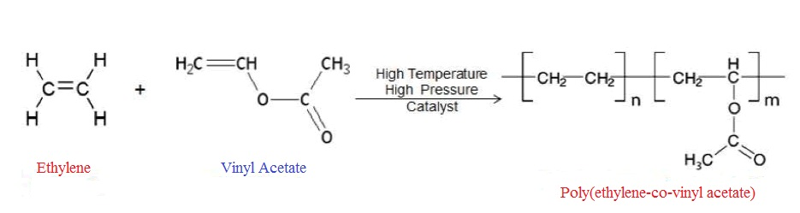

Figure 1.9. Formation of Poly(ethylene-co-vinyl acetate).
The first effect disrupts the crystalline regions formed by the polyethylene segments of the PEVA copolymer. The second effect of vinyl acetate content results from the polar nature of the acetoxy side chain. As the vinyl acetate content increases, the polarity of the copolymer also increases. Although less obvious than the reduction in crystallization, the increase in polarity also raises some interesting features and important, it's responsible for the wide diversity of applications for EVA copolymers. Molecular weight (MW) has a major influence on other properties besides the melt viscosity, although, it should be appreciated that the influence of other structural features invariably modifies the effect. Another advantage of EVA it has a good adhesion strength and good adhesion to a variety of materials. The primary applications for EVA copolymers are packaging film, adhesives or paper coatings, wire and cable insulation, carpet backing, moulding and extrusion, foam, and sound barrier sheet [24]. In general, EVA-based hot melt adhesives are widely used in various substrates such as paper, wood, plastics, rubbers, metals, and painted metals.
The addition of vinyl acetate into the ethylene polymerization method produces a copolymer which have a lesser crystallinity than pure ethylene homopolymer. These lower crystallinity organic polymers have lesser melting points and heat-stop temperature, along with reduced rigidity, tensile strength, and stiffness. EVAs have improved clarity, low-temp flexibility, stress-crack resistance, and impact strength but reduced high- temperature, properties than Low-Density Polyethylene (LDPE). Ethylene Vinyl Acetate resins are more permeability to atomic oxygen, water vapour, and Co₂. Chemical resistivity of EVA is similar to that of LDPE, with somewhat enhanced resistance to lubricants such as oil and grease for EVA resins with higher VA content. Exposure to a temperature above 130ºC causes loss of acetic acid, which leaves behind a structure more susceptible to attack by oxygen. This is more noticeable in higher VA resins, in which a combination of temperature and exposure time can produce significant degradation. With increasing VA content, EVA resin properties range from those of LDPE to those of highly plasticized PVC, higher VA resins are soft and flexible, with excellent toughness and good stress-crack resistance with EVA resins, these are permanent properties; these characteristics do not dissipate with time because of the loss of liquid plasticizer [25]. This is not the case with PVC resins. They are real thermoplastics and can be reprocessed without waste, except for resins that are cross-linked during processing to achieve enhanced elastomeric properties.
EVA copolymers are used in a variety of moulding, compounding, and extrusion applications. Some typical end users include flexible hose and tubing, footwear components,
wire-and – cable compounding, toys, and athletic goods, colour concentrates, extruded gaskets, moulded automotive parts (such as energy-absorbing bumper components), moulded gaskets for coating plastic lenses and cap and closure seats. In footwear applications, EVA resins are used in canvas box toes and flocked or fabric laminated counters. Foamed and cross-linked EVA is used in athletic or leisure shoe midsoles and sandals. EVA compares favourably in space-filling characteristics with such other soft thermoplastics as plasticized PVC. EVA has a specific gravity of 0.95 to 1.0 as compared to 1.2 for PVC, which gives it a space-filling advantage per unit weight of 20%. The flame retardant properties of prepared Poly(ethylene-co-vinyl acetate) nanocomposites are analysed by calorimeter which shows better results even with low percentage of clay.
Conclusion
We reported that short analysis of adsorption of heavy metals chromium, permeability of O₂, N₂ gas and fire retardant properties of different weight percentage of clay polymer nanocomposites. These materials are prepared from various techniques and applied in different tannery waste effluents in industries. The new methodology is applied to polymer nanocomposite to overcome the difficulties of existing techniques. Solution polymerization, microwave assisted, conventional methods are generally used to prepare a nanocomposites. Depending upon the nature of polymer, clay, organic modifier the preparation methodology are varied with selectivity and sensitivity. The application of synthesized nanocomposites depends on nature of the polymer (organic, biopolymer) and modified clay. The novel nanocomposite materials uses new methods for reducing gas permeability, fire retardant and adsorption of chromium which focuses on the factors of availability, eco friendly, decomposable, recovery solvent. The montmorillonite clay is surfactant modified by using triocylamine and it is used as an adsorbent for heavy chromium metal present in tannery wastewater treatment. Gas permeability properties of polyurethane clay nanocomposites is synthesized by solution polymerization method. Flame retardant properties of Poly(ethylene-co-vinyl acetate) clay nanocomposites is synthesized by solution polymerization method.

References
[1] M. B. Armand, Polymer Electrolytes, Ann. Rev. Mater. Sci., 1986, 16, 245-261.
[2] M. Watanabe, T. Endo, A. Nishimoto, K. Miura, and M. Yanagida, High ionic conductivity and electrode interface properties of polymer electrolytes based on high molecular weight branched polyether, J. Power Sources., 1999, 81, 786-789.
[3] A. Nishimoto, K. Agehara, N. Furuya, T. Watanebe, and M. Watanebe, High ionic conductivity of polyether-based network polymer electrolytes with hyperbranched side chains, Macromolecules., 1999, 32, 1541-1548.
[4] J. M. Tarascon, and M. Armand, Issues and challenges facing rechargeable lithium batteries, Nature., 2001, 414, 359-367.
[5] M. Alexander and P. Dubois, Polymer-layered silicate nanocomposites: preparation, properties and use of a new class materials, Mater. Sci. Eng. R. Rep., 2000, 28, 1-63.
[6] P. Malakul, K. R. Srinivasan, and H. Y. Wang, Metal adsorption and desorption characteristics of surfactant-modified clay complexes, Ind. Eng. Chem. Res., 1998, 37, 4296-4301.
[7] S. Kalidhasan, S. Sricharan, M. Ganesh, and N. Rajesh, Liquid-Liquid extraction of chromium(VI) with tricaprylmethylammonium chloride using isoamylalcohol as the diluent and its application to industrial effluents, J. Chem. Eng. Data., 2010, 55, 5627-5633.
[8] D. Mohan, and CU. Jr. Pittman, Arsenic removal from water/wastewater using adsorbents- A critical review, J. Hazard. Mater., 2007, 142, 1-53.
[9] R. Saha, R. Nandi, and B. Saha, Sources and toxicity of hexavalent chromium, J. Coord. Chem., 2011, 64, 1782-1806.
[10] M. M. Chumchal, T. R. Rainwater, S. C. Osborn, A. P. Roberts, M. T. Abel, G. P. Cobb, P. N. Smith, and F. C. Bailey, Mercury speciation and biomagnifications in the food web of Caddo lake, Texas and Louisiana, USA, a subtropical freshwater ecosystem, Environ. Toxicol. Chem., 2011, 30, 1153-62.
[11] Y. Liu, Z. Xu, and S. M. Kuznicki, Development of a novel mercury cartridge for mercury analysis, Energ. Fuels., 2010, 24, 10-17.
[12] T. Duan, X. Song, J. Xu, P. Guo, H. Chen, and H. Li, Determination of Hg(II) in waters by on-line preconcentration using Cyanex923 as a sorbent-cold vapour atomic absorption spectrometry, Spectrochim. Acta., 2009, 61, 1069-1073.
[13] Q. H. Zeng, A. B. Yu, G. Q. Lu, and D. R Paul, Clay-based polymer nanocomposites: research and commercial development, J. Nanosci. Nanotechnol., 2005, 5, 1574-92.
[14] P. Yuan, M. Fan, D. Yang, M. Hongping He, D. Liu, A. Yuan, J. X. Zhu, and T. H. Chen, Montmorillonite - supported magnetite nanoparticles for the removal of hexavalent chromium[Cr(VI)] from aqueous solutions, J. Hazard. Mater., 2009, 166, 821-9.
[15] F. Bergaya, and G. S. Lagaly, Surface modification of clay minerals, Appl. Clay. Sci., 2001, 19, 1-78.
[16] S. S. Ray and M. Okamoto, Polymer/Layered silicate nanocomposites: a review from preparation to processing, Prog. Polym. Sci., 2003, 28, 1539-641.
[17] M. Darder, M. Colilla, and E. Ruiz-Hitzky, Chitosan - clay nanocomposites:application as electrochemical sensors. Appl. Clay Sci., 2005, 28, 199-208.
[18] D. K. Chattopadhyay, and K.V.S.N. Raju, Structural engineering of polyurethane coating for high performance applications, Prog. Polym. Sci., 2007, 35, 352-418.
[19] G. V. R. Reddy, M. Joshi, B. Adak, and B. L. Deopura, Studies on the dyeability and dyeing mechanism of polyurethane/clay nanocomposite filaments with acid, basic and reactive dyes, Coloration. Technol., 2018, 134, 117-125.
[20] I. S. Stefanovic, M. Spirkova, S. Ostojic, P. Stefanov, V. B. Pavlovic, and M. V. Pergal, Montmorillonite/poly(urethane-siloxane) nanocomposites: morphological, thermal, mechanical and surface properties, Appl. Clay. Sci., 2017, 149, 136-146.
[21] H. M. Lee, B. J. Park, H. J. Choi, R. K. Gupta, and S. N. Bhattachary, Preparation and rheological characteristics of Ethylene-Vinyl Acetate Copolymer/Organoclay Nanocomposites, J. Macromol. Sci. Pt B., 2007, 46, 261-73.
[22] Y. Zhong, D. Janes, Y. Zheng, M. Hetzer, and D. D. Kee, Mechanical and oxygen barrier properties of organoclay-polyethylene nanocomposite films. Poly. Eng. Sci., 2007, 47, 1101-107.
[23] R. Wilson, S. M. Georage, J. M. Hanna, S. P. Tomas, S. Anil kumar, and S. Thomas, Clay Inetcalation and its influence on the Morphology and Transport Properties of EVA/Clay Nanocomposites., J. Phys. Chem. C., 2012, 116, 20002-14.
[24] W. S. Wan Ngah, S. Fatinathan, Adsorption of Cu(II) ions aqueous solution using chitosan beads, chitosan - GLA beads and chitosan-alginate beads, Chem. Eng. J., 2008, 143, 62-72.
[25] X. J. Hu, J. S. Wang, Y. G. Liu, X. Li, G. M. Zeng, Z. L. Bao, X. X. Zeng, A. W. Chen, and F. Long, Adsorption of chromium (VI) by ethylenediamine-modified cross- linked magnetic chitosan resin: isotherms, kinetics and thermodynamics, J. Hazard. Mater., 2011, 185, 306-14.

