CONVERSION OF AMERICAN SIGN LANGUAGE TO TEXT USING DEEP LEARNING FOR FEATURE EXTRACTION

Abstract

In order to recognise people's hand gestures (Deaf people) and improve communication with non-Deaf people, this project proposes a vision based approach. American Sign Language (ASL) movements used by deaf persons are intended to be recognised and translated into text using this technique. After careful consideration, the most effective method for applying the Transfer Learning Approach with the Alexnet and algorithms for classification in MATLab application to translate real-time American Sign Language into text is explained. AlexNet is a very common convolution neural network (CNN) for identifying objects. Comparatively to beginning from scratch and creating a set of networks with randomly created weights, transfer learning often accelerates and facilitates system fine-tuning. You are able to rapidly apply learnt characteristics to a new assignment by using less training photos. The accuracy of the three classification techniques (SVM, KNN, and Naive Bayes) will be assessed subsequently, and the technique that performs most efficiently for our work will be selected.

Existing System

1] Nelson, Ann, K. J. Price, and Rosalie Multari [2] demonstrated a web-based ASL interpreting system built with Convolutional Neural Networks (CNN) that offers an effective method for real-time comprehension of 29 ASL signs, which includes 26 alphabet indications and three extra signs ("space", "delete," and "nothing"). Automation sign interpretation requires two things to be true in order to obtain this level of accuracy: two requirements: a large number of input photographs that are of a good quality, and (2) use a pre-trained model (VGG16), and (3) modify the algorithm to the data collection.

2] Bhumika Gupta, Pushkar Shukla, and Ankush Mittal [11] proposed an approach that can identify still images of signed letters in Indian Sign Language. The written alphabet of the Indian sign language is both single-handed and double-handed, despite the alphabets of other sign languages, such as American Sign Language and Chinese Sign Language. To make them easier to identify, the model first divides them into single-handed and double-handed categories. For the training collection of images for all categories, two features HOG and SIFT are retrieved and combined into one matrix.

Proposed System
As part of this project, we created a model that can translate American Sign Language into text in real time. They are categorised and divided into the appropriate categories using three classifiers. We determine the accuracy of each of the three types of classifiers with different calculations, and then, according to the highest accuracy, we choose which classifier to utilise in real time for rapid and precise results.

Methodology

The levels of the system model are covered in the following sections.
- Dataset Creation
- Feature Extraction using Alexnet
- Classification using Naive Bayes
- Classification using KNN
- Classification using SVM

1. Dataset Creation
The American Sign Language alphabets from A to Z and some extra signs used in daily life such as "Hello", "How are you", "Call me" etc,. are represented by images in the dataset. This image resolution is set to 227x227x3. This dataset serves as both test images as well as training data for the algorithm. To improve precision and results, the dataset size was increased to roughly 46000 images.

2. Feature Extraction using Alexnet
One of the most popular Convolution Neural Network (CNN) for object detection is Alexnet. Five convolutional layers, three max-pooling layers, two normalisation layers, two fully connected layers, and one SoftMax layer make up the design. Before the image is extracted, multiple factors are taken into account. In real-time applications, it is significant.

The following steps are followed to Reuse the Pretrained Network:
- Load data
- Load Pretrained Network
- Replace the Final Layers
- Train Network
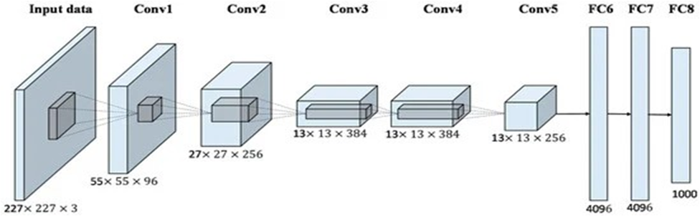

3. Classification using Naive Bayes
A supervised learning technique built on the Bayes theorem for issues with classification is the Naive Bayes algorithm. It makes predictions in the form of probabilistic classifiers based on the likelihood that a given event will occur. The Bayes theorem, also referred to as Bayes' rule or Bayes' law, is a formula in mathematics used to determine how likely an assumption is given some prior knowledge. The concept of a conditional probability governs this.
The Bayes theorem's formula is as follows:
P(A|B)= (P(B/A)P(A))÷P(B)

4. Classification using KNN
One of the easiest machine learning algorithms, using the supervised learning method, is K-Nearest Neighbour. The KNN method considers that the fresh case/data and the existing cases are comparable, and it places the new instance in a category which seems most comparable to the existing categories. A fresh data point is classified using the algorithm known as K-NN on the basis of similarity after all the existing data has been stored. This means that utilising the K-NN method, fresh data can be quickly and accurately sorted into a suitable category. Although the KNN technique is most frequently employed for classification problems, it can also be utilised for regression. Since KNN is a non-parametric algorithm, it makes no assumptions about the actual data. It is also known as a lazy learner algorithm since it saves the training dataset rather than learning from it immediately. Rather, it uses the information in the dataset to execute an action when classifying data.
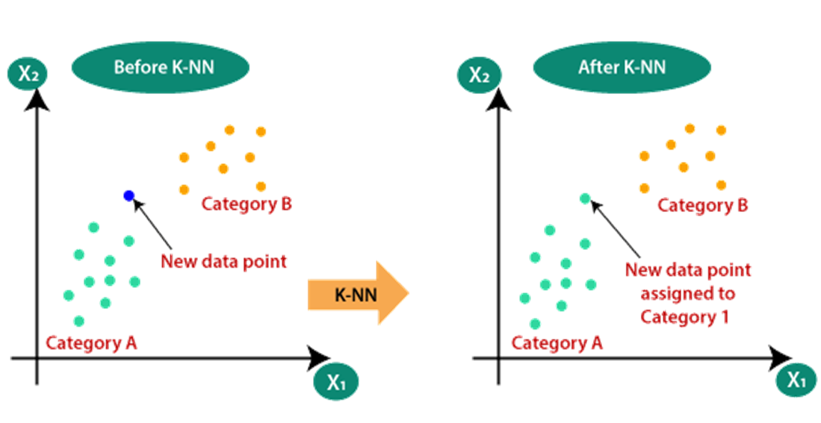
5. Classification using SVM
One of the most well-liked supervised learning algorithms, Support Vector Machine, or SVM, is utilised to solve Classification and Regression problems. But it is largely employed in Machine Learning Classification issues. The SVM algorithm's objective is to establish the most suitable decision boundary or line that can separate the space with n dimensions into classes, allowing us to quickly classify fresh data points in the future. A hyperplane is the name given to this optimal decision boundary.
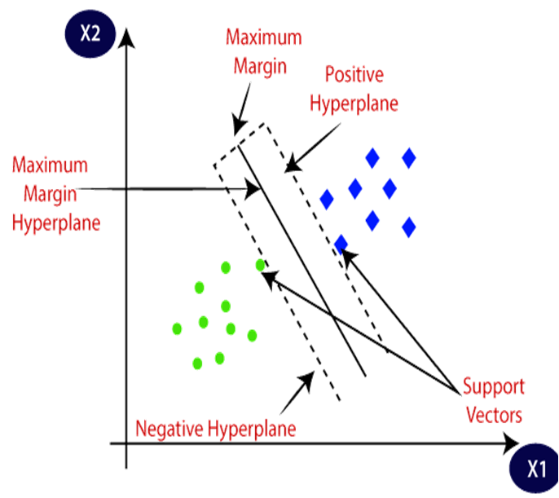
RESULTS

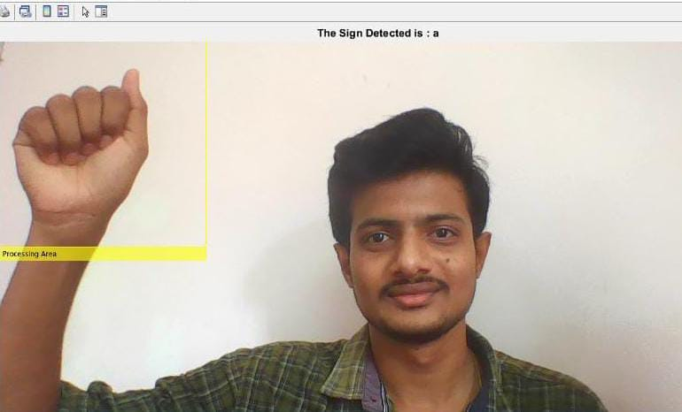

Fig 1 - Detection of Sign A into Text using Live camera

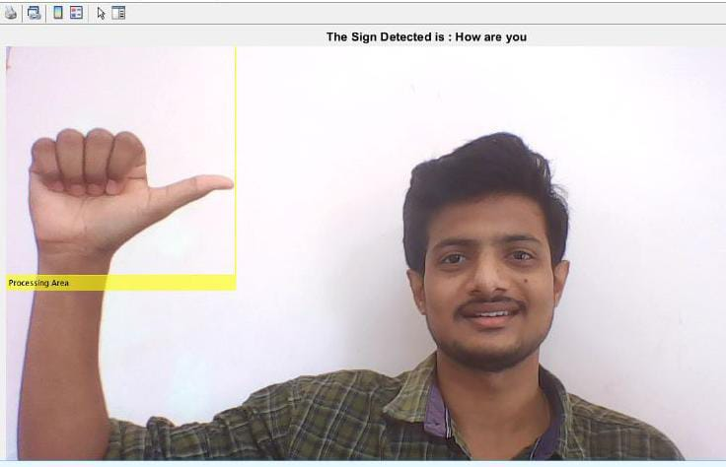
Fig 2 - Detection of Sign Sentence How are you into Text using Live camera

CONCLUSION

By using the pretrained Alexnet network for feature extraction and various machine learning models (SVM, KNN, and Logistic regression) for classification and training, we were able to construct a dataset for ASL Sign language. We also produced the code for testing and training of images in the dataset. Additionally, the outcome was confirmed using test pictures from the dataset and input data collected from live camera indications.

The project's future developments include utilising hardware equipment to put this paradigm into practise. It is necessary to put into practise the translation of sign language into spoken voice.

REFERENCES

- Patwary, Muhammed J. A. & Parvin, Shahnaj & Akter, Subrina. (2015). Significant HOGHistogram of Oriented Gradient Feature Selection for Human Detection. International Journal of Computer Applications. 132. 20-24. 10.5120/ijca2015907704.
- Ann Nelson, KJ Price , Rosalie Multari (2019) ASL Reverse Dictionary - ASL Translation Using Deep Learning.
- Dumitrescu, & Boiangiu, Costin-Anton. (2019) A Study of Image Upsampling and Downsampling Filters. Computers. 8. 30. 10.3390/computers8020030.
- Saeed, Khalid & Tabedzki, Marek & Rybnik, Mariusz & Adamski, Marcin (2010) K3M: A universal algorithm for image skeletonization and a review of thinning techniques. Applied Mathematics and Computer Science. 20. 317-335. 10.2478/v10006-010-0024-4.
- Mohan, Vijayarani. (2013) Performance Analysis of Canny and Sobel Edge Detection Algorithms in Image Mining. International Journal of Innovative Research in Computer and Communication Engineering. 1760-1767. M. Young, The Technical Writer’s Handbook. Mill Valley, CA: University Science, 1989.
- Tzotsos, Angelos & Argialas, Demetre. (2008) Support Vector Machine Classification for Object-Based Image Analysis. 10.1007/978-3-540- 77058-9_36.

