Renewable Energy Sources: A Sustainable Path to a Greener Future
Jyoti Verma, Hemlata Pant, Deepanjana Padhi, Anuradha Yadav, Nidhi Gupta & Aditya Sharma
Department of Zoology, CMP Degree College, University of Allahabad, Prayagraj-211001
Email id- dr.jyotiverma@ymail.com, padhideepanjana@gmail.com

Abstract
Renewable energy sources and technologies hold tremendous promise in addressing the persistent energy challenges faced by developing nations. Countries like India can effectively tackle energy shortages by harnessing wind energy, solar energy, geothermal energy, ocean energy, biomass energy, and fuel cell technology. These energy sources are derived from natural resources that are continuously replenished and have minimal environmental impact. In contrast to finite fossil fuels that contribute to climate change, renewable energy offers a sustainable and cleaner alternative to meet energy demands. Presently, approximately 33% of India's primary energy consumption is sourced from renewable energy. The country is making notable strides in adopting responsible renewable energy practices, striving towards decarbonization, cleaner air, and a more sustainable future. With robust government support and an increasingly favorable economic landscape, India has emerged as a leading player in the world's most attractive renewable energy markets.

Key-words: wind energy, solar energy, biomass energy, fuel cell technology, sustainability, climate change,

Introduction
Electricity generation sources such as coal, oil, and natural gas have contributed significantly to global greenhouse gas emissions, accounting for approximately one-third of the total. Elevating living conditions while providing greener and more consistent electrical supply has become crucial. Over 79% of the primary energy used in the world today comes from fossil fuels, with the transport sector accounting for a significant 57.7% of this amount, a figure that is steadily decreasing. An essential prerequisite for promoting a country's economic development is meeting the rising energy demands.
Surprisingly, India ranks fourth internationally in terms of carbon emissions, accounting for about 6.65% of all emissions, after China (26.73%), the US (14.36%), and the EU (9.66%). The world's natural balance will be disturbed as a result of climate change. Intended Nationally Determined Contributions (INDCs), which aim to keep the rise in the global temperature well below 2°C, have been submitted under the UNFCCC and the Paris Agreement in recognition of the seriousness of the issue.
The growing need for conventional energy and the depletion of natural resources have made it necessary for planners and policymakers to investigate alternate energy sources. Renewable energy sources come from regenerative sources, which don't degrade over time and can be used to drastically cut carbon emissions, enhance air quality, and create a more sustainable society. These resources boost energy security and promote global economic expansion. Modern biomass is a chemical storage for solar energy that results from photosynthesis. Remarkably, eighteen percent of the world's final energy consumption comes from renewable sources. The global demand for power is expected to have peaked by 2030, according to the World Energy Council.
Coal and oil are used to meet a staggering 74% of India's energy needs, which has a significant impact on the energy landscape of the nation. The country imports a large amount of coal (171 million tonnes in 2013–2014, 215 million tonnes in 2014–2015, 195 million tonnes in 2015–16, and 213 million tonnes in 2017–18) because of its reliance on coal. Investigating alternate electrical sources must be done right away. This shift to renewable energy technologies is crucial for guiding the nation towards sustainable growth and preventing the devastating repercussions of climate change. Renewable energy sources are essential for providing low-emission, sustainable energy solutions. It is a widely held opinion that these technologies can greatly meet the demand for electricity while cutting emissions. India has been working to move towards a more sustainable energy paradigm by encouraging energy conservation and adopting renewable energy sources like solar, wind, biomass, waste, and water.
Types of Renewable Energy Sources
Biomass Energy: The use of biomass as an energy source has recently attracted growing interest and presently makes up around 14% of the world's total final energy consumption. According to projections, biomass might make up 15–50% of the primary energy used globally by 2050, signalling a huge shift towards renewable fuels. The development of renewable energy has been a priority for many countries, with biomass emerging as a key element of a diverse and sustainable energy matrix.
Because biomass-derived energy does not contribute to the atmospheric release of carbon dioxide, the primary greenhouse gas, it has the distinct advantage of being a renewable resource in contrast to fossil fuels. Estimates from all over the world suggest that photosynthesis generates an astonishing 220 billion dry tonnes of biomass annually, despite its pitiful 1% conversion efficiency. A wide range of biomass sources, from firewood collected from farms and natural forests to forestry and agricultural goods developed expressly for energy production, are accessible for the production of energy.
India has enormous promise in this area because of its wealth of biomass resources. The capacity of the country includes 2,700 MW from waste-to-energy projects, 16,881 MW from agro-residues and plantations, and 5,000 MW from bagasse cogeneration. Over Rs. 600 million has been invested in India's biomass energy sector, which yearly produces more than 5,000 million units of power.
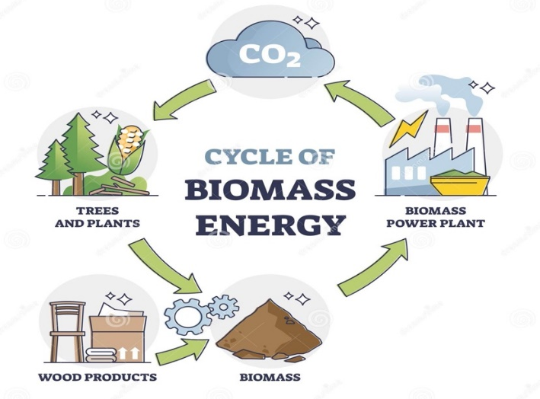

(Fig-1: Biomass Energy)
Ref: https://www.123rf.com/photo_172711954_cycle-of-biomass-energy-as-direct-combustion-in-power-plant-outline-diagram.html
2.Hydropower Energy:
Hydropower is the ideal renewable energy source since it converts the kinetic and latent energy in water into both mechanical and electrical energy through the production of electricity from water. These two types of energy can be used to power textile machines and water mills. This energy source uses the kinetic energy of moving water, typically from rainfall and river movement.
Primary hydroelectric power plants are strategically located in several Indian states, including Bihar, Punjab, Uttaranchal, Karnataka, Uttar Pradesh, Sikkim, Jammu & Kashmir, Gujarat, and Andhra Pradesh. Small hydropower plants (SHP) with station capacities as high as 25 megawatts (MW) are part of the hydropower landscape, among other scales. It is estimated that 15,000 MW or about 11% of India's hydroelectric potential has already been utilized. The development of SHP projects nationwide is actively encouraged by the Ministry of New and Renewable Energy (MNRE), which authorized the construction of 523 projects totaling 1705 MW of installed energy. Furthermore, 205 SHP projects with a combined capacity of 479 MW are now under construction.
Hydropower currently makes up the majority of renewable energy used in the electrical industry. The predictability of local rainfall patterns is a prerequisite for its utility, and droughts resulting from climate change and ecosystem modifications that modify these patterns may have an impact on its efficacy. The development of hydroelectric infrastructure may have a negative impact on nearby ecosystems. In light of these considerations, small-scale hydropower is gaining popularity as a greener alternative; it is especially beneficial for communities situated in remote and environmentally sensitive areas.
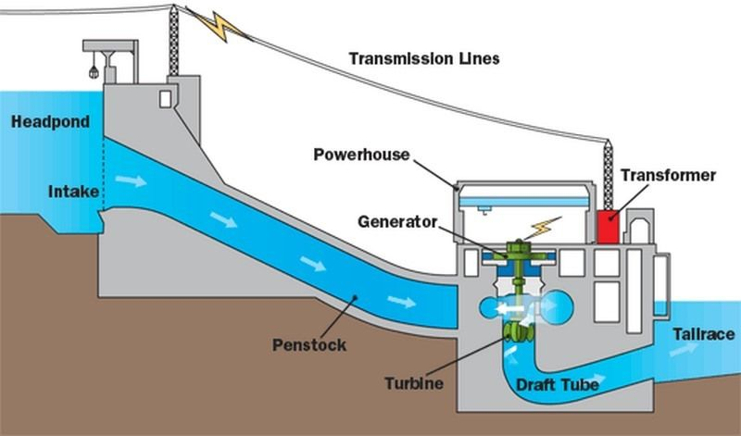

(Fig-2: Hydropower Energy)
Ref: https://studiousguy.com/hydroelectric-power-plant-working-principle/
3.Wind Energy:
Intricate interactions between the Earth's rotating dynamics, the sun's thermal effect, oceanic and polar cooling, temperature differences between land and water, and the interactions of geographical features like mountains and impediments all contribute to the development of wind energy. These numerous processes control the universal force of wind. The abundance of wind energy is not consistent, however, as different places see fluctuations in its supply.
Wind resources are best utilized in areas where the wind energy density surpasses a threshold of 400 W/m2 at a height of 30 metres above the ground. Through the Resource Assessment Programme, the Centre for Wind Energy Technology advances the exploration of this potential in collaboration with state-level nodal organizations. A network of 211 wind monitoring stations covers 13 states and union territories, including the Andaman and Nicobar Islands, Andhra Pradesh, Gujarat, Karnataka, Kerala, Lakshadweep, Madhya Pradesh, Maharashtra, Orissa, Rajasthan, Tamil Nadu, Uttaranchal, and West Bengal. At these stations, it has been observed that the annual average wind power density exceeds 200 W/m2 at a height of 50 metres. These figures provide as evidence of the country's diverse wind energy potential. Cumulatively, India's wind energy capacity holds promise, with estimates projecting its potential to soar to 45,000 MW. This potential stands as a testament to both the intricate ballet of natural forces and the country's commitment to embracing renewable energy sources.
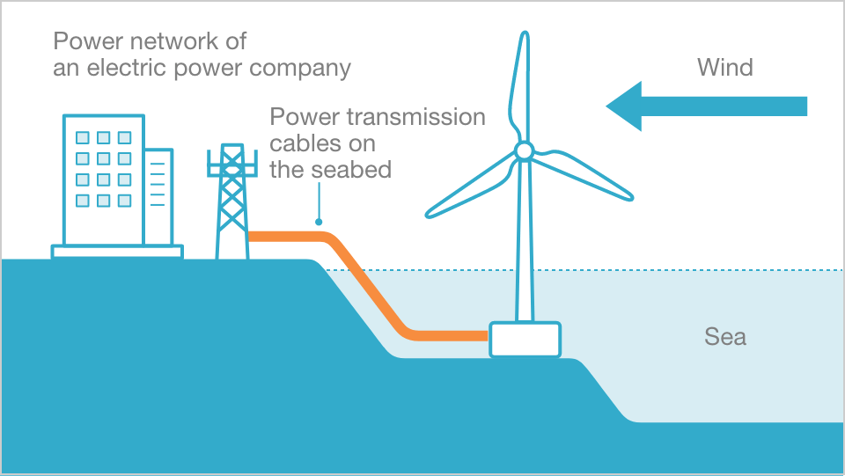

(Fig-3: Wind Energy)
Ref: https://www.jre.co.jp/english/business/offshore-wind-power/
4. Solar Energy:
A mosaic of potential energy sources is created by solar energy, a plentiful and eternal gift from the sun, which manifests in both direct (sunlight) and indirect (wind, biomass, hydro, ocean, etc.) manifestations. This dynamic energy manifests as warmth and illumination and extends its usefulness along two different paths. The thermal pathway makes use of solar heat for a variety of tasks, including cooking, drying, heating water, purifying water, and more. Parallel to this, the photovoltaic pathway converts light into power, providing off-grid areas with a flexible resource for lighting, pumping, communication, and electrification.
The sun's embrace bestows a radiant daily solar radiation of 4–7 kWh per square metre across the majority of India, along with roughly 250–300 days with significant amounts of sunshine each year. Notably, the northeastern parts have a very minor solar input, whereas the expanse of western Rajasthan receives the most annual solar radiation.
The National Action Plan on Climate Change (NAPCC), introduced by the Prime Minister on June 30, 2008, was a major step towards sustainable practises. This framework incorporates solar thermal and solar photovoltaic technology and is the cornerstone of the Ministry's comprehensive solar energy plan. This project intends to capitalise on India's tremendous solar energy potential, estimated to be in the range of 20 to 35 MW/km2 of solar thermal energy. It is sometimes cited as one of the largest in the world.
India's solar energy potential includes water heating systems, which are thought to have a vast 140 million m2 collecting area. The state provides financial support for solar concentrator technologies as well as devices for drying and heating air using the sun. Aiming to improve energy efficiency, the Ministry promotes solar buildings in recognition of the critical role that solar efficiency plays in the larger context of energy. Notably, the state of Himachal Pradesh actively promotes the incorporation of passive solar design principles into the construction of buildings. The Solar Photovoltaic Programme (SPV), promoted by the Ministry, has greatly changed rural and remote areas over the past 20 years, promoting electrification and empowerment. The Ninth Plan period saw a nationwide effort to demonstrate and adopt SPV technology, which serves as evidence of this ambitious program's accomplishment.
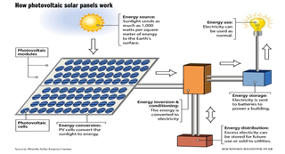
(Fig-4: Solar Energy)
Ref: https://www.linkedin.com/pulse/mechanisms-solar-panels-saeid-azizi/
5.Geothermal Energy:
Geothermal energy, which is generated from heat stored within the Earth, requires the extraction of absorbed heat from subterranean sources. Massive amounts of thermal energy are produced and stored by the Earth's crust, mantle, and core. There is already 10,000 MW of geothermal energy contributed globally, and even in India there is opportunity for growth. Approximately 340 hot springs can be discovered spread across seven distinct geothermal provinces in India, according to studies conducted by the Geological Survey of India. These provinces are particularly noticeable in states like Gujarat and Rajasthan on the west coast, as well as in the 1500 km long Himalayan range along a west-southwest-east-northeast axis that extends from the coast to Bangladesh's western border.
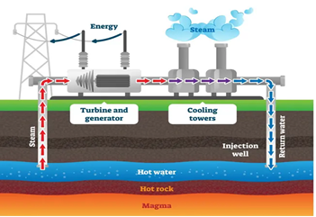

(Fig-5: Geothermal Energy)
Ref: https://xeero.io/geothermal-energy/

6. Solar Thermal Technology:
Solar thermal technologies, especially solar water heating system, solar cookers and solar production systems are the most commercialized technologies among renewable energy technologies in India. Policies are set to provide further impetus spread of solar technology.
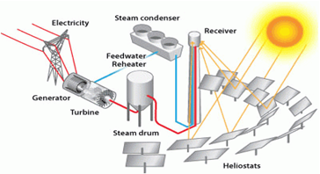
(Fig-6: Solar Thermal Energy)
Ref: https://www.energy.gov/eere/solar/power-tower-system-concentrating-solar-thermal-power-basics
7. Biogass Energy:
A renewable energy source primarily derived from biological waste is biogas. India has encouraged the use of biogas, which is mostly produced from animal waste—most notably cow dung—for more than 30 years. Anaerobic digestion of a variety of organic wastes, including waste from homes, businesses, farms, and animals, produces biogas, a clean fuel substitute. Through the advancement of rural cooking techniques, technology has improved food quality and provided social and environmental benefits, such as lowering indoor pollution. As part of the National Biogas Programme, more than 3.7 million biogas stations with capacities ranging from 1 to 6 cubic metres have been erected since December 2004. This program's ultimate objective is to establish biogas stations in approximately 12 million households that possess sufficient livestock to ensure a consistent supply of organic matter for the production of biogas.
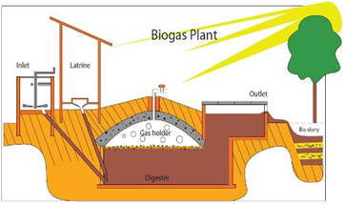

(Fig-7: Biogas Energy) Ref; https://www.build-a-biogas-plant.com/biogas-digester-plans/

8. Hydrogen Energy:
Hydrogen power development is still in its early stages. Emerging and renewable energy sources are contributing to the funding of research initiatives including all aspects of hydrogen energy technology advancement. Future hurdles for India in this field include bringing down the cost of producing hydrogen significantly, increasing production efficiency through a range of methods, creating small, reasonably priced storage options, setting up an extensive hydrogen distribution network, creating hydrogen combustion engines, and optimising efficiency in different types of fuel cell systems.

To direct efforts in research, development, and demonstration across many areas of hydrogen energy technology, a strategic roadmap has been drawn forth. With the implementation of one million hydrogen-powered cars and the installation of 1,000 megawatts of combined hydrogen-based power generation capacity across the country, this plan has big goals.
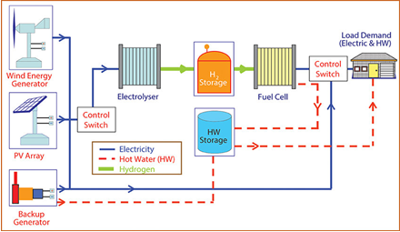

(Fig-8: Hydrogen Energy)
Ref: https://www.researchgate.net/figure/Overall-concept-of-a-hydrogen-renewable-energy-system-for-distributed-power-generation_fig4_266951079

Environmental Sustainability
Addressing energy shortages is essential for maintaining economic growth and raising living standards. While increasing supply is a simple solution, it's important to recognise two other equally important factors: environmental sustainability and social development. The current model of economic expansion has resulted in serious environmental consequences, many of which come from the energy sector, including air pollution, significant waste output, ecological degradation, and the acceleration of climate change.

Additionally, the effect on social advancement cannot be ignored. A number of societal issues, such as poverty, deteriorating health, unemployment, and inequality, are made worse by the lack of adequate access to energy services. Oil is still a crucial energy source in today's economic environments. Even while several Asian nations continue to consume more oil than any other nation in the world, the United States still leads the pack. The Republic of Korea comes in sixth, followed by China, Japan, and India. Natural gas's importance is also expanding as a result of its improved fuel efficiency.

Water pollution and the growing amount of waste being disposed of, notably hazardous nuclear waste, are two more urgent environmental issues. Over-reliance on ecologically sensitive places is concerning in rural communities. For cooking, heating, and lighting, biomass fuels are a common choice for rural residents. Overuse of these resources may cause habitat loss, biodiversity loss, and watershed damage. Notably, the majority of energy used to produce heat, electricity, and transportation involves burning fossil fuels, which account for around 70% of all greenhouse gas (GHG) emissions.

Countries can cut their greenhouse gas emissions in a number of ways, some of which come with little, no, or even negative costs. Improvements in energy efficiency, energy management strategies, environmentally friendly production and consumption practises, and lifestyle adjustments are some of these measures. Accepting more efficient and environmentally friendly technologies helps to mitigate the consequences of climate change even more. Long-term incentives grounded in scientific data can help countries make decisions by encouraging a more environmentally friendly and energy-efficient economy and ensuring that more people have access to contemporary energy services.

1. Climetic changes:
Climate change, as a result of global warming caused greenhouse gases, especially carbon dioxide (CO2) produced during the burning of fossil fuels has caused significant changes ecosystems and leads to nearly 150,000 additional deaths every year. This increase is mainly due to unsustainable use fossil fuels and land use change.
2. Clean Development Mechanism:
The Kyoto Protocol's Clean Development Mechanism (CDM) was created to assist poor nations in achieving sustainable development by supporting initiatives that reduce greenhouse gas emissions and produce emission credits (certified emission reduction, or CER) for industrialised nations. The CDM is utilised by many nations in the region. This clause in the Kyoto Protocol was first put up as a bilateral method by which industrialised nations might invest in clean technologies in developing nations and receive certified emission reductions (CER). For recipient developing countries, this can increase returns projects by up to 12% for wind, water and geothermal projects and by 15-17% for biomass and municipal waste projects (UNEP).

Current Energy Policies
1. National Electricity Policy, 2005:
The National Electricity Policy aims to achieve a number of goals, including ensuring that everyone has access to electricity, meeting energy demand, addressing peak shortages, maintaining a rolling reserve capacity, guaranteeing a consistent and high-quality energy supply adhering to established standards, promoting efficiency and affordability, increasing per-person electricity availability to over 1000 units by 2012, and improving the financial viability of the electricity sector.

2. The Electricity Act, 2003:
The National Electricity and Tariff Policy must be developed and released on a regular basis by the Central Government in coordination with state governments and power development bodies, according to Sections 3, subsections 1 and 2. Utilisation of resources including coal, natural gas, nuclear materials, water, and renewable energy sources will be maximised under this policy framework. According to Section 4, the Central Government must develop and publish the national strategy after consulting with the State Governments.

3. Tariff Policy, 2006:
The appropriate Commission is entrusted with calculating the minimum percentage of energy acquisition from diverse sources, taking into account the availability of resources in the region and its potential influence on retail pricing, in accordance with the provisions of Section 86, subsection 1, clause e) of the act. It can take some time before unconventional technologies become gradually cost-effectively competitive with conventional sources. As a result, the relevant commission will set preferential pricing for the procurement of distribution businesses.
4. National Rural Electrification Policy, 2006:
The National Rural Electrification Policy is focused on achieving a number of objectives, including providing all households with access to electricity by 2009, supplying power consistently and reliably at affordable rates, and ensuring a minimum consumption of 1 unit per household per day by 2012. Off-grid solutions based on freestanding systems may be used to provide power for settlements or homes where grid connection is impractical or expensive. State governments are required to create and disseminate a rural electrification plan within a time frame of six months that outlines the specific procedures for delivering electrification.
Committees
1. District Advisory Committees (DACs):
These committees have aided in the formation of a strong local network for support of renewable energy, encouraging the fusion of renewable energy programmes with other developmental agencies. The cooperative endeavour is currently supported by 550 DACs operating throughout the districts of the nation.
2. Rajiv Gandhi Akshay Urja Diwas (Rajiv Gandhi Renewable Energy Day):
The nation-wide celebration of "Rajiv Gandhi Akshay Urja Diwas" took place on August 20, 2006, the deceased Sh. Rajiv Gandhi's birthday. The purpose of this event is to raise awareness about renewable energy on a large scale at the federal, state, and local levels.

3. Renewable Energy Clubs:
Through the creation of Renewable Energy (RE) clubs in engineering colleges and technological institutes across the nation that are recognized/approved by the AICTE, a programme has been designed to support the investigation of renewable energy resources. These organisations aim to inform and raise awareness among young and aspiring scientists about various facets of emerging and renewable energy technology.

4. Akshay Urja Shops:
District-wide openings of Akshay Urja stores have made it easy for people to access equipment and systems for renewable energy. The goal of these businesses is to actively promote the use of renewable energy sources by the general population, helping them meet their energy needs for lighting, cooking, and power generating.

The Future of Renewable Energy in India
The integrated energy strategy report has emphasised how important it is to diversify energy sources and fully capitalise on domestic supply potentials. In all sectors, the committee has placed a major emphasis on increasing the use of renewable resources. By 2031–2022, it is anticipated that renewable energy sources would contribute significantly to energy production, amounting to 60,000 MW. Renewable energy sources are anticipated to be crucial in promoting social inclusion and encouraging growth among marginalised communities as the timeline moves forward to 2031–2022. Over the next 25 years, it is projected that investments in the renewable energy sector will total about Rs. 300 billion. The Ministry of New and Renewable Energy (MNRE) has firmly integrated within its mission the goals of enhancing energy security and elevating the share of clean energy for improved energy availability.

India must make a determined effort to increase the importance of renewable energy sources in upcoming energy systems because of the country's dual concerns of environmental sustainability and energy security. A wide range of technological sophistication and commercial viability define the renewable energy technology landscape. Renewable energy is on the rise in India, and a variety of obstacles still need to be cleared before these technologies can have a significant impact on society as a whole. Stakeholders like enterprises, industries, government agencies, and consumers are actively tackling these obstacles. India is faced with the combined issues of environmental sustainability and energy security, necessitating a deliberate effort to increase the importance of renewable energy sources in upcoming energy systems. Various levels of technological sophistication and commercial feasibility can be found in the landscape of renewable energy technologies. In India, the trajectory of renewable energy is growing, and stakeholders including enterprises, industries, governmental organisations, and consumers are actively tackling a variety of difficulties that must be addressed before these technologies can have a significant impact on society.
Conclusion
The main drivers behind the energy policies of countries around the world are energy security, economic expansion, and environmental protection. Everyone agrees that there is a pressing need to step up efforts to promote renewable energy sources, especially given the rising cost of oil. In order to address issues with energy security, economic growth despite rising energy prices, competitiveness, healthcare costs, and environmental degradation, it is crucial to support renewable energy technology. There is a persistent commitment to the expansion of renewable energy, according to the National Action Plan on Climate Change (NAPCC) and other trustworthy sources.
This commitment is made evident through a number of particular actions, including supporting the adoption, advancement, and fundamental study of renewable energy technologies. This agenda includes overcoming obstacles to the development and commercialization of technologies for biomass, hydropower, solar, and wind. Supporting the development of direct biomass combustion and biomass gasification technologies, as well as promoting the expansion of tiny wind energy generators, is equally important. A strategic move to mainstream renewable energy in the domestic electricity system is the strengthening of the regulatory and tariff framework.

Since renewable energy is expected to account for around 5% of the composition of power by the year 2032, there is a greater emphasis on speeding its deployment. The gradual adoption of alternative fuels, in particular biofuels, into the energy mix is intended to work in concert with more traditional fuels like diesel and petrol, primarily for transportation-related uses. In conclusion, renewable energy offers a number of benefits and has the potential to significantly contribute to the country's energy mix, consequently reducing expenses on the social, economic, and environmental fronts. According to the predicted trajectory, in the ensuing years, the proportion of renewable energy in the total production capacity will increase.
References:
- https://www.twi-global.com/technical-knowledge/faqs/renewable
- https://www.un.org/en/climatechange/what-is-renewable-energy#:~:text=Renewable%20energy%20is%20energy%20derived,plentiful%20and%20all%20around%20us.
- https://energsustainsoc.biomedcentral.com/articles/10.1186/s13705-019-0232-1#Sec5
- file:///Users/sourindrasuman/Downloads/RenewableenergyinIndia.pdf
- http://eagri.org/eagri50/ENVS302/pdf/lec02.pdf
- https://www.researchgate.net/publication/317561674_An_Introduction_to_the_Renewable_Energy_Resources
- http://eagri.org/eagri50/AENG352/lec02.pdf
- https://www.eia.gov/energyexplained/renewable-sources/
- https://www.nationalgrid.com/stories/energy-explained/what-is-green-energy

