**Understanding qRT PCR:**

**Basic principles and applications**

Introduction

The discovery of the enzyme **RNA dependent DNA polymerase**, renamed as **reverse transcriptase (RT)** led to the conceptualization “**RT coupled PCR technique”** which has risen to become a key laboratory technique used for sensitive and specific detection of RNA molecules from living cells. The **RT** is an enzyme that catalyses the formation of DNA from single stranded RNA. The natural RNA (sometimes present in trace quantity) is first reverse transcribed to complementary DNA (cDNA) followed by polymerase chain reaction (PCR) for detection and quantification the amplified cDNA product. The RT was first discovered in retroviruses (viruses with RNA as genetic material) by David Baltimore (MIT, Cambridge, USA) and Howard Temin (UW, Madison, USA) simultaneously in the year 1976(1). In this chapter we will summarise the developments leading to refinement of the present day quantitative reverse transcriptase coupled polymerase chain reaction (PCR) technique also known as **qRT PCR** and its widespread applications with help of few examples.

After the discovery of DNA as genetic material (in the 18th century), DNA was recognised as the unit of heredity and the master blueprint of life, it was widely accepted that genetic information within most biological systems (prokaryotes and eukaryotes) flows unidirectionally, that is: DNA to RNA to Protein, classically known as the Central Dogma of Molecular Biology, wherein the RNA is an information carrying intermediate during protein synthesis. The worldwide recognition of the reverse transcriptase although contradicted the theory of Central Dogma of Molecular Biology (fig. 1), became the major driving force behind the identification and characterization of group of virus with RNA genomes (RNA viruses and retroviruses). The development of RT PCR technique and its variations such as qRT PCR and qRT- digital droplet PCR not only enabled the identification of cancer-causing retroviruses (including human immunodeficiency virus (HIV) and human T cell leukemia viruses (HTLVs)) but also accelerated scientific research involving expression analysis of disease-specific mRNA biomarkers, profiling several types of RNAs (including ribosomal RNA (rRNA), transfer RNA (tRNA), messenger RNA (mRNA), non-coding RNAs, etc), detection of pathogens (especially RNA viruses) from biological and environmental samples.

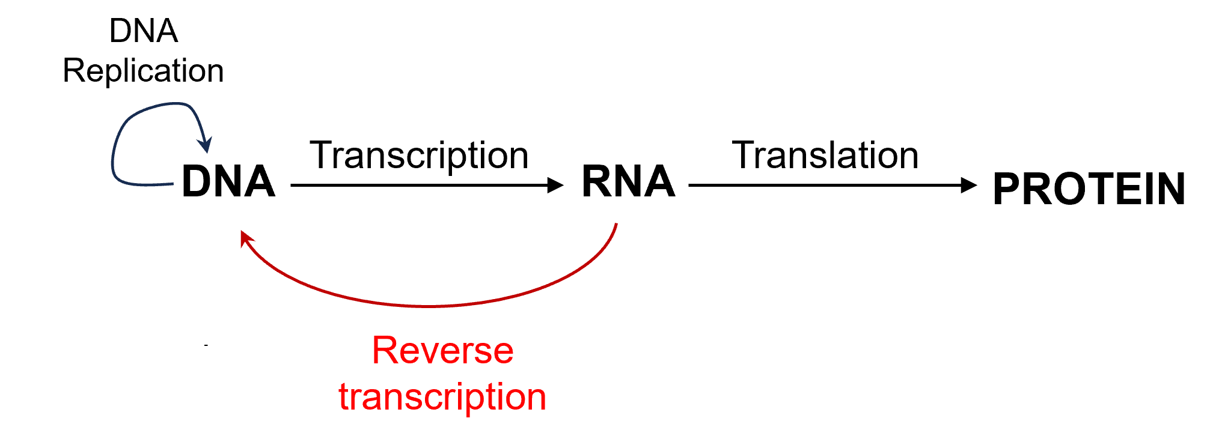

Figure 1

For example, the commercially available cDNA synthesis kits (such as by Thermo Scientific, Waltham, MA, USA ) incorporate a recombinant version of the RT originally isolated from The **m**olomy **mu**rine **l**eukemia **v**iruses (M-MuLV) which are group/type VI retroviruses belonging to the gammaretroviral genus of the Retroviridae family. The enzyme possesses RNA-dependent and DNA dependent polymerase activity, but lacks RNase H activity due to a point mutation in the RNase H domain. As a consequence of the point mutation, this enzyme does not degrade the RNA in RNA-DNA hybrids during synthesis of the first strand cDNA and therefore high yields of full-length cDNA from long templates. The enzyme activity is stable over a wide temperature range (42-55°C) and is capable of synthesizing full-length cDNA up to 13 kb. Several genetically modified RTs are being developed which are capable of synthesizing cDNA up to 20 kb.

The earlier models of PCR thermal cyclers were designed to perform amplification of input DNA. The instrument comprised of a thermal block with slots into which the micro-tube or 96 well plate is inserted. In a very precise and pre-programmed manner, the machine elevates and lowers the temperature of the block so that the reaction mixture is first heated above the melting point of the DNA (usually 95-980C, 1-3 minutes), which allows the DNA strands to separate (or denature), and is referred to as the **denaturation step**. The temperature is then lowered (50-600C, 15-45 seconds) to allow the primers to bind to their complementary site in the target DNA strand in a sequence specific manner, a process called hybridization or **annealing step**. The temperature is elevated again to 720C (30 seconds per kb) which is an optimal temperature for the DNA polymerase to be able to extend the primers by adding nucleotides to the emerging new DNA strand. The thermal block is programmed to repeat the thermal cycles of denaturation, annealing and extension to nearly 20 to 40 times as required by the assay, and with each repeating cycle the number of copied DNA is doubled. The final copy number of the DNA molecules at the end of the PCR cycle is determined as 2n, where n is the number of cycles. The PCR products were then run on agarose gel electrophoresis for detection. This labor-intensive end-point detection involved limitations such as and post-PCR processing, inaccurate quantification, poor sensitivity as well as risk of carryover contamination.

Higuchi and coworkers in 1992 described the idea of “real-time PCR” wherein inclusion of a fluorescent reporter system (fluorescent DNA intercalating dye of fluorescent probe) made it possible to continuously monitor the accumulation of PCR amplicons in “real-time” alongside the amplification. The real-time PCR thermal cyclers (PCR thermal cyclers with additional fluorescence detection units) were thereafter developed and this refinement of the technology was shown to be more sensitive and specific. As it offered the possibility of quantification without post-PCR processing, the risk of carryover contamination became minimal. The basic principle underlining **qPCR** is to monitor the accumulation of PCR amplicons in **“real time”** by measuring the change in emission of fluorescence from either fluorescent DNA-intercalating dyes or target-specific fluorescently labeled primers or probes added to the PCR mixture. The designing of the primers and probes will be discussed in the later section.

1. **principles:**



Figure 1: A typical work flow demonstrating setting up of quantitative RT PCR assay.

The fluorescent reporter system employed to monitor the accumulation of PCR amplicons in “real-time” is either Fluorescent dye based (SyBr Green, Eva Green etc) of Fluorescent probe based as described below.



The Real time PCR (qPCR as well as qRT PCR) results are visualized in an amplification plot. Fluorescence is represented on the Y axis, whereas the number of PCR cycles is plotted along the X axis.





1. **Applications**
2. Reverse transcriptase PCR (RT-PCR) has been successfully employed for detection of clinically prevalent viruses comprising of RNA based genomes such as enteroviruses, West Nile virus, dengue virus, hantavirus, human metapneumovirus and more recently severe acute respiratory syndrome (SARS, eg. SARS CoV-2). More recently, among the few changes forced by the SARS CoV-2 pandemic the installation of real time thermal cyclers in molecular diagnostic facilities across the world has led the medical fraternity to turn to RT-PCR based diagnosis of infectious disease above culture based assays.
3. Quantitative RT-PCR assays are also commonly used for the detection of **viral load** (amount of these HIV and HCV present in the blood of a patient) testing. Viral load data are helpful for monitoring the response of the individual patient to therapy. For instance, after appropriate antiretroviral therapy, the patient infected with HIV virus should demonstrate an increase in CD4 count and a decrease in HIV viral load.
4. RT-PCR may also be used**to detect microorganisms** (bacteria, parasites, and fungi) by targeting their RNA. As RNA to DNA ratio of any microbe in any type of sample indicates the presence of **viable** organisms.
5. Quantitative real-time PCR (qPCR) has been widely used in recent environmental microbial ecology studies as a tool for detecting and quantifying microorganisms of interest, which aids in better understandings of the complexity of wastewater microbial communities.

References:

1. Annu Rev Virol. 2016 Sep 29;3(1):29-51. doi: 10.1146/annurev-virology-110615-035556. Epub 2016 Jul 22. PMID: 27482900
2. Verma, I.M., Reverse transcriptase, The Enzymes (Boyer, P.D., ed), Academic Press Inc., vol. 14, 87-103, 1981.
3. Gerard, G.F. and D'Alessio, J.M., Methods in Molecular Biology, 16, Humana Press, Totowa, N.J., 73-93, 1993.