Futuristic trends in fermentation of milk using plant sources
Ujjwali Bhardwaj , Rekha Rani
1 Ujjwali Bhardwaj, M.Sc Food Technology, Warner College Of Dairy Technology, SHUATS ,Prayagraj, Uttar Pradesh
2 Rekha Rani, Department of Dairy Chemistry, College of Dairy and Food technology, Agriculture University, Jodhpur, Rajasthan
Abstract
Milk fermentation is mainly associated with the starter culture preparation or being using inoculum containing starter culture. This time milk fermentation has been done using plant source which act either as a probiotic or prebiotic. The main focus in this study was mainly on the capability or properties of plant sources which acts as an inoculum for fermentation of milk i.e. chilli stalks which contain Lactobacillus species. Also, oatmeal used in fermentation of milk which acts as a prebiotic in milk that enhances the growth of probiotic culture that are used for milk fermentation. Milk fermented using plant sources enhance the quality by increasing antioxidant property of the fermented product. Therapeutically, fermented milk products have added health benefits to human individual mainly with their gut health which get enhanced by addition of beneficial microorganism to intestinal gut microbiota by replacing pathogenic microorganism from the gut. Various other benefits have also been observed by the individual consuming fermented milk products like reduction in bad cholesterol level, anti-carcinogenic properties, rise in antioxidant levels, cardiovascular health etc. Precise fermentation techniques are widely accepted on the global basis to provide individuals with quality fermented product which adds nutritional benefits and healthy food habits in humans so that they have well sustained, healthy and well balanced lifestyle free of disease risks regarding foods.
Keywords: Fermentation, Plant sources, Probiotics, Prebiotics, Therapeutic effects

1. Introduction
Fermentation of food products have been practiced since the early ages. The term “fermentation” is taken from latin word “fermentare” that describes to rise or expand. Therefore, fermentation is a biochemical process in which carbohydrate or glucose molecule is broken down into biomolecules which produces primary metabolites, secondary metabolites, enzymes, vitamins etc. The process of fermentation is mostly anaerobic and carried out in the presence of microorganism that are either present naturally or inoculated in the substrate that perform the action of fermentation. Fermentation should be taken place in a biovessel known as Fermentor on an industrial scale(fig:1) .French chemist and microbiologist Louis Pasteur in the 19th century used the word fermentation in a limited perception that explains the modification carried out by yeasts and other microorganisms that are increasing in the absence of air (anaerobically); he also perceived hat ethyl alcohol and carbon dioxide are not the only outcomes of fermentation.
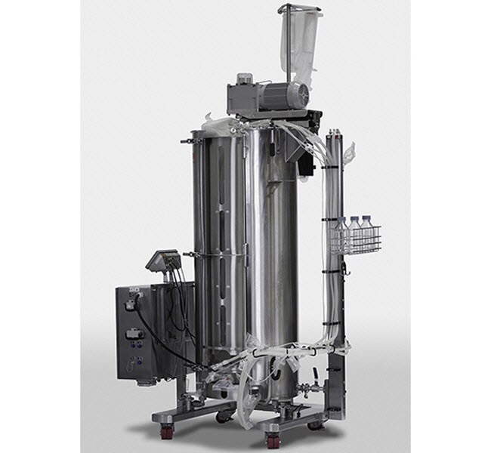

Fig:1 Fermentor

The ordinary class of microorganisms associated with food fermentations are bacteria, yeasts and moulds. The majority of bacteria in the fermentation of foods are the Lactobacillaceae, that are capable to bring about lactic acid from saccharides. More salient bacteria are the Acetobacter that produce vinegar acid or ethanoic acid by fermenting fruits and vegetables and Bacillus species from fermented legumes. The favourable yeasts in case of preferable food fermentation are from the Saccharomyces family, chiefly S. cerevisiae.

2. What is the need of using fermentation technology in milk production industry?

With increasing therapeutic effects of leavened food products, consumers are adding fermented milk foods containing probiotic culture in their daily food habits. Presently above 400 distinct marketed products are present for consumers that are traditionally and industrially produced by fermentation milk. The specification of particular type of product is defined by the applied starter cultures, milk quality, and process conditions [25,33,34]. Fermentation procedure normally supplement the nutritional interest of numerous meals or foostuffs and enhance the bioavailability of nutriments. The leavening act of particular lactic acid bacteria (LAB) strains possibly results in elimination of harmful or antinutritional factors, such as lactose and galactose, from leavened dairy products to avert lactose intolerance and increasing concentration of galactose[45].

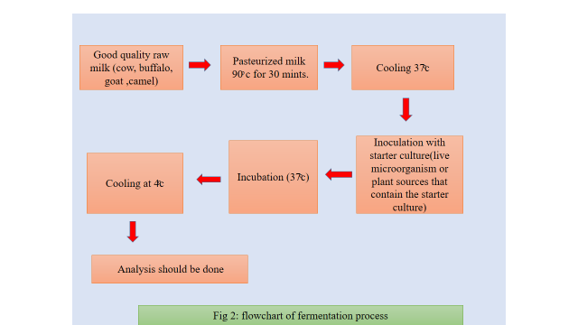

2. Types of fermented milk product
Various types of fermented milk products are procured by utilizing the method of fermentation. Fermented dairy prodcuts that are obtained with using specific starter culture includes yogurt, kefir, acidophilus milk, kumyss(Table 1)
Variety of fermented dairy products. .
Modified from Codex Alimentarius (2011)

Yogurt | Symbiotic culture of Streptococcus thermophiles and Lactobacillus subsp. delbruckii
Yogurt based on alternative cultures | Culture of Streptococcus thermophiles and all species of Lactobacillus
Acidophilus milk
Kefir | Culture prepared from kefir granules, Lactobacillus kefiri, species of the genus Leuconostoc, Lactococcus and Acetobacter that grow in a close specific relationship. The kefir granules constitute lactose fermenting yeast (Kluyveromyces marxianus) and lactose-free fermenting yeasts (Saccharomyces unisporus, Saccharomyces cerevisiae y Saccharomyces exiguous)
Kumys | Lactobacillus delbrueckii subsp. Bulgaricus y Kluyveromyces marxianus

3. Fermented milk products having Immunological Properties
Fermented milk products having the probiotic properties enhance the immune system. The increasing number of benefical microorganism reduces the pathogenic effects inside the body and helps in removing toxins. The beneficial microbes get utilized by direct cooperation with consumption of vival microbes with the host (probiotic effect), or alternatively by having primary metabolites produced by the fermented milk products[42].
Part of vital health aids regarding consumption of fermented milk products are below:

3.1 Modulation of intestinal microbiota
Fermented milk products enhances the gut microflora by inducing the growth of benefical microorganism inside the gut and removal of pathogenic microorganism from the intestine. As a matter of reality, it is studied that the actual development of immunity that is linked with the establishment of the alimentary gut microbiome having specific part of individual species of Bifidobacterium[20].

3.2Anti-carcinogenic effect
The inhibitory consequences of probiotics on the carcinogenesis may be correlated with the regulation of the immune response and replacement in the gut microflora, averting the rise of bacteria that become pro carcinogens in oncogens [13].Fermented milks may regulate the immune system of the mucosa. The administration of fermented products may have effect on the intestinal microflora, restoring immune cells correlated to the intestine and it is beneficial in case of intestinal infection and colon cancer[13]. Additionally, Lactobacillus acidophilus isolated from yogurt reduced tumor growth rate and increased lymphocyte proliferation in a mouse model of breast cancer[38].Fermented dairy products induce apoptosis, cell cycle arrest and turned down proliferation of tumor in breast cancer cells; as a result, possibly acceptable in the prohibition or cure of breast cancer[43].

3.3 Hypocholesteromic effects
The live culture containing yogurt consumption that include Lactobacillus acidophilus and Bifidobacterium lactis be the cause of notable decrease in low density lipoproteins cholesterol level in blood compared with regular yogurt [3].It is supposed that live bacteria can metabolize cholesterol and thus reduces its resorption in GI tract. In vitro and in vivo studies specifies that lactobacilli, bifidobacteria and other milk bacteria assimilate cholesterol, by combining into the cellular membranes, deconjugation and precipitation of cholesterol with bile acids.

3.4 Hypotensive effects
The proteolytic action of milk bacteria during milk fermentation initiate hypotensive peptides with a massive amount of amino acid units - casokinins and lactokinis[16]. It has been shown that some fermented milks in vitro and in vivo assays and in clinical studies are antihypertensive agents, and their consequences in majority of instances have been assigned to milk peptides. These fermented milks are as efficacious as artificial ACE inhibitors. Consequently, they can be contemplate hypotensive agents because they can be part of the day to day diet.
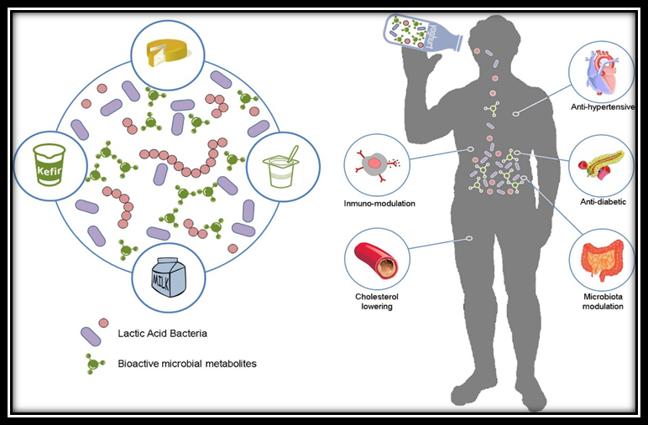
Fig:3 Advantageous results by the ingestion of biologically enhanced fermented milk based meals. Lactic acid bacteria play major role in fermented dairy products and essentially add the fermented dairy product with a wide variety of biologically active metabolites. Ensuing consumption of this product can employ major health elevating activities on the consumer, such as anti-hypertensive, and anti-diabetic, immune-modulatory, anti-cholesterolemic or microbiome modulation[42].

4..Advantages of milk fermentation

Fermented milk produce have advantageous impact on individual intestinal fitness. Fermented milk produce contain live microorganism in the food products that enhances the enzymatic activity which leads to proper digestion of food inside the digestive system. For maintaining a healthy gut microflora of human individual the recent advancements are taking place in enhancing the role of probiotic and prebiotic. The majority of ordinary species of lactic acid bacteria are utilized in milk fermentation are Streptococcus thermophilus, typically alongwith Bifidobacteria, such as Bifidobacterium breve C50, Bifidobacterium lactis, Bifidobacterium longum and Bifidobacterium animalis, or with Lactobacilli such as Lactobacillus acidophilus, Lactobacillus rhamnosus, Lactobacillus johnsonii and Lactobacillus casei[21].In reality,majority of meals that includes probiotics and prebiotics are fermented dairy products like yogurt, which is the most considered fermented dairy product, kumys, skyr, yakult, and kefir [6,9].

Various kinds of probiotic products. .
Modulated from McFarland, 2015[32]

Probiotic | Formulation | Evidence based efficacy | References
Bifidobacterium animalis subsp lactis DN-173010 | Yogurt | Constipation | [60]
Lactobacillus casei subsp Shirota | Fermented milk | Constipation, H. pylori infection | [30]
Lactobacillus casei DN-114001 | Fermented drink, yogurt | Antibiotic-related diarrhoea, avoidance of  pediatric diarrhoea, respiratory inflammations | [14]
Lactobacillus plantarum 299v (DSM9843) | Fermented oat gruel in fruit  drink, capsules | Irritable bowel syndrome, Clostridium crucial  Contamination or inflammation | [29]
Lactobacillus reuteri DSM 17,938 | Capsules, yogurt | Severe pediatric diarrhoea, cholesterol | [46]
Lactobacillus rhamnosus GG (ATCC 53013) | Yogurt, capsules | Severe pediatric diarrhoea, antibiotic-related  diarrhoea | [27]
Lactobacillus acidophilus +  Bifidobacterium animalis  subsp lactis | Yogurt | Improves in microbiota | [44]

5.What is the need of using plant source for fermentation of milk?
From decades we are using dairy starter culture or LAB cultures for milk fermentation but with recent development in the research are leading to sources other than dairy for fermented milk products like plant sources.
Instead of using starter culture or inoculum for fermentation of milk, these days plant sources are in focus for milk fermentation. Recently developed yogurts with plant sources are nowadays well accepted in the dairy market. As buyers are gradually focused in physically fit nourishment, with the assumption that food can provide them be health fitness or may even be able to prevent diseased condition, probiotic food obtained by the action of fermentation of milk, cereals, fruits, and vegetables are gaining recoginition from scientists along with the public that consume the dairy probiotic.[22].
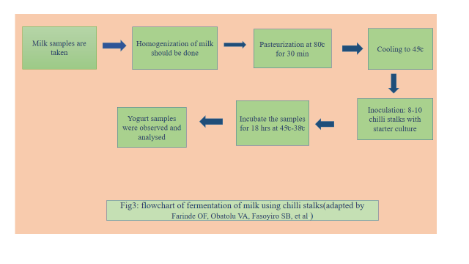
Researches have been done on the addition of chilli stalks for milk fermentation and it is generally practised in colder climate for fermentation. Red chili is a common spice used in many food items and also in various pharmaceutical preparations[4].Capsaicin (8-methyl-N-vanillyl-6-nonenamide), one of the vital ingredients in red chili, is known to have several medicinal properties, such as its potential to attenuate hypertension[60]and to suppress tumor growth by inducing apoptosis [37]. Numerous researches in the medical literature have related the utilization of chili-supplemented feed with enhanced energy dissipation and oxidation of fats[15]. Available declarations said that the calyx of capsicums fruits such as chilli, are frequently abundant in numerous lactobacilli. These innate bacteria produce as an inoculum for lacto-fermentation of milk.
Additionally, capsaisin from the chilli turn out to enhance the metabolic rate of the lactobacilli [24,47] The stalks (calyx) of chilli (Capsicum spp.) are commonally separated as waste throuhgout food processing. The application of this regarded as a waste used in the curding of milk can still change its condition from being a waste product to a product of elevated economic value as a result turning waste to wealth[25]. This will provide an easy access to healthy starter culture in yogurt making instead of using the inoculum that is limited up for sale.Red chili pepper is also accustomed in curdling of milk, particularly in the colder regions or during winters or when starter cultures run out[21]. Oatmeals are being used as a prebiotic culture to enhance the growth of bacteria that is capable to ferment dairy milk. ). Prebitoics are given special attention as they play role of dietary fiber which cannot be compensated by the use of probiotic exclusively. Dietary fiber provide substrate for Intestinal microflora growth and also maintain healthy gut microbiota for smooth working of intestinal digestion. Dietary fiber enlarges the individual alimentary canal through water absorption, improving stool volume, alleviating stool, restoring gastrointestinal peristalsis, and relieving coanstipation. Dietary fiber is known as the seventh major nutrient because of its physiological functions such as lowering of the lipid levels, regulation of sugar metabolism, regulation of intestinal microbes, and reduction of the risk of depression.The composition of milk with cereal grains like oats combines the nutritional supplement or act like nutraceuticals in human individual to maintain the balance of dietary fibers,vitamins and some essential amino acids that is required by human to fight against stressed and diseased condition and ensures a healthy and well balanced scenario of human health with their increasing age and reducing immunity. The manufacturing of milk foods with oatmeal will feed the community with complete fiber rich food components having therapeutic properties[57].
Plant sources | microorganism | Fermented product | Therapeutic effect
Chilli stalks | Lactic acid bacteria | Curd | Acts as a probiotic to enhance intestinal health
Red chilli | Lactic acid bacteria | Curd | Probiotic to ehance gut microflora
Oats | Streptococcus thermophiles and L.plantarum | Yogurt | Acts as a prebiotic for starter culture and ehnace dietary fiber to the intestinal digestion

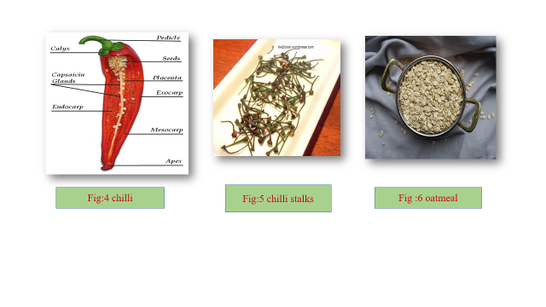
7. Futuristics trends in fermented products
Fermentation are widespread and have blooming platform in food industries nowadays .Recently, precise fermentation become evident as a innovative aimed techniques in food applications with the focus of presuming valuable combinations [8]. The present innovative techniques influences organic manufacturing mechanism to constitute as a factory of biochemical components like protein, pigments, vitamins, and fats to improve the properties of plant-based substitutes [50,59]. Moreover, fermentation is predominant for feasible food solutions and can offer a useful effect on the sustainability index for the food industry [8–5]. In contrast to typical protein sources, biomass fermentation for protein production can swiftly give rise to much elevated protein ranges in respect to other nutrients. Additionally, food by-products and wastes can be utilized as substrates to be modified in invaluable food and feed products [6–9]. This is an ecologically safe approach that could vitalize a more optimized and feasible economy.
The global market of plant-based products made using fermentation was valued at USD 329.29 million in 2021 and is expected to reach USD 422.26 million by 2026, with a compound annual growth rate (CAGR) of 5.0% [19,48]. Figure 6 illustrates the development of the number of the products instigated in the global market throughout the last two decades (2002–2022). From 2002 to 2012, the sum total of all fermented plant-based products escalated, but at a slow rate. Throughout the period 2013–2022, this market observed an expanding growth and reached a peak in 2021 on an account to the scale up of fermented plant-based meat and dairy substitutes [31], and it is anticipated to retain growth in the future years. The epidemic of COVID-19 contributed to inflaming consumer inquisitiveness in fermented plant-based products, providing them healthiness comforts like enhancing immune system action and relieving gastro-intestinal condition and irritating reactions [14,37].
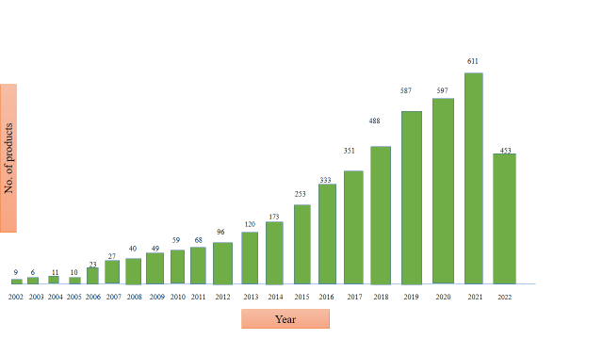
Fig:6 Development on instigation of fermented plant-based foods in the global market. Research was organized on Mintel GNPD (Global New Products Database) on 15 September 2022. Date: from 1January 2002, to 15 September 2022.

Efforts to generate inventive results for improved nourishment with substitute proteins have been rushed with emergence of hi-tech equipments and further newly discovered transformations. Earlier described that the implementation of hi- tech equipments, namely artificial intelligence, advanced detectors, automated machinery, throughout fermentation that enhance observation or execute action[53]. As instances, all through leavening procedure of rice wine, numerous criterias like heat, moisture, amount of glucose and alcohol, and acidity can be estimated using technologies, permiting producers to practically detect the entire leavening procedure electronically connected [40]. Addition of Industry 4.0 technologies into fermentation benefits, “Fermentation 4.0” has just now been debated, underlining their capability of resolving correlated complications like the execution of convoluted culture constrains[2]. The application of such newly developed technologies to attain automated identification and management of beer fermentation was lately evaluated and entirely considered [55].
Inspecting the procedure will provide a recommendable interpretation of the coordination amidst the microorgnaism and their interaction with distinct media (other fresh components instead of milk). Three-dimensional (3D) cameras and hyperspectral imaging (HSI) would allow real-time inspection, and consequently procedures are practically modified or enhanced in reality throughout processing [12,36]. Like, in a latest studies, HSI was acclimated to project and evaluate the overall acid content and reducing sugar content of fermented grains [26]. The implication of digital technologies and other recently developed transformation has been conclusively well organized in enhancing the value and well-being of fermented foods and beverages [21,56]. Current development in Industry 4.0 technologies have allowed extensive development in accurate fermentation due to latest improvement in AI, bioinformatics, and systems and computational biology [23,51]. Similar improvements could provide value standardization by detecting any prospective inconsistency in the fermentation procedure (e.g., mutation), and steady yield, and therefore more economical food production techniques. Development of accurate fermentation are anticipated to be basic components in the upcoming years to choose taste and texture, increase the longevity of fermented food products from plant sources, and to imitate their animal counterparts [52–58].

7. Conclusion
This study on using plant source for fermentation of milk mainly draw attention toward the evolution in fermented milk products. Since,the early ages the starter cultures are being in practise for fermentation till nowadays, but there is a limitation of starter cultures on industrial scale and it is also difficult to maintain the culture for a longer period of time as there are chances of contamination of the starter culture species. So, recent advances are suggesting to introduce plant sources in fermentation industry especially chilli, chilli stalks, oatmeals in fermentation of milk. Also fermentation of milk with plant source add therapeutic value to fermented food products that have the ability to enhance immunological properties to fight off various kind of infection and disease. So we can extend the research related to plant sources for fermentation of milk furthermore to gain knowledge about its different probiotic and prebiotic strains that are present in plant sources and also to study more about the nutritional values of functional foods products that produced using plant based fermentation.

References
- Alimentarius, Codex (2011). Milk and milk products (2nd ed.). Rome, Italy: WHO and FAO.144.
- Alarcon, C.; Shene, C. Fermentation 4.0, a Case Study on Computer Vision, Soft Sensor, Connectivity, and Control Applied to theFermentation of a Thraustochytrid. Comput. Ind. 2021, 128, 103431.
- Ataie-Jafari, A., Larijani, B., Alavi Majd, H., & Tahbaz, F. (2009). Cholesterol-lowering effect of probiotic yogurt in comparison with ordinary yogurt in mildly to moderately hypercholesterolemic subjects. Annals of Nutrition and Metabolism, 54(1), 22–27.
- Barceloux, D. G. 2008. Pepper and capsaicin (Capsicum and Piper species). Pages 71–73 in Medical Toxicology of Natural Substances: Foods, Fungi, Medicinal Herbs, Plants and Venomous Animals.John Wiley and Sons Inc., Hoboken, NJ.
- BIS Research Fermented Plant Based Alternatives Market Analysis and Forecast Upto 2026|BIS Research. Available online:https://bisresearch.com/industry-report/fermented-plant-based-alternatives-market.html (accessed on 25 September 2022).
- Bourrie, B. C. T., Willing, B. P., & Cotter, P. D. (2016). The microbiota and health promoting characteristics of the fermented beverage kefir. Frontiers in Microbiology, 7, 1–17.27.
- Boukid, F. Plant-Based Meat Analogues: From Niche to Mainstream. Eur. Food Res. Technol. 2021, 247, 297–308.28. Boukid, F.; Pera, J.; Parladé, J.; Castellari, M. Fungal Bioconversion of Brewery By-Products: Assessment of Fatty Acids and Sterols Profiles. Qual. Assur. Saf. Crop. Foods 2022, 14, 202–211. Foods 2023, 12, 1005 16 of 214.
- Chai, K.F.; Ng, K.R.; Samarasiri, M.; Chen, W.N. Precision Fermentation to Advance Fungal Food Fermentations. Curr. Opin. Food Sci. 2022, 47, 1008815.
- Chen, M., Ye, X., Shen, D., & Ma, C. (2019). Modulatory effects of gut microbiota on constipation: The commercial beverage yakult shapes stool consistency. Journal of Neurogastroenterology and Motility, 25(3), 475–477
- Cicho´ nska, P.; Ziarno, M. Legumes and Legume-Based Beverages Fermented with Lactic Acid Bacteria as a Potential Carrier of Probiotics and Prebiotics. Microorganisms 2022, 10, 91.
- Chakraborty, A.; Bhowal, J. Bioconversion of Jackfruit Seed Waste to Fungal Biomass Protein by Submerged Fermentation. Appl. Biochem. Biotechnol. 2022, 1–14.
- Caporaso, N.; Whitworth, M.B.; Fowler, M.S.; Fisk, I.D. Hyperspectral Imaging for Non-Destructive Prediction of Fermentation Index, Polyphenol Content and Antioxidant Activity in Single Cocoa Beans. Food Chem. 2018, 258, 343–351
- De Moreno De Leblanc, A., & Perdigón, G. (2010). The application of probiotic fermented milks in cancer and intestinal inflammation. Proceedings of the Nutrition Society,69(3), 421–428.
- Dietrich, C. G., Kottmann, T., & Alavi, M. (2014). Commercially available probiotic drinks containing Lactobacillus casei DN-114001 reduce antibiotic-associated diarrhea World Journal of Gastroenterology, 20(42), 15837–15844.
- Diepvens, K., K. R. Westerterp, and M. S. Westerterp-Plantenga. 2007. Obesity and thermogenesis related to the consumption of caffeine, ephedrine, capsaicin, and green tea. Am. J. Physiol.Regul. Integr. Comp. Physiol. 292:R77–R85
- Ebringer, L., Ferencik, M., & Krajcovic, J. (2008). Beneficial health effects of milk and fermented dairy products – review. Folia Microbiologica, 53(5), 378–394.
- Farinde OF, Obatolu VA, Fasoyiro SB, et al. Use of alternative raw materials for yogurt production. Afr J Biotechnol. 2008;7(18):3339-45.
- Finnigan, T.; Needham, L.; Abbott, C. Mycoprotein: A Healthy New ProteinWith a Low Environmental Impact. In Sustainable Protein Sources; Academic Press: Cambridge, MA, USA, 2016; pp. 305–325.
- Fonseca, S.C.; Rivas, I.; Romaguera, D.; Quijal, M.; Czarlewski, W.; Vidal, A.; Fonseca, J.A.; Ballester, J.; Anto, J.M.; Basagana,X.; et al. Association between Consumption of Fermented Vegetables and COVID-19 Mortality at a Country Level in Europe. medRxiv 2020.
- Granier, A., Goulet, O., & Hoarau, C. (2013). Fermentation products: Immunological effects on human and animal models. Pediatric Research, 74, 238–244.
- Gonzalez Viejo, C.; Harris, N.M.; Fuentes, S. Quality Traits of Sourdough Bread Obtained by Novel Digital Technologies and Machine Learning Modelling. Fermentation 2022, 8, 516
- Gupta, S., and Abu-Ghannam, N. (2012). Probiotic fermentation of plant based products: possibilities and opportunities. Crit. Rev. Food Sci. Nutr. 52, 183–199. doi: 10.1080/10408398.2010.499779
- Hassoun, A.; Bekhit, A.E.; Jambrak, A.R.; Regenstein, J.M.; Chemat, F.; Morton, J.D.; Gudjónsdóttir, M.; Carpena, M.; Prieto, A.; Varela, P.; et al. The Fourth Industrial Revolution in the Food Industry—Part II: Emerging Food Trends Trends. Crit. Rev. Food Sci. Nutr. 2022, 1–31.
- Harini P. Vegan Recepies. A blog in tongueticklers.com. 2013;4.
- Iličić M, Milanović S, Carić M (2015): Rhelogy and texture of fermented milk products. In: E. Karpushkin (ed.), Rheology, Principles, Applications and Environmental Impacts, New York: Nova Publisher.
- Jiang, X.; Tian, J.; Huang, H.; Hu, X.; Han, L.; Huang, D.; Luo, H. Nondestructive Visualization and Quantification of Total Acid and Reducing Sugar Contents in Fermented Grains by Combining Spectral and Color Data through Hyperspectral ImaginFood Chem. 2022, 386, 132779.
- Jia, R., Chen, H., Chen, H., & Ding, W. (2016). Effects of fermentation with Lactobacillus rhamnosus GG on product quality and fatty acids of goat milk yogurt. Journal of Dairy Science, 99(1), 221–227.
- Katz, S. E. 2011. The Art of Fermentation. Chelsea Green Publishing, White River Junction, VT.
- Klarin, B., Johansson, M. L., Molin, G., Larsson, A., & Jeppsson, B. (2005). Adhesion of the probiotic bacterium Lactobacillus plantarum 299v onto the gut mucosa in critically ill patients: A randomised open trial. Critical Care, 9(3), R285–R293.
- Maragkoudakis, P. A., Chingwaru, W., Gradisnik, L., Tsakalidou, E., & Cencic, A. (2010).Lactic acid bacteria efficiently protect human and animal intestinal epithelial and immune cells from enteric virus infection. International Journal of Food Microbiology,141(1), S91–S97.
- Mintel Emerging Trends in the Plant-Based Industry|Mintel.Com. Available online: https://www.mintel.com/emerging-plantbased-trends (accessed on 24 September 2022).
- McFarland, L. V. (2015). From yaks to yogurt: The history, development, and current use of probiotics. Clinical Infectious Diseases, 60(2), S85–S90.
- Milanović S, Iličić M, Carić M (2017): Fermentisani mlečni proizvodi, Novi Sad: Tehnološki fakultet.
- Milanović S, Hrnjez D, Iličić M , Kanurić K , Vukić V (2016): Novel Fermented Dairy Products, Chapt. 9. In: KS Ojha, BK Tiwari (eds.), Novel Food Fermentation Technologies, Springer Int. Publ., 165–201.
- Olatide M, Arawande JO, George OO, et al. Pilot study on chilli stalks as a source of non-dairy lactic acid bacteria in yogurt making. Appl Food Sci J. 2019;3(1):5-8.
- 146. Özdo˘gan, G.; Lin, X.; Sun, D.W. Rapid and Noninvasive Sensory Analyses of Food Products by Hyperspectral Imaging: Recent Application Developments. Trends Food Sci. Technol. 2021, 111, 151–165.
- Pramanik, K. C., and S. K. Srivastava. 2012. Apoptosis signal-regulating kinase 1-thioredoxin complex dissociation by capsaicin causes pancreatic tumor growth suppression by inducing apoptosis. Antioxid.Redox Signal. 17:1417–1432.
- Pei, R., Martin, D. A., DiMarco, D. M., & Bolling, B. W. (2017). Evidence for the effects of yogurt on gut health and obesity. Critical Reviews in Food Science and Nutrition, 57(8),1569–1583.
- Quantification of Total Acid and Reducing Sugar Contents in Fermented Grains by Combining Spectral and Color Data through Hyperspectral Imaging. Food Chem. 2022, 386, 132779.
- Research and Markets Fermented Plant-Based Alternatives Market—A Global and Regional Analysis: Focus on Applications,Products, Patent Analysis, and Country Analysis-Analysis and Forecast, 2019–2026. Waste Biomass Valorization 2019, 10, 2487–2496
- Sar, T.; Larsson, K.; Fristedt, R.; Undeland, I.; Taherzadeh, M.J. Demo-Scale Production of Protein-Rich Fungal Biomass from Potato Protein Liquor for Use as Innovative Food and Feed Products. Food Biosci. 2022, 47, 101637.
- Stanton, C., Ross, R. P., Fitzgerald, G. F., and Van Sinderen, D. (2005). Fermented functional foods based on probiotics and their biogenic metabolites. Curr. Opin. Biotechnol. 16, 198–203. doi: 10.1016/j.copbio.2005.02.008
- Sharifi, M., Moridnia, A., Mortazavi, D., Salehi, M., Bagheri, M., & Sheikhi, A. (2017).Kefir: A powerful probiotics with anticancer properties. Medical Oncology,34(11), 1–7.
- Simpson, M. R., Avershina, E., Storrø, O., Johnsen, R., Rudi, K., & Øien, T. (2018). Breastfeeding-associated microbiota in human milk following supplementation with Lactobacillus rhamnosus GG, Lactobacillus acidophilus La-5, and Bifidobacterium animalis ssp. lactis Bb-12. Journal of Dairy Science, 101(2), 889–899.
- Shiby, V. K., & Mishra, H. N. (2013). Fermented milks and milk products as functional foods-A review. Critical Reviews in Food Science and Nutrition, 53(5), 482–496.
- Spinler, J. K., Taweechotipatr, M., Rognerud, C. L., Ou, C. N., Tumwasorn, S., &Versalovic, J. (2008). Human-derived probiotic Lactobacillus reuteri demonstrateantimicrobial activities targeting diverse enteric bacterial pathogens. Anaerobe,14(3), 166–171.
- Sharma SJ, Nair GN, Ramachandran S. Capsicum annuum enhances L-lactate production by lactobacillus acidophilus: implication in curd formation. J Dairy Sci. 2013;96(7):4142-8.
- Shahbazi, R.; Sharifzad, F.; Bagheri, R.; Alsadi, N.; Yasavoli-Sharahi, H.; Matar, C. Anti-Inflammatory and Immunomodulatory Properties of Fermented Plant Foods. Nutrients 2021, 13, 1516.
- Souza Filho, P.F.; Zamani, A.; Taherzadeh, M.J. Edible Protein Production by Filamentous Fungi Using Starch PlantWastewater
- Terefe, N.S. Recent Developments in Fermentation Technology: Toward the next Revolution in Food Production. In Food Engineering Innovations across the Food Supply Chain; Elsevier: Amsterdam, The Netherlands, 2022; pp. 89–106134. Teng, T.S.; Chin, Y.L.; Chai, K.F.; Chen,W.N. Fermentation for Future Food Systems: Precision Fermentation Can Complement the Scope and Applications of Traditional Fermentation. EMBO Rep. 2021, 22, e52680
- Teng, T.S.; Chin, Y.L.; Chai, K.F.; Chen,W.N. Fermentation for Future Food Systems: Precision Fermentation Can Complement the Scope and Applications of Traditional Fermentation. EMBO Rep. 2021, 22, e52680.
- Tyndall, S.M.; Maloney, G.R.; Cole, M.B.; Hazell, N.G.; Augustin, M.A. Critical Food and Nutrition Science Challenges for Plant-Based Meat Alternative Products. Crit. Rev. Food Sci. Nutr. 2022, 1–16.
- Viejo, C.G.; Fuentes, S. Editorial: Special Issue “Implementation of Digital Technologies on Beverage Fermentation”. Fermentation 2022, 8, 127.
- Vošahlík, J.; Hart, J. Measurability of Quality in Fermentation Process of Rice Wine by IoT in the Field of Industry 4.0. Agron. Res. 2021, 19, 1318–1324.
- Violino, S.; Figorilli, S.; Costa, C.; Pallottino, F. Internet of Beer: A Review on Smart Technologies from Mash to Pint. Foods 2020, 9, 950.
- Viejo, C.G.; Fuentes, S. Low-Cost Methods to Assess Beer Quality Using Artificial Intelligence Involving Robotics, an Electronic Nose, and Machine Learning. Fermentation 2020, 6, 104
- V.A. Smirnov, Traditional and non-traditional fillers Dairy industry 2, 56-57 (2018)
- Viejo, C.G.; Fuentes, S.; Hernandez-Brenes, C. Smart Detection of Faults in Beers Using Near-Infrared Spectroscopy, a Low-Cost Electronic Nose and Artificial Intelligence. Fermentation 2021, 7, 117.
- Williams, R.A. Opportunities and Challenges for the Introduction of New Food Proteins. Annu. Rev. Food Sci. Technol. 2021, 12,75–9124.
- Yang, Y. X., He, M., Hu, G., Wei, J., Pages, P., Yang, X. H., & Bourdu-Naturel, S. (2008).Effect of a fermented milk containing Bifidobacterium lactis DN-173010 on Chinese constipated women. World Journal of Gastroenterology, 14(40), 6237–6243.
- Yang, D., Z. Luo, S. Ma, W. T. Wong, L. Ma, J. Zhong, H. He, Z. Zhao, T. Cao, Z. Yan, D. Liu, W. J. Arendshorst, Y. Huang, M. Tepel, and Z. Zhu. 2010. Activation of TRPV1 by dietary capsaicin improves endothelium-dependent vasorelaxation and prevents hypertension. Cell Metab. 12:130–141

