Development of Swarm Bot for Defence and Medical application

¹Soumayadeep Pal, ¹Parthib Banerjee , ¹Avrajeet Ghosh, ¹Ankita Show,
²Susmita Das
¹B. Tech Student, Electronics and Instrumentation Engg., Narula Institute of Technology
²Assistant Professor, Electronics and Instrumentation Engg., Narula Institute of Technology
Corresponding Author Mail ID: susmitad2011@gmail.com

Abstract – Design of Swarm bot is an initiative towards the synchronized performance of multiple bots as a total system consisting huge numbers of plain real-time bots. It is observed that an expected groupwise behavior is expressed from the interactions between the bots and the master device. The head posture movement is used to send the signal from the master device to communicate the slave devices. This methodology has come out in the field of artificial swarm intelligence, as well as the bio-inspired researches of insects and other fields in nature with the occurrence of swarm behavior. This process depends on the master-slave concept to operate the whole system. The wireless communication utilizes the SPI (Serial Peripheral Interface) protocol with radio waves in the range of 2.4-2.5 GHz. The ISM (Industrial Scientific Medical) band is used for the communication purpose.

Keywords – Swarm bot; Master-Slave; Wireless; Remote location.

1.0 Introduction

Swarm bot is the way of presenting the workflow mapping of several bots as a system consisting huge numbers of physical bots. It is seen that a required team appearance comes out from the connectivity between the automated systems and wireless connections of bots with the main controller. This approach is implementable in the application area of artificial swarm intelligence and other fields such as medical and defence. The instructions about 'Swarm Bots’ is Assembly and Co-operative Transport which can be prepared as our own master and slave bot. The slave will follow the instructions of master robot and the master robot will be controlled with our android devices or through designed application softwares. It is a smart and intelligent automated system to monitor human activities. We are moving towards the goal to achieve the controlling of a group of slave bots in fully autonomous way so that they locate, approach and connect with an object. In Swarm robotics field, in a distributed and decentralized way multi-robotics is involved or participated in the form of large number of robots. The main application-oriented goal of the Swarm-bots is to study and understand the controlling of the slave bots assembled into structures. Swarm-bot is made of master and slave where the master controls the slave using Radio Frequency wave operated modules to carry out the dedicated job.

A Swarm-bot is connected with number of identical robots, called slave bots, which are wirelessly connected. The Swarm-bot is present with self-arranged feature. This challenging work initiates the functionality of the Swarm-bot assembly with one master and two numbers of slaves as the prototype development and gives presentation about its application as transportation bot in defence and medical fields.

The bots in the swarm configuration must have some primary functions-

1) Interconnection among swarm bots: Participated bots in the swarm connection exchange the knowledge with each other and cultivate the facts to the total swarm through self-operated nature resulting in the swarm-level cooperation.

2) Keeping away from collision between swarm bots.

3) Coordination between bots.

There are some more features of swarm bots that fit neither of the above mentioned categories.
• Recovery process allows the swarm to get rid of different issues caused by short-falls of each and every bots. The aim is to almost eliminate the effect of robot performance failure on the remaining part of the swarm to improve the overall reliability, robustness, and performance.
• Reproduction process by its own allows an array of bots either to create newer design of robots or mimic the pattern generated from many other systems. The aim is to increase the self sufficiency of the swarm by reducing the requirement of a human operator to create new bots.
• Human-swarm interaction gives allowance the humans to operate the robots in the swarm or collect information from those bots. The connectivity can be set remotely, such as through a computer such as through visual or air medium.

2.0 Methodology

Construction of Mechanical Structure:

• Assembly of autonomous controller unit
• Assembly of different types of ambient sensors
• Assembly of different types of communication protocol

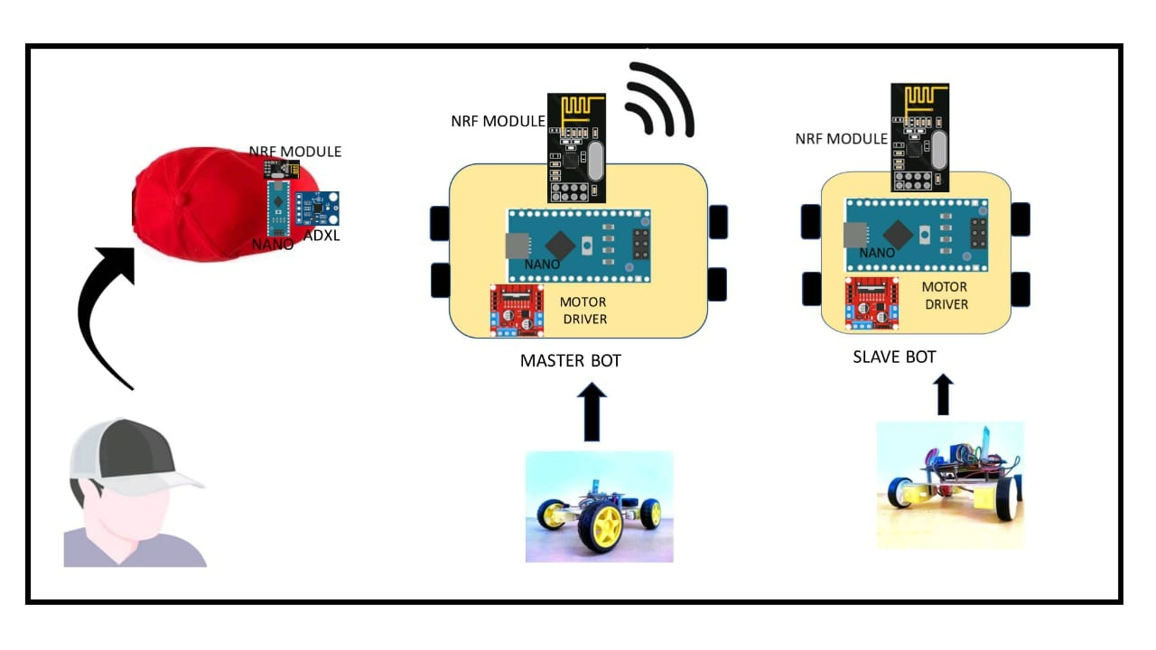

Fig 1: Schematic Diagram of Robotic car
representation of the swarm robotic system

Synchronized location shifting:

This work finds the challenges of
a) The controlling methods to separate slave bots to connect with an object and/or with each other.
b) The process of having a swarmbot or a group of swarm-bots to send an object towards a destination.
The design and effectiveness of a hybrid control mechanism for operating a self-arranged group of slave bots engaged in a collaborative transmitting task that have already been nurtured in simulation. The issues has been classified into the categories of controlling the steps.
1. Slave bots that can self-manage themselves. Assembled slave bots can locate the target during transmission.
2. Assembled slave bots those are not able to locate the target during sending, uses one master and one slave microcontrollers.
3. Interfacing is included with optical avoider sensor with swarm bot.
4. Development of SPI communication among swarm bots.
5. Coordination among the swarm bots. Transportation issues of material is the only limitation.

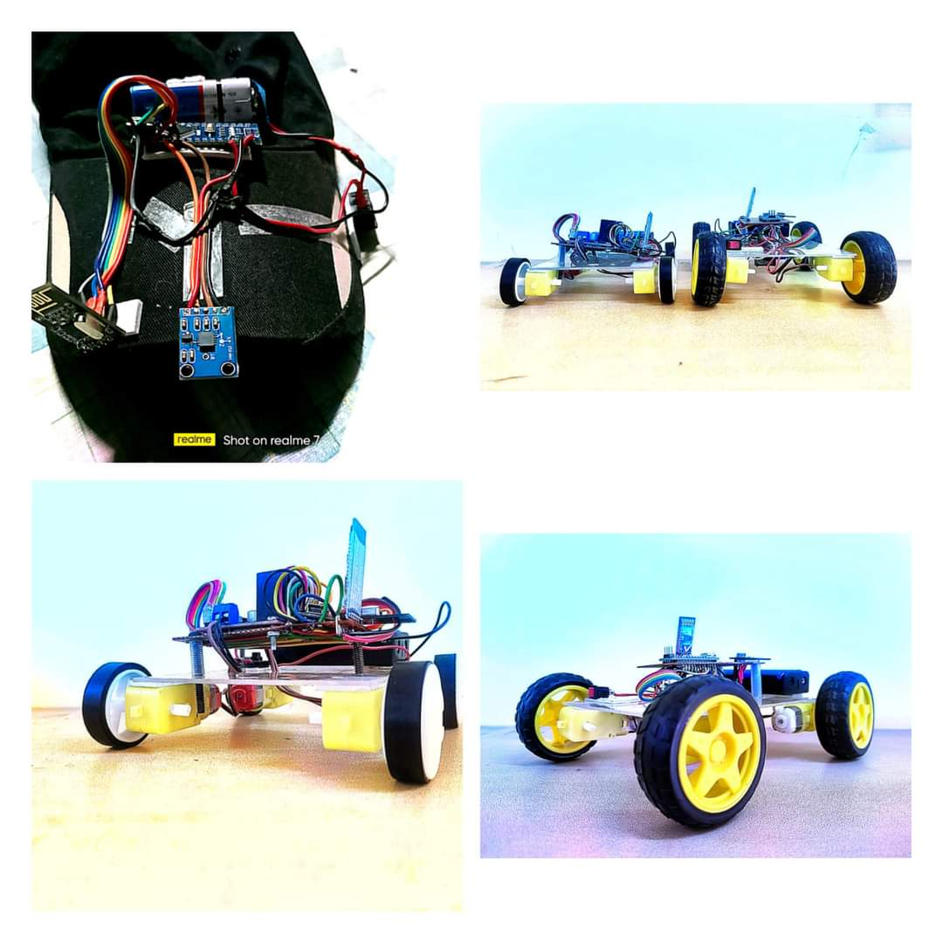

Fig 2: Pictorial Robotic car
representation of the swarm robotic system
Fig 3: prototype of the head posture movement to operate swarm robotic car

Specified jobs in particular regions Swarm robotics is very necessary to apply in border areas. In the no man’s zone large areas are distributed with arrays of robots, and they act in group to complete the work. In this specific areas such as collecting information and act accordingly is the main function to defeat the terrorists.
• The hazardous zones:
Attaining an assignment in hazardous areas is not easy or safe for the human beings. It is acceptable to send robot swarms instead, in those risky zones. An example can be looking for hazardous objects in unreachable fields.
• Tasks scalable up and down:
Utilizing swarm robotics in jobs that can be scaled up and down according to the ambience is very useful because if a task is being scaled up due to a particular reason, the count of bots in a swarm can be increased and if a task is being scaled down then the count of bots can be decreased. Natural disasters can scale up very quickly as an example.
• Jobs with redundancy requirement:
Redundancy is a basic criteria of swarm robotics and because of robustness represented by swarm robotic setup. The robots can adjust with the performance failure of other bots. They should do their work continuously and the absence of some members should not have any effect on the outcome. In the zones mentioned above, there are different types of tasks those can be done by swarm robotic setup.

3.0 CONCLUSION

Through this prototype development the observation has been achieved that the master-slave is implemented. The wireless connection between master device and the slave device is made through transceiver pair using radio waves. The places which are not reachable by human beings can be tracked and monitored through this kind of devices in a group.

4.0 FUTURE SCOPE

- By increasing the number of slave devices in different forms, shifting of bulk-sized and heavier objects can be accomplished.
- These swarm bots can be used for various food delivery operations in the restaurants.
- The utilization of swarm robotics can be extended to serve a nation through military services. This will reduce the number of casualties from a war.

5.0 References

1. A Survey of Swarm Robotics System, Advances in Swarm Intelligence, 2012, Volume 7331, ISBN : 978-3-642-30975-5, Zhiguo Shi, Jun Tu, Qiao Zhang, Lei Liu, Junming Wei.
2. Diemer, J.; Alpers, G. W.; Peperkorn, H. M.; Shiban, Y.; Mühlberger, A. The impact of perception and presence on emotional reactions: a review of research in virtual reality. Frontiers in psychology 2015, 6, 26.
3. Bindman, S. W.; Castaneda, L. M.; Scanlon, M.; Cechony, A. Am I a Bunny? The Impact of High and Low Immersion Platforms and Viewers' Perceptions of Role on Presence, Narrative Engagement, and Empathy during an Animated 360 Video. In Proceedings of the 2018 CHI conference on human factors in computing systems, 2018, April. p. 457. ACM.
4. Robert George Reid, “Large-Scale Simultaneously Localization and Mapping for Teams of Mobile Robots”, Australia, July 2016.
5. Sugawara K., Correll N., Reishus D, “Object Transportation by Granular Convection Using Swarm Robots,” in Ani Hsieh M., Chirikjian G. (eds) Distributed Autonomous Robotic Systems. Springer Tracts in Advanced Robotics, vol 104. Springer, Berlin, Heidelberg, 2014.
6. Paul Levi, Eugen Meister and Florian Schlachter,”Reconfigurable swarm robots produce selfassembling and self-repairing organisms”,Journal: Robotics and Autonomous Systems, Netherlands, October 2014.
7. Jin, Yaochu & Meng, Yan,” Morphogenetic Robotics: An Emerging New Field”, IEEE Transactions Developmental Robotics. Systems, Man, and Cybernetics, 2011.
8. S. Sankhar Reddy Chennareddy, Anita Agrawal, and Anupama Karuppiah,” Modular Self-Reconfigurable Robotic Systems: A Survey on Hardware Architectures”, Journal of Robotics, 2017.
9. Vorobyev G., Vardy A., Banzhaf W.,”Supervised Learning in Robotic Swarms: From Training Samples to Emergent Behavior”,2014
10. “How Robots Can Acquire NewSkils from Their Shared Experience”,Available:https://research.googleblog.com/2016/10/how-robots-can-acquire-new-skills-from.html?m=1. [Accessed Feb. 15, 2018].
11. Daniel Faggella,” Machine Learning in Robotics – 5 Modern Applications”, Available: https://www.techemergence .com/machine - learning- in-robotics/ [Accessed:15- Feb2018].

DEVELOPMENT OF VERTICLE CLIMBING CAMOUFLAGE
SURVEILLANCE BOT
¹Niladri Ganguly, ¹Raktim Dutta, ¹Ankita Kundu, ¹Santanu Chowdhury,
²Susmita Das
¹B. Tech Student
²Assistant Professor
Department of Electronics and Instrumentation Engineering
Narula Institute of Technology
Corresponding Author’s email: susmitad2011@gmail.com

Abstract- Scientists are trying to make vehicles that can move through both vertical and horizontal planes simultaneously for a long time. Moving against gravity makes it very difficult because of wheel spin in a steeply inclined surface plane. In this paper, we are dealing with the design and development of a WI-FI controlled bot that can move on both horizontal and vertical surfaces. The air suction technique is used to hold the bot on a vertically inclined surface.
This paper presents the design and development of a wall climbing bot using an ESP32 CAM microcontroller. The wall climbing feature is achieved by using a 2200kv BLDC motor and 600 mm propeller. When the propeller is rotated using the BLDC motor, the propeller sucks the air underneath the robot, creating a vacuum. As a result, outside air pressure works on the robot and makes it stick to the horizontal surface. The robot`s movement is done by using 4 100 RPM dc motors. The motors are connected to the ESP32 microcontroller via motor driver L298N and can be manually controlled using any ESP32 Android/IOS mobile application. We have used the TCS3200 colour sensor and RGB LED lights to change the colour of the body as per the surroundings.
The robot can be used for any surveillance purposes from general surveillance purposes to surveillance of hostile areas.

Keywords: Wall Climbing; ESP32 CAM; BLDC Motor; L298N Motor Driver; TCS3200

1. INTRODUCTION:
Robots are among the utmost vital and futuristic inventions in modern science. It is an electro-mechanical device or machine that can perform various tasks mechanically with the help of software commands. These can be used to perform various tasks in hazardous settings where humans cannot go and perform them. In the 21st century, robots are the machines or aids that have made our lives far easier and more comfortable. Robots are primarily used in fields where direct access to human personnel is very costly and terribly dangerous because of the presence of hostile or hazardous surroundings. Within the last few decades, various applications have been visualized for wall climbing bots, primarily in industrial inspections, maintenance, area surveillance, field activities and diagnosing breakdown and failure in hazardous fields. These applications are mainly used outside of skyscrapers, bridges, nuclear power plants and pipelines, for examining surfaces of gas and petroleum tanks, platforms in seas, for non-destructive experiments in industrial sectors, in planes or big ships, also these are used in the construction of buildings, repairing and maintenance of them, furthermore in firefighting situations, in counter-terrorists activities, in the improvement of working in skyscrapers, for wall cleaning of buildings, restaurants, surveillance and intelligence activities in urban areas. At last, these are also used within education and human welfare activities.
In this paper, we present the design, fabrication and testing of a miniature, wall mounting mechanism, that uses Veroboard as body material and a completely different approach in wall climbing techniques than those other techniques employed in robots. Consequently, this new bot is more efficient. The bot operates by the management of two programmable microcontrollers and is powered by a 3000 Mah Lithium-Ion Battery, creating the robot whole active. The robot can work on information acquisition purposes and surveillance purposes. We have used the TCS3200 colour sensor and RGB LED lights to change the colour of the body and made it like a camouflage bot.

2. COMPONENTS USED:
1. ARDUINO UNO
2. L298N MOTOR DRIVER
]3. ESP32 CAM Microcontroller
4. 3000 Mah Li-ion Battery
5. 2200KV BLDC Motor
6. 9-volt DC Motor
7. 30A ESC
8. Servo Controller
9. TCS3200 colour sensor
10. RGB LED lights
11. Wires
12. Veroboard
13. Wheels

3. METHODOLOGY:
The steps involved in the building of this robot are as follows:
1. To develop an appropriate program in the ESP32 CAM module to interact with the WI-FI controller.
2. To build the whole circuit of the robot.
3. To rotate the propeller to create a vacuum underneath the robot and create drag force to hold the robot on a horizontal surface.
4. To build a circuit using Arduino Uno, TCS3200 colour sensor and RGB LED lights to change the colour of the body as per the surroundings.
5. To produce a wall climbing camouflage Surveillance Robot that is controlled by an Android smartphone W-FI controller Application which can be used in various fields like surveillance, defence, scientific experiments and so on.

3.1. BLOCK DIAGRAMS:
3.1.1. Block Diagram of Movement part of Robot:
ESP32 CAM
Lithium-ion Battery
Motor Driver
L298N
M1
M2
M3
M4
Smartphone

FIGURE 1: Block Diagram of Movement part of Robot
Here is the Block diagram for this Wi-Fi Controller car part of the robot Using the Esp32 CAM microcontroller. We will control the four 9-volt DC motors via the L298N motor driver. We used L298N. When the W-FI module inside the ESP32 receives digital data, the ESP32 converts it into analog data and gives voltage to the motor driver pins and through the motor driver the motors get powered and move as per instructions.

3.1.2. Block Diagram of speed controlling of BLDC Motor

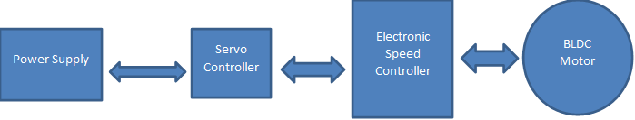

Figure 2: Block Diagram of speed controlling part of BLDC Motor
The battery is connected to the servo controller. The BLDC motor is rotated and controlled via the ESC module, and the BLDC Motor’s rotation speed is controlled via the Servo controller.
3.1.3. Block Diagram of Colour Sensing Part:
/
Figure 3: Block Diagram of Colour Sensing Part:
From the block diagram, we can see that the photodiodes of the TCS3200 colour sensor sense the light's intensity and measure the light's wavelength. The data is given to the Arduino Uno microcontroller and as per the coding the output ports of the Arduino Uno get power and the RGB LED light starts emitting light.

3.2. CIRCUIT ANALYSIS:
/
FIGURE 4: Circuit Diagram of Movement Part of Robot
Here is the circuit diagram for this Wi-Fi Controller car part of the bot using ESP32 CAM microcontroller. we are going to control the four 9-volt DC motors via L298N motor Driver. We have used L298N. The motor driver is a highly powered and robust motor driver capable of running at 5V to 35V DC Motor at a cost of 25W. We have used a five hundred revolutions per minute 9-volt DC Motor for this project. The most microcontroller is the ESP32 CAM module that controls the complete circuit and bot. we have connected the battery to the L298N Motor Driver power supply input. Then we connected all six inputs of L298N to ESP32, D3, D4, D7, D8, D5 & D6 Pins. supply 5V to ESP32 CAM module through L298N 5V Pin. Connected the o/p pins of L298N four 9-volt DC motors.
/
Figure 5: Circuit Diagram of Colour Sensing Part:
From the circuit diagram, we can see that the photodiodes of the TCS3200 colour sensor sense the light's intensity and measure the light's wavelength. The data is given to the Arduino Uno microcontroller and as per the coding the output ports of the Arduino Uno get voltage and the RGB LED light starts emitting light.
4. RESULTS:
A recurring problem with the operation of the robot was the polycarbonate frame, which deformed during movement. For the complex design of the chassis, backlash vibrations at the joint connecting the elements sometimes tend to deform. When climbing an almost vertical wall, the momentum caused by body weight caused structural reforms in the chassis that blocked the suction chamber from touching the wall surface directly and creating suction. The second important problem observed was the deformation of the bot`s own suction chamber when shifting the robot's weight. Using plywood would help the Frame perpendicular to the surface and direct guidance of the sinker, which prevents the frame edge from getting caught on the surface prematurely.
Research is ongoing to effectively improve the bot's ability to climb on smoother surfaces in all planes. In other test fields, performance qualities are determined, including the maximum movement speed of the robot at different wall positions, the maximum load capability and lowering power consumption. In future, a touch or light sensor will be added to the bot to detect the presence of walls.
The colour-sensing part is working successfully. The TCS3200 Colour Sensor is detecting three colours Red, Green and Blue. And the surrounding colour, the RGB LED lights are emitting the three colours.

Port | Command  (ESP32) | Motor Output
 |  | Without Command |  | With  Command
 |  | Vin | Vout | Vin | Vout
3 | Right Reverse | 0.01v | 0.01v | 9.89v | 9.76v
4 | Right Forward | 0.01v | 0.01v | 9.79v | 9.70v
7 | Left Reverse | 0.01v | 0.01v | 9.95v | 9.91v
8 | Left Forward | 0.01v | 0.01v | 9.88v | 9.76v
TABLE 1: OBSERVATION TABLE
From the above table, we can observe that when no command is given, the motors do not get powered, which means there is no leakage voltage flowing and when we are giving commands the motors are getting powered and the difference between an input voltage and output voltage is minimum so, we can observe the circuit is well designed and the voltage loss is minimum, and the motors are working up to expectations.

5. APPLICATIONS AND FUTURE SCOPE OF THE PROJECT:
1. The bot can be used as a surveillance bot.
2. The bot can be used for surveillance where humans cannot travel.
3. Mini autonomous cars getting used for military purposes to destroy enemy territories.
4. Bots are getting used for stealth purposes.

6. CONCLUSION:
This Wall climbing Bot is principally done by the suction method that is fruitful below the air atmosphere, however, in places wherever gas pressure is very low or air-less like space; a secondary technique for holding in a vertical plane like magnetic or adhesive technique can be implemented. This bot had to be capable of being both strong and light at the same time but making it stronger increased its weight and made it big and heavier. That’s why the space between the suction chamber and ducted propeller has been designed and built many times to make the body of the bot rigid as well as lighter. Presently, the Bot is controlled using lower-range Wi-Fi for wireless communication. Because of that, the range to regulate the bot is very limited. It's doable to extend the range by using GPS and satellite technology to regulate the bot from very remote distances. In future, an associate degree arm-like mechanism can be implemented to scavenge things. Many other utilities like, night vision cameras, X-Ray cameras or fire extinguishers can be implemented for surveillance and rescue actions. AI can be implemented in order that it will take some fast and instant calls by itself in varied situations.
In the end, we would like to thank our mentor Ms. Susmita Das Madam for her great contribution to our project, without her this project wouldn`t become a success.

7. REFERENCES:
[1] B. Vishanth, S. Kathiravan, S. Giri prasad, R. Raju and D. James deepak ”Analysis of wall climbing robot”, International Journal of Innovative Research in Science, Engineering and Technology, vol. 3, no. 3, pp. 1-2, 2014.
[2] H. Kim, D. Kim, H. Yang, K. Lee, K. Seo, D. Chang and J. Kim ”Development of a wall-climbing robot using a tracked wheel mechanism”, Journal of Mechanical Science and Technology, vol. 22, no. 8, pp. 1490-1498, 2008.
[3] ”A Brief History of Robotics , Historical Background”.
[4] ”Daily News Report By Dr.Li Hiu Yeung, Bionic Gecko Robot”.
[5] ”D. Graham-Rowe, ”Wall-Climbing Robot”, 2007”.
[6] ”Wall-Climbing Robot Spies”, IEEE Spectrum: Technology, Engineering, and Science News, 2008”.
[7] ”VertiGo - A Wall-Climbing Robot including Ground-Wall Transition - Disney Research”,
[8] H. Yang, R. Liu, Q. Hong and N. Shun Bu he ”A Miniature Multi Joint Wall Wall - Climbing Robot Based On New Vibration Suction Robotic Foot”, in IEEE International Conference On Automation And Logistics Qingdao, China, 2008, pp.
[9] Jonathan Garcia, Ali Alsuwaylih and Sabri Tosunoglu; “Security Partolling Autonomous Robot”: Florida Conference on Recent Advances in Robotics- 2015[Text Wrapping Break]10. Radhika.P, V.Gopika; “Human Surveillance and Landmine Detecting Robot using Labview”: International Journal of Advanced Research in Electronics and Communication Engineering-2016
[10] Dr.B.Subrahmanyeswara Rao, C.Soumya; “PC Controlled Bomb Detection and Diffusion Robot”: International Journal of Advanced Research, 2016
[11] Priyanka D.Balapure, Darshana N.Wagh; “Intelligent Robot for Surveillance”: International Research Journal of Engineering and Technology- 2018
[12] Anas f. Ahmed, Ruaa h. Ahmeed; “Design and Implementation Surveillance Robot Using ATmega328 Microcontroller”: Iraqi Journal of Information Technology. V.8 N.4. 2018
[13]Tarunpreet Kaur, Dilip Kumar; “Wireless Multifunctional Robot for Military Applications”: Proceedings of 2015 RAECS UIET Panjab University Chandigarh 21-22nd December 2015
[14] Widodo Budiharto; “Intelligent Surveillance Robot with Obstacle Avoidance Capabilities Using Neural Network”: Computational Intelligence and Neuroscience
[15]Shaik Shoeb Maroof Nasima, Ansari Asgar Ali Shamshul Haque Shakina. “Surveillance Robot Controlled Using An Android Application”. Department of Computer Engineering, School Of Engineering and Technology, Anjumaan-I-Islam’s Kalsekar Technical Campus, Mumbai, India. (2015)
[16]Merlin Ruby.K.M, Anne Jenefer.F, Vidhya.D. “Study of Arduino Controlled Robotic System” Department of Electronicsand Communication Engineering, Panimalar Engineering College, Chennai, India. (2016)

Arduino Uno
TCS3200
RGB LED

