# 3D BIOPRINTING- TRENDS IN FUTURE PHARMACY

Dr Sneha thakur 1, Dr Kalepu Swathi2, Dr Mitta Chaitanya 3,Dr Koduru Swathi4,Rushitha Gollapalli5

1, - Associate Professor, HOD, Department of Pharmacognosy, St. Pauls college of Pharmacy, Turkayamjal, R.R Dist, Hyderabad-501510, Telangana

2,3,4- Associate Professor, Bojjam Narasimhulu Pharmacy College for Women, Saidabad, Hyderabad-500059

5-Student, Bojjam Narasimhulu Pharmacy College for Women, Saidabad, Hyderabad-500059

# Introduction

In order to create complex living tissues and organs with the desired 3D cellular architecture and functions, 3D bioprinting is a computer-aided technology that involves the rapid printing of bio functional materials[1] and their supporting components in a layer-by-layer manner on a substrate or a tissue culture dish. Humans have long aspired to the in vitro biomanufacturing of tissues and organs for two reasons: organ transplantation and precise tissue models. First off, there[2] is a severe lack of organs available for transplant. In 2016, there were only 16000 organ donors in the United States compared to 160,000 organ transplant recipients. Using 3D bioprinting to address the scarcity of organ transplantation is now much too optimistic due to the complexity of human organs, which is evident in both the duplication of delicate structures[3] manufacturing and the biologically unknown process of organ growth. Second, traditional approaches used for drug screening and medical mechanism research, such as two-dimensional (2D) cell culture or animal experiments, have many drawbacks. The microenvironment[4] in vivo is much more complex than the 2D cell culture, where 2D models may produce the[5] opposite outcomes. Furthermore, the interior environments of animals and humans are very[6] different from one another. These elements increase the urgency of the need for more precise[7] in vitro models, which 3D bioprinting is good at. The most ideal method for creating live[8], 3D cell-laden structures in vitro is now 3D bioprinting, which enables spatio-temporal[9] directional manipulation of a variety of cells. In a predictable amount of time, 3D bioprinting[10] will undoubtedly play a bigger and bigger part in the creation of in vitro organ models.

# Evolution, process and classification of 3D bioprinting

The ability to 3D bioprint (Figure 1) fully functional organs[11] for transplant is currently not very plausible. The fact that bioprinting techniques have evolved[12] significantly cannot be disputed, though. Several pioneers, including Thomas Boland, Gabor Forgacs, and Vladimir Mironov, saw the natural fusion of technologies, including cell patterning, with others, such as commercial inkjet printing, decades ago in order to construct living structures that might one day be used in human organ transplantation. The image below shows a chronology of the development of bioprinting technology up to the present.

Extrusion 3Dprinting technology, also known as fused filament fabrication (FFF), is a popular additive manufacturing process that involves the deposition of melted thermoplastic materials in a layer fashion. This technology has gained significant attention due to its ability to fabricate complex geometries, high accuracy, and relatively low cost compared to other 3D printing techniques. Firstly, the fundamental principles of extrusion 3D printing, including the types[14] of thermoplastic materials used, extrusion process, and nozzle geometry, will be discussed, Secondly, the different parameters that affect the quality of printed objects such as layer height, printing speed, and nozzle temperature will be explained. Finally, the applications of extrusion 3D printing technology will be highlighted. This includes its use in prototyping, production of low volume parts, and even in medical applications such as the fabrication of prosthetic and implants. In conclusion extrusion 3D printing technology isa promising technology that has the potential to revolutionize many industries and has already made[15] significant contributions to the field of additiv4 manufacturing.

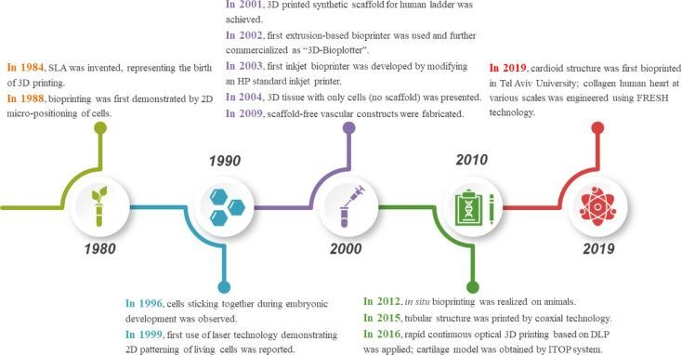

Figure 1: Development of 3D Printing technique[2]

Stereolithography (SLA)[16], which Charles Hull created in 1984 to print 3D objects from digital data, is regarded as the invention that gave rise to 3D printing. In 1988, Klebe used cytoscribing technology to deposit[17] cells on a surface using a conventional Hewlett-Packard (HP) inkjet printer. In order to assess tissue cohesion, Forgacs and colleagues discovered in 1996 that apparent tissue[18] surface tension constituted the macroscopic expression of cellular molecular adhesion. Odde and Renn used laser assisted bioprinting for the first time in 1999 to deposit living cells[19] for creating analogues with intricate anatomical structures. Direct printing of a bladder-shaped scaffold and the seeding of human cells both happened in 2001. Landers et al. described the first extrusion-based bioprinting method in 2002; it was later marketed as "3D-Bioplotter." By adapting[20] an HP ordinary inkjet printer, Wilson and Boland created the first inkjet bioprinter in 2003. A year later, their team used a commercial SLA printer to achieve cell-loaded bioprinting[21]. The same year, 3D tissue made entirely of cells— without a scaffold—was created. In order to deposit living cells, electrohydrodynamic jetting was used in 2006. Norotte et al. created[22] scaffold-free vascular tissue in 2009 via bioprinting. Skardal et al. attempted in situ bioprinting[23] in 2012 using mice models. Many other bioprinting items were introduced in the years that followed[24], including artificial livers and articular cartilage in 2012, tissue integration with the circulatory system in 2014, and more. Gao et al. used coaxial technology to create a tubular framework in 2015. Rapid continuous optical 3D printing based on DLP was used by Pyo et al. in 2016[25]. The same year, Anthony Atala's research team used an integrated tissue-organ printer to create a cartilage model (ITOP). Noor and colleagues created a perfusable scale-down heart in 2019[26]. A few months later, Lee et al. used the freeform reversible embedding of suspended hydrogels (FRESH) technique to successfully bioprint collagen human hearts at different scales[27].

There are four steps that make up the 3D bioprinting process:

* 1. **Data acquisition**: 3D models can be created directly using computer-aided design (CAD) software or indirectly by scanning and reconstructing objects using X-ray, computed tomography (CT), magnetic resonance imaging (MRI), etc. techniques. Then, using specialised software, 3D models would be cut into 2D horizontal slices with adjustable size and orientation. The various bioprinting techniques would further transform these data into particles or filaments[28].
  2. **Material selection**: Depending on the needs of printed structures and methodologies, materials like as cells, growth factors, hydrogels, etc., should be carefully selected. The combination of these biomaterials is technically referred to as **Bioinks[29]**, though they are typically just thought of as cell-filled hydrogels. To ensure biocompatibility, printability, and mechanical property, the choice of bioinks is essential as shownin Figure 2
  3. **Bioprinting:** Before bioprinting, appropriate configuration of printing parameters needs to be confirmed. And observation during printing process is necessary to make adjustment when encounters any problems[30].
  4. **Functionalization**: After printing, the goal is to physically and chemically stimulate dispersed cells to link and produce some functions of real tissue or organ.

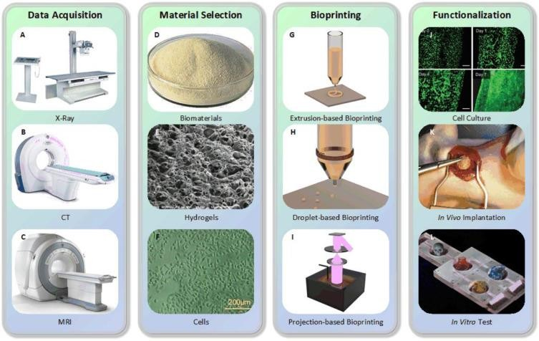

Figure 2: Process of 3D printing

The bioprinting technique (X-ray (A), CT (B), and MRI(C) machines, respectively) Alginate is (D). Image of GelMA captured with a scanning electron microscope (E) (used with permission from WILEYVCH Verlag GmbH & Co. KGaA, Weinheim, Copyright 2018), (F) Illustration of human umbilical vein endothelial cells (HUVECs) (copyrighted 2018 WILEYVCH Verlag GmbH & Co. KGaA, Weinheim)[31]; (G) The extrusion-based bioprinting principle, (H) The piezoelectric inkjet bioprinting principle, (I) Digital light processing theory (DLP), (J) Blood vessel cultured with endothelial progenitor[32] cells (reproduced with permission from, Copyright 2017 Gao et al.), (K) Rats were used for the in-vivo implantation of cardiac patches made using laser induced forward transfer (LIFT)[33] (reproduced with permission from, Copyright 2011 Elsevier), (L) Biochip for in vitro testing, modified from our unpublished research[34].

Extrusion-based, droplet-based, and photocuring-based bioprinting are the three primary methodologies used in 3D bioprinting[35], which are based on various prototype principles and printing materials. Extrusion-based bioprinting uses continuous filaments made of bioinks to make structures; droplet-based bioprinting[35] creates discrete droplets to stack into structures; and photocuring-based bioprinting uses photocuring materials to solidify and build 3D models layer by layer[36].

# Extrusion-based bioprinting:

Because of its adaptability and accessibility, extrusion-based bioprinting, also known as direct ink writing and derived from inkjet printing, is the most popular method of 3D bioprinting[37]. Extrusion-based bioprinting creates ongoing filaments with continuous extrusion force rather than a single droplet. This method can be used to print biomaterials with a wide variety of viscosities and varied cell densities. Extrusion-based bioprinting is preferred by researchers to create tissue architectures with adequate mechanical properties. For a variety of applications, coaxial and multi-material bioprinting can also be flawlessly compatible with extrusion-based bioprinting.

# Principles:

Theoretically, extrusion-based bioprinting uses mechanical or pneumatic drive to extrude bioink (often from a syringe) via a nozzle to create continuous micro filaments that are then deposited on a receptive substrate and finally stacked into the required structures. The substrate might be either solid (like a culture dish), liquid (like a growth media), or something made of gel. After configuration[38], software often generates the nozzle's path based on digital models. The final bioprinted structures would be influenced by factors like temperature, nozzle diameter, extrusion pressure, movement speed, extrusion speed, route interval, etc as shown in Figure 3,4

Pneumatic, piston, and screw-driven are the three main categories of popular extrusion-based bioprinting, respectively, based on the various actuating ways of liquid dispensing systems[23].

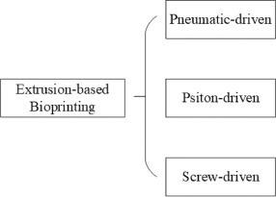Figure 3: Types of extrusion Printers

# Classification of extrusion-based bioprinting:

**Pneumatic-driven extrusion:**

Compressed air is used by a pneumatically[24] driven extrusion device to achieve liquid dispensing. Typically, it consists of a syringe filled with bioink and connected to an air pump using pipes and an adapter. Because they maintain their filament condition after extrusion, hydrogels with shear-thinning properties function well with pneumatically powered systems. Air from the air pump must be sterilised for pneumatic systems. Therefore, the best strategy to reduce contamination of the bioprinted constructions is to use a filter on the airway.

Additionally, smooth extrusion must be ensured as much as possible, which necessitates the addition of additional liquid or gel-based medium whenever semi-solid or solid state bioink is encountered in order to maximise its viscosity.

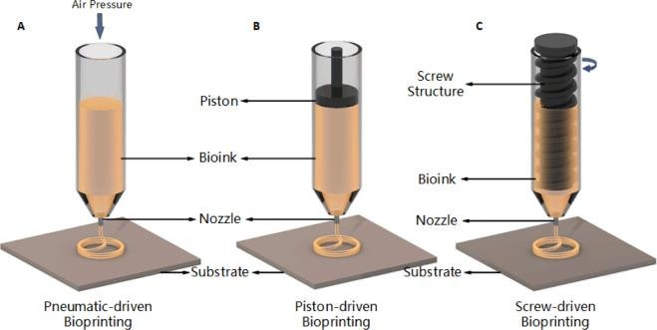

Figure 4: Types of Extrusion Based Printers[6]

# Piston-driven extrusion:

Using mechanically driven liquid dispensing devices, high viscosity biomaterials, such as synthetic or naturally occurring high-molecular polymers, can be extruded more successfully. Piston-driven extrusion is one of them, and the market is flooded with related goods like micro-infusion pumps. The piston and motor are connected in this configuration by a guiding screw. When the motor turns on, the piston[26] converts the spinning motion of the guiding screw into linear motion, which pushes the bioink out of the nozzle to produce filaments.

# Screw-driven extrusion:

Screw-driven devices, a different kind of mechanically[25] driven liquid dispensing system, offer more volumetric control and aid in the extrusion of biomaterials with higher viscosities. The operation of a screw-driven system is similar to that of a piston-driven system, with the exception that a screw attached to the motor is used directly for extrusion rather than a piston. Screw-driven devices, however, may inadvertently harm the cell loaded with bioink while also providing increased pressure. Consequently, it is vital to design the screw pieces cautiously. There have also been studies that combine screw- and piston-driven systems. Polycaprolactone (PCL) was originally[21] printed by Visser et al. using a screw-driven method, and later hydrogel was printed on PCL using a piston-driven method. In summary, piston and screw-driven systems offer greater printability and higher resolution with semi-solid- or solid-state biomaterials than pneumatic-driven methods do (e.g., cell aggregates). Contrarily, devices adopting these two techniques have restricted volume, are more difficult to clean and disinfect (particularly for screw-driven devices), and are more expensive.

Extrusion-based bioprinting is a dependable method for creating biomaterials when the right bioinks are used, especially for creating hydrogels[18] with shear-thinning and quick crosslinking capabilities. The final bioprinted formation will be influenced by the nozzle diameter, bioink viscosity, nozzle movement speed, bioink extrusion speed, extrusion pressure, substrate surface characteristics, and other factors.

Extrusion-based bioprinting is popular among academics worldwide because of its versatility, affordability, and ability to print porous materials.

# TRIALS:

The first lab-grown bladder was successfully transplanted into dogs. In the lab, bladder cells were seeded into a mould fashioned like a bladder, where they multiplied and eventually formed an organ. Synthetic bladders typically don't work since they aren't compatible with bodily tissue. Utilizing the urothelial cells that line the inside of the bladder as well as the smooth muscle cells that line the bladder's exterior, bladder[19] was grown in lab. A synthetic human bladder was developed as the first human organ in 1999. Cells from seven spina bifida patients were taken from Wake Forest University School of Medicine in Winston-Salem, North Carolina, and used to generate slender sacs of tissue. An artificial scaffold of a human bladder was created by scientists using building blocks, and it was then covered in human bladder cells, which multiplied to construct a new bladder. They used the patient's cells in order to prevent rejection by the body. The bladder is the only organ(Figure 5) that has been 3D printed[17] and successfully transplanted into a human so far. Luke Massella received it in 2004 to replace his damaged bladder, and since then, there have been no issues related to the transplant. Luke Massella's bladder's cells and tiny scraps were removed by surgeon Anthony Atala at the Boston Children's Hospital to start the process. Atala was able to build a new bladder in a lab using these samples. Later, a 14- hour medical procedure was performed on Atala to implant the artificial bladder.

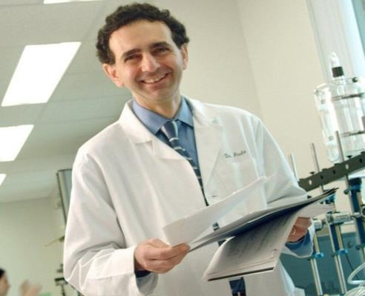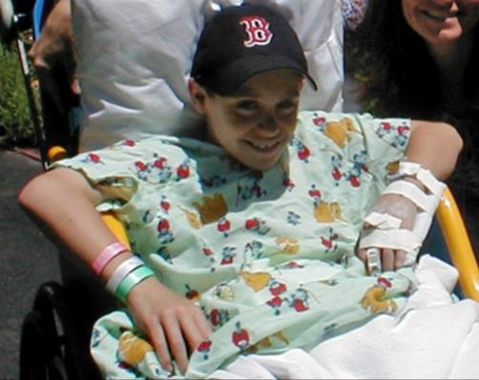

Figure 5: Trials and applications of 3D printing[7]

# Applications

The four types of bioprinting applications include cytobiology, drug discovery, tumour models, and regenerative medicine. Cytobiology includes research on fundamental questions regarding cell proliferation, intercellular relationships, and transgenosis. It also encompasses the creation of single cells or multicellular combinations. Pharmacokinetics, drug screening, and auxiliary drug development are all components of drug research. The major goals of a tumour model are the construction of various tumour pathology models, the study of carcinogenesis mechanisms, targeted therapy, and other related activities. Regenerative medicine, which is more closely related to bioprinting[38], entails the production of artificial tissues and organs, including the fabrication of neuronal, cardioid, liver, and other organ tissues, as well as scaled-up tissue vascularization and cell therapy. As we previously indicated, these applications span 3D bioprinting in both a broad and specific sense.

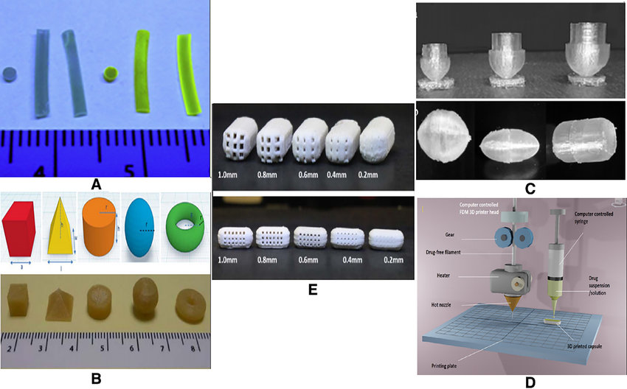

Figure 6: applications of 3D printing in pharmaceutical sector[10]

**References**

1. Wang J, Goyanes A, Gaisford S, Basit AW. Stereolithographic (SLA) 3D printing of oral modified-release dosage forms. *Int J Pharm.*2016;503(1–2):207–212. doi: 10.1016/j.ijpharm.2016.03.016. [[PubMed](https://pubmed.ncbi.nlm.nih.gov/26976500)] [[CrossRef](https://doi.org/10.1016%2Fj.ijpharm.2016.03.016" \t "_blank)] [[Google Scholar](https://scholar.google.com/scholar_lookup?journal=Int+J+Pharm&title=Stereolithographic+(SLA)+3D+printing+of+oral+modified-release+dosage+forms&author=J+Wang&author=A+Goyanes&author=S+Gaisford&author=AW+Basit&volume=503&issue=1%E2%80%932&publication_year=2016&pages=207-212&pmid=26976500&doi=10.1016/j.ijpharm.2016.03.016&)]
2. 9. Pere CPP, Economidou SN, Lall G, Ziraud C, Boateng JS, Alexander BD, *et al*. 3D printed microneedles for insulin skin delivery. Int J Pharm. 2018;544:425–32. [[PubMed](https://pubmed.ncbi.nlm.nih.gov/29555437)]
3. 10. Clark EA, Alexander MR, Irvine DJ, Roberts CJ, Wallace MJ, Sharpe S, Yoo J, Haguea RJM, Tucka CJ, Wildman RD. 3D printing of tablets using inkjet with UV photoinitiation. *Int J Pharm.*2017;529(1–2):523–530. doi: 10.1016/j.ijpharm.2017.06.085. [[PubMed](https://pubmed.ncbi.nlm.nih.gov/28673860)] [[CrossRef](https://doi.org/10.1016%2Fj.ijpharm.2017.06.085" \t "_blank)] [[Google Scholar](https://scholar.google.com/scholar_lookup?journal=Int+J+Pharm&title=3D+printing+of+tablets+using+inkjet+with+UV+photoinitiation&author=EA+Clark&author=MR+Alexander&author=DJ+Irvine&author=CJ+Roberts&author=MJ+Wallace&volume=529&issue=1%E2%80%932&publication_year=2017&pages=523-530&pmid=28673860&doi=10.1016/j.ijpharm.2017.06.085&)]
4. 11. Kyobula M, Adedeji A, Alexander MR, Saleh E, Wildman R, Ashcroft I, Gellerte PR, Roberts CJ. 3D inkjet printing of tablets exploiting bespoke complex geometries for controlled and tuneable drug release. *J Control Release.*2017;261(March):207–215. doi: 10.1016/j.jconrel.2017.06.025. [[PubMed](https://pubmed.ncbi.nlm.nih.gov/28668378)] [[CrossRef](https://doi.org/10.1016%2Fj.jconrel.2017.06.025" \t "_blank)] [[Google Scholar](https://scholar.google.com/scholar_lookup?journal=J+Control+Release&title=3D+inkjet+printing+of+tablets+exploiting+bespoke+complex+geometries+for+controlled+and+tuneable+drug+release&author=M+Kyobula&author=A+Adedeji&author=MR+Alexander&author=E+Saleh&author=R+Wildman&volume=261&issue=March&publication_year=2017&pages=207-215&pmid=28668378&doi=10.1016/j.jconrel.2017.06.025&)]
5. 12. Jamróz W, Kurek M, Łyszczarz E, Szafraniec J, Knapik-Kowalczuk J, Syrek K, Paluch M, Jachowicz R. 3D printed orodispersible films with aripiprazole. *Int J Pharm.*2017;533(2):413–420. doi: 10.1016/j.ijpharm.2017.05.052. [[PubMed](https://pubmed.ncbi.nlm.nih.gov/28552800)] [[CrossRef](https://doi.org/10.1016%2Fj.ijpharm.2017.05.052" \t "_blank)] [[Google Scholar](https://scholar.google.com/scholar_lookup?journal=Int+J+Pharm&title=3D+printed+orodispersible+films+with+aripiprazole&author=W+Jamr%C3%B3z&author=M+Kurek&author=E+%C5%81yszczarz&author=J+Szafraniec&author=J+Knapik-Kowalczuk&volume=533&issue=2&publication_year=2017&pages=413-420&pmid=28552800&doi=10.1016/j.ijpharm.2017.05.052&)]
6. 13. Arafat B, Wojsz M, Isreb A, Forbes RT, Isreb M, Ahmed W, Arafat T, Alhnan MA. Tablet fragmentation without a disintegrant: a novel design approach for accelerating disintegration and drug release from 3D printed cellulosic tablets. Eur J Pharm Sci. 10.1016/j.ejps.2018.03.019. [[PubMed](https://pubmed.ncbi.nlm.nih.gov/29559404)]
7. 14. Li Q, Guan X, Cui M, Zhu Z, Chen K, Wen H, Jia D, Hou J, Xu W, Yang X, Pan W. Preparation and investigation of novel gastro-floating tablets with 3D extrusion-based printing. *Int J Pharm.*2018;535(1–2):325–332. doi: 10.1016/j.ijpharm.2017.10.037. [[PubMed](https://pubmed.ncbi.nlm.nih.gov/29051121)] [[CrossRef](https://doi.org/10.1016%2Fj.ijpharm.2017.10.037" \t "_blank)] [[Google Scholar](https://scholar.google.com/scholar_lookup?journal=Int+J+Pharm&title=Preparation+and+investigation+of+novel+gastro-floating+tablets+with+3D+extrusion-based+printing&author=Q+Li&author=X+Guan&author=M+Cui&author=Z+Zhu&author=K+Chen&volume=535&issue=1%E2%80%932&publication_year=2018&pages=325-332&pmid=29051121&doi=10.1016/j.ijpharm.2017.10.037&)]
8. 15. Khaled SA, Burley JC, Alexander MR, Yang J, Roberts CJ. 3D printing of tablets containing multiple drugs with defined release profiles. Int J Pharm. 2015;494:643–50. [[PubMed](https://pubmed.ncbi.nlm.nih.gov/26235921)]
9. 16. Huang W, Zheng Q, Sun W, Xu H, Yang X. Levofloxacin implants with predefined microstructure fabricated by three-dimensional printing technique. *Int J Pharm.*2007;339(1–2):33–38. doi: 10.1016/j.ijpharm.2007.02.021. [[PubMed](https://pubmed.ncbi.nlm.nih.gov/17412538)] [[CrossRef](https://doi.org/10.1016%2Fj.ijpharm.2007.02.021" \t "_blank)] [[Google Scholar](https://scholar.google.com/scholar_lookup?journal=Int+J+Pharm&title=Levofloxacin+implants+with+predefined+microstructure+fabricated+by+three-dimensional+printing+technique&author=W+Huang&author=Q+Zheng&author=W+Sun&author=H+Xu&author=X+Yang&volume=339&issue=1%E2%80%932&publication_year=2007&pages=33-38&pmid=17412538&doi=10.1016/j.ijpharm.2007.02.021&)]
10. Lamichhane, S., Bashyal, S., Keum, T., Noh, G., Seo, J. E., Bastola, R., … Lee, S. (2019). *Complex formulations, simple techniques: Can 3D printing technology be the Midas touch in pharmaceutical industry? Asian Journal of Pharmaceutical Sciences.* doi:10.1016/j.ajps.2018.11.008
11. Gioumouxouzis CI, Tzimtzimis E, Katsamenis OL, *et al.* Fabrication of an osmotic 3D printed solid dosage form for controlled release of active pharmaceutical ingredients. European Journal of Pharmaceutical Sciences. 2020;**143**:105176. doi:[10.1016/j.ejps.2019.105176](https://doi.org/10.1016/j.ejps.2019.105176)
12. Reddy Dumpa N, Bandari S, A. Repka M. Novel Gastroretentive Floating Pulsatile Drug Delivery System Produced via Hot-Melt Extrusion and Fused Deposition Modeling 3D Printing. Pharmaceutics. 2020;**12**:52. doi:[10.3390/pharmaceutics12010052](https://doi.org/10.3390/pharmaceutics12010052)
13. Chatzitaki A-T, Tsongas K, Tzimtzimis EK, *et al.* 3D printing of patient-tailored SNEDDS-based suppositories of lidocaine. Journal of Drug Delivery Science and Technology. 2021;**61**:102292. doi:[10.1016/j.jddst.2020.102292](https://doi.org/10.1016/j.jddst.2020.102292)
14. Krause J, Müller L, Sarwinska D, *et al.* 3D Printing of Mini Tablets for Pediatric Use. Pharmaceuticals. 2021;**14**:143. doi:[10.3390/ph14020143](https://doi.org/10.3390/ph14020143)
15. Wang J, Zhang Y, Aghda NH, *et al.* Emerging 3D printing technologies for drug delivery devices: Current status and future perspective. Advanced Drug Delivery Reviews. 2021;**174**:294–316. doi:10.1016/j.addr.2021.04.019
16. Khaled SA, Burley JC, Alexander MR, *et al.* 3D printing of five-in-one dose combination polypill with defined immediate and sustained release profiles. Journal of Controlled Release. 2015;**217**:308–14. doi:[10.1016/j.jconrel.2015.09.028](https://doi.org/10.1016/j.jconrel.2015.09.028)
17. Khaled SA, Burley JC, Alexander MR, *et al.* 3D printing of tablets containing multiple drugs with defined release profiles. International Journal of Pharmaceutics. 2015;**494**:643–50. doi:[10.1016/j.ijpharm.2015.07.067](https://doi.org/10.1016/j.ijpharm.2015.07.067)
18. Sadia M, Isreb A, Abbadi I, *et al.* From ‘fixed dose combinations’ to ‘a dynamic dose combiner’: 3D printed bi-layer antihypertensive tablets. European Journal of Pharmaceutical Sciences. 2018;**123**:484–94. doi:[10.1016/j.ejps.2018.07.045](https://doi.org/10.1016/j.ejps.2018.07.045)
19. Genina N, Boetker JP, Colombo S, *et al.* Anti-tuberculosis drug combination for controlled oral delivery using 3D printed compartmental dosage forms: From drug product design to in vivo testing. Journal of Controlled Release. 2017;**268**:40–8. doi:[10.1016/j.jconrel.2017.10.003](https://doi.org/10.1016/j.jconrel.2017.10.003)
20. Robles-Martinez P, Xu X, Trenfield SJ, *et al.* 3D Printing of a Multi-Layered Polypill Containing Six Drugs Using a Novel Stereolithographic Method. Pharmaceutics. 2019;**11**:274. doi:[10.3390/pharmaceutics11060274](https://doi.org/10.3390/pharmaceutics11060274)
21. Gioumouxouzis CI, Baklavaridis A, Katsamenis OL, *et al.* A 3D printed bilayer oral solid dosage form combining metformin for prolonged and glimepiride for immediate drug delivery. European Journal of Pharmaceutical Sciences. 2018;**120**:40–52. doi:[10.1016/j.ejps.2018.04.020](https://doi.org/10.1016/j.ejps.2018.04.020)
22. Seoane-Viaño I, Ong JJ, Luzardo-Álvarez A, *et al.* 3D printed tacrolimus suppositories for the treatment of ulcerative colitis. Asian Journal of Pharmaceutical Sciences. 2021;**16**:110–9. doi:[10.1016/j.ajps.2020.06.003](https://doi.org/10.1016/j.ajps.2020.06.003)
23. Yang Y, Xu Y, Wei S, *et al.* Oral preparations with tunable dissolution behavior based on selective laser sintering technique. International Journal of Pharmaceutics. 2021;**593**:120127. doi:[10.1016/j.ijpharm.2020.120127](https://doi.org/10.1016/j.ijpharm.2020.120127)
24. Lin X, Fu H, Hou Z, *et al.* Three-dimensional printing of gastro-floating tablets using polyethylene glycol diacrylate-based photocurable printing material. International Journal of Pharmaceutics. 2021;**603**:120674. doi:10.1016/j.ijpharm.2021.120674
25. Li Q, Guan X, Cui M, *et al.* Preparation and investigation of novel gastro-floating tablets with 3D extrusion-based printing. International Journal of Pharmaceutics. 2018;**535**:325–32. doi:[10.1016/j.ijpharm.2017.10.037](https://doi.org/10.1016/j.ijpharm.2017.10.037)
26. Xu X, Goyanes A, Trenfield SJ, *et al.* Stereolithography (SLA) 3D printing of a bladder device for intravesical drug delivery. Materials Science and Engineering: C. 2021;**120**:111773. doi:[10.1016/j.msec.2020.111773](https://doi.org/10.1016/j.msec.2020.111773)
27. Liang K, Carmone S, Brambilla D, *et al.* 3D printing of a wearable personalized oral delivery device: A first-in-human study. Sci. Adv. 2018;**4**. doi:[10.1126/sciadv.aat2544](https://doi.org/10.1126/sciadv.aat2544)
28. Alhnan MA, Okwuosa TC, Sadia M, *et al.* Emergence of 3D Printed Dosage Forms: Opportunities and Challenges. Pharm Res. 2016;**33**:1817–32. doi:[10.1007/s11095-016-1933-1](https://doi.org/10.1007/s11095-016-1933-1)
29. Awad A, Trenfield SJ, Pollard TD, *et al.* Connected healthcare: Improving patient care using digital health technologies. Advanced Drug Delivery Reviews. 2021;**178**:113958. doi:[10.1016/j.addr.2021.113958](https://doi.org/10.1016/j.addr.2021.113958)
30. Norman J, Madurawe RD, Moore CMV, *et al.* A new chapter in pharmaceutical manufacturing: 3D-printed drug products. Advanced Drug Delivery Reviews. 2017;**108**:39–50. doi:[10.1016/j.addr.2016.03.001](https://doi.org/10.1016/j.addr.2016.03.001)
31. Trenfield SJ, Awad A, McCoubrey LE, *et al.* Advancing pharmacy and healthcare with virtual digital technologies. Advanced Drug Delivery Reviews. 2022;**182**:114098. doi:[10.1016/j.addr.2021.114098](https://doi.org/10.1016/j.addr.2021.114098)
32. Spritam (levetiracetam); full prescribing information. Spritam. 2015.[https://spritam.com/#/hcp/zipdose-technology/manufactured-using-3d-printing.](https://spritam.com/" \l "/hcp/zipdose-technology/manufactured-using-3d-printing.) (accessed Mar 2022).
33. TRIASTEK RECEIVES FDA IND CLEARANCE FOR 3D PRINTED DRUG TO TREAT RHEUMATOID ARTHRITIS. 3D Printing Industry. 2021.<https://3dprintingindustry.com/news/triastek-receives-fda-ind-clearance-for-3d-printed-drug-to-treat-rheumatoid-arthritis-184159/> (accessed Mar 2022).
34. Zheng Y, Deng F, Wang B, *et al.* Melt extrusion deposition (MEDTM) 3D printing technology – A paradigm shift in design and development of modified release drug products. International Journal of Pharmaceutics. 2021;**602**:120639. doi:[10.1016/j.ijpharm.2021.120639](https://doi.org/10.1016/j.ijpharm.2021.120639)
35. Consultation on Point of Care manufacturing. Gov.uk. 2021.<https://www.gov.uk/government/consultations/point-of-care-consultation/consultation-on-point-of-care-manufacturing> (accessed Mar 2022).
36. Elbadawi M, Gustaffson T, Gaisford S, *et al.* 3D printing tablets: Predicting printability and drug dissolution from rheological data. International Journal of Pharmaceutics. 2020;**590**:119868. doi:[10.1016/j.ijpharm.2020.119868](https://doi.org/10.1016/j.ijpharm.2020.119868)
37. Elbadawi M, McCoubrey LE, Gavins FKH, *et al.* Harnessing artificial intelligence for the next generation of 3D printed medicines. Advanced Drug Delivery Reviews. 2021;**175**:113805. doi:[10.1016/j.addr.2021.05.015](https://doi.org/10.1016/j.addr.2021.05.015)
38. Elbadawi M, Muñiz Castro B, Gavins FKH, *et al.* M3DISEEN: A novel machine learning approach for predicting the 3D printability of medicines. International Journal of Pharmaceutics. 2020;**590**:119837. doi:[10.1016/j.ijpharm.2020.119837](https://doi.org/10.1016/j.ijpharm.2020.119837)

# 