MATING DESIGNS IN TREE IMPROVEMENT
Anchal and Anita Kumari
ABSTRACT

Tree improvement enhances the value of tree species by selecting the most desirable trees, breeding or mating the selected trees and evaluating the resulting progeny. The effectiveness of the tree breeding programs depends upon the effective mating design (Surendran et al., 2003). The primary objective of mating design is to determine the genetic variance based on the correlation between the relatives and how they are used for variation into various genetic components using the second degree of statics. The choice of breeding strategy is significantly influenced by mating design (Van Buijtenen 1986; Bridgwater and Franklin, 1985). Mating designs are usually adopted to achieve the goals like providing information to evaluate parents, estimating genetic gains and genetic parameters, producing a base population suitable for successive cycles of selection and being cost-effective (Fins et al., 1992). In all mating designs, the individuals are randomly selected or chosen and crossed to produce progenies that are related to one another as full or half siblings (Nduwumuremyi et al., 2013). No single mating design will be most effective for achieving all the objectives (Zobel and Talbert, 1984). The type of information obtained from the testing program will depend on the mating designs. Breeder must choose a design that provides necessary genetic information. The complexity of the mating design and the necessity to maintain complete pedigree records both affect the economic cost of mating design. Although various mating techniques have been developed, only a small number of them have been optimized for tree or crop improvement (Awata et al., 2018).

- INTRODUCTION

Improvement means increasing the yield as well as the quality of any material. Increasing yield means an increase in productivity and it is very important as forest cover is reducing with the increase in the demand for forest products. To overcome this bridge gap, tree improvement act as an important tool that increases the productivity of forest to a greater extent. Tree Improvement is the increase in the yield and quality of the wood products in a short time period by combining silviculture management (more yield) and control of parentage (superior quality). There are two other related terms to tree improvement: Forest Genetics and Tree Breeding. Forest Genetics is the genetic study of the heredity and variation of inherited characteristics of forest trees. Tree breeding is the application of genetic, reproductive biology and economic principles to the genetic improvement and management of forest trees.
Trees in general are selected, based on their phenotypic superiority for planning in the seed orchard. Once parents are selected, their genetic worth is tested by mating them in any fashion and their genetic worth is established. Or we can say that, tree improvement increases the value of a tree species by 1) Selecting the most desirable trees from natural stands or plantations, 2) Breeding or mating these select trees. 3) Testing the resulting progeny.
Mating design refers to a system of crossing, which is used to develop progenies of certain kinds that serve to predict the genetic worthiness of their parents (Surendran et al., 2003). Or simply, the methods by which trees are combined to produce progeny are known as mating designs. This creates a progeny population and gives information for further testing programs.

- FACTORS INFLUENCING THE CHOICE OF MATING DESIGNS
Some factors are taken into consideration while selecting a mating design (Acquaah, 2012):
- Objectives of the experiment (breeding or genetic studies)
- Type of pollination (Self or cross-pollinated)
- Type of cross (natural or artificial)
- Type of pollen dispersal (wind or insect)
- Presence of male sterility system
- Size of population

- OBJECTIVES OF MATING DESIGNS
The following are the broad objectives of a mating design:
- Progeny testing
- Estimation of variance components
- Estimation of genetic gains
- Estimation of heritability
- Creation of base population
- Determination of combining abilities
  - Progeny testing
The mating design may provide information to evaluate the parents i.e., Progeny testing. It involves the selection of parents based on the performance of their progeny. The best way to evaluate the genetic worth of selected parents in seed orchards is to grow progeny in such a way that allows the estimation of breeding values of the parents. The genetic values of a parent that can be measured from the progeny test are: variance, heritability, general combining ability and specific combining ability (Surendran et al., 2003). This will help breeders to separate the parents whose phenotypic superiority had resulted due to growing in a good environment from those that are superior because they have a good phenotype.

  - Estimation of variance components
The selection of parents depends upon the degree of inheritance to perform a specific role in the tree improvement programs. The components of variance are separated as follows:
Phenotypic variance (PV) = Genotypic variance (GV) + Environmental variance (EV)
Environmental variance can be obtained by the analysis of variance based on the experimental design of the field. According to Fisher (1918), Genotypic variance can be divided into three components i.e., Additive, Dominance and Epistasis variances.
- Additive variance: is that component that arises from differences between two homozygotes of a gene for example, AA and aa.
Some features of additive variance:
- It is fixable i.e.; it fixes the average effect of the genes present on all the segregating loci.
- Additive genes show a lack of dominance i.e., intermediate expression.
- It is a measure of additive gene action.
- It responds to selection.
- GCA is a measure of additive variance.
- Dominance variance: is due to the deviation of heterozygotes (Aa) from the average effect of two homozygotes (AA and aa).
Some features of dominance variance:
- It is not fixable
- It is due to intra allelic interactions
- It is a measure of dominance gene action
- It is associated with heterozygosity
- It is the main cause of heterosis
- Epistasis variance: results from the interaction between two or more genes.
Some features of epistasis variance:
- It is due to inter allelic interactions.
- It is of three types viz., Additive x Additive (interaction of AA and BB); Additive x Dominance (AA x Bb, Aa x BB); Dominance x Dominance (Aa x Bb).
- Gene action: is a behaviour or mode of expression of genes in a genetic population. It is of two types: 1) Additive gene action 2) non-additive gene action
Additive gene action
- Joint effects of additive variance and additive x additive type of epistasis.
- Mode of action is additive (fixable).
Non-additive gene action
- It includes dominance variance and additive x dominance, and dominance x dominance types of epistasis.
- Mode of action is non-additive (non-fixable).

  - Estimation of genetic gains
Genetic gain is the improvement in average genetic value in a population or improvement in average phenotypic value due to selection within a population over cycles of breeding. The best way to estimate the progress made in a tree improvement program is to compare the relative performance of the improved and unimproved population by the same test. All the mating designs have an in-built mechanism to provide the expected and realized genetic gains due to genetic tests by using mating design (Surendran et al., 2003).

  - Estimation of heritability
It is the portion of the total variance due to genetic factors. It is of two types: broad sense and narrow sense heritability
- Broad sense heritability: (Lush,1940) It is the ratio of total genetic variance to total phenotypic variance. It can be estimated from parental and segregating material. It is useful in the selection of elite types from homozygous population.
- (h²) =V_{g}/V_{p} X 100
- If it is high then characters are least influenced by the environment
- Narrow sense heritability: (Smith, 1952) It is the ratio of additive genetic variance to the total phenotypic variance. It requires crossing in a definite fashion. It is useful in selection of elite types from segregating material.
- (h²) =V_{a}/V_{p} X 100
- If it is high then characters are governed by additive gene action
Estimation of narrow-sense heritability is most important because it throws light on the nature of the population as well as the dependence upon the traits for transmission in the subsequent generation. It is useful in predicting the effectiveness of selection and also gives an idea about the response of various characters to selection pressure.

  - Creation of base population
Base population act as a source material from which subsequent selections can be obtained. To satisfy this objective, the mating design must first permit co-ancestry management i.e., use controlled mating and must keep complete pedigree records. Secondly; the selected design must produce sufficient numbers of families and individuals to maintain desired selection differential (difference between the mean phenotypic value of selected population to mean phenotypic value of original population). To fulfill the second objective is difficult when parents of unknown breeding values mated together to provide the base population for the next cycle of selection. In this case, it is necessary to make sufficient numbers of crosses per parent so that there is a reasonable probability that it will have been mated with at least one average or a better parent. Thus, it may be possible to select progenies only from parents with good breeding values rather than from mating between parents of good and poor breeding values.

  - Estimation of combining abilities
The ability of an organism to transmit genetic superiority to its offspring is known as combining ability. It is of two types: General and Specific combining abilities
- General combining abilities: it is an average performance of a parent in a series of cross combinations, which will be estimated from the performance of F₁ progeny. It is estimated by half sib mating. It has a relationship with narrow sense heritability. It is due to additive genetic variation and additive x additive type of gene interaction. It denotes combining ability of genotypes especially inbred with various testers. It helps in identification and selection of best genotypes to use it in hybridization, as a parent.
Information on GCA can be used for:
- Choosing best parents for seed orchard
- Choosing parents of progeny for future genetic improvement programs
- Specific combining abilities: it is the performance of F₁ progeny in a particular combination that ultimately tells upon specific parents to produce such a cross or in a simple way it is the performance of parents in specific combinations. It is estimated by full sib mating. It has a relationship with heterosis. It is due to dominance genetic variation and all the three types of gene interactions. It also helps into identification and hence selection of best cross combinations i.e., those with the desired output. When we see that an inbred line combines well in any cross, it is because of specific combining ability. Identification of higher SCA results in the production of superior hybrids and such hybrid combinations can be identified through a mating design.
After deciding on the breeding program’s goals, there are two more key decisions to be taken i.e., choice of mating design to create a progeny population, choice of experimental design to be followed in the field. There are large numbers of experimental designs available. But generally, complete randomized design and the randomized complete block design are used in breeding programs because they are cheap, simple and can be applied in the field without any difficulty as compared with other complex designs. Breeder must choose a design that provides necessary genetic information and at the same time it should be cost effective. The economic cost of mating design is also determined by the complexity of mating design and need to keep the complete pedigree records.

- CLASSIFICATION OF MATING DESIGNS
Mating designs are classified into two main categories i.e., Incomplete pedigree design and Complete pedigree design
  - Incomplete pedigree design: In this, only one parent is known for any given progeny and further classified into two categories viz., Open-pollinated mating design and poly mix mating design.
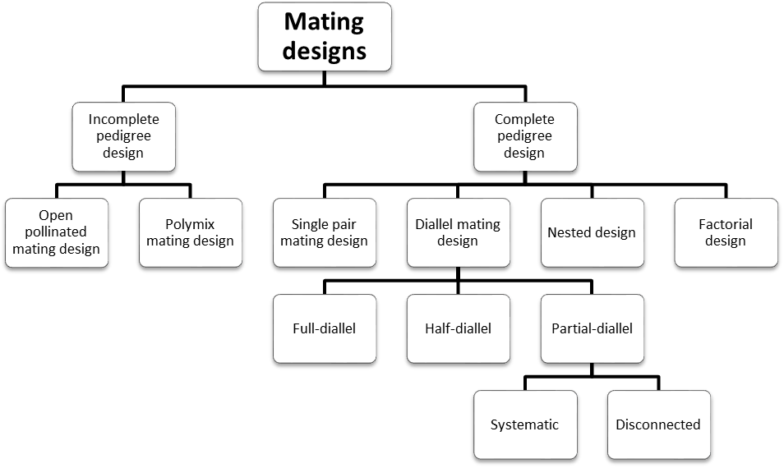

    - Open Pollinated mating design
In this, trees are allowed to mate randomly through open pollination. Open-pollinated seeds may be collected from female parents. Seed collection may be from the plus tree growing in natural stands or plantations and from genotypes in seed orchards. If we collect seeds from seed orchards so it is advisable that seed orchards must have heavy seed production because pollination characteristics may be differed in young seed orchards as compared to fully productive seed orchards (Mandal and Gibson, 1998). At a young age only, a few clones produce most of the pollen therefore, seeds collected from young orchards may have only a limited number of pollen parents.
Advantages:
- Easiest and least expensive
- GCA can be estimated
- Helps in the estimation of heritability values
- Advanced generation selection can be made
- Helps in rouging of genetically inferior trees
- Component of variance or covariance for females gives reliable estimates of ¼ D (additive genetic variance)
- Used to quickly test selected trees
Disadvantages:
- SCA cannot be estimated
- Limited utility for the future generation
- Lack of complete pedigree
- Possibility of selfing
- Inbreeding depression

    - Poly mix mating design
It is also known as poly cross and sometimes top cross mating design. In this design, some trees are selected as male parents and their pollen are collected in equal quantity from each parent and mixed. The mixture of the collected pollens is then applied to female parents. Generally, a considerable number of pollens are included in the mix to ensure that female parents are pollinated by a representative sample of other parents. The number of male parents selected should not be less than 10 (Mandal and Gibson, 1998).
Advantages:
- GCA can be estimated
- Helpful in estimation of realized and expected gains that arise from additive genetic variation
- Provides heritability and breeding values of female parents involved in the pollen mix
- Less expensive than other mating designs except for open-pollinated mating design
- Component of variance or covariance gives reliable estimates of ¼ D (additive genetic variance)
Disadvantages:
- SCA cannot be estimated
- Breeding value may be biased due to non-random pollination by pollens included in the mix, because pollens of some clones are more viable than that of others and it can result in an erroneous estimate of GCA
- Advanced generation selection is difficult
  - Complete pedigree design: In this, the pedigree of both the male and female parents is known. So, it is possible to predict the performance of progenies based on their ancestral inheritance. It is further classified as follows:

    - Single pair mating design
In this, each parent is mated to another member of the population only at once. In the given example, even several parents who can be used as either males or females are mated in a single pair fashion and produces 4 crosses viz., 1x2, 3x4, 5x6, 7x8. This design works particularly well if the objective is to produce a population for the selection of individuals for a new seed orchard or use in continuous breeding (Surendran et al., 2003). Single pair mating with genetically proven parents will be useful in a breeding program to produce populations for advanced generation selection.
Male parents
Female parents | Clones | 1 | 2 | 3 | 4 | 5 | 6 | 7 | 8
Female parents | 1 | - | x | - | - | - | - | - | -
Female parents | 2 | - | - | - | - | - | - | - | -
Female parents | 3 | - | - | - | x | - | - | - | -
Female parents | 4 | - | - | - | - | - | - | - | -
Female parents | 5 | - | - | - | - | - | x | - | -
Female parents | 6 | - | - | - | - | - | - | - | -
Female parents | 7 | - | - | - | - | - | - | - | x
Female parents | 8 | - | - | - | - | - | - | - | -

Advantages:
- Easy to carry out
- SCA can be estimated
- Provide estimates of heritability
- Creates a maximum number of unrelated families
- It involves a minimum number of crosses
- Component of variance among full-sib family means can be used to estimate ½ D
- Helps in the maintenance of large and effective population size
Disadvantages:
- It requires an even number of trees all time
- GCA cannot be estimated
- Not suitable for rouging seed orchards

    - Diallel mating design
The diallel term was introduced by Schmidt (1919). Diallel design is a very useful design that is used to produce crosses for the evaluation of genetic variances. Diallel cross-refers to all possible combinations of crosses. It is further classified into three types: complete, half and partial diallel mating design

- Full diallel mating design
In this, each parent is crossed to all others in every combination including, self, direct and reciprocal crosses. Reciprocal crosses are two matings involving two parents in which, in the first mating, the first parent is used as a female, the second as the male; whereas in the second mating, the second parent is used as a female and the first parent is used as a male. It involves n² number of combinations where n is the number of parents (Zobel and Talbert, 1984). According to Wright (1976), this design becomes cumbersome if the number of parents exceeds 15. In the below example, 8 parents are involved in a cross which produces 64 hybrids including selfed parents.

Male parents
Female parents | Clones | 1 | 2 | 3 | 4 | 5 | 6 | 7 | 8
Female parents | 1 | x | x | x | x | x | x | x | x
Female parents | 2 | x | x | x | x | x | x | x | x
Female parents | 3 | x | x | x | x | x | x | x | x
Female parents | 4 | x | x | x | x | x | x | x | x
Female parents | 5 | x | x | x | x | x | x | x | x
Female parents | 6 | x | x | x | x | x | x | x | x
Female parents | 7 | x | x | x | x | x | x | x | x
Female parents | 8 | x | x | x | x | x | x | x | x

Advantages:
- Maximum number of unrelated families produce
- It is good to estimate all genetic parameters
- Provides good estimates of GCA and SCA values
- Component of variance for GCA estimates is ¼ D and that of SCA estimates is ¼ H
- Dominance type of gene action is possible
- It contributes to the knowledge of heterotic system
- Provide knowledge of quantitative traits
Disadvantages:
- Very cumbersome to apply
- Produces a very large number of crosses
- Very time consuming
- Very costlier
- Rarely used in progeny testing

- Half diallel mating design
In this, each parent is mated to every other parent only once as a male parent only. This design is similar to full diallel except that reciprocal cross is not made and sometimes self also. The number of crosses will be n(n-1)/2, when self-parents does not involve in the cross. This design is not as efficient as full diallel but is mostly used as it creates fewer crosses than full diallel. For example, 8 parents are involved in a cross that produces 36 hybrids including selfed parents.

Male parents
Female parents | Clones | 1 | 2 | 3 | 4 | 5 | 6 | 7 | 8
Female parents | 1 | X | - | - | - | - | - | - | -
Female parents | 2 | X | X | - | - | - | - | - | -
Female parents | 3 | X | X | X | - | - | - | - | -
Female parents | 4 | X | X | X | X | - | - | - | -
Female parents | 5 | X | X | X | X | X | - | - | -
Female parents | 6 | X | X | X | X | X | X | - | -
Female parents | 7 | X | X | X | X | X | X | X | -
Female parents | 8 | X | X | X | X | X | X | X | X

Advantages:
- It is the best to design for forest species
- Provides good estimates of GCA, SCA and genetic parameters
- Component of variance for GCA estimates is ¼ D and that of SCA estimates is ¼ H
- Less expensive than full diallel design
Disadvantages:
- Not efficient as full diallel
- Number of crosses still large and requires extra care in handling the crosses
Griffing (1956) developed four main methods of diallel mating design. The choice among the four methods depends on the inbreeding depression of the parents.
Method 1: Full diallel crosses including parents and reciprocals (n=p²)
 | Males
Females | Clones | 1 | 2 | 3 | 4 | 5
Females | 1 | 1x1 | 2x1 | 3x1 | 4x1 | 5x1
Females | 2 | 1x2 | 2x2 | 3x2 | 4x2 | 5x2
Females | 3 | 1x3 | 2x3 | 3x3 | 4x3 | 5x3
Females | 4 | 1x4 | 2x4 | 3x4 | 4x4 | 5x4
Females | 5 | 1x5 | 2x5 | 3x5 | 4x5 | 5x5
Method 2: Full diallel crosses with no parents (n=p(p-1))
 | Males
Females | Clones | 1 | 2 | 3 | 4 | 5
Females | 1 | - | 2x1 | 3x1 | 4x1 | 5x1
Females | 2 | 1x2 | - | 3x2 | 4x2 | 5x2
Females | 3 | 1x3 | 2x3 | - | 4x3 | 5x3
Females | 4 | 1x4 | 2x4 | 3x4 | - | 5x4
Females | 5 | 1x5 | 2x5 | 3x5 | 4x5 | -
Method 3: Half diallel crosses including parents and no reciprocals (n=p(p+1)/2)
 | Males
Females | Clones | 1 | 2 | 3 | 4 | 5
Females | 1 | 1x1 | - | - | - | -
Females | 2 | 1x2 | 2x2 | - | - | -
Females | 3 | 1x3 | 2x3 | 3x3 | - | -
Females | 4 | 1x4 | 2x4 | 3x4 | 4x4 | -
Females | 5 | 1x5 | 2x5 | 3x5 | 4x5 | 5x5
Method 4: Half diallel crosses with no parents and no reciprocals (n=p(p-1)/2)
 | Males
Females | Clones | 1 | 2 | 3 | 4 | 5
Females | 1 | - | - | - | - | -
Females | 2 | 1x2 | - | - | - | -
Females | 3 | 1x3 | 2x3 | - | - | -
Females | 4 | 1x4 | 2x4 | 3x4 | - | -
Females | 5 | 1x5 | 2x5 | 3x5 | 4x5 | -

- Partial diallel mating design
In this, only a portion of required crosses are made i.e., each parent is not mated to every parent. This design can have a series of different conformations (Braten 1965). There is a systematic way of mating individuals and this way is discussed in two types of partial mating design viz., Systematic or progressive and disconnected diallel mating design.
- Systematic or progressive mating design
In this design, crosses are made that fall in particular diagonals. Diagonals are chosen so that no one parent is involved in more than a few crosses. It reduces the involvement of a single parent in a large number of crosses and creates a maximum number of unrelated crosses. It estimates GCA for each parent and SCA for a part of possible combinations. The component of the variance for GCA estimates is ¼ additive and for SCA it is ¼ nonadditive variance (Zobel and Talbert, 1984). For example, 12 parents involving each parent in 8 crosses as shown below
Male parents
Female parents | Clones | 1 | 2 | 3 | 4 | 5 | 6 | 7 | 8 | 9 | 10 | 11 | 12
Female parents | 1 |  | x | x |  |  |  |  | x | x | x
Female parents | 2 |  |  | x | x |  |  |  |  | x | x | x
Female parents | 3 |  |  |  | x | x |  |  |  |  | x | x | x
Female parents | 4 |  |  |  |  | x | x |  |  |  |  | x | x
Female parents | 5 |  |  |  |  |  | x | x |  |  |  |  | x
Female parents | 6 |  |  |  |  |  |  | x | x
Female parents | 7 |  |  |  |  |  |  |  | x | x
Female parents | 8 |  |  |  |  |  |  |  |  | x | x
Female parents | 9 |  |  |  |  |  |  |  |  |  | x | x
Female parents | 10 | x |  |  |  |  |  |  |  |  |  | x | x
Female parents | 11 | x | x |  |  |  |  |  |  |  |  |  | x
Female parents | 12 | x | x | x
- Disconnected mating design
In this design, parents are divided into small 5 to 10 tree groups and diallel or half diallel matings are done within each group. This design reduces the number of crosses. Helpful in the estimation of GCA and SCA values. This design is less costly than a full diallel design. For example, 12 parent breeding population has been divided into two groups involving six parents each and these parents has been mated in half diallel fashion excluding self-crosses and results in 30 population as shown below
Male parents
Female parents | Clones | 1 | 2 | 3 | 4 | 5 | 6 | 7 | 8 | 9 | 10 | 11 | 12
Female parents | 1 |  | x | x | x | x | x
Female parents | 2 |  |  | x | x | x | x
Female parents | 3 |  |  |  | x | x | x
Female parents | 4 |  |  |  |  | x | x
Female parents | 5 |  |  |  |  |  | x
Female parents | 6
Female parents | 7 |  |  |  |  |  |  |  | x | x | x | x | x
Female parents | 8 |  |  |  |  |  |  |  |  | x | x | x | x
Female parents | 9 |  |  |  |  |  |  |  |  |  | x | x | x
Female parents | 10 |  |  |  |  |  |  |  |  |  |  | x | x
Female parents | 11 |  |  |  |  |  |  |  |  |  |  |  | x
Female parents | 12

    - Nested design
This design is also known as hierarchical mating design. In this group of parents of one sex are mated to members of the other sex. It was first developed by maize corn breeders to estimate 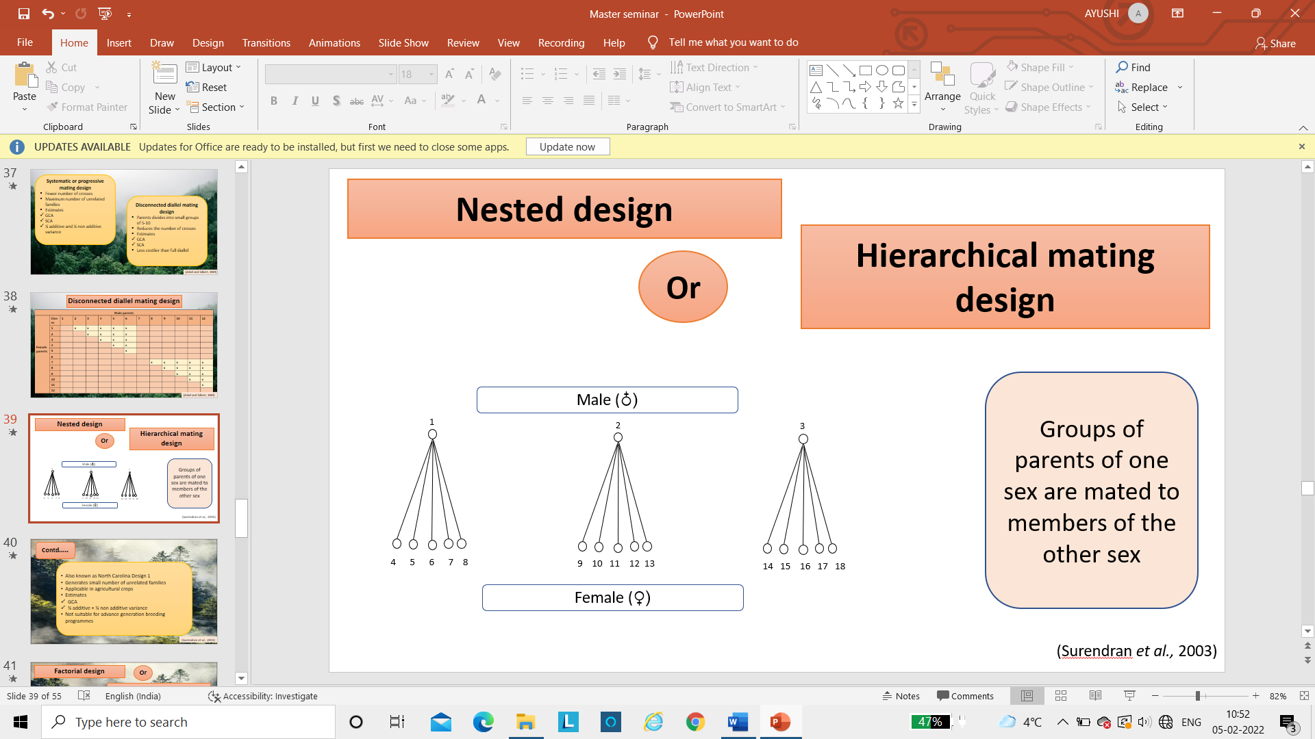
variance components. It is also called North Carolina Design I. It is a control pollinated design that has been used in forest trees (Surendran et al., 2003). In the figure, 1,2 and 3 are males of rarer sex and each is mated to five different female parents.
Advantages:
- This design is applicable in agricultural crops
- GCA value can be estimated
- Components of variance among parental groups of male estimates ¼ additive variance and ¼ dominance variance
- Easy and less costly
Disadvantages:
- Generates a small number of unrelated families
- Not suitable for advanced generation breeding programs
- GCA can be obtained only for members of the rarer sex

    - Factorial design
In this design members of one sex are crossed in all combinations with several members of the other sex (Mandal and Gibson, 1998). Males and females are different but they crossed in all combinations and males are designated as “testers” while females as “lines” that’s why this design is known as “Line X Tester” design. Tester is a genotype that is used to identify superior
Male parents
Female parents | Clones | 1 | 2 | 3 | 4 | 5
Female parents | 6 | x | x | x | x | x
Female parents | 7 | x | x | x | x | x
Female parents | 8 | x | x | x | x | x
Female parents | 9 | x | x | x | x | x
Female parents | 10 | x | x | x | x | x
Female parents | 11 | x | x | x | x | x
Female parents | 12 | x | x | x | x | x

germplasm and that’s why this is also designated as “Tester” design. The line X tester design permits evaluation of general combining abilities of lines crossed to a set of testers as well as general combining abilities of the latter (Kempthorne, 1957). This design was first studied or used in North Carolina State University, US and named “North Carolina Design II”. It is very useful for progeny testing programs because breeding values can be estimated for all genotypes in the population which is being tested.
Advantages:
- Useful in progeny testing program
- GCA and SCA can be estimated
- Component of variance among male and female groups estimates ¼ D and for male and female, it estimated ¼ H.
- Helps in the estimation of heritability values
- Helps in the estimation of realized and expected gains that arise from additive and non-additive genetic variation
Disadvantages:
- Produces a small number of unrelated families
- Number of parents that can be selected for the subsequent generation will be limited to the number of testers
References
Acquah G. 2012. Principles of plant genetics and breeding. Wiley-Blackwell, Oxford. 536p.
Awata AO, Tongoona P, Danquah E, Efie BE and Marchelo-Dragga PE. 2018. Common Mating Designs in Agricultural Research and Their Reliability in Estimation of Genetic Parameters. IOSR Journal of Agriculture and Veterinary Science 11: 16-36.
Braten MO. 1965. The union of partial diallel mating designs and incomplete block environmental designs. Inst. Of Statistics Monograph No. 432p.
Bridgwater RRZ and Franklin EC. 1985. Forest tree breeding strategies achievements and constraint. Attributes of trees as crop plants: 36-48.
Fins L, Friedman ST, Brotschol JV (eds). Handbook of Quantitative Forest Genetics. Kluwer Academic Publishers. 403p.
Fisher RA. 1918. The correlation between relatives on the supposition of Mendelian inheritance. Proceedings of the Royal Society, Edinburgh 52: 399-433.
Griffing B. 1956. Concept of general and specific combining ability in relation to diallel crossing systems. Australian Journal of Biological Sciences 9: 463-493.
Kempthorne O. 1957. An introduction to genetics statistics. John Willey & Sons, New York. 439p.
Lush JL. 1940. Intra-sire correlations or regressions of offspring on dam as a method of estimating heritability of characteristics. Proceedings of the American Society of Animal Nutrition 1940(1): 293-301.
Mandal AK and Gibson GL. 1998. Forest genetics and tree breeding. CBS Publishers & distributers New Delhi. 268p.
Nduwumuremyi A, Tongoona P and Habimana S. 2013. Mating designs: Helpful tool for quantitative plant breeding analysis. Journal of plant breeding and genetics 01: 117-129.
Surendran C, Sehgal RN and Paramathma M (eds). 2003. Textbook of forest tree breeding. Directorate of Information and Publications of Agriculture, New Delhi. 246p.
Van Buijtenen JP and Bridgewater FE. 1986. Mating and genetic test designs. p. 5-10. In: Southern cooperative series bulletin no. 309. Advanced Generation Breeding of Forest Trees. Proceedings of a Workshop on Advanced Generation Breeding. Current Status and Research Needs, June 6-7, 1984. Baton Rouge, La.
Wright JW. 1976. Introduction to forest genetics. Academic Press, New York. 682p.
Zobel Bruce and Talbert John. 1984. Applied Forest Tree Improvement. John Wiley and Sons, New York. 505p.

