“Potential of Artificial Intelligence to Combat Challenges in Transforming Agriculture”
Neha Chand
Research Scholar, College of Agriculture, Govind Ballabh Pant University of Agriculture and Technology, Pantnagar, Udham Singh Nagar, Uttarakhand -263145
Email: nikitachandrajwar999@gmail.com
Abstract:
The agricultural industry has many difficulties in the twenty-first century, such as issues with food security, sustainability and rising demand brought on by population increase. To tackle these issues, artificial intelligence (AI) has emerged as a game-changing tool with enormous potential. This essay examines how artificial intelligence (AI) could revolutionize agriculture by improving production, resource management and decision-making. Precision farming, which uses AI-powered sensors, drones and machine learning algorithms to assist farmers in enhancing crop yields, minimizing waste and optimizing resource use, is a significant component of AI’s impact on agriculture. AI also helps with disease outbreak prediction, task automation and monitoring soil conditions, all of which increase productivity and lower labour costs. AI-driven data analytics also promote sustainable practices and guarantee food security by enabling better-informed decisions, from crop selection to market forecasts.
Keywords: Artificial Intelligence, Agriculture, Precision Farming, Sustainability, Resource Management, Crop Yields, Food Security

Introduction
The world population is projected to reach around 10 billion by 2050, leading to a 50% increase in agricultural demand compared to 2013, despite modest economic growth (FAO, 2017). The term ‘Artificial Intelligence’ was first introduced during the 1955 Dartmouth Conference, when John McCarthy suggested a research endeavor based on the idea that machines could simulate every aspect of learning and intelligence. The initial application of AI in agriculture dates back to 1985 when McKinion and Lemmon developed GOSSYM, a cotton crop simulation model utilizing Expert Systems to optimize cotton production, considering factors like irrigation, fertilization, weed control, climate and more. In the 1950s, Alan Turing proposed the famous Turing Test, a game designed to address the question of whether a machine can exhibit human-like thinking (Zha, J. 2020). According to (Bostrom, Nick. 2014) AI is the simulation of human intelligence in machines programmed to think logically and mimic human actions. Furthermore, it’s worth noting that smart drip irrigation has demonstrated significant water savings, with a reduction of approximately 41.5% compared to traditional flood irrigation and 13% compared to conventional drip irrigation methods (Barkunan et al., 2019).
Agriculture holds a crucial position within the economy and the growing interest in automating agricultural processes has become a global focus. The world's population is experiencing significant growth, resulting in heightened demands for both food and employment opportunities. Traditional farming techniques, previously relied upon by farmers, have proven inadequate to meet these escalating demands. Consequently, innovative automated methods have been introduced to address this challenge. These modern approaches not only meet the requirements for food production but also generate employment opportunities for billions of individuals. Artificial Intelligence (AI) has played a transformative role in agriculture, sparking a revolution in the field. This technology has effectively protected crop yields against various factors, including climate variations, population growth, labor shortages and food security concerns.
Agriculture serves as the key element of numerous economies, ensuring food security and sustaining the livelihoods of countless individuals worldwide. Nevertheless, this industry confronts a multitude of obstacles, encompassing climate change, soil degradation, resource constraints and population expansion. Addressing these challenges now relies heavily on the utilization of technology. Among these technologies, Artificial Intelligence (AI) stands out as a potent tool with the potential to profoundly transform agriculture.
But what exactly is Artificial Intelligence?
AI constitutes a field within computer science that harnesses machine and deep learning algorithms, among other techniques, to acquire knowledge from data and make inferences, emulating human intelligence. In essence, AI involves the emulation of human thought processes and actions through the programming of machines to think logically and replicate human behavior. There are several approaches to achieving AI, some of which are outlined as follows: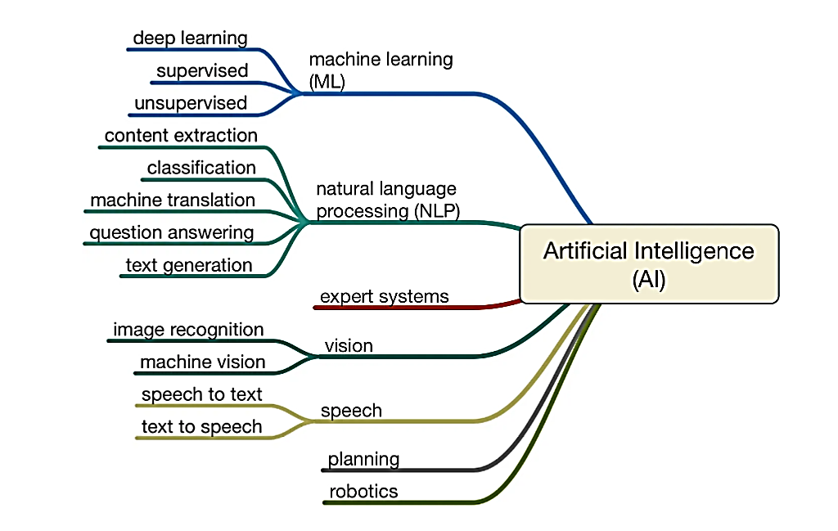Fig. Subdomains of Artificial Intelligence

Categories of Artificial Intelligence:
- Artificial Narrow Intelligence (ANI): Commonly referred to as Weak AI, ANI represents the initial phase of Artificial Intelligence development, involving machines capable of executing a limited and narrowly defined set of specific tasks. At this stage, machines lack any form of cognitive reasoning and solely perform predefined functions. Examples of Weak AI encompass virtual assistants like Siri and Alexa, self-driving cars, the Alpha-Go program, humanoid robots like Sophia and various AI systems created to date, all of which fall within the realm of Weak AI.
- Artificial General Intelligence (AGI): Also known as Strong AI, AGI marks an advanced stage in the progression of Artificial Intelligence, where machines will possess the capacity to engage in thinking and decision-making akin to human beings. Currently, there are no existing instances of Strong AI, but it is anticipated that we will soon have the capability to craft machines that exhibit human-level intelligence.
- Artificial Super Intelligence (ASI): Artificial Super Intelligence denotes the ultimate stage of Artificial Intelligence, where computer system’s capabilities surpass those of human beings. ASI remains a theoretical concept, as portrayed in movies and science fiction literature, where machines have gained supremacy over the world.
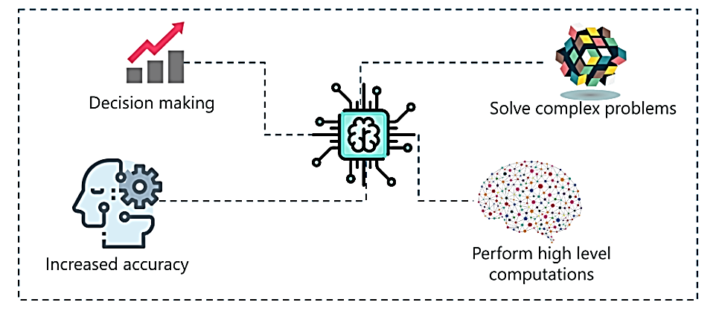
Fig. How AI works?
AI applications in agriculture:
AI has the potential to significantly enhance agricultural productivity by implementing five critical strategies. These include intelligent water management (such as drip or sprinkler irrigation), the selection of suitable crop varieties (resistant to heat, drought and stress), conservation tillage (reducing moisture and soil loss), precise nutrient supplementation (minimizing input costs) and the utilization of farm management software to revolutionize production processes (Zhang et al., 2021). Precision agriculture leverages AI to identify plant diseases, pests and nutrient deficiencies on farms. AI-powered cameras on drones capture and analyze images of entire farms in near real-time, enabling the identification of issues and suggesting potential improvements. For instance, robots can address the challenge of a diminishing agricultural workforce, increasing efficiency while reducing labor costs. Advanced robotic systems can not only care for and harvest crops but also collect on-farm data, ultimately boosting crop yields. Agricultural robots often referred to as Agri-robots, perform tasks like crop harvesting at higher volumes and faster speeds than human laborers. Computer vision technology is maximized for monitoring, weeding and spraying in in-vivo agriculture (Dharmaraj and Vijayanand 2018; Waleed et al., 2020).
The adoption of robotics in Indian agriculture has several benefits, including cost reduction, as Agri-bots can handle tasks like crop harvesting and weeding, reducing the need for fertilizer and human labor. Additionally, it can attract and retain young people in the agricultural sector. AI will undoubtedly help farmers find more efficient ways to protect their crops from weeds. The future of agriculture, especially in India, will witness AI innovations tailored to regional needs and diverse climatic conditions (Awasthi Y. 2020; Maurya et al., 2023). Autonomous tractors are set to revolutionize the farming sector, performing multiple tasks independently, saving time and labor costs. These self-driving tractors use computer programs to execute plowing, harvesting and weed control operations autonomously. Pest management is another task for AI, as pests can cause significant crop losses (Vijayakumar and Balakrishnan 2021). AI can be employed to control these infestations and use satellite images for forecasting emerging threats.
AI-based technology, such as the PEAT application called Plantix, can identify soil defects, nutrient deficiencies, plant pests and diseases, providing timely solutions via smartphone-based image recognition (Grace et al., 2018). This helps farmers monitor soil and crop health, leading to healthier and more productive crops. Agriculture requires a substantial portion of available freshwater, with increasing demands expected in the future. Efficient water utilization is essential and modern drip irrigation systems significantly reduce water usage compared to traditional methods. Some crops require varying amounts of water as they grow, such as paddy rice (John et al., 2023). An automated drip irrigation system, which uses smartphone-captured soil images to calculate wetness levels and transmit data to a microcontroller via a GSM module, offers a solution. The microcontroller makes irrigation decisions and communicates field status to the farmer's mobile phone. Experimental results indicate water savings of approximately 41.5% compared to conventional flood irrigation and 13% compared to traditional drip irrigation methods when applied to paddy fields over a three-month period (Barkunan et al., 2019).
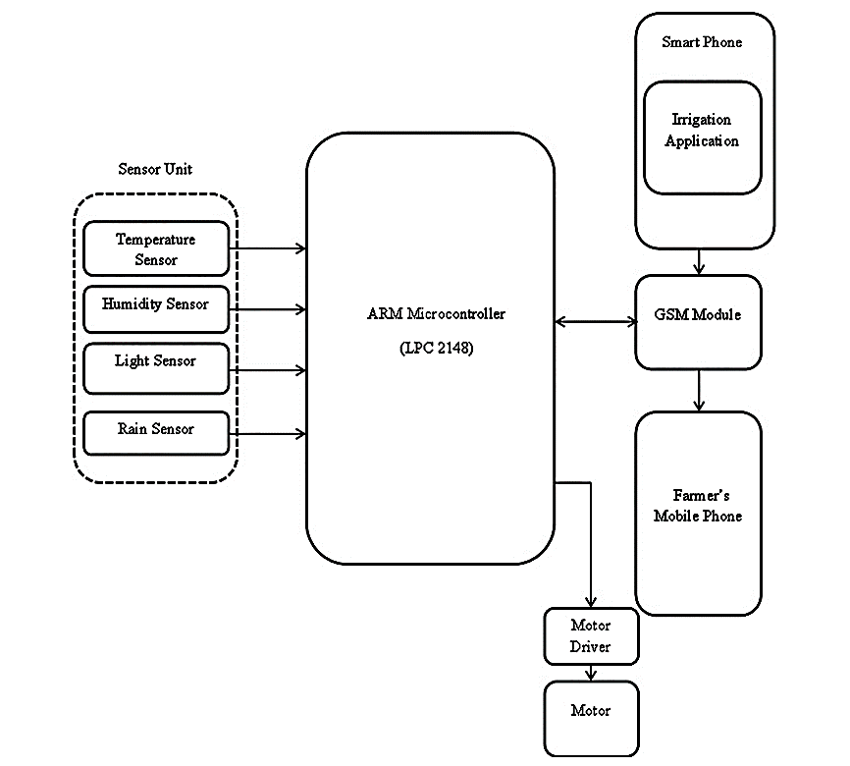Fig. 2. Block diagram of proposed Smart Sensor based irrigation system.
The working of proposed irrigation system is classified into three major categories based on the moisture content of the soil and inputs from the sensor unit. The categories are as follows:
1. Soil is in wet condition - Motor needs to be in OFF state.
2. Soil is in dry condition and the possibility of rainfall - Motor needs to be in OFF state.
3. Soil is in dry condition and no possibility of rainfall - The motor needs to be in an ON state.
The system continuously captures the soil image and sensor inputs and manages the agricultural field by repeatedly doing the above-mentioned process at predefined time intervals. Finally, the status of the irrigation process is updated periodically on the farmer’s mobile through SMS.
Weather Forecasting and Sowing Management App
- FASAL (Forecasting agricultural output using Space, Agro-meteorological and land-based observations)
- AI Sowing App powered by Microsoft Cortana
FASAL: 2018 was when Fasal started the journey with just four team members and now they are on their way to impact Indian Agriculture in a big way! Since its inception, Fasal has helped its numerous farmers reduce the cost of cultivation and increase quality and yield, through our AI-powered platform for horticulture, delivering farm-specific, crop-specific, crop-stage-specific, actionable advisory. They propagate sustainable agriculture and solution impacts on social, economic and environmental facets, hence making a big impact on the UN’s Sustainable Development Goals (Bolandnazar et al., 2020).
Microsoft, in collaboration with ICRISAT, developed an AI Sowing App powered by Microsoft Cortana Intelligence Suite including Machine Learning and Power BI. The app sends sowing advisories to participating farmers on the optimal date to sow. The best part is the farmers don’t need to install any sensors in their fields or incur any capital expenditure. All they need is a feature phone capable of receiving text messages.
Role of AI in Livestock Management
A smart collar for cows could revolutionize farming. Halter is a New Zealand-based startup bringing farming into the future with smart collars for cows. The current behavior monitoring and analysis automation system is commonly equipped with components such as sensors attached to the leg, neck, or ear of animals, sensor nodes to process and transmit the observations and an AI-enabled model to update the status of the animal. Livestock automation systems are also data-driven and these livestock data are generally unstructured. It can fall into any category of text, image, audio and so on. The data can be made available in a public dashboard that can be accessed remotely from any location. Providing summary data on a daily basis can help in planning for the upcoming days (Ullah et al., 2018).
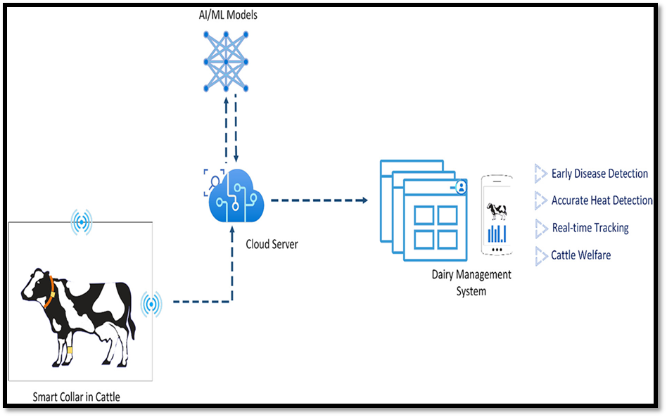
Fig. 3. Smart collar system for smart dairy management
AI Robots in Agriculture:
Robotics was first developed in agriculture in the early times of the year 1920. Israel-based startup with an idea to help farmers solve the labor shortage problem. Designed to work in a greenhouse environment. Driverless robots have two robotic arms to pick and harvest tomatoes on both sides of a row simultaneously. More than 30% of the crops grown in greenhouses are tomatoes. Robots can reduce the labor needs of harvesting by about 90% and cut production costs by about 50% by saving on manpower costs (John et al., 2023).
Challenges in the Adoption of AI-Based Technologies in India:
- Subdivision of land into small and fragmented holdings.
- The high initial costs and ongoing expenses of implementation and maintenance.
- Concerns related to privacy and security.
- Limited access to advanced technology.
- A shortage of technical expertise.
- Insufficient connectivity and infrastructure deficiencies in rural areas.
- A lack of awareness and accessibility among smallholders regarding the latest technologies and government programs and subsidies.
Pros and Cons of Artificial Intelligence:
Pros | Cons
AI, when properly coded, exhibits a low error rate compared to humans. | AI lacks human creativity and out-of-the-box thinking.
It offers incredible precision, accuracy and speed. | Overreliance on AI can lead to human passivity and reduced productivity.
AI can predict user actions, queries and behaviors. | Building, rebuilding and repairing AI systems can be costly and time-consuming.
AI systems can serve as efficient assistants, offering recommendations and guidance. | The replacement of jobs by robots can lead to unemployment issues.
It can detect fraudulent activities in card-based systems and potentially other domains. | Concerns exist regarding the societal impact of widespread job displacement.
AI can interact with humans in various forms for entertainment or task completion. | Some AI applications, like robotic repair, may require additional resources and expenses.
It has applications in medical fields, such as health risk assessment and emotional state analysis | AI lacks human creativity and out-of-the-box thinking.

Future Prospects and Emerging Trends:
a. Integration of AI with other technologies (e.g., Internet of Things, blockchain)
b. Collaborative platforms and knowledge sharing for agricultural innovation.
c. Advancements in machine learning and deep learning algorithms
d. AI-powered decision support systems for personalized farming recommendations.
The future of agriculture, particularly in India, is Equipped for significant advancements with the integration of AI-powered machinery. This transformation will bring about a revolution in the farming sector, where autonomous tractors will be employed to carry out a variety of tasks, resulting in both time and cost savings in labor (Nawaz et al., 2020). While AI promises efficiency gains and reduced labor requirements, there is also a paradoxical concern that the substantial workforce in agriculture may face unemployment. Nevertheless, there are strategies to address this apprehension.
- Introduce cost-effective AI technologies accessible to farmers.
- Promote collaboration between policymakers and AI experts.
- Develop AI-based automated irrigation systems for efficient water usage.
- Conduct location-specific trials to expand the database for improved farm-level management using digital technologies.
References
- Awasthi Y. (2020). Press “A” for artificial intelligence in agriculture: a review. JOIV: Int. J. Inf. Visual. 4(3):112–116.
- Barkunan, S. R., Bhanumathi, V. and Sethuram, J. (2019). Smart sensor for automatic drip irrigation systems for paddy cultivation. Compt. Electr. Eng., 73: 180-193.
- Bolandnazar, E., Rohani, A. and Taki, M. (2020). Energy consumption forecasting in agriculture by artificial intelligence and mathematical models. Energy Sources, Part A Recovery, Util Environ Eff. 42(13):1618–1632.
- Bostrom, Nick (2014). Superintelligence: Paths, Dangers and Strategies. Oxford, UK: Oxford University Press.
- Dharmaraj, V. and Vijayanand, C. (2018). Artificial intelligence (AI) in agriculture. Int. J. Curr. Microbiol. Appl. Sci. 7(12):2122–2128.
- FAO (2017). Food and Agriculture Organization of the United Nations, 2017978-92-5-1098738, pp. 1-181.
- John, V., John. V., Maurya, A. K and Srivastava, D. K. (2023). Implementation of Artificial Intelligence to advance Agricultural activity. Renewable Energy and Sustainable Environment. Society of Biological Sciences and Rural Development. 151-155. ISBN : 978-81-923535-9-3
- Maurya, A. K, John, V., Kumar, H. and John, V. (2023). Approach to AI-based Management of Pests and Diseases in Mushroom Cultivation. Renewable Energy and Sustainable Environment. Society of Biological Sciences and Rural Development. 88-92. ISBN : 978-81-923535-9-3
- Nawaz, A. N., Nadaf, H. A., Kareem, A. M. and Nagaraja, H. (2020). Application of artificial intelligence in agriculture-pros and cons. Vigyan Varta, 1(8), 22-25.
- Ullah, M. W., Mortuza, M. G., Kabir, M. H., Ahmed, Z. U., Supta, S. K. D., Das, P. and Hossain, S. M. D. (2018). Internet of things based smart greenhouse: remote monitoring and automatic control. DEStech Trans. Environ. Energy Earth Sci. (5), 278–291.
- Vijayakumar, V. and Balakrishnan, N. (2021). Artificial intelligence-based agriculture automated monitoring systems using WSN. J. Ambient Intell Hum Comput. 12(7): 8009–8016.
- Waleed, M., Um, T. W., Kamal, T., Khan, A. and Iqbal, A. (2020). Determining the precise work area of agriculture machinery using internet of things and artificial intelligence. Appl Sci.10 (10):3365.
- Zha, J. (2020). Artificial intelligence in agriculture. J. Phys. Conference Series :1693, No. 1, p. 012058. IOP Publishing.
- Zhang, P., Guo, Z., Ullah, S., Melagraki, G., Afantitis, A. and Lynch, I. (2021). Nanotechnology and artificial intelligence to enable sustainable and precision agriculture. Nat. Plants. 7(7):864–876.

Other reference sites are listed below:-
- https://data-flair.training/blogs/artificial-intelligence-advantages-disadvantages/ (18/09/2023)
- https://fasal.co/ (17/09/2023)
- https://news.microsoft.com/en-in/features/ai-agriculture-icrisat-upl-india/ (19/09/2023)
- https://www.cnbc.com/video/2019/05/10/root-ai-unveils-a-ripeness-detecting-tomato-picking robot.html (17/09/2023)

