AN OVERVIEW – DIABETIC NEUROPATHY

Introduction

The Disease Diabetic neuropathy (DN) are diversified, influencing different sections of the nervous system that present with various clinical manifestations.
The disease belongs a family of nerve disorders which is due to diaabetic patients. Diabetes patients can start to damage the nerves all over the body.Some of the patients shows no symptoms with nerve damage.Other patients may show most ordinary symptoms like- pain, tingling, numbness, a burning feeling, cramps,weakness and loss of feelings in the upper and lower limbs.
This disease is a serious complication that may affect as numerous as 50% of diabetes people. Patients can prevent their disease naturally by eat a balanced diet that involves a healthy food especially fruits,vegetables and whole grains.

1.1 Definition and risk factors:

The diabetic neuropathy is also known as Diabetic nerve damage that can occur with diabetes people. Nerves are present in the form of bundles with special tissues that transfer signals between your brain and other parts which are present in our body. The signals send information about how things feel, move your body parts, control body functions like digestion.

The vulnerable factors includes many following factors-
i)Poor blood sugar control.
ii)Diabetes history.
iii)Kidney Disease.
iv)Smoking.
v)Being overweight.

1.2 Diabetic Neuropathy classification:

S.No. | Classification of Diabetes Neuropathy | Symptoms of Diabetes Neuropathy | Diagnosis
1. | Peripheral Neuropathy | - numbness or insensitivity to pain or temperature  - a tingling and burning.  - sharp pains or cramps  - extreme sensitivity to touch, even light touch  - Balance loss and coordination | - Diagnosis is based on the signs and a physical examination  - Firstly, the doctors measure the blood pressure, heart rate, muscle strength, reflexes, and sensitivity to position changes, vibration, temperature, or light touch.  - With the help of comprehensive foot examine estimate the skin, muscles, bones, circulation, and sensation of the feet.  - By temperature perception or use a tuning fork, which is more sensitive than touch pressure, to assess vibration perception.
2. | Autonomic Neuropathy | - Heart- Nerves are damage which control heartrate.  - Stomach-constipation and Gastroparesismakes the level of glucose fluctuate, swallowing difficulty and uncontrolled diarrhoea.  - Bladder and Sex organs- urinary tract infections, the sexual response is low in both males and females.  - Sweat glands-start sweating at night.  - Eyes- the responsive is low with changes in light.
3. | Proximal neuropathy | - Start discomfort in the highs,legs and hips.  - legs weak.  - feeling difficulty in changing the position.
4. | Focal neuropathy | Difficulty in eyes.  - Double vision.  Causes strain in the lower back or pelvis.  - Pain in the thigh, chest, stomach, or side  - Pain on the outside of the shin or inside of the foot  - Chest or abdominal pain that is sometimes inaccurate for heart disease, a heart attack, or appendicitis

Nerve damage signs and symptoms-
- numbness, tingling, or feeling in the legs,hands,arms,toes and fingers.
- indigestion, nausea, or vomiting
- diarrhoea or constipation
- dizziness or faintness
- problems with urination
dysfunction in men or vaginal dryness in women
- fatique.

The classification of diabetic neuropathy (DN) are –
Each neuropathy affects many segments of the body in different manner.

- Peripheral neuropathy- It is the first and greater classification of diabetic neuropathy (DN).The ordinary symptoms are pain and absence of feeling in the feet,legs, toes,hands and arms.
- Autonomic neuropathy- This neuropathy develops changes in the process of digestion, sexual response and perspiration. It control blood pressure and nerves which are present in the lungs and eyes. It can effect hypoglycaemia ignorance, a condition in which people no longer experience the warning mark of less blood glucose levels.
- Proximal neuropathy-It mainly causes suffering from the hips,thighs or buttocks and leads to leg weakness.
- Focal neuropathy- It develops sudden deficiency in the nerves and causes muscle weakness and pain.

Peripheral Neuropathy
Peripheral neuropathy, also called distal symmetric neuropathy or sensorimotor neuropathy, is damaging the nerves which are present in the legs and arms. Our arms and hands are less affected than feet and legs. Many diabetes patients shows the signs of neuropathy that only doctor could observe.
Symptoms:
- numbness or insensitivity to pain or temperature
- a tingling and burning.
- sharp pains or cramps
- extreme sensitivity to touch, even light touch
- coordination
It may also cause muscles weakness, loss of reflexes, mainly at the ankle.
In the foot Blisters and sores may appear on numb areas because pressure or injury goes unnoticed.
If foot injuries are not treated promptly, the infection may transmit to the bone, and the foot may then have to be amputated.

Autonomic Neuropathy
This type of neuropathy can alter the nerves that regulate the heart, blood pressure, and control the level of blood glucose. It can also affect the internal organs, which causes trouble in digestion, respiratory function, urination, sexual response, and vision. These system that restores the level of glucose to normal after a hypoglycaemic episode may be affected, resulting in loss of the warning symptoms of hypoglycaemia.
It mainly affects the nerves which is present in our heart, intestines, bladder, sex organs,stomach, sweat glands, eyes, and lungs.

This type of Neuropathy alter the following systems:

- Hypoglycaemia Unawareness-Normally, the signs are shakiness, sweating, and palpitations occur when the level of blood glucose drop under 70 mg/dL.
- Blood Vessels and Heart- Both the organs belongs to the cardiovascular system, which controls the blood circulation.It damages the nerves which interferes the body ability to modify the blood pressure and heart rate.As a result, blood pressure shows some sharply changes after sitting or standing, causing a person to feel light-headed or even to faint.
- Digestive System- This system nerves damages and the most commonly cause is constipation. Damage can also effect the stomach to empty too slowly, a condition called gastroparesis. Severe gastroparesis can cause nausea, bloating, and loss of appetite. Due to abnormal food digestion.,gastroparesis may also make the level of glucose fluctuate very widely.
- Urinary Tract and Sex Organs-It often may affects the organs that control urination and sexual function. When the nerves present in the bladder are damaged, urinary incontinence may result because sometimes person are not capable to sense when the bladder is full or control the muscles that release urine.
- Sweat Glands- This type of glands can also alter the nerves that regulates sweating. When the damaging nerves prevents the sweat glands, the body cannot control its temperature. Nerve damage can also cause sweating while eating or at night.
- Eyes- It can alter the pupils of the eyes, and the response is very low with changes in light. Thats why, a person may be not capable to see clear when a light is turned on in a dark room.

Proximal Neuropathy
This neuropathy is also known as lumbosacral plexus neuropathy, femoral neuropathy, or diabetic amyotrophy.The signs and symptoms are- discomfort in the thighs, hips, buttocks, or legs. This type of neuropathy is more common.It causes deficiency in the legs and feeling the difficulty from changing the positions without help. The length of the recovery period varies, depends on the reason of the nerve damage.

Focal Neuropathy
Focal neuropathy alter a nerve or group of nerves and causes sudden pain or weakness. It can lead to focus in the eye, double vision, aching in one eye, paralysis on one side of the face, known as Bell’s palsy,discomfort in the pelvis and in the forepart of a thigh, and in the chest, stomach, or side, pain on the inside of the foot, chest or abdominal pain that is sometimes inaccurate for heart disease, a heart attack, or appendicitis.
The causes of focal neuropathy are- high blood glucose, and the high level of fats like triglycerides, which is present in the blood from diabetes patients can harm your nerves and the blood vessels which are small.
There are some ordinary classification of pain are-
Acute pain,Chronic pain,Radicular pain,Neuropathic pain and Nociceptive pain.
There are some examples which includes Carpal tunnel syndrome,which causes pain,numbness,tingling in your thumb,index finger and middle finger.

Diagnosis of Neuropathy:

Your health care provider can easily determine the disease by performing a physical exam and diagnose your symptoms and medical history. Providers basically checks your following points-
- Overall muscle strength and tone.
- Tendon reflexes.
- Sensitivity to touch,pain,temperature and vibration.
Along with the physical exam,your health provider may perform or order specific tests to help diagnose the disease such as:

i)Filament testing
ii)Sensory testing
iii)Electromyography
iv)Autonomic testing

Treatment of Neuropathy:

i)Urinary tract problems – Some drugs affect bladder function , so the health care person may recommended stopping or changing medications.Other methods including self-catheterization , may be needed to remove urine from a nerve-damaged bladder.

ii)Digestive problems – To relieve mild symptoms of gastroparesis – indigestion,
nausea, more frequent meals may help.Diet changes and medications may help to relieve nausea,constipation and diarrhoea.

iii)Sexual dysfunction – Medications taken by mouth or injection may improve sexual function in some men,but they are not safe and effective for everyone.

Self care:
-Maintain your Blood pressure undercontrol.
-Make healthy food choices.
-Be active everyday.
-Stop smoking.

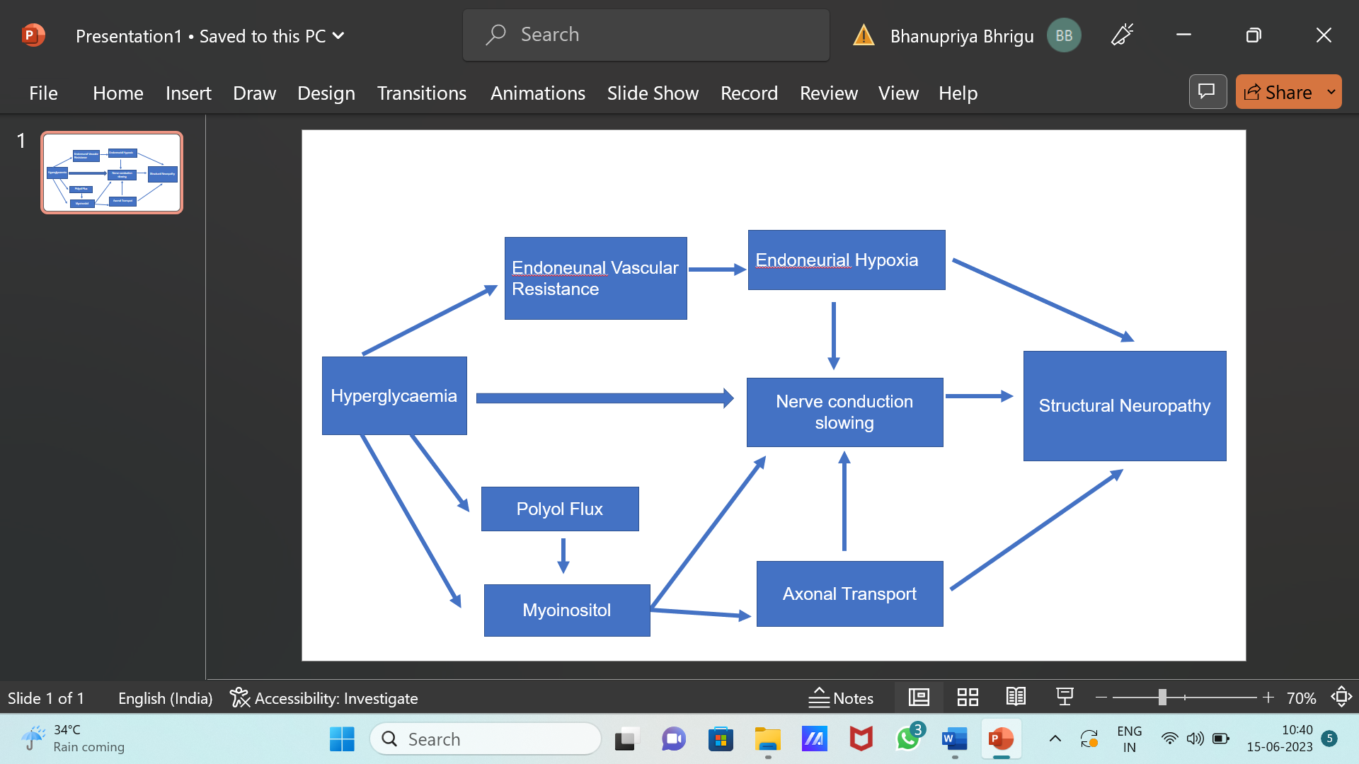

1.3 CURRENT TREATMENT OPTIONS

Duloxetine (Cymbalta)

(+) -(S)-N-Methyl-3-(naphthalene-1-yloxy)-3-(thiophen-2-yl) propan-1-amine

A drug is basically used for peripheral neuropathy and depression. The symptoms are – pain, numbness, tingling, burning or deficiency in the hands and feet that can occur with diabetes.
It may improve your mood,sleep.appetite and energy level. The side effects of duloxetine are-

-Difficulty in sleeping.

-Feeling dizzy.

-Blurred vision.

-Diarrheoa and Feeling sick.

Norpramin

3-(10,11-dihydro-5H-dibenzo[b,f]azepin-5-yl)-N-methylpropan-1-amine

Mitchell B et al 1990 use Desipramine has the low sedative effect and low anticholinergic effect of the first-generation tricyclic antidepressants. It is taken by mouth and used to handle depression. May be it is not a first choice treatment because it shows many side effects like – confusion, drowsiness and problem in keeping balance.The normal adult dose is 100mg to 200mg per day.In more severely ill patients , dosage may be further increases gradually to 300mg\day if necessary.It may take 2 to 3 weeks for you to feel benefit of this medicine.The half life of norpramine is 7 to 65 hours, so limited of the concentartion in your body could be gone within as small as 7 hours.

Gabapentin (Gabantin)

1-(Amino methyl cyclohexane acetic acid)

Backonja Met al 1998 explained that it is a medication which is commonly called as a gamma aminobutyric acid (GABA) analogue. It decreases the excitability of nerve cells which are present in the brain, plays a very beneficial role in transmission of pain signals and seizures.
The basic side effects are – Feeling sleepy, Diarrhoea, Mood swings, Dry mouth, Blurred vision and nausea.

Carbamazepine (Tegretol)

3, 5 Diamino-6-(2, 3 dichlorophenyl)-1, 2, 4 triazine

Wiffen PJet al2017 reviewed 10 studies involving 480 participants with Diabetic Polyneuropathy, trigeminal neuralgia, or post-stroke pain treated with carbamazepine.
The drug generally provided better short-term pain free in comparison with placebo in Diabetic Polyneuropathy patients, but the authors noted that the relevant studies has badly defined outcomes, incomplete reporting, and small numbers of participants.

Valproate sodium

2-propylpentanoic acid

Kochar DKet al 2004Two randomized, double-blind, placebo-controlled trials have evaluatedvalproate sodium in DPN patients. Firstly, the study of 116 52 patients received valproate sodium. The authorsreported significant improvements in the pain scores (SF-MPQ) of patients treated with valproate sodium compared with those givenplacebo (P < 0.05). It is mainly used to deal epilepsy and bipolar disorder. It is effective in mood and anxiety disorders which are shown.

Dextromethorphan

6-methoxy-11-methyl-1,3,4,9,10,10a-hexahydro-2H-10,4a-(epiminoethano)phenanthrene

Nelson KA et al 1997 conducted two randomized, double-blind, crossover studies of DXM in a total of31 DPN patients, who collect DXM ata mean dosage of 381 mg per day for six weeks. It is basically for temporaily relieve cough because of the common cold, the flu or many other conditions. It works by decreasing activity in the sections of the brain that causes coughing.

Tramadol

2-[(Dimethylamino)methyl]-1-(3-methoxyphenyl) cyclohexano

The brand name is ultram among others,is an opioid pain medication used for moderate to moderely severe pain. It is basically used for the short-term relief pain. It should only be used when other forms of non-opioid can not treat successfully. It is a selective agonist of mu receptors and inhibits serotonin reuptake. The serious side effects are – feel dizzy, tired and have low energy. It usually 3 to 4 times a day. It can raise or lower the blood pressure.
Naloxone is a type of narcotic that may be used to help alter the effects of a tramadol overdose.

PREVENTIVE CARE:
- The very first step is to avoid alcohol, improving vitamin deficiencies, eating a healthy diet, losing weight, avoid toxins and exercising regularly. You can prevent diabetic neuropathy and itd complications.
- Treatment of this type of neuropathy which is very painful with oral medications, although other types of treatments may help some people. People with severe nerve pain may advantage from a combination of medications or treatments.
- Mainly many of the medications shows side effects and some are not recommended for use in adults or those with heart disease. Treatments that are start from the skin typically to the feetinclude capsaicin cream and lidocaine patches.
- Eat a balanced diet that involves a variety of fresh fruits, vegetables and whole grains. Fixed portion sizes to help achieve or maintain a healthy weight. Be active and energetic everday. Do regular exercise which helps in lower the level of blood sugar,improves blood flow and keeps your heart safe and healthy.
- Lifestyle choices plays a very beneficial role to stop peripheral neuropathy. Treatments that involve electrical nerve stimulation, magnetic therapy, and laser or light therapy may be helpful but need further study. Researchers are also studying several new therapies in clinical trials.
- People with neuropathy give sometime for special care of their feet. Mainly the nerves of the feet. Circulation problems also increase the possibility of foot ulcers. Routine health care that includes screenings, check-ups and patients counseling to stop illness, disease or health related problems.

CONCLUSION
Limited of the lower-limb sever in the India held in with diabetes patients - 100,000 amputations per year. It is estimated that nearly half of the amputations which is due to neuropathy and poor circulation could be prevented by careful foot care. Numerous pharmacological treatments both approved and off-label have been used to reduce the pain of the diabetic patients and to improve patient’s lifestyle. These treatments include antidepressant, anticonvulsant, analgesic, topical medications and some are under clinical trials for management.
To curb the epidemic of diabetes and its associated complications, there isa need for amultipronged strategy involving early diagnosis ofdiabetes, screening for its complications, and offering optimaltherapy at all levels of care for those who already have diabetes and main prevention of diabetes.

