**Organic Chemistry in Metaverse: A Future Prospect**

1. **Introduction**

In recent years, organic chemistry has undergone remarkable changes due to technological advances, digitalization and innovative thinking. One of the most exciting and forward-looking directions in organic chemistry in era of artificial intelligence (AI) is "Organic Chemistry in the Metaverse". This emerging interdisciplinary field encompasses the convergence of organic chemistry, nanotechnology, quantum computing, and virtual reality, and promises to reshape the way we approach molecular design, synthesis, and understanding (Figure 1). This chapter explores the intriguing possibilities and potential applications of metaverse in organic chemistry, and how it can revolutionize areas ranging from drug discovery to materials science. Moreover, organic chemistry virtual labs are gaining the attention of not only chemists or scientists but also teachers for demonstration of basic organic reactions for better understanding and making them interesting for the learners.

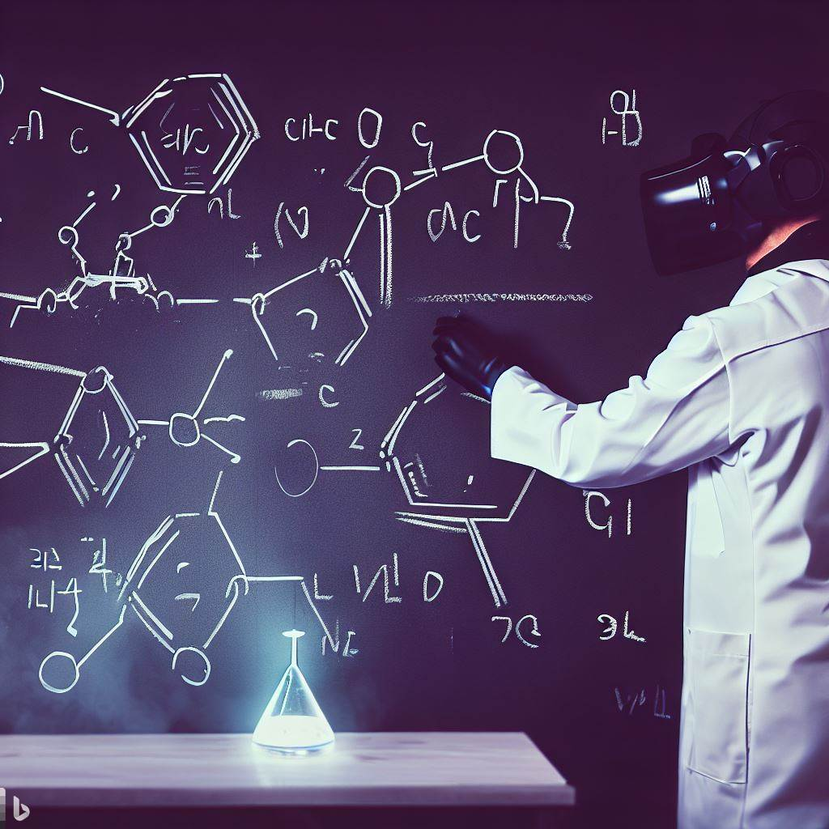

**Figure 1: Visualization of designing organic synthesis in metaverse**

1. **Organic Chemistry in Metaverse: A Conceptual Overview**

Metaversal Organic Chemistry is a dynamic and transformative field based on the synergistic effects of several scientific disciplines. At its core, Organic chemistry in metaverse aims to transcend the traditional limitations of physical experimentation by harnessing the power of digital simulation, quantum mechanics, and immersive virtual environments. The term “metaverse,” with organic chemistry refers to the fusion of organic chemistry with the collective virtual shared space. The use of virtual reality in the the teaching of organic chemistry is a commendable intervention in terms of educational technology and will contribute to the improvement of didactics in experimental chemistry. Salvador *et al* reported that use of VR technology projects in high school students improves their learning abilities of organic chemistry concepts such as nomenclature of organic compounds and functional group identification. Moreover, emerging technologies in education such as virtual reality allows not only the development of specific educational skills of the learners but also enhance the competencies in the teaching of experimental chemistry for teachers (Table 1).

|  |  |  |
| --- | --- | --- |
| **Aspect** | **Traditional** | **Metaverse** |
| Molecular Design | Manual | Virtual design |
| Reaction Prediction | Limited by empirical data | Quantum simulations for predictions |
| Collaboration | Physical presence required | Collaborative virtual laboratories |
| Experiment Optimization | Trial and error | Real-time parameter optimization |
| Material Discovery | Limited screening | Quantum-assisted material exploration |
| Learning Curve | Steep | Training for virtual interfaces |

**Table 1: Comparison of traditional vs. metaverse approaches in organic chemistry teaching**

The Metaverse technology in organic chemistry changed the paradigm of research in organic chemistry through a supported system primarily by human researchers. In addition, the future development of chemistry by emerging technologies such as metaverse driven by integrated data from experiments, simulations, and theory should not be overlooked.

1. **Virtual Molecular Design and Exploration**

Virtual molecular design can be greatly improved by incorporating state-of-the-art technologies, that of AI, than conventional molecular design and research methods (Figure 2). As chemistry becomes increasingly intertwined with nanotechnology and quantum computing, the potential to manipulate matter at the atomic and molecular scale is more feasible than ever. In metaverse, researchers can harness the power of quantum computers to virtually simulate and explore vast chemical spaces. This allows rapid design of organic compounds and their screening for specific properties such as drug binding affinity or catalytic activity. Utilizing virtual reality interfaces, chemists can immerse themselves in these digital molecular environments, interact with molecular structures, and gain intuitive insights that are not readily apparent in traditional 2D depictions.



**Figure 2: Visualization of a chemist interacting with a molecular structure in a digital environment**

A collective virtual shared space created from the convergence of virtual augmented physical reality and permanent virtual reality, the metaverse provides a unique platform for uniting these disciplines. In the context of designing and exploring virtual molecules, the metaverse serves as an immersive environment for chemists, and researchers to interact with molecules on a scale that transcends the limits of the physical world. The Mateverse platform, based on Metaverse technology, makes all of this possible through a digital process supported primarily by human researchers, which will drastically change the research paradigm in chemistry. Metaverse is a technology that should not be overlooked for the future development of chemistry driven by integrated data from experiments, simulations and theory.

Designing and exploring virtual molecules is powered by numerous methodologies and tools from advances in computational chemistry, nanotechnology, quantum computing, and virtual reality technologies. These tools are designed to bridge the gap between theoretical models and experimental observations, allowing chemists to visualize, manipulate and predict the behavior of molecules.

The designing and exploring virtual molecules can be implacable in a variety of scientific and industrial domains (Table 2) may include as follow:

* 1. **Drug discovery**: One of the most promising applications is drug discovery. The ability to simulate and predict interactions between drug molecules and biological targets can accelerate the identification of potential drug candidates, reducing the time and cost associated with traditional trial and error methods.
  2. **Materials Science**: Virtual molecular design opens the way to create new materials with customized properties. By exploring different molecular configurations and configurations, researchers can design materials that exhibit enhanced strength, conductivity, and other desirable properties.
  3. **Catalysis and Chemical Reactions**: Understanding the complexities of chemical reactions is critical to optimizing industrial processes. Virtual molecular design enables exploration of catalytic pathways and reaction mechanisms, enabling the development of more efficient and sustainable chemical processes.
  4. **Environmental impact**: The ability to design molecules with specific environmental properties can have a significant impact on sustainability efforts. From designing biodegradable materials to discovering new methods of carbon capture, virtual molecular design contributes to solving global challenges.

|  |  |
| --- | --- |
| **Application** | **Description** |
| Drug Discovery | Rapid virtual screening for drug candidates |
| Reaction Optimization | Real-time adjustment of reaction conditions |
| Materials Design | Tailoring materials properties using quantum simulations |
| Education and Training | Interactive learning environments for budding chemists |
| Sustainable Chemistry | Circular chemistry strategies in virtual labs |

**Table 2: Potential applications of metaverse in organic chemistry**

1. **Acceleration Response Prediction And Optimization**

Quantum simulations in a metaverse world will enable accurate prediction of reaction pathways, their transition states and reaction energies. This predictive ability restructure organic synthesis to avoid trial-and-error processes and finding the most efficient synthesis route. The metaverse approach in organic synthesis will allow chemists to design real-time optimization of reaction conditions to significantly reduce experimental time. Visualization through virtual reality will help to study the details of the reaction mechanism and identify potential acceleration opportunities. Organic chemists will be able to observe real-time reaction kinetics changes while interacting with molecules and could virtually manipulate conditions and catalyst.

The accelerated response of prediction and optimization through metaverse in organic chemistry holds tremendous promise in many areas (Table 2).

* 1. **Drug Discovery**: Predicting the accelerating behavior of drug synthesis reactions in the pharmaceutical industry can significantly shorten development timelines. By rapidly identifying efficient response pathways, researchers can accelerate the synthesis of potential drug candidates to rapidly deliver life-saving drugs to patients.
  2. **Sustainable Chemistry:** Organic Chemistry in metaverse can contributes to sustainable practices by optimizing catalytic processes. With the ability to predict accelerated responses, scientists can design greener, more energy-efficient reactions to reduce waste and minimize environmental impact.
  3. **Materials Design**: Accelerated reaction kinetics can be imposed in materials science to design new materials with desired properties. With virtual prediction and optimization, rapidly designed materials that exhibit specific mechanical, electronic, or optical properties could be achieved.
  4. **Energy Conversion**: In metaverse approach, optimization of reaction kinetics to fine-tune reaction rates could improve energy conversion rates and overall performance of the reaction.

1. **Discovery Of Quantum Auxiliary Materials**

Metaversal Organic Chemistry extends its influence to materials science. Researchers can leverage quantum simulations to identify new materials with tailored properties for applications ranging from electronics to energy storage. The integration of virtual reality interfaces allows scientists to manipulate and explore the atomic-scale structure of materials, enabling a deeper understanding of structure-property relationships (Figure 3).

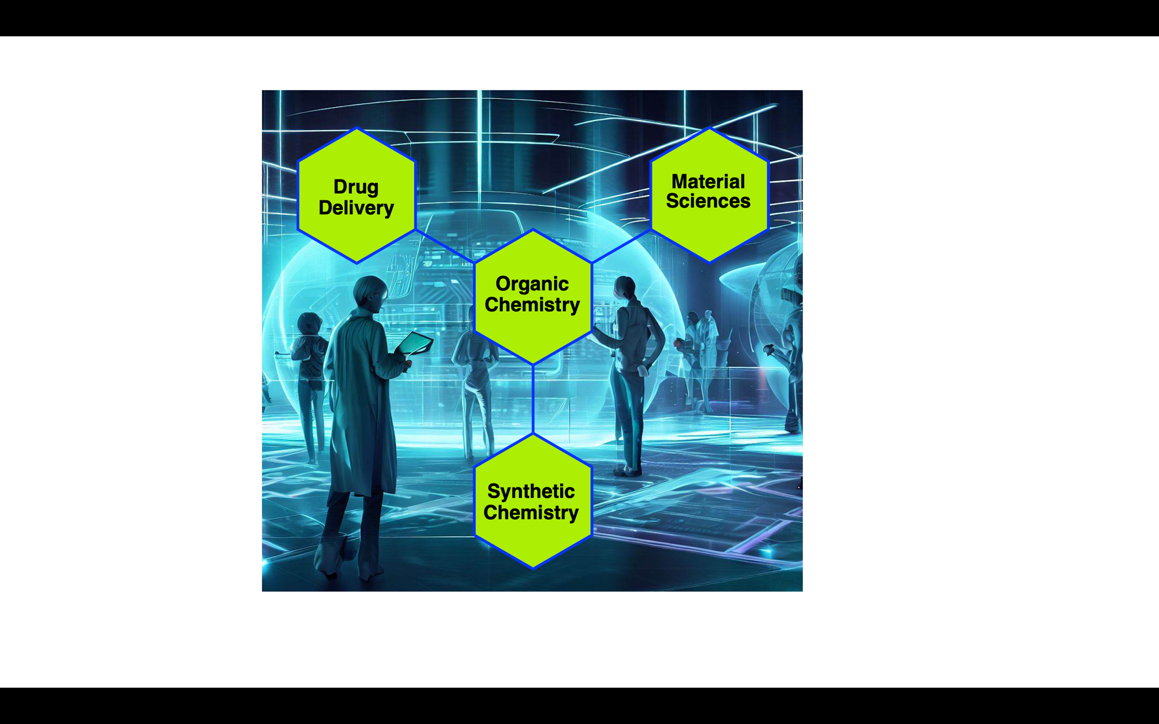

**Figure 3: Integration of Organic Chemistry in metaverse with different fields**

With the help of virtual reality, researchers can thoroughly explore the effects of modification in material parameters such as their composition, geometry, and electronic structures. These real-time experiments accelerate the iterative process of materials design, allowing scientists to quickly identify promising candidates for further investigation. The ability to observe molecular interactions and dynamic behavior in virtual reality provides insights to guide the selection and optimization of materials with desired properties.

The discovery of quantum auxiliary materials through organic chemistry in metaverse holds immense promise across various domains include:

* Catalysis
* Materials for Sustainable Practices
* Electronics
* Energy Storage
* Emerging Technologies

By harnessing the power of quantum simulations and virtual reality interfaces, researchers can usher in a new era in materials design, enabling tailor-made properties for a variety of applications. This approach not only accelerates the materials discovery process, but also allows scientists to explore unknown territories of molecular interactions and behavior. As metaversal approaches mature and interdisciplinary collaborations flourish, the impact of quantum assistive materials on technological advances and scientific innovation will be profound.

1. **Challenges And Considerations**

The convergence of organic chemistry with metaverse offers unusual opportunities to innovate and explore, however, researchers could face a set of unique challenges and considerations. As researchers further explore this emerging field, it becomes important to address these issues to fully exploit the potential of organic chemistry in metaverse.

* 1. **Accuracy of virtual simulation:** Quantum simulations and computational modeling are at the heart of organic chemistry in metaverse. However, ensuring the accuracy and reliability of these simulations remains a major challenge. Theoretical models must accurately capture the behavior of molecules and materials in the real world. Even minor inaccuracies in initial assumptions or parameters can lead to incorrect predictions, potentially derailing the entire design and exploration process. Achieving a balance between computational efficiency and accuracy is an ongoing endeavor that requires collaboration among computational chemists, physicists, and materials scientists.
  2. **Verification and experimental integration:** The Metaverse can create virtual environments where chemists can interact with molecules in unprecedented ways. These interactions provide valuable insights but must be validated against real experimental data. Integrating simulation results with experimental observations is essential to confirm the predictive power of the metaverse approach. Researchers must develop strategies to seamlessly merge virtual and real data so that models and simulations can iteratively improve.
  3. **Ethical Considerations:**As with any emerging technology, ethical considerations must be at the forefront of development. Metaversal organic chemistry has the potential to revolutionize fields such as drug discovery and materials science, but it also raises questions about data privacy, intellectual property rights, and the responsible use of technology. It is paramount that virtual simulations are used for beneficial purposes and not inadvertently lead to harmful applications. Ethical guidelines and frameworks should be established to guide the responsible application of metaverse technologies.
  4. **Accessibility and inclusiveness:** Metaversal organic chemistry offers exciting possibilities, but it is important to ensure that access to these technologies is not restricted to a select few. Access and inclusion are critical factors in stimulating widespread innovation and progress. Researchers must address barriers such as technology infrastructure, cost, and training. Designing user-friendly interfaces and tools that cater to a wide range of users, including students and researchers from diverse backgrounds, is essential to the democratization of organic chemistry in metaverse.
  5. **Interdisciplinary Collaboration:** Organic chemistry in metaverse draws from a variety of disciplines including chemistry, physics, computer science, and materials science. Effective communication and collaboration between experts in these diverse fields is critical to success. Overcoming language barriers and bridging gaps between expertise is essential to facilitating a seamless exchange of ideas and insights. Interdisciplinary teams must work cohesively to solve complex problems and leverage the unique strengths each discipline brings to the table.
  6. **Education and training:** Organic chemistry in metaverse becomes more integrated into research and education, comprehensive education and training programs are needed. Researchers, students, and educators must become familiar with the complexities of quantum simulations, virtual reality interfaces, and other metaverse technologies. Developing curricula, workshops, and training materials that enable individuals to confidently explore and utilize these tools is critical to the successful adoption and advancement of metaverse organic chemistry.
  7. **Technical limitations:** The metaverse offers exciting possibilities, but it's important to acknowledge its current limitations. Virtual reality interfaces, quantum computing and other technologies may still be evolving and are not fully mature yet. Researchers need to be aware of the limitations of these technologies and develop a clear understanding of their capabilities and drawbacks. This awareness will help manage expectations and guide the strategic implementation of a metaverse approach.
  8. **Data integration and management:**The vast amount of data generated through virtual simulations and experiments in the metaverse poses challenges related to data storage, organization, and management. Developing efficient methods for data integration, discovery, and analysis is critical to maximizing the usefulness of the insights gained. Researchers must establish strong data management practices to ensure that valuable information is not lost or overlooked in the complexities of metaverse experiments.

1. **Conclusion**

Metaverse Organic Chemistry is not a glimpse into the future of organic chemistry. It is a transformative journey that promises to redefine how we understand and manipulate matter at the molecular level. As quantum computing, virtual reality, and interdisciplinary collaborations continue to advance, the potential applications of metaversal organic chemistry will expand, impacting fields from drug discovery to materials design. By embracing this paradigm shift, researchers can explore the complexities of molecular interactions with unprecedented precision, accelerate innovation, and open new avenues for scientific inquiry.

1. **References**
2. Ruiz-Cerrillo, S. (2020). Augmented reality and learning in organic chemistry. *Apertura*, *12*, 106-117.
3. Ali, N., Ullah, S., & Khan, D. (2022). Interactive laboratories for science education: A subjective study and systematic literature review. *Multimodal Technologies and Interaction*, *6*(10), 85.
4. Raucci, U., Weir, H., Sakshuwong, S., Seritan, S., Hicks, C. B., Vannucci, F., ... & Martínez, T. J. (2023). Interactive Quantum Chemistry Enabled by Machine Learning, Graphical Processing Units, and Cloud Computing. *Annual Review of Physical Chemistry*, *74*, 313-336.
5. Nechypurenko, P. P., & Pokhliestova, O. Y. (2023). Cloud technologies of augmented reality as a means of supporting educational and research activities in chemistry for 11th grade students.
6. Bhutto, J. A., Mubashir, T., Tahir, M. H., Ahmad, F., Sayed, S. R., El-ansary, H. O., & Ishfaq, M. (2023). Virtual screening and library enumeration of new hydroxycinnamates based antioxidant compounds: A complete framework. *Journal of Saudi Chemical Society*, *27*(4), 101670.
7. Park, S. M., & Kim, Y. G. (2022). A metaverse: Taxonomy, components, applications, and open challenges. *IEEE access*, *10*, 4209-4251.
8. Kaddoura, S., & Al Husseiny, F. (2023). The rising trend of Metaverse in education: challenges, opportunities, and ethical considerations. *PeerJ Computer Science*, *9*, e1252.
9. Zhu, X. (2023). Toward the Uniform of Chemical Theory, Simulation, and Experiments in Metaverse Technology. *Precision Chemistry*.
10. Visini, R., Arús-Pous, J., Awale, M., & Reymond, J. L. (2017). Virtual exploration of the ring systems chemical universe. *Journal of chemical information and modeling*, *57*(11), 2707-2718.