Renewable Energy Sources: A Sustainable Path to a Greener Future
Jyoti Verma, Hemlata Pant, Deepanjana Padhi, Anuradha Yadav, Nidhi Gupta & Aditya Sharma
Department of Zoology, CMP Degree College, University of Allahabad, Prayagraj-211001
Email id- dr.jyotiverma@ymail.com, padhideepanjana@gmail.com
Abstract
Renewable energy sources and technologies hold tremendous promise in addressing the persistent energy challenges faced by developing nations. Countries like India can effectively tackle energy shortages by harnessing wind energy, solar energy, geothermal energy, ocean energy, biomass energy, and fuel cell technology. These energy sources are derived from natural resources that are continuously replenished and have minimal environmental impact. In contrast to finite fossil fuels that contribute to climate change, renewable energy offers a sustainable and cleaner alternative to meet energy demands. Presently, approximately 33% of India's primary energy consumption is sourced from renewable energy. The country is making notable strides in adopting responsible renewable energy practices, striving towards decarbonization, cleaner air, and a more sustainable future. With robust government support and an increasingly favorable economic landscape, India has emerged as a leading player in the world's most attractive renewable energy markets.
Key-words: wind energy, solar energy, biomass energy, fuel cell technology, sustainability, climate change,
Introduction
Electricity generation sources such as coal, oil, and natural gas have contributed significantly to global greenhouse gas emissions, accounting for approximately one-third of the total. The imperative to elevate living standards while ensuring cleaner and more dependable electricity provision has become paramount. Fossil fuels currently constitute over 79% of the world's primary energy consumption, with a substantial 57.7% attributed to the transport sector, a figure that is rapidly declining. Meeting the escalating energy demands is a pivotal precondition for fostering a nation's economic progress.
Remarkably, India ranks fourth globally in carbon emissions, responsible for nearly 6.65% of total emissions, trailing behind China (26.83%), the US (14.36%), and the EU (9.66%). The repercussions of climate change extend to disrupting the world's ecological equilibrium. Acknowledging the gravity of the situation, Intended Nationally Determined Contributions (INDCs) have been submitted under the United Nations Framework Convention on Climate Change (UNFCCC) and the Paris Agreement, striving to restrict global temperature rise well below 2°C.
The escalating demand for conventional energy, coupled with the depletion of natural resources, has compelled policymakers and planners to explore alternative energy resources. Renewable energy sources derive from regenerative sources that don't diminish over time, holding the potential to significantly mitigate carbon emissions, enhance air quality, and establish a more sustainable societal foundation. These sources also bolster energy security and spur economic advancement on a global scale. Modern biomass, a product of photosynthesis, stands as a chemical repository of solar energy. Impressively, renewable energy contributes to 18% of the world's final energy consumption. Forecasts from the World Energy Council project a peak in global electricity demand by 2030.
India's energy landscape hinges significantly on coal and oil consumption, with a staggering 74% of energy demand being met by these fossil fuels. The country's reliance on coal has led to substantial imports – 171 million tons in 2013–14, 215 million tons in 2014–15, 195 million tons in 2015–16, and 213 million tons in 2017–18. Urgently, the exploration of alternative electricity sources is warranted. This transition to renewable energy technologies is vital for steering the nation towards sustainable growth and averting the dire consequences of climate change. Renewable energy sources assume a pivotal role in furnishing sustainable energy solutions with minimal emissions. It's widely recognized that these technologies hold the potential to substantially meet electricity demands while reducing emissions. India has progressively shifted towards a more sustainable energy paradigm, promoting energy conservation and encouraging the adoption of solar, wind, biomass, waste, and water energy sources among its citizens.
Types of Renewable Energy Sources
Biomass Energy: In recent times, the utilization of biomass as an energy source has garnered escalating interest, now contributing to approximately 14% of the global final energy consumption. Projections indicate that biomass could account for 15-50% of the world's primary energy consumption by 2050, marking a significant shift towards renewable resources. Various nations have incorporated the enhancement of renewable energy into their policy agendas, with biomass emerging as a pivotal component of a diverse and sustainable energy matrix.
Biomass-derived energy holds a distinct advantage as a renewable resource since its utilization doesn't contribute to the release of carbon dioxide – the primary greenhouse gas – into the atmosphere, unlike fossil fuels. Global estimates suggest that photosynthesis yields a staggering 220 billion dry tons of biomass annually, albeit with a mere 1% conversion efficiency. The spectrum of biomass sources suitable for energy production spans an array of materials, ranging from firewood collected from farmlands and natural forests to dedicated agricultural and forestry crops cultivated expressly for energy generation.
India, endowed with abundant biomass resources, exhibits remarkable potential in this sphere. The nation's capacity encompasses 16,881 MW from agro-residues and plantations, 5,000 MW from bagasse cogeneration, and 2,700 MW from waste-to-energy initiatives. The biomass energy industry in India has attracted investments exceeding Rs. 600 million, generating over 5,000 million units of electricity annually.
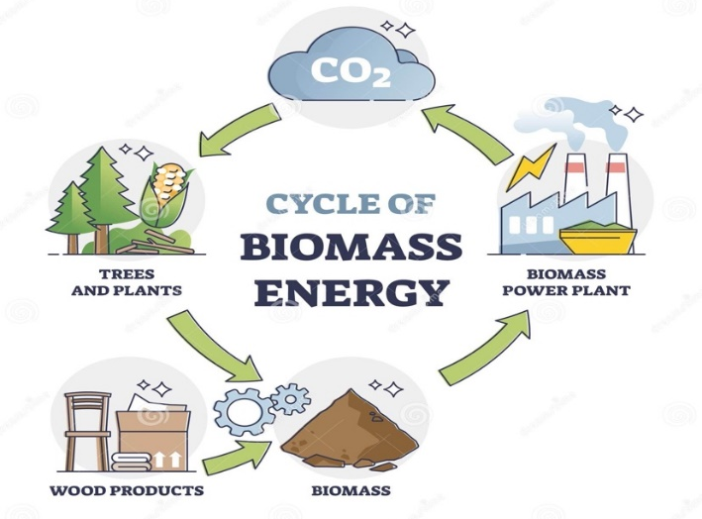

(Fig-1: Biomass Energy)
Ref: https://www.123rf.com/photo_172711954_cycle-of-biomass-energy-as-direct-combustion-in-power-plant-outline-diagram.html
2.Hydropower Energy:
Hydropower stands as a quintessential source of renewable energy, translating the latent potential and kinetic energy within water into both mechanical energy, harnessed through devices like water mills and textile machinery, and electrical energy, through the generation of electricity from water. This energy source harnesses the kinetic force of water in motion, often sourced from rainfall and river flow.
Across India, primary hydroelectric power installations are strategically situated in states such as Bihar, Punjab, Uttaranchal, Karnataka, Uttar Pradesh, Sikkim, Jammu and Kashmir, Gujarat, and Andhra Pradesh. The hydropower landscape encompasses various scales, including small hydropower plants (SHP) with station capacities of up to 25 megawatts (MW). India's hydroelectric potential is estimated to be around 15,000 MW, with approximately 11% of this potential already harnessed. The Ministry of New and Renewable Energy (MNRE) actively supports the development of SHP projects nationwide, having facilitated the installation of 523 projects, aggregating to 1705 MW of installed power. Additionally, 205 SHP projects with a combined capacity of 479 MW are currently under implementation.
Presently, hydropower stands as the preeminent contributor to renewable energy in the electricity sector. Its functionality hinges on the predictability of regional rainfall patterns, and its performance can be influenced by climate-induced droughts and shifts in ecosystems that alter these patterns. The establishment of hydropower infrastructure can also induce negative impacts on local ecosystems. Given these considerations, the concept of small-scale hydropower gains traction as a greener alternative, proving particularly suitable for communities situated in remote and ecologically sensitive areas.
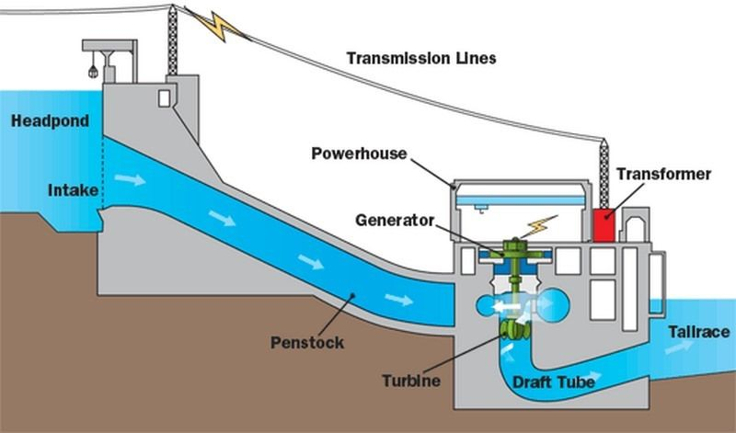

(Fig-2: Hydropower Energy)
Ref: https://studiousguy.com/hydroelectric-power-plant-working-principle/
3.Wind Energy:
The genesis of wind energy is a symphony of intricate interplays encompassing Earth's rotational dynamics, the sun's thermal influence, oceanic and polar cooling, disparities in temperature between land and sea, and the interactions of geographical features like mountains and obstacles. Wind, a ubiquitous force, is governed by these multifaceted mechanisms. Nevertheless, the bounty of wind energy is not uniform across the globe, as its availability waxes and wanes across diverse regions.
Harnessing wind resources proves most effective in areas where wind energy density reaches a threshold of at least 400 W/m² at a height of 30 meters above the terrain. The pursuit of this potential is advanced through the Resource Assessment Program, overseen by the Center for Wind Energy Technology in collaboration with state-level nodal agencies. Across a network of 211 wind monitoring stations spanning 13 states and union territories—namely Andaman and Nicobar Islands, Andhra Pradesh, Gujarat, Karnataka, Kerala, Lakshadweep, Madhya Pradesh, Maharashtra, Orissa, Rajasthan, Tamil Nadu, Uttaranchal, and West Bengal—an annual average wind power density exceeding 200 W/m² at a height of 50 meters has been recorded. These measurements stand as a testament to the nation's diverse wind energy potential. Cumulatively, India's wind energy capacity holds promise, with estimates projecting its potential to soar to 45,000 MW. This potential stands as a testament to both the intricate ballet of natural forces and the country's commitment to embracing renewable energy sources.
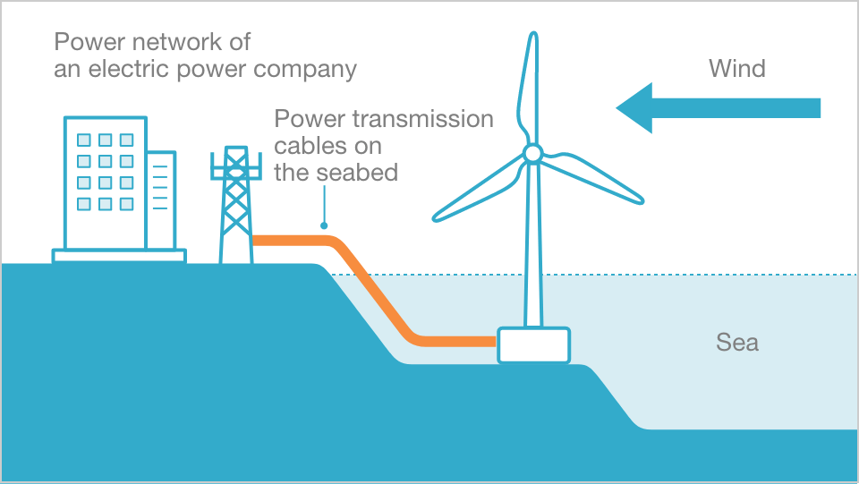

(Fig-3: Wind Energy)
Ref: https://www.jre.co.jp/english/business/offshore-wind-power/
4.Solar Energy:
Solar energy, a bountiful and perpetual gift from the sun, presents itself in both direct (sunlight) and indirect (wind, biomass, hydro, ocean, etc.) manifestations, forming a mosaic of potential energy sources. This dynamic energy, experienced as warmth and illumination, unfurls its utility through two distinct avenues. The thermal pathway utilizes solar heat for purposes ranging from water heating, cooking, drying, and water purification to power generation and beyond. In parallel, the photovoltaic route transmutes light into electricity, endowing a versatile resource for lighting, pumping, communication, and electrification in off-grid regions.
Across most of India, the embrace of sunshine bestows a radiant daily solar radiation of 4–7 kWh per square meter, accompanied by approximately 250-300 sun-drenched days annually. Notably, the expanse of western Rajasthan garners the highest annual solar radiation, while the northeastern regions witness a relatively modest solar influx.
In a significant stride towards sustainable practices, the National Action Plan on Climate Change (NAPCC) was unveiled on June 30, 2008, by the Prime Minister. This framework integrates both solar thermal and solar photovoltaic technologies, forming a cornerstone of the Ministry's expansive solar energy program. This initiative, often regarded as one of the world's largest, seeks to tap into India's considerable solar energy potential, projected to be within the range of 20 to 35 MW/km² of solar thermal energy.
The canvas of India's solar energy potential extends to encompass water heating systems, estimated to span an expansive 140 million m² collector area. The state lends financial support to solar air heating and drying systems, as well as solar concentrator technologies. Acknowledging the crucial role of solar efficiency in the broader context of energy, the Ministry supports solar buildings, propelling a drive towards enhanced energy efficiency. Notably, Himachal Pradesh's state government actively promotes the integration of passive solar design principles into building architecture. Over the past two decades, the Solar Photovoltaic Program (SPV), championed by the Ministry, has significantly transformed rural and remote regions, fostering electrification and empowerment. This ambitious program's success narrative is underscored by a nationwide endeavor in demonstrating and embracing SPV technology during the Ninth Plan period.
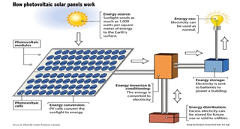
(Fig-4: Solar Energy)
Ref: https://www.linkedin.com/pulse/mechanisms-solar-panels-saeid-azizi/
5.Geothermal Energy:
Geothermal energy, arising from heat stored within the Earth, involves the extraction of absorbed heat from underground sources. Enormous amounts of thermal energy are generated and preserved within the Earth's core, mantle, and crust. Presently, geothermal energy contributes approximately 10,000 MW globally, with potential for growth even in India. Research by the Geological Survey of India has identified roughly 340 hot springs within the nation, distributed across seven distinct geothermal provinces. Notably, these provinces exhibit particular prominence along the west coast in regions like Gujarat and Rajasthan, as well as along a west-southwest-east-northeast axis that spans from the western coast to the western border of Bangladesh, forming a notable presence in the extensive stretch of the Himalayas spanning 1500 km.
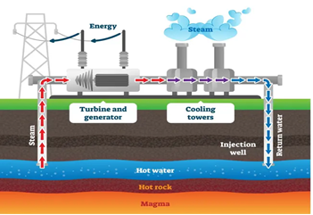
(Fig-5: Geothermal Energy)
Ref: https://xeero.io/geothermal-energy/
6.Solar Thermal Technology:
Solar thermal technologies, especially solar water heating system, solar cookers and solar production systems are the most commercialized technologies among renewable energy technologies in India. Policies are set to provide further impetus spread of solar technology.
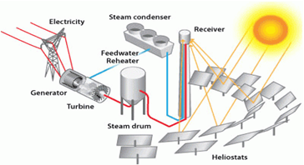
(Fig-6: Solar Thermal Energy)
Ref: https://www.energy.gov/eere/solar/power-tower-system-concentrating-solar-thermal-power-basics
7.Biogass Energy:
Biogas serves as an alternative energy source primarily derived from organic waste. In India, the utilization of biogas, primarily extracted from animal waste, particularly cow dung, has been supported for over three decades. Biogas, generated through the anaerobic digestion of diverse organic materials including animal, agricultural, domestic, and industrial waste, represents a clean fuel option. This technology has propelled cooking practices in rural areas towards advanced levels, transforming the culinary experience and offering social and environmental benefits such as eliminating indoor pollution. Since December 2004, as a component of the National Biogas Program, the installation of over 3.7 million biogas stations with capacities ranging from 1 to 6 cubic meters has been accomplished. This program's ultimate objective is to establish biogas stations in approximately 12 million households that possess sufficient livestock to ensure a consistent supply of organic matter for the production of biogas.
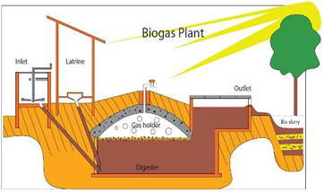
(Fig-7: Biogas Energy) Ref; https://www.build-a-biogas-plant.com/biogas-digester-plans/
8.Hydrogen Energy:
Hydrogen power is currently in its nascent stages of development. Emerging and renewable energy sources are contributing to the funding of research projects encompassing various aspects of hydrogen energy technology advancement. India's forthcoming challenges in this realm encompass significant reductions in hydrogen production costs, enhancements in production efficiency through diverse methods, the creation of compact and cost-effective storage solutions, the establishment of a comprehensive hydrogen distribution network, the evolution of hydrogen combustion engines, and the optimization of efficiency in various types of fuel cell systems.
A strategic roadmap has been laid out to guide research, development, and demonstration endeavors across different sectors of hydrogen energy technologies. This roadmap envisions ambitious targets, including the establishment of one million hydrogen-powered vehicles and the installation of 1000 megawatts of aggregated hydrogen-based power generation capacity within the nation.
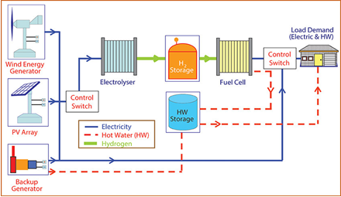
(Fig-8: Hydrogen Energy)
Ref: https://www.researchgate.net/figure/Overall-concept-of-a-hydrogen-renewable-energy-system-for-distributed-power-generation_fig4_266951079

Environmental Sustainability
Sustaining economic growth and elevating living standards hinge upon addressing energy shortages. While a straightforward solution lies in augmenting supply, it's crucial to recognize two equally vital dimensions: environmental sustainability and social development. The prevailing model of economic expansion has engendered severe environmental repercussions—air pollution, substantial waste generation, ecological degradation, and the hastening of climate change—many of which emanate from the energy sector.

Simultaneously, the impact on social progress cannot be disregarded. Insufficient access to energy services compounds a range of societal challenges, including poverty, compromised health, joblessness, and inequality. In modern economic landscapes, oil remains a pivotal energy source. The United States of America continues as the world's largest consumer of oil, yet several Asian countries follow closely. China ranks second, Japan third, India fourth, and the Republic of Korea sixth. Furthermore, the significance of natural gas is growing due to its enhanced fuel efficiency.
Among other pressing environmental concerns are water pollution and the mounting disposal of waste, particularly hazardous nuclear waste. In rural regions, excessive reliance on ecologically delicate areas is a worry. Many rural inhabitants depend on biomass fuels for cooking, heating, and lighting. Overuse of these resources can lead to the degradation of watersheds and the depletion of biodiversity and habitats. Notably, approximately 70% of total greenhouse gas (GHG) emissions stem primarily from energy derived from burning fossil fuels for heat, electricity generation, and transportation.
Nations possess various avenues to curtail greenhouse gas emissions, some of which incur minimal, zero, or even net-negative costs. These strategies encompass energy conservation, heightened efficiency, improved energy management, cleaner production and consumption practices, and lifestyle adjustments. Embracing renewable and more efficient technologies further aids in mitigating the impact of climate change. In the grand scheme, countries can underpin decision-making through scientifically informed incentives that facilitate a cleaner, more energy-efficient economy, while concurrently expanding access to contemporary energy services for all.
1.Climetic changes:
Climate change, as a result of global warming caused greenhouse gases, especially carbon dioxide (CO2) produced during the burning of fossil fuels has caused significant changes ecosystems and leads to nearly 150,000 additional deaths every year. This increase is mainly due to unsustainable use fossil fuels and land use change.
2.Clean Development Mechanism:
Clean Development Mechanism (CDM) of the Kyoto Protocol was established to help developing countries achieve sustainable development by promoting greenhouse gas emissions reduction projects that generate emission credits (certified emission reduction, CER) for industrialized countries. Many countries in the region use the CDM. This is a provision of the Kyoto Protocol that was proposed originally as a bilateral mechanism through which entities industrialized countries could obtain certified emission reductions (CER) by investing in clean technologies in developing countries. For recipient developing countries, this can increase returns projects by up to 12% for wind, water and geothermal projects and by 15-17% for biomass and municipal waste projects (UNEP).
Current Energy Policies
1. National Electricity Policy, 2005:
The National Electricity Policy is oriented towards accomplishing several objectives, including universal access to electricity, fulfilling energy demand, addressing peak shortages, maintaining a rolling reserve capacity, ensuring a consistent and high-quality energy supply adhering to established standards, promoting efficiency and affordability, raising per capita electricity availability to over 1000 units by 2012, enhancing the financial viability of the electricity sector, and safeguarding consumer interests.
2. The Electricity Act, 2003:
Under Section 3, subsection 1, and Section 3, subsection 2, it is stipulated that the Central Government shall periodically formulate and release the National Electricity and Tariff Policy in collaboration with state governments and power development authorities. This policy framework is designed to optimize the utilization of resources such as coal, natural gas, nuclear materials, water, and renewable energy sources. Section 4 dictates that the Central Government, in consultation with State Governments, shall formulate and announce the national policy.
3. Tariff Policy, 2006:
As per the stipulations of Section 86, subsection 1, clause e) of the act, the relevant Commission is tasked with determining the minimum percentage of energy procurement from various sources, taking into account the availability of resources in the region and its potential impact on retail tariffs. The gradual competitiveness of non-conventional technologies with conventional sources in terms of cost-effectiveness may require some time. Consequently, distribution companies' procurement will occur at preferential rates established by the relevant commission.
4. National Rural Electrification Policy, 2006:
The National Rural Electrification Policy centers on achieving several goals, including ensuring universal electricity access to all households by 2009, delivering consistent and reliable power supply at reasonable rates, and guaranteeing a minimum consumption of 1 unit per household per day by 2012. For villages or dwellings where grid connection is unfeasible or uneconomical, off-grid solutions based on standalone systems may be employed to provide electricity. State Governments are mandated to devise and communicate a rural electrification plan within a span of 6 months, outlining detailed mechanisms for electrification delivery.
Committees
1. District Advisory Committees (DACs):
These committees have facilitated the establishment of an effective local-level network for renewable energy support, promoting the integration of renewable energy initiatives with other developmental departments. Presently, there are 550 DACs operational across the country's districts, contributing to the collaborative effort.
2. Rajiv Gandhi Akshay Urja Diwas (Rajiv Gandhi Renewable Energy Day):
On August 20, 2006, the birth anniversary of the former Prime Minister, the late Sh. Rajiv Gandhi, marked the observance of 'Rajiv Gandhi Akshay Urja Diwas' nationwide. This event serves as a platform for raising awareness on a large scale, spanning national, state, and district levels, to promote renewable energy.
3. Renewable Energy Clubs:
A program has been devised to bolster the exploration of renewable energy resources through the establishment of Renewable Energy (RE) clubs within AICTE recognized/approved engineering colleges and institutes of technology throughout the country. These clubs are intended to educate and sensitize young and aspiring scientists about various aspects of new and renewable energy technologies.
4. Akshay Urja Shops:
Akshay Urja shops have been inaugurated across districts throughout the country, ensuring convenient accessibility to renewable energy systems and equipment. These establishments are envisioned to encourage the general public to actively adopt renewable energy technologies, addressing their energy requirements for cooking, lighting, and power generation.
The Future of Renewable Energy in India
The integrated energy policy report has underscored the imperative of fully capitalizing on domestic supply potentials and diversifying energy sources. The committee has placed a strong emphasis on augmenting the utilization of renewable resources across all sectors. It is envisioned that the contribution of renewable sources to energy production could reach a substantial 60,000 MW by 2031-2032. As the timeline progresses to 2031-2032, renewable energy sources are projected to play a pivotal role in driving social inclusivity and fostering development among marginalized communities. An initial estimation places investments in the renewable energy sector at approximately Rs. 300,000 million over the next 25 years. The Ministry of New and Renewable Energy (MNRE) has firmly integrated within its mission the goals of enhancing energy security and elevating the share of clean energy for improved energy availability.

India is confronted with the dual challenges of energy security and environmental sustainability, compelling a concerted effort to elevate the role of renewable energy sources in forthcoming energy systems. The landscape of renewable energy technologies is characterized by a broad spectrum of technological sophistication and commercial viability. In India, the trajectory of renewable energy is advancing, and stakeholders such as businesses, industries, government bodies, and consumers are actively grappling with a myriad of challenges that must be overcome before these technologies can achieve widespread impact. Given India's abundant renewable energy resources, including solar photovoltaics, wind, solar heating, small hydro, and biomass, the nation is poised to embark on an expansive journey of developing and deploying renewable energy projects. The goal to achieve 10% of the country's power generation from renewable sources by 2012 is within sight, accompanied by ambitious plans to establish biogas stations, introduce solar PV applications, and even establish solar cities. Additionally, the introduction of tradable renewable energy certificates (RECs) is set to further catalyze the growth of renewable energy adoption.
Conclusion
Energy security, economic growth, and environmental protection are the driving forces behind the energy policies of nations worldwide. The imperative to intensify efforts in advancing the promotion of renewable energy sources is universally recognized, fueled by the escalating prices of oil. A pivotal aspect of the solution lies in bolstering renewable energy technologies to address concerns encompassing energy security, economic growth amid surging energy costs, competitiveness, healthcare expenditures, and environmental deterioration. The National Action Plan on Climate Change (NAPCC) and other reliable sources assert a steadfast commitment to the advancement of renewable energy.
This commitment is manifested through specific action points, which encompass providing support for the deployment, innovation, and fundamental research of renewable energy technologies. Overcoming hurdles in the development and commercialization of biomass, hydropower, solar, and wind technologies is an integral part of this agenda. Equally essential is backing the progress of both direct biomass combustion and biomass gasification technologies, alongside facilitating the growth of small wind electric generators. Strengthening the regulatory and tariff framework is a strategic measure aimed at mainstreaming renewable energy within the national power system.

Consequently, there is a heightened emphasis on accelerating the deployment of renewable energy, which is projected to constitute approximately 5% of the electricity composition by the year 2032. The gradual integration of alternative fuels, particularly biofuels, into the energy landscape is designed to synergize with conventional fuels like diesel and gasoline, predominantly for transportation applications. In conclusion, renewable energy bestows substantial advantages and possesses the potential to significantly contribute to the nation's energy mix, thereby mitigating economic, environmental, and social costs. The anticipated trajectory points toward an augmentation of the share of renewable energy within the overall production capacity in the forthcoming years.
References:
- https://www.twi-global.com/technical-knowledge/faqs/renewable
- https://www.un.org/en/climatechange/what-is-renewable-energy#:~:text=Renewable%20energy%20is%20energy%20derived,plentiful%20and%20all%20around%20us.
- https://energsustainsoc.biomedcentral.com/articles/10.1186/s13705-019-0232-1#Sec5
- file:///Users/sourindrasuman/Downloads/RenewableenergyinIndia.pdf
- http://eagri.org/eagri50/ENVS302/pdf/lec02.pdf
- https://www.researchgate.net/publication/317561674_An_Introduction_to_the_Renewable_Energy_Resources
- http://eagri.org/eagri50/AENG352/lec02.pdf
- https://www.eia.gov/energyexplained/renewable-sources/
- https://www.nationalgrid.com/stories/energy-explained/what-is-green-energy
ss

