Integrating Blockchain Technology and Artificial Intelligence in 5G Networks

¹N.Umasankari, ²D.Geethanjali, ³K.Ishwarya, ⁴Sai Varun
^{1,2,3} Assistant Professor, ⁴ Student
Department of Computer Science and Engineering, Sathyabama Institute of Science and Technology, Chennai, India
san_june18@yahoo.com,anjali.geetha81@gmail.com, ishuk80@gmail.com,saivarunchandrashekar@gmail.com

Introduction

The development of 5G technology has opened up previously unheard-of possibilities for instantaneous, high-capacity connection and data exchange in our quickly changing technological environment. The potential for innovation appears limitless as Internet of Things (IoT) devices multiply and data traffic volumes soar. However, the convergence of these developments has also highlighted the urgent need for innovative answers to difficult problems, especially in the areas of data security and network effectiveness. Enter the strategic marriage of Blockchain and Artificial Intelligence (AI), a dynamic synergy that not only promises to tackle these complex problems but also to map out totally new dimensions for the 5G network environment. This fusion is more than just a meeting of technologies; it's a creative strategy that might completely alter how we think about and design the digital world of the future. This ground-breaking fusion envisions a cooperative ecosystem that is painstakingly constructed to negotiate the challenges of 5G networks at its heart. It makes use of blockchain technology's inherent qualities of decentralisation, security, and trust. This base opens the way for a revolution in network architecture, supported by artificial intelligence's flexible decision-making powers and predictive analytics. In the ecosystem that is envisioned, security would not be a secondary concern but would instead be ingrained in the very fabric of the network. Traditional centralised systems frequently have flaws, but blockchain decentralised ledger ensures that transactions are safe and impervious to manipulation. In addition, AI's capacity for prediction enables proactive defence against prospective threats by making wise choices in real-time to protect the integrity of the network. Imagine a world where 5G networks serve as both data conduits and bulwarks of trust, enabling seamless device communication thanks to the inherent transparency of blockchain technology. Imagine a network that utilises AI's analytical ability to adapt and change in response to real-time data discoveries. This coming together might usher in a transformational era where possibilities abound, data flows easily, and our digital infrastructure is resilient to new threats. The combination of Blockchain and AI is poised to open the door to a future in which the potential of 5G is fully realised as we stand at the cusp of innovation. A paradigm shift, it shapes the future of digital connectivity, security, and intelligence through the fusion of imagination and technology. Although the path ahead may be challenging, the final destination offers a beautiful symphony.

Keywords—Blockchain, Artificial Intelligence, 5G Networks, Connectivity, Network Optimization, IOT Devices

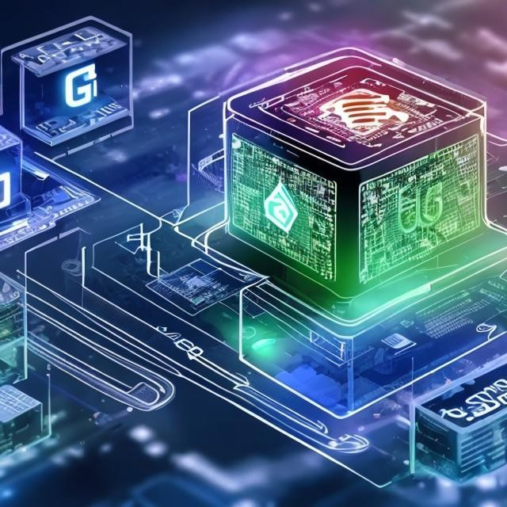

Figure 1: Integration of Blockchain and Artificial Intelligence in 5G Networks

Literature Review

Block5GIntell for AI-enabled 5G networks
The paper "Block5GIntell: Blockchain for AI-enabled 5G networks" by El Azzaoui et al. proposes a blockchain-based framework for AI-enabled 5G networks. A distributed AI controller, a blockchain-based incentive system, and a blockchain network make up the framework's three primary parts. The study "Block5GIntell: Blockchain for AI-enabled 5G networks," written by El Azzaoui and coworkers, proposes a visionary idea—a blockchain-driven framework made especially for the world of AI-enabled 5G networks. This idea is at the cutting edge of research. This study seeks to tackle the many issues that the development of technology has brought forth. Examining this framework's intricate details reveals a carefully planned architecture divided into three crucial parts. The architecture firstly introduces a distributed AI controller—an intelligence orchestrator capable of traversing the complex environment of AI-powered 5G networks. The wide 5G infrastructure and the dynamic interaction amongst AI algorithms are orchestrated and optimised by this controller, which serves as the brain. The framework also introduces a groundbreaking blockchain-based incentive system, a breakthrough that acts as a beacon for encouraging participation and cooperation within the network ecosystem. This mechanism of intrinsic motivation matches individuals' interests, encouraging teamwork that promotes innovation and resilience. A self-sustaining model that increases network effectiveness through the power of shared interest, it represents a paradigm leap in the field of network dynamics. Naturally, the actual underlying network is necessary for a blockchain-based architecture to function. The report emphasises the need to create a blockchain network specifically for this purpose, one that is integrated into the fundamental structure of the AI-enabled 5G infrastructure. The transactions and interactions that pulse through the network are encapsulated by this blockchain fabric, which adds an additional degree of security, transparency, and accountability. This framework has numerous applications that are truly transformational. It becomes a powerful barrier, protecting data repositories and AI models from the onslaught of hostile attacks that the digital environment frequently provides. Beyond security, the framework has the power to completely transform how resources are distributed inside 5G networks by maximising resource consumption and skillfully directing computational power. However, difficulties do arise as with any pioneering step. The lack of defined methods and the need for significant computational resources are two of the main issues the research skillfully
handles. The Block5GIntell framework implementation is not without its difficulties, but it is in these difficulties that there is room for growth and creativity. In essence, the work contained in this paper serves as a model for the future rather than just research. It serves as a monument to the unwavering effort to improve the capabilities of 5G networks through the merger of blockchain and AI—a synergy that defies expectations and ushers in a time of previously unimaginable possibilities. Frameworks like Block5GIntell serve as sentinels of progress as the digital landscape changes more, pointing us in the direction of the future.

Converging Pathways: Exploring the Synergy of Blockchain, Artificial Intelligence and 5G Networks

The coming together of blockchain, artificial intelligence (AI), and 5G networks represents a pivotal moment in the history of technical advancement. Connectivity, data management, and convergence are three strong factors that have the ability to transform industries. In addition to AI's knowledge and insights, 5G networks provide unprecedented speed and connectivity. Blockchain ensures safe, transparent transactions. Through the convergence of these channels, new opportunities for ground-breaking solutions are created, including improved cybersecurity, real-time data analysis, decentralised applications, and seamless, high-speed communication. By combining the strengths of blockchain, AI, and 5G networks, industries can tap into a wealth of new opportunities and completely transform the technological environment.

1. Role of Blockchain Technology in 5G Networks

- In-Depth Overview of Blockchain Technology and Its Relevance in 5G Networks

Decentralisation: Blockchain runs on a decentralised network, in contrast to conventional centralised systems, in which a single entity controls control. This implies that neither the network nor the data are completely under the control of a single entity. Because of decentralisation, security is improved and single points of failure are avoided.

Distributed Ledger: The ledger, which keeps track of all transactions, is shared among all network users (nodes). A duplicate of the full ledger is kept by each participant, assuring reliability and redundancy. As a result of its distributed structure, transactions no longer require validation by a centralised body.

Immutability: It is very difficult to change or remove data once it has been stored on a blockchain. A chain of blocks that are inextricably linked together is created because each block carries a cryptographic hash of the one before it. It would be computationally impossible to change the data in one block without also changing the data in all succeeding blocks.

Consensus Mechanism: Blockchain networks employ consensus procedures to verify and concur on the ledger's current state. Common approaches include Proof of Work (PoW) and Proof of Stake (PoS). While PoS relies on users "staking" bitcoin to confirm transactions, PoW forces participants (miners) to solve challenging mathematical problems in order to validate transactions.

Security: Cryptography is used to secure transactions. A block's data is hashed to make sure that any changes are immediately visible. Furthermore, the network's decentralisation and consensus procedures make blockchain incredibly resistant to attacks.

Transparency: All participants have access to the same ledger, which promotes accountability and openness. This is especially helpful in sectors like supply chain management and finance where transparency and trust are paramount.
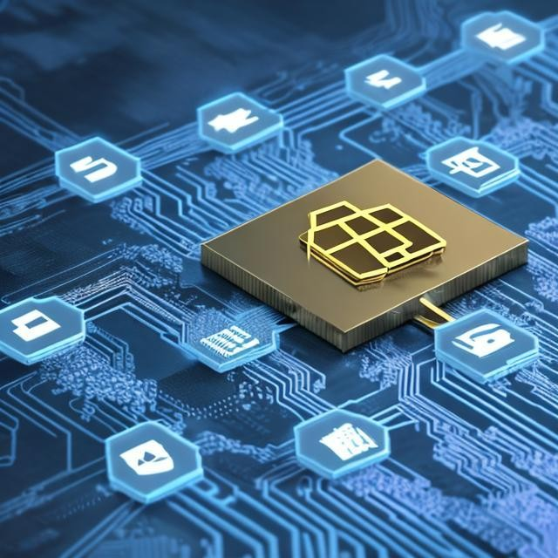

Figure 1: Overview of Blockchain Technology

- Role of Artificial Intelligence in 5G Networks

  - Introduction
Communication and data sharing have undergone a fundamental leap with the advent of 5G technology. Wide-ranging sectors have been inspired by its promise of ultra-low latency, high-speed networking, and large device connectivity. Real-time interactions are made possible by this ground-breaking development, opening up possibilities for uses that were previously restricted to science fiction. However, the promise of 5G networks must be unlocked with equal parts innovation and prudence due to the quick spread of Internet of Things (IoT) devices, the exponential expansion of data traffic, and the ominous spectre of security threats. Two technical giants, namely Blockchain and Artificial Intelligence (AI), stand out in this environment as strong contenders to meet the obstacles and maximise the potential presented by the developing 5G ecosystem. The combination of these two revolutionary technologies creates a special synergy that has the potential to transform the architecture, features, and security environment of 5G networks and advance them beyond their present limits. This study explores how blockchain technology and artificial intelligence may work together to help 5G networks reach their full potential.


Figure 4: Introduction to Artificial Intelligence
- Introduction to 5G Networks

Fifth-generation networks, often known as 5G networks, are at the cutting edge of contemporary communication technology. These networks stand at the apex of wireless communication development, ushering in a new era of connection that expands on the groundwork established by its forerunners, such as 4G or LTE. However, their significance goes much beyond merely advancement; they represent a revolutionary step forward that has the power to fundamentally alter the way we engage with the digital world. In a nutshell, 5G networks are the result of a never-ending quest for technological progress in wireless communication. While the upgrades from 3G to 4G were noticeable in terms of speed and capacity, the switch to 5G goes beyond small gains. It ushers in a convergence of capabilities that resonate with the needs of our hyper-connected society and introduces a fundamental shift in how data is transmitted, received, and processed. The primary focus of 4G networks was on providing quick and dependable connectivity for smartphone use, whereas 5G networks take this paradigm to a new level. The architecture, processes, and technologies that make up this transformation's core combine to generate a network fabric with unmatched strength. Higher frequency bands, referred to as millimetre waves, are combined with cutting-edge antenna technology in 5G networks to enable incredibly fast data throughput and ultra-low latency. This translates into almost immediate transmission, making delays almost invisible. This has significant implications for real-time applications like remote surgery and augmented reality. The distinction between the physical and digital worlds is blurred by 5G networks' ultra-low latency speed enhancement and IoT potential enablement. They paved the way for future developments by bridging the divide between the physical and digital worlds like never before. The development of 5G networks is a sign of human brilliance as we approach this disruptive period and invites us to investigate, unearth, and navigate a new connectedness dimension.
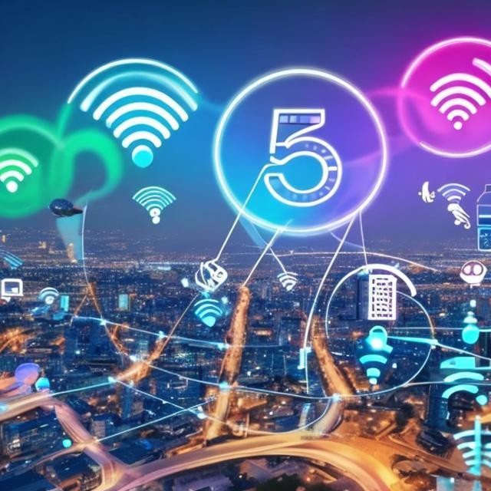

Figure 3: Introduction to 5G Networks

Why These Technologies: Exploring the Intersection of blockchain Technology, Artificial Intelligence and 5G Networks

Transformational Potential: Artificial Intelligence (AI), blockchain, and 5G are three cutting-edge technologies that when combined have a transformational potential that goes beyond their individual effects. With the convergence of AI's cognitive strength, blockchain's secure decentralisation, and 5G's blazing-fast connectivity, corporate interactions, communication dynamics, and development methodologies are being redefined. Together, they give organisations the ability to make better decisions thanks to AI-driven data
insights, secure trust and transparency with blockchain-enabled transactions, and foster real-time collaboration and creativity with 5G's fast connectivity. This combination creates a new paradigm where industries may effectively collaborate, communicate without interruption, and launch previously unimaginable projects, ultimately transforming the face of business and technology.

Data Integrity and Security: Due to its built-in security features and immutable nature, blockchain stands as the perfect answer to address the urgent concerns surrounding data integrity, authenticity, and transparency. Blockchain integration provides a robust barrier against tampering and unauthorised changes in a digital environment plagued by data breaches and fraudulent activity. Due to its decentralised architecture and cryptographic protections, it is nearly impossible for unscrupulous actors to alter or delete data records without being noticed. As a result, stakeholders have faith in the organisations' rigorous structure for ensuring the reliability and accuracy of their data sources. A new era of data-driven insights is also ushered in by the combination of blockchain and AI. The value of blockchain's safe infrastructure is amplified by artificial intelligence's unparalleled capacity to analyse complex data patterns, draw insightful correlations, and forecast trends. Organisations can gain greater insights from the verified data recorded on the blockchain by utilising AI's cognitive capabilities. This synergy gives firms the ability to foresee market changes, find possibilities that would have been hidden within complicated information, and make informed decisions.
The fusion of blockchain with AI has wide-ranging effects on numerous industries. For instance, the combination ensures openness across the supply chain management process, from the sourcing of raw materials through the delivery of the finished product. Stakeholders may confirm the authenticity of goods by tracing each step on an unchangeable blockchain, lowering the risk of counterfeiting and boosting consumer confidence. Similar to this, in the healthcare industry, private patient information kept on a blockchain may be accessed securely by designated individuals, and AI algorithms can analyse this information to create individualised treatment regimens.

In conclusion, a strong framework that tackles the crucial concerns of data integrity, authenticity, and transparency is produced by the synergy between blockchain's impenetrable security mechanisms and AI's data analysis skills.

Enhanced Automation and Efficiency: A substantial improvement in automation and efficiency has been made possible by the combination of blockchain technology and artificial intelligence (AI). This confluence presents the idea of autonomous smart contracts, which are contracts that can self-execute when certain predetermined circumstances are met. This ground-breaking integration has enormous potential for use in a variety of industries, including banking, healthcare, and supply chain management. The use of autonomous smart contracts simplifies complex processes in sectors like supply chain management. When certain conditions are satisfied, these contracts automatically take action, negating the need for manual intervention. Processes are accelerated, errors are reduced, and supply chain transparency is improved as a result. These smart contracts help to save money and get rid of bottlenecks by removing the need for middlemen, which eventually increases productivity. The combination of blockchain and AI in the banking industry enables the development of self-executing contracts that react to data and events in real time. This may result in automated compliance checks, smoother cross-border transactions, and more effective loan disbursements. The removal of middlemen from financial operations increases security by lowering the likelihood of failure while simultaneously speeding up transaction processing. Additionally, the healthcare industry has a lot to gain from this convergence. Through the use of cryptographic techniques, autonomous smart contracts can enable immediate and secure patient data transfer between healthcare providers. This development simplifies the recording of clinical trial data, processing of insurance claims, and maintenance of medical records. Healthcare personnel can concentrate more on patient care and research by automating these processes, which will enhance patient outcomes.
In conclusion, the merging of AI and blockchain technology into self-executing smart contracts represents a paradigm change in a number of different businesses. This invention increases operational efficiency, lowers expenses, and boosts production by streamlining complex processes and eliminating intermediaries.
Real-Time Decision-making: A revolutionary era of real-time decision-making has begun thanks to the combination of artificial intelligence (AI) and 5G networks' high-speed capabilities. This potent mix makes it possible for instant communication and quick data analysis, altering the way important decisions are made, especially in time-sensitive situations. One of this synergy's most significant benefits is its potential to produce quick, data-driven decisions with the ability to save lives and valuable resources, particularly in emergency situations like disaster response and autonomous vehicle navigation. Emergency responders now have unmatched capabilities because of the convergence of AI and 5G networks in disaster response. Rapid evaluation of disaster-affected areas is made possible by real-time data streaming and AI's highly developed analytical capabilities. This gives decision-makers thorough understanding of the damage's scope, resource needs, and high-priority locations. As a result, relief measures can be planned and carried out more successfully, reducing reaction times and maximising resource distribution to quickly assist affected communities. Additionally, the fusion of AI and 5G networks has the potential to transform the navigation of autonomous vehicles. AI-driven systems can make split-second judgments that improve the safety and effectiveness of self-driving cars by processing enormous volumes of data in real time. These cars have the ability to instantly assess real-time traffic information, pedestrian movement, and road conditions, changing their routes and speeds as necessary. By ensuring smoother traffic flow and avoiding accidents, this lowers traffic congestion and fuel consumption.
In essence, decision-making is changing as a result of the convergence of AI and 5G networks, especially in instances where speed is of the essence. By enabling systems and experts to evaluate complicated data streams in real time, this technology alliance enables better-informed and more efficient decisions. This synergy has the potential to bring in a new era of efficiency, safety, and resource optimization, whether it's speeding up disaster response or improving the navigation of autonomous vehicles.

Advanced Analytics: A quantum jump in information processing and comprehension is possible with the combination of AI-driven advanced analytics and the vast data capabilities of 5G networks. This combination enables the effective analysis of massive datasets produced by 5G networks, making it possible to quickly derive insightful information. The use of blockchain technology in conjunction with this integration, which ensures transparent management of data ownership and sharing, is a crucial component. By implementing blockchain, a safe and unchangeable record, the data transmission procedure becomes extremely reliable, promoting an environment favourable to group research, in-depth analysis, and creative discoveries. In advanced analytics, the combination of AI and 5G networks enables quick dissection of complicated information and real-time actionable insights. This has ramifications for many other fields, including real-time health monitoring in healthcare and predictive maintenance in industry. Additionally, the inclusion of blockchain strengthens this by fostering confidence in data exchange. Data integrity and unwanted access worries are eliminated because data ownership and transfer are effortlessly recorded and confirmed on the blockchain. This is especially useful in fields like research and creation where data authenticity and integrity are crucial.
In conclusion, the convergence of blockchain technology, 5G networks, and AI-powered advanced analytics transforms how we process, distribute, and use data. The rapid processing of large datasets by AI, accelerated by the speed of 5G networks, is strengthened by the secure and transparent data sharing provided by blockchain. Through the use of reliable and meaningful data, this combination has the ability to promote creativity and discovery and expedite developments across many sectors.

New Business Models: Beyond only improving current processes, the confluence of these technologies spurs the development of fresh business models. This convergence creates opportunities for novel and revolutionary commercial strategies. Notably, the fusion of blockchain and AI results in the development of unique ideas like decentralised AI marketplaces. Through these platforms, people and organisations may safely sell their AI models thanks to blockchain's open and unchangeable transactional infrastructure. By encouraging a collaborative environment where AI knowledge is shared, this not only encourages a wider adoption of AI solutions but also fosters the creation of cutting-edge products and the growth of revenue streams. A paradigm that moves computation and data storage closer to the data source, edge computing is made possible by the union of AI with 5G. This integration makes processing possible closer to where data is created, improving
response times and lowering latency. It is supported by the real-time capabilities of 5G. Such developments may inspire the development of novel partnerships and services. For instance, businesses can use this technology to give customers data-driven, real-time information so they can make decisions right now. Through improved value offers, this in turn creates new revenue sources and strengthens client relationships.
In essence, a new era of business model innovation is ushered in by the fusion of AI and blockchain with the capabilities of 5G. Edge computing ecosystems and decentralised AI markets are just two examples of the countless possibilities that these technologies open up. Businesses can access new revenue streams and foster dynamic collaborations that help to define the future of industries by reinventing how value is created, traded, and delivered.

Trust and Privacy: In order to address growing concerns in the era of data-driven insights, the combination of blockchain and AI adds an essential layer to the conversation on trust and privacy. With this integration, sophisticated privacy-enhancing methods are introduced, including federated learning and zero-knowledge proofs, which are crucial for protecting user privacy while facilitating the extraction of insightful data. These technologies provide a flexible response to the problem as data privacy acquires an ever-more-important role.The security and openness of blockchains power federated learning, which enables AI models to be trained cooperatively across several devices without transferring raw data. This method ensures the anonymity of the entities that contribute to the data while enabling models to learn from decentralised data sources. Similar to this, zero-knowledge proofs allow the validation of information without disclosing the data itself thanks to blockchain's immutable ledger. By ensuring that data can be analysed without revealing private information, this cryptographic technique strikes a key balance between privacy and data-driven benefit.
These privacy-enhancing methods play a critical role in fostering user confidence in technology amid growing worries about data privacy. Blockchain and AI integration enables enterprises to provide data-driven insights while upholding people's right to privacy, allaying concerns, and promoting a more secure digital environment. By utilising these technologies, businesses may successfully negotiate the complex landscape of privacy laws and changing user expectations, paving the way for the peaceful coexistence of data-driven progress and the protection of individual privacy.

Getting over Limitations: Every technological development comes with its own set of restrictions and difficulties. For instance, despite being secure, blockchain technology may be seen as sluggish due to the consensus procedures it uses. Similar to human intelligence, AI models frequently require large amounts of computer power, which makes them resource-intensive. In addition, there are infrastructure limitations that could prevent a smooth rollout of 5G networks. However, the deliberate blending of different technologies offers a chance to go beyond these particular weaknesses and strengthen the ecosystem as a whole. Organisations may reduce the shortcomings of each component through synergistic collaboration by combining blockchain, AI, and 5G. While AI's intelligence can be used to maximise the effectiveness and scalability of blockchain operations, blockchain's transparency and security can help to improve data integrity and trust in AI processes. Furthermore, latency issues related to blockchain and AI applications can be reduced by utilising the real-time capabilities of 5G networks.
This integration represents a proactive response to technology's flaws, turning constraints into chances for development. As these technologies combine their advantages, the ensuing synergy reduces weaknesses while simultaneously fostering a more resilient and flexible technological environment. Blockchain, AI, and 5G work together to form a potent tapestry that has the ability to transform sectors, solve flaws, and advance innovation to new heights.

Research and Innovation: The fusion of blockchain, AI, and 5G technology creates a favourable environment for fascinating research projects that cover a wide range of interesting topics. This confluence offers a range of fascinating study topics that could spark creativity and push the limits of technological development. The development of energy-efficient AI models designed specifically for integration within the dynamic landscape of 5G edge computing settings represents an intriguing area of investigation. Researchers may unlock the potential for effective real-time decision-making while reducing energy consumption by designing AI algorithms that are in line with the resource limits of edge computing. By doing this, they can contribute to the
sustainable evolution of technology. A fascinating area ripe for research is also introduced by the combination of AI and blockchain: the enhancement of consensus mechanisms within blockchain networks through the incorporation of AI. Increasing the scalability, security, and effectiveness of blockchain systems offers the promise of utilising AI techniques to improve and develop these mechanisms. The convergence of these technologies creates a challenging intellectual environment that promotes multidisciplinary cooperation and fosters the development of novel solutions.
Exploring these research questions opens up new vistas of possibility and knowledge, creating the foundation for game-changing discoveries. The interaction of blockchain, AI, and 5G acts as an intellectual stimulant, promoting a culture of ongoing research and invention. As scientists delve into the complexities at the intersection of these technologies, they not only discover new directions for research but also help to shape the development of our technological environment, laying the foundation for a future filled with unheard-of developments.

Impact on Society: The combination of blockchain, AI, and 5G technology has significant societal repercussions and is expected to have a profound impact on how we live our lives. This complex integration has a wide range of effects, from the development of intelligent, networked cities to the improvement of agricultural operations through the use of precision agriculture methods. Additionally, it has an impact on healthcare, where the secure and interoperable interchange of health data presents disruptive opportunities. The incorporation of these technologies paves the way for networked, smarter urban environments as cities develop. Cities can improve public safety, energy use, and transportation by leveraging the power of AI and 5G through real-time surveillance and data-driven decision-making. Similar to the possibilities for precision agriculture, 5G connection and AI analytics have the ability to revolutionise agricultural operations. Farmers are able to optimise agricultural cultivation through data-driven insights thanks to advanced sensors, drones, and AI-driven insights, promoting sustainability by minimising resource usage while optimising yields. The healthcare industry has the potential to change dramatically as well. Blockchain-enabled safe and transparent health data sharing assures privacy and data integrity, creating opportunities for improved illness management, individualised therapies, and improved diagnostics. AI's computational power combined with 5G's speed can speed up drug discovery, increase the accuracy of medical imaging, and enable remote patient monitoring, all of which can enhance healthcare results.
Investigating the complex effects of these technologies on society exposes a range of never-before-seen potential. The fusion of blockchain, AI, and 5G creates the foundation for cutting-edge solutions that go beyond established borders, advancing cities, agriculture, healthcare, and numerous other industries. Societies can put themselves at the forefront of technological development by embracing this integration, helping to create a future marked by improved efficiency, sustainability, and general quality of life.

Harnessing the Advantages of Integrating Blockchain, AI, and 5G for Next-Gen-Solutions

- Increased Trust and Data Security:

- Data security and integrity are guaranteed by the decentralised and tamper-resistant nature of blockchain.
- An additional layer of protection can be added by using AI to study behavioural patterns and spot anomalies.
- This integration creates a reliable data environment by combining it with 5G's quick and secure transmission.

- Enhanced Automation and Productivity:

- Processes are streamlined through AI-driven automation and smart contracts built on the blockchain.
- The real-time execution of AI commands is made possible by 5G's low latency, increasing operational effectiveness.
- The possibility of autonomous, effective processes increases, lowering the need for human interaction and potential errors.

- Continuity of Real-time Insights

- The massive amount of data produced by 5G networks is processed by AI, giving real-time insights.
- Integration with blockchain ensures data verifiability and provenance, enabling precise decision-making.
- Businesses quickly obtain useful insights that allow for swift reactions to shifting circumstances.

- New Business Models

- New business models, such marketplaces for AI models, are made possible by tokenization on the blockchain.
- By extending these markets' reach and user base, 5G networks improve their usability.
- Decentralised applications (DApps) can be used to deliver AI-driven services, opening up prospects for revenue generation.

- Improved user encounters

- Services can be customised based on user preferences thanks to AI-driven personalisation.
- Blockchain guarantees that user data is used in an ethical and transparent manner, increasing user trust.
- The seamless and immersive experiences made possible by 5G networks further improve user engagement.

- Rapidly advancing science and technology

- Research cooperation can be accelerated by combining blockchain's transparent data exchange and AI's predictive insights.
- Due to 5G's minimal latency, researchers can communicate in real time, fostering quick invention.
- The combined intelligence of AI, secure data sharing of blockchain, and fast connectivity of 5G can all be used to enhance collaborative ventures.

- Fostering decentralisation

- The decentralised architecture of blockchain is in line with the idea of democratised access and control.
- Decentralised applications' decision-making can be improved by AI, and 5G supports their scalability and responsiveness.
- These technologies enable people and smaller businesses across a range of industries.

- Solutions that are sector-specific

- The collaboration tackles issues unique to each business; for example, healthcare can benefit from safe data transfer while supply chains can improve traceability.
- Blockchain and AI-powered analytics can guarantee the legitimacy of digital assets.
- Industry sectors including manufacturing and logistics are boosted by 5G's support for real-time monitoring and control of IoT devices.

- Competitiveness and Sustainable Growth:
●
- Through effective operations and cutting-edge services, businesses who embrace this integration gain a competitive edge.
- Improved client experiences, lower costs, and optimised resource usage all support sustainable growth.
- This convergence puts industries in a position to advance in a technology environment that is rapidly changing.

Addressing Challenges and Disadvantages in the Convergence of Blockchain, AI, and for 5G Technologies

- Challenges of Complexity and Integration:

- Three sophisticated technologies must be integrated, which may be difficult and need extensive technical know-how.
- It can be difficult and time-consuming to ensure smooth compatibility across blockchain, AI, and 5G components.

- High Demand for Resources:

- Blockchain networks, 5G infrastructure, and AI models all require a significant amount of computing and energy resources.
- Scaled implementation of this integration might result in higher energy use and environmental issues.

- Data Security and Privacy Issues:

- Although blockchain improves data security, transaction information may still be exposed on open blockchain networks.
- If handled improperly, AI-driven data analysis may reveal private information, posing privacy concerns.

- Issues of bias and ethics

- Biases that AI models may inherit from training data may become immutable when paired with blockchain.
- Consideration must be given to the moral ramifications of these biases, especially in light of the information-dissemination speed of 5G.

- Edge computing and latency problems

- Even with 5G's reduced latency, some real-time analysis-requiring AI applications might still have latency issues.
- To reduce latency, edge computing solutions can be required, complicating the design.

- Complexities in regulatory and compliance:

- The autonomy of AI and the decentralised nature of blockchain can provide regulatory issues, particularly in sectors with stringent compliance standards.
- Verifying transactions on blockchain networks and ensuring compliance with data protection requirements can be challenging.

- Absence of Standards
- Lack of established protocols could cause compatibility problems and prevent broad adoption of blockchain, AI, and 5G technologies.
- Such standards may need to be developed and put into use, which could take time and industry cooperation.

- Training Needs and the Skills Gap:

- A trained workforce knowledgeable in blockchain, artificial intelligence, and 5G networks is required to integrate these cutting-edge technologies.
- To close the talent gap and successfully manage the integration, organisations may need to invest in training programs.

- Cost factors to consider

- Infrastructure, software development, and ongoing operating expenditures can all be significant expenses when integrating and managing these systems.

Exploring Diverse Applications of blockchain, AI, for 5G Technologies

- Supply chain traceability and transparency

- The supply chain may be tracked transparently and securely thanks to blockchain technology.
- Real-time monitoring and prediction insights are improved by AI-driven analytics.
- Due to 5G's reduced latency, stakeholders may share data quickly, enabling real-time updates on the status and placement of items.

- Healthcare Data Interoperability and Sharing:

- Sharing patient health records in a safe and unhackable manner is made possible by blockchain.
- While protecting patient privacy, AI-driven research can glean insights from compiled patient data.
- Real-time remote diagnostics made possible by 5G allow clinicians to treat patients right away.

- Infrastructure management in smart cities:

- Blockchain protects IoT data from numerous smart city devices.
- AI optimises traffic, energy use, and public services by processing data from IoT devices.
- Effective city administration is made possible by 5G, which guarantees quick connectivity between devices and central management systems.

- Traffic management and autonomous vehicles:

- Blockchain protects communication between infrastructure and autonomous vehicles.
- AI-driven decision-making improves traffic control and navigation for autonomous vehicles.
- Vehicle coordination is safe and effective thanks to 5G's continuous and low-latency communication guarantees.

- Decentralised Banking and Finance (DeFi):

- In DeFi applications, blockchain supports safe and open transactions.
- Risk assessment powered by AI improves lending and investing decisions.
- Real-time transaction processing and flawless mobile banking experiences are made possible by 5G.

- Farming with precision and agriculture:

- Agriculture items' provenance and quality are confirmed through blockchain.
- IoT sensor data is analysed by AI to maximise crop productivity, pest management, and irrigation.
- Data transfer and remote operation of agricultural equipment are made possible by 5G's connectivity of rural areas.

- Energy Grid Management and Optimization:

- In a decentralised energy market, blockchain ensures transparent and secure energy transactions.
- AI examines energy use trends to improve grid administration.
- Real-time monitoring and management of energy distribution are made possible by 5G.

- Retail and Personalized Marketing:

- Blockchain facilitates consent-based data sharing while protecting consumer information.
- AI-driven analysis creates individualised marketing plans.
- Customers may interact in real time and experience augmented reality thanks to 5G.

- Environmental Watch and Protection:

- The validity of environmental data gathered from sensors is confirmed via blockchain.
- AI analyses data to forecast alterations in the environment and the behaviour of wildlife.
- For quick conservation measures, 5G offers immediate communication and data transmission.

- Distance learning and education:

- Blockchain protects academic transcripts and diplomas.
- Platforms for personalised learning powered by AI adjust to the demands of students.
- High-quality video streaming for distance learning is made possible by 5G.

Conclusion

In conclusion, the introduction of AI and Blockchain technology into the 5G network environment ushers in a revolutionary era of improved security, improved resource management, and unheard-of automation. The decentralised and impenetrable architecture of blockchain provides 5G networks with a solid foundation of trust and data integrity, protecting private data and facilitating secure transactions. Simultaneously, real-time network optimization, predictive maintenance, and dynamic resource allocation are orchestrated by AI's data analytics and decision-making capabilities, assuring optimal performance and responsiveness across a range of use cases. The promise of 5G networks is enhanced by the synergistic combination of Blockchain and AI, enabling the development of intelligent, secure, and flexible ecosystems that will change businesses and revolutionise how we interact and communicate in the digital age.

References

- Dhar Dwivedi, Ashutosh, et al. "Blockchain and artificial intelligence for 5G‐enabled Internet of Things: Challenges, opportunities, and solutions." Transactions on Emerging Telecommunications Technologies (2021): e4329.
- Gupta, Rajesh, Aparna Kumari, and Sudeep Tanwar. "Fusion of blockchain and artificial intelligence for secure drone networking underlying 5G communications." Transactions on Emerging Telecommunications Technologies 32.1 (2021): e4176.
- Haris, Raseena M., and Somayya Al-Maadeed. "Integrating blockchain technology in 5g enabled iot: A review." 2020 IEEE international conference on informatics, IoT, and enabling technologies (ICIoT). IEEE, 2020.
- Haris, Raseena M., and Somayya Al-Maadeed. "Integrating blockchain technology in 5g enabled iot: A review." 2020 IEEE international conference on informatics, IoT, and enabling technologies (ICIoT). IEEE, 2020.
- Li, Weiwei, et al. "Blockchain-based data security for artificial intelligence applications in 6G networks." IEEE Network 34.6 (2020): 31-37.
- El Azzaoui, Abir, et al. "Block5GIntell: Blockchain for AI-enabled 5G networks." IEEE Access 8 (2020): 145918-145935.
- Moudoud, Hajar, Soumaya Cherkaoui, and Lyes Khoukhi. "An overview of blockchain and 5G networks." Computational Intelligence in Recent Communication Networks (2021): 1-20
- French, Aaron, et al. "The 4th Industrial Revolution powered by the integration of AI, blockchain, and 5G." Communications of the Association for Information Systems 49.1 (2021): 6.
- Lu, Yunlong, et al. "Blockchain and federated learning for 5G beyond." Ieee Network 35.1 (2020): 219-225.
- Gupta, Nitin, et al. "A Comprehensive Study on Artificial Intelligence and Blockchain Driven Beyond 5G Networks." 2022 International Conference on Computer, Information and Telecommunication Systems (CITS). IEEE, 2022.

