ALKAPTONURIA: BLACK URINE DISEASE

Jeggula Keerthana¹, Neelam Shivani¹, Bandi Srija¹, Kolanupaka Shivani¹ and Gundi Archana¹

¹Jyothishmati Institute of Pharmaceutical Sciences, Thimmapur, Karimnagar, Telangana-India, 505481.

INTRODUCTION:

Urine with alkaptonuria, a genetic disorder, becomes black when exposed to air. The condition is also characterized by ochronosis, an accumulation of dark pigment in connective tissues like cartilage and skin [1]. After age 30, this blue-black coloring typically becomes visible. In early adulthood, people with alkaptonuria frequently start to experience arthritis, especially in the spine and major joints. Heart issues, kidney stones, and stones in the prostate are possible additional symptoms of this illness [2].

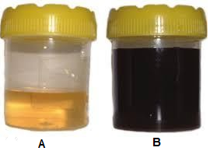

FIGURE 1. A. NORMAL URINE B. ALKAPTONURIA URINE

EPIDEMIOLOGY:

The worldwide prevalence of AKU is 1 case in 250,000–1 000 000 births. So far, 950 AKU sufferers have been identified in 40 countries. It is a condition that is reported to be more prevalent in Slovakia, the Dominican Republic, India, and Jordan. The highest prevalence is in Slovakia where up to 1 in 19 000 are affected. Analysis of the affected families revealed they typically live within isolated hamlets, leading to conclusions that the usually high incidence was predominantly due to the founder effect (loss of genetic variation) as a result of genetic isolation. Although difficult to perform with such a rare condition, there is also no genotype-phenotype correlation; all mutations lead to the development of ochronosis [3].

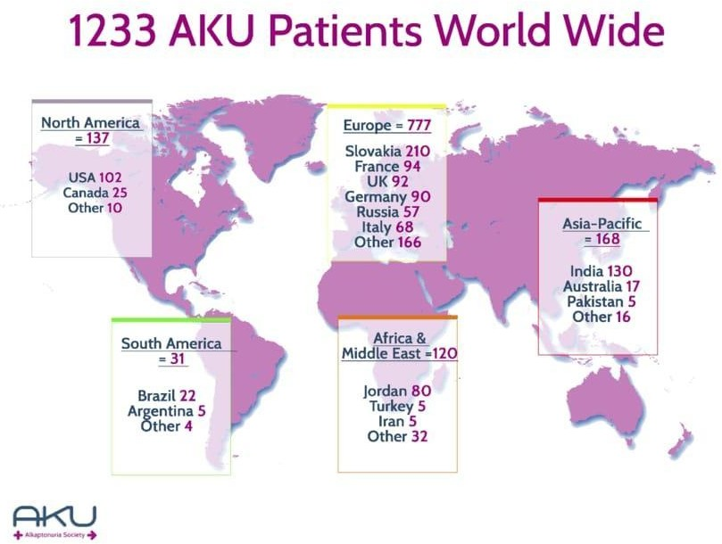

FIGURE 2. OVERVIEW OF THE NUMBER OF PATIENTS WITH ALKAPTONURIA REPORTED WORLD WIDE.

ETIOLOGY:

INFECTION:. Untreated infections can lead to eye damage. This includes phthisis bulbi.

CHRONIC RETINAL DETACHMENT: Retinal detachment is the process in which the retina separates from the choroid. This rare, but serious condition requires an emergency visit to a retinal specialist. A retinal detachment interferes with the blood flow through your eye, depleting necessary components such as oxygen. In turn, your eye tissues may get damaged or can die. Complications from surgery. Any type of surgery carries the risk of adverse effects. This includes eye surgery. Some people with phthisis bulbi may have tissue damage from eye surgery that develops into this condition.

LONG-TERM INFLAMMATION: Also called uveitis, long-term inflammation of the eye can damage related tissues. According to British researchers behind a study published in Acta Ophthalmological trusted source, uveitis is the most common cause of end-stage eye.

PERSISTENT HYPERPLASTIC HYPERPLASTIC PRIMARY VITREOUS: Also known as PHPV, this is a genetic condition that’s present at birth. Babies born with PHPV have a malformed eye. Fetal eye development occursTrusted Source between weeks 7 and 20 of gestation.

RETINOBLASTOMA: This condition refers to a mass that accumulates and calcifies on the eye. Eventually, the calcification can form a tumor-like entity. It’s most commonTrusted Source in children, and is curable. However, prompt treatment is required for full recovery.

TRAUMA OF THE EYE: Significant injuries to your eye may eventually lead to phthisis bulbi. Even if your eye has healed from traumatic events, such as a car accident, there may be lingering tissue damage that you may not be able to see. Eventually, the tissues can break down and lead to further complications [4].

INHERITENCE:

This condition is inherited in an autosomal recessive pattern, which means both copies of the gene in each cell have mutations. The parents of an individual with an autosomal recessive condition each carry one copy of the mutated gene, but they typically do not show signs and symptoms of the condition [5].

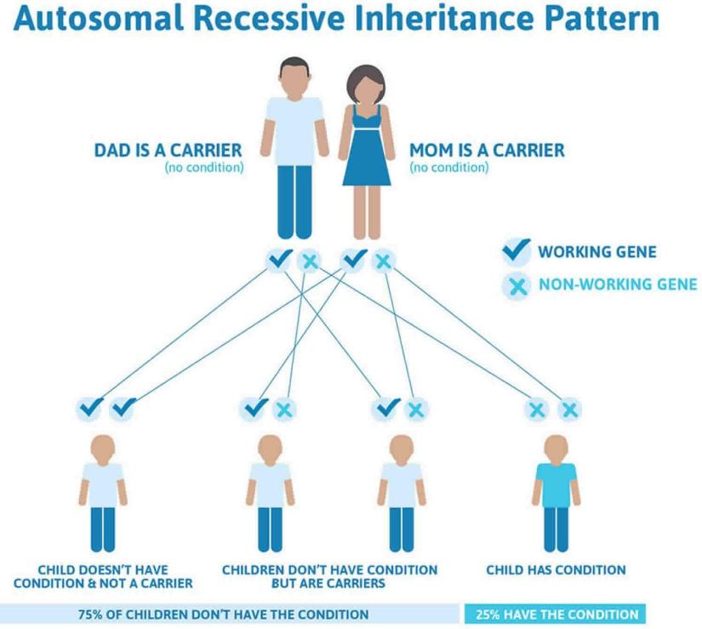
FIGURE 3. AUTOSOMAL RECESSIVE INHERITANCE PATTERN

SIGNS AND SYMPTOMS:

Homogenisic acid gradually accumulates in tissues throughout the body over time.It can accumulate in nearly any part of the body, including cartilage, tendons, bones, nails, ears, and the heart. It darkens the tissues and creates a variety of disorder.When an individual with alkaptonuria reaches their 30s, they may begin to have joint difficulties.Lower back pain and stiffness are common, followed by knee, hip, and shoulder pain. These symptoms are similar to the early stages of osteoarthritis. Cartilage, a strong, flexible tissue present throughout the body, can eventually become brittle and rupture, causing joint and spinal damage. It is possible that joint replacement operations will be required [6].

- JOINTS AND BONES :

A person with alkaptonuria may begin to have joint issues while they are in their 30s.They frequently first experience lower back pain and stiffness, then knee, hip, and shoulder pain.These resemble the initial symptoms of osteoarthritis. Over time, cartilage, a resilient, adaptable tissue present throughout the body, can break down and fracture, causing harm to the spine and joints. There may be a necessity for joint replacement surgeries.

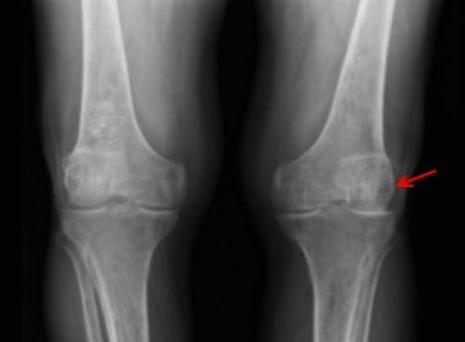
FIGURE 4. JOINTS AND BONES

EARS AND EYES:

Many people develop brown or black spots on the whites of their eyes.Another sign in many adults with alkaptonuria is thickening of ear cartilage. The cartilage may also look blue, grey or black. This is called ochronosis.The earwax may be black or reddish-brown.
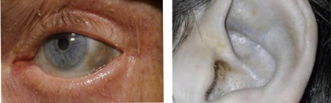

FIGURE 5. DARK SPOTS IN THE EYE AND EAR.

SKIN AND NAILS:

Alkaptonuria can result in discoloured sweat, which can stain clothes and cause some people to have blue or black speckled areas of skin. Nails may also turn a bluish or brownish colour. skin colour changes are most obvious on areas exposed to the sun and where sweat glands are found – the cheeks, forehead, armpits and genital area.
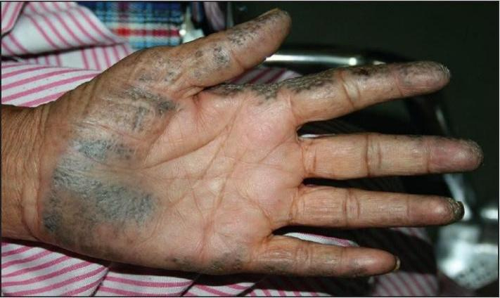
FIGURE 6. DISCOLOURATION OF SKIN

BREATHING DIFFICULTIES:

If the bones and muscles around the lungs become stiff, it can prevent the chest expanding and lead to shortness of breath or difficulty breathing.

- HEART, KIDNEY AND PROSTATE PROBLEMS:

Deposits of homogentisic acid around heart valves can cause them to narrow, harden and turn brittle and black. Blood vessels can also become stiff and weaken.This can lead to heart disease and may require heart valve replacements.The deposits can also lead to kidney stones, bladder stones and prostate stones[7].

PATHOPHYSIOLOGY:

FIGURE 7: STRUCTURE OF HOMOGENTISIC ACID

Chemical skeletal formula of homogenistic acid

Chemical skeletal formula of homogentisic acid, which accumulates in the body fluids of people with alkaptonuria.All people carry in their DNA two copies (one received from each parent) of the gene HGD, which contains the genetic information to produce the enzyme homogentisate 1,2-dioxygenase (HGD) which can normally be found in numerous tissues in the body (liver, kidney, small intestine, colon, and prostate). In people with alkaptonuria, both copies of the gene contain abnormalities that mean that the body cannot produce an adequately functioning enzyme. HGD mutations are generally found in certain parts (exons 6, 8, 10, and 13), but a total of over 100 abnormalities has been described throughout the gene. The normal HGD enzyme is a hexamer (it has six subunits) that are organized in two groups of three (two trimers) and contains an iron atom. Different mutations may affect the structure, function, or solubility of the enzyme. Very occasionally, the disease appears to be transmitted in an autosomal-dominant fashion, where a single abnormal copy of HGD from a single parent is associated with alkaptonuria; other mechanisms or defects in other genes possibly are responsible in those cases [8].

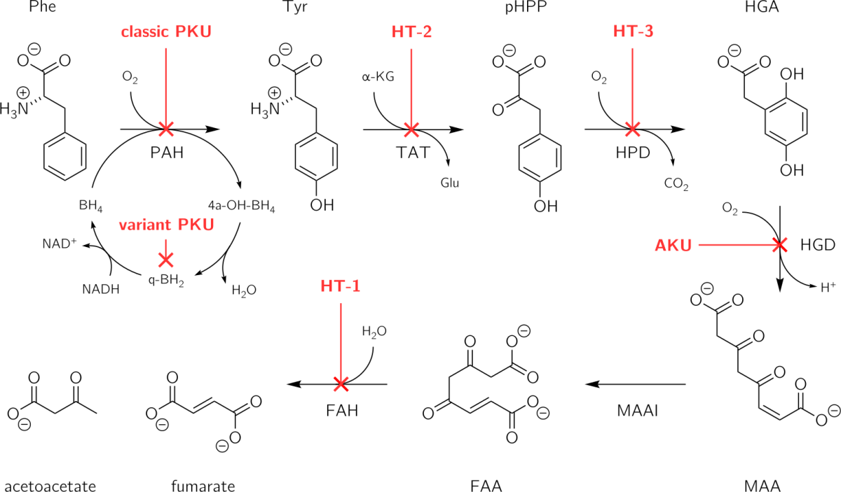
FIGURE 8. PATHOPHYSIOLOGY OF ALKAPTONURIA IS DUE TO THE ABSENCE OF FUNCTIONAL HOMOGENTISATE DIOXYGENASE IN THE LIVER.

The HGD enzyme is involved in the metabolism (chemical processing) of the aromatic amino acids phenylalanine and tyrosine. Normally, these enter the bloodstream through protein-containing food and the natural turnover of protein in the body. Tyrosine is specifically required for a number of functions, such as hormones (e.g. thyroxine, the thyroid hormone), melanin (the dark pigment in the skin and hair), and certain proteins, but the vast majority (over 95%) is unused and is metabolized through a group of enzymes that eventually generate acetoacetate and malate. In alkaptonuria, the HGD enzyme cannot metabolize the homogentisic acid (generated from tyrosine) into 4-maleylacetoacetate, and homogentisic acid levels in the blood are 100-fold higher than would normally be expected, despite the fact that a substantial amount is eliminated into the urine by the kidneys [8].The homogentisic acid is converted to the related substance benzoquinone acetic acid which forms polymers that resemble the skin pigment melanin. These are deposited in the collagen, a connective tissue protein, of particular tissues such as cartilage. This process is called ochronosis (as the tissue looks ochre); ochronotic tissue is stiffened and unusually brittle, impairing its normal function and causing damage [9].

MICROSCOPIC (HISTOLOGIC) DESCRIPTION:

Features of ochronosis are similar in both alkaptonuria and exogenous ochronosis. Early changes include homogenization of collagen and degenerating elastotic fibers [10], Yellow-brown, banana shaped, sickled or round ochronotic bodies deposit in the connective tissue.Occasional bodies may be seen in direct continuity with collagen or elastic fibers, exogenous ochronosis, extensive solar elastosis-like change is noted in an interfollicular distribution. Decreased basal keratinocyte pigmentation occasionally, ochronotic bodies are seen in association with colloid milium and are designated pigmented colloid milium Granulomatous reaction has also been reported Similar ochronotic bodies are seen in the connective tissues of cardiac, scleral and bony tissue when involved.
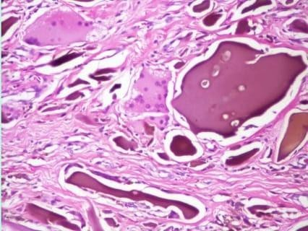
FIGURE 9. MICROSCOPIC IMAGE OF ALKAPTONURIA

HISTORY:

Garrod’s use of AKU in the Croonian lectures brought the condition into the spotlight in 1908. Yet many descriptions of the triad of features associated with AKU date back long before this. Documentation of the condition began in the 16th and 17th centuries.The earliest clinical case of AKU was found in the Egyptian mummy Harwa, which is believed to date back as far as 1500 BC. The name Alkaptonuria is derived from the Arabic word “alkali” (meaning alkali) and the Greek word meaning “to suck up oxygen greedily in alkali”. The name was created by Boedeker in 1859 after he discovered unusual reducing properties in the urine of a patient.Ochronosis was first described and named by Virchow in 1866, because under microscopy the HGA pigment appeared to be ochre (yellow/brown) in color.In 1891 HGA was identified as the causative component and named so due to its close structural relationship with gentisic acid, a derivative of benzoic acid.By 1995 the genetic defect was discovered, cloned, and mapped to chromosome 3q21-q23.

PHYSICAL FINDINGS:

Alkaptonuria has multiple clinical spectrums. Ochronosis, homogenistic aciduria, and ochronotic osteoarthropathy are called the triad of alkaptonuria. Ochronosis commonly presents in the third or fourth decade, which develops as the deposition of benzoquinone acetate in both extra- and intra-cellularly connective tissue. Finally, ochronotic arthropathy develops as an accumulation of Homogentisinic acid polymer within hyaline articular cartilages [11]. The clinical features are secondary to ochronosis:

GENERAL: Grey pigmentation in the ear cartilage or the sclerae, also skin discoloration.
BONE AND JOINT: Lumbar pain (ankylosis), arthritis leading to joint effusions, decreased joint mobility, impaired spinal, and thoracic mobility may lead to disability. There is also an increase in the prevalence of fractures secondary to osteopenia.
RESPIRATORY:: Decreased respiratory reserve and restrictive lung disease.
CARDIAC:: Valvular heart disease like aortic stenosis(more common), aortic regurgitation, mitral valve stenosis; cardiac arrhythmias; heart failure, and an increase in the incidence of coronary artery disease.
NEUROLOGICAL: Peripheral neuropathy, tinnitus, diplopia, and an increase in the incidence of stroke.
METABOLIC: Increase in the incidence of renal, gallbladder, and prostatic stones.

EVALUATION FOLLOWING INITIAL DIAGNOSIS:

To determine the level of disease and needs in an individual diagnosed with alkaptonuria, the following assessments are advised (if not completed as part of the evaluation that led to the diagnosis): Complete medical history and physical examination, with special emphasis on range of motion in the spine and major joints. If you have limited range of motion or joint pain, you should see a physical therapist. Electrocardiogram and echocardiography in people over the age of 40 Renal ultrasonography or helical abdomen CT to check for the existence of renal calculi TSH and free thyroxine levels are measured to rule out primary hypothyroidism.
Consultation with a medical geneticist, certified genetic counselor, or certified advanced genetic nurse to inform affected individuals and their families on the nature, significance, and implications of their condition..

TREATMENT OF MANIFESTATIONS:Symptomatic management of joint pain is tailored to the individual; physical and occupational therapy help promote optimal muscle strength and flexibility; knee, hip, and shoulder replacements are options when needed; surgical intervention for prostate stones and renal stones as needed; aortic stenosis may necessitate valve replacement; thyroid hormone replacement.
SURVEILLANCE: In individuals older than age 40 years, echocardiography to detect aortic dilatation, aortic or mitral valve calcification, and stenosis. In individuals with suggestive symptoms, consider CT imaging to detect coronary artery calcification.
Assess thyroid function at the time of initial diagnosis, and monitor every 1-2 years thereafter.
AGENTS/CIRCUMSTANCES TO AVOID: Physical stress to the spine and large joints (including heavy manual labor or high-impact sports) to try to reduce progression of severe arthritis.
EVALUATION OF RELATIVES AT RISK:It is appropriate to evaluate apparently asymptomatic older and younger sibs of an affected individual in order to identify as early as possible those who would benefit from preventive measures to help preserve overall joint mobility and function.

LABORATORY STUDIES:

Diagnosis is suspected upon clinical examination and is based on the amount of HGA found in the urine using gas chromatography-mass spectroscopy.Spectrophotomeztric quantitation shows 2 orders of magnitude elevations above normal As many patients present without dark urine, it may be advisable to look for HGA in all patients with radiographic evidence of osteoarthritis. A spinal x-ray will reveal disk degeneration combined with dense calcification, particularly in the lumbar area. Genetic testing confirms the diagnosis.

DIAGNOSIS:

Adults may have alkaptonuria if their urine becomes black when exposed to air. Diapers with black streaks from dried pee in infants may be an indication of alkaptonuria. Additionally, a thorough family history can show whether a person is more likely to develop alkaptonuria. However, a few conclusive tests can establish the diagnosis of alkaptonuria [5].

The following are highlighted:

DETECTION OF HOMOGENISTIC ACID IN URINE: Homogentisic Acid can be detected and quantified in 24-hour urine samples using gas chromatography-mass spectrometry.

MOLECULAR GENETIC TESTING :It is possible to identify HGD gene mutations in urine or blood using molecular methods like the polymerase chain reaction (PCR).

PROGNOSIS:

The disease is progressive in nature. There is usually a slow but progressive functional decline in the patient. Complications such as arthritis in the spine, hips, shoulders and knees can develop. There is a greater propensity for the Achilles tendon to rupture and for kidney and prostate stones to develop. The aortic and mitral valves as well as the coronary arteries may become stiff and hardened. The patients experience increased pain and loss of mobility as time progresses, often requiring the use of physical mobility aids such as crutches or wheelchairs.
Although cardiac complications may worsen the prognosis, life expectancy is not significantly reduced.

MANAGEMENT:

- Reduction of HGA formation: with a regimen of low tyrosine intake i.e low protein diet but it is difficult to maintain in the long term and has no demonstrable efficacy on the symptoms of AKU.
- Nitisinone, a triketone herbicide that inhibits p.HPPH, the second enzyme in the tyrosine catabolic pathway. In a murine model of AKU, oral nitisinone reduces urinary HGA excretion by about 80%, but with a side effect, an increase of plasma tyrosine level. In human, nitisinone has the same biological effect, but during a 3-year randomized therapeutic trial in 40 alkaptonuria patients, one individual has developed keratopathy classical for tyrosine toxicity38. With a 2 mg/day oral administration, nitisinone is well tolerated with a reduced urinary HGA excretion by >95% and plasma tyrosine levels averaged to 800 µM. Nitisinone treatment should be applied early in life to prevent ochronosis and associated joint arthropathies.Recently in a mouse model of AKU, nitisinone has been shown to completely prevent pigment deposition in the chondrocytes within the articular cartilage of knee.
- Reduction of pain by classical analgesic drugs, physiotherapy and/or rest, pain control is crucial in the day-life of AKU patients and is tackled by a wide range of analgesic drugs: paracetamol, non-steroidal anti-inflammatory drugs and opioids. Physiotherapy has also been shown to improve activity.
- Reduction of physical disabilities by knee, shoulder, and/or hip replacements. It is quite frequent in old AKU patients to have 3 to 5 surgical effective, with short-term efficacy procedures. Hyaluronic acid joint injections may be, as demonstrated in a patient with early ochronotic arthropathy.
- Enzyme or gene replacement by liver transplant or gene therapy, but enzyme or gene replacements are not yet available [8].

The main focus is providing symptomatic relief, preventive measures, and supportive care. Some of the treatment strategies are briefly highlighted below:

ASCORBIC ACID:

Large doses of ascorbic acid (vitamin C) has sometimes been recommended for the treatment of alkaptonuria since it prevents the accumulation of HGA in the tissues(1G/day)However, research studies have shown that long-term use of ascorbic acid is generally ineffective for the treatment of this condition.

NITISINONE:

A new drug named nitisinone is under investigation as a potential treatment for alkaptonuria. Nitisinone is classified as an orphan drug by the United States Food and Drug Administration (USFDA) and has been approved for the treatment of a metabolic disorder known as tyrosinemia [12]. Studies have shown that nitisinone therapy can reduce plasma and urinary HGA by more than 95%. The main drawback is the accumulation of tyrosine, the long-term risks of which are unknown [13].
Applies to the following strengths: 2 mg; 5 mg; 10 mg; 20 mg; 4 mg/ml

The most common adverse reactions associated with nitisinone use include
Adverse Metabolic Reactions
- Elevated levels of tyrosine
- Seizures
Adverse Blood Reactions
- Leukopenia
- Granulocytopenia
- Thrombocytopenia
Adverse Ocular Reactions
- Conjunctivitis
- Eye pain
- Corneal opacities
- Photophobia
- Keratitis
- Cataracts
Adverse Dermatological Reactions
- Epistaxis
- Exfoliative dermatitis
- Pruritis
- Dry skin
- Maculopapular rash
- Alopecia

Toxicity:
Toxicity due to nitisinone treatment is mainly a consequence in individuals who maintain a regular diet without restricting phenylalanine and tyrosine, precipitating symptoms of hypertyrosinemia. Tyrosine toxicity can mimic the effects of the different hereditary tyrosinemia subtypes, inducing potential neurological symptoms, hyperkeratotic plaques on the palms and soles, intellectual disability, and developmental delay

PAIN MEDICATION:

Painkillers and anti-inflammatory agents such as paracetamol, ibuprofen and naproxen can help to relieve pain and swelling. Procedures like transcutaneous electrical nerve stimulation (TENS) can help in appreciably reducing pain by numbing the nerve endings of the spinal cord [14].

SURGERY: Surgical intervention may be necessary if joint replacement or heart valve replacement is required.
Hip replacement.
Knee replacement.
Aortic valve replacement.

DIET:

Dietary restriction of protein may help in reducing the intake of phenylalanine and tyrosine, thereby slowing the progression of the disease by reducing the production of HGA. Here are some foods that are generally low in both protein and tyrosine[15].

Fruits: Most fruits are low in both protein and tyrosine. Examples include apples, pears, oranges, berries, and melons. Be cautious with avocados, bananas, and nuts, as they contain moderate amounts of tyrosine.
- Vegetables: Many vegetables are low in protein and tyrosine. Some examples include lettuce, cucumbers, peppers, carrots, and zucchini. However, spinach and broccoli have slightly higher tyrosine content, so they should be consumed in moderation.
- Grains: Most grains like rice, pasta, and bread are low in both protein and tyrosine. Check food labels for any protein or tyrosine content added during processing.
- Dairy Substitutes: If you need a milk substitute, choose low-protein, non-dairy alternatives like rice milk or almond milk. These are typically low in tyrosine as well.
- Low-Protein Breads and Pastas: Some specially formulated low-protein bread and pasta products are available for individuals on restricted diets. These can be found in health food stores or online.
- Cooking Oils: Oils such as olive oil, canola oil, and vegetable oil are low in protein and tyrosine and can be used for cooking.
- Sweets and Desserts: Some sweets like hard candies, jelly beans, and some non-chocolate-based candies can be low in both protein and tyrosine. However, always check labels, as some may contain gelatin or other protein sources.
- Beverages: Most beverages, including water, fruit juices (without added protein), and certain herbal teas, are low in protein and tyrosine. Be cautious with protein shakes, sports drinks, and some nutritional supplements.
- Condiments: Mustard, ketchup, and certain low-protein salad dressings can be included in a low-tyrosine diet. However, be mindful of high-protein condiments like soya beans

EXERCISE:

Exercises help improve some of the symptoms of alkaptonuria, such as joint stiffness and pain. Regular and routine exercises help build muscles and also help strengthen the joints. But you have to ensure that the exercises do not strain your joints. If you feel there is additional strain, then avoid such exercises that are putting stress on the joints. Besides this, exercises also help in lowering stress, weight loss, and posture improvement.

EMOTIONAL HELP: Being diagnosed with chronic conditions like alkaptonuria can be emotionally stressful, but anxiety and depression can worsen the symptoms. So taking a doctor’s help is very important for mental health.(15)

COMPLICATIONS:
- Renal and prostate stones.
- Gallbladder stone.
- Salivary gland stones.
- Ruptures of tendons, and ligaments.
- Osteopenia and fractures.
- Aortic valvular calcification, and stenosis.
- Amyloidosis(16).

Life style modifications:

Patient should be referred for genetic counseling.
The need for rigorous follow-up with a biochemical geneticist should be emphasized.

FUTURE PERSPECTIVES:

Although nitisinone is a safe and effective therapy for AKU, it can only treat and not cure the disease. Patients receiving nitisinone have to follow a restrictive, low-tyrosine diet and need monitoring to ensure that their circulating tyrosine levels do not become too elevated. The big step in single-gene diseases like AKU would be to treat the underlying genetic cause with gene replacement therapy, developing of agents that will specifically target cartilage. No molecules are available yet, and this is a significant factor in the lack of progress in developing diagnostic imaging methods and new therapies. This contrasts starkly with the situation in bone, where the identification of bisphosphonates led to bone scintigraphy and the most successful family of therapeutic agents for bone disease.

REFERENCES :

1. Mannoni A (2004) Alkaptonuria, ochronosis, and ochronotic arthropathy. Semin Arthritis Rheum 33:239–248. https://doi.org/10.1053/S0049-0172(03)00080-5
2. Lubics A (2000) Extensive Bluish Gray Skin Pigmentation and Severe Arthropathy. Arch Dermatol 136:547-b-552. https://doi.org/10.1001/archderm.136.4.547-b
3. Mistry JB, Bukhari M, Taylor AM (2013) Alkaptonuria. Rare Dis 1:e27475. https://doi.org/10.4161/rdis.27475
4. Tharini G, Ravindran V, Hema N, et al (2011) Alkaptonuria. Indian J Dermatol 56:186. https://doi.org/10.4103/0019-5154.80415
5. Zatkova A (2011) An update on molecular genetics of Alkaptonuria (AKU). J Inherit Metab Dis 34:1127–1136. https://doi.org/10.1007/s10545-011-9363-z
6. Fisher AA, Davis MW (2004) Alkaptonuric Ochronosis with Aortic Valve and Joint Replacements and Femoral Fracture: A Case Report and Literature Review. Clin Med Res 2:209–215. https://doi.org/10.3121/cmr.2.4.209
7. Gottschalk BH, Blankenstein J, Guo L (2018) Ochronosis of Mitral Valve and Coronary Arteries. Ann Thorac Surg 106:e19–e20. https://doi.org/10.1016/j.athoracsur.2018.01.074
8. Ranganath LR, Jarvis JC, Gallagher JA (2013) Recent advances in management of alkaptonuria (invited review; best practice article). J Clin Pathol 66:367–373. https://doi.org/10.1136/jclinpath-2012-200877
9. Peker E, Yonden Z, Sogut S (2008) From darkening urine to early diagnosis of alkaptonuria. Indian J Dermatol Venereol Leprol 74:700. https://doi.org/10.4103/0378-6323.45142
10. Chowdary S, Mahalingam M, Vashi NA (2014) Reading Between the Layers. Am J Dermatopathol 36:989–991. https://doi.org/10.1097/DAD.0000000000000142
11. Zaib S, Rana N, Hussain N, et al (2023) Identification of Potential Inhibitors for the Treatment of Alkaptonuria Using an Integrated In Silico Computational Strategy. Molecules 28:2623. https://doi.org/10.3390/molecules28062623
12. Abbas K, Basit J, Rehman ME ur (2022) Adequacy of nitisinone for the management of alkaptonuria. Ann Med Surg 80:. https://doi.org/10.1016/j.amsu.2022.104340
13. Wolffenbuttel BHR, Heiner-Fokkema MR, van Spronsen FJ (2021) Preventive use of nitisinone in alkaptonuria. Orphanet J Rare Dis 16:343. https://doi.org/10.1186/s13023-021-01977-0
14. Gallagher JA, Dillon JP, Ranganath LR (2021) Development of an effective therapy for alkaptonuria – Lessons for osteoarthritis. Rheumatol Immunol Res 2:79–85. https://doi.org/10.2478/rir-2021-0011
15. Judd S, Khedr M, Milan AM, et al (2020) The nutritional status of people with alkaptonuria: An exploratory analysis suggests a protein/energy dilemma. JIMD Rep 53:45–60. https://doi.org/10.1002/jmd2.12084

