Advancements and Applications of Nanotechnology in Material Science
M. Saravanan and I. Vetha Potheher
Department of Physics, University College of Engineering, Bharathidasan Institute of Technology Campus, Anna University, Tiruchirappalli-620 024, Tamil Nadu, India.
- Introduction
Nanotechnology is a way of looking at the world based on very close observation of atoms. It represents our deep curiosity about understanding the world and using that knowledge. The term "atomically precise technology" (APT) describes the idea of creating things atom by atom and controlling their structure and physical properties at an atomic level [1]. Some experts in nanotechnology imagine a future where we can build anything, even food, by arranging atoms from basic materials like acetylene, using only energy and instructions. However, a more realistic view acknowledges that there are different steps to this process. We might start by making things with a high level of accuracy, improving what already exists or creating new things. While some experts strive to develop nanoscale systems with absolute precision, a more practical perspective recognizes that while we theoretically can create nearly anything atom by atom, the actual enhancements in characteristics might be minor. At times, a combination of methods might yield better results. This is particularly true for large objects like houses or airplanes, and even relatively complex items like easily cultivable natural food. In this chapter, we will explore the essential definitions of nanotechnology before outlining its principles. Another approach is to define nanotechnology based on what is currently widely accepted and expand it to encompass future expectations. Alternatively, it can be defined based on its historical development. We also consider the question "Why nanotechnology?" along with broader justifications. The chapter concludes by presenting a list of newly coined terms associated with nanotechnology.
- Definition of Nanotechnology
In 1974, Norio Taniguchi from the University of Tokyo first used the word "nanotechnology." He meant making materials very precisely at the incredibly small size of nanometers [2-3]. And that's still what it means today. "Engineer materials" includes designing, making, and using materials. Now, it's even about making devices and systems, not just materials. So, nanotechnology is about designing and making things like materials, devices, and systems that are super tiny, at the nanometer size. The main ideas are the small size and being able to control things at that size. Some people say "nanotechnologies" because it's used in lots of ways, but they all deal with things at the nanoscale. The definition often includes a variety of sizes: Materials and processes used in nanotechnology have at least one dimension between 0.1 and 100 nanometers. Additionally, study, development, manipulation, control, or usage of materials at that level are all considered being part of nanotechnology. This alteration is carried out to take advantage of a novel trait of the material at that scale. Although some of the key features of nanotechnology are covered by this definition, the scope is not much narrowed. For now, a definition cannot adequately include the topic of nanotechnology. This is evident from the variations that exist even within a small collection of evaluations that adhere to the aforementioned standard. Both naturally occurring and artificial particles are covered under the term. Dendrimers, composites, DNA, and carbon and metal-based materials are all covered. Waste reduction, energy production, cleanup, detection, and filtering applications are just a few of the research fields and finished goods that fit under this criterion. The following definitions have additionally been developed in addition to the general one: Nanoscale refers to one or more dimensions that are 100 nm or smaller [4]. Nanoscience involves examining and manipulating materials at the atomic, molecular, and macromolecular levels, where properties differ significantly from those at larger scales.
Sometimes, people separate nanotechnology from nanoscience. Nanoscience is about watching and learning about things at the super-tiny nanometer size and how we can change things at that size. At this scale, stuff can act very differently from how it does in our regular world. But the difference between these two words isn't very big. A nanotechnologist also has to watch, learn, and change things as part of their work. Nanoscience might sound like it has a lot of clear ideas behind it that can be used to build technology. But the truth is, those clear ideas are still forming. And both nanotechnologists and nanoscientists are figuring things out together. In this essay, we will use the word "nanotechnology" in a broad sense that includes everything. Nanotechnology is a recently developed area of study, but it's not the sole domain focused on atoms and molecules. Physics, chemistry, and biology have also been studying and working with these tiny building blocks for a long time. And quantum mechanics is already a well-established science that focuses on the tiniest things.
History of Nanotechnology
Even though nanotechnology seems like a new field, human utilization of it isn't entirely novel. Natural asbestos nanofibers were incorporated into ceramic matrices around 4500 years ago, signifying an early use of nanoparticles in construction. The Egyptians, among the world's oldest, most prosperous, and advanced civilizations, already recognized the possibilities of nanotechnology 4000 years ago [5]. Before millennial technical advancements exploited it, the history of nanomaterials and nanotechnology was summarised in a road map in Fig.1.

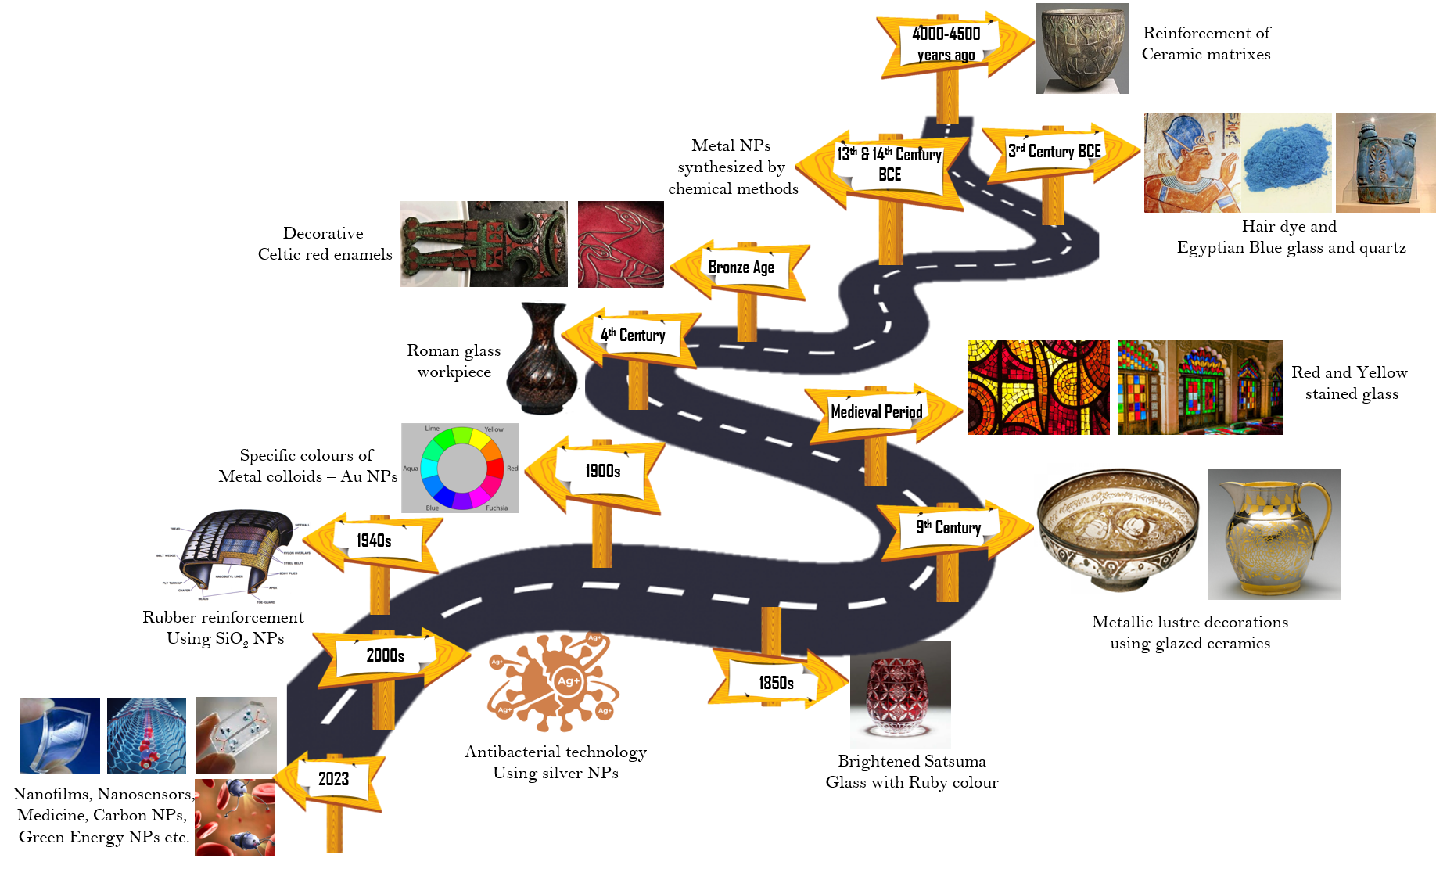
Fig.1. Road map of history of nanomaterials and nanotechnology
- Evolution of nanotechnology
Physics, chemistry, biology, and other fields have undergone significant changes due to the use of nanoscale materials, bringing forth new research possibilities [6]. The nanotechnology story has been marked by several pivotal moments. The invention of scanning tunneling microscopes and atomic force microscopes in the early 1980s provided the necessary tools for measuring and manipulating nanostructures. Scanning probe microscopes enabled the observation and manipulation of individual atoms and molecules on surfaces, opening up a new dimension of nanotechnology. To gain better control over manipulating atoms, additional techniques like beam-probe, mechanical-probe, and particle trapping methods were introduced. Increased computational power also allowed for advanced simulations of material behavior at the nanoscale. Technology leverages scientific advancements to create new practical applications. It's a major force driving human progress by providing innovative materials, tools, and machinery that enhance our quality of life. In 1974, Taniguchi coined the term "nanotechnology" to describe the manufacturing of items with tolerances under one millimeter. In contrast to the usual top-down approach, Feynman proposed creating using molecules, suggesting that nearly any chemically stable structure could be manufactured. Nanotechnology echoes Feynman's thoughts: Physics doesn't seem to prevent shrinking computers until bits are as small as atoms, and quantum behavior takes over. The groundbreaking work done by Drexler in molecular nanotechnology is significant [7-8]. He discussed tiny nanoscale robots that can construct objects molecule by molecule and even replicate themselves. These tiny structures can only be seen using specialized microscopes. Scanning electron and scanning probe microscopes are the two types of microscopes employed. They assist us in taking a close look at things. Additionally, these microscopes have the ability to move atoms and other tiny objects. Special techniques are employed to draw tiny structures or lines at the nanoscale. These techniques include removing material with energy beams. Photolithography, electron beam machining, X-ray lithography and laser beam machining are a few examples. Different sorts of energy beams are used by each technique [9-12].
3.1 Chemistry
Chemistry is closely linked to nanotechnology, but there is a significant difference. In chemistry, molecules are manipulated, albeit at the nanoscale. However, chemists lack the direct control that engineers have. Molecules tend to settle in stable states, and guiding them to desired outcomes relies on creativity and luck. In contrast, engineers exert precise control over outcomes. Chemistry role in nanotechnology has posed challenges, as chemical reactions don't always align with nanotechnologists goals. For instance, in a famous experiment, Eigler and Schweizer arranged xenon atoms into 'IBM' on a surface [13]. They tried to dictate the arrangement, but chemistry rules limited them. They couldn't place atoms exactly where they wanted due to specific surface lattice sites, even at extremely low temperatures. Chemistry might set fundamental boundaries on nanotechnologists freedom to manipulate matter at atomic and molecular levels.
3.2 Biology
Biology showcases nanotechnology potential through living examples. Large biological structures are formed using self-assembly, a principle highly valued in nanotechnology. These structures, mostly protein-based, possess remarkable lightness and strength, often resembling intricate miniature mechanisms. Notable among these are the F1ATPase enzyme, which generates the biological energy molecule ATP using a proton gradient, and the type III secretion system (TTSS), spherical assemblies of needles on certain harmful bacteria's surfaces, used to deliver toxins to their targets [1].
3.3 Physics - Quantum mechanics
Size is a relative concept, but in quantum mechanics, true smallness is defined by the act of observation altering something, as seen with photons. Most nanosystems aren't that tiny, but quantum effects matter for objects like quantum dots. These are small solid spheres, often semiconductors, where electrons aren't point-like but have a measurable extension called the Bohr radius. This can vary from a few to hundreds of nanometers. Making nanoparticles smaller than this radius subjects electrons to quantum confinement, causing shifts in their behavior. Even ultra-small electronic circuitry, like single-electron devices, deals with quantum effects. In a nutshell, physics, chemistry, and biology connect with nanoscience, exploring the molecular scale. Nanotechnology seeks to manage materials and devices at the nanoscale. Quantum mechanics also influences devices at the lower size range of nanoobjects. Both nanoscience and nanotechnology blend chemistry, biology, physics, and engineering. "Nanotechnology" emphasises this blend, while "nanotechnologies" showcases its varied applications.
- Why Nanotechnology
Nanotechnology offers several key advantages:
- Unique Material Properties: It enables the creation of materials with distinct combinations of properties.
- Efficiency: Nanoscale devices require less material and energy to manufacture, while their functions can be improved by reducing their size.
- Universal Fabrication: It presents a universal fabrication method, with the concept of personal nanofactories as its ultimate achievement.
Yet, the surge in global nanotechnology activity is motivated by more than just practicality. Two significant human motivations are also at play. One is the desire to explore the uncharted, similar to how a mountaineer climbs an unexplored peak. The other is the persistent urge to "conquer nature". However, these opportunities at the macroscopic scale have dwindled due to environmental concerns and extensive development. Feynman's description of the world at the nanoscale being largely uncharted is accurate. However, from a practical perspective, nanotechnology can already benefit existing products through replacement or gradual improvement. This is evident in areas such as the space industry urgent need to create lightweight spacecraft and bimolecular engineering. As long as reliable nanomaterials, devices, and systems can be developed, nanotechnology is well-suited for this purpose.

- Nanoparticles
Nanotechnology is the study and application of materials with sizes ranging from 1 nm to 100 nm. Every time a new technology is developed, there is legitimate concern about how it will affect social interactions, human health, and the environment. Due of the minimal number of materials needed, which makes them affordable for a vast population, nanotechnology may produce excellent items at cheaper costs. Small groups or nanoparticles aren't just pieces of larger stuff. In clusters, there may be completely distinct topologies as well as bonds and bond strengths that vary even from nanomaterials. It is now widely accepted that all materials, whether they are metals, semiconductors, insulator clusters, or nanomaterials, have physicochemical features that rely on their size. It's amazing that at such a small scale, even the form of the material and interactions between clusters or nanoparticles determine the materials properties. Through the use of its nanocatalysts, such as silver, gold, and other particles, nanotechnology may aid to lessen soil, water, and air pollution. The interaction of nanoparticles with body tissues or cells is enhanced by their small size, which also boosts their absorption. Nanotechnology will undoubtedly have a significant impact on industries including electronics, communications, health, architecture, and more. The creation and analysis of nanomaterials are still difficult, thus numerous researchers worldwide have made significant and ongoing efforts to investigate novel synthetic and analytical techniques for nanoarchitectures and nanostructures. Our daily lives are increasingly impacted by the intriguing realm of these nanomaterials and their numerous applications [14-16].
  - Metal Nanoparticles
Metals and their oxides are crucial in the realm of nanomaterials for various technological applications. Among nanoparticles, metals are predominant. Nanosilver, nanogold, metal oxides like titanium dioxide, and densely packed semiconductors like quantum dots form this array of nanomaterials. These encompass metals (like gold, silver, iron), metal oxides (such as zinc oxide, iron oxide, titanium dioxide, cerium oxide), and quantum dots (like cadmium sulphide and cadmium selenide). Below is a compilation of some widely recognized nanomaterials.
  - Naturally available metal nanoparticles
Natural nanomaterials originate from naturally occurring sources. Iron oxide nanoparticles are abundantly present in the environment and have applications as contrast agents for magnetic resonance imaging, drug delivery, gene therapy, and clinical diagnosis due to their remarkable magnetic properties and low toxicity. Nanoparticles are also found in biological systems and in natural substances like volcanic ash, ocean spray, fine sand, and dust. Complex nanostructures in biological systems encompass substances such as polysaccharides, viruses, bacterial exudates, and DNA, which play a role in regulating diverse biological processes. Nano-sized components are also created through processes like
5.3 Artificial metal nanoparticles
Artificial nanoparticles are intentionally created using a well-defined mechanical and production process. Among these, zinc oxide nanoparticles are notable. These nanoparticles are traditional band gap semiconductors, finding applications in electronic devices, chemical sensors, solar cells, antimicrobial agents, water filtration technologies, and sunscreens. They possess the ability to block harmful UV-A and UV-B rays while maintaining optical transparency. Similarly, titanium dioxide is also significant. It has gained significant attention due to its stability and affordability. It is extensively used in photocatalytic activities, photocells, paints, coatings, sunscreens, energy storage devices, and various other products. The most widely applied metal nanoparticles in medicinal field includes silver and gold.
  - Silver nanoparticles
Silver nanoparticles have garnered significant research interest due to their remarkable properties, which encompass conductivity, catalytic activity, chemical stability, nonlinear optical behavior, and antibacterial effectiveness. These unique attributes make them highly versatile for various applications, including inks, microelectronics, and as a potent antibacterial agent in medical tools like catheters, infusion systems, and medical fabrics.
  - Gold nanoparticles
Gold nanoparticles exhibit the ability to modify their electrical and optical characteristics while maintaining strong stability and inertness. In medical contexts, they are utilized for binding with biomolecules. For example, they can sensitively and selectively detect DNA in clinical samples and serve as contrast agents for cancer diagnosis and treatment. They also excel at detecting mutations, single nucleotide polymorphisms (SNPs), chromosomal translocations, gene expression, and infections. Nanomaterials are categorized into various dimensions: zero-dimensional (0-D), one-dimensional (1-D), two-dimensional (2-D), and three-dimensional (3-D), based on their structural characteristics.
- Zero Dimensional (0-D)
All three orientations of these nanoparticles exist at the nanoscale. The prime examples of such nanoparticles include semiconductors like quantum dots and metallic nanoparticles like gold and silver nanoparticles. The majority of these nanoparticles are spherical in shape.

- One Dimensional (1-D)
One of the nanostructure's dimensions in these nanostructures will be larger than a nanometer. These materials have a diameter of only a few nanometers, despite being lengthy (several micrometres in length). Examples of this type of material include metal, oxide, and other material nanowires and nanotubes.Two Dimensional (2-D)
In this type of nanomaterials, two dimensions are outside the nanometer range. These include different kind of nano films such as coatings and thin-film-multilayers, nano sheets or nano-walls.
- Three Dimensional (3-D)
None of their dimensions fall within the nanometer range. These are bulk materials composed of building blocks that are at the nanoscale in size.
  - Properties of nanomaterials
Reducing the dimensions of a material strongly impacts its physical properties, often causing significant deviations from those of the corresponding bulk substance. This can be attributed to factors such as: 1) A higher number of surface atoms, 2) Increased surface energy, and 3) Enhanced structural integrity due to tighter boundaries and fewer defects.
    - Optical property
Over the past few decades, researchers have been captivated by metallic nanoparticles, mainly because of the vivid colors displayed by their colloidal solutions. These colors result from the synchronized excitement of all the "free" electrons within the conduction band, creating an in-phase oscillation called surface plasmon resonance (SPR). Consequently, the size of metallic nanoparticles can influence their color, as it affects SPR.
5.6.2 Magnetic property
Nanostructured materials exhibit distinct magnetic properties compared to bulk materials. When ferromagnetic particles shrink below a certain size, their stability decreases. The heightened surface energy triggers spontaneous polarization changes, shifting them from ferromagnetic to a unique paramagnetic state called superparamagnetism. This transition occurs due to increased surface effects at the nanoscale. Magnetic nanoparticles have diverse applications like protein immobilization, bioseparation, immunoassays, drug delivery, and biosensors. Ferromagnetic nanoparticles are crucial due to their small size, supporting only single magnetic domains.
5.6.3 Mechanical property
As nanomaterials decrease in size, their mechanical properties improve. Current research particularly emphasizes the mechanical attributes of one-dimensional structures like nanowires. The heightened mechanical strength of these structures, such as nanowires and nanorods, stems from their exceptional internal integrity.
6.7. Application of nanomaterials
The properties of a material change in its nanoscale when compared to its bulk materials. These changes lead to making new devices, consumer goods, instruments, etc.
6.7.1 Energy
Nanotechnology is poised to be a significant player in the energy sector, owing to the high efficiency and cost-effectiveness of nanomaterials. Efforts are underway to enhance the efficiency of solar cells for energy generation through the utilization of nanoparticles. Hydrogen gas is said to be future fuel for automobile. But the task of storing the hydrogen is not easy one, because it can be easily fired. So, carbon nanotubes are developing to manufacture in low cost to store these hydrogen gas.
6.7.2 Sports and Toys
Nanotechnology has been integrated into both sports equipment and toys. Take tennis balls as an example: nanoclay is utilized to effectively seal pores, resulting in better air pressure retention and a longer lifespan for the balls. In the domain of toys, nanotechnology-powered motors are revolutionizing the movements of dolls and robots, providing seamless, lifelike motions that enhance the play experience for children.
6.7.3 Textiles
Nanomaterials have captured significant attention within the textile industry. Some garments offer the attractive look of synthetic fibers combined with the comfort of cotton. Special threads and colors developed through nanotechnology are now utilized in textiles. Clothing created using nanotechnology requires less frequent ironing and cleaning. Notably, silver nanoparticles are incorporated into washing machines by some companies to eliminate germs and sanitize clothes. By incorporating silver into the washing process or directly into the fabric, the necessary sterile environment for bandages, surgical procedures, and baby care products is ensured.
6.7.4 Cosmetics
Nanoparticles play a vital role in cosmetics too. Liposomes, solid lipid nanoparticles, and nanoemulsions are commonly used in creating various cosmetic products such as face creams, lipsticks, body sprays, hair care items, sunscreens, and more. These substances are combined with nanoparticles like gold, silver, copper, platinum, as well as metal oxide nanoparticles like zinc oxide, alumina, silica, and titanium oxide in the formulation process.
6.7.5 Medical Field
Nanotechnology is leading a significant transformation in the fields of biology and medicine. Nanoparticles, due to their small size and diverse range of materials, can be administered through injection, inhalation, or ingestion for various treatments. This versatility allows them to be used for both diagnostic and therapeutic purposes in laboratories. Nanoparticles can be shaped into spheres, wires, rods, tubes, or core-shell structures, allowing them to carry functional molecules inside or outside for tasks like drug delivery or molecular identification. Traditional remedies have even incorporated silver and gold compositions.
6.7.6 Domestic Appliances
Silver nanoparticles are finding their way into various household appliances like water purifiers, air purifiers, and freezers. Silver has been recognized for its antimicrobial properties for a long time, making it a popular choice for kitchenware. However, recent research has shown that silver nanoparticles are even more effective in this regard, requiring only a small amount to achieve significant antimicrobial effects.
6.7.7. Laser Photonics
Photonics is the technology of harvesting light and other forms of radiation energy. In photonics photons play the same role as that played by electrons in electronics. The subject of photonics is therefore also referred to as optoelectronics. Photons travel with a speed far larger than that of electrons, and light beams can cross each other without a affecting each other. Optical signals have large bandwidth and can accommodate a large number of channels per a given volume. Laser photonics is mainly concerned with laser for the possible usage in nanotechnology for material preparation and applications.
- Impact of Nanotechnology on 10 Industries

The chart map below, based on the innovation map, and illustrates how nanotechnology will impact 10 industries by 2023. Nanotechnology is fast-tracking advancements in healthcare, biotech, pharmaceuticals, and food sectors due to its ability to enhance particle bioavailability. Nanobots enable precise particle delivery in pharmaceutical and medical applications. Industries like manufacturing, energy, and semiconductors are utilizing nanotechnology to modify material properties for improved processes and products. Nanomaterials contribute to sustainability by reducing emissions, refining energy generation, and enhancing carbon capture. Moreover, personal care companies utilize nanotechnology to enhance formulation efficiency, while the chemical manufacturing sector employs it to enhance process effectiveness.
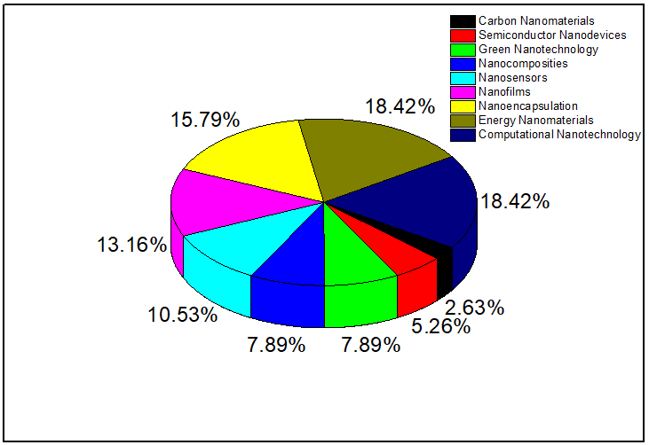
Fig.2. Chart reveals the impact of nanotechnology on 10 industries
- Future directions
While many consider nanotechnology a futuristic gateway to advancements in energy, electronics, biomechanics, and medicine, it's not as distant as it may seem. In the realm of materials science, there's significant potential for ongoing development in various areas like energy, space, environment, drug delivery, electronics, and targeted cell treatments. For instance, developments in nano and bio-physics, tissue engineering, and food science could lead to groundbreaking advancements in fields like plastic surgery, producing innovative tissue surfaces that are crucial for successful artificial implant integration. Moreover, there is hope that these specialized tools could evolve into versatile devices capable of performing multiple functions, offering technological advantages across different sectors. The domain of nanotechnology in medicine is wide open for exploration, holding the promise of uncovering even more remarkable discoveries.
- Summary
Nanotechnology encompasses various definitions, and a compilation of previously established ones points to a growing consensus. At its core, nanotechnology is centered on materials, tools, and processes that exhibit organization or activity at the nanoscale level. A concerted effort is being made to establish standardized terminology within a structured conceptual framework. Furthermore, the term "nanotechnology" is defined both ostensively – by examining what already falls under the "nano" category – and historically, tracing its evolution over time. It's interesting to note that biology serves as a living example of nanotechnology's principles, a concept with not only historical importance but also ongoing inspiration. Delving deeper, the link between nanotechnology and biology underscores the discipline's practicality and its potential to address complex challenges. The motivating factors behind the development and advancement of nanotechnology are also expounded upon, highlighting its potential for transformative impacts across various sectors and fields.
Acknowledgments
M. Saravanan is thankful to University Grants Commission (UGC), India for providing Dr. D.S. Kothari Post Doctoral Fellow (No.F.4-2/2006 (BSR)/PH/20-21/0074) to carry out this research work.
References
- N. Taniguchi, “On the basic concept of nano-technology”. Proc. Intl Conf. Prod. Engng Tokyo, Part II (Jap. Soc. Precision Engng).
- Jeremy Ramsden, Nanotechnology: An Introduction, Elsevier Science, (2011) ISBN 9781437778373
- Royal Society, Nanoscience and nanotechnologies: opportunities and uncertainties, The Royal Society, London, 2004.
- Scientific Committee on Emerging and Newly Identified Health Risks, Opinion on: The appropriateness of existing methodologies to assess the potential risks associated with engineered and adventitious products of nanotechnologies, European
Commission: Health and Consumer Protection Directorate-General, 2007.
- Y.-M. Li, Y.-Y. Wang, B.-N. Cheng, In-vitro cytotoxicity of biosynthesized gold nanoparticles against thyroid cancer cell lines, Trop. J. Pharm. Res. 16 (2017)
1523–1528.
- X. Liang, M.-A.-M.-J. Perez, K.C. Nwoko, P. Egbers, J. Feldmann, L. Csetenyi, G. M. Gadd, Fungal formation of selenium and tellurium nanoparticles, Appl. Microbiol. Biotechnol. 103 (2019) 7241–7259
- P. Tartaj, M. Morales, S. Verdaguer, T. Carreno and C. Sema, J. Phys., D 36R (2003) 182
- K.E. Drexler, Engines of creation: the coming era of nanotechnology, Doubleday; (1986) (ISBN: 0-385-19973-2).
- K.E. Drexler, Nanosystems: molecular machinery, manufacturing and computation., New York: Wiley; (1992) (ISBN: 0-471-57518-6).
- J. Corbett, P.A. McKeown, G.N. Peggs and R. Whatmore, Ann CIRP 49(2) (2000) 523.
- A.G. Mamalis, New trends in nanotechnology. In: Proceedings of the Symposium on the 50th Anniversary of Department of Manufacturing Enginering of Budapest University of Technology and Economics, Budapest, Hungary; (2001).
- A.G. Mamalis, L.O.G. Vogtl~inderand A. Markopoulos, Precision Engineering 28 (2004) 16
- D.M. Eigler and E.K. Schweizer, “Positioning single atoms with a scanning tunnelling microscope”. Nature (Lond.) 344 (1990) 524–526.
- Charles P. Poole, Jr. and Frank J. Owens, Introduction to Nanotechnology (John
Wiley & Sons, 2007).
- Sulabha K. Kulkarni, Nanotechnology: Principles & Practices (Wiley, Capital Publishing Company, Third Edition, 2011).
- K. K. Chattopadhyay and A. N. Banerjee, Introduction to Nanoscience and
Technology (PHI Learning Private Limited, 2009).

