Channel estimation of OFDM vehicular technology by using WI Comm-T
M.Suba, S.Swaminathan, K.Ramasamy, Department of ECE, SRC, SASTRA Deemed University, kumbakonam

Abstract
A wireless communication system's performance is highly dependent on channel estimation. Unlike offset quadrature amplitude modulation-based filter bank multicarrier (OQAM/FBMC) systems, conventional orthogonal frequency division multiplexing (OFDM) only satisfy the orthogonality condition in the real world, resulting in a more complex channel estimation process. In this paper an overview of channel estimation in OFDM systems and frequency response curve for various equalization techniques and their performances are evaluated by using Wi Comm-T.
Keywords- orthogonal frequency division multiplexing (OFDM), Channel estimation, Frequency
Response, vehicular technology.

Introduction
In OFDM systems, each subcarrier acts as an independent channel as long as there is no Inter-Carrier Interference (ICI) left in the synchronized signal. The options of both a training sequence and individual pilots are available for channel estimation and the choice between the two depends on time variation rate of the channel as well as the computational complexity. Many systems acquire the channel through the preamble while employ the pilots for channel tracking.
For a simplified OFDM system model, the signal after the FFT at the receiver can be written as a product between the data symbols a[k] and channel frequency response H[k] at each subcarrier k.
Z[k] = a[k] . H[k]
for each k=−N/2,…..,N/2−1
Orthogonal Frequency Divison Multiplexing (OFDM)
A subset of frequency division multiplexing called OFDM makes use of several sub-carriers on nearby frequencies in a single channel. An OFDM system also uses sub-carrier overlapping to increase spectral efficiency. Normally, adjacent channels that overlap can cause interference. Yet, in an OFDM system, the sub-carriers are perfectly orthogonal to one another. As a result, they can overlap without interfering. Because of this, OFDM systems can maximize spectral efficiency without interfering with neighboring channels. The diagram below shows how an OFDM system's frequency domain is depicted.
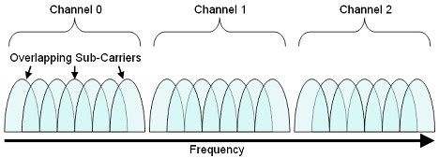
Fig.1 Orthogonal Frequency Division Multiplexing
The number of sub-carriers for each individual channel is seven, as you can see above. This solution permits a higher data throughput than with an FDM system since the symbol rate rises as the channel bandwidth rises.
Orthogonality of Sub-Channel Carriers
Through the use of overlapping sub-carriers, OFDM communications systems are able to use the frequency spectrum more efficiently. Because the maximum power of each sub-carrier directly correlates with the lower power of each adjacent channel, these sub-carriers can partially overlap without interfering with one another. The frequency domain of an OFDM system is graphically shown below. Each sub-carrier is represented by a separate peak, as seen in the picture. Moreover, the zero crossing of all channels coincides exactly with the peak of each sub-carrier.
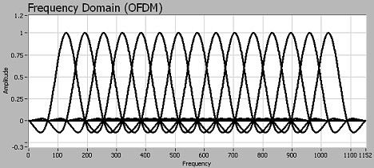

Fig.2 OFDM signal spectrum

Advantages of OFDM
Because it offers various benefits over the conventional FDM approach to communications channels, orthogonal frequency division multiplexing is frequently used in several developing communications protocols. More particular, OFDM systems support multi-path distortion resistance, reduced inter-symbol interference (ISI), and higher spectrum efficiency.
Spectral Efficiency. Each channel in a conventional FDM system is separated by around 25% of the channel width. To prevent interference from neighboring channels, this is done. The guard bands between separate channels are depicted in the diagram below to help understand this.
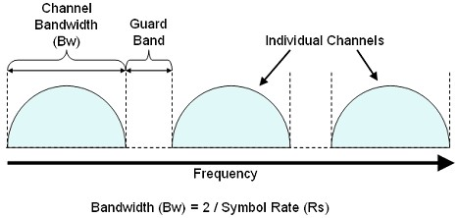
Fig.3 Spectral Efficiency
It is necessary for the symbol rate to permit guard bands to exist due to the requirement for guard bands. The permitted channel bandwidth (BW) is typically 2/Rs. The channels can thus be effectively divided as a result.
Channel estimation
In all communication systems, data is transferred from source to the destination in form of signals. These signals traverse different medium which can be wired or wireless. Copper wires or fiber cables are two examples of wired medium while air is a wireless medium. These mediums are also called channel. When a signal passes from channel, it is distorted from the noise or from other signals traversing that same medium. This means that when signal is received at its destination, it could have errors. So, in order to remove the noise and distortion effects of channel from the received signal, channel’s properties have to be found out. The process of figuring out channel characteristics is called Channel Estimation.
Channel estimation plays an important part in an OFDM system. It is used for increasing the capacity of orthogonal frequency division multiple access (OFDMA) systems by improving the system performance in terms of bit error rate. The data to be transmitted on an OFDM signal is spread across the carriers of the signal, each carrier taking part of the payload. This reduces the data rate taken by each carrier. The lower data rate has the advantage that interference from reflections is much less critical.
Wi COMM-T
The Wi COMM-T – the ultimate Wireless Digital Communication Training Platform –
is the actual implementation of modern digital communication systems with direct interface to MATLAB through the Hi-Speed USB port of a PC.The WiCOMM-T provides maximum flexibility in learning complete digital communication system concepts, which includes digital modulation techniques, Baseband Equalization, Filtering concepts, and the basics of CDMA, GSM etc.
WiCOMM-T is a SDR platform. It has ADC/DAC blocks, IF/RF modulation blocks and the interface to the PC. Rest of the systems is the software written in Matlab. All this put together forms the WiCOMM-T platform that is easy enough to use it. Modern digital communication systems, say a cell phone, today uses only the above said blocks. Instead of PC and Matlab, they employ DSPs or ASICs to do the specific actions.
Other forms of kits include DSP based systems where algorithms may have to be downloaded to the DSPs or FPGAs built in the hardware. This means that code optimization factors will get added to the work. Since users need to be focused to the concept and algorithms, WiCOMM-T ensures that all codes are handled at the PC level under Matlab. This helps to stay in focus with the concepts and not to worry about code optimization, code conversion, requirement of other development platforms etc. So WiCOMM-T is a practical setup to understand modern digital communication platform.
Results and Discussion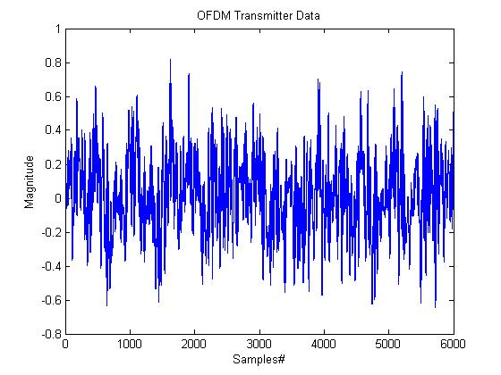
Fig.4

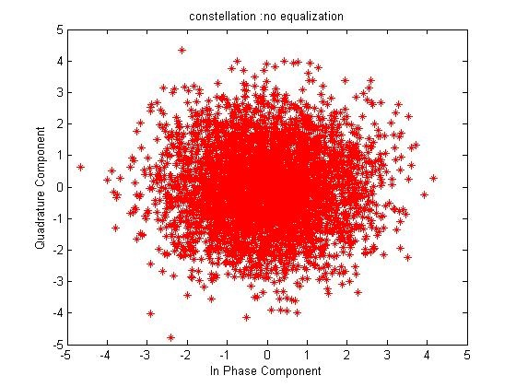
Fig.5

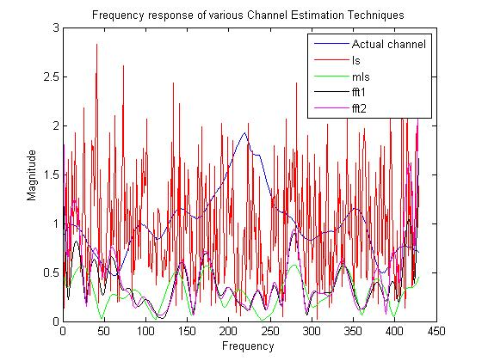
Fig.6
Conclusion

