**Role of Artificial Intelligence in Microbiology: Implementations and Obstacles**

**Khalid Imran1, Rajkumar N2, Nikesh V V3**

1Department of Microbiology, Krupanidhi Degree College, Bengaluru, Karnataka, India

2Department of Computer Applications, Krupanidhi College of Management, Bengaluru, Karnataka, India

3Krupanidhi Degree College, Bengaluru, Karnataka, India

**INTRODUCTION**

John McCarthy proposed the field of artificial intelligence (AI) at the Dartmouth Conference in the summer of 1956. AI is concerned with modelling human intelligence's extending capabilities and developing related theoretical frameworks, methodological tools, and application systems **(Jiang et al., 2022**). Alan Turing, creator of the Turing test used to distinguish between humans and machines, had previously highlighted concerns about the prospect of machines mimicking human behaviour and thought. Since then, advances in computing power have made it possible to perform computations in a flash and to compare new data with older data that has already been evaluated **(Mintz & Brodie, 2019).** Over several decades, AI has progressed from using simple codes to increasingly complicated algorithms with human-like capabilities **(Kaul et al., 2020).** Personal assistants (Siri, Alexa, Google Assistant, etc.), automated public transport, aviation, and computer games are just a few examples of how AI has made its way into our everyday lives today **(Mintz & Brodie, 2019).** Machine learning, deep learning, and computer vision are just a few of the many subfields within artificial intelligence **(Kaul et al., 2020).**

In 1959, **Arthur Samuel (Bell Labs, IBM, Stanford)** suggested ML as a subfield of artificial intelligence to extract features from massive datasets of diverse types **(Jiang et al., 2022).** Machine learning (ML) employs a set of characteristics to examine a problem. The computer can "learn" from this experience and use it to improve its performance in similar future situations. Rather than using a predetermined formula, this forecasting tool can be dynamically applied to clinical decision-making, allowing for more individualised patient care **(Kaul et al., 2020).** What matters is applying algorithms to data to parse it, automatically analyse it for patterns, and then use those patterns to forecast and act upon real-world occurrences **(Jordan & Mitchell, 2015).** ML uses massive amounts of data and trains them using algorithms to understand how to do jobs, as opposed to traditionally written software programs that are hard-coded to solve certain tasks **(Domingos, 2012).**

Parametric models taught by gradient descent provide the backbone of DL. This ground-breaking machine-learning approach models high-level data abstractions in a deep network with many layers of processing units **(Lecun et al., 2015).** As can be seen in Figure 01, ML is a technique for implementing AI, and DL is a technology for executing ML.

John McCarthy first discussed artificial intelligence at the 1956 Dartmouth Conference. Its main goal is to extend human intellect through simulation and develop new theoretical frameworks, methodologies, and practical systems **(Jiang et al., 2022)**. The concept of machines mimicking human behaviour and thought was first presented by Alan Turing, who also developed the Turing test to tell humans and machines apart. As computing power has increased, it has been possible to perform complex computations in a matter of seconds and to compare current data with historical data in real time **(Mintz & Brodie, 2019).** Artificial intelligence (AI) began with very straightforward programs and has subsequently advanced to include complex algorithms capable of mimicking human intelligence **(Kaul et al., 2020).** Personal assistants (Siri, Alexa, Google Assistant, etc.), automated public transportation, aircraft, and computer games are only a few examples of the pervasiveness of artificial intelligence in modern life **(Mintz & Brodie, 2019).** A few of the many branches of AI are machine learning, deep learning, and computer vision **(Kaul et al., 2020).**

**Arthur Samuel** established ML in 1959 at Bell Labs, IBM, and Stanford as a unique field of artificial intelligence to extract features from large and varied datasets **(Jiang et al., 2022).** Pattern detection in ML relies on very particular attributes, allowing for very targeted analysis. Next, the computer "learns" from this data and uses it to better respond to similar situations in the future. This predictive power can dynamically influence clinical decision-making, allowing for individualised patient care rather than relying on predetermined algorithms **(Kaul et al., 2020).** The core idea is based on using algorithms to automatically evaluate data patterns, which may then be used to make predictions and judgements about real-world occurrences **(Jordan & Mitchell, 2015).** ML uses massive datasets and algorithms to learn how to execute jobs directly from the data, as opposed to traditionally coded software programs, which are rigorously written for specific tasks **(Domingos, 2012).**

As a novel machine learning technique, DL employs a multi-layered network of processing units (or parametric models) taught using gradient descent to create complex input representations **(Lecun et al., 2015).** **Figure 01** illustrates how ML can be used to implement AI and how DL can be used to implement ML.

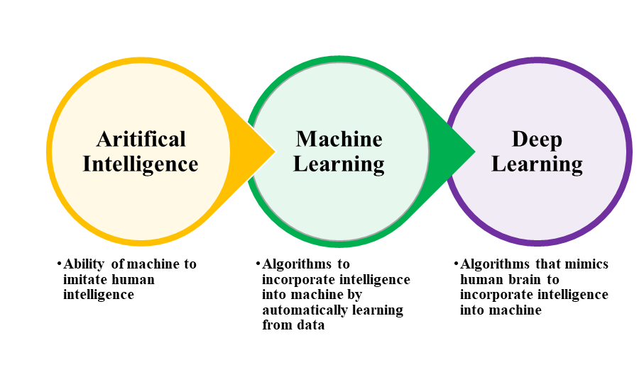

**Figure 01**: Relationship between AI vs. ML vs. DL **(Zhao & Krauze, 2021)**

In contrast to conventional ML, DL operates with higher dimensionality and aims to comprehensively capture relationships within the raw data, as illustrated in **Figure 02**. Depending on whether labelled data is required, DL can be broken down into supervised, unsupervised, and hybrid models. As shown in **Figure 03**, hybrid models often use unsupervised model outcomes as input data or as substantial supplements to supervised models.

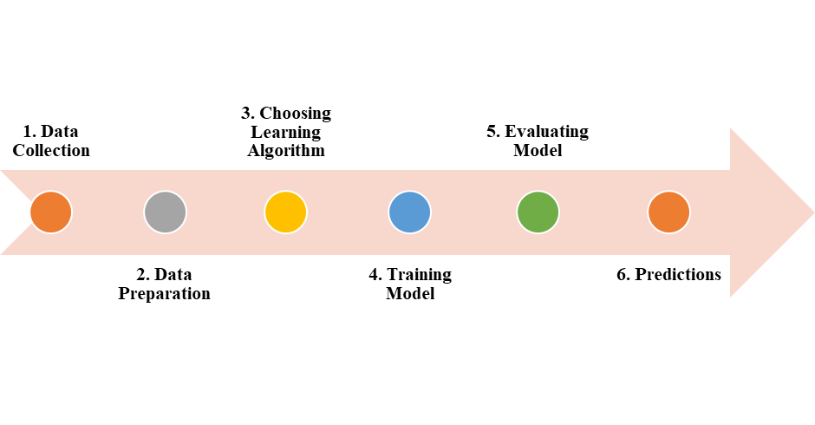

**Figure 02**: Machine Learning workflow **(Kanade, 2022)**

**Figure 03**: Machine Learning Types **(Kanade, 2022).**

The excessive use of antibiotics has resulted in a growing issue of drug resistance among pathogenic bacteria, posing a significant threat to human health. Screening soil microorganisms for secondary metabolites that can inhibit the growth of pathogenic bacteria is the standard and primary method for identifying new antibiotics **(Wright, 2017).** However, the present challenge lies in the diminishing rate of new antibiotic discoveries, demanding urgent attention and resolution.

In the modern era of drug research, voluminous data resources have become indispensable. Artificial intelligence's use in modelling evolving, heterogeneous, and large drug datasets has driven significant advances in drug development strategies **(Zhu, 2020).**

The use of ML in the discovery and prediction of new classes of antibiotic structures has progressed significantly and has been widely used **(Camacho et al., 2018).** Rapidly screening compounds from existing chemical libraries for those with antibiotic properties is made easier with DL **(Dimasi et al., 2016).** In the fight against antibiotic resistance, antimicrobial peptides (AMPs) show great promise as a new line of defence.

The compatibility between model predictions and appropriate experimental design is crucial to the success of antibiotic development guided by deep neural network models. After researchers realised that using complementary data and experiments may improve results, they embraced this "wet-dry" combination strategy.

Recently, AI has been integrated into the medical field to enhance patient care through increased efficiency and improved precision, leading to advancements in overall healthcare delivery. Radiological scans, pathology slides, and electronic medical records (EMR) are now routinely evaluated using ML to further aid in patient diagnosis and treatment **(Mintz & Brodie, 2019).**

Microbiologists are presently experiencing a period characterised by the collection of biological data on an unparalleled scale through high-throughput intelligent technologies. This growing demand necessitates skills beyond traditional laboratory and field experiments, as researchers must now employ computational techniques to extract valuable insights from these vast datasets.

Clinical microbiology informatics is rapidly expanding the role of AI. The potential for AI-driven testing to improve test turnaround time, quality, and cost has piqued the curiosity of scientists, microbiologists, laboratory workers, and diagnosticians. Although **Mathison et al. (2020)** used AI for computer vision in their research, there is room for other AI applications in the clinical microbiology lab.

Within clinical microbiology, extensive datasets suitable for developing AI diagnostics encompass genomic information from isolated bacteria **(Nguyen et al., 2018),** metagenomic microbial findings from primary specimens, mass spectra obtained from cultured bacterial isolates, and large digital images, the medium chosen by **Mathison et al. (2020)** AI, particularly computer vision, represents emerging tools that clinical microbiologists should explore, develop, and implement to enhance clinical microbiology practices.

Foreseeing drug targets and vaccine candidates, identifying microorganisms responsible for infectious diseases, classifying drug resistance to antimicrobial medications, predicting disease outbreaks, and investigating microbial interactions are all examples of computationally demanding tasks where ML has found applications. Many subfields of microbiology have incorporated ML into their study, including virology, parasitology, mycology, and bacteriology **(Goodswen et al., 2021).**

**APPLICATIONS AND CHALLENGES OF AI IN MICROBIOLOGY LABORATORY**

Understanding images is essential for clinical microbiology laboratory diagnostics. For example, Gram stains, faecal and blood smears, and histopathologic slides require the interpretation of expert microbiologists and pathologists. Important diagnostic information, such as the types of microorganisms present, the host's inflammatory response, and the quality of the material, can be gleaned from these samples. When viewed in a clinical context, this information is crucial for confirming the presence of an infection and often provides clues for a potential differential diagnosis that guides appropriate therapy.

The clinical microbiology laboratory faces an extra challenge due to a persistent shortage of medical laboratory scientists **(Garcia et al., 2018)**. To address this issue, there is growing interest in automating visually demanding interpretative tasks within the workflow. Until recently, previous attempts at automating image-based interpretative tasks were not satisfactory. However, the emergence of advanced AI algorithms capable of superior image discrimination has paved the way for automated clinical microbiology interpretation. This advancement promises to improve efficiency and diagnostic accuracy significantly.

AI algorithms will be used in conjunction with automation to do preliminary screening and categorisation of picture data, hence increasing productivity and allowing for more exact diagnoses through the combined efforts of AI and microbiologists. Once established, AI analysis of images is both cost-effective and flexible, making it a promising tool for in-person and distant diagnostics.

Laboratory automation incorporating AI capabilities is becoming a standard practice for interpreting agar plate growth in clinical diagnostics. However, these uses are limited to screening for infectious diseases and analysing urine samples. Despite their integration, certain aspects related to algorithm development remain complex and need to be thoroughly grasped by laboratory professionals.

Certain parts of interpretive microbiology have the potential to be standardised thanks to the availability of AI and advanced digital imaging tools. The computational modelling used in developing AI algorithms relies on many inputs to produce an output with a high likelihood of producing accurate results for a given application **(Ford and McElvania, 2020).**

Creating a dependable algorithm that undergoes thorough evaluation and is suitable for its intended purpose poses significant challenges, demanding stringent conditions and processes to establish an appropriate dataset for inputs and training. The task's difficulty increases when one considers the need to test, validate, and verify the algorithm's performance compared to a reference standard.

There is a clear need for AI expertise amongst laboratory personnel, and as more in-depth books and articles are published on the topic, so too is the want for education and training in AI methods. This will help us learn where the technology stands and how to improve it.

There is growing evidence that AI techniques can be effective in the clinical microbiology laboratory setting. This article goes into the use of AI for image analysis, discussing its implementation in settings as diverse as Gram stain staining, the analysis of eggs and parasites, and the reading of bacterial cultures on digital plates. It also delves into AI's function in cutting-edge analyses of mass spectral data gathered by matrix-assisted laser desorption ionisation/time of flight mass spectrometry (MALDI-TOF) and whole-genome sequencing data gathered from microorganisms.

Antigen, antibody, and molecular approaches have made great strides in finding therapeutically important species. However, morphologic analysis is still the gold standard for diagnosing parasite infections in most cases **(Garcia et al., 2018).** For most intestinal helminths and protozoa, the "gold standard" for morphologic detection is the microscopic ova-and-parasite (O&P) examination. On the other hand, blood-borne parasites like Plasmodium and Babesia can only be positively identified by a microscopic examination.

Microscopic examination for parasites is a laborious task, frequently requiring extended hours of examining slides that may or may not contain parasites, leading to decreased job satisfaction and increased burnout **(George, 2010).** The incorporation of AI has the potential to expedite this procedure, thereby making it more productive and profitable. Specifically, in malaria diagnostics, AI can be used to aid in identifying and characterising parasites based on their morphology and quantifying the parasite burden. Implementing AI in malaria diagnostics offers potential benefits such as enhanced efficiency in busy laboratories and improved accuracy in settings with limited expertise, such as field hospitals.

Antimicrobial resistance prediction and strain typing and relatedness research are two areas where MALDI-TOF MS applications using ML techniques have made significant strides. It is worth noting that MALDI-TOF MS has been investigated for antimicrobial susceptibility testing outside of ML methods in several separate publications. These kinds of studies are explored in a recent review, nevertheless, and are outside the focus of this article.

MALDI-TOF MS bridges the gap between a microbial isolate's genetic and phenotypic properties as a proteomic method. Its complex data structure lends itself naturally to the application of ML methods. Antimicrobial resistance prediction and strain typing/outbreak investigation are two areas where MALDI-TOF MS combined with ML approaches could be useful. However, existing data on the clinical effectiveness of this approach is sparse and conflicting.

**CHALLENGES OF AI IN MICROBIOLOGY LABORATORY**

Although AI holds significant promise for microbiology laboratories, its successful implementation also poses several challenges that must be addressed. Some of the primary challenges include:

**Data Quality and Availability:** AI, ML, and DL models require high-quality data for training and validation. In some cases, obtaining such data in microbiology can be challenging due to limited sample sizes, data variability, or issues with data standardisation.

**Interpretable Models:** AI models, particularly DL, can be complex and difficult to interpret. In critical applications like disease diagnosis or drug discovery, it is essential to understand how the model arrived at a particular result. Achieving interpretability in AI models is an ongoing challenge in the field.

**Domain-Specific Expertise:** Developing effective AI solutions for microbiology requires collaboration between computer scientists, data scientists, and microbiologists who understand the nuances of the domain. Bridging the gap between these disciplines can be a challenge.

**Algorithm Bias:** If the training data used to build AI models are biased or unrepresentative, the models can also exhibit bias. This can lead to inaccurate results and unfair decision-making, which is particularly concerning in healthcare applications.

**Model Generalization:** Ensuring that AI models can generalise well to new, unseen data is crucial. Overfitting, where a model performs well on training data but poorly on new data, is a common challenge that needs to be addressed.

**Data Privacy and Security:** Microbiology labs handle sensitive patient data and proprietary research information. Implementing AI solutions without compromising data privacy and security is a significant challenge.

**Cost and Infrastructure:** Developing and deploying AI, ML, and DL solutions requires substantial computational resources, including high-performance computing and specialised hardware. These resources can be costly and only readily available in some labs.

**Regulatory Compliance:** In healthcare and clinical applications, AI solutions are required to adhere to rigorous regulatory requirements and rules as established by the Food and Drug Administration (FDA). The procedure of ensuring compliance with these regulations is intricate.

**Ethical Considerations:** The integration of AI technologies within microbiology laboratories gives rise to a range of ethical considerations, including but not limited to data ownership, informed consent, and the potential for biases to influence decision-making processes. The ethical challenges need the adoption of transparent and accountable practices in AI.

**Integration with Existing Workflows:** Integrating AI solutions into pre-existing laboratory operations is a formidable challenge. The technology must seamlessly integrate with existing processes and tools to optimise productivity and promote user acceptance.

**Continuous Learning and Adaptation:** The microbiology domain is characterised by its dynamic nature, continuously generating discoveries and data. In order to remain pertinent and efficient over time, AI models must possess the ability to engage in ongoing learning and adaptation.

The issues above necessitate the engagement of multiple disciplines, effective data management, continuous research and innovation, and a dedication to artificial intelligence's ethical and responsible utilisation. The importance of addressing these difficulties must be addressed to fully harness the potential of AI in microbiology to advance scientific research and healthcare outcomes.

In summary, integrating AI with microbiology can fundamentally transform our comprehension of the microbial realm and its crucial contribution to preserving life on our planet. In the current epoch of significant change, it is imperative to prioritise the cultivation of conscientious and principled utilisation of AI to fully exploit its capacity for advancing the welfare of mankind and the environment. By using the potential of AI to address microbiological concerns, a future can be envisioned wherein the control of infectious illnesses is improved, tailored medicine becomes the prevailing approach, and attainable solutions to environmental issues are realised. The expedition is in its nascent stages, with the most favourable outcomes still on the horizon.

**References**

Jiang, Y., Luo, J., Huang, D., Liu, Y., & Li, D. D. (2022). Machine learning advances in microbiology: A review of methods and applications. Frontiers in Microbiology, 13, 925454.

Mintz, Y., & Brodie, R. (2019). Introduction to artificial intelligence in medicine. Minimally Invasive Therapy & Allied Technologies, 28(2), 73-81.

Kaul, V., Enslin, S., & Gross, S. A. (2020). History of artificial intelligence in medicine. Gastrointestinal endoscopy, 92(4), 807-812.

Jordan M. I., Mitchell T. M. (2015). Machine learning: trends, perspectives, and prospects. Science 349, 255–260.

Domingos P. (2012). A few useful things to know about machine learning. Commun. ACM 55, 78–87.

Lecun Y., Bengio Y., Hinton G. (2015). Deep learning. Nature 521, 436–444.

Zhao R, Krauze AV. Survival Prediction in Gliomas: Current State and Novel Approaches. In: Debinski W, editor. Gliomas [Internet]. Brisbane (AU): Exon Publications; 2021 Apr 30. Chapter 9. Available from: https://www.ncbi.nlm.nih.gov/books/NBK570711/ doi: 10.36255/exonpublications.gliomas.2021.chapter9

Vijay Kanade, (2022), What Is Machine Learning? Definition, Types, Applications, and Trends for 2022, Retrieved from https://www.spiceworks.com/tech/artificial-intelligence/articles/what-is-ml/#lg=1&slide=0, Accessed on 28th July 2023.

Wright, G. D. (2017). Opportunities for natural products in 21st century antibiotic discovery. *Nat. Prod. Rep.* 34, 694–701. doi: 10.1039/c7np00019g

Zhu, H. (2020). Big data and artificial intelligence modeling for drug discovery. *Annu. Rev. Pharmacol. Toxicol.* 60, 573–589. doi: 10.1146/annurev-pharmtox-010919-023324

Camacho, D. M., Collins, K. M., Powers, R. K., Costello, J. C., and Collins, J. J. (2018). Next-generation machine learning for biological networks. *Cell* 173, 1581–1592. doi: 10.1016/j.cell.2018.05.015

Dimasi, J. A., Grabowski, H. G., and Hansen, R. W. (2016). Innovation in the pharmaceutical industry: new estimates of R&D costs. *J. Health Econ.* 47, 20–33. doi: 10.1016/j.jhealeco.2016.01.012

Mathison BA, Kohan JL, Walker JF, Smith RB, Ardon O, Couturier MR. 2020. Detection of intestinal protozoa in trichrome-stained stool specimens by use of a deep convolutional neural network. J Clin Microbiol 58:e02053-19. https://doi.org/10.1128/JCM.02053-19.

Nguyen M, Long SW, McDermott PF, Olsen RJ, Olson R, Stevens RL, Tyson GH, Zhao S, Davis JJ. 2018. Using machine learning to predict antimicrobial MICs and associated genomic features for nontyphoidal Salmonella. J Clin Microbiol 57:e01260-18. https://doi.org/10.1128/JCM.01260-18.

Goodswen, S. J., Barratt, J. L., Kennedy, P. J., Kaufer, A., Calarco, L., & Ellis, J. T. (2021). Machine learning and applications in microbiology. FEMS microbiology reviews, 45(5), fuab015.

Garcia E, Kundu I, Ali A, Soles R. The American Society for Clinical Pathology’s 2016e2017 vacancy survey of medical laboratories in the United States. Am J Clin Pathol 2018;149:387e400.

Ford, B. A., and McElvania, E. (2020). Machine learning takes laboratory automation to the next level. J. Clin. Microbiol. 58:e00012-20. doi: 10.1128/JCM.00012-20

Garcia LS, Arrowood M, Kokoskin E, Paltridge GP, Pillai DR, Procop GW, et al. Laboratory diagnosis of parasites from the gastrointestinal tract. Clin Microbiol Rev 2018;31.

George E. Occupational hazard for pathologists: microscope use and musculoskeletal disorders. Am J Clin Pathol 2010;133:543-8.