To Study the Impact of Population Growth, Industrialization, and Primary- and Secondary-Level Toxins on the Depletion of Forestry Resources: A Mathematical Model

Nancy Gupta and Vimlesh*
Department of Mathematics,
National P.G. College, Lucknow-226001,India
*Faculty of Mathematical & Statistical Sciences,
Shri Ramswaroop Memorial University, Barabanki-225003, India
nancy2807@gmail.com
*aryansmath.lko@gmail.com

ABSTRACT
In order to investigate the effects of industrialization, population growth, and primary-secondary toxicants on the depletion of forestry resources, a nonlinear mathematical model was created and examined. It is assumed that primary toxicants are released into the environment at a constant specified pace and that industrialization and population expansion both promote their proliferation. Additionally, a portion of the primary toxicant is changed into a more toxic secondary toxicant, which affects the population and resource at the same time. The stability theory of differential equations has been used to demonstrate the nature and uniqueness of equilibrium as well as the prerequisites for the presence of their local and global equilibrium points. In order to analyse the dynamics of the system using a fourth order Runge-Kutta approach and identify the crucial variables contributing to the depletion of forestry resources, numerical simulations are carried out.
Keywords: Resource-biomass, Population, Primary & Secondary Toxicants, Industrialization, Stability.
Mathematics Subject Classification (2010) 34D20 · 34D23 · 34D30

1. INTRODUCTION
India's environmental issues are becoming worse very quickly. According to the WHO, air pollution causes nearly two million premature deaths annually and affects many more through breathing problems, heart disease, lung infections, and even cancer. One of the worst types of air pollution produced by business, transportation, home heating, cooking, and outdated coal- or oil-fired power plants is classified as fine particles or tiny dust from coal or wood fires and unfiltered diesel engines. The two basic types of airborne contaminants are primary and secondary. Primary pollutants are those that are released into the atmosphere by a variety of sources, including the burning of biomass for agricultural and land clearing purposes, the combustion of fossil fuels from power plants, automobile engines, and industrial activities. When a primary pollutant combines with sunlight, oxygen, water, and other chemicals in the air, secondary pollutants are created in the atmosphere. Simple answers can be given to the questions of whether primary and secondary air pollutants are relevant to atmospheric pollution, their effects on biological species, and the quality of the environment: atmospheric processes, such as oxidation procedures, particle formation, and equilibria, determine the fate of primary emissions, and, in most cases, the secondary product of these processes are the more significant ones regarding their effects on human health. Therefore, pollutants constitute a major threat to the survival of the resource biomass and the population that is exposed to them in both of their forms. In order to intelligently manage these pollutants, we must determine the risk to the resource biomass and population that is exposed to them. Therefore, it is crucial to employ mathematical models to examine how contaminants affect biological populations that depend on resources. So, in this study, an effort is made to predict how these environmental contaminants affect biological populations that depend on resources.
Freedman and Shukla [1] conducted research on the impact of toxicants on a biological population and predator-prey system recently. They demonstrated that when toxicant emission rates rise, population levels fall into an equilibrium, the size of which relies on the toxicant's inflow and washout rates. To examine the impact of harmful compounds on a two-species competitive system, Chattopadhyay [2] created a model. The impact of two toxicants on the development and survival of biological species was researched by Shukla and Dubey [3]. Studies on the proliferation and persistence of biomass-dependent species in reduced forest habitats as a result of industrialization pressure may be found in [4, 5]. Shukla and Dubey [6] investigated how increased population density and pollution emissions lead to the depletion of a forestry resource in a habitat. Dubey et al. [7] investigated how population pressure and increased industrialization contributed to the loss of forestry resources. They demonstrated that even if population growth is only partially dependent on resources, industrialization and high population pressure will eventually lead to the extinction of resource biomass. The consequences of industrialization, population growth, and pollution on a renewable resource were examined by Dubey and Narayanan [8].. The impacts of main and secondary toxicants on renewable resources were investigated by Shukla et al. [9]. In his analysis, the direct emission of main toxicants is taken into consideration; nevertheless, in actuality, the amount of toxicants in the environment rises due to increased population density and industrialization. Misra P. et al. [10] also investigated the best harvest strategy for toxicant-affected forestry biomass using a mathematical model. Constant toxicant release into the environment and dynamic biomass harvesting efforts using tax as a management tool have been implemented. Lata. K et al. [11] assessed the influence of wood and non-wood based industries on the depletion of forestry biomass in their investigation of the effects of industrialization on forestry resources. The metabolism of forestry resources is shown to suffer as a result of the uptake of these pollutants by the forestry resources when the amount of pollutants from wood and non-wood based enterprises grows. Mishra & Lata, [12] investigated the depletion and conservation of forestry biomass in the presence of industrialization by assuming that industries migrate owing to forestry biomass availability and their expansion rises due to forestry biomass availability. Further The effectiveness of media campaigns to preserve forestry resources and reduce population pressure was researched by Verma V. and Singh V. [13]. The study came to the conclusion that trees can be protected if forestry resources are conserved and public awareness of the significance of trees is increased.
In light of the aforementioned factors, a nonlinear mathematical model is suggested and examined in this study for the survival of a biological population that depends on resources in the presence of two toxicants (primary and secondary). Population growth and industrialization are thought to increase the density of primary pollutants in the environment, which then forms secondary pollutants that are much more hazardous. The set of five ordinary differential equations models this situation. The fourth order Runge-Kutta technique and the stability theory of nonlinear differential equations are used to analyze and forecast the behavior of the model.

2. MATHEMATICAL MODEL
It is assumed that the dynamics of the resource biomass, population, and industrialization are governed by logistic type equations and that the pressure of industrialization, population growth, and primary-secondary environmental toxicants is causing the resource biomass to be depleted in the ecosystem. It is also anticipated that the growth rate of resource biomass reduces with increasing population density and industrialization, while its carrying capacity diminishes with increasing primary-secondary toxicant concentrations in the environment. It is also believed that the population growth rate increases as the density of resource biomass and industrialization grows. Also, as the density of resource biomass and population grows, so does the rate of industrialization. It is also believed that primary toxicant emissions into the environment are industrialization and population dependent, as well as secondary toxicant emissions into the environment, which are more toxic than primary toxicants. It is considered that the rate of secondary toxicant transformation is proportional to the concentration of primary toxicant in the environment. Based on these considerations, the system is supposed to be regulated by the differential equations:

$\frac{\text{dB}}{\text{dt}}=r_{B}\left(N\right)B−\frac{r_{B0}B^{2}}{K_{B}\left(P_{1},\text{.}P_{2}\right)}−α\text{IB},$
$\frac{\text{dN}}{\text{dt}}=r_{P}\left(B\right)N−\frac{r_{P0}N^{2}}{M\left(P_{1},P_{2}\right)}+γ_{1}\text{IN},$
$\frac{{\text{dP}}_{1}}{\text{dt}}=Q\left(I,N\right)−δ_{0}P_{1}−α_{1}{\text{BP}}_{1}−α_{2}{\text{NP}}_{1}−{\text{gP}}_{1},$ (2.1)
$$\frac{{\text{dP}}_{2}}{\text{dt}}=θ{\text{gP}}_{1}−δ_{1}P_{2}−β_{1}{\text{BP}}_{2}−β_{2}{\text{NP}}_{2},$$
$$\frac{\text{dI}}{\text{dt}}=r_{1}I\left(1−\frac{I}{L}\right)+β\text{IB}+γ_{2}\text{IN}\text{.}$$

$$B\left(0\right)≥0,N\left(0\right)≥0,P_{1}\left(0\right)≥0,P_{2}\left(0\right)≥0,I\left(0\right)≥0\text{.}$$
In model (2.1), B represents the density of resource biomass, N represents population density, $P_{1}\text{ and }P_{2}$ represents the densities of primary and secondary toxicants in the environment. $I$is the industrialization density.$α$is the depletion rates coefficients of the resource biomass due to the industrialization and $β$ is the corresponding growth rate coefficient of industrialization. The positive constant $k$ is the transformation rate coefficient of primary toxicant into secondary toxicant in the environment.$γ_{1}\text{ and }γ_{2}$ are the growth rate coefficients of industrialization and population respectively due to their interaction. $r_{1}$ is the intrinsic growth rate coefficient of industrialization.$α_{1}\text{, }α_{2}\text{ and }β_{1},β_{2}$ are the depletion rate coefficients of primary and secondary toxicants due to resource biomass and population respectively. $δ_{0}\text{ and }δ_{1}$ are the natural washout rate coefficients of the primary and secondary toxicants respectively from the environment .The constant $θ≤1,$is a fraction, which represent the magnitude of transformation of primary toxicant into secondary toxicant.
In model (2.1), the function $r_{B}\left(N\right)$ denotes the specific growth rate of resource biomass which decreases as $N$increases. Hence we take
$r_{B}\left(0\right)=r_{B0}>0,$ $r_{B^{′}}\left(N\right)≤0$ for$N≥0\text{.}$ (2.2)

The function $K_{B}\left(P_{1},P_{2}\right)$ represent the maximum density of resource biomass which the environment can support in the presence of primary and secondary toxicants, and it also decreases as $P_{1}\text{ and }P_{2}$ increases. Hence we take
$K_{B}\left(0,0\right)=K_{B0}>0,$ $\frac{∂K_{B}\left(P_{1},P_{2}\right)}{∂P_{1}}<0,$ $\frac{∂K_{B}\left(P_{1},P_{2}\right)}{∂P_{2}}<0$ for $P_{1}≥0, P_{2}≥0\text{.}$ (2.3)
The function $r_{P}\left(B\right)$ denotes the growth rate coefficient of the population and it increases as the resource biomass density increases. Hence we take
$r_{P}\left(0\right)=r_{P0}>0,$ $r_{P^{′}}\left(B\right)≥0$ for $B≥0\text{.}$ (2.4)
The function $M\left(P_{1},P_{2}\right)$ represent the maximum density of population which the environment can support in the presence of primary and secondary toxicants, and it also decreases as $P_{1}\text{ and }P_{2}$ increases. Hence we take
$M\left(0,0\right)=M_{0}>0,$ $\frac{∂M\left(P_{1},P_{2}\right)}{∂P_{1}}<0,$ $\frac{∂M\left(P_{1},P_{2}\right)}{∂P_{2}}<0$ (2.6)
for$P_{1}≥0,P_{2}≥0\text{.}$
The function $Q\left(I,N\right)$ is the rate of introduction of toxicant into the environment which increases as $I\text{ and }N$ increase. Hence we take
$Q\left(0,0\right)=Q_{0}≥0,$ $\frac{∂Q\left(I,N\right)}{∂I}≥0,$ $\frac{∂Q\left(I,N\right)}{∂N}≥0$ for $I≥0, N≥0\text{.}$ (2.7)
Before analyzing the model we state and prove the following lemma corresponding to the region of attraction for solution of model (2.1).

Lemma (2.1): The set $Ω=\left\{\left(B,N,P_{1},P_{2},I\right):0≤B≤K_{B0},0≤N≤N_{m},0≤P_{1}+P_{2}≤Q_{m},0≤I≤L_{a}\right\}$
is the region of attraction for all solutions of model (2.1) initiating in the interior of positive orthant, where $Q_{m}=\frac{Q\left(L_{a},N_{m}\right)}{δ}, δ=\text{min}\left(δ_{0}+g−θg,δ_{1}\right)\text{.}$
3. EQUILIBRIUM ANALYSIS

The system (2.1) may have eight nonnegative equilibrium in the $B,N,P_{1},P_{2},I$ space namely, $\begin{aligned}E_{1}\left(0,0,\frac{Q_{0}}{δ_{0}+g},\frac{θQ_{0}g}{δ_{1}\left(δ_{0}+g\right)},0\right), E_{2}\left(0,0,\frac{Q_{0}}{δ_{0}+g},\frac{θQ_{0}g}{δ_{1}\left(δ_{0}+g\right)},L\right), E_{3}\left(0,\tilde{N},{\tilde{P}}_{1},{\tilde{P}}_{2},0\right), E_{4}\left(0,\tilde{\tilde{N}},{\tilde{\tilde{P}}}_{1},{\tilde{\tilde{P}}}_{2},\tilde{\tilde{I}}\right), E_{5}\left(\hat{B},0,{\hat{P}}_{1},{\hat{P}}_{2},0\right), \\ {\text{ E}}_{6}\left(\hat{\hat{B}},\hat{\hat{N}},{\hat{\hat{P}}}_{1},{\hat{\hat{P}}}_{2},0\right), E_{7}\left(\overset{˘}{B},0,{\overset{˘}{P}}_{1},{\overset{˘}{P}}_{2},\overset{˘}{I}\right), E∗ \\ \end{aligned}$The existence of $E_{1}\text{ and }E_{2}$ is obvious. We prove the existence of other equilibrium points.
Existence of $E_{3}\left(0,\tilde{N},{\tilde{P}}_{1},{\tilde{P}}_{2},0\right):$
In this case, ${\tilde{N},{\tilde{P}}_{1}\text{ and \{}\tilde{P}}_{2}$ are the positive solutions of the following equations:
$N=M\left(P_{1},P_{2}\right),$ (3.1)
$Q\left(0,N\right)−δ_{0}P_{1}−α_{2}{\text{NP}}_{1}−{\text{gP}}_{1}=0,$ (3.2)
$θ{\text{gP}}_{1}−δ_{1}P_{2}−β_{2}{\text{NP}}_{2}=0\text{.}$ (3.3)
From equations (3.2) and (3.3), respectively we get
$P_{1}=\frac{Q\left(0,N\right)}{δ_{1}+α_{2}N+g}=f_{1}\left(N\right),\text{ say,}$ (3.4)
and $P_{2}=\frac{θ{\text{gf}}_{1}\left(N\right)}{δ_{1}+β_{2}N}=f_{2}\left(N\right)\text{.}\text{, say}\text{.}$ (3.5)
It is noted that from equation (3.4) and (3.5) that $P_{1}\text{ and }P_{2},$ are the functions of $N$ only. To show the existence of $E_{3},$ we define a function $F_{1}\left(N\right)$ from equation (3.1), after using (3.4) and (3.5) as follows
$F_{1}\left(N\right)=N−M\left(f_{1}\left(N\right),f_{2}\left(N\right)\right)\text{.}$ (3.6)
From equation (3.6), we note that
$F_{1}\left(0\right)=−M\left(f_{1}\left(0\right),f_{2}\left(0\right)\right)<0\text{.}$
Also from (3.6), we note that
$F_{1}\left(N_{m}\right)=N_{m}−M\left(f_{1}\left(N_{m}\right),f_{2}\left(N_{m}\right)\right)>0,$
under the condition, $N_{m}−M\left(f_{1}\left(N_{m}\right),f_{2}\left(N_{m}\right)\right)>0,$ (3.7)
Thus there exists a root $\tilde{N}$ in the interval $0<\tilde{N}<N_{m}$ given by
$F_{1}\left(\tilde{N}\right)=0\text{.}$ (3.8)
Now, the sufficient condition for $E_{3}$ to be unique is $\frac{{\text{dF}}_{1}}{\text{dN}}>0\text{ at \{}\tilde{N},$ where
$\frac{{\text{dF}}_{1}}{\text{dN}}=1−\left(\frac{∂M}{∂P_{1}}\frac{{\text{df}}_{1}}{\text{dN}}+\frac{∂M}{∂P_{2}}\frac{{\text{df}}_{2}}{\text{dN}}\right)\text{.}$ (3.9)
From (3.9), we note that $\frac{{\text{dF}}_{1}}{\text{dN}}>0\text{ at \{}\tilde{N},\text{ if }\frac{∂M}{∂P_{1}}\frac{{\text{df}}_{1}}{\text{dN}}+\frac{∂M}{∂P_{2}}\frac{{\text{df}}_{2}}{\text{dN}}<1$ with this value of $\tilde{N},$ value of ${{\tilde{P}}_{1}\text{ and \{}\tilde{P}}_{2}$ can be found from equation (3.4) and (3.5) and is positive since $\frac{∂M}{∂P_{1}}\frac{{\text{df}}_{1}}{\text{dN}}+\frac{∂M}{∂P_{2}}\frac{{\text{df}}_{2}}{\text{dN}}<1\text{.}$
Existence of $E_{4}\left(0,\tilde{\tilde{N}},{\tilde{\tilde{P}}}_{1},{\tilde{\tilde{P}}}_{2},\tilde{\tilde{I}}\right):$
In this case $\tilde{\tilde{N}},{\tilde{\tilde{P}}}_{1},{\tilde{\tilde{P}}}_{2}\text{ and \{}\tilde{\tilde{I}}$ are the solutions of the following equations:
$r_{P0}−\frac{r_{P0}N}{M\left(P_{1},P_{2}\right)}+γ_{1}I=0,$ (3.10)
$Q\left(I,N\right)−δ_{0}P_{1}−α_{2}{\text{NP}}_{1}−{\text{gP}}_{1}=0,$ (3.11)
$θ{\text{gP}}_{1}−δ_{1}P−β_{2}{\text{NP}}_{2}=0,$ (3.12)
$I=\frac{L\left(r+γ_{2}N\right)}{r}=g_{1}\left(N\right),\text{ say}$ (3.13)
Using the value of $I,$ from equation (3.13) in equations (3.11) and (3.12) we obtain
$P_{1}=\frac{Q\left(g_{1}\left(N\right),N\right)}{δ_{0}+α_{2}N+g}=g_{2}\left(N\right),\text{ say,}$ (3.14)
$P_{2}=\frac{θ{\text{gQ}}_{2}\left(N\right)}{δ_{1}+β_{2}N}=g_{3}\left(N\right),\text{ say}\text{.}$ (3.15)
It is noted from equations (3.13), (3.14) and (3.15) that $I,P_{1}\text{ and }P_{2},$ are the functions of $N,$ only. To show the existence of $E_{4},$ we define a function $F_{2}\left(N\right)$ from equation (3.10), after using (3.13), (3.14) and (3.15) as follows
$F_{2}\left(N\right)=r_{P0}N−\left(r_{P0}+γ_{1}g_{1}\left(N\right)\right)M\left(g_{2}\left(N\right),g_{3}\left(N\right)\right)\text{.}$ (3.16)
From equation (3.16), we note that
$F_{2}\left(0\right)=−\left(r_{P0}+γ_{1}L\right)M\left(\frac{Q\left(L,0\right)}{δ_{0}+g},\frac{θ\text{gQ}\left(L,0\right)}{δ_{1}\left(δ_{0}+g\right)}\right)<0\text{.}$
Also from (3.16), we note that
$F_{2}\left(N_{m}\right)=r_{P0}N_{m}−\left(r_{P0}+γ_{1}g_{1}\left(N_{m}\right)\right)M\left(g_{2}\left(N_{m}\right),g_{3}\left(N_{m}\right)\right)>0\text{.}$
under the condition, $r_{P0}N_{m}>\left(r_{P0}+γ_{1}g_{1}\left(N_{m}\right)\right)M\left(g_{2}\left(N_{m}\right),g_{3}\left(N_{m}\right)\right)\text{.}$ (3.17)
Thus there exists a root $\tilde{\tilde{N}}$ in the interval $0<\tilde{\tilde{N}}<N_{m},$ given by
$F_{2}\left(\tilde{\tilde{N}}\right)=0\text{.}$ (3.18)
Now, the sufficient condition for $E_{4}$ to be unique is $\frac{{\text{dF}}_{2}}{\text{dN}}>0\text{ at \{}\tilde{\tilde{N}},$ where
$\frac{{\text{dF}}_{2}}{\text{dN}}=r_{P0}−L\frac{γ_{1}γ_{2}}{r}M\left(g_{2}\left(N\right),g_{3}\left(N\right)\right)−\left(r_{P0}+γ_{1}g_{1}\left(N\right)\right)\left(\frac{∂M}{∂P_{1}}\frac{{\text{dg}}_{2}}{\text{dN}}+\frac{∂M}{∂P_{2}}\frac{{\text{dg}}_{3}}{\text{dN}}\right)\text{.}$ (3.19)
From (3.19), we note that $\frac{{\text{dF}}_{2}}{\text{dN}}>0\text{ at \{}\tilde{\tilde{N}},\text{ if }$
$r_{P0}−L\frac{γ_{1}γ_{2}}{r}M\left(g_{2}\left(N\right),g_{3}\left(N\right)\right)−\left(r_{P0}+γ_{1}g_{1}\left(N\right)\right)\left(\frac{∂M}{∂P_{1}}\frac{{\text{dg}}_{2}}{\text{dN}}+\frac{∂M}{∂P_{2}}\frac{{\text{dg}}_{3}}{\text{dN}}\right)>0\text{.}$ (3.20)
With this value of $\tilde{\tilde{N}},$ value of ${\tilde{\tilde{I}},{\tilde{\tilde{P}}}_{1}\text{ and \{}\tilde{\tilde{P}}}_{2},$ can be found from equation (3.13), (3.14) and (3.15) and is positive since condition (3.20) is satisfied.
Existence of $E_{5}\left(\hat{B},0,{\hat{P}}_{1},{\hat{P}}_{2},0\right):$
In this case $\hat{B},{\hat{P}}_{1},{\hat{P}}_{2}$ are the solutions of the following equations
$B=K_{B}\left(P_{1},P_{2}\right),$ (3.21)
$P_{1}=\frac{Q_{0}}{δ_{0}+α_{1}B+g}=h_{1}\left(B\right),\text{ say,}$ (3.22)
$P_{2}=\frac{θ{\text{gh}}_{1}\left(B\right)}{δ_{1}+β_{1}B}=h_{2}\left(B\right),\text{ say,}$ (3.23)
It is noted from equations (3.22) and (3.23) that $P_{1}\text{ and }P_{2},$ are functions of $B$ only. To show the existence of $E_{5},$ we define a function $F_{3}\left(B\right)$ from equation (3.21), after using (3.22) and (3.23) as follows
$F_{3}\left(B\right)=B−K_{B}\text{.}\left(h_{1}\left(B\right),h_{2}\left(B\right)\right)$ (3.24)
From equation (3.24), we note that
$F_{3}\left(0\right)=−K_{B}\left(\frac{Q_{0}}{δ_{0}+g},\frac{θ{\text{gQ}}_{0}}{δ_{1}\left(δ_{0}+g\right)}\right)<0\text{.}$
Also from (3.24), we note that
$F_{3}\left(K_{B0}\right)=K_{B0}−K_{B}\left(h_{1}\left(K_{B0}\right),h_{2}\left(K_{B0}\right)\right)>0,$ under the conditions
$K_{B0}>K_{B}\left(h_{1}\left(K_{B0}\right),h_{2}\left(K_{B0}\right)\right)\text{.}$ (3.25)
Thus there exists a root $\hat{B},$ in the interval $0<\hat{B}<K_{B0},$ given by
$F_{3}\left(\hat{B}\right)=0\text{.}$ (3.26)
Now, the sufficient condition for $E_{5}$ to be unique is $\frac{{\text{dF}}_{3}}{\text{dB}}>0\text{ at \{}\hat{B},$where
$\frac{{\text{dF}}_{3}}{\text{dB}}=1−\left(\frac{∂K_{B}}{∂P_{1}}\frac{{\text{dh}}_{1}}{\text{dB}}+\frac{∂K_{B}}{∂P_{2}}\frac{{\text{dh}}_{2}}{\text{dB}}\right)\text{.}$ (3.27)
From (3.27), we note that $\frac{{\text{dF}}_{3}}{\text{dB}}>0\text{ at \{}\hat{B},\text{ if}$$\left(\frac{∂K_{B}}{∂P_{1}}\frac{{\text{dh}}_{1}}{\text{dB}}+\frac{∂K_{B}}{∂P_{2}}\frac{{\text{dh}}_{2}}{\text{dB}}\right)<1\text{.}$
With this value of $\hat{B},$ value of ${{\hat{P}}_{1}\text{ and \{}\hat{P}}_{2},$ can be found from equations (3.22) and (3.23) and is positive since $\left(\frac{∂K_{B}}{∂P_{1}}\frac{{\text{dh}}_{1}}{\text{dB}}+\frac{∂K_{B}}{∂P_{2}}\frac{{\text{dh}}_{2}}{\text{dB}}\right)<1\text{.}$
Existence of $E_{6}\left(\hat{\hat{B}},\hat{\hat{N}},{\hat{\hat{P}}}_{1},{\hat{\hat{P}}}_{2},0\right):$
In this case, $\hat{\hat{B}},\hat{\hat{N}},{\hat{\hat{P}}}_{1},{\hat{\hat{P}}}_{2}$ are the solutions of the following equations:
$r_{B}\left(N\right)−\frac{r_{B0}B}{K_{B}\left(P_{1},P_{2}\right)}=0,$ (3.28)
$r_{P}\left(B\right)−\frac{r_{P0}N}{M\left(P_{1},P_{2}\right)}=0,$ (3.29)
$Q\left(0,N\right)−δ_{0}P_{1}−α_{1}{\text{BP}}_{1}−α_{2}{\text{NP}}_{1}−{\text{gP}}_{1}=0,$ (3.30)
$θ{\text{gP}}_{1}−δ_{1}P_{2}−β_{1}{\text{BP}}_{2}−β_{2}{\text{NP}}_{2}=0\text{.}$ (3.31)
From the equation (3.30), we have
$P_{1}=\frac{Q\left(0,N\right)}{δ_{0}+α_{1}B+α_{2}N+g}=d_{1}\left(B,N\right),\text{ say,}$ (3.32)
With this value of $P_{1},$ and from the equation (3.31), we have
$P_{2}=\frac{θg}{\left(δ_{1}+β_{1}B+β_{2}N\right)}\frac{Q\left(0,N\right)}{\left(δ_{0}+α_{1}B+α_{2}N+g\right)}=d_{2}\left(B,N\right),\text{ say,}$ (3.33)
Using values of $P_{1}\text{ and }P_{2}$ from (3.32) and (3.33) in equations (3.28) and (3.29) respectively, we get
$\left(r_{B0}−r_{B1}N\right)\left(K_{B0}−K_{B1}d_{1}\left(B,N\right)−K_{B2}d_{2}\left(B,N\right)\right)−r_{B0}B=0,$ (3.34)
$\left(r_{P0}+r_{P1}B\right)\left(M_{0}−M_{1}d_{1}\left(B,N\right)−M_{2}d_{2}\left(B,N\right)\right)−r_{P0}N=0,$ (3.35)
From (3.34), we note that $\frac{\text{dN}}{\text{dB}}>0,$ if
$r_{B0}+r_{B}\left(N\right)\left(K_{B1}\frac{∂d_{1}}{∂B}+K_{B2}\frac{∂d_{2}}{∂B}\right)<0,$and
$r_{B1}K_{B}\left(d_{1}\left(B,N\right),d_{2}\left(B,N\right)\right)+r_{B}\left(N\right)\left(K_{B1}\frac{∂d_{1}}{∂N}+K_{B2}\frac{∂d_{2}}{∂N}\right)>0\text{.}$
From (3.35), we note that $\frac{\text{dN}}{\text{dB}}<0,$ if
$r_{P}\left(B\right)\left(M_{1}\frac{∂d_{1}}{∂B}+M_{2}\frac{∂d_{2}}{∂B}\right)>r_{P1}M\left(d_{1}\left(B,N\right),d_{2}\left(B,N\right)\right),$
and

$r_{P0}+r_{P}\left(B\right)\left(M_{1}\frac{∂d_{1}}{∂N}+M_{2}\frac{∂d_{2}}{∂N}\right)>0\text{.}$
Thus the two isoclines (3.34) and (3.35) intersects at $\hat{\hat{B}}\text{ and \{}\hat{\hat{N}}$ provided
$$r_{B0}+r_{B}\left(N\right)\left(K_{B1}\frac{∂d_{1}}{∂B}+K_{B2}\frac{∂d_{2}}{∂B}\right)<0,$$
$$r_{B1}K_{B}\left(d_{1}\left(B,N\right),d_{2}\left(B,N\right)\right)+r_{B}\left(N\right)\left(K_{B1}\frac{∂d_{1}}{∂N}+K_{B2}\frac{∂d_{2}}{∂N}\right)>0\text{.}$$
$r_{P}\left(B\right)\left(M_{1}\frac{∂d_{1}}{∂B}+M_{2}\frac{∂d_{2}}{∂B}\right)>r_{P1}M\left(d_{1}\left(B,N\right),d_{2}\left(B,N\right)\right),$

$r_{P0}+r_{P}\left(B\right)\left(M_{1}\frac{∂d_{1}}{∂N}+M_{2}\frac{∂d_{2}}{∂N}\right)>0\text{.}$

Using these values of $\hat{\hat{B}}\text{ and \{}\hat{\hat{N}}$ we get ${{\hat{\hat{P}}}_{1}\text{ and \{}\hat{\hat{P}}}_{2}$ from (3.32) and (3.33), respectively as follows

$P_{1}=\frac{Q\left(0,N\right)}{δ_{0}+α_{1}B+α_{2}N+g},$ and
$$P_{2}=\frac{θg}{\left(δ_{1}+β_{1}B+β_{2}N\right)}\frac{Q\left(0,N\right)}{\left(δ_{0}+α_{1}B+α_{2}N+g\right)}\text{.}$$

Existence of $E_{7}\left(\overset{˘}{B},0,{\overset{˘}{P}}_{1},{\overset{˘}{P}}_{2},\overset{˘}{I}\right):$
In this case $\overset{˘}{B},{\overset{˘}{P}}_{1},{\overset{˘}{P}}_{2},\overset{˘}{I}$ are the solutions of the following equations
$r_{B0}−\frac{r_{B0}B}{K_{B}\left(P_{1},P_{2}\right)}−αI=0,$ (3.36)
$P_{1}=\frac{Q\left(e_{1}\left(B\right),0\right)}{δ_{0}+α_{1}B+g}=e_{2}\left(B\right),\text{ say,}$ (3.37)
$P_{2}=\frac{θ{\text{ge}}_{2}\left(B\right)}{δ_{1}+β_{1}B}=e_{3}\left(B\right),\text{ say,}$ (3.38)
$I=L\left(1+\frac{βB}{r_{1}}\right)=e_{1}\left(B\right),\text{ say}\text{.}$ (3.39)
It is noted from equations (3.37), (3.38) and (3.39) that $P_{1}\text{ , }P_{2}\text{ and }I$ are functions of $B$ only. To show the existence of $E_{7},$ we define a function $F_{5}\left(B\right)$ from equation (3.36), after using (3.37), (3.38) and (3.39) as follows
$F_{5}\left(B\right)=r_{B0}B−\left(r_{B0}−{αe}_{1}\left(B\right)\right)K_{B}\text{.}\left(e_{2}\left(B\right),e_{3}\left(B\right)\right)$ (3.40)
From equation (3.40), we note that
$F_{5}\left(0\right)=−\left(r_{B0}−αL\right)K_{B}\left(\frac{Q\left(L,0\right)}{δ_{0}+g},\frac{θ\text{gQ}\left(L,0\right)}{δ_{1}\left(δ_{0}+g\right)}\right)<0\text{.}$
Also from (3.40), we note that
$F_{5}\left(K_{B0}\right)=r_{B0}K_{B0}−\left(r_{B0}−{αe}_{1}\left(K_{B0}\right)\right)K_{B}\left(e_{2}\left(K_{B0}\right),e_{3}\left(K_{B0}\right)\right)>0\text{.}$
under the conditions
$r_{B0}K_{B0}>\left(r_{B0}−{αe}_{1}\left(K_{B0}\right)\right)K_{B}\left(e_{2}\left(K_{B0}\right),e_{3}\left(K_{B0}\right)\right)\text{.}$ (3.41)
Thus there exists a root $\overset{˘}{B},$ in the interval $0<\overset{˘}{B}<K_{B0},$ given by
$F_{3}\left(\overset{˘}{B}\right)=0\text{.}$ (3.42)
Now, the sufficient condition for $E_{7}$ to be unique is $\frac{{\text{dF}}_{5}}{\text{dB}}>0\text{ at \{}\overset{˘}{B},$where $\frac{{\text{dF}}_{5}}{\text{dB}}=r_{B0}+αe_{1}^{'}\left(B\right)K_{B}\left(e_{2}\left(B\right),e_{3}\left(B\right)\right)−\left(r_{B0}−{αe}_{1}\left(B\right)\right)\left(\frac{∂K_{B}}{∂P_{1}}\frac{{\text{de}}_{2}}{\text{dB}}+\frac{∂K_{B}}{∂P_{2}}\frac{{\text{de}}_{3}}{\text{dB}}\right)\text{.}$ (3.43)
From (3.43), we note that $\frac{{\text{dF}}_{5}}{\text{dB}}>0\text{ at \{}\overset{˘}{B},\text{ if}$
$r_{B0}+αe_{1}^{'}\left(B\right)K_{B}\left(e_{2}\left(B\right),e_{3}\left(B\right)\right)>\left(r_{B0}−{αe}_{1}\left(B\right)\right)\left(\frac{∂K_{B}}{∂P_{1}}\frac{{\text{de}}_{2}}{\text{dB}}+\frac{∂K_{B}}{∂P_{2}}\frac{{\text{de}}_{3}}{\text{dB}}\right)\text{.}$ (3.44)
With this value of $\overset{˘}{B},$ value of ${{\overset{˘}{P}}_{1}\text{, \{}\overset{˘}{P}}_{2}\text{ and \{}\overset{˘}{I}$ can be found from equations (3.37), (3.38) and (3.39) and is positive since condition (3.44) is satisfied.
Existence of $E∗$
In this case, $B\text{*,}N\text{*,}P_{1}\text{*,}P_{2}\text{*,}I∗$ are the solutions of following equations:
$r_{B}\left(N\right)−\frac{r_{B0}B}{K_{B}\left(P_{1},P_{2}\right)}−αI=0,$ (3.45)
$r_{P}\left(B\right)−\frac{r_{P0}N}{M\left(P_{1},P_{2}\right)}+γ_{1}I=0,$ (3.46)
$Q\left(I,N\right)−δ_{0}P_{1}−α_{1}{\text{BP}}_{1}−α_{2}{\text{NP}}_{1}−{\text{gP}}_{1}=0,$ (3.47)
$θ{\text{gP}}_{1}−δ_{1}P_{2}−β_{1}{\text{BP}}_{2}−β_{2}{\text{NP}}_{2}=0,$ (3.48)
$r_{1}\left(1−\frac{I}{L}\right)+βB+γ_{2}N=0\text{.}$ (3.49)
From the equation (3.49), we have
$I=\frac{L}{r_{1}}\left(r_{1}+βB+γ_{2}N\right)=s_{1}\left(B,N\right),\text{ say,}$ (3.50)
With this value of $I,$ and from the equation (3.47) and (3.48), we have
$P_{1}=\frac{Q\left(s_{1}\left(B,N\right),N\right)}{\left(δ_{0}+α_{1}B+α_{2}N+g\right)}=s_{2}\left(B,N\right),\text{ say,}$ (3.51)
$P_{2}=\frac{θ{\text{gs}}_{2}\left(B,N\right)}{\left(δ_{1}+β_{1}B+β_{2}N\right)}=s_{3}\left(B,N\right),\text{ say,}$
(3.52)
Using values of $I,P_{1}\text{ and }P_{2}$ from (3.50), (3.51) and (3.52) in equations (3.45) and (3.46) respectively, we get
$\left(r_{B0}−r_{B1}N−{αs}_{1}\left(B,N\right)\right)\left(K_{B0}−K_{B1}s_{2}\left(B,N\right)−K_{B2}s_{3}\left(B,N\right)\right)−r_{B0}B=0,$ (3.53)
$\left(r_{P0}+r_{P1}N+γ_{1}s_{1}\left(B,N\right)\right)\left(M_{0}−M_{1}s_{2}\left(B,N\right)−M_{2}s_{3}\left(B,N\right)\right)−r_{P0}N=0,$ (3.54)
From (3.53), we note that $\frac{\text{dN}}{\text{dB}}<0,$ if
$α\frac{∂s_{1}}{∂B}K_{B}\left(s_{2}\left(B,N\right),s_{3}\left(B,N\right)\right)+\left(r_{B}\left(N\right)−{αs}_{1}\left(B,N\right)\right)\left(K_{B1}\frac{∂s_{2}}{∂B}+K_{B2}\frac{∂s_{3}}{∂B}\right)+r_{B0}>0,$ and
$\left(r_{B1}+α\frac{∂s_{1}}{∂N}\right)K_{B}\left(s_{2}\left(B,N\right),s_{3}\left(B,N\right)\right)+\left(r_{B}\left(N\right)−{αs}_{1}\left(B,N\right)\right)\left(K_{B1}\frac{∂s_{2}}{∂N}+K_{B2}\frac{∂s_{3}}{∂N}\right)>0,$
From (3.54), we note that $\frac{\text{dN}}{\text{dB}}>0,$ if
$\left(−r_{P1}−γ_{1}\frac{∂s_{1}}{∂B}\right)M\left(s_{2}\left(B,N\right),s\left(B,N\right)\right)+\left(r_{P}\left(B\right)+γ_{1}s_{1}\left(B,N\right)\right)\left(M_{1}\frac{∂s_{2}}{∂B}+M_{2}\frac{∂s_{3}}{∂B}\right)>0,$
and
$γ_{1}\frac{∂s_{1}}{∂N}M\left(s_{2}\left(B,N\right),s\left(B,N\right)\right)−\left(r_{P}\left(B\right)+γ_{1}s_{1}\left(B,N\right)\right)\left(M_{1}\frac{∂s_{2}}{∂N}+M_{2}\frac{∂s_{3}}{∂N}\right)−r_{P0}>0\text{.}$
Thus the two isoclines (3.53) and (3.54) intersects at $B∗\text{ and }N∗$ provided

$$α\frac{∂s_{1}}{∂B}K_{B}\left(s_{2}\left(B,N\right),s_{3}\left(B,N\right)\right)+\left(r_{B}\left(N\right)−{αs}_{1}\left(B,N\right)\right)\left(K_{B1}\frac{∂s_{2}}{∂B}+K_{B2}\frac{∂s_{3}}{∂B}\right)+r_{B0}>0,$$
$$\left(r_{B1}+α\frac{∂s_{1}}{∂N}\right)K_{B}\left(s_{2}\left(B,N\right),s_{3}\left(B,N\right)\right)+\left(r_{B}\left(N\right)−{αs}_{1}\left(B,N\right)\right)\left(K_{B1}\frac{∂s_{2}}{∂N}+K_{B2}\frac{∂s_{3}}{∂N}\right)>0,$$
$\left(−r_{P1}−γ_{1}\frac{∂s_{1}}{∂B}\right)M\left(s_{2}\left(B,N\right),s\left(B,N\right)\right)+\left(r_{P}\left(B\right)+γ_{1}s_{1}\left(B,N\right)\right)\left(M_{1}\frac{∂s_{2}}{∂B}+M_{2}\frac{∂s_{3}}{∂B}\right)>0,$

$γ_{1}\frac{∂s_{1}}{∂N}M\left(s_{2}\left(B,N\right),s\left(B,N\right)\right)−\left(r_{P}\left(B\right)+γ_{1}s_{1}\left(B,N\right)\right)\left(M_{1}\frac{∂s_{2}}{∂N}+M_{2}\frac{∂s_{3}}{∂N}\right)−r_{P0}>0\text{.}$

Using these values of $B∗\text{ and }N∗$ we get $P_{1}∗\text{ , }P_{2}∗\text{ and }I∗$ from (3.50), (3.51) and (3.52), respectively as follows

$I=\frac{L}{r_{1}}\left(r_{1}+βB+γ_{2}N\right),$ $P_{1}=\frac{Q\left(s_{1}\left(B,N\right),N\right)}{\left(δ_{0}+α_{1}B+α_{2}N+g\right)}\text{, }P_{2}=\frac{θ{\text{gs}}_{2}\left(B,N\right)}{\left(δ_{1}+β_{1}B+β_{2}N\right)}\text{.}$$\text{.}$

4. STABILITY ANALYSIS
4.1 Local Stability
The local stability behavior of each equilibrium point can be studied by computing the corresponding variational matrix. From these matrices we note the following.
- $E_{1}$ is also a saddle point with stable manifold locally in the $P_{1}−P_{2}$ plane and with unstable manifold locally in the $B−N−I$ space.
- $E_{2}$is a saddle point with stable manifold locally in the $P_{1}−P_{2}−I$ space and with unstable manifold locally in the $B−N$ plane.
- $E_{3}$ is a saddle point with stable manifold locally in the $N−P_{1}−P_{2}$ space and with unstable manifold locally in the $B−I$ plane.
- $E_{4}$ is a saddle point with stable manifold locally in the $N−P_{1}−P_{2}−I$ space and with unstable manifold locally in the $B$ direction.
- $E_{5}$ is a saddle point with stable manifold locally in the $B−P_{1}−P_{2}$ space and with unstable manifold locally in the $N−I$plane.
- $E_{6}$ is a saddle point with stable manifold locally in the $B−N−P_{1}−P_{2}$ space and with unstable manifold locally in the $I$ direction.
- $E_{7}$ is a saddle point with stable manifold locally in the $B−P_{1}−P_{2}−I$ space and with unstable manifold locally in the $N$ direction.
In the following theorem we show that $E∗$is locally asymptotically stable:

Theorem 1: If the following inequalities hold
$r_{P1}N∗+α_{1}P_{1}∗+β_{1}P_{2}∗+βI∗ < r_{B0}\frac{B∗}{K_{B}(P_{1}\text{*,}P_{2}∗)},$ (4.1) $r_{B1}B∗+Q_{2}−α_{2}P_{1}∗+β_{2}P_{2}∗+γ_{2}I\text{* }< r_{P0}\frac{N∗}{M(P_{1}\text{*,}P_{2}∗)},$ (4.2)
$\frac{K_{B1}}{K_{B^{2}}(P_{1}\text{*,}P_{2}∗)}r_{B0}B∗^{2}+\frac{M_{1}}{M^{2}(P_{1}\text{*,}P_{2}∗)}r_{P0}N∗^{2}+θg < Q$ (4.3)
$\frac{K_{B2}}{K_{B^{2}}(P_{1}\text{*,}P_{2}∗)}r_{B0}B∗^{2}+\frac{M_{2}}{M^{2}(P_{1}\text{*,}P_{2}∗)}r_{P0}N∗^{2} θ\frac{{\text{gP}}_{1}∗}{P_{2}∗},$ (4.4)
$αB∗+γ_{1}N∗+Q_{1}<r_{1}\frac{I∗}{L}\text{.}$ (4.5)
then $E∗$ is locally asymptotically stable.
Proof: If inequalities (4.1) – (4.5) hold, then by Gerschgorin’s theorem (Lancaster and Tismenetsky, 1985), all eigenvalues of $V(E∗)$ have negative real parts and interior equilibrium $E∗$ is locally asymptotically stable.
4.2. GLOBAL STABILITY
Theorem 2: In addition to the assumption (2.2) – (2.7), let $r_{B}(N),{\text{ r}}_{P}(B), K_{B}\left(P_{1},P_{2}\right)\text{ , }M\left(P_{1},P_{2}\right)$and $Q(I,N)$ satisfy the conditions $0≤−r_{B}^{'}\left(N\right)≤ρ_{1},\text{ 0}≤−r_{P}^{'}\left(B\right)≤ρ_{2},M_{n}≤M\left(P_{1},P_{2}\right)≤M_{0}, K_{m}≤K_{B}(P_{1},P_{2})≤K_{B0},0≤\frac{∂Q}{∂I}≤ρ_{3},0≤\frac{∂Q}{∂N}≤ρ_{4},$$0≤−\frac{∂K_{B}}{∂P_{1}}≤k_{1},0≤−\frac{∂K_{B}}{∂P_{2}}≤k_{2},0≤−\frac{∂M}{∂P_{1}}≤m_{1,}0≤−\frac{∂M}{∂P_{2}}≤m_{2}\text{.} (4\text{.}6)$in $Ω$for some positive constants $ρ_{1},ρ_{2},ρ_{3},ρ_{4},k_{1}\text{, }k_{2}\text{, }K_{0},K_{m},M_{0},M_{n},m_{1},m_{2}$ Then if the following inequalities hol
${\left(ρ_{1}+ρ_{2}\right)}^{2}<\frac{1}{4}\frac{r_{B0}}{K_{B}(P_{1}\text{*,}P_{2}∗)}\frac{r_{P0}}{M(P_{1}\text{*,}P_{2}∗)},$ (4.7)
${\left(α_{1}Q_{m}+r_{B0}K_{B0}\frac{k_{1}}{K_{m^{2}}}\right)}^{2}<\frac{1}{4}\frac{r_{B0}}{K_{B}(P_{1}\text{*,}P_{2}∗)}$ (4.8) ${\left(β_{1}Q_{m}+r_{B0}K_{B0}\frac{k_{2}}{K_{m^{2}}}\right)}^{2}<\frac{1}{3}\frac{r_{B0}}{K_{B}(P_{1}\text{*,}P_{2}∗)}$ (4.9)
${\left(β+α\right)}^{2}<\frac{1}{3}\frac{r_{B0}}{K_{B}(P_{1}\text{*,}P_{2}∗)}\frac{r_{1}}{L},$ (4.10) ${\left(ρ_{4}+α_{2}Q_{m}+r_{P0}N_{m}\frac{m_{1}}{M_{n^{2}}}\right)}^{2}<\frac{1}{4}\frac{r_{P0}}{M}$ (4.11)
${\left(β_{2}Q_{m}+r_{P0}N_{m}\frac{m_{2}}{M_{n^{2}}}\right)}^{2}<\frac{1}{4}\frac{r_{P0}}{M}$ (4.12)
${\left(γ_{1}+γ_{2}\right)}^{2}<\frac{1}{3}\frac{r_{P0}}{M}$ (4.13) ${\left(θg\right)}^{2}<\frac{1}{3}$ (4.14)
$ρ_{3^{2}}<\frac{1}{3}\frac{r_{1}}{L}$l (4.15)
$E∗$ is globally asymptotically stable with respect to all solutions initiating in the positive orthant $Ω\text{.}$
Proof: Consider the following positive definite function about $E∗$
$V\left(B,N,P_{1},P_{2},I\right)=$
Differentiating $V$ with respect to time t, we get
$$\frac{\text{dV}}{\text{dt}}=$$
Substituting values of $\frac{\text{dB}}{\text{dt}},\frac{\text{dN}}{\text{dt}},\frac{{\text{dP}}_{1}}{\text{dt}},\frac{{\text{dP}}_{2}}{\text{dt}}$and $\frac{\text{dW}}{\text{dt}}$ from the system of equation (2.1) in the above
equation and after doing some algebraic manipulations and considering functions,

$η_{B}\left(N\right)=\begin{aligned} \\ \end{aligned}$

(4.16) $η_{P}\left(B\right)=\begin{aligned} \\ \end{aligned}$ (4.17) $η_{Q1}\left(I,N\right)=\begin{aligned}\left\{\frac{Q\left(I,N\right)−Q\left(I\text{*,}N\right)}{I−I∗},\text{ ,}I≠\text{I*,}\right.\end{aligned}$ (4.18) $ξ_{B1}\left(P_{1},P_{2}\right)=\begin{aligned}\left\{\frac{\frac{1}{K_{B}\left(P_{1},P_{2}\right)}−\frac{1}{K_{B}\left(P_{1}\text{*,}P_{2}\right)}}{P_{1}−P_{1}∗},\text{ ,}P_{1}≠P_{1}\text{*,}\right.\end{aligned}$ (4.19) $ξ_{B2}(P_{1}\text{*,}P_{2})=\begin{aligned}\left\{\frac{\frac{1}{K_{B}(P_{1}\text{*,}P_{2})}−\frac{1}{K_{B}(P_{1}\text{*,}P_{2}∗)}}{P_{2}−P_{2}∗}, ,P_{2}≠P_{2}\text{*,}\right. \\ \end{aligned}$ (4.20)

$τ_{P1}(P_{1},P_{2})=\begin{aligned}\left\{\frac{\frac{1}{M(P_{1},P_{2})}−\frac{1}{M(P_{1}\text{*,}P_{2})}}{P_{1}−P_{1}∗}, ,P_{1}≠P_{1}\text{*,}\right. \\ \end{aligned}$

(4.21)
$τ_{P2}(P_{1}\text{*,}P_{2})=\begin{aligned}\left\{\frac{\frac{1}{M(P_{1}\text{*,}P_{2})}−\frac{1}{M(P_{1}\text{*,}P_{2}∗)}}{P_{2}−P_{2}∗}, ,P_{2}≠P_{2}\text{*,}\right. \\ \end{aligned}$

(4.22)

$η_{Q2}(I\text{*,}N)=\begin{aligned} \\ \end{aligned}$

(4.23)

we get
$\frac{\text{dV}}{\text{dt}}=−\frac{1}{4}a_{\text{11}}$
$=−\frac{1}{4}a_{\text{11}}$
$=−\frac{1}{4}a_{\text{11}}$
$=−\frac{1}{4}a_{\text{11}}$
$=−\frac{1}{4}a_{\text{22}}$
$=−\frac{1}{4}a_{\text{22}}$
$=−\frac{1}{4}a_{\text{22}}$
$=−\frac{1}{4}a_{\text{33}}$
$=−\frac{1}{4}a_{\text{33}}$
where
$a_{1_{1}}=\frac{r_{\text{B0}}}{K_{B}}$ $a_{1_{3}}=\text{ -}α_{1}P_{1}−r_{B0}{Bξ}_{B1}\left(P_{1},P_{2}\right){\text{, a}}_{1_{4}}=\text{ -}β_{1}P_{2}−r_{B0}{Bξ}_{B2}\left(P_{1}\text{*,}P_{2}\right), a_{3_{4}}=θg,{\text{ a}}_{4_{4}}=δ_{1}+β_{1}B∗+β_{2}N\text{*,}{\text{ a}}_{5_{5}}=\frac{r_{1}}{L},{\text{ a}}_{\text{15}}=−α+β,$
$$a_{\text{24}}=−r_{P0}{Nτ}_{P2}\left(P_{1}\text{*,}P_{2}\right)−β_{2}P_{2},a_{\text{25}}=γ_{1}+γ_{2},a_{\text{35}}=η_{Q1}\left(I,N\right)$$
Then sufficient conditions for $\frac{\text{dV}}{\text{dt}}$ to be negative definite are that the following inequalities hold
$a_{1_{2}^{2}}<\frac{1}{4}a_{1_{1}}a_{2_{2}},$ $a_{1_{3}^{2}}<\frac{1}{4}a_{\text{11}}a_{3_{3}},$ $a_{{\text{14}}^{2}}<\frac{1}{3}a_{\text{11}}a_{\text{44}},$ $a_{{\text{15}}^{2}}<\frac{1}{3}a_{1_{1}}a_{\text{55}},$ $a_{{\text{23}}^{2}}<\frac{1}{4}a_{\text{22}}a_{\text{33}},$ $a_{{\text{24}}^{2}}<\frac{1}{3}a_{\text{22}}a_{\text{44}},$ $a_{{\text{25}}^{2}}<\frac{1}{3}a_{\text{22}}a_{\text{55}}\text{.}$ $a_{{\text{34}}^{2}}<\frac{1}{3}a_{\text{33}}a_{\text{44}},$ $a_{{\text{35}}^{2}}<\frac{1}{3}a_{\text{33}}a_{\text{55}}\text{.}$ (4.24)
Now, from (4.6) and mean value theorem, we note that
$\left|η_{B}\left(N\right)\right|≤ρ_{1}, \left|η_{P}\left(B\right)\right|≤ρ_{2}, \left|η_{Q1}\left(I,N\right)\right|≤ρ_{3},\left|η_{Q2}\left(I\text{*,}N\right)\right|<ρ_{4},\left|τ_{P1}\left(P_{1},P_{2}\right)\right|<\frac{m_{1}}{M_{n^{2}}},$
$\left|τ_{P2}\left(P_{1}\text{*,}P_{2}\right)\right|<\frac{m_{2}}{M_{n^{2}}}, \left|ξ_{B1}\left(P_{1},P_{2}\right)\right|≤\frac{k_{1}}{K_{m^{2}}}, \left|ξ_{B2}\left(P_{1}\text{*,}P_{2}\right)\right|≤\frac{k_{2}}{K_{m^{2}}}\text{.}$ (4.25)
Further, we note that the stability conditions (4.7)-(4.15) as stated in theorem 2, can be obtained by maximizing the left-hand side of inequalities (4.24). This completes the proof of theorem 2.

5 NUMERICAL SIMULATIONS AND DISCUSSION
To facilitate the interpretation of our mathematical findings by numerical simulation, we integrated system (2.1) using fourth order Runge-Kutta method. We take the following particular form of the functions involved in the model (2.1):

$\begin{aligned}r_{B}\left(N\right)=r_{B0}−r_{B1}N, r_{P}\left(B\right)=r_{P0}+r_{P1}B, K_{B}\left(P_{1},P_{2}\right)=K_{B0}−K_{B1}P_{1}−K_{B2}P_{2}, \\ M\left(P_{1},P_{2}\right)=M_{0}−M_{1}P_{1}−M_{2}P_{2}, Q\left(I,N\right)=Q_{0}+Q_{1}I+Q_{2}N\text{.}\end{aligned}$ (5.1)
Now we choose the following set of values of parameters in model (2.1) and equation (5.1).
$\begin{aligned}r_{B0}=\text{11}, r_{B1}=0\text{.}2, K_{B0}=\text{12}\text{.}2, K_{B1}=0\text{.}1, K_{B2}=0\text{.}3, α=0\text{.}\text{01}, r_{P0}=\text{20}, r_{P1}=0\text{.}1,M_{0}=\text{10}, M_{1}=0\text{.}\text{1, }M_{2}=0\text{.}2, γ_{1}=0\text{.}\text{02},Q_{0}=\text{20}, Q_{1}=0\text{.}3, \\ Q_{2}=0\text{.}2, δ_{0}=\text{14},α_{1}=0\text{.}\text{001},α_{2}=0\text{.}\text{08},\text{ g}=5, θ=0\text{.}5, δ_{1}=\text{17}, β_{1}=0\text{.}6, β_{2}=0\text{.}1, r_{1}=9,l=5, β=0\text{.}\text{1, }γ_{2}=0\text{.}2,K_{m}=0\text{.}\text{001} \\ k_{1}=0\text{.}2,k_{2}=0\text{.}\text{01}, m_{1}=0\text{.}\text{02},m_{2}=0\text{.}\text{01}, M_{n}=1\text{.}3,ρ_{1}=0\text{.}2, ρ_{2}=0\text{.}1, ρ_{3}=1, ρ_{4}=0\text{.}1, (5\text{.}2) \end{aligned}$With the above values of parameters, we note that condition for the existence of $E∗$ are satisfied, and $E∗$ is given by
$B∗9\text{.}\text{6912}, N∗\text{10}\text{.}\text{3966}, P_{1}∗1\text{.}\text{2140}, P_{2}∗0\text{.}\text{1272}, I∗6\text{.}\text{6936}\text{.}$ (5 .3)
It is further noted that all conditions of local stability (4.1) – (4.5), global stability (4.7) – (4.15) are satisfied for the set of values of parameters given in (5.2).
In fig. 1, the primary and secondary toxicants against time are plotted. It shows that as direct emission of toxicant i.e. $Q_{0},$ increases both primary and secondary toxicants into the environment increases rapidly. Also it has been taken in the model that emission of primary toxicant is industrialization and population dependent so its growth rate increases with increase in parameters $Q_{1}\text{ and }Q_{2},$ respectively, which ultimately result in increase of secondary toxicant into the environment. This can be seen in figs. 2-3. Fig. 4, shows the dynamics of resource-biomass for different values of $α,$ w.r.t time t. This shows that density of resource-biomass decreases as $α,$increases. It is also noted that the resource-biomass density initially increases w.r.t time t and after certain time it settle down to its steady state. Figs. 5-7, show the effect of $θ\text{ for }g=\text{12}$ on the dynamics of resource-biomass, population and secondary toxicant w.r.t time t. From fig. 7, it is obvious that as $θ,$ increases secondary toxicant into the environment increases rapidly. From figs 5-6, we can infer that as the level of secondary toxicant increases into the environment, densities of resource-biomass and population decreases.
Fig. 8, shows the dynamics of secondary toxicant for different values of $g,$ with respect to time t. It is found that as $g,$ rate of transformation of primary toxicant to secondary toxicant, increases density of secondary toxicant increases into the environment. Also table is formed for different values of $g\text{ and }θ=\text{1, }$which shows resource-biomass, population, primary toxicant and industrialization decreases while secondary toxicant increases. From the table we can infer that resource-biomass, population may driven to extinction if rate of formation of secondary toxicant is large.

g | Resource-Biomass(B) | POPULATION (N) | Primary Toxicant (P₁) | Secondary Toxicant (P₂) | Industrialization (I)
0.5 | 9.6892 | 10.3788 | 1.5700 | 0.0329 | 6.6915
1 | 9.6861 | 10.3773 | 1.5204 | 0.0638 | 6.6912
5 | 9.6666 | 10.3684 | 1.2138 | 0.2547 | 6.6891
10 | 9.6511 | 10.3613 | 0.9694 | 0.4069 | 6.6874
15 | 9.6407 | 10.3566 | 0.8069 | 0.5082 | 6.6863

From figs. 9-10, we note that density of industrialization increases as $β\text{ and }γ_{2},$ increases. Fig. 11, shows that density of population increases as $γ_{1},$increases with time. Figs. 12-13, show the effects of $K_{B1}\text{ and }K_{B2},$on the dynamics of resource-biomass. In both cases the density of resource-biomass increases initially then decreases for some time and finally obtain its equilibrium level. These figs also show that primary pollutant has an adverse effect on the resource-biomass carrying capacity for a larger period than secondary toxicant. Similar behavior can be seen in figs. 14-15, which is plotted between population and time for different values of $M_{1}\text{ and }M_{2},$respectively.
6. CONCLUSION
In this paper, a nonlinear mathematical model to study the effects of industrialization, population, primary–secondary toxicants on depletion of forestry resource is proposed and analyzed. It is assumed that primary toxicant is emitted into the environment with a constant prescribed rate as well as its growth is enhanced by increase in density of population and industrialization. Further, a part of primary toxicant is transformed into secondary toxicant, which is more toxic, both affecting the resource and population simultaneously. Criteria for local stability, instability and global stability are obtained by using stability theory of differential equation. It is found that if the densities of industrialization and population increases, then the density of primary toxicant into the environment become very large due to which the densities of resource biomass and population decreases & it settle down at its equilibrium level whose magnitude is lower than its original carrying capacity. It is also found that due to high level of primary toxicant into the environment which led in large transformation of secondary toxicant, which is more toxic, decreases the densities of resource biomass and population more than the case of single toxicant. Further, it is noted that if these factor increases unabatedly, then resource biomass and population may be driven to extinction.
REFERENCES

- H. I. Freedman, J. B. Shukla, “ Models for the effect of toxicant in single species and predator prey systems”, J. Math. Biol., vol. 30, pp. 15-30, 1991.
- J. Chattopadhyay, “Effect of toxic substances on a two species competitive system”, Ecological Modeling, vol. 84, pp. 287-289, 1996.
- J.B.Shukla and B.Dubey, “Simultaneous effect of two toxicants on biological species: a mathematical model”, Journal of Biological Systems, vol. 4, pp.109-130, 1996.
- J. B. Shukla, B. Dubey and H. I .Freedman, “,Effect of changing habitation survival of species”, Ecological Modeling, vol. 87(1-3), pp. 205-216, 1996.
- J. B. Shukla, H. I. Freedman, V. N. Pal, O .P. Mishra, M .Agarwal, A. Shukla, “Degradation and subsequent regeneration of a forestry resource: A Mathematical model”, Ecol. Model., vol. 44, pp. 219-229, 1989.
- J. B. Shukla and B. Dubey, “ Modeling the depletion and conservation of forestry resources: effects of population and pollution”, J. Math. Biol., vol. 36, pp. 71-94, 1997.
- B. Dubey, S. Sharma, P. Sinha, J. B. Shukla, “Modeling the depletion of forestry resource by population and population pressure augmented industrialization”, Appl. Math. Model., vol. 33, pp. 3002-3014, 2009.
- B. Dubey, A.S. Narayanan, “Modeling effects of industrialization, population and pollution on a renewable resource ‘, Nonlinear Anal: Real World Appl., vol. 11 pp. 2833-2848, 2010.
- J. B. Shukla, A. K. Agarwal, B. Dubey and Prawal Sinha, “Modeling effects of primary and secondary toxicants on renewable resources, Natural Resource Modeling, vol. 16, pp. 99-119, 2003.
- P. Mishra, V. Singh, RKS, A. Kumar, “Optimal Management of Forestry Biomass affected with Toxicant”, International Journal of Research and Scientific Innovation (IJRSI), Vol. VIII, Issue VIII, August 2021.
- K. Lata, B. Dubey, and A. K. Misra, “Modeling the effects of wood and non-wood based industries of forestry resources”, Natural Resource Modeling , vol. 29(4) , pp. 559-580, 2016.
- A. K. Misra, and K. Lata,. “Deletion and Conservation of forestry Resources : A Mathematical Model”, Differ. Equ. Dyn. Syst., vol. 23, 25-41, 2015.
- V. Verma and V. Singh, “The Influence of Media Campaigns Efforts to Control Population Pressure and Conserve Forestry Resources: A Modeling Study”,
Int. J. Appl. Comput. Math., vol.13, pp. 9-33, 2023.

Figures
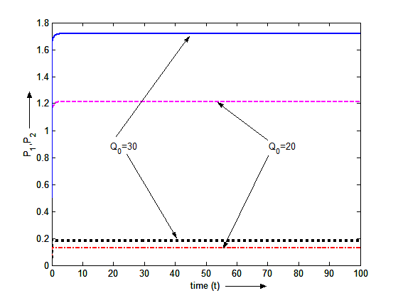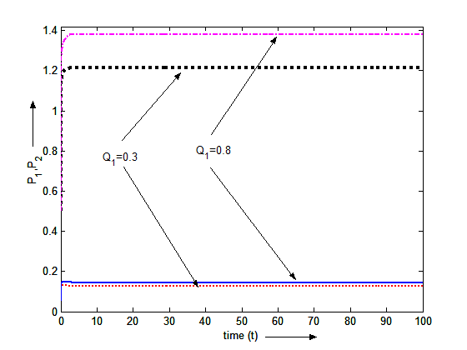

Fig.1, Variation of Primary and Secondary Fig.2, Variation of Primary and Secondary toxicants
toxicants with time for different values of with time for different values of$Q_{1}$ and other values of
$Q_{0}$ and other values of parameters are parameters are same as in (5.2)
same as in (5.2).

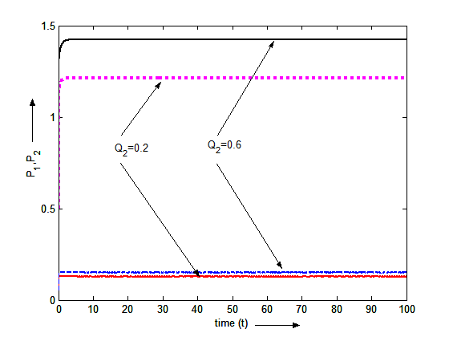
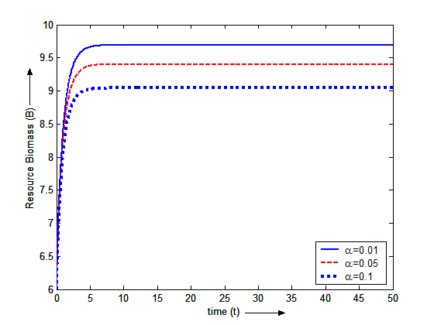
Fig.3, Variation of Primary and Secondary toxicants Fig. 4, Variation of resource-biomass with time for different values of with time for different values of $Q_{2}$ $α$and other values of parameters are same as in (5.2) and other values of parameters are same as in (5.2)

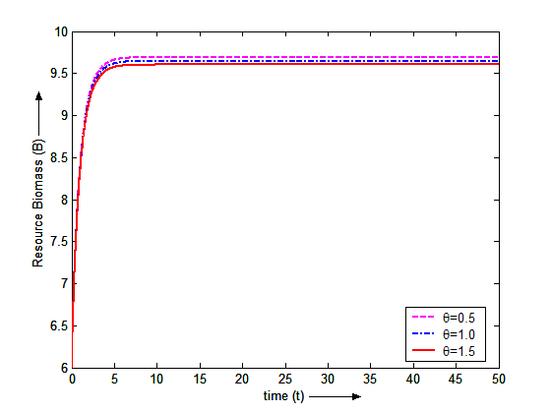
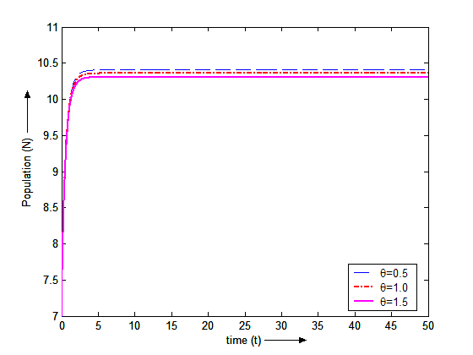
Fig. 5, Variation of resource-biomass with Fig. 6, Variation of population with time
for different values of $θ$ and other values time for different values of $θ$and other
of parameters are same as in (5.2) values of parameters are same as in (5.2)

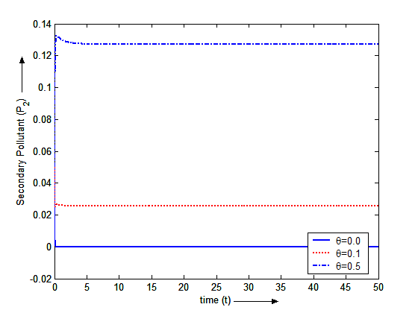
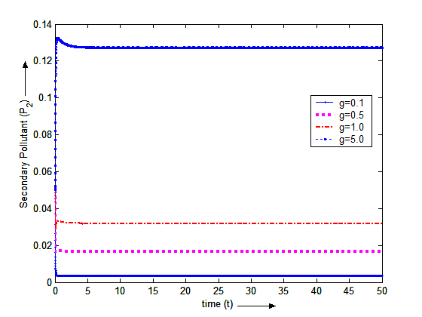
Fig. 7, Variation of secondary toxicant with Fig. 8, Variation of secondary toxicant with time for different values
time for different values of $θ$ and other values of $g$ and other values are same.
Of parameters are same as in (5.2)
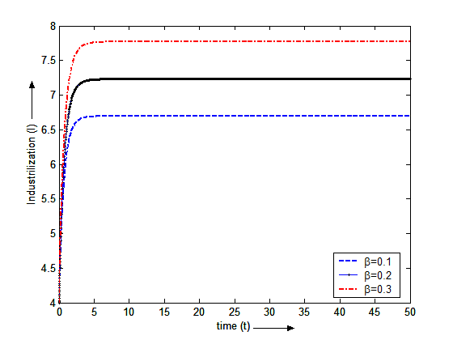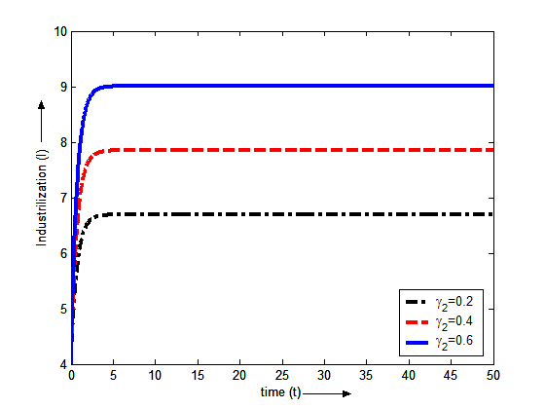
Fig. 9, Variation of Industrialization with time Fig. 10, Variation of Industrialization with
for different values of $β$ and other values time for different values of $γ_{2}$ and other
of parameters are same as in (5.2) values of parameters are same as in (5.2)

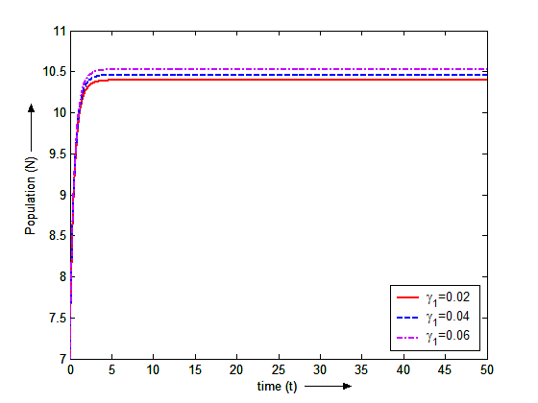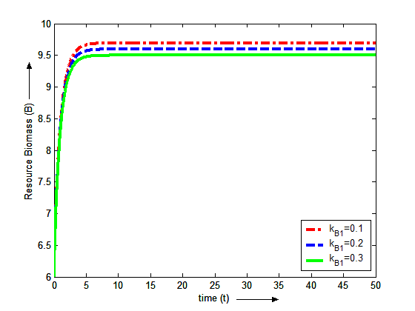
Fig. 11, Variation of Population with time Fig. 12, Variation of resource-biomass with
for different values of $γ_{1}$ and other time for different values of $K_{B1}$ and other
values of parameters are same as in (5.2) values of parameters are same as in (5.2)
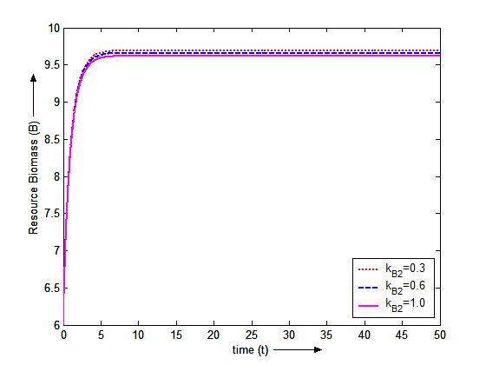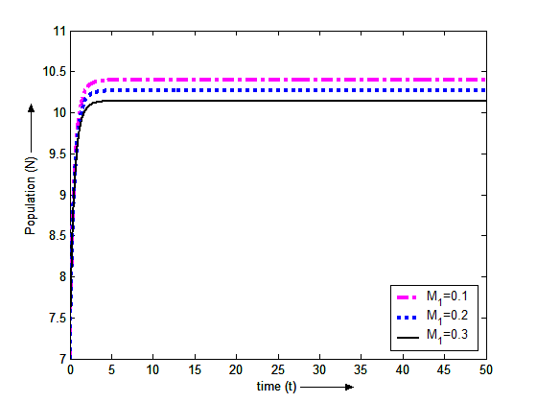
Fig. 13, Variation of resource-biomass with time Fig. 14, Variation of population with time
for different values of $K_{B2}$ and other for different values of $M_{1}$ and other
values of parameters are same as in (5.2) values of parameters are same as in (5.2)

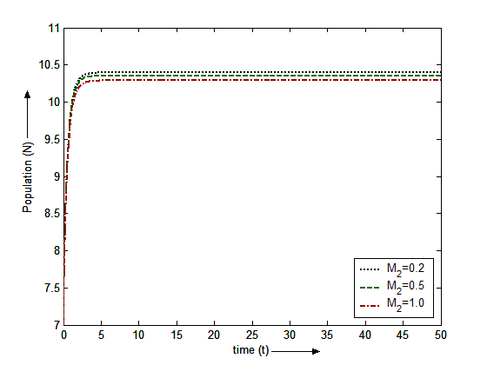
Fig. 15, Variation of population with time
for different values of $M_{2}$ and other
values of parameters are same as in (5.2)

