***Alternative Modalities Of Care, Alternative System Of Health And Complementary Therapies.& Telemedicine.***

**Ruqeeb jan(Msc.Mental Health Nursing) tutor college of nursing ,GMC ,Srinagar,ruqeeb1235jan@gmail.com,8491864279/9622755489.**

**INTRODUCTION**

* Alternative/complementary modalities of care have been defined as treatment techniques whose goals are to evoke healing, taking into account the body mind spirit connection of every individual (DOSSEY 1995)
* The National Center for Complementary and Alternative Medicine (NCCAM) defines Complementary and Alternative Medicine (CAM) as a group of diverse medical and health care system, practices & products that are not presently considered to be part of conventional medicine. ***Complementary therapies*** are those used in conjunction with conventional medical practices. ***Alternative therapies*** are those that are used instead of conventional medicine.
* Alternative medicine includes therapies & health care practices not widely taught in most medical schools, however, many such practices are popular & some are used in Hospitals. Alternative medicine often defines health as a balance of body system physical, emotional & spiritual. Conventional medicine generally defines health as the absence of disease & treatment often involves drugs or surgery. Patients are most likely to seek alternative medicine for conditions such as chronic low back pain, stress, cancer, headaches etc. Some patients seek alternative medicine when conventional medicine offers little hope, especially at the end of life.

**ALTERNATIVE SYSTEM OF HEALTH**

* Alternative system of health is a complete system of theory and practice that evolved independently of biomedical approach. It includes Ayurveda, Siddha, Unani, Homeopathy, Neuropathy, Traditional Chinese medicine, American Indian medicine.

1. **AYURVEDA**:

* It is a system of healing based on homeopathy & naturopathy with an extensive use of herbs. It is traditional medical system of India originating more than 4,000 years ago. The word Ayurveda comes from Sanskrit word Ayur means ‘life’ & Veda means ‘knowledge’. It considers the disease results from the accumulation of toxin in the body and an imbalance of emotions. It prescribes individualized diets, detoxification, cleaning from orifices, meditation & yoga. The aim is to remove the cause of disorders, prevent illness and harmonize body, mind and consciousness. Ayurveda aids in maintaining good health increasing longevity and overall quality of life.
* Alternative Ayurveda treatments and self-help regimens include nutrition, herbal remedies, aromatherapy, lifestyle recommendations, message treatments, color/sound therapy, meditation, yoga, and rejuvenation therapies.

**Tri-Dosha**

* Recognizing that human beings are part of nature, Ayurveda describes three fundamental energies that govern our inner and outer environments: movement, transformation, and structure. Known in Sanskrit as Vata (Wind), Pitta (Fire), and Kapha (Earth), these primary forces are responsible for the characteristics of our mind and body.

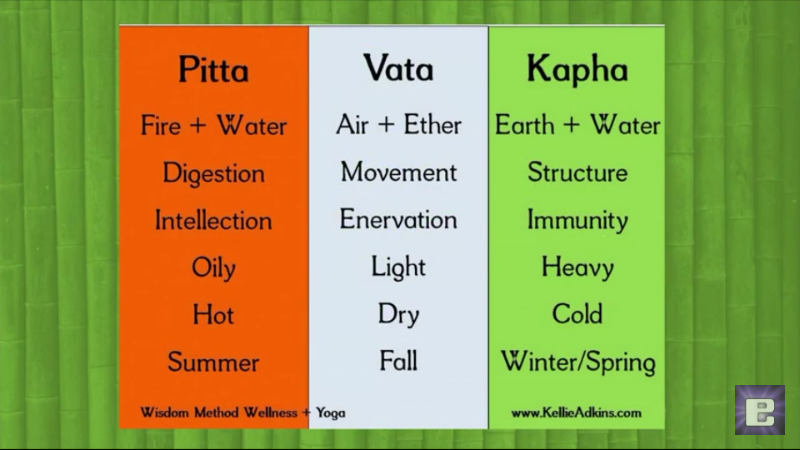

**Body Types**

* Each of us has a unique proportion of these three forces that shapes our nature. If Vata is dominant in our Ayurvedic Consultation system, we tend to be thin, light, enthusiastic, energetic, and changeable. If Pitta predominates in our nature, we tend to be intense, intelligent, and goal-oriented and we have a strong appetite for life. When Kapha prevails, we tend to be easy-going, methodical, and nurturing. Although each of us has all three forces, most people have one or two elements that predominate.
* For each element, there is a balanced and imbalance expression. When Vata is balanced, a person is lively and creative, but when there is too much movement in the system, a person tends to experience anxiety, insomnia, dry skin, constipation, and difficulty focusing. When Pitta is functioning in a balanced manner, a person is warm, friendly, disciplined, a good leader, and a good speaker. When Pitta is out of balance, a person tends to be compulsive and irritable and may suffer from indigestion or an inflammatory condition. When Kapha is balanced, a person is sweet, supportive, and stable but when Kapha is out of balance, a person may experience sluggishness, weight gain, and sinus congestion.

1. **YOGA**:

* Yoga is derived from Sanskrit word Yuj means to unite or to control. It is an Indian practice that includes postures(asana) breathing exercises(pranayama) & cleansing practices (kriyas). Yoga is an ancient Indian practice using physical postures to obtain a harmony of mind, body & spirit. It works by increasing oxygenation of blood, muscle toning throughout the body, a clearer & more relaxed mind , improved posture, improved circulation of blood & lymph & regulation of bodily functions. Main branches of yoga are:

1. **HATHA YOGA**: yoga of purifying physique and mind.
2. **KARMA YOGA**: yoga of action.
3. **JHANA YOGA**: yoga of knowledge.
4. **BHAKTI YOGA**: yoga of devotion.
5. **RAJA YOGA**: yoga of controlling mind.

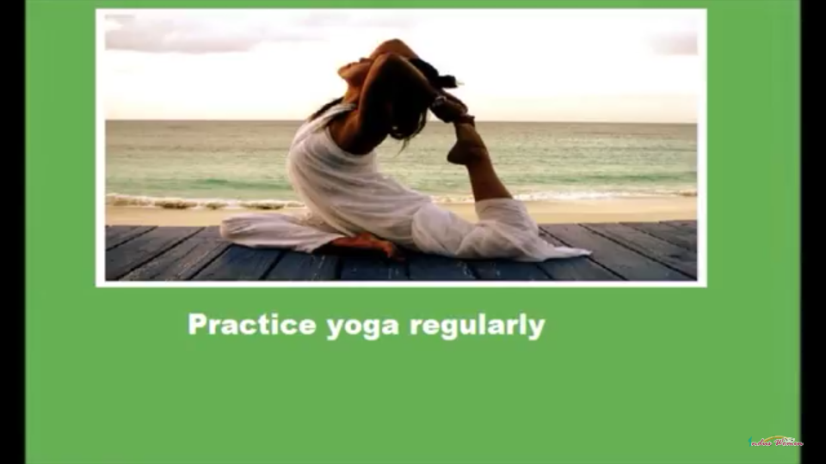

Yoga system advocates identification of soul(Atman) with its final aim being union with supreme being(Paramatma). This is brought by following eight steps:

1. **Self-control (yama),** obtained by such devices as chastity, non- stealing, non-violence, truthfulness & avoidance of greed.
2. **Religious observance (Niyama**) through chanting of Vedic hymns, austerity, purity & controlled rhythmic.
3. **Assumption of certain positions(Aasana).**
4. **Regulation of breath (Pranayama)** with controlled rhythmic exhalation, inhalation & temporary suspension of breathing.
5. **Restrain of the senses (Pratyahara).**
6. **Steadying of mind(Dharana),** through fixation on some body part, such as nose or navel.
7. **Meditation (Dhayana)** on true object of knowledge, the supreme spirit, to the exclusion of other things in life.
8. **Profound contemplation (Samadhi**), with such complete absorption &detachment that there is insensitivity to heat & cold, pain & pressure.

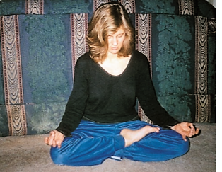

1. **UNANI AND TIBBI:**

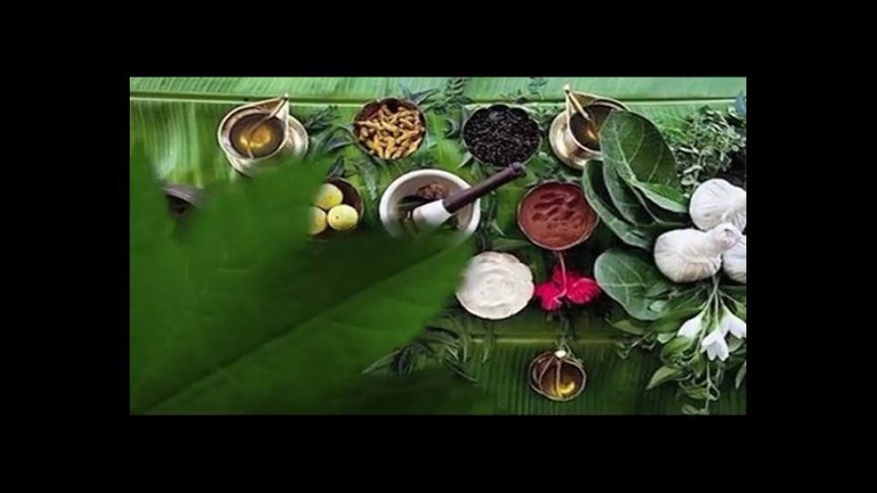

As an alternative form of medicine, unani has found favour in Asia especially India. In India, these unani practitioners can practice as qualified doctors , as the Indian government approves their practice. Unani medicine is very close to Ayurveda. Both are based on theory of the presence of the elements( in unani, they are considered to be fire, water, earth & air) in human body. According to the followers of medicine these elements are present in different fluids and their balance leads to health and their imbalance results in disease. All these elaborations were built on the basic Hippocratic theory of four humors( body of blood, phlegm, yellow bile & black bile). Each person’s unique mixture of these substances determine his temperament: predominance of blood gives a sanguine temperament; predominance of phlegm makes one phlegmatic; yellow bile, choleric& black bile, melancholic.

1. **SIDDHA:**

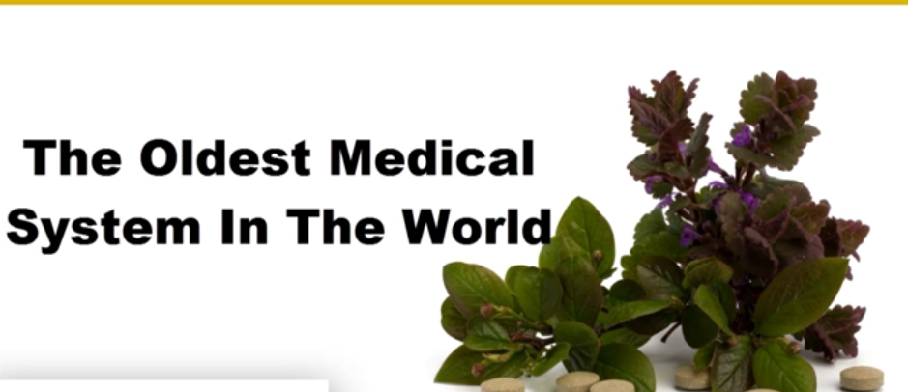

* Siddha medicine is a form of south India Tamil traditional medicine and part of the trio Indian medicines Ayurveda, siddha &unani. This system of medicine was popular in ancient india, due to antiquity of this medical system, the siddha system of medicine is believed to be the oldest medical system in the universe.
* siddharas were of the concept that a healthy soul can only be developed through a healthy body. So they developed methods and medication that are believed to strengthen their physical body and thereby their soul. The treatment in siddha medicine is aimed at keeping the three humors in equilibrium and maintenance of seven elements. So proper diet, medicine & a disciplined regimen of life are advised for a healthy living & to restore humors in diseased condition.
* Thiruvalluvar explains four requisites of successful treatment. These are the patient, the attendant, physician and medicine. When the physician is well qualified and the other agents possess the necessary qualities, even severe disease can be cured easily. Treatment is classified into three categories: devamaruthuvum (divine method) manudamaruthuvum (rational method), and asuramaruthuvum(surgical method).
* according to the therapies the treatment of siddha medicines could be further categorized into purgative therapy, emetic therapy, fasting therapy, steam therapy, physical therapy, solar therapy, yoga therapy etc.

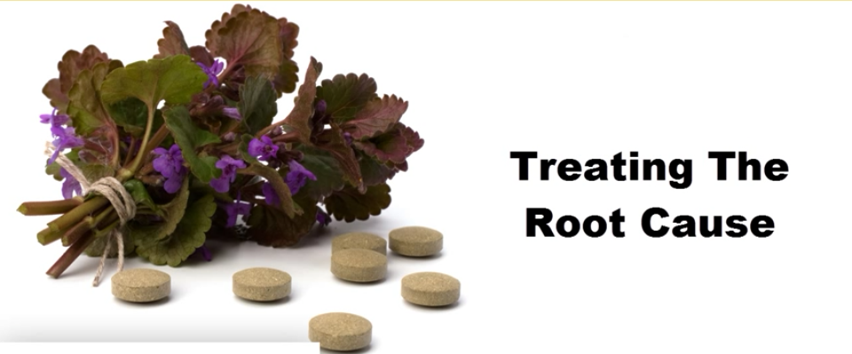

1. **HOMEOPATHY:**

It is the system of therapy based on the concept that disease can be treated with drugs in minute doses which are capable of producing the same symptoms in healthy people as the disease itself. Homeopathy was developed in Germany in the late 1700s, it is based on principal that “like cures like”. Homeopathy medicine are taking original substance from plants, animals and minerals and highly diluting them. It is believed body’s own healing ability is stimulated by these medicines. Homeopaths believe that their remedies mobilize the body’s vital force to archestrate co-ordinated healing responses throughout the body system. The body translates the information on the vital force into local physical changes that leads to recovery from acute & chronic diseases. However homeopathy has few risks rarely an allergic or toxic reaction occurs.

1. **NATUROPATHY**



It is a system of medicine based on preventive care, and on the use of heat, water, light, air, and massage as primary therapies for disease. This therapy began as a formal healthcare system in US in early 1990s. It cures the disease by harnessing the body’s own natural healing powers. Rejecting synthetic drugs and invasive procedures; it stresses the restorative powers of nature. It takes seriously the motto “first do no harm”. It relies on natural healing approaches such as herbs, nutrition, and movements and manipulation of body. Attempt is to eliminate the fundamental cause of illness, not simply to remove symptoms. Naturopathy is based on belief that the body is self-healing. The body will repair itself & recover from illness spontaneously if it is in a healthy environment.

**The following therapies are considered to be of primary importance in naturopathic treatment of disease.**

* **NUTRITION AND DIETETIC**: This includes the prescription of a balanced wholesome, natural diet, based on the principles advocated by naturopathic treatment of disease.
* **FASTING**: It was advocated by Hippocrates as a treatment for many diseases because it allowed the body to concentrate its resources on dealing with the disease rather than the process of digestion.
* **STRUCTURAL ADJUSTMENT**: By such methods as osteopathy, chiropractic, neuromuscular technique, postural re-education and remedial exercises, the naturopathic practitioner seeks to balance and integrate the spine, muscles, ligaments and joints of the whole body.
* **HYDROTHERAPY**: This is the use of water, both internally & externally in the form of baths, packs, compresses, sprays &douches. It is of value in most conditions & rightly applied can give remarkable results in the treatment of both acute & chronic conditions.
* **HEALTHY LIFESTYLE**: This includes the general care of one’s body, the use of moderate physical exercise, the cultivation of a positive approach to life & health, relaxation technique, etc.
* **EDUCATION**: In naturopathic philosophy it is just as important, if not more so, to explain to the patient why disease occurs & what patient can do for himself or herself to maintain the new improved level of health given to them by naturopathic treatment. In this way patient is given responsibility for his or her health.

1. **TRADITIONAL CHINESE MEDICINE:**

Traditional chinese medicine view the people as ecosystem in miniature. Chinese medicine is based on the theory that disease results from improper flow of life force (qi). Qi is restored by balancing the opposing forces, which manifest in body as heat & cold, external & internal & deficiency & excess. Various practices(eg, acupuncture, herbal remedies, massage, meditation) are used to preserve & restore health.

1. **AMERICAN INDIAN MEDICINE:**

* Physical illness is attributed to spiritual cause or spirit. Healing involves activities that appease the spirits, rid the individual of impurities & restore them to a healthful, spiritually pure state.
* The central figure in American Indian Medicine man (healer, sorcerer,, educator,& priest), often called as Shaman, who seeks to drive evil spirit out.
* **CHIROPRACTICE**: In chiropractic, the relationship between the structure of the spine & function of nervous system is thought to be the key in maintaining or restoring health. The main method for achieving balance is spinal manipulation. It is often useful in treating low back pain, headaches, & nerve impingement syndrome.

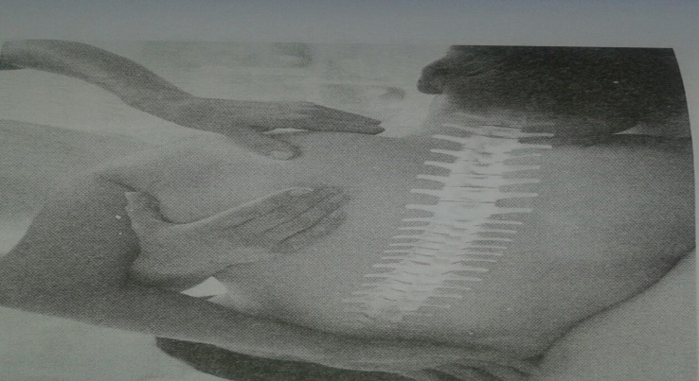

* **Tai Chi Qigong**: It has recently been considered as an alternative method for lowering the blood pressure levels. The discovery has big implication for patients who are suffering from chronic hypertension. Meditation, including Tai Chi Qigong therapy, leads to a relaxation response.
* **COMLEMENTARY THERAPIES:**

Complimentary therapy is known by many different terms, including, Alternative therapy, Alternative medicine, Holistic therapy, & Traditional medicine. A wide range of treatments exist under the umbrella term Complementary Therapy. Some of the Complementary Therapies are as follows:

1. **HERBAL MEDICINE:**

* Herbal medicine has always attached some scientific interest & many well-known drugs are plant derived, e.g. digoxin foxgloves and morphine from poppies.

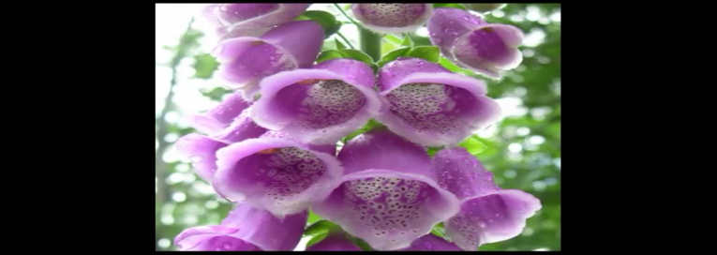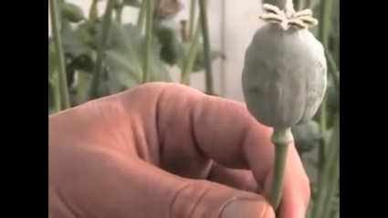

* **Here are some of the herbs commonly thought to be effective:**
* St johnswort (Hypericumperforatum) is a safe & effective treatment for mind to moderate depression.

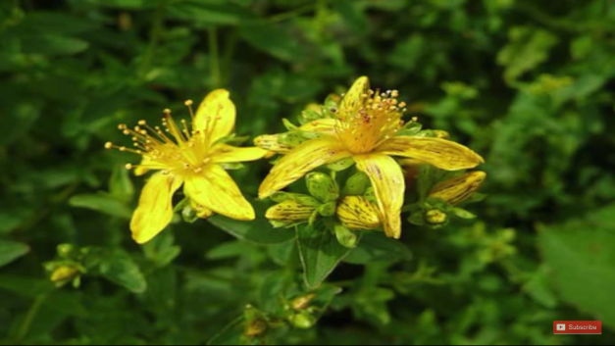

* Ginkgo Bilobia may be effective in relieving the symptoms of dementia.

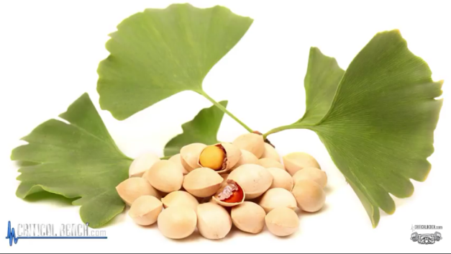

* Horse chestnut seed extract can alleviate the symptoms of varicose veins.

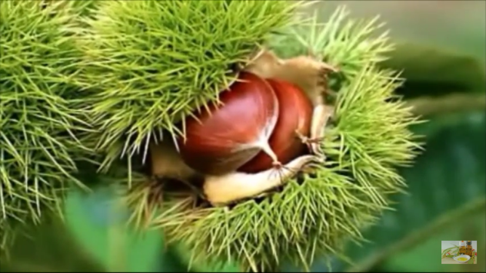

1. **MIND-BODY TECHNIQUES:**

* Mind body techniques are based on theory that mental & emotional factors can influence physical health. Behavioral, Psychological, social, spiritual methods are used to preserve health & prevent or cure disease. Methods include the following :
* **MEDITATION:** In Meditation People regulate their attention or systematically focus on particular aspects of inner or outer experiences. Usually involves sitting or resting quietly, often with the eyes closed. Sometimes it involves the repetitive sounding of a phrase meant to help the person to focus.
* **RELAXATION TECHNIQUES**: These are practices specifically designed to relieve tension & strain. The specific technique may be aimed at reducing activity of the nerves that control stress response, lowering BP, easing muscle tension etc.
* **HYPNOTHERAPY**: In Hypnotherapy people are guided into an advanced state of relaxation & heightened attention. Hypnotized people become absorbed in the images suggested by the Hypnotherapist & are able to suspend disbelief. Hypnotherapy can be used to help people change their behavior & thus improve health or help treat purely psychological symptoms.

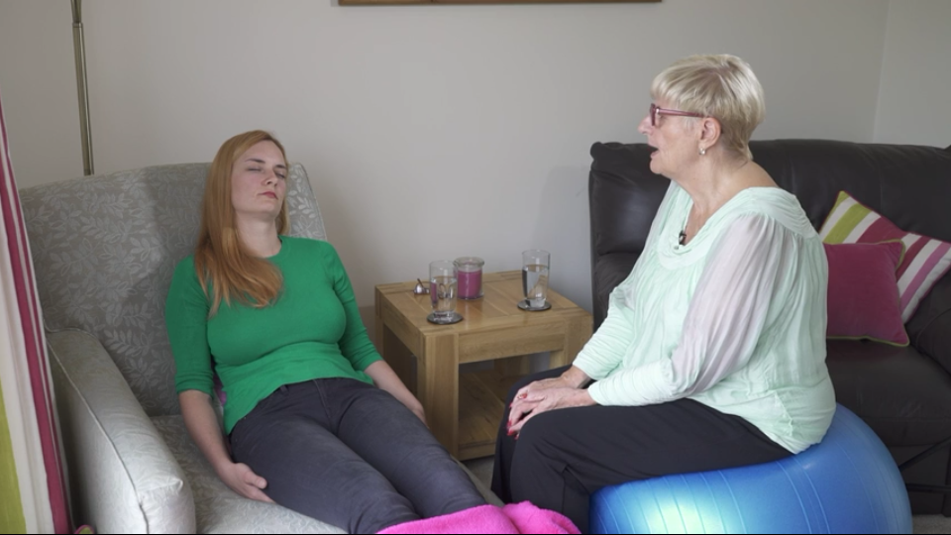

* **BIOFEEDBACK**: It is a method of bringing unconscious biologic process under conscious control. Biofeedback involves the use of electronic devices to measure & report back to the conscious mind information such as heart rate, BP, muscle tension, brain surface electrical activity. It has shown to be clinically effective in treating certain problems e.g. headaches, incontinence & attention deficit disorder.
* **ENERGY THERAPIES:**
* **MASSAGE THERAPY**: Body tissues are manipulated to promote wellness & reduce pain & stress. Massage has been shown to help relieve muscle soreness, pain due to back injuries, & fibromyalgia & to help relieve anxiety in cancer patients.
* **ACUPUNCTURE**: A therapy within traditional Chinese medicine is mostly accepted in western world. Specific points on body are stimulated, usually by inserting thin needles into the skin & underlying tissues. Sometimes additional stimulation is added by using low voltage current. Stimulating these specific points is believed to unblock the flow of qi along energy pathway & thus restore balance.

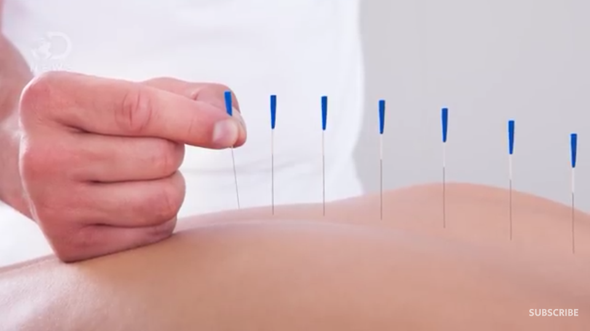

* **ACUPRESSURE**: A variation of acupuncture, called acupressure uses localized massage instead of needles to stimulate acupuncture points. It is used as an adjunct therapy to either acupuncture or massage to relieve pain & stress in a particular area of the body.
* **REFLEXOLOGY**: A variant of massage therapy relies on manual pressure applied to specific area of foot; these areas are believed to correspond to different organs or body systems via meridians. Stimulation of these areas is believed to eliminate blockage of energy responsible for pain or disease in the corresponding body part.

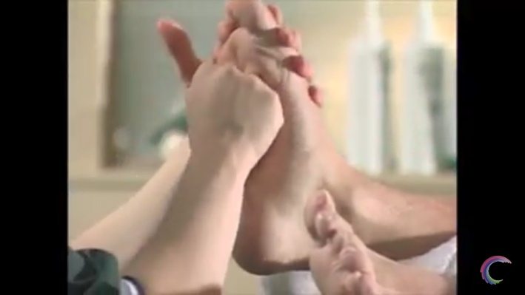

* **OTHER THERAPIES:**
* **AROMA THERAPY**: Aroma therapy is based on the healing power of plant oils which may be massaged into the skin, inhaled or used in the bath. This therapy massage relieves tension & improves circulation & can reduce anxiety in a short-term setting such as intensive care.
* **SPIRITUAL THERAPY**: It is a regimen designed to heal ones spirit & psyche as well as the body. It treats the whole being especially the spirit to promote a healthy whole person. It includes faith & prayer.
* **MUSIC THERAPY**: It is an interpersonal process in which a trained music therapist uses music & all of its facets physically, emotionally, mentally, socially & spiritually to help clients to improve or maintain their health. It is used with individuals of all ages. It is used to improve learning, build self-esteem, reduce stress, support physical exercise etc.
* **BIOELECTROMEGNATIC THERAPY**: It is the application of electromagnetic field to treat & prevent disease & promote health & longevity. Electromagnetism is a powerful clinical tool, simple to apply yet complex in its biological effects. Some of the documented effects of electromagnetic therapy include accelerated healing, greater cellular energy, increased blood flow, reduced inflammation &edema reduces stress etc.

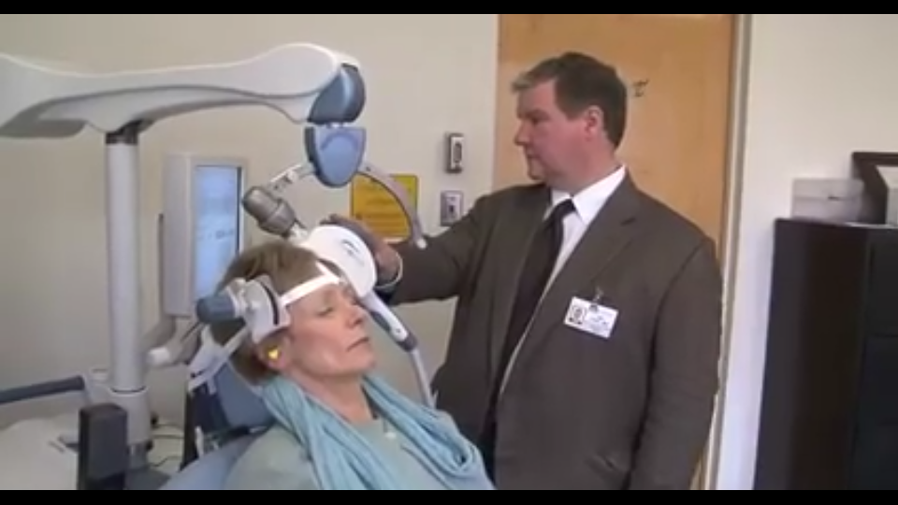

* **PHOTO ENERGY THERAPY**: Photo energy therapy devices emit near infrared light typically at a wavelength of 880nm. This wavelength is believed to stimulate the release of nitric oxide, an endothelium derived releasing factor into the blood stream, thus vasodilating the capillaries &vacuoles in the microcirculatory system. This increase in circulation has been effective to decrease pain in diabetic & non-diabetic patients.

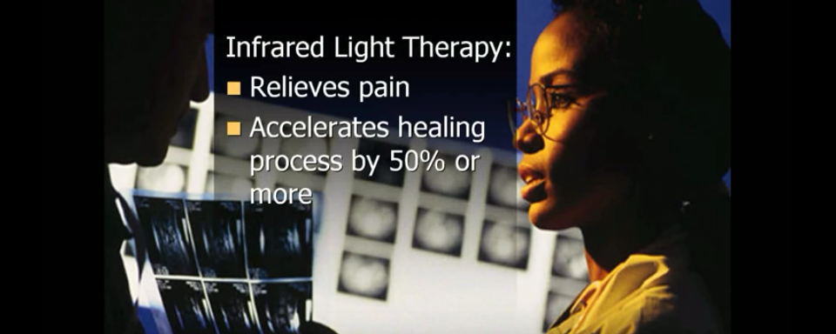

* **DETOXIFICATION THERAPY**: Detoxification involves the removal of toxic substances. Some of the methods of detoxification are colonic irrigation, fasting, special diets, hyperthermia, lymphatic stimulation & nutritional supplements like vitamin A, vitamin B&C, & minerals like magnesium.
* **ANIMAL ASSISTED THERAPY**: It is a type of therapy that involves an animal with specific characteristics becoming a fundamental part of a person’s treatment. It is designed to improve the physical, social, emotional, & other cognitive functioning of patient, as well as provide educational & motivational effectiveness of participants. This therapy improves fine motor skills, lower BP, decrease depression, increase self-esteem, reduce anxiety, develop leisure, reduce loneliness etc.
* **TELEMEDICINE**
* The term ‘Telemedicine’ has been derived from the Greek word ‘tele’ meaning at a ‘distance’ & ‘medicine’ which is from the Latin word ‘mederi’ meaning ‘healing’.
* Telemedicine can be defined as, the use of modern information technology, especially two-way interactive audio/video telecommunications, computers & telemetry to deliver health services to remote patients and to facilitate information exchange between primary care physicians & specialists at some distance from each other.
* Telemedicine is a method by which patients can be examined, investigated, monitored & treated, with the patient & doctor located in different places. Telemedicine generally refers to use of communications & information technologies for delivery of clinical care.
* **HISTORY OF TELEMEDCINE**
* Care at a distance (absentia care), is an old practice which has often conducted via post. In early 1900s, people living in remote areas in Australia use two-way radios, powered by a dynamo driven by a set of bicycle pedals, to communicate with the Royal Flying Doctor service of Australia.
* In 1967 one of the first telemedicine clinics was founded by kenneth bird at Massachusetts General Hospital to provide occupational health services to airport employees & to deliver emergency care & medical attention to travellers.
* The first interactive telemedicine system, operating over standard telephone lines, designed to remotely diagnose & treat patients requiring cardiac resuscitation was developed & launched by an American company, Med Phone corporation, in 1989.
* **APPLICATION IN DIFFERENT FORMS**
* Information exchange between Hospitals & Physicians.
* Networking of group of Hospitals, research centers.
* Linking rural health clinics to a central Hospital.
* Video conferencing between a patient & doctor, among members of healthcare teams.
* Training of healthcare professionals in widely distributed or remote clinical settings.
* Instant access to medical knowledge base, technical papers etc.
* **BENEFITS OF TELEMEDICINE**
* Telemedicine can be beneficial to patients in isolated communities & remote regions, who can receive care from doctors or specialists far away without the patient having to travel to visit them.
* Telemedicine can allow healthcare professionals in multiple locations to share information & discuss patient issues as if they were in same place.
* Telemedicine can reduce the need for outpatient visits & enable remote prescription verification & drug administration oversight, potentially significantly reducing the overall cost of medical care.
* Telemedicine can facilitate medical education by allowing workers to observe experts in their fields & share best practices more easily.
* Telemedicine can eliminate the possible transmission of infectious diseases or parasites between patient & medical staff.
* Telemedicine are helpful for patients who are home-bound & require ambulance to move.
* **DRAWBACKS OF TELEMEDICINE**
* Downsides of Telemedicine include the cost of telecommunication & data management equipment &of technical training of medical personnel who will employ it.
* Decreased interaction between medical professionals & patients, increase risk of error when medical services delivered in absence of a registered professional.
* Increased risk that protected health information may be compromised through electronic storage & transmission.
* Poor quality of transmission records & decreased access to relevant clinical information are risks that can compromise the quality of patient care.
* Inability to start treatment immediately.
* Obstacles to the implementation of Telemedicine include unclear legal regulation for some Telemedicine practices.
* **TYPES OF TELEMEDCINE**
* Telemedicine is practiced on basis of two concepts:

1. **Real time Telemedicine**: Could be simple as a telephonic call or as complex as robotic surgery. It requires presence of both parties at the same time & a communication links between them that allows a real-time interaction to take place. Video conferencing equipment is one of the most common forms of technologies used in synchronous telemedicine.
2. **Store-and-forward Telemedicine**: It involves acquiring medical data & then transmitting this data to doctor or medical specialist at a convenient time for assessment offline. It does not required presence of both parties at same time. Dermatology, radiology & pathology are common specialties that are conductive to asynchronous Telemedicine. A properly structured medical record preferably in electronic form should be component of this transfer. This process requires the clinician to rely on history report & audio/video information. There is no actual physical examination.

* **TELENURSING**

Telemedicine refers to use of telecommunications & information technology in order to provide nursing services in health care whenever a large physical distance exists between patient & nurse, or between any numbers of nurses. As a field it is part of telehealth, & has many points of contacts with other medical & non-medical applications, such as tele-diagnosis, teleconsultation, tele-monitoring etc.

* Telenursing is achieving significant growth rates in many countries due to several factors: the preoccupation in reducing the costs of health care, increase in number of aging & chronically ill population, & the increase in coverage of health care to distant, rural, small or sparsely populated regions.
* Telenursing may help solve increasing shortages of nurses; to reduce distance & save travel time, &keep patients out of Hospital. A great degree of job satisfaction has been registered among tele-nurses.

**BIBLIOGRAPHY**

* www.wikipedia.com
* www.medicinenet.com>main>mobileart
* Sreevani R. A Guide To Mental Health And Psychiatric Nursing.3rded.NewDelhi:jaypee brothers;2010:121-125
* Basheer S P,Yaseen S. A textbook of Advanced Nursing Practice.2nded. New Delhi:EMMESS medical publishers;2017:625-638 & 116-119